Innovation & Technology

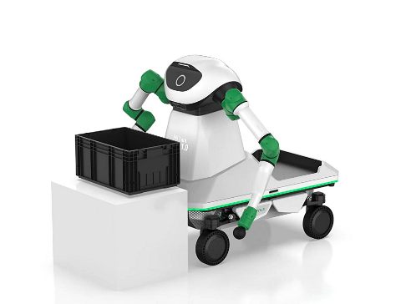

**Disruptive Technologien: Schaeffler entwickelt humanoiden Roboter:** Mitarbeitende des Schaeffler Hub for Advanced Research an der Nanyang Technological University (NTU) haben den humanoiden Roboter Lifelike Intelligent Nexus Humanoid, kurz LINH, entwickelt. Dieser markiert einen wichtigen Meilenstein in der Zusammenarbeit zwischen Menschen und humanoiden Robotern in der industriellen Fertigung.

[WEITERLESEN](https://worksite.sharepoint.com/sites/today/SitePages/Disruptive-Technologien--Schaeffler-entwickelt-humanoiden-Roboter-%E2%80%93-mit-Video.aspx)

**Disruptive Technologies: Schaeffler develops humanoid robots:** Employees at the Schaeffler Hub for Advanced Research (SHARE) at Nanyang Technological University (NTU) have developed a humanoid robot called Lifelike Intelligent Nexus Humanoid, or LINH for short. The robot marks an important milestone in collaboration between humans and humanoid robots in industrial production.

[READ MORE](https://worksite.sharepoint.com/sites/today/SitePages/en/Disruptive-Technologien--Schaeffler-entwickelt-humanoiden-Roboter-%E2%80%93-mit-Video.aspx)

Sustainability & Engagement

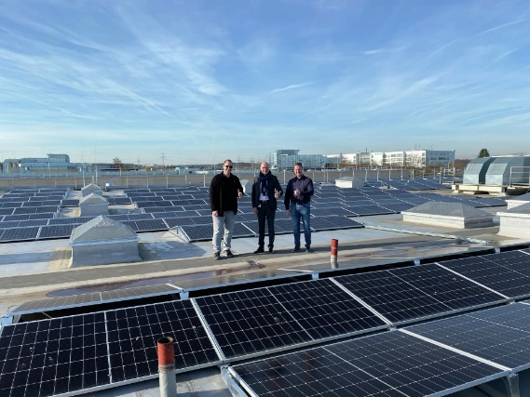

**Zwei Photovoltaikanlagen am Schaeffler Campus Erlangen:** Die Eigenerzeugung erneuerbarer Energien spielt eine wichtige Rolle bei der Dekarbonisierung der Produktion der Schaeffler Gruppe. Seit Sommer wird am Schaeffler Campus Erlangen durch zwei neue Photovoltaik-Dachanlagen mit einer Gesamtfläche von rund 4.500 m2 und knapp 926 Kilowatt-Peak (kWp) grüner Strom erzeugt.

[WEITERLESEN](https://worksite.sharepoint.com/sites/today/SitePages/Zwei-Photovoltaikanlagen-am-Schaeffler-Campus-Erlangen.aspx)

**Two photovoltaic systems at the Schaeffler Campus Erlangen:** Own generation of renewable energies plays an important role in the decarbonization of the Schaeffler Group's production. Since the summer, green electricity has been generated at the Schaeffler Campus Erlangen (Germany) by two new photovoltaic rooftop systems with a total area of around 4,500 m2 and almost 926 kilowatt peak (kWp).

[READ MORE](https://worksite.sharepoint.com/sites/today/SitePages/en/Zwei-Photovoltaikanlagen-am-Schaeffler-Campus-Erlangen.aspx)

Digitalization & IT

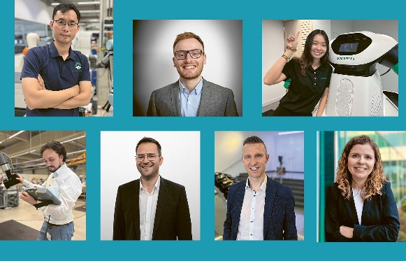

**Wie KI im Job hilft: Gesichter aus der Schaeffler-Welt**: Das Wort KI ist in aller Munde und aus dem Privat- und Arbeitsleben nicht mehr wegzudenken. Auch bei Schaeffler wird Künstliche Intelligenz in vielen Bereichen eingesetzt. In Teil 3 der dreiteiligen Serie zu Künstlicher Intelligenz bei Schaeffler erfahren Sie, woran Menschen bei Schaeffler mit KI arbeiten.

[WEITERLESEN](https://worksite.sharepoint.com/sites/today/SitePages/Wie-KI-im-Job-hilft--Gesichter-aus-der-Schaeffler-Welt.aspx)

Den ersten Teil der Serie finden Sie [hier](https://worksite.sharepoint.com/sites/today/SitePages/Wie-KI-Im-Job-hilft--%E2%80%9ENachhaltigkeit-ist-die-Herausforderung-und-Digitalisierung-die-L%C3%B6sung%E2%80%9C.aspx). Den zweiten Teil [hier](https://worksite.sharepoint.com/sites/today/SitePages/Wie-KI-im-Job-hilft-%E2%80%93-Teil-2--Hier-wird-KI-bei-Schaeffler-eingesetzt.aspx).

**How AI helps in the workplace: Faces from around the Schaeffler world**: The term AI is on everyone’s lips and has become an integral part of our private and professional lives. Artificial intelligence is also used in many areas at Schaeffler. In part 3 you will find out what people at Schaeffler are working on with AI.

[READ MORE](https://worksite.sharepoint.com/sites/today/SitePages/en/Wie-KI-im-Job-hilft--Gesichter-aus-der-Schaeffler-Welt.aspx)

You can read the first part of the series [here](https://worksite.sharepoint.com/sites/today/SitePages/en/Wie-KI-Im-Job-hilft--%E2%80%9ENachhaltigkeit-ist-die-Herausforderung-und-Digitalisierung-die-L%C3%B6sung%E2%80%9C.aspx) and find the second part [here](https://worksite.sharepoint.com/sites/today/SitePages/en/Wie-KI-im-Job-hilft-%E2%80%93-Teil-2--Hier-wird-KI-bei-Schaeffler-eingesetzt.aspx).

Employee Video

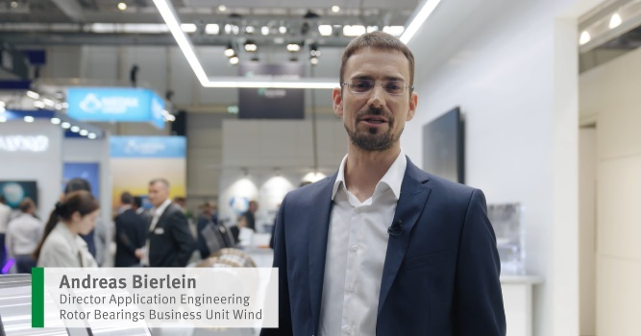

Andreas Bierlein, Director Applications Engineering Rotor Bearings Business Unit Wind, berichtet von der Messe Wind Energy 2024 aus Hamburg. Im Fokus dabei unter anderem: Das split asymetrical spherical roller bearing. Das vollständige Video finden Sie [hier](https://worksite.sharepoint.com/sites/Execution-Program/_layouts/15/stream.aspx?id=%2Fsites%2FExecution%2DProgram%2FSiteAssets%2FSitePages%2FProgram%2DCommunication%2FEmployee%20Videos%2FEpisode%2033%20split%20spherical%20roller%20bearing%20%28Andreas%20Bierlein%29%5F%2Emp4&referrer=StreamWebApp%2EWeb&referrerScenario=AddressBarCopied%2Eview%2E9997d622%2D6b7e%2D49e1%2Dbcc2%2Da0afec5ef113).

Andreas Bierlein, Director Applications Engineering Rotor Bearings Business Unit Wind, reports from the Wind Energy 2024 trade fair in Hamburg. Among other things, the focus is on split asymmetrical spherical roller bearing. You can find the full video here. Watch the full video [here.](https://worksite.sharepoint.com/sites/Execution-Program/_layouts/15/stream.aspx?id=%2Fsites%2FExecution%2DProgram%2FSiteAssets%2FSitePages%2FProgram%2DCommunication%2FEmployee%20Videos%2FEpisode%2033%20split%20spherical%20roller%20bearing%20%28Andreas%20Bierlein%29%5F%2Emp4&referrer=StreamWebApp%2EWeb&referrerScenario=AddressBarCopied%2Eview%2E9997d622%2D6b7e%2D49e1%2Dbcc2%2Da0afec5ef113)

Employee Video

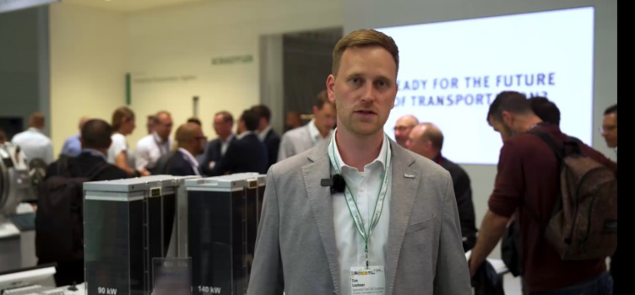

Tim Lochner, Spezialist für Brennstoffzellensysteme bei Schaeffler, berichtet im Mitarbeitervideo von der IAA Transportation und gibt Einblicke in Schaefflers Brennstoffzellen-Portfolio. Das vollständige Video finden Sie [hier](https://worksite.sharepoint.com/sites/Execution-Program/_layouts/15/stream.aspx?id=%2Fsites%2FExecution%2DProgram%2FSiteAssets%2FSitePages%2FProgram%2DCommunication%2FEmployee%20Videos%2FEpisode%2032%20Fuel%20Cell%20%28Tim%20Lochner%29%20DE%2Emp4&referrer=StreamWebApp%2EWeb&referrerScenario=AddressBarCopied%2Eview%2E533cdf3a%2D68d0%2D4b85%2Db89e%2D08f99f212bf3).

In the latest employee video, Tim Lochner, Specialist for fuel cell systems, reports from the IAA Transportation and provides insights into Schaeffler's fuel cell product portfolio. Watch the full video [here](https://worksite.sharepoint.com/sites/Execution-Program/_layouts/15/stream.aspx?id=%2Fsites%2FExecution%2DProgram%2FSiteAssets%2FSitePages%2FProgram%2DCommunication%2FEmployee%20Videos%2FEpisode%2032%20Fuel%20Cell%20%28Tim%20Lochner%29%20EN%2Emp4&referrer=StreamWebApp%2EWeb&referrerScenario=AddressBarCopied%2Eview%2E921a4cb0%2D32b7%2D40d7%2D9aa9%2D148133896f1c).