**Title: Real-Time Detection of Missing and New Objects in Video**

**Name:**

Akshat Singh

**Email:**

[akshatsingh2301@gmail.com](mailto:akshatsingh2301@gmail.com)

**Date:**

**28/04/25**

**1. Objective**

To build a real-time video analytics system that:

* Detects when a previously present object goes missing.
* Detects when a new object appears in the scene.

**2. Approach / Architecture**

* **Object Detection**: YOLOv5 (YOLOv5s or YOLOv5n models) were used to detect objects frame-by-frame.
* **Object Tracking**: SORT (Simple Online and Realtime Tracking) was used to assign consistent IDs to detected objects.
* **Comparison of IDs** across frames was done to identify:
  + New objects (IDs not seen before).
  + Missing objects (IDs disappeared).
* **Real-Time Optimization**:
  + Resized input frames to 640×360 and 480×270 to increase FPS.
  + Used lighter models like YOLOv5n for speed improvement.
  + Disabled video writing during testing phase for faster performance.

**3. Hardware Configuration**

| **Component** | **Specification** |
| --- | --- |
| CPU | (AMD Ryzen 5 5600H with Radeon Graphics 3.30 GHz) |
| RAM | (16.0 GB) |
| Storage | (475 gb) |
| Operating System | (Windows 11) |

**4. FPS Achieved**

* **FPS Achieved**:  
  **5.17 FPS** during processing of 640×360 resolution video on CPU.
* **Remarks**:  
  FPS is acceptable given CPU processing. Higher FPS can be achieved on GPU or by using smaller frame sizes.

**5. Sample Output Frames**

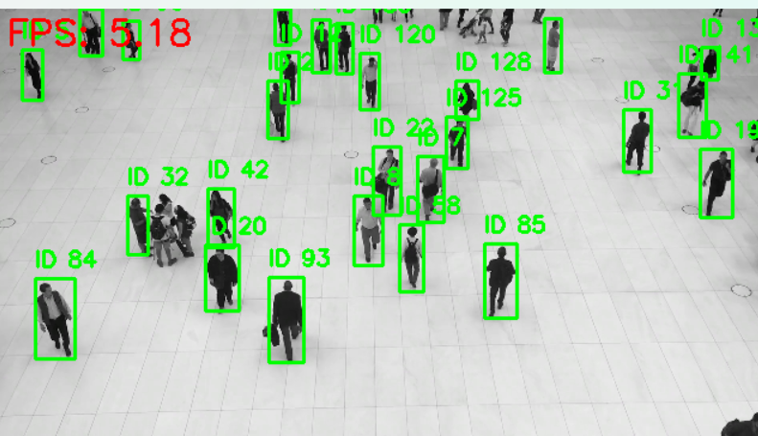

**6. Optimizations Implemented**

* Used **YOLOv5n** model variant for faster inference.
* **Frame resizing** to 480x270 for faster detection.
* **SORT tracking** for efficient ID management.
* **Disabled output video writing** during real-time testing to maximize FPS.
* Used **OpenCV's efficient frame handling**.

**7. Challenges Faced**

* Achieving high FPS without GPU acceleration.
* Ensuring smooth program exit on manual window close.
* Handling object reappearances accurately with simple tracking.

**8. Conclusion**

Successfully built a real-time object missing and new object placement detection system.  
The solution runs at acceptable speed on CPU and can be easily accelerated using GPU deployment.