multitask_s1_paramsBehav

K. Garner

28 August 2018

### Summary

Having identified the candidate network underpinning modulations in connectivity due to multitasking demands, we sought to identify whether parameter estimates for each subject correlate with the observed behaviour. We would expect the parameter estimates to correspond to multitasking costs in behaviour, rather than to observations of response time under single-task conditions (i.e. when there is no multitasking).

First I present the correlations between parameter estimates and single-task response times (separately for the visual-manual [VM] and auditory-manual [AM] tasks), then I present the correlations between parameter estimates and multi-task response times (seperately for VM and AM). Then I show the correlations between parameter estimates and the multitask cost estimated for each task separately (i.e. VM mixed - VM single | AM mixed - AM single). Lastly I show correlations between parameter estimates and the mean multitasking cost [mean(VM mixed - VM single, AM mixed - AM single)], and the summed multitasking cost [sum(VM mixed - VM single, AM mixed - AM single)]

### What this code does:

1. load the subject individual parameter estimates (Session 1 DCM - influence of multitasking)
2. load the behaviour and extract variables of interest - join to the parameter estimate data
3. Plot correlations between parameter estimates and behaviour and perform correlation tests between estimated parameters and observed data

## Q. Do b parameters correlate with single-task RTs or with multitasking cost?

1. Load subject parameter estimates
2. Load behavioural data and extract variables of interest, and join to parameter data

## Warning: Column `sub` joining factors with different levels, coercing to  
## character vector

1. Plot the data and compute pearson and spearman correlations

### VM single-task

draw.scatters(data, "Pre_VS")

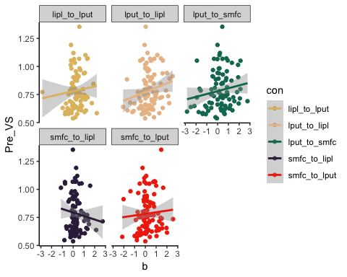

lapply(unique(data$con), get.cors, data = data, dv = "Pre_VS", method="spearman")

## Warning in cor.test.default(x, y, method = method): Cannot compute exact p-  
## value with ties  
  
## Warning in cor.test.default(x, y, method = method): Cannot compute exact p-  
## value with ties  
  
## Warning in cor.test.default(x, y, method = method): Cannot compute exact p-  
## value with ties

## [[1]]  
##   
## Spearman's rank correlation rho  
##   
## data: x and y  
## S = 115980, p-value = 0.3129  
## alternative hypothesis: true rho is not equal to 0  
## sample estimates:  
## rho   
## 0.1062374   
##   
##   
## [[2]]  
##   
## Spearman's rank correlation rho  
##   
## data: x and y  
## S = 98532, p-value = 0.02082  
## alternative hypothesis: true rho is not equal to 0  
## sample estimates:  
## rho   
## 0.2406957   
##   
##   
## [[3]]  
##   
## Spearman's rank correlation rho  
##   
## data: x and y  
## S = 113270, p-value = 0.2273  
## alternative hypothesis: true rho is not equal to 0  
## sample estimates:  
## rho   
## 0.1270985   
##   
##   
## [[4]]  
##   
## Spearman's rank correlation rho  
##   
## data: x and y  
## S = 132830, p-value = 0.8235  
## alternative hypothesis: true rho is not equal to 0  
## sample estimates:  
## rho   
## -0.02357329   
##   
##   
## [[5]]  
##   
## Spearman's rank correlation rho  
##   
## data: x and y  
## S = 118270, p-value = 0.4002  
## alternative hypothesis: true rho is not equal to 0  
## sample estimates:  
## rho   
## 0.08862106

* now perform correction for inflated type 1 error

Pre_VS_ps = c(0.3129, 0.02082, 0.2273, 0.8235, 0.4002)  
p.adjust(Pre_VS_ps, method="fdr")

## [1] 0.50025 0.10410 0.50025 0.82350 0.50025

* as can be seen above, none survive correction

### AM single-task

draw.scatters(data, "Pre_AS")

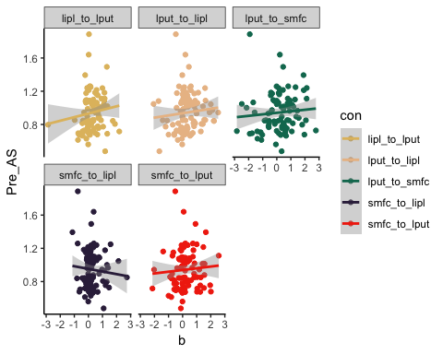

lapply(unique(data$con), get.cors, data = data, dv = "Pre_AS", method="spearman")

## Warning in cor.test.default(x, y, method = method): Cannot compute exact p-  
## value with ties  
  
## Warning in cor.test.default(x, y, method = method): Cannot compute exact p-  
## value with ties  
  
## Warning in cor.test.default(x, y, method = method): Cannot compute exact p-  
## value with ties

## [[1]]  
##   
## Spearman's rank correlation rho  
##   
## data: x and y  
## S = 104380, p-value = 0.06173  
## alternative hypothesis: true rho is not equal to 0  
## sample estimates:  
## rho   
## 0.1956445   
##   
##   
## [[2]]  
##   
## Spearman's rank correlation rho  
##   
## data: x and y  
## S = 105010, p-value = 0.06854  
## alternative hypothesis: true rho is not equal to 0  
## sample estimates:  
## rho   
## 0.1907595   
##   
##   
## [[3]]  
##   
## Spearman's rank correlation rho  
##   
## data: x and y  
## S = 110270, p-value = 0.1529  
## alternative hypothesis: true rho is not equal to 0  
## sample estimates:  
## rho   
## 0.1502325   
##   
##   
## [[4]]  
##   
## Spearman's rank correlation rho  
##   
## data: x and y  
## S = 124400, p-value = 0.6954  
## alternative hypothesis: true rho is not equal to 0  
## sample estimates:  
## rho   
## 0.04136693   
##   
##   
## [[5]]  
##   
## Spearman's rank correlation rho  
##   
## data: x and y  
## S = 117680, p-value = 0.3766  
## alternative hypothesis: true rho is not equal to 0  
## sample estimates:  
## rho   
## 0.09312146

### VM mixed

draw.scatters(data, "Pre_VM")

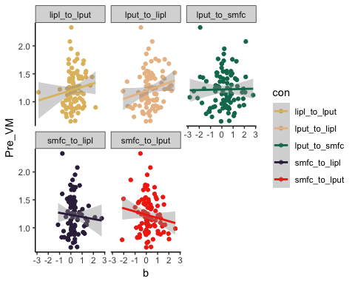

lapply(unique(data$con), get.cors, data = data, dv = "Pre_VM", method="spearman")

## Warning in cor.test.default(x, y, method = method): Cannot compute exact p-  
## value with ties  
  
## Warning in cor.test.default(x, y, method = method): Cannot compute exact p-  
## value with ties  
  
## Warning in cor.test.default(x, y, method = method): Cannot compute exact p-  
## value with ties

## [[1]]  
##   
## Spearman's rank correlation rho  
##   
## data: x and y  
## S = 106910, p-value = 0.09308  
## alternative hypothesis: true rho is not equal to 0  
## sample estimates:  
## rho   
## 0.176117   
##   
##   
## [[2]]  
##   
## Spearman's rank correlation rho  
##   
## data: x and y  
## S = 104710, p-value = 0.06519  
## alternative hypothesis: true rho is not equal to 0  
## sample estimates:  
## rho   
## 0.1930713   
##   
##   
## [[3]]  
##   
## Spearman's rank correlation rho  
##   
## data: x and y  
## S = 125380, p-value = 0.749  
## alternative hypothesis: true rho is not equal to 0  
## sample estimates:  
## rho   
## 0.03381484   
##   
##   
## [[4]]  
##   
## Spearman's rank correlation rho  
##   
## data: x and y  
## S = 133350, p-value = 0.7938  
## alternative hypothesis: true rho is not equal to 0  
## sample estimates:  
## rho   
## -0.02762676   
##   
##   
## [[5]]  
##   
## Spearman's rank correlation rho  
##   
## data: x and y  
## S = 143080, p-value = 0.3298  
## alternative hypothesis: true rho is not equal to 0  
## sample estimates:  
## rho   
## -0.1026155

* no correlations achieve statistical significance

### AM mixed

draw.scatters(data, "Pre_AM")

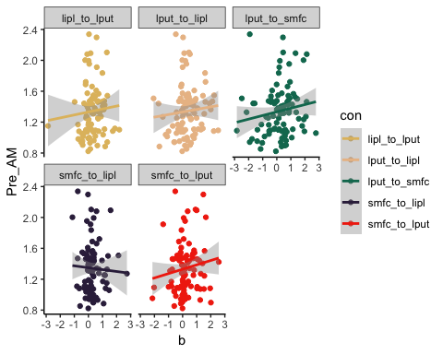

lapply(unique(data$con), get.cors, data = data, dv = "Pre_AM", method="spearman")

## Warning in cor.test.default(x, y, method = method): Cannot compute exact p-  
## value with ties  
  
## Warning in cor.test.default(x, y, method = method): Cannot compute exact p-  
## value with ties  
  
## Warning in cor.test.default(x, y, method = method): Cannot compute exact p-  
## value with ties

## [[1]]  
##   
## Spearman's rank correlation rho  
##   
## data: x and y  
## S = 109890, p-value = 0.1447  
## alternative hypothesis: true rho is not equal to 0  
## sample estimates:  
## rho   
## 0.153168   
##   
##   
## [[2]]  
##   
## Spearman's rank correlation rho  
##   
## data: x and y  
## S = 108780, p-value = 0.1235  
## alternative hypothesis: true rho is not equal to 0  
## sample estimates:  
## rho   
## 0.1617302   
##   
##   
## [[3]]  
##   
## Spearman's rank correlation rho  
##   
## data: x and y  
## S = 107120, p-value = 0.09612  
## alternative hypothesis: true rho is not equal to 0  
## sample estimates:  
## rho   
## 0.1745302   
##   
##   
## [[4]]  
##   
## Spearman's rank correlation rho  
##   
## data: x and y  
## S = 130790, p-value = 0.9407  
## alternative hypothesis: true rho is not equal to 0  
## sample estimates:  
## rho   
## -0.007868039   
##   
##   
## [[5]]  
##   
## Spearman's rank correlation rho  
##   
## data: x and y  
## S = 112200, p-value = 0.1978  
## alternative hypothesis: true rho is not equal to 0  
## sample estimates:  
## rho   
## 0.1353976

### VM multitasking cost (VM mixed - VM single)

draw.scatters(data, "Pre_VM_DC")

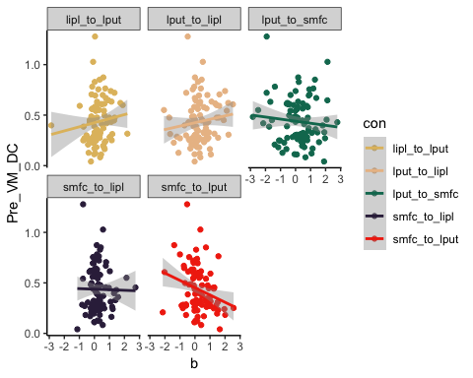

lapply(unique(data$con), get.cors, data = data, dv = "Pre_VM_DC", method="spearman")

## Warning in cor.test.default(x, y, method = method): Cannot compute exact p-  
## value with ties  
  
## Warning in cor.test.default(x, y, method = method): Cannot compute exact p-  
## value with ties  
  
## Warning in cor.test.default(x, y, method = method): Cannot compute exact p-  
## value with ties

## [[1]]  
##   
## Spearman's rank correlation rho  
##   
## data: x and y  
## S = 106760, p-value = 0.0909  
## alternative hypothesis: true rho is not equal to 0  
## sample estimates:  
## rho   
## 0.1772883   
##   
##   
## [[2]]  
##   
## Spearman's rank correlation rho  
##   
## data: x and y  
## S = 110730, p-value = 0.1628  
## alternative hypothesis: true rho is not equal to 0  
## sample estimates:  
## rho   
## 0.1467262   
##   
##   
## [[3]]  
##   
## Spearman's rank correlation rho  
##   
## data: x and y  
## S = 135450, p-value = 0.6785  
## alternative hypothesis: true rho is not equal to 0  
## sample estimates:  
## rho   
## -0.04378668   
##   
##   
## [[4]]  
##   
## Spearman's rank correlation rho  
##   
## data: x and y  
## S = 127100, p-value = 0.8459  
## alternative hypothesis: true rho is not equal to 0  
## sample estimates:  
## rho   
## 0.02053705   
##   
##   
## [[5]]  
##   
## Spearman's rank correlation rho  
##   
## data: x and y  
## S = 162220, p-value = 0.0164  
## alternative hypothesis: true rho is not equal to 0  
## sample estimates:  
## rho   
## -0.2501117

* now perform correction for inflated type 1 error

Pre_VS_ps = c(0.0909, 0.1628, 0.6785, 0.8459, 0.0164)  
p.adjust(Pre_VS_ps, method="fdr")

## [1] 0.2272500 0.2713333 0.8459000 0.8459000 0.0820000

* doesn’t quite survive correction

### AM multitasking cost (AM mixed - AM single)

draw.scatters(data, "Pre_AM_DC")

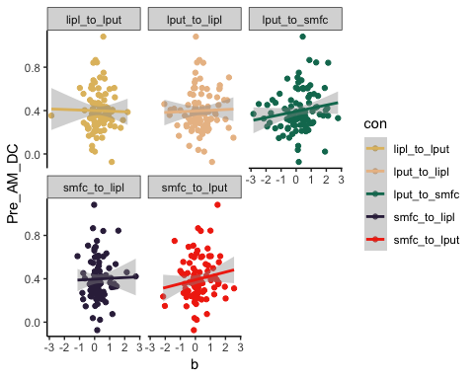

lapply(unique(data$con), get.cors, data = data, dv = "Pre_AM_DC", method="spearman")

## Warning in cor.test.default(x, y, method = method): Cannot compute exact p-  
## value with ties  
  
## Warning in cor.test.default(x, y, method = method): Cannot compute exact p-  
## value with ties  
  
## Warning in cor.test.default(x, y, method = method): Cannot compute exact p-  
## value with ties

## [[1]]  
##   
## Spearman's rank correlation rho  
##   
## data: x and y  
## S = 127960, p-value = 0.8949  
## alternative hypothesis: true rho is not equal to 0  
## sample estimates:  
## rho   
## 0.01394818   
##   
##   
## [[2]]  
##   
## Spearman's rank correlation rho  
##   
## data: x and y  
## S = 129960, p-value = 0.9889  
## alternative hypothesis: true rho is not equal to 0  
## sample estimates:  
## rho   
## -0.00146418   
##   
##   
## [[3]]  
##   
## Spearman's rank correlation rho  
##   
## data: x and y  
## S = 104520, p-value = 0.0631  
## alternative hypothesis: true rho is not equal to 0  
## sample estimates:  
## rho   
## 0.1945664   
##   
##   
## [[4]]  
##   
## Spearman's rank correlation rho  
##   
## data: x and y  
## S = 127980, p-value = 0.8967  
## alternative hypothesis: true rho is not equal to 0  
## sample estimates:  
## rho   
## 0.01372476   
##   
##   
## [[5]]  
##   
## Spearman's rank correlation rho  
##   
## data: x and y  
## S = 111860, p-value = 0.1894  
## alternative hypothesis: true rho is not equal to 0  
## sample estimates:  
## rho   
## 0.137956

### Mean multitasking-cost

draw.scatters(data, "Pre_DC_Mean")

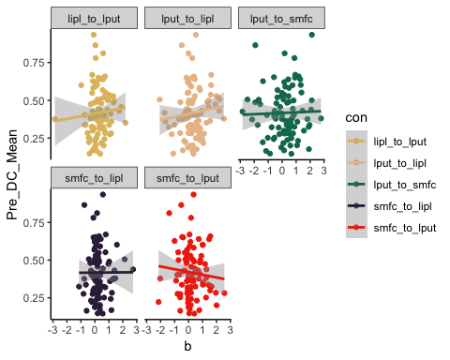

lapply(unique(data$con), get.cors, data = data, dv = "Pre_DC_Mean", method="spearman")

## Warning in cor.test.default(x, y, method = method): Cannot compute exact p-  
## value with ties  
  
## Warning in cor.test.default(x, y, method = method): Cannot compute exact p-  
## value with ties  
  
## Warning in cor.test.default(x, y, method = method): Cannot compute exact p-  
## value with ties

## [[1]]  
##   
## Spearman's rank correlation rho  
##   
## data: x and y  
## S = 112120, p-value = 0.1958  
## alternative hypothesis: true rho is not equal to 0  
## sample estimates:  
## rho   
## 0.1359986   
##   
##   
## [[2]]  
##   
## Spearman's rank correlation rho  
##   
## data: x and y  
## S = 118710, p-value = 0.4195  
## alternative hypothesis: true rho is not equal to 0  
## sample estimates:  
## rho   
## 0.08518443   
##   
##   
## [[3]]  
##   
## Spearman's rank correlation rho  
##   
## data: x and y  
## S = 123610, p-value = 0.6533  
## alternative hypothesis: true rho is not equal to 0  
## sample estimates:  
## rho   
## 0.04745483   
##   
##   
## [[4]]  
##   
## Spearman's rank correlation rho  
##   
## data: x and y  
## S = 130660, p-value = 0.948  
## alternative hypothesis: true rho is not equal to 0  
## sample estimates:  
## rho   
## -0.006897057   
##   
##   
## [[5]]  
##   
## Spearman's rank correlation rho  
##   
## data: x and y  
## S = 138540, p-value = 0.5211  
## alternative hypothesis: true rho is not equal to 0  
## sample estimates:  
## rho   
## -0.06764484

### Summed multitasking-cost

draw.scatters(data, "Pre_Sum_DC")

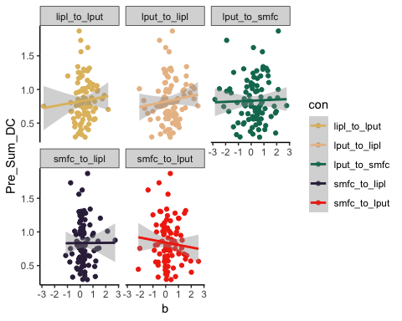

lapply(unique(data$con), get.cors, data = data, dv = "Pre_Sum_DC", method="spearman")

## Warning in cor.test.default(x, y, method = method): Cannot compute exact p-  
## value with ties  
  
## Warning in cor.test.default(x, y, method = method): Cannot compute exact p-  
## value with ties  
  
## Warning in cor.test.default(x, y, method = method): Cannot compute exact p-  
## value with ties

## [[1]]  
##   
## Spearman's rank correlation rho  
##   
## data: x and y  
## S = 112120, p-value = 0.1958  
## alternative hypothesis: true rho is not equal to 0  
## sample estimates:  
## rho   
## 0.1359986   
##   
##   
## [[2]]  
##   
## Spearman's rank correlation rho  
##   
## data: x and y  
## S = 118710, p-value = 0.4195  
## alternative hypothesis: true rho is not equal to 0  
## sample estimates:  
## rho   
## 0.08518443   
##   
##   
## [[3]]  
##   
## Spearman's rank correlation rho  
##   
## data: x and y  
## S = 123610, p-value = 0.6533  
## alternative hypothesis: true rho is not equal to 0  
## sample estimates:  
## rho   
## 0.04745483   
##   
##   
## [[4]]  
##   
## Spearman's rank correlation rho  
##   
## data: x and y  
## S = 130660, p-value = 0.948  
## alternative hypothesis: true rho is not equal to 0  
## sample estimates:  
## rho   
## -0.006897057   
##   
##   
## [[5]]  
##   
## Spearman's rank correlation rho  
##   
## data: x and y  
## S = 138540, p-value = 0.5211  
## alternative hypothesis: true rho is not equal to 0  
## sample estimates:  
## rho   
## -0.06764484