multitask_prac_paramsBehav

K. Garner

29/08/2018

### Summary

Having identified the candidate network underpinning modulations in connectivity due to multitasking practice, we sought to identify whether parameter estimates for each subject correlate with the observed behaviour, and whether correlation differences are different between groups. For the modulations associated with practice related changes to single-task performance, we would expect the parameter estimates to correspond to practice-related reductions in single-task RT, and potentially reductions to multitasking costs (given they are at least in part attributable to changes in single task performance)

First we examine the distributions of the data for changes to single-tasks (mean), visual-tasks & auditory tasks, and the b parameters for the LPut -> LIPL connection (the one influenced by practice on single task trials). This determines the correlation performed (i.e. parametric or not parametric). Then we correlate across all p’s. If significant, we correlate within group and compare correlation strengths

For the difference in RT for auditory-manual tasks, a negative correlation was found with the Putamen -> SMFC coupling parameter. When broken down by group, this relationship was statistically significant for the control group (-.373) but not for the training group (-.024), even thought the difference between the two groups was not statistically different (p=.08)

### What this code does:

1. load the subject individual parameter estimates
2. load the behaviour and extract variables of interest - join to the parameter estimate data
3. Plot correlations between parameter estimates and behaviour and perform correlation tests between estimated parameters and observed data

with(data, hist(prct_down, breaks = 20))

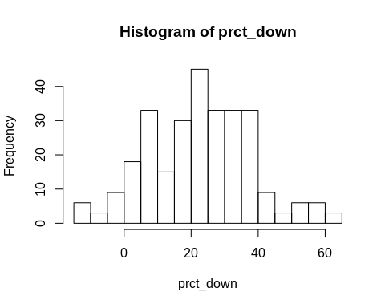

with(data, hist(b, breaks = 20))

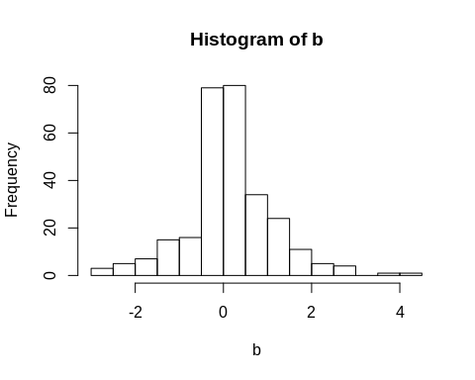

with(data, boxplot(b))

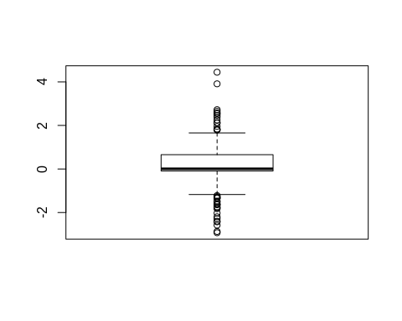 Not too bad in terms of normality, but will use a spearman’s correlation due to violation of normality assumptions

# params vs. Mu Sing Diff

#   
draw.scatters.grp(data, "prct_down")

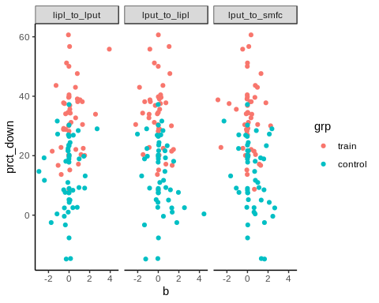

lapply(unique(data$con), get.cors, data = data, dv = "prct_down", method="spearman")

## Warning in cor.test.default(x, y, method = method): Cannot compute exact p-  
## value with ties  
  
## Warning in cor.test.default(x, y, method = method): Cannot compute exact p-  
## value with ties  
  
## Warning in cor.test.default(x, y, method = method): Cannot compute exact p-  
## value with ties

## [[1]]  
##   
## Spearman's rank correlation rho  
##   
## data: x and y  
## S = 119840, p-value = 0.1185  
## alternative hypothesis: true rho is not equal to 0  
## sample estimates:  
## rho   
## 0.1612483   
##   
##   
## [[2]]  
##   
## Spearman's rank correlation rho  
##   
## data: x and y  
## S = 169980, p-value = 0.06558  
## alternative hypothesis: true rho is not equal to 0  
## sample estimates:  
## rho   
## -0.1897003   
##   
##   
## [[3]]  
##   
## Spearman's rank correlation rho  
##   
## data: x and y  
## S = 178540, p-value = 0.01471  
## alternative hypothesis: true rho is not equal to 0  
## sample estimates:  
## rho   
## -0.2496116

Sidak correction = 1-(1-.05)^(1/3) = .017 The correlation between lput_to_smfc and single task improvement is -vely correlated, the greater the improvement, the smaller the influence of practice on this connection

#   
draw.scatters.grp(data[data$grp == "train", ], "prct_down")

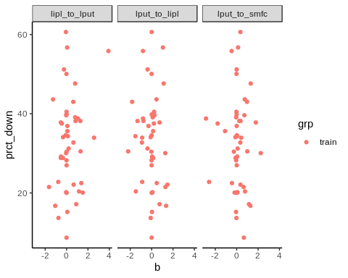

lapply(unique(data$con), get.cors, data = data[data$grp == "train", ], dv = "prct_down", method="spearman")

## [[1]]  
##   
## Spearman's rank correlation rho  
##   
## data: x and y  
## S = 14694, p-value = 0.534  
## alternative hypothesis: true rho is not equal to 0  
## sample estimates:  
## rho   
## 0.09380204   
##   
##   
## [[2]]  
##   
## Spearman's rank correlation rho  
##   
## data: x and y  
## S = 18042, p-value = 0.4547  
## alternative hypothesis: true rho is not equal to 0  
## sample estimates:  
## rho   
## -0.1126735   
##   
##   
## [[3]]  
##   
## Spearman's rank correlation rho  
##   
## data: x and y  
## S = 16254, p-value = 0.9876  
## alternative hypothesis: true rho is not equal to 0  
## sample estimates:  
## rho   
## -0.00240518

#   
draw.scatters.grp(data[data$grp == "control", ], "prct_down")

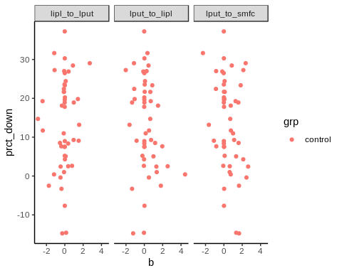

lapply(unique(data$con), get.cors, data = data[data$grp == "control", ], dv = "prct_down", method="spearman")

## Warning in cor.test.default(x, y, method = method): Cannot compute exact p-  
## value with ties  
  
## Warning in cor.test.default(x, y, method = method): Cannot compute exact p-  
## value with ties  
  
## Warning in cor.test.default(x, y, method = method): Cannot compute exact p-  
## value with ties

## [[1]]  
##   
## Spearman's rank correlation rho  
##   
## data: x and y  
## S = 16994, p-value = 0.3624  
## alternative hypothesis: true rho is not equal to 0  
## sample estimates:  
## rho   
## 0.1329626   
##   
##   
## [[2]]  
##   
## Spearman's rank correlation rho  
##   
## data: x and y  
## S = 22775, p-value = 0.2661  
## alternative hypothesis: true rho is not equal to 0  
## sample estimates:  
## rho   
## -0.1619939   
##   
##   
## [[3]]  
##   
## Spearman's rank correlation rho  
##   
## data: x and y  
## S = 25817, p-value = 0.02637  
## alternative hypothesis: true rho is not equal to 0  
## sample estimates:  
## rho   
## -0.317202

Again, none of the correlations meet the criteria for significance (Sidak adjust = .0169) Although the controls tend to show a larger effect size than the practice group.