**Ectotherm ER: Frogs Under the Weather**

**Student Brainstorm Challenge** Name __________________________________

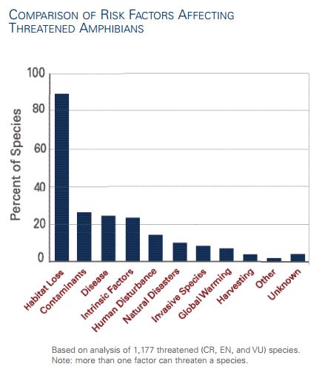

1. Look at the bar graph and answer the following question.What are the 3 largest threats to threatened amphibian species?

__________________________________________

__________________________________________  
__________________________________________

1. **Brainstorm Challenge**:

What kinds of things could change in a frog’s habitat or environment that could impact survival? List at least 3 things.

_____________________________________________ _____________________________________________ _____________________________________________

1. **Brainstorm Challenge**:

What life processes of a frog might climate change affect? _________________________________________ ____________________________________________________________________________________________ What could a frog do to maximize its chance for survival in a warmer climate? _______________________ _____________________________________________________________________________________________ _____________________________________________________________________________________________ In a more variable climate? ____________________________________________________________________ _____________________________________________________________________________________________ _____________________________________________________________________________________________

1. **Brainstorm Challenge:** Design an experiment that would test how microhabitat conditions affect body temperature of an ectotherm. Use a numbered list to explain your procedure.

**HELPFUL** **HINTS**:

* The habitat will be your school grounds.
* We can use a temperature gun or ibutton temperature sensors to measure temperature in different microhabitats.
* We can’t use actual live frogs.

________________________________________________________________________________________

________________________________________________________________________________________

________________________________________________________________________________________

________________________________________________________________________________________

________________________________________________________________________________________

________________________________________________________________________________________

________________________________________________________________________________________

________________________________________________________________________________________

________________________________________________________________________________________

________________________________________________________________________________________

________________________________________________________________________________________

________________________________________________________________________________________

________________________________________________________________________________________

________________________________________________________________________________________

________________________________________________________________________________________

________________________________________________________________________________________

________________________________________________________________________________________

________________________________________________________________________________________

________________________________________________________________________________________

________________________________________________________________________________________

What are some microhabitats a frog might live in? How would different microhabitats affect an ectotherm? ______________________________________________________________________________ ________________________________________________________________________________________

________________________________________________________________________________________

________________________________________________________________________________________