In our project, we obtained the quarterly and non-seasonally adjusted data from Federal Reserve bank. The dataset of the unemployment rate of Mexico covers the period from quarter one, 1987 to quarter 4, 2017. The dataset of GDP of Mexico starts from the first quarter of 1993 to the fourth quarter of 2017. We first did some preliminary analysis on the dataset we are interested in:

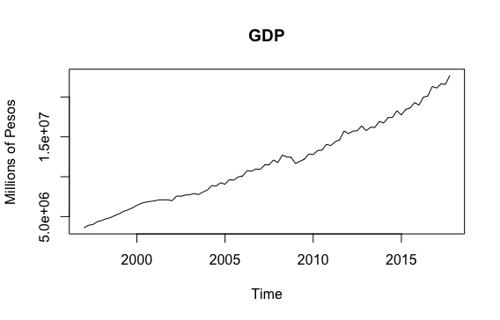

We can see clearly that the GDP has a trend here and then we want to try to eliminate the trend by using log.

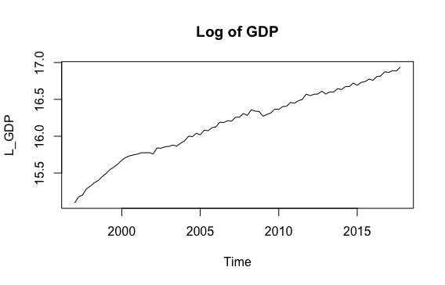

However, the trend is not eliminated so that we want to test whether it is a stochastic trend or deterministic one. Then we do the following CADF test.

Null Hypothesis: The trend is stochastic and non-stationary

Alternative Hypothesis: The trend is deterministic

P-value: 0.039<0.05

Conclusion: Reject the null hypothesis and work in difference.

After we work in difference then the data becomes stationary.

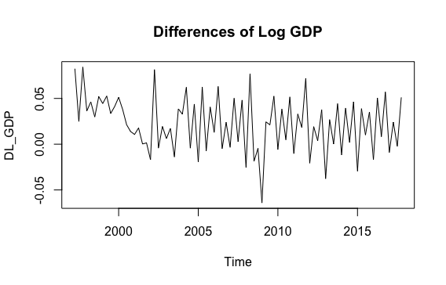

The next step is to check seasonality, we use the monthplot and seasonalplot to do the test.

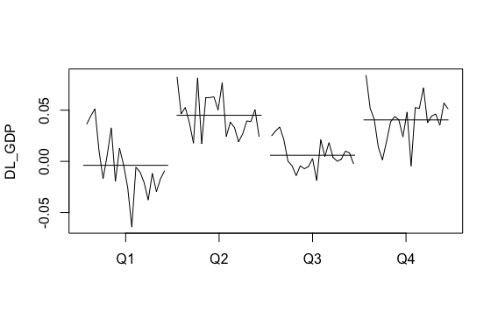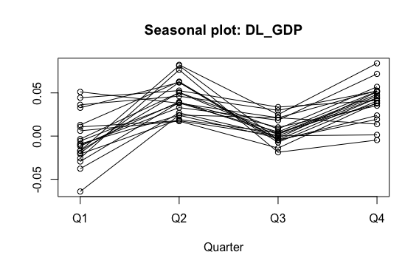

From those 2 plots above, we can clearly see the dataset has a seasonality and we want to do the difference to eliminate the seasonality. After we did the difference, the seasonality was eliminated.

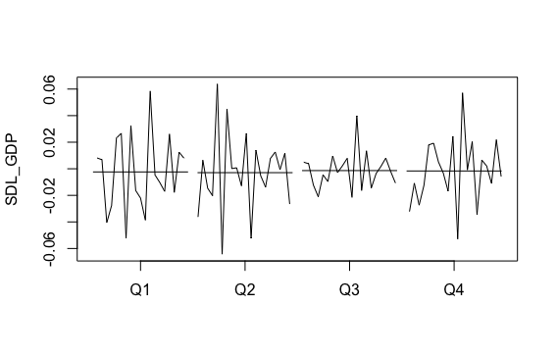

Then we want to choose the appropriate ARIMA parameter to build the model. First we need to take a look at both acf and pacf graphs.

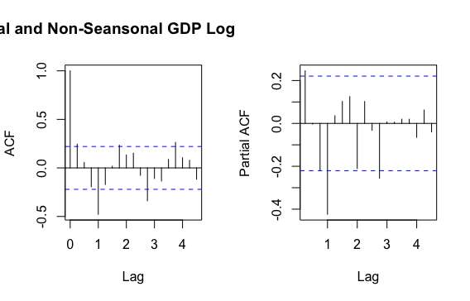

After combining above 2 graphs with the seasonality, we want to try 2 different models.

1. ARIMA order=c(0,1,1),seasonal=c(0,1,1)

The model can be validated because the residual is a white noise

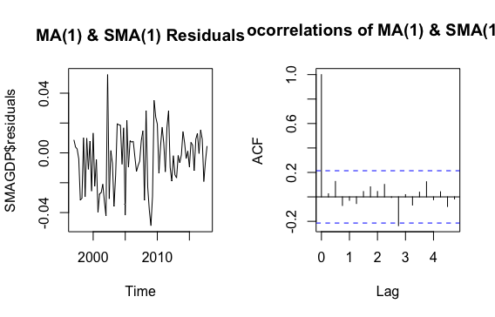

2. ARIMA order=c(0,1,0),seasonal=c(1,1,0)

The model can be also validated.

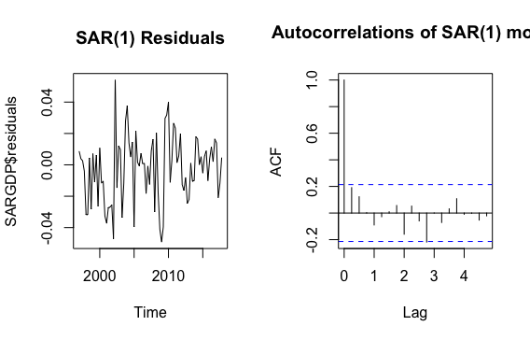

Since both models can be validated so that we want to choose the one with smaller BIC.

Model1: BIC= -375.1754, Model2: BIC= -372.6072

In conclusion, SMA(1) model has a smaller BIC and we want to use it as the best choice to build the model for GDP dataset