NAME: AGBOR NKONGHO KELLY

MATRICULE: FE21A126

KEEPASS

KeePass is a free and open-source password manager that helps you store and manage your passwords securely. It is designed to help users generate strong and unique passwords and store them in an encrypted database.

To download KeePass, you can follow these steps:

1. Visit the Official Website: Open a web browser and go to the official KeePass website. The website URL is <https://keepass.info/>.

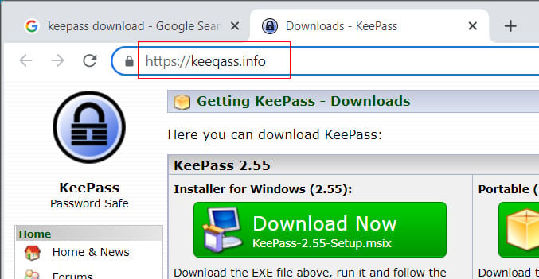

2. Navigate to the Downloads Page: On the KeePass website homepage, you will find a navigation menu at the top. Click on the "Downloads" link in the menu.

3. Choose the Version: On the Downloads page, you will see different versions of KeePass available for various operating systems. Select the version that corresponds to your operating system. For example, if you are using Windows, choose the Windows version. The version I downloaded is Keepass2.

4. Download the Installer: Once you have selected the appropriate version, you will see a list of download options. Click on the download link for the installer file (usually an executable file with a .exe extension) to initiate the download.

5. Save the Installer: Your web browser will prompt you to choose a location to save the installer file. Select a location on your computer where you want to save the file, and click "Save" or "OK."

6. Run the Installer: Once the download is complete, navigate to the location where you saved the installer file. Double-click on the file to run the installer.

7. Follow the Installation Wizard: The installer will launch an installation wizard that guides you through the installation process. Follow the instructions provided by the wizard to install KeePass on your computer. You may need to agree to the terms of service, choose an installation location, and select any additional options during the installation process.

8. Complete the Installation: Once the installation is complete, you will see a confirmation message indicating that KeePass has been successfully installed on your computer.

After completing these steps, you should have KeePass installed on your computer. You can launch the KeePass application and start using it to create and manage your password database. Remember to always download KeePass from the official website to ensure you are getting the authentic and secure version

Here's a description of how KeePass works:

1. Database Creation: While using KeePass, I created a password database, which is a file that stores all my passwords and related information. This database file is encrypted using a master password or key file, ensuring that only you can access its contents.

2. Master Password: The master password is the primary means of unlocking your KeePass database. It should be a strong and unique password that you can remember, as losing it may result in permanent data loss. KeePass uses advanced encryption algorithms to protect your passwords from unauthorized access.

3. Password Entry: Once you have a database, you can start adding password entries. Each entry typically consists of a website or application name, username, password, and additional notes. KeePass allows you to generate strong and random passwords for each entry, ensuring better security.

4. Auto-Type Functionality: KeePass offers an auto-type functionality that automatically fills in login credentials for websites and applications. With a few simple keyboard shortcuts, KeePass can simulate keystrokes to enter the username and password for a selected entry, saving you the hassle of manually typing them.

5. Organizing Entries: KeePass allows you to organize your password entries into groups and subgroups, making it easier to manage large collections of passwords. You can create custom groups and arrange entries based on your preferred organizational structure.

6. Search and Filters: KeePass provides search and filter options to quickly find specific password entries within your database. This feature comes in handy when you have a large number of entries and need to locate a particular password quickly.

7. Backup and Synchronization: To prevent data loss, KeePass allows you to create backups of your password database. You can regularly export the encrypted database file and store it securely in multiple locations. Additionally, you can synchronize your database across multiple devices using cloud storage services like Dropbox or Google Drive.

8. Plugins and Extensions: KeePass offers a variety of plugins and extensions that enhance its functionality. These include browser integrations, password strength analyzers, and import/export tools, among others. You can customize KeePass according to your specific requirements by installing the relevant plugins.

It's important to note that while KeePass helps you manage your passwords securely, you should also take precautions to protect your master password and database file. Regularly updating your master password, using strong encryption settings, and keeping your software up to date are essential for maintaining the security of your KeePass database.

**ILLUSTRATION:**

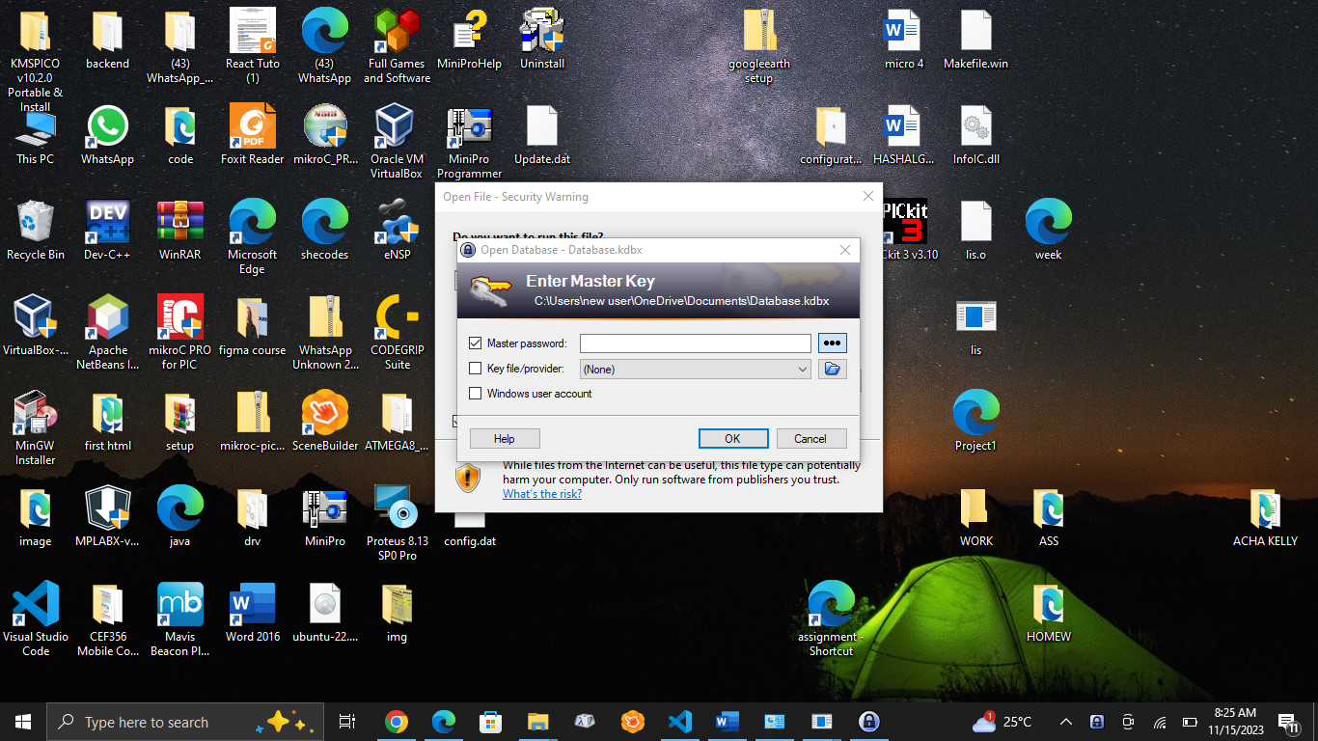

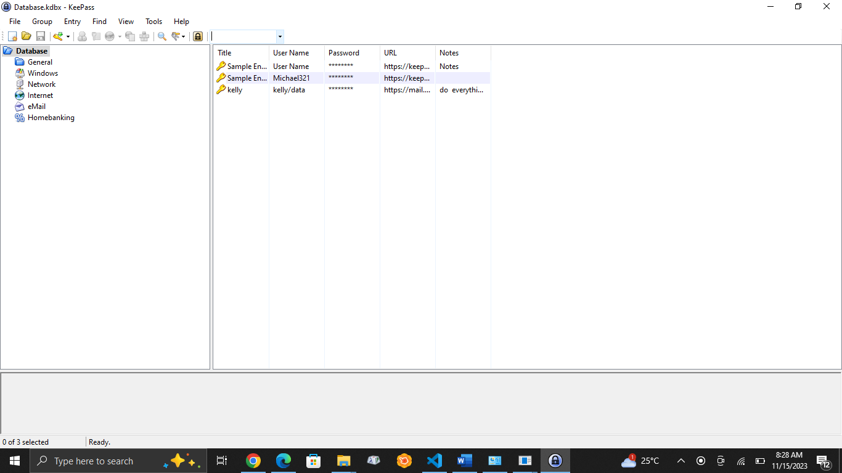

TESTING:

Test Auto-Type: To test the auto-type functionality, open a web browser and go to the Gmail login page. In KeePass, select the entry you created for Gmail, right-click, and choose "Perform Auto-Type" or use the associated keyboard shortcut. KeePass will simulate keystrokes to automatically fill in the username and password fields on the Gmail login page.

7. Search for an Entry: If you have multiple entries in your KeePass database, you can test the search feature. Use the search bar within KeePass to search for a specific entry. For example, you can search for "Gmail" to quickly find the Gmail account entry you created earlier.

8. Backup and Restore: As a best practice, it's essential to regularly back up your KeePass database to prevent data loss. You can test the backup and restore functionality by creating a backup copy of your database file and then restoring it to ensure that your data is recoverable.

Remember to exercise caution when testing KeePass and avoid using real passwords or sensitive information during the testing process. It's also crucial to follow best practices for securing your KeePass database, such as using a strong master password, keeping the database file in a secure location, and regularly backing up your data.