**How to set up Android Studio in a Windows environment**

**How to set up the SDK**

1. Make sure that you have installed Android Studio (the correct version) and the JDK (Java Development Kit).
2. If a proxy dialog box pops up, make sure you copy the link from your browser properties. Generally, the port number is port 80, although for your network it may be different. Also make sure whether or not you need authentication from your network.
3. Click next three times. Make sure you set your mode to standard.

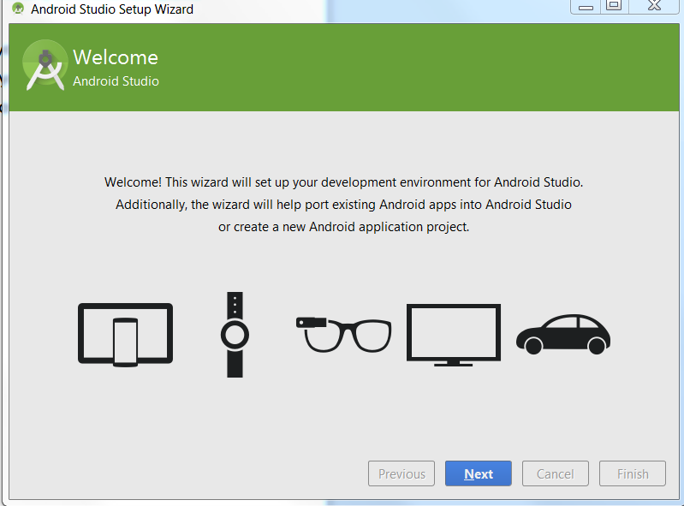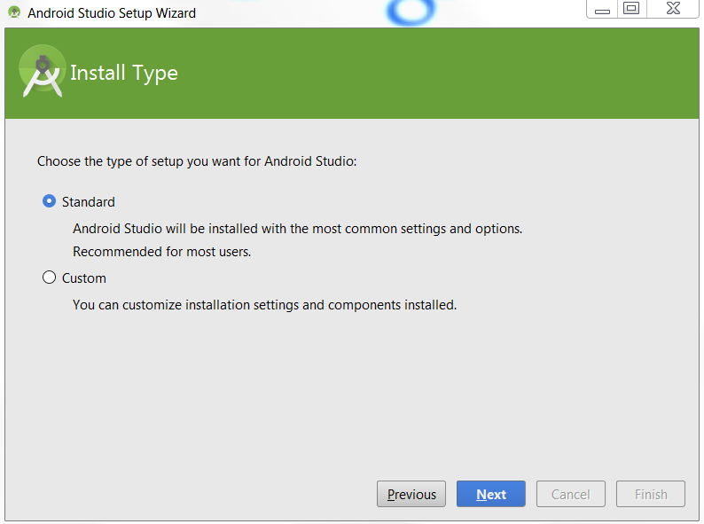

1. Accept both license agreements. One for the license, one for the preview license. Then press finish.
2. The Android SDK is now downloading.
3. If any folders did not correctly download, click retry. Otherwise, congratulations, your SDK is set up.

**How to set up the emulator in Android Studio**

Notes: You need the dimensions of the Device, and resolution and other properties. You can generally find this by googling your phone.

1. Open Android Studio.
2. Click Tools, Android, AVD Manager.
3. Click Create Virtual device.
4. Choose the phone that you have.

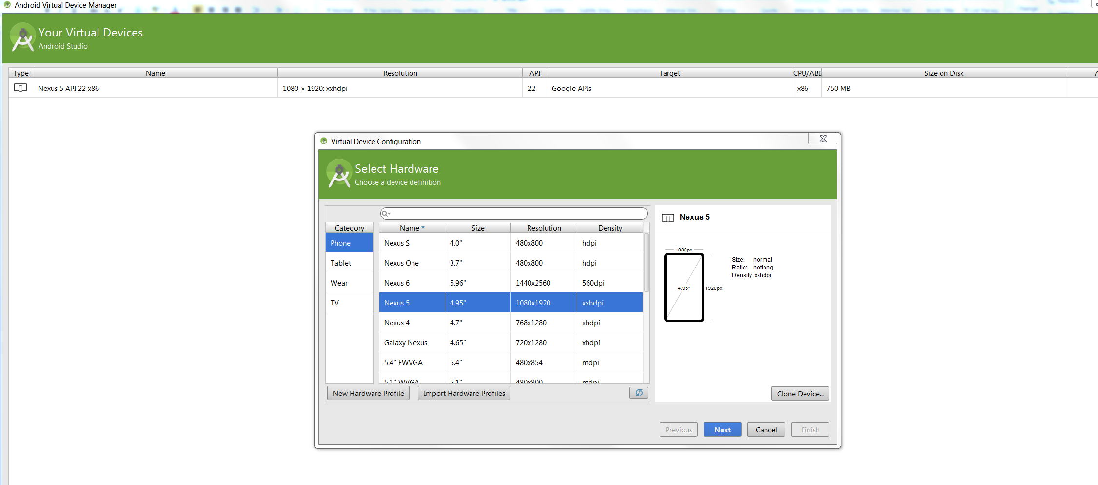

1. If your phone is not listed, click new hardware profile.

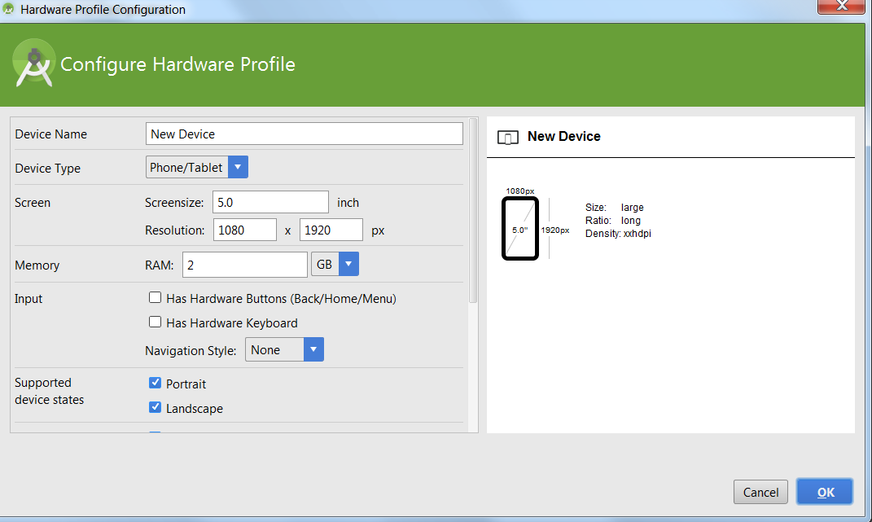

1. Fill in each of the different fields by looking up the specifications for your phone online.

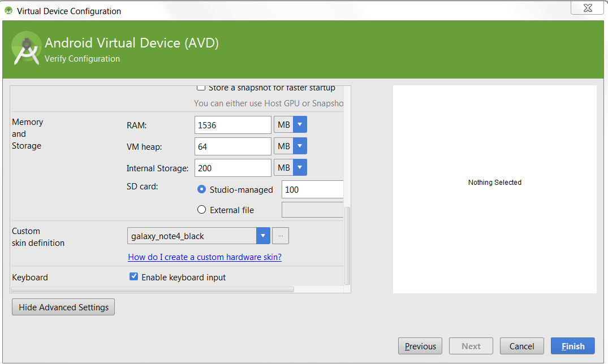

1. If your phone is not listed in the default skins list, then find your preset skin online. If you have a Samsung phone, here is a link to where you can download the skins into the correct directory:

<http://developer.samsung.com/technical-doc/list.do?ct=CT350000>

1. Go to this link, extract the files to the directory android/lib/device-art-resources.
2. Click next twice, and when you get to a screen that lists different Android versions, be sure to pick a version with ARM next to it. Unless you absolutely must use an accelerated emulator, just pick Arm. Then click finish.
3. Next, click Tools, Android, SDK manager.
4. Scroll all the way to the bottom and make sure that Intel x86 HAXM Accelerator is checked if you are using an accelerated emulator. If you have no idea what I’m talking about, install it anyway, but make sure when you get to the emulator screen, you choose an Android version with Arm next to it. Click install packages.

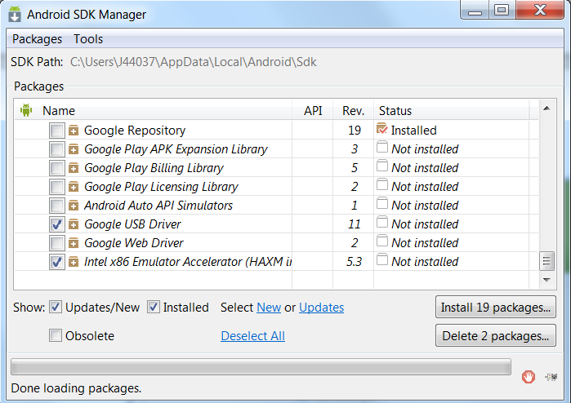

1. Accept the license agreement, then click install.

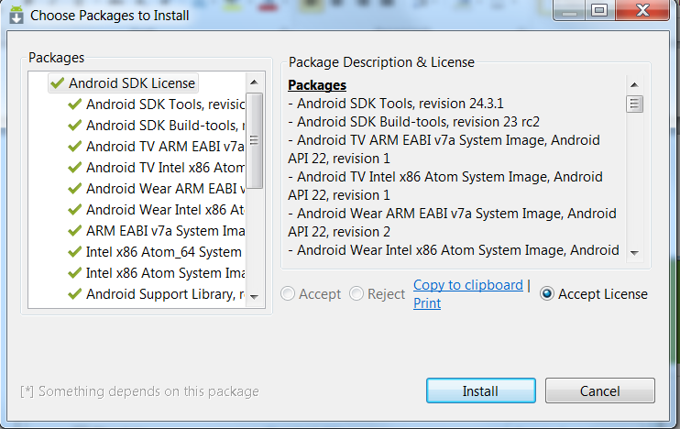

1. Now wait ten years for the SDK to install. Well, I was exaggerating a little. But seriously, this can take up to an hour.

**How to install APK’s from unknown sources using ADB**

1. First you need to set up your device so it can talk to your computer. Continue reading.
2. Click this link: <http://www.androidcentral.com/sites/androidcentral.com/files/uploads/tools/android-tools.zip>
3. Open the zip file and you'll see a folder named android-tools. Extract that folder somewhere easy to get to.
4. Next, visit the manufacturers page for your device and install the adb and fastboot drivers for Windows. You'll need this so that your computer can talk to your Android device.
5. Go to the official website and manually select the correspond driver to download and install

|  |  |
| --- | --- |
| Sony | <http://esupport.sony.com/perl/select-system.pl?DIRECTOR=DRIVER> |
| Samsung | [**Download link**](http://d-h.st/KYc) |
| Lenovo | <http://developer.lenovomm.com/developer/download.jsp> |
| ZTE | <http://support.zte.com.cn/support/news/NewsDetail.aspx?newsId=1000442> |
| Google Nexus | <http://developer.android.com/sdk/win-usb.html> |
| Motorola | <http://developer.motorola.com/docstools/USB_Drivers/> |
| LGE | <http://www.lg.com/us/mobile-phones/mobile-support/mobile-lg-mobile-phone-support.jsp> |
| Huawei | <http://www.huaweidevice.com/worldwide/downloadCenter.do?method=index> |
| HTC | [http://www.htc.com](http://www.htc.com/) |
| Alcatel One Touch | <http://www.alcatelonetouch.com/global-en/support/download.html> |
| Asus | <http://support.asus.com/download/> |
| Acer | <http://www.acer.com/worldwide/support/mobile.html> |

1. Enable USB debugging on your device, and plug it into your computer.
2. Review this list of important ADB commands:

|  |  |
| --- | --- |
| adb push | Transfers files from your computer to your device. You need to know the full path for both the computer and device. |
| adb pull | Transfers files from your device to your computer. You need to know the full path for both the computer and device. |
| adb reboot | Reboots your device. |
| adb reboot-bootloader | Reboots your device to the bootloader. |
| fastboot devices |  |
| fastboot oem unlock | Unlocks your phone, but be careful, it might void your warranty. Also deletes everything. |
| adb shell |  |
| adb install | Installs an APK file from an unknown source. |
| adb logcat | Displays a list of logcat messages. These are a list of call backs from events on your device. |
| adb devices | Use this command to see if you get the serial number of your device. If you do, your computer and device are officially communicating. |

1. To open an adb portal, simply press shift and then right click on the adb.exe file that you downloaded inside of the tools zip file.
2. If this does not work, type cmd into the start textbox.
3. Then type cd and the folder you want to navigate to.
4. Then go to your tools file that you downloaded earlier.
5. Copy any files you wish to transfer into that folder.
6. And use any adb command to do what you want!

**Rooting your Android Device**

**Step 1: Install Kingo on Your PC**

Now download the [**Kingo**](http://www.kingoapp.com/index.htm) software onto your Windows computer, run the **Android_Root.exe** file, and follow all of the instructions in order to successfully install it on your Windows computer.

**Step 2: Root with Kingo**

Once installed, open up Kingo and connect your device, which the application will recognize instantly, giving you the device name and model number. You'll see a few notes about the root process, as well as your root status in the upper left-hand corner.

Once you're ready to root your device, click on the big, bad **ROOT** button. The program will then begin working its magic, with the entire process taking about five minutes in all.

[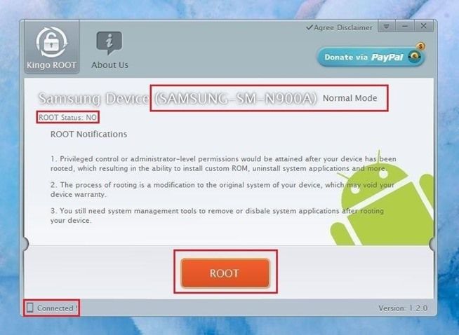](http://img.wonderhowto.com/img/original/35/12/63531355649242/0/635313556492423512.jpg)

**Step 3: Install MtkCamera on your Device**

During the rooting process, your device will automatically ask you to install an application called **MtkCamera**, which is the exploit used to gain root access through the processor.

Make sure "I understand that this app may be dangerous" is checked and hit the **Install** button to proceed. Don't worry, this file is totally safe and absolutely necessary to root.

NOTE: This step might not pop up. Your phone might be rooted even if you get an error that says “Server failure.” If you do get this message, simply open SuperSU to check to see if it is rooted. If SuperSU is not on your phone, then your phone is not rooted yet. If that’s the case, simply repeat the above steps.

[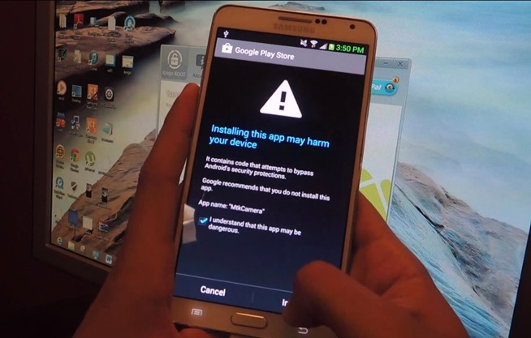](http://img.wonderhowto.com/img/original/17/24/63531362348336/0/635313623483361724.jpg)

Your device will now reboot.

**Step 4: Verify Root Status**

When your android device reboots the process is complete, and Kingo will say on your PC that root was successful. You should now see the **SuperSU** app on your device, which grants permissions to applications that require root access.

SuperSU might have a message that asks you if you want to disable KNOX. Click ok to disable this feature.

Additionally, you can download [**Root Checker**](https://play.google.com/store/apps/details?id=com.joeykrim.rootcheck) for free from Google Play to verify your newly rooted status.

[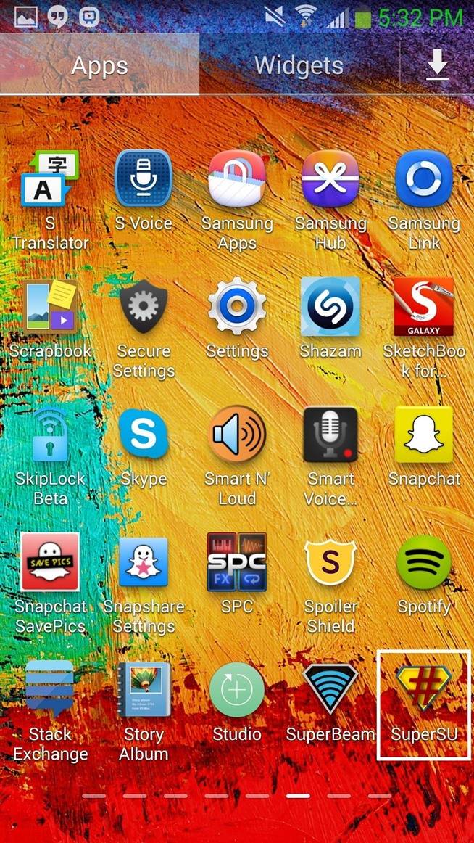](http://img.wonderhowto.com/img/original/27/00/63530933647156/0/635309336471562700.jpg)[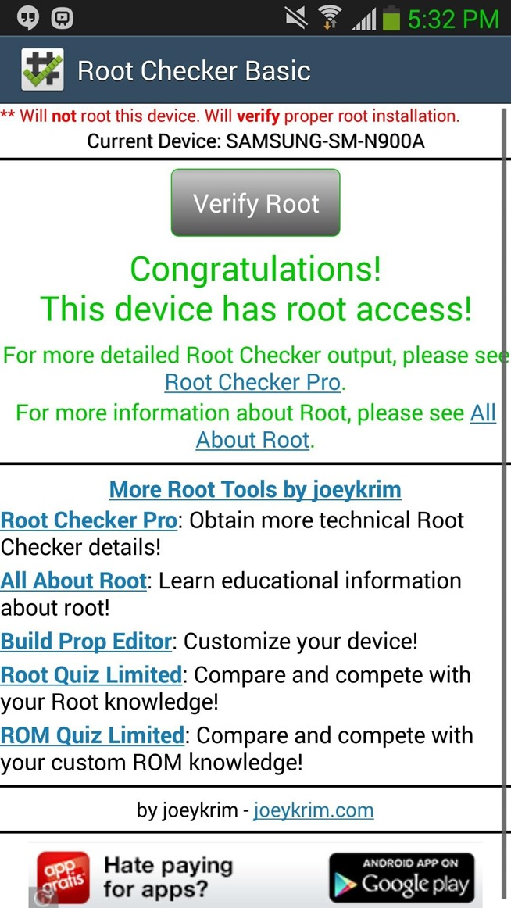](http://img.wonderhowto.com/img/original/16/80/63530933629171/0/635309336291711680.jpg)

Okay, so all in all, this wasn't exactly "one-click" rooting (it's more like "two-click" because of the MtkCamera exploit, or technically "one-click, one-tap"), but it's way easier than you thought, right?

**How to Programmatically set the IP address of your Android**

In the Android Manifest type:

<uses-permission android:name="android.permission.WRITE_SETTINGS"/>

Then you need to actually change the setting using the following code:

android.provider.Settings.System.putString(getContentResolver(), android.provider.Settings.System.WIFI_USE_STATIC_IP, "0");

android.provider.Settings.System.putString(getContentResolver(), android.provider.Settings.System.WIFI_STATIC_DNS1, "192.168.0.2");

android.provider.Settings.System.putString(getContentResolver(), android.provider.Settings.System.WIFI_STATIC_DNS2, "192.168.0.3");

android.provider.Settings.System.putString(getContentResolver(), android.provider.Settings.System.WIFI_STATIC_GATEWAY, "192.168.0.1");

android.provider.Settings.System.putString(getContentResolver(), android.provider.Settings.System.WIFI_STATIC_NETMASK, "255.255.255.0");

android.provider.Settings.System.putString(getContentResolver(), android.provider.Settings.System.WIFI_STATIC_IP, "1");

All of this code essentially accesses the wifi settings and changes the Static IP, DNS1, DNS2, Gateway, Netmask, and static ip.