To start, Megan and I learned how to use the Truss program, and tried out different basic designs, using only solid carbon steel members. Our first design primarily consisted of right triangles, with a criss-cross in the middle. Naturally, we didn’t include enough support, so the entire bridge collapsed, killing the truck driver and breaking everything inside. Even with lack of support, our truss still cost $334,000. According to our analysis, the first truss had way too much stress in the center, due to lack of stability. We tried out several more designs, and discovered that extra support connected to cable anchorages were well worth the price. We also realized that you need support not just from the bottom of the truss, but the top of the truss as well.

Consistently, our bridge failed on the far left and far right, because of too much stress on the supporting bars. Contrary to what we initially believed, the bridge didn’t actually have to stay completely static. While each individual member, and each triangle, should stay static, since each triangle is connected using pins, having a slight symmetrical moment can actually help the bridge stay secure. Once we were able to harness slight movements without our entire bridge collapsing, we were one step closer to creating a bridge that would be able to support multiple truck loads.

Given the parameters and constraints, we recognized the power of equilateral triangles. If each member of the triangle is the same length, the forces Fx and Fy become evenly distributed across the entire truss, thus creating less stress and strain. Obviously, in an attempt to lower the price, we tried a variety of unique designs. Shapes other than triangles are certainly not recommended for use in a truss. A few of our designs actually bent like rainbows when the truck attempted to cross. We had created this design in the hopes that the longer beams would hold the bridge together to prevent extra movement. Needless to say, this idea **failed miserably**. Moreover, we tried to create a truss composed entirely of hollow carbon tubing, using a suspension-like support to prevent collapse. This idea resulted in the entire bridge collapsing using no load at all. However, we learned that you can minimize materials to save money, and then simply replace the weakest members with hardcore Quenched and Tempered steel beams. We found that the middle material of High-Strength Low Alloy Steel was ineffective in supporting our truss and minimizing costs, so we decided not to use it in any of our working designs.

At first, we decreased the thickness of all of the members to find the cheapest possible cost of our working designs. The result of this caused the bridge to break apart, from too much strain. Ultimately, the best design included members of primarily one thickness, with a few thinner members to reduce cost. Interestingly enough, the default thickness of 140 x 140 x 7 mm gave us the best results. When we decreased all of the members to only 10mm thinner, none of our working designs succeeded.

During our cost-analysis, we ascertained that using a pier gave our truss a significant advantage. Upon this revelation, we went back and combined our previous designs with a pier extension. Extending the pier as far as possible reduced the force of the load threefold and allowed us to use almost exclusively carbon hollow tubing, with a few exceptions.

Rather than starting with the sample designs, we started from scratch. Ironically, our final design ended up becoming very similar to a few of the sample designs.

Our cheapest and most effective design was a variation of a deck truss made out of small equilateral triangles below the bridge with a 24 meter high pier left of center of the bridge. It had two cable anchorages and was made of high strength concrete to hold a standard 225 kN truck on a two lane bridge. There were also two vertical members above ground that helped support the weight of the truss and truck. Most of the members were made out of hollow carbon steel tubes, but for the ones that were under too much stress, we changed to solid tubes to keep the truss from collapsing. Almost every bottom horizontal member was upgraded to quenched and tempered steel for additional support. We then did some fine tuning to achieve the cheapest working bridge possible, and found the best design to be only **$252,881.22**. We tried several different designs, but the others that functioned were too expensive, and so we stuck with the previous design as our final design (pictured below). The truck driver is alive and well thanks to our final design, and has profusely thanked us for his survival.

As you can probably tell based on our designs below, neither Megan nor I are majoring in Civil Engineering, nor will we ever become civil engineers. This project has given Megan and I a deeper respect for architects and civil engineers worldwide.

First Design:

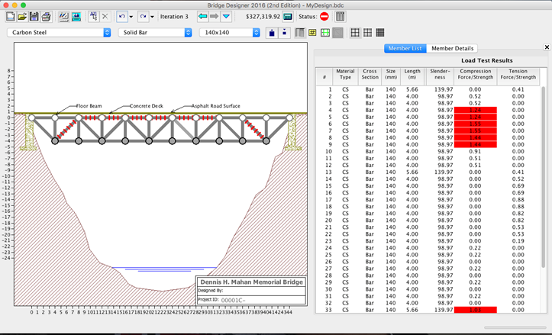

First Working Design:

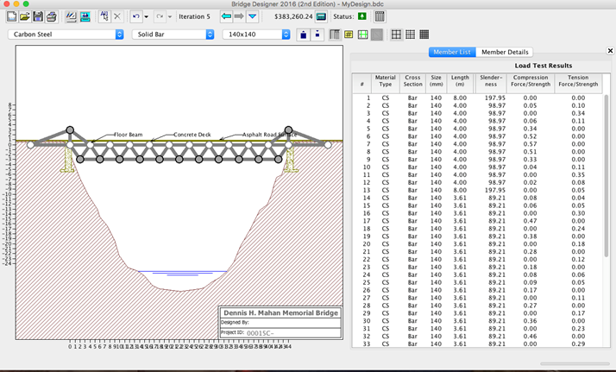

Final Design: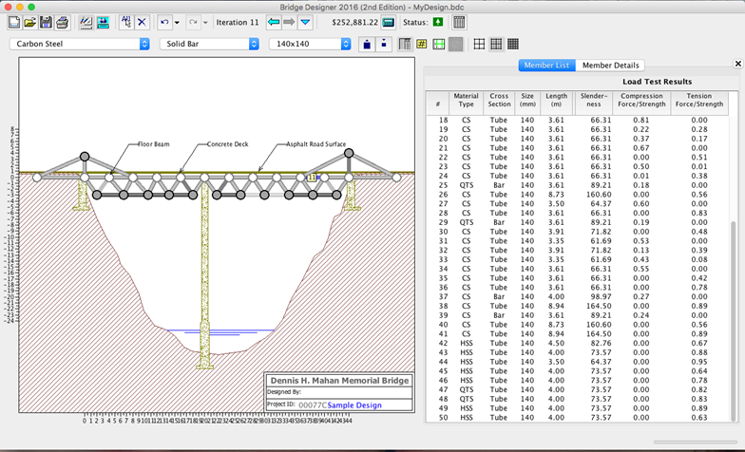

Other Attempts:

