**PROJECT 2(150 pts Due on November 15 by 11:59 PM)**

The international standard letter/number mapping found on the telephone is shown below:

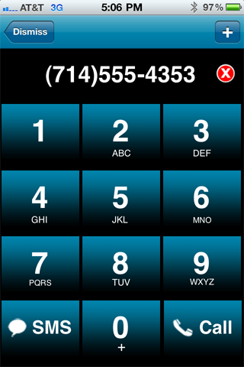

Using these characters on the keypad, we can come up with word-based representation of a phone number so that it would be easy to remember. For example, 1-800-AAA-HELP. This is much easier to remember than 1-800-222-4357. It is obvious that some phone numbers cannot be turned into word-based representation. For example, if the number has 1 or 0, then there are no corresponding characters on the key-pad. Some time we may not find meaningful word to represent the given number even if it does not contain 0 or 1. In this project, you will write a program that will ask user to enter a phone number (10-digit excluding leading 1) and will print out the word-based representation if exist otherwise it will indicate that there is no meaningful word-based representation of the given number and just print out the given number in the following form: 1-*area-exchange-number*.

A typical phone number has three components:

1. *area* (three digit)
2. *exchange* (three digit)
3. *number* (four digit)

If someone wants to find out the word-based representation of a given phone number, he/she will find the word based representation of *area*, *exchange* and *number*. There are several possibilities here:

1. If there is a word-based representation of phone number for 10 digit.
2. Else If there is word-based representation of whole 7 digits
3. Else If there is word-based representation of *exchange* (3 digit) and *number* (4 digit)
4. Else If there is word-based representation of only *exchange* (3 digit)
5. Else If there is word-based representation of only *number* (4 digit)
6. Else there is no word-based representation of the given number.

Hence your program should do the following:

1. If there exist 10-digit word-based exist, then print it (or all if more than one).
2. If there exist 7-digit excluding area code, then print out it (or all if more than one).
3. If 7 and 10 are not possible, then print 3-digit followed 4-digit form. Again, print all possibilities.
4. If step 1, 2, and 3 are not possible, then print only the *exchange* in a word-based form.
5. If step 1, 2, 3, and 4 are not possible, then print only the *number* in word-based form.
6. If none is possible, then print the number in 1-*area-exchange-number* form.

**Examples:**

1. Given number is 2266762559, then your output should be:

1-ABNORMALLY

1. If the given number is 2702637422, then your output should be:

1-270-AMERICA.

1. If the given number is 6157862243, then your program should print out the following numbers:

1-615-RUN-ACHE

1-615-RUN-ACID

There is no meaningful word for 7862243. So, we look at the words for 786 and 2243. These are RUN, SUM, SUM and ACHE, ACID, CAGE. All possible are listed as above.

1. If the given number is 1939292244, then it returns/lists the following phone number:

1-193-WAX-2244

1-193-WAY-2244

1. If the given number is 18003218428, then it returns/lists the following phone number

1-800-321-THAT

1. If the given number is 18002002244, then it returns/lists the following phone number

1-800-200-2244

**Project 2 has two stages**:

**Stage 1**: This is stage one. First, think about the data structures that you will choose to use in the project. Next, determine how could you solve this problem and what is the complexity of your solution.

**Stage 2**: The next stage, I will give you some suggestions for data base and related functions. Compare my suggestions with yours. Determine which one is more efficient. Finaly, decide which solution you will implement.

I am giving you a chance to form a group (two students only). I need to know the names of the group members by September 30. **If the number of group is not reported by September 30 and then there is a group submission of the project 2, than that group will not receive more than 50% of the grade**. It is extremely important to form your group before September 30. I am not taking any responsibility for how group members are participating in the project because this is voluntary group work.

At the end of the project, here are the document/files you need to submit:

**Documentation:**

1. (10) Clearly described solution of the problem.
2. (10) List data structures that you use in your solution.
3. (30) Complexity of your solution.
4. (100)Your code.

**How to submit:**

Create folder with **LastFirst** name, place all the files above, zip it and submit.

**NOTE**: if you use a language that I cannot run, then I will ask you to come and run your code.