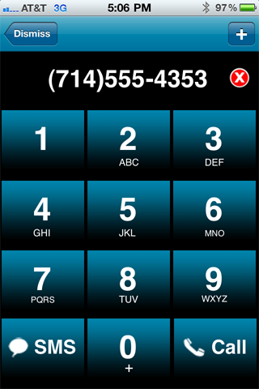

Let us try to create a has table T with size m where m>=1000 using has function

h(K)= $\left\lfloor M(KA mod 1)\right\rfloor$, where A= $\frac{\sqrt{5}-1}{2}$ =0.6180

Note that you can choose to use any other hash functions. My examples will use the above function for demonstration purposes. Also, I would use separate chaining to construct the table. That is, the table is array of linked list.

1. Create a array of linked list with size m=5003.
2. An object representing a word will be the following:

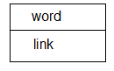

1. Let us determine what K is in the above function: Assume that 10-character word is *abbreviate*. Using the table given above, we will get 2227384283. Let us calculate h(2227384283).
2. (2227384283\*0,6180 mod 1) is 0.70226
3. 5003\*0.70226=3513.
4. We have the following image. If you have two or more words representing same phone number, they will go into same linked list.

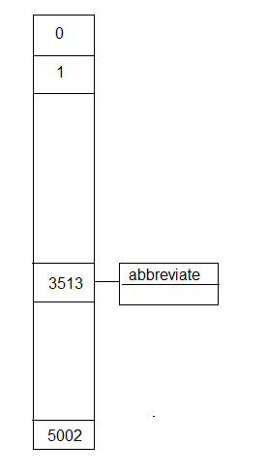

1. As above, you will create 4 hash tables. Table1 is all the words of length 10, Table 2 is for all the words of length 7, Table 3 for words of length 4, and Table 4 is words of length 3.
2. Suppose a 10-digit phone number K is given.
3. You first compute h(k)
4. Look at Table1 for length 10. If index h(k) is NILL, then look at Table2 etc.