Finger Lakes Advanced Monitoring Reporting Draft

NYSDEC SMAS

2021-03-11

# Section 1 - General

Harmful algal blooms (HABs) are increasingly a global concern because they pose a threat to human and aquatic ecosystem health and cause economic damages. Most HABs management strategies are focused on reduction of nitrogen and phosphorus loading to the lakes. However, lakes, bays, and coves can harbor different phytoplankton communities, including communities that shift between harmful and benign species, under similar nutrient loads or concentrations. Cyanobacterial HABs (CyanoHABs) represent a substantial threat to drinking-water supplies and safe recreational uses of freshwater resources in New York, including the Finger Lakes region. Toxins produced by some species of cyanobacteria (called cyanotoxins) can cause acute and chronic illnesses in humans. Aquatic ecosystem health also is affected by cyanotoxins, as well as low dissolved oxygen concentrations and changes in aquatic food webs caused by an over-abundance of cyanobacteria. Environmental factors that have been attributed to CyanoHAB occurrence include cyanobacterial community composition, nutrient concentrations, light conditions, water temperature, hydrologic conditions, and meteorological conditions. Yet despite a general understanding of factors contributing to CyanoHABs, many unanswered questions remain about occurrence, environmental triggers for toxicity, and the ability to predict the timing, duration, and toxicity of CyanoHABs. For these reasons, the U.S. Geological Survey, in cooperation with New York State Department of Environmental Conservation (NYSDEC) and New York State Department of Health (NYSDOH), has developed a comprehensive monitoring strategy in three lakes that have recently been affected by CyanoHABs: Owasco Lake, Seneca Lake, and Skaneateles Lake.

The Finger Lakes Advanced Monitoring site descriptions (Table1) and locations (Figure1) are included below. Measures of water and habitat quality included:

1. Water Chemistry and Stream Discharge
2. Benthic Macroinvertebrate Community
3. Stream Reach Physical Habitat Characteristics
4. Observer Ranking of Recreational Ability

This data report provides water quality information in a format designed to update the WI/PWL and document water quality violations. It has been structured into two primary sections: I) an overview to convey results from the five measures of water quality described above at the watershed and WI/PWL scale, and II) a site-specific data summary to present all major findings for each sampling location. Additional sections (III, IV) include literature cited and appendices covering all references and additional source material.

Table 1: Sampling locations. Locations are ordered from upstream to downstream according to river mile and mainstem confluence

| **Location ID** | **Group** | **Rivermile** | **WI/PWL** | **Waterbody   Classification** | **Description** | **Latitude** | **Longitude** |
| --- | --- | --- | --- | --- | --- | --- | --- |
| 07-CATH-0.6 | a | 0.6 | 0705-0011 | C(TS) | SOUTH GENESEE ST BRIDGE. | 42.32875 | -76.84401 |
| 07-KASH-0.3 | a | 0.3 | 0705-0017 | C | AT WEST LAKE RD. | 42.76482 | -76.97656 |
| 07-KEUK-0.1 | a | 0.1 | 0705-0020 | C(T) | 0.5 M U.S. OF MOUTH. | 42.68200 | -76.94900 |
| 07-REED-0.1 | a | 0.1 | 0705-0074 | C(T) | 300' WEST OF INTERSECTION WITH 125. | 42.78620 | -76.92700 |
| 07-GLNK-0.2 | a | 0.2 | 0705-0082 | C(TS) | JUNCTION OF MCGEE AND SHANNON STREET. | 42.37800 | -76.86200 |
| 07-BGST-0.1 | a | 0.1 | 0705-0087 | C(TS) | AT SOUTH GLENORA RD. | 42.49000 | -76.91430 |
| 07-THOL-1.8 | a | 1.8 | 0705-0073 | C | 10 M ABOVE SATTERLY HILL RD. BRIDGE. | 42.42696 | -76.84438 |
| 07-OWLI-3.0 | b | 3.0 | 0706-0002 | C(T) | 20 M BELOW SR 38. | 42.71667 | -76.43773 |
| 07-DUCH-0.3 | b | 0.3 | 0706-0003 | C(TS) | EAST LAKE RD. | 42.86400 | -76.50800 |
| 07-DUCH-8.3 | b | 8.3 | 0706-0003 | C(TS) | 10 M ABOVE OLD STATE RD. BRIDGE. | 42.83167 | -76.41277 |
| 07-OWAL_T46-0.1 | b | 0.1 | 0706-0010 | C | OFF FIRE LANE NEAR SR 38. | 42.82400 | -76.52100 |
| 07-OWAL_T9-0.1 | b | 0.1 | 0706-0010 | C | OFF WIDEWATERS RD. | 42.80500 | -76.49100 |
| 07-SCKR-0.1 | b | 0.1 | 0706-0010 | C | 100 M UPSTREAM OF SR 38A. | 42.90200 | -76.52700 |
| 07-VENE-1.5 | b | 1.5 | 0706-0010 | C | DOWNSTREAM OF SILVER STREET RD. BRIDGE. | 42.88016 | -76.56232 |
| 07-GROU-1.5 | c | 1.5 | 0706-0001 | AA(T) | CO RTE 101 AT SWEENEY HILL RD. BRIDGE. | 42.74194 | -76.26528 |
| 07-SKAT_T2-0.1 | c | 0.1 | 0707-0005 | AA | EAST LAKE RD. AT PUBLIC FISHING ACCESS. | 42.92439 | -76.40494 |
| 07-SKAT_T5-0.1 | c | 0.1 | 0707-0005 | AA | EAST LAKE RD. BRIDGE. | 42.90400 | -76.39399 |
| 07-SKAT_T89-0.2 | c | 0.2 | 0707-0005 | AA | WEST LAKE RD. BRIDGE. | 42.89800 | -76.41900 |
| 07-BSWP-0.1 | c | 0.1 | 0707-0005 | AA(T) | APPLETREE FIRE LANE. | 42.82246 | -76.32969 |

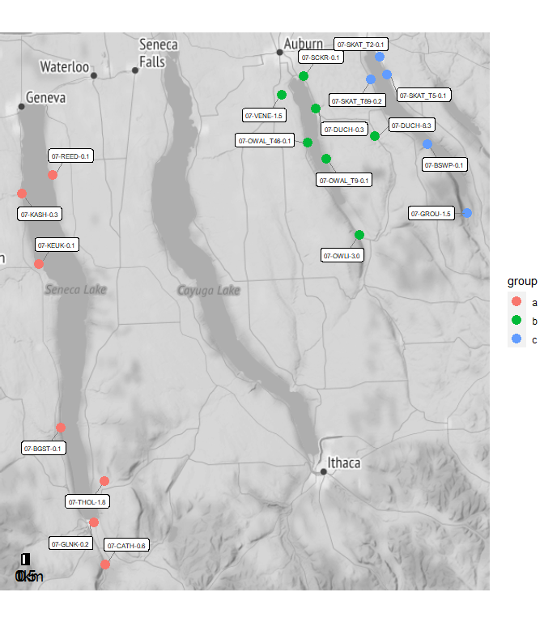

Figure 1: Map of sampling locations. Site names reference the Location ID and River Mile presented in 1

# Section 1A - Water Chemistry and Stream Discharge

## Water Chemistry Methodology

SMAS  
Methods used for water chemistry data collection are described by NYSDEC standard operating procedures (SOP). The collection of water chemistry samples followed procedures described in SOP #210(17-19) Collection of Water Column Samples for the Rotating Integrated Basin Studies (RIBS) Program. Where the depth of water permitted, water chemistry samples were collected using the depth-integrating suspended sediment sampler – wading (DH-81) method (SOP #210(17-19)), section 11.2). Where the depth of water was too shallow water chemistry samples were collected using the direct grab method (SOP #210(¬17-19), section 11.6). Water samples were processed using a contract lab with NYS Environmental Laboratory Approval Program (ELAP) certification.

Stream discharge was measured using the velocity-area method according to Turnipseed and Sauer (2010). The velocity-area method (Midsection Method) calculates discharge by subdividing a stream cross-section into 10 equally spaced stations and measuring depth and velocity within each station and summing the products (Turnipseed and Sauer, 2010). A top-set wading rod and Sontek FlowTracker was used. Methods are described in detail in Turnipseed and Sauer (2010) and Appendix I provides pertinent elements. Appendix II provides the field sheet used in collection of stream depth and velocity for discharge calculations.

Ambient water chemistry sampling included in situ and lab measured water quality analytes (Table2). Where applicable, chemistry results were analyzed for exceedances of state water quality standards and summarized below using R programing software (R Core Team, 2017). All raw chemistry results (in situ and lab reported) with all applicable standards and exceedance determinations accompany this report as Attachment I.

All survey data were subjected to the quality assurance/quality control (QA/QC) protocols detailed in Appendix III. For water chemistry, an evaluation of the precision, accuracy, and completeness of processed water chemistry samples after lab analyses were performed following the methods detailed in part A of Appendix III of this report. Appendix III.B includes a compilation of quality assurance results for each site. Only data meeting the highest data quality standard are reported and used in this report (Appendix III).

Table 2: Water chemistry analytes sampled as part of the Stream Assessment Survey. Table lists sampled analytes and analytical specifications. ^ Precision objectives are defined by results of duplicate samples as described in Appendix III

| **Analytes** | **Analytical  Lab** | **Method** | **Precision** | **Accuracy** | **Calibration:   Initial** | **Calibration:   Ongoing** | **Calibration:   Blanks** | **Detection   Limit** | **Reporting   Limit** |
| --- | --- | --- | --- | --- | --- | --- | --- | --- | --- |
| Temperature | in situ | 2550 B | ± 1oC | ± 1.5oC | Factory Set | ~ | ~ | ~ | ~ |
| Dissolved Oxygen | in situ | 4500-O G | ± 1% | ± 2% | Daily | ~ | ~ | ~ | ~ |
| pH | in situ | 4500-H+B | ± .05 SU | ± .2 SU | Weekly | ~ | ~ | ~ | ~ |
| Salinity | in situ | Calculated | 0.001 ppt | ± 1% | N/A | ~ | ~ | ~ | ~ |
| Specific Conductance | in situ | 2510 B | ± 1µs/cm | ± 1% | Weekly | ~ | ~ | ~ | ~ |
| Ammonia | ALS | D6919-09 | ^ | ± 20% | As needed | Every 10 | Every 10 | 0.008 mg/L | 0.01 mg/L |
| Total Kjeldahl Nitrogen | ALS | EPA 351.2 | ^ | ± 20% | Daily | Every 10 | Every 10 | 0.08 mg/L | 0.1 mg/L |
| Nitrogen, Nitrate | ALS | EPA 353.2 | ^ | ± 20% | Daily | Every 10 | Every 10 | 0.02 mg/L | 0.05 mg/L |
| Nitrogen, Total | ALS | Calculated | ^ |  |  |  |  |  |  |
| Total Phosphorus | ALS | EPA 365.1 | ^ | ± 20% | Daily | Every 10 | Every 10 | 0.002 mg/L | 0.003 mg/L |
| Ortho-phosphate | ALS | EPA 365.1 | ^ | ± 20% | Daily | Every 10 | Every 10 | 0.001 mg/L | 0.005 mg/L |
| Total Dissolved Solids | ALS | SM 2540C | ^ | ± 20% | Daily | Every 20 | Every 20 | 4.0 mg/L | 10 mg/L |
| Turbidity | ALS | EPA 180.1 | ^ | ± 10% | Daily | Every 10 | Every 10 | 0.06 NTU | 0.1 NTU |
| Dissolved Organic Carbon | ALS | 5310C | ^ | ± 20% | As needed | Ever 10 | Every 10 | 0.4 mg/L | 10 mg/L |
| Alkalinity | ALS | SM 2320B | ^ | ± 20% | Daily | Every 10 | Every 10 | 1.0 mg/L | 2.0 mg/L |
| Hardness | ALS | SM 2340C | ^ | ± 20% | Daily | Every 10 | Every 10 | 0.3 mg/L | 2.0 mg/L |
| Calcium | ALS | EPA 200.7 | ^ | ± 20% | Daily | Every 10 | Every 10 | 0.1 mg/L | 1.0 mg/L |
| Magnesium | ALS | EPA 200.7 | ^ | ± 20% | Daily | Every 10 | Every 10 | 0.04 mg/L | 1.0 mg/L |
| Potassium | ALS | EPA 200.7 | ^ | ± 20% | Daily | Every 10 | Every 10 | 0.06 mg/L | 2.0 mg/L |
| Sodium | ALS | EPA 200.7 | ^ | ± 20% | Daily | Every 10 | Every 10 | 0.03 mg/L | 1.0 mg/L |
| Chloride | ALS | EPA 300.0 | ^ | ± 20% | As needed | Every 10 | Every 10 | 0.02 mg/L | 0.2 mg/L |
| Fluoride | ALS | EPA 300.0 | ^ | ± 20% | As needed | Every 10 | Every 10 | 0.004 mg/L | 0.1 mg/L |
| Sulfate | ALS | EPA 300.0 | ^ | ± 20% | As needed | Every 10 | Every 10 | 0.02 mg/L | 0.2 mg/L |
| Iron (total) | ALS | EPA 200.7 | ^ | ± 20% | Daily | Every 10 | Every 10 | 6 µ/L | 100 µ/L |
| Manganese (total) | ALS | EPA 200.7 | ^ | ± 20% | Daily | Every 10 | Every 10 | 0.5 µ/L | 10 µ/L |
| Arsenic (total) | ALS | EPA 200.8 | ^ | ± 20% | Daily | Every 10 | Every 10 | 0.3 µ/L | 1 µ/L |
| Silver (total) | ALS | EPA 200.8 | ^ | ± 20% | Daily | Every 10 | Every 10 | 0.07 µ/L | 1 µ/L |
| Aluminum (total) | ALS | EPA 200.8 | ^ | ± 20% | Daily | Every 10 | Every 10 | 4.0 µ/L | 50 µ/L |
| Cadmium (total) | ALS | EPA 200.8 | ^ | ± 20% | Daily | Every 10 | Every 10 | 0.03 µ/L | 1 µ/L |
| Copper (total) | ALS | EPA 200.8 | ^ | ± 20% | Daily | Every 10 | Every 10 | 0.04 µ/L | 1 µ/L |
| Lead (total) | ALS | EPA 200.8 | ^ | ± 20% | Daily | Every 10 | Every 10 | 0.08 µ/L | 1 µ/L |
| Nickel (total) | ALS | EPA 200.8 | ^ | ± 20% | Daily | Every 10 | Every 10 | 0.04 µ/L | 1 µ/L |
| Zinc (total) | ALS | EPA 200.8 | ^ | ± 20% | Daily | Every 10 | Every 10 | 0.7 µ/L | 10 µ/L |
| Aluminum (dissolved) | ALS | EPA 200.8 | ^ | ± 20% | Daily | Every 10 | Every 10 | 0.9 µ/L | 10 µ/L |
| Cadmium (dissolved) | ALS | EPA 200.8 | ^ | ± 20% | Daily | Every 10 | Every 10 | 0.02 µ/L | 1 µ/L |
| Copper (dissolved) | ALS | EPA 200.8 | ^ | ± 20% | Daily | Every 10 | Every 10 | 0.02 µ/L | 1 µ/L |
| Lead (dissolved) | ALS | EPA 200.8 | ^ | ± 20% | Daily | Every 10 | Every 10 | 0.02 µ/L | 1 µ/L |
| Nickel (dissolved) | ALS | EPA 200.8 | ^ | ± 20% | Daily | Every 10 | Every 10 | 0.1 µ/L | 1 µ/L |
| Zinc (dissolved) | ALS | EPA 200.8 | ^ | ± 20% | Daily | Every 10 | Every 10 | 3 µ/L | 5 µ/L |

## Water Chemistry by PWL ID

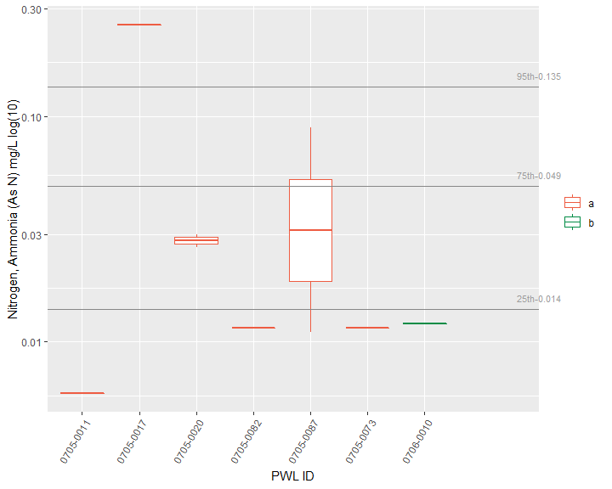

Figure 2: Nitrogen, Ammonia (As N), The X-axis presents WI/PWL ID of the sampling locations from upstream to downstream and axis labels correspond with Table 1, Figure 1 and Figure 2. Color of the box represents the location of the WI/WPL in the watershed as indicated in the plot legend. Horizontal lines represent the 95th, 75th, and 25th percentiles of statewide data for each endpoint.

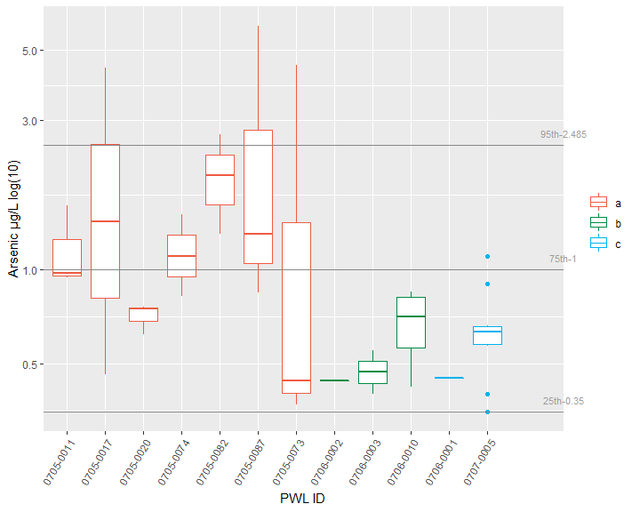

Figure 3: Arsenic, The X-axis presents WI/PWL ID of the sampling locations from upstream to downstream and axis labels correspond with Table 1, Figure 1 and Figure 2. Color of the box represents the location of the WI/WPL in the watershed as indicated in the plot legend. Horizontal lines represent the 95th, 75th, and 25th percentiles of statewide data for each endpoint.

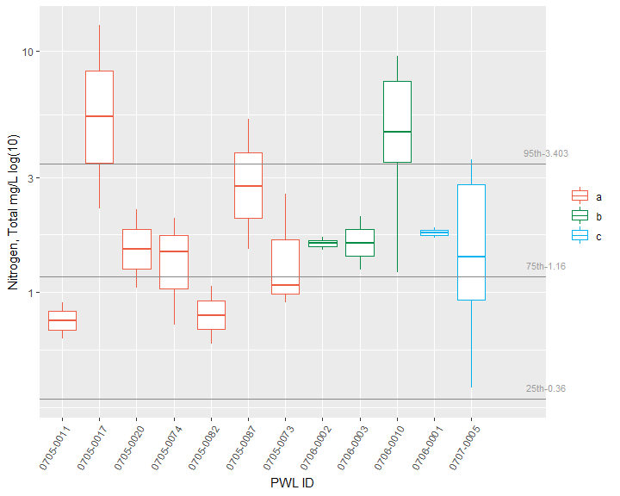

Figure 4: Nitrogen, Total, The X-axis presents WI/PWL ID of the sampling locations from upstream to downstream and axis labels correspond with Table 1, Figure 1 and Figure 2. Color of the box represents the location of the WI/WPL in the watershed as indicated in the plot legend. Horizontal lines represent the 95th, 75th, and 25th percentiles of statewide data for each endpoint.

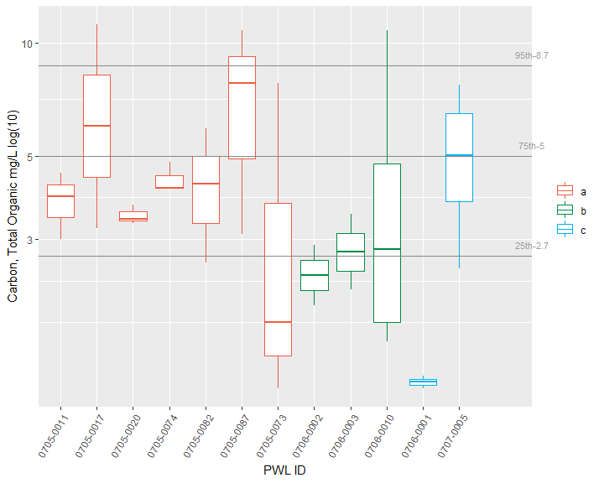

Figure 5: Carbon, Total Organic, The X-axis presents WI/PWL ID of the sampling locations from upstream to downstream and axis labels correspond with Table 1, Figure 1 and Figure 2. Color of the box represents the location of the WI/WPL in the watershed as indicated in the plot legend. Horizontal lines represent the 95th, 75th, and 25th percentiles of statewide data for each endpoint.

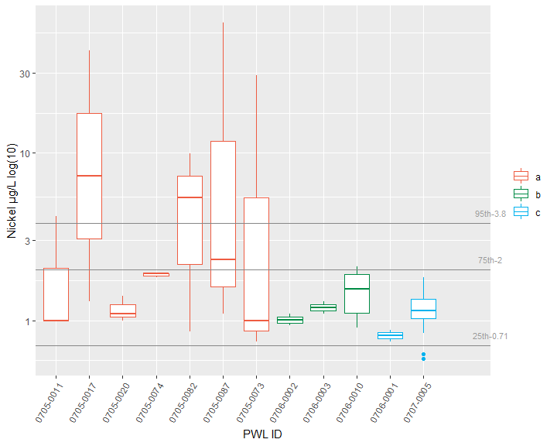

Figure 6: Nickel, The X-axis presents WI/PWL ID of the sampling locations from upstream to downstream and axis labels correspond with Table 1, Figure 1 and Figure 2. Color of the box represents the location of the WI/WPL in the watershed as indicated in the plot legend. Horizontal lines represent the 95th, 75th, and 25th percentiles of statewide data for each endpoint.

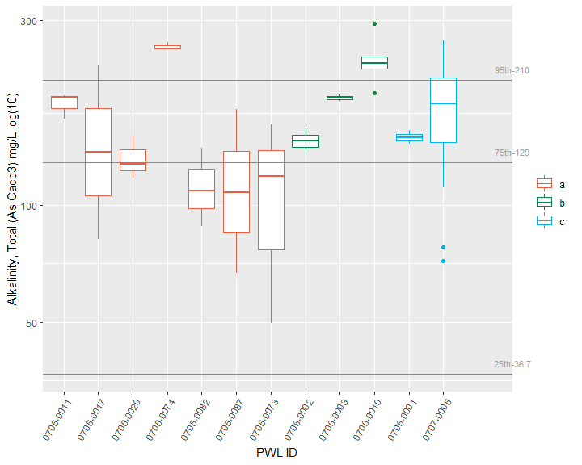

Figure 7: Alkalinity, Total (As Caco3), The X-axis presents WI/PWL ID of the sampling locations from upstream to downstream and axis labels correspond with Table 1, Figure 1 and Figure 2. Color of the box represents the location of the WI/WPL in the watershed as indicated in the plot legend. Horizontal lines represent the 95th, 75th, and 25th percentiles of statewide data for each endpoint.

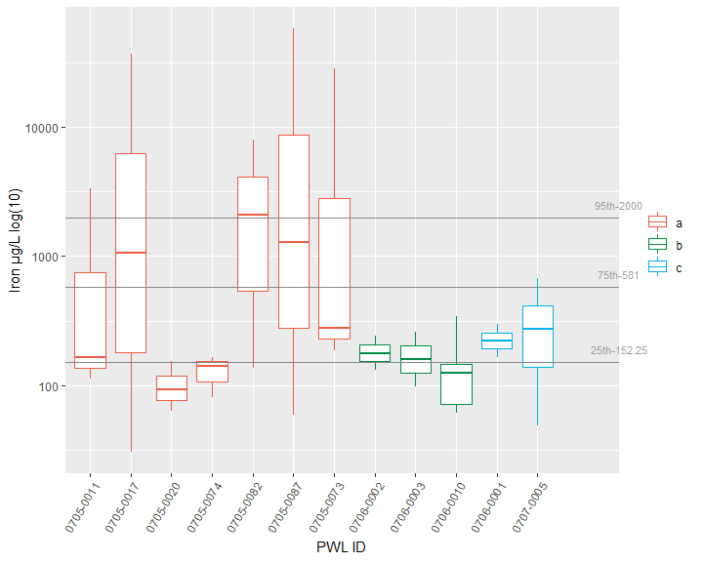

Figure 8: Iron, The X-axis presents WI/PWL ID of the sampling locations from upstream to downstream and axis labels correspond with Table 1, Figure 1 and Figure 2. Color of the box represents the location of the WI/WPL in the watershed as indicated in the plot legend. Horizontal lines represent the 95th, 75th, and 25th percentiles of statewide data for each endpoint.

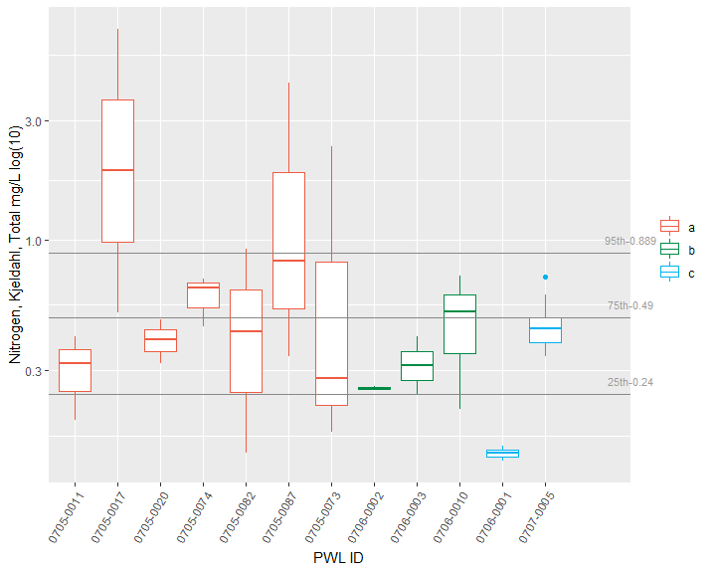

Figure 9: Nitrogen, Kjeldahl, Total, The X-axis presents WI/PWL ID of the sampling locations from upstream to downstream and axis labels correspond with Table 1, Figure 1 and Figure 2. Color of the box represents the location of the WI/WPL in the watershed as indicated in the plot legend. Horizontal lines represent the 95th, 75th, and 25th percentiles of statewide data for each endpoint.

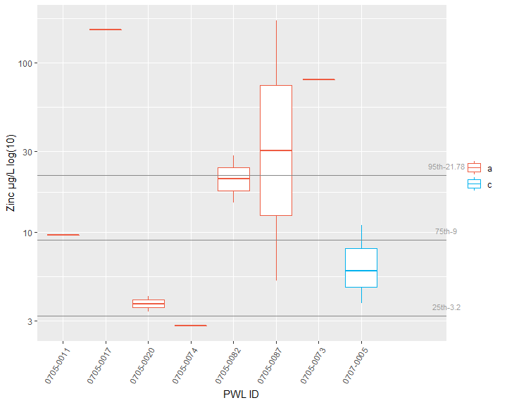

Figure 10: Zinc, The X-axis presents WI/PWL ID of the sampling locations from upstream to downstream and axis labels correspond with Table 1, Figure 1 and Figure 2. Color of the box represents the location of the WI/WPL in the watershed as indicated in the plot legend. Horizontal lines represent the 95th, 75th, and 25th percentiles of statewide data for each endpoint.

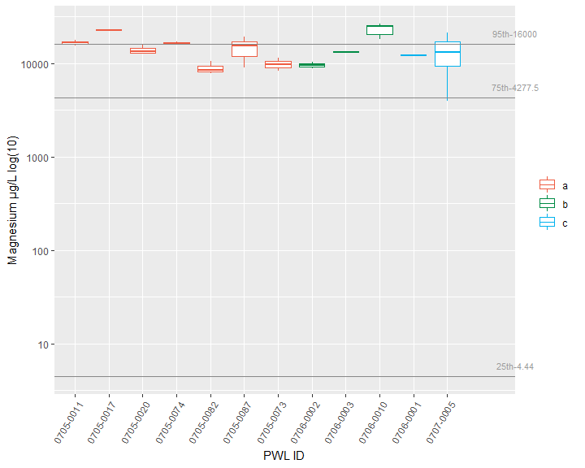

Figure 11: Magnesium, The X-axis presents WI/PWL ID of the sampling locations from upstream to downstream and axis labels correspond with Table 1, Figure 1 and Figure 2. Color of the box represents the location of the WI/WPL in the watershed as indicated in the plot legend. Horizontal lines represent the 95th, 75th, and 25th percentiles of statewide data for each endpoint.

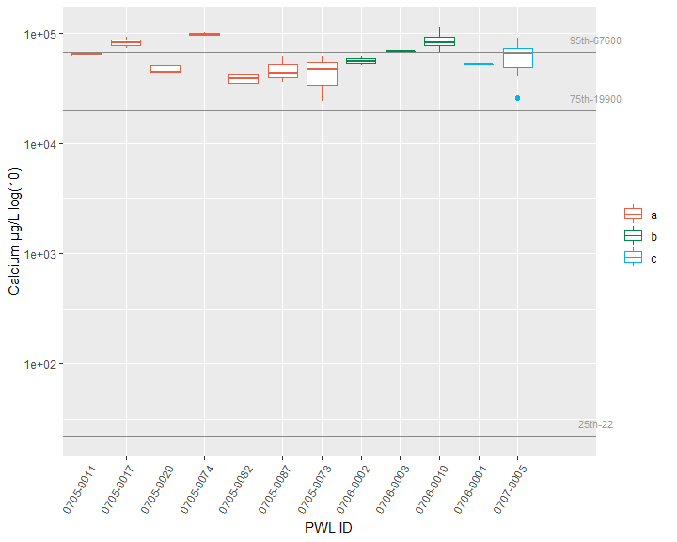

Figure 12: Calcium, The X-axis presents WI/PWL ID of the sampling locations from upstream to downstream and axis labels correspond with Table 1, Figure 1 and Figure 2. Color of the box represents the location of the WI/WPL in the watershed as indicated in the plot legend. Horizontal lines represent the 95th, 75th, and 25th percentiles of statewide data for each endpoint.

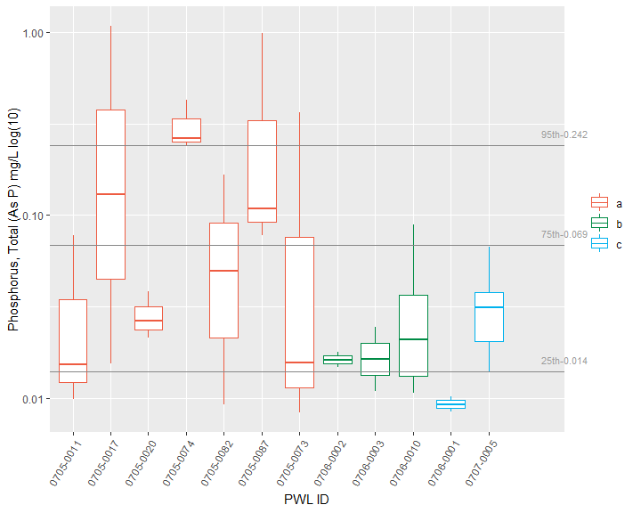

Figure 13: Phosphorus, Total (As P), The X-axis presents WI/PWL ID of the sampling locations from upstream to downstream and axis labels correspond with Table 1, Figure 1 and Figure 2. Color of the box represents the location of the WI/WPL in the watershed as indicated in the plot legend. Horizontal lines represent the 95th, 75th, and 25th percentiles of statewide data for each endpoint.

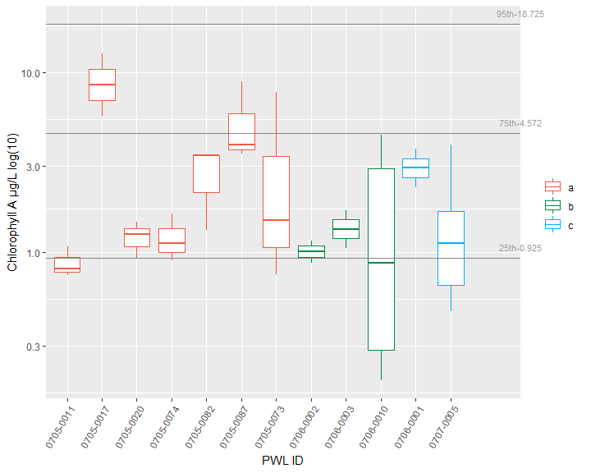

Figure 14: Chlorophyll A, The X-axis presents WI/PWL ID of the sampling locations from upstream to downstream and axis labels correspond with Table 1, Figure 1 and Figure 2. Color of the box represents the location of the WI/WPL in the watershed as indicated in the plot legend. Horizontal lines represent the 95th, 75th, and 25th percentiles of statewide data for each endpoint.

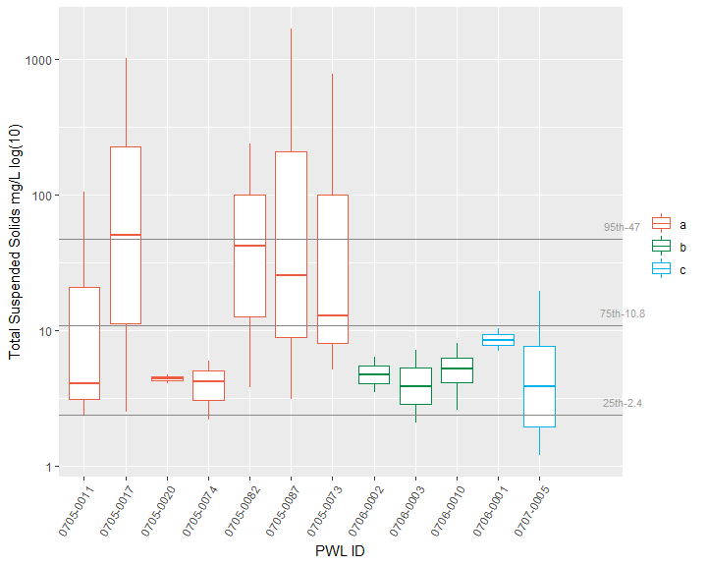

Figure 15: Total Suspended Solids, The X-axis presents WI/PWL ID of the sampling locations from upstream to downstream and axis labels correspond with Table 1, Figure 1 and Figure 2. Color of the box represents the location of the WI/WPL in the watershed as indicated in the plot legend. Horizontal lines represent the 95th, 75th, and 25th percentiles of statewide data for each endpoint.

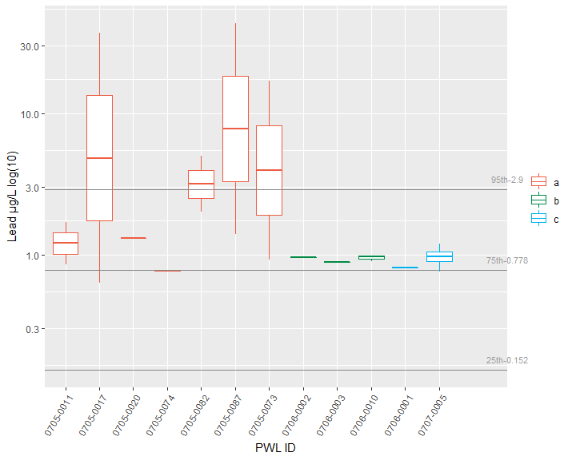

Figure 16: Lead, The X-axis presents WI/PWL ID of the sampling locations from upstream to downstream and axis labels correspond with Table 1, Figure 1 and Figure 2. Color of the box represents the location of the WI/WPL in the watershed as indicated in the plot legend. Horizontal lines represent the 95th, 75th, and 25th percentiles of statewide data for each endpoint.

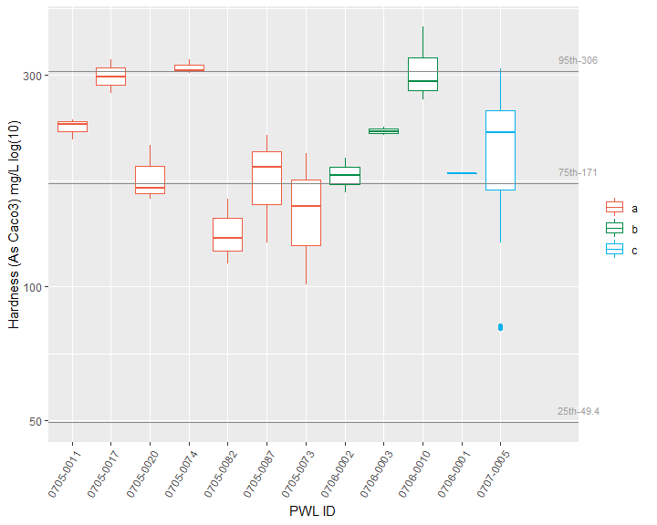

Figure 17: Hardness (As Caco3), The X-axis presents WI/PWL ID of the sampling locations from upstream to downstream and axis labels correspond with Table 1, Figure 1 and Figure 2. Color of the box represents the location of the WI/WPL in the watershed as indicated in the plot legend. Horizontal lines represent the 95th, 75th, and 25th percentiles of statewide data for each endpoint.

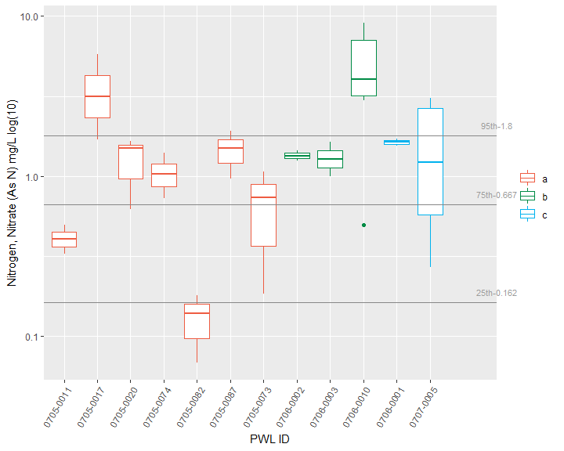

Figure 18: Nitrogen, Nitrate (As N), The X-axis presents WI/PWL ID of the sampling locations from upstream to downstream and axis labels correspond with Table 1, Figure 1 and Figure 2. Color of the box represents the location of the WI/WPL in the watershed as indicated in the plot legend. Horizontal lines represent the 95th, 75th, and 25th percentiles of statewide data for each endpoint.

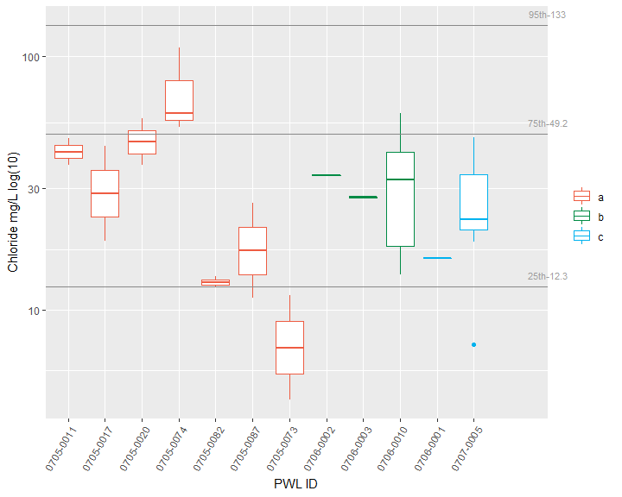

Figure 19: Chloride, The X-axis presents WI/PWL ID of the sampling locations from upstream to downstream and axis labels correspond with Table 1, Figure 1 and Figure 2. Color of the box represents the location of the WI/WPL in the watershed as indicated in the plot legend. Horizontal lines represent the 95th, 75th, and 25th percentiles of statewide data for each endpoint.

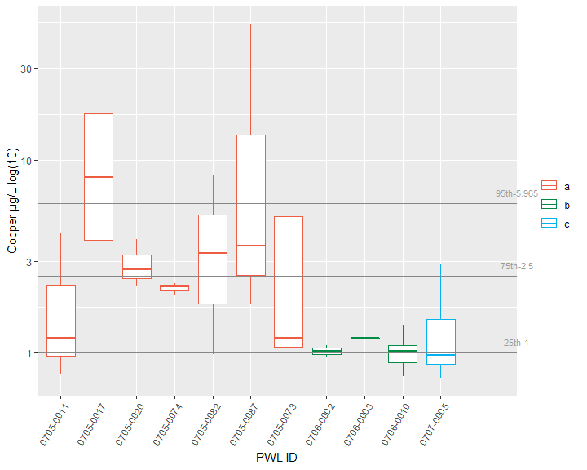

Figure 20: Copper, The X-axis presents WI/PWL ID of the sampling locations from upstream to downstream and axis labels correspond with Table 1, Figure 1 and Figure 2. Color of the box represents the location of the WI/WPL in the watershed as indicated in the plot legend. Horizontal lines represent the 95th, 75th, and 25th percentiles of statewide data for each endpoint.

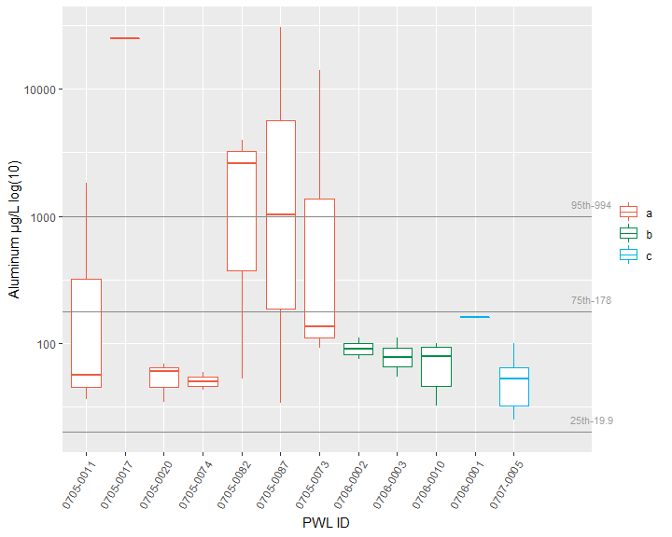

Figure 21: Aluminum, The X-axis presents WI/PWL ID of the sampling locations from upstream to downstream and axis labels correspond with Table 1, Figure 1 and Figure 2. Color of the box represents the location of the WI/WPL in the watershed as indicated in the plot legend. Horizontal lines represent the 95th, 75th, and 25th percentiles of statewide data for each endpoint.

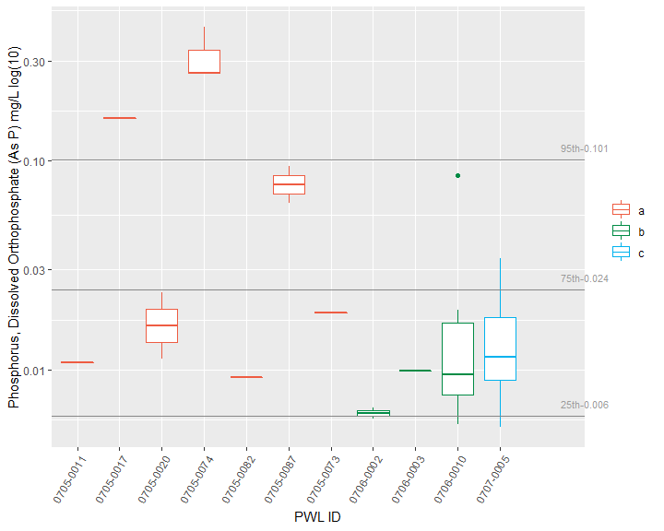

Figure 22: Phosphorus, Dissolved Orthophosphate (As P), The X-axis presents WI/PWL ID of the sampling locations from upstream to downstream and axis labels correspond with Table 1, Figure 1 and Figure 2. Color of the box represents the location of the WI/WPL in the watershed as indicated in the plot legend. Horizontal lines represent the 95th, 75th, and 25th percentiles of statewide data for each endpoint.

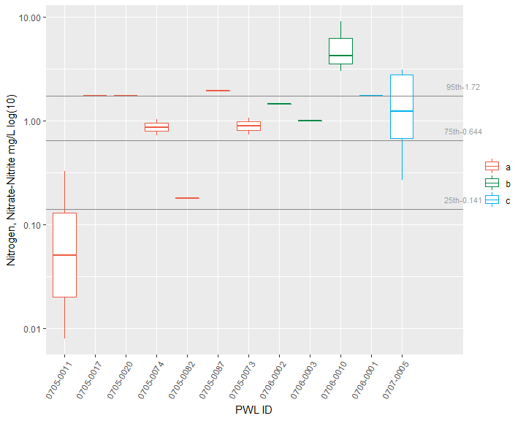

Figure 23: Nitrogen, Nitrate-Nitrite, The X-axis presents WI/PWL ID of the sampling locations from upstream to downstream and axis labels correspond with Table 1, Figure 1 and Figure 2. Color of the box represents the location of the WI/WPL in the watershed as indicated in the plot legend. Horizontal lines represent the 95th, 75th, and 25th percentiles of statewide data for each endpoint.

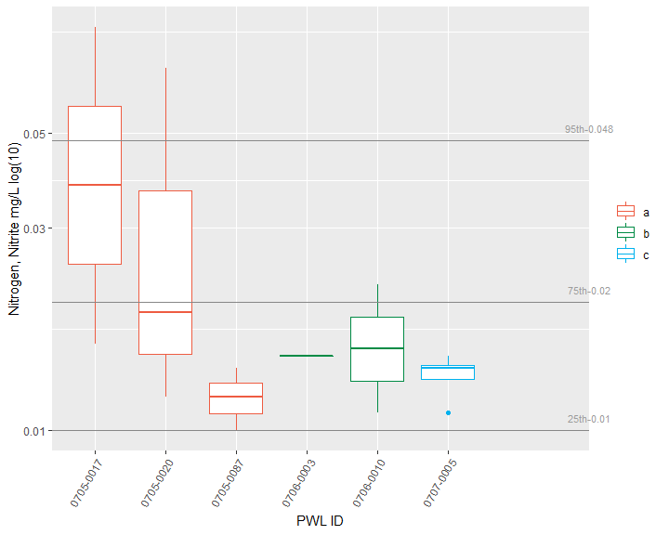

Figure 24: Nitrogen, Nitrite, The X-axis presents WI/PWL ID of the sampling locations from upstream to downstream and axis labels correspond with Table 1, Figure 1 and Figure 2. Color of the box represents the location of the WI/WPL in the watershed as indicated in the plot legend. Horizontal lines represent the 95th, 75th, and 25th percentiles of statewide data for each endpoint.

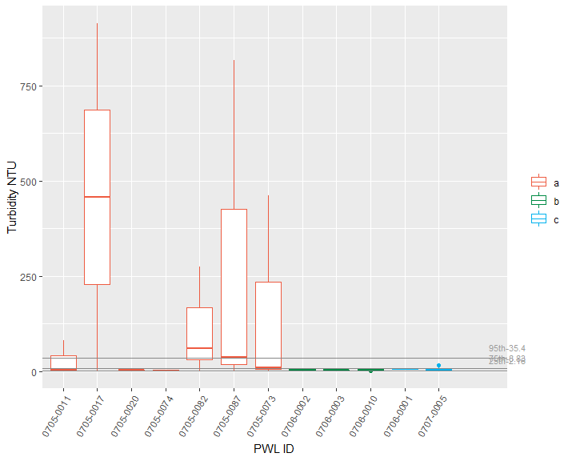

Figure 25: Turbidity, The X-axis presents WI/PWL ID of the sampling locations from upstream to downstream and axis labels correspond with Table 1, Figure 1 and Figure 2. Color of the box represents the location of the WI/WPL in the watershed as indicated in the plot legend. Horizontal lines represent the 95th, 75th, and 25th percentiles of statewide data for each endpoint.

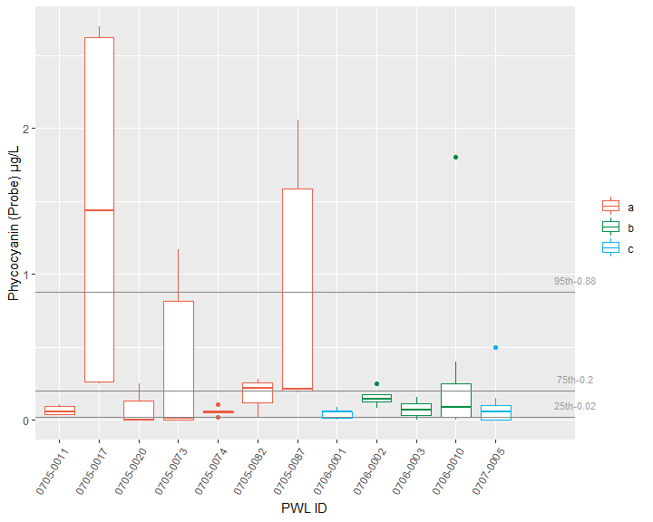

Figure 26: Phycocyanin (Probe), The X-axis presents WI/PWL ID of the sampling locations from upstream to downstream and axis labels correspond with Table 1, Figure 1 and Figure 2. Color of the box represents the location of the WI/WPL in the watershed as indicated in the plot legend. Horizontal lines represent the 95th, 75th, and 25th percentiles of statewide data for each endpoint. The total number of reported values illustrated for each sampling location can vary due to non-detection and QA/QC procedures. Descriptions of removed records are presented in Appendix III.

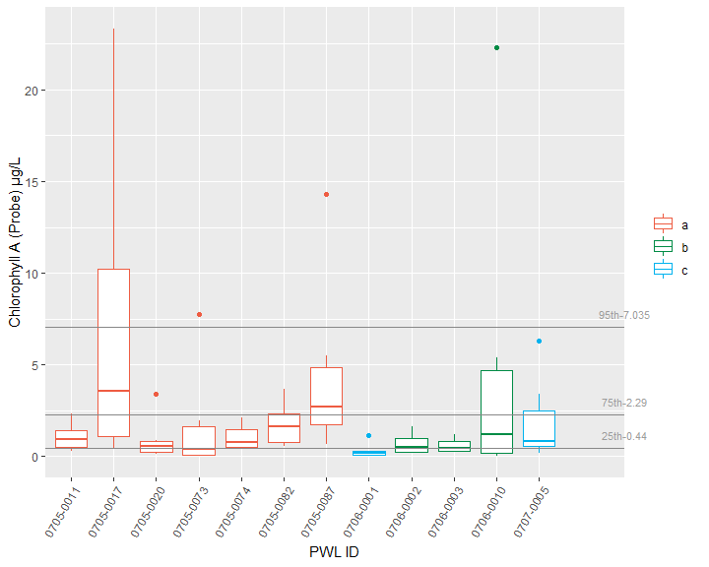

Figure 27: Chlorophyll A (Probe), The X-axis presents WI/PWL ID of the sampling locations from upstream to downstream and axis labels correspond with Table 1, Figure 1 and Figure 2. Color of the box represents the location of the WI/WPL in the watershed as indicated in the plot legend. Horizontal lines represent the 95th, 75th, and 25th percentiles of statewide data for each endpoint. The total number of reported values illustrated for each sampling location can vary due to non-detection and QA/QC procedures. Descriptions of removed records are presented in Appendix III.

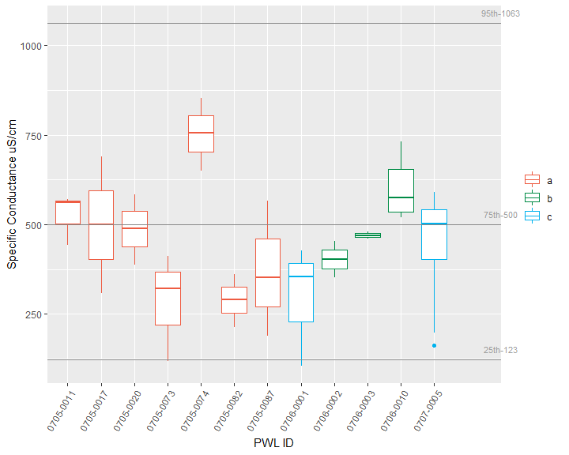

Figure 28: Specific Conductance, The X-axis presents WI/PWL ID of the sampling locations from upstream to downstream and axis labels correspond with Table 1, Figure 1 and Figure 2. Color of the box represents the location of the WI/WPL in the watershed as indicated in the plot legend. Horizontal lines represent the 95th, 75th, and 25th percentiles of statewide data for each endpoint. The total number of reported values illustrated for each sampling location can vary due to non-detection and QA/QC procedures. Descriptions of removed records are presented in Appendix III.

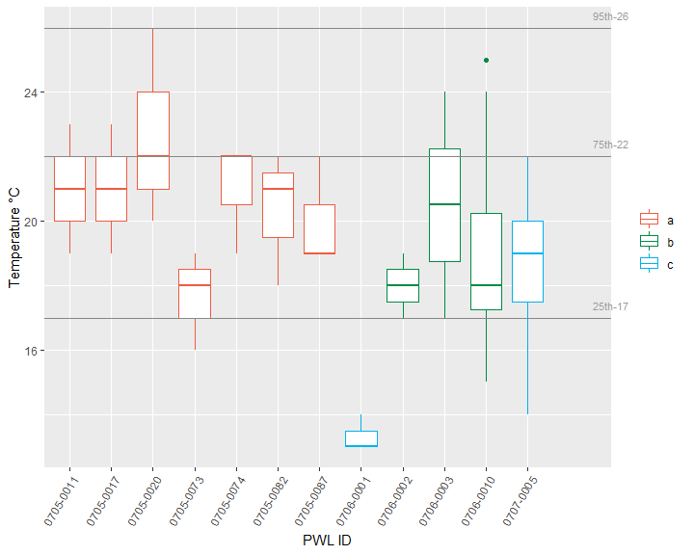

Figure 29: Temperature, The X-axis presents WI/PWL ID of the sampling locations from upstream to downstream and axis labels correspond with Table 1, Figure 1 and Figure 2. Color of the box represents the location of the WI/WPL in the watershed as indicated in the plot legend. Horizontal lines represent the 95th, 75th, and 25th percentiles of statewide data for each endpoint. The total number of reported values illustrated for each sampling location can vary due to non-detection and QA/QC procedures. Descriptions of removed records are presented in Appendix III.

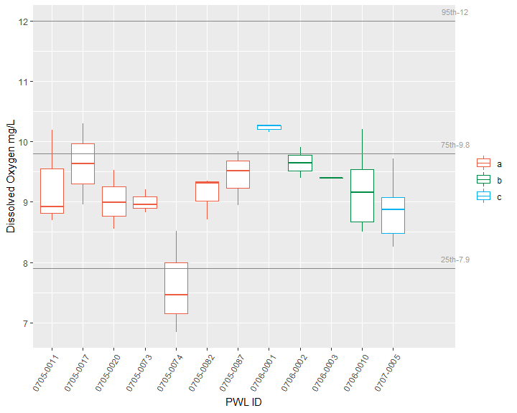

Figure 30: Dissolved Oxygen, The X-axis presents WI/PWL ID of the sampling locations from upstream to downstream and axis labels correspond with Table 1, Figure 1 and Figure 2. Color of the box represents the location of the WI/WPL in the watershed as indicated in the plot legend. Horizontal lines represent the 95th, 75th, and 25th percentiles of statewide data for each endpoint. The total number of reported values illustrated for each sampling location can vary due to non-detection and QA/QC procedures. Descriptions of removed records are presented in Appendix III.

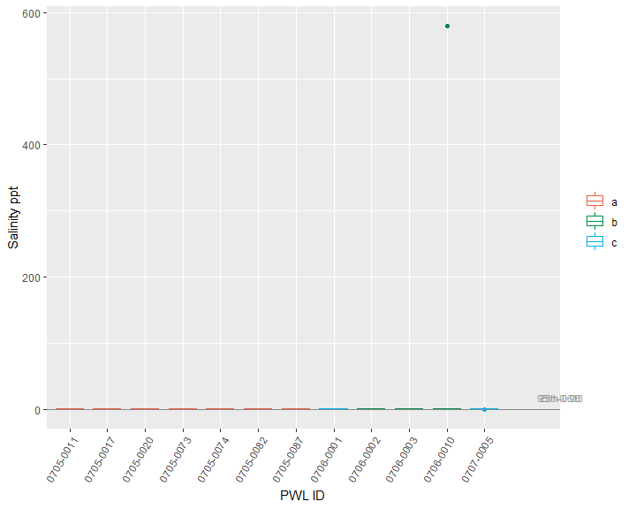

Figure 31: Salinity, The X-axis presents WI/PWL ID of the sampling locations from upstream to downstream and axis labels correspond with Table 1, Figure 1 and Figure 2. Color of the box represents the location of the WI/WPL in the watershed as indicated in the plot legend. Horizontal lines represent the 95th, 75th, and 25th percentiles of statewide data for each endpoint. The total number of reported values illustrated for each sampling location can vary due to non-detection and QA/QC procedures. Descriptions of removed records are presented in Appendix III.

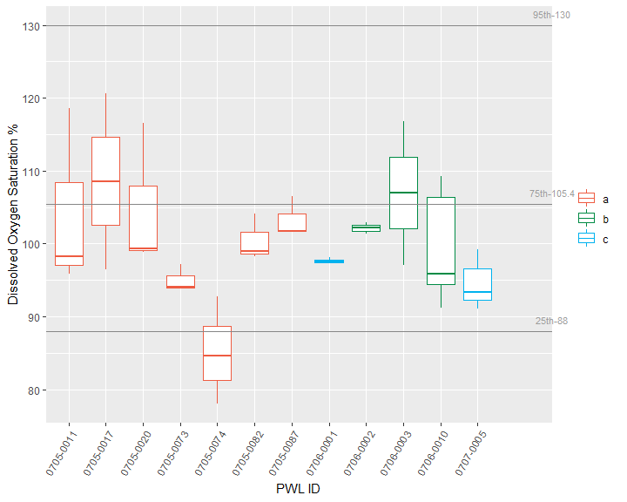

Figure 32: Dissolved Oxygen Saturation, The X-axis presents WI/PWL ID of the sampling locations from upstream to downstream and axis labels correspond with Table 1, Figure 1 and Figure 2. Color of the box represents the location of the WI/WPL in the watershed as indicated in the plot legend. Horizontal lines represent the 95th, 75th, and 25th percentiles of statewide data for each endpoint. The total number of reported values illustrated for each sampling location can vary due to non-detection and QA/QC procedures. Descriptions of removed records are presented in Appendix III.

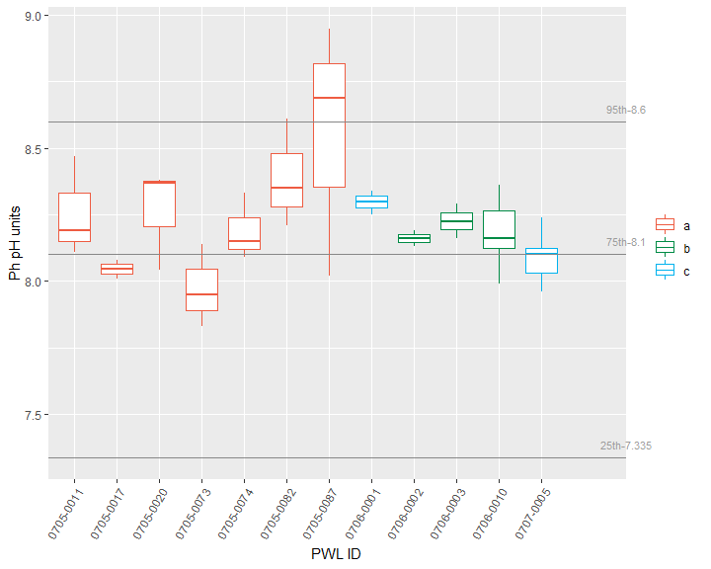

Figure 33: Ph, The X-axis presents WI/PWL ID of the sampling locations from upstream to downstream and axis labels correspond with Table 1, Figure 1 and Figure 2. Color of the box represents the location of the WI/WPL in the watershed as indicated in the plot legend. Horizontal lines represent the 95th, 75th, and 25th percentiles of statewide data for each endpoint. The total number of reported values illustrated for each sampling location can vary due to non-detection and QA/QC procedures. Descriptions of removed records are presented in Appendix III.

# Section 1B - Benthic Macroinvertebrate Community

Benthic macroinvertebrate communities were sampled to evaluate water quality impacts to the aquatic life use. Where appropriate riffle habitat was present, collection of macroinvertebrates was preformed using the kick method described in section 9.4 of SOP #208-19 Biological Monitoring of Surface Waters in New York State. With the exception of PEERS sites, replicate (n=4/site) macroinvertebrate samples were collected once at each site during years water chemistries were collected. For traveling kick samples, the contents of replicates for each site were field-inspected to determine major groups of organisms present, and then preserved in alcohol for lab inspection and identification of 100-specimen subsamples. For non-wadable sites, multiplates were deployed for a five-week colonization period, scraped, contents preserved and processed to a minimum of 250 organisms and a quarter of the sample. If target counts were not met, samples were processed in their entirety. Specimens were identified to lowest possible taxonomic resolution, typically genus or species.

Biological assessments of water quality are generated from Biological Assessment Profile (BAP) scores (SOP #208-19). BAP scores are calculated by taking the average of five normalized 10-scale community metrics and assigning that score to a four-tiered system of impact category of non (7.5-10), slight (5.0-7.5), moderate (2.5-5.0), or severe (0-2.5) impacts see (Figure34). A final BAP score below 5 suggests that the sampled stream is not achieving its aquatic life use goals (SOP #208-19). A BAP score above 5 indicates that the sampled stream is attaining its aquatic life use goals (Figure 10; SOP #208-19). Expected variability in the results of benthic macroinvertebrate community samples is presented in Smith and Bode (2004).

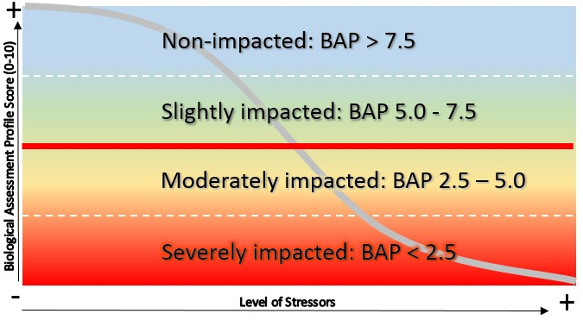

Biological Assessment Profile (BAP) score impact categories based on the macroinvertebrate community. Scores below 5 suggest impairment to aquatic life and scores above 5 indicate attainment of aquatic life of use.

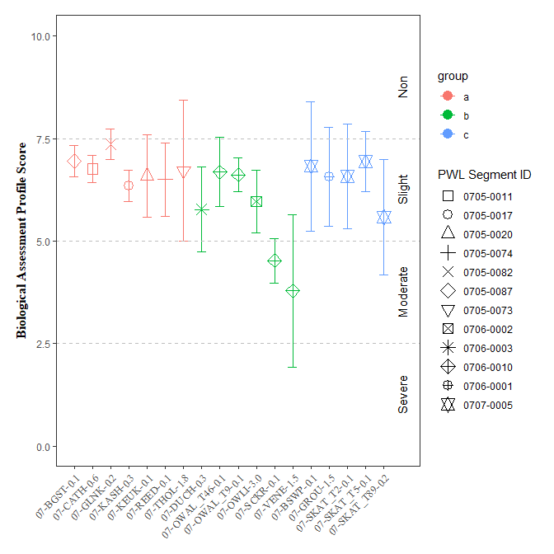

Figure 34: Biological Assessment Profile (BAP) Scores and 95% confidence intervals for benthic macroinvertebrate community assessment data for the Survey, 2019. Symbology corresponds with WI/PWL segmentation as indicated in the plot legend.

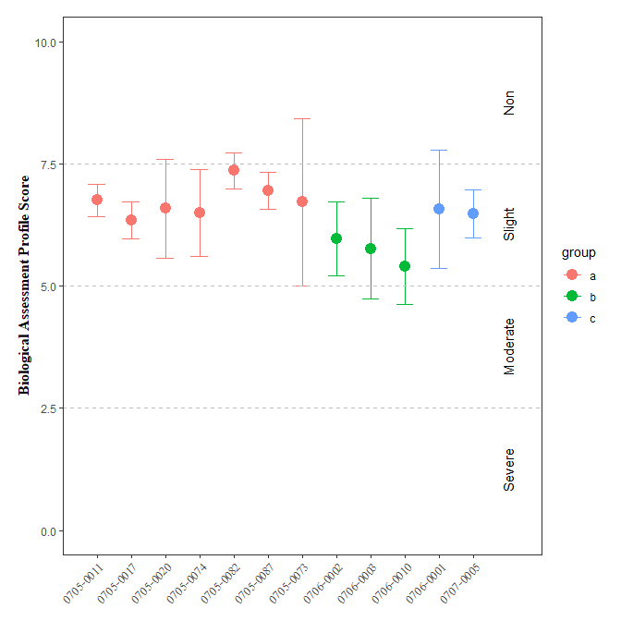

Figure 35: Biological Assessment Profile (BAP) Scores and 95% confidence intervals for benthic macroinvertebrate community assessment data for the Survey, by PWL. Symbology corresponds with WI/PWL segmentation as indicated in the plot legend.

On average, Biological Assessment Profile (BAP) scores ranged from slightly to moderately impacted across all sites on the WI/PWL segments in the watershed (SOP #208-19). No segments fell below a mean BAP score of 5 for the study period. (Figure34). However ninety-five percent confidence intervals suggest inconclusive results for segments,0706-0003, However ninety-five percent confidence intervals suggest inconclusive results for segments,0706-0010.

`

# Section 1C - Stream Reach Physical Characteristics

Assessments of physical habitat conditions were performed by field crews at sites along with macroinvertebrate collections following the methods detailed in section 9.10 of SOP #208-19. Each habitat category was averaged over the two years of sampling conducted at each location. The information collected in these assessments are used to calculate the Habitat Model Affinity (HMA) (Table 3), an overall estimate of habitat quality which describes potential habitat stress on aquatic life. The HMA is based on rankings of individual habitat characteristics on a scale from 0 (poor) to 20 (optimal) which are then compared to a statewide reference condition (Appendix IV). HMA scores are used to make final physical habitat assessments; Natural (80-100), Altered (70 – 80), Moderate (60 – 70), and Severe (< 60). Results are described in terms of percent similarity to the reference condition.

Habitat model affinity (HMA) scores and resulting final physical habitat assessments ranged from natural to severe alteration across all sites (SOP #208-19; Table3). Physical habitat final assessments demonstrate that habitat may have been a factor influencing benthic communities at sampling locations where HMA scores indicate moderate or severely altered conditions (Table3); natural (n=11), altered (n=4), moderate (n=3), severe (n=0).

Table 3: Ranked habitat characteristics and calculated HMA. Epifaunal substrate (Epi. Cover); Embeddedness/Pool Substrate Characterization (Embed. Pool.); Velocity Depth Regime/Pool Variability (Vel/Dep Reg.); Sediment Deposition (Sed. Dep.); Channel Flow Status (Flow Status); Channel Alteration (Chan. Alt.); Riffle Frequency/Stream Sinuosity (Rif. Freq.); Left and Right Bank Stability (L.B. and R.B. Stability); Left and Right Bank Vegetation (L.B. and R.B. Veg); Width of Left and Right Bank Vegetative Zone (L.B. and R.B. Veg Zone); Habitat Model Affinity Score (HMA Score); HMA Assessment (HMA Assess.)

| **PWL** | **Site** | **Gradient** | **Epi.  Cover** | **Embed.   Pool.** | **Vel/Dep.   Reg.** | **Sed.   Dep.** | **Flow   Status** | **Chan.   Alt** | **Rif.   Freq** | **L.B.   Stability** | **R.B.   Stability** | **L.B.   Veg** | **R.B.  Veg** | **L.B.   Veg Zone** | **R.B.   Veg Zone** | **HMA   Score** | **HMA   Assess.** |
| --- | --- | --- | --- | --- | --- | --- | --- | --- | --- | --- | --- | --- | --- | --- | --- | --- | --- |
| 0705-0087 | 07-BGST-0.1 | High | 8 | 17 | 19 | 20 | 18 | 18 | 18 | 9 | 9 | 9 | 4 | 10 | 1 | 87.3 | Natural |
| 0707-0005 | 07-BSWP-0.1 | High | 18 | 17 | 16 | 12 | 16 | 17 | 19 | 7 | 8 | 9 | 3 | 9 | 2 | 84.0 | Natural |
| 0705-0011 | 07-CATH-0.6 | High | 14 | 17 | 17 | 18 | 10 | 13 | 10 | 3 | 3 | 7 | 7 | 3 | 3 | 69.1 | Moderate |
| 0706-0003 | 07-DUCH-0.3 | High | 17 | 18 | 18 | 18 | 18 | 18 | 19 | 9 | 9 | 9 | 9 | 8 | 9 | 98.3 | Natural |
| 0705-0082 | 07-GLNK-0.2 | High | 12 | 18 | 19 | 20 | 13 | 8 | 18 | 8 | 4 | 2 | 2 | 1 | 1 | 68.0 | Moderate |
| 0706-0001 | 07-GROU-1.5 | High | 20 | 17 | 19 | 18 | 17 | 19 | 19 | 9 | 9 | 9 | 8 | 9 | 5 | 96.1 | Natural |
| 0705-0017 | 07-KASH-0.3 | High | 11 | 16 | 18 | 13 | 7 | 13 | 15 | 8 | 4 | 8 | 1 | 8 | 0 | 67.4 | Moderate |
| 0705-0020 | 07-KEUK-0.1 | High | 14 | 15 | 19 | 14 | 16 | 14 | 19 | 9 | 9 | 9 | 9 | 9 | 9 | 91.2 | Natural |
| 0706-0010 | 07-OWAL_T46-0.1 | High | 17 | 18 | 13 | 18 | 18 | 19 | 19 | 9 | 8 | 9 | 8 | 3 | 2 | 87.8 | Natural |
| 07-OWAL_T9-0.1 | High | 14 | 15 | 9 | 10 | 14 | 17 | 16 | 8 | 7 | 7 | 8 | 4 | 4 | 73.5 | Altered |
| 0706-0002 | 07-OWLI-3.0 | High | 14 | 17 | 15 | 13 | 19 | 17 | 18 | 6 | 6 | 8 | 9 | 5 | 4 | 83.4 | Natural |
| 0705-0074 | 07-REED-0.1 | High | 16 | 17 | 12 | 7 | 10 | 20 | 16 | 10 | 6 | 9 | 9 | 5 | 5 | 77.3 | Altered |
| 0706-0010 | 07-SCKR-0.1 | High | 15 | 16 | 6 | 16 | 7 | NA | 13 | 9 | 10 | 7 | 7 | 7 | 8 | 76.2 | Altered |
| 0707-0005 | 07-SKAT_T2-0.1 | High | 18 | 11 | 18 | 17 | 16 | 14 | 17 | NA | 7 | 10 | NA | 9 | 9 | 90.6 | Natural |
| 07-SKAT_T5-0.1 | High | 19 | NA | 18 | 17 | 10 | 16 | 18 | 8 | 6 | 9 | 9 | 9 | 9 | 90.1 | Natural |
| 07-SKAT_T89-0.2 | High | 16 | 16 | 16 | 18 | 17 | 14 | 18 | 7 | 6 | 9 | 9 | 9 | 9 | 90.6 | Natural |
| 0705-0073 | 07-THOL-1.8 | High | 17 | 16 | 19 | 17 | 14 | 18 | 19 | 8 | 8 | 10 | 10 | 10 | 10 | 95.0 | Natural |
| 0706-0010 | 07-VENE-1.5 | High | 10 | 11 | 6 | 12 | 18 | 18 | 4 | 9 | 9 | 9 | 9 | 9 | 3 | 70.2 | Altered |

# Section 1D - User Perception

Perceptions of recreational ability were ranked at all sampling locations during each site visit as per standard site visit protocols (SOP #208-19). The observer ranking of recreational ability is a method of evaluating impacts to recreational use of a stream segment. Impacts to recreational use have been correlated with “impairment of aquatic life use from nutrient enrichment” and rankings below slightly impacted (rank of 3) are indicative of significant impacts to recreational ability (Smith et al. 2014). The ranking assesses primary (1°) and secondary (2°) contact recreation, as well as a user’s desire to fish.

The first two questions of the recreational use evaluation describe the observers perceived ability to participate in 1° and 2° contact recreation (Appendix V). Results of this ranking are the primary gauge of whether the Finger Lakes Advanced Monitoring site(s) are achieving the designated recreational uses. (Figure36) illustrates the average observer ranking for desire to participate in 1° and 2° contact recreation at each sampling location. Results of this survey suggest observers (NYSDEC field staff) considered the desire to participate in 1° and 2° contact recreation to be slightly impacted (ranked > 3) at PWL segments 0705-0087, 0707-0005, 0705-0011, 0705-0082, 0705-0017, 0705-0020, 0705-0073,(Figure37)

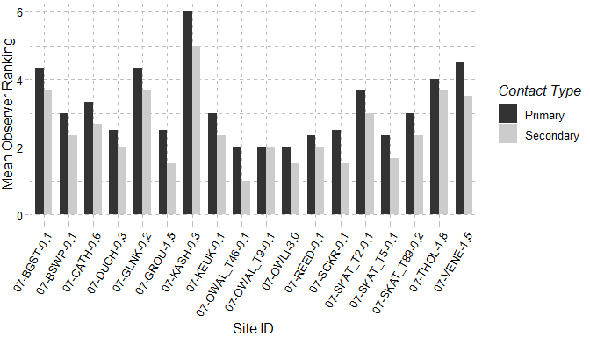

Figure 36: Mean observer ranking of recreational ability for each sampling location. Columns represent observer rankings for the desire to participate in 1° and 2° contact recreation. Ranking of recreation ability was performed for all locations during each site visit.

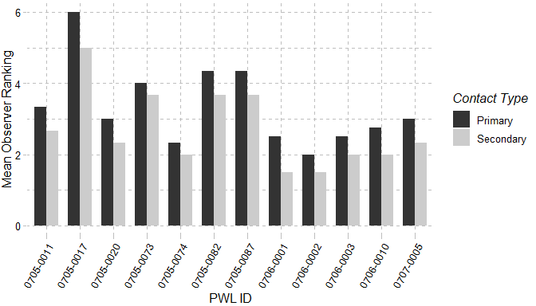

Figure 37: Mean observer ranking of recreational ability for sampling locations, grouped by PWL. Columns represent observer rankings for the desire to participate in 1° and 2° contact recreation. Ranking of recreation ability was performed for all locations during each site visit.

Additional questions on a scale of 0-10 (0 – Best/Natural; 10 Worst/Severe) help determine the factors influencing the user’s perception. Those factors are: 1) Water Clarity; 2) Trash; 3) Periphyton; 4) Odor; 5) Discharge Pipes. (Table4) shows the mean recorded value for these factors at each sampling location and (Table5) shows the most commonly selected factors reducing an observer’s desire to participate in 1° and 2° contact recreation. Other factors described by observers were: 1) Low Dissolved Oxygen; 2) Proximity to Road; 3) Proximity to a State Superfund Site; 4) Proximity to WWTF effluent discharge.

Table 4: Mean observer ranked value for factors influencing desire to participate in 1° and 2° contact recreation. Factors were ranked on a 10 scale (0 – Best/Natural; 10 Worst/Severe) according to perceived impact on a location. Ranking of recreation ability was performed for all locations during each site visit

| **PWL** | **Site** | **Water   Clarity** | **Susp. Phyto.** | **Periphyton** | **Macro.** | **Odor** | **Trash** | **Dishcarge   Pipes** |
| --- | --- | --- | --- | --- | --- | --- | --- | --- |
| 0705-0087 | 07-BGST-0.1 | 6 | 0 | 1 | 1 | 2 | 0 | 0 |
| 0707-0005 | 07-BSWP-0.1 | 2 | 0 | 2 | 0 | 0 | 1 | 0 |
| 0705-0011 | 07-CATH-0.6 | 3 | 0 | NA | NA | 0 | 0 | 0 |
| 0706-0003 | 07-DUCH-0.3 | 4 | 0 | 2 | 0 | 0 | 0 | 0 |
| 0705-0082 | 07-GLNK-0.2 | 6 | 0 | 2 | 0 | 0 | 2 | 0 |
| 0706-0001 | 07-GROU-1.5 | 2 | 0 | 3 | 0 | 0 | 0 | 0 |
| 0705-0017 | 07-KASH-0.3 | NA | NA | NA | NA | NA | NA | NA |
| 0705-0020 | 07-KEUK-0.1 | 1 | 0 | 3 | 0 | 3 | 0 | 0 |
| 0706-0010 | 07-OWAL_T46-0.1 | 0 | 0 | 2 | 0 | 2 | 0 | 0 |
| 07-OWAL_T9-0.1 | 3 | 0 | 2 | 0 | 0 | 1 | 0 |
| 0706-0002 | 07-OWLI-3.0 | 4 | 1 | 2 | 1 | 0 | 0 | 0 |
| 0705-0074 | 07-REED-0.1 | 0 | 0 | 2 | 0 | 1 | 0 | 0 |
| 0706-0010 | 07-SCKR-0.1 | 2 | 0 | 2 | 0 | 0 | 0 | 0 |
| 0707-0005 | 07-SKAT_T2-0.1 | 4 | 2 | NA | 2 | 1 | 0 | 0 |
| 07-SKAT_T5-0.1 | 0 | 0 | 2 | 0 | 0 | NA | 0 |
| 07-SKAT_T89-0.2 | 2 | 1 | 4 | 0 | 0 | 0 | 0 |
| 0705-0073 | 07-THOL-1.8 | 4 | 0 | 0 | 0 | 0 | 0 | 0 |
| 0706-0010 | 07-VENE-1.5 | NA | NA | 6 | 0 | 1 | 0 | 0 |

Table 5: Most frequently ranked factor influencing observer desire to participate in 1° and 2° contact recreation. Factors influencing desire to recreate were ranked and a primary factor influencing the desire to participate in 1° and 2° contact recreation was chosen during each site visit. Column values represent the factor selected most frequently at each site.

| **PWL** | **Sites** | **Primary** | **Secondary** |
| --- | --- | --- | --- |
| 0705-0087 | 07-BGST-0.1 | Odor | Other, Periphyton, Water Clarity |
| 07-BGST-0.1 | Water Clarity | Other, Periphyton, Water Clarity |
| 0707-0005 | 07-BSWP-0.1 | Periphyton | Periphyton |
| 07-BSWP-0.1 | Water Clarity | Periphyton |
| 0705-0011 | 07-CATH-0.6 | Periphyton | Periphyton, Water Clarity |
| 07-CATH-0.6 | Water Clarity | Periphyton, Water Clarity |
| 0706-0003 | 07-DUCH-0.3 | Water Clarity | Periphyton, Water Clarity |
| 0705-0082 | 07-GLNK-0.2 | Periphyton | Trash |
| 07-GLNK-0.2 | Water Clarity | Trash |
| 0706-0001 | 07-GROU-1.5 | Periphyton | Periphyton |
| 07-GROU-1.5 | Water Clarity | Periphyton |
| 0705-0017 | 07-KASH-0.3 | Periphyton | Other |
| 07-KASH-0.3 | Water Clarity | Other |
| 0705-0020 | 07-KEUK-0.1 | Odor | None, Odor, Periphyton |
| 07-KEUK-0.1 | Periphyton | None, Odor, Periphyton |
| 07-KEUK-0.1 | Water Clarity | None, Odor, Periphyton |
| 0706-0010 | 07-OWAL_T46-0.1 | None | None, Odor |
| 07-OWAL_T46-0.1 | Odor | None, Odor |
| 07-OWAL_T9-0.1 | Other | Trash, Water Clarity |
| 07-OWAL_T9-0.1 | Water Clarity | Trash, Water Clarity |
| 0706-0002 | 07-OWLI-3.0 | Water Clarity | Water Clarity |
| 0705-0074 | 07-REED-0.1 | Periphyton | Periphyton |
| 07-REED-0.1 | Water Clarity | Periphyton |
| 0706-0010 | 07-SCKR-0.1 | Other | None, Water Clarity |
| 07-SCKR-0.1 | Water Clarity | None, Water Clarity |
| 0707-0005 | 07-SKAT_T2-0.1 | Odor | Water Clarity |
| 07-SKAT_T2-0.1 | Water Clarity | Water Clarity |
| 07-SKAT_T5-0.1 | Periphyton | Periphyton |
| 07-SKAT_T5-0.1 | Proximity_to_Development_Roads | Periphyton |
| 07-SKAT_T5-0.1 | Water Clarity | Periphyton |
| 07-SKAT_T89-0.2 | Periphyton | Periphyton |
| 07-SKAT_T89-0.2 | Water Clarity | Periphyton |
| 0705-0073 | 07-THOL-1.8 | Other | Other, Water Clarity |
| 07-THOL-1.8 | Water Clarity | Other, Water Clarity |
| 0706-0010 | 07-VENE-1.5 | Other | Periphyton, Water Clarity |
| 07-VENE-1.5 | Periphyton | Periphyton, Water Clarity |