Finger Lakes Advanced Monitoring Reporting Draft

NYSDEC SMAS

2020-12-01

# Section 1 - General

Table 1: Wallkill River (WALK) sampling locations. Locations are ordered from upstream to downstream according to river mile and mainstem confluence

| **Location ID** | **Group** | **Rivermile** | **WI/PWL** | **Waterbody   Classification** | **Description** | **Latitude** | **Longitude** |
| --- | --- | --- | --- | --- | --- | --- | --- |
| 07-CATH-0.6 | a | 0.6 | 0705-0011 | C(TS) | SOUTH GENESEE ST BRIDGE. | 42.32875 | -76.84401 |
| 07-KASH-0.3 | a | 0.3 | 0705-0017 | C | AT WEST LAKE RD. | 42.76482 | -76.97656 |
| 07-KEUK-0.1 | a | 0.1 | 0705-0020 | C(T) | 0.5 M U.S. OF MOUTH. | 42.68200 | -76.94900 |
| 07-REED-0.1 | a | 0.1 | 0705-0074 | C(T) | 300' WEST OF INTERSECTION WITH 125. | 42.78620 | -76.92700 |
| 07-GLNK-0.2 | a | 0.2 | 0705-0082 | C(TS) | JUNCTION OF MCGEE AND SHANNON STREET. | 42.37800 | -76.86200 |
| 07-BGST-0.1 | a | 0.1 | 0705-0087 | C(TS) | AT SOUTH GLENORA RD. | 42.49000 | -76.91430 |
| 07-OWLI-3.0 | b | 3.0 | 0706-0002 | C(T) | 20 M BELOW SR 38. | 42.71667 | -76.43773 |
| 07-DUCH-0.3 | b | 0.3 | 0706-0003 | C(TS) | EAST LAKE RD. | 42.86400 | -76.50800 |
| 07-DUCH-8.3 | b | 8.3 | 0706-0003 | C(TS) | 10 M ABOVE OLD STATE RD. BRIDGE. | 42.83167 | -76.41277 |
| 07-OWAL_T46-0.1 | b | 0.1 | 0706-0010 | C | OFF FIRE LANE NEAR SR 38. | 42.82400 | -76.52100 |
| 07-OWAL_T9-0.1 | b | 0.1 | 0706-0010 | C | OFF WIDEWATERS RD. | 42.80500 | -76.49100 |
| 07-SCKR-0.1 | b | 0.1 | 0706-0010 | C | 100 M UPSTREAM OF SR 38A. | 42.90200 | -76.52700 |
| 07-GROU-1.5 | c | 1.5 | 0706-0001 | AA(T) | CO RTE 101 AT SWEENEY HILL RD. BRIDGE. | 42.74194 | -76.26528 |
| 07-SKAT_T2-0.1 | c | 0.1 | 0707-0005 | AA | EAST LAKE RD. AT PUBLIC FISHING ACCESS. | 42.92439 | -76.40494 |
| 07-SKAT_T5-0.1 | c | 0.1 | 0707-0005 | AA | EAST LAKE RD. BRIDGE. | 42.90400 | -76.39399 |
| 07-SKAT_T89-0.2 | c | 0.2 | 0707-0005 | AA | WEST LAKE RD. BRIDGE. | 42.89800 | -76.41900 |

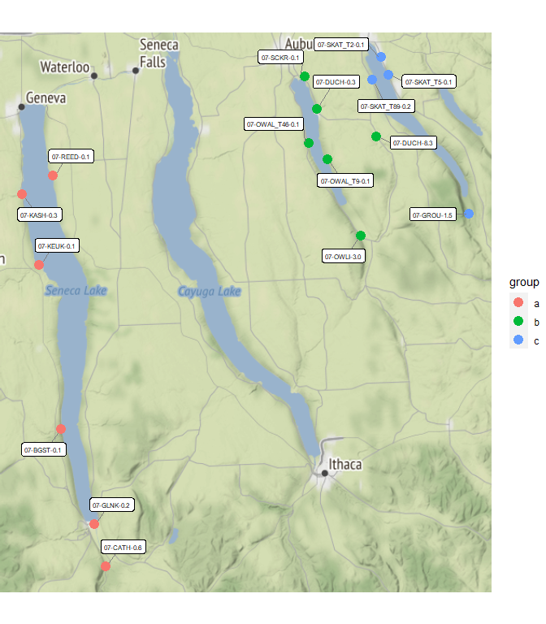

Figure 1: Map of sampling locations. Site names reference the Location ID and River Mile presented in 1

# Section 1A - Water Chemistry and Stream Discharge

## Analyte Table

Table 2: Water chemistry analytes sampled as part of the Stream Assessment Survey. Table lists sampled analytes and analytical specifications. ^ Precision objectives are defined by results of duplicate samples as described in Appendix III

| **Analytes** | **Analytical  Lab** | **Method** | **Precision** | **Accuracy** | **Calibration:   Initial** | **Calibration:   Ongoing** | **Calibration:   Blanks** | **Detection   Limit** | **Reporting   Limit** |
| --- | --- | --- | --- | --- | --- | --- | --- | --- | --- |
| Temperature | in situ | 2550 B | ± 1oC | ± 1.5oC | Factory Set | ~ | ~ | ~ | ~ |
| Dissolved Oxygen | in situ | 4500-O G | ± 1% | ± 2% | Daily | ~ | ~ | ~ | ~ |
| pH | in situ | 4500-H+B | ± .05 SU | ± .2 SU | Weekly | ~ | ~ | ~ | ~ |
| Salinity | in situ | Calculated | 0.001 ppt | ± 1% | N/A | ~ | ~ | ~ | ~ |
| Specific Conductance | in situ | 2510 B | ± 1µs/cm | ± 1% | Weekly | ~ | ~ | ~ | ~ |
| Ammonia | ALS | D6919-09 | ^ | ± 20% | As needed | Every 10 | Every 10 | 0.008 mg/L | 0.01 mg/L |
| Total Kjeldahl Nitrogen | ALS | EPA 351.2 | ^ | ± 20% | Daily | Every 10 | Every 10 | 0.08 mg/L | 0.1 mg/L |
| Nitrogen, Nitrate | ALS | EPA 353.2 | ^ | ± 20% | Daily | Every 10 | Every 10 | 0.02 mg/L | 0.05 mg/L |
| Nitrogen, Total | ALS | Calculated | ^ |  |  |  |  |  |  |
| Total Phosphorus | ALS | EPA 365.1 | ^ | ± 20% | Daily | Every 10 | Every 10 | 0.002 mg/L | 0.003 mg/L |
| Ortho-phosphate | ALS | EPA 365.1 | ^ | ± 20% | Daily | Every 10 | Every 10 | 0.001 mg/L | 0.005 mg/L |
| Total Dissolved Solids | ALS | SM 2540C | ^ | ± 20% | Daily | Every 20 | Every 20 | 4.0 mg/L | 10 mg/L |
| Turbidity | ALS | EPA 180.1 | ^ | ± 10% | Daily | Every 10 | Every 10 | 0.06 NTU | 0.1 NTU |
| Dissolved Organic Carbon | ALS | 5310C | ^ | ± 20% | As needed | Ever 10 | Every 10 | 0.4 mg/L | 10 mg/L |
| Alkalinity | ALS | SM 2320B | ^ | ± 20% | Daily | Every 10 | Every 10 | 1.0 mg/L | 2.0 mg/L |
| Hardness | ALS | SM 2340C | ^ | ± 20% | Daily | Every 10 | Every 10 | 0.3 mg/L | 2.0 mg/L |
| Calcium | ALS | EPA 200.7 | ^ | ± 20% | Daily | Every 10 | Every 10 | 0.1 mg/L | 1.0 mg/L |
| Magnesium | ALS | EPA 200.7 | ^ | ± 20% | Daily | Every 10 | Every 10 | 0.04 mg/L | 1.0 mg/L |
| Potassium | ALS | EPA 200.7 | ^ | ± 20% | Daily | Every 10 | Every 10 | 0.06 mg/L | 2.0 mg/L |
| Sodium | ALS | EPA 200.7 | ^ | ± 20% | Daily | Every 10 | Every 10 | 0.03 mg/L | 1.0 mg/L |
| Chloride | ALS | EPA 300.0 | ^ | ± 20% | As needed | Every 10 | Every 10 | 0.02 mg/L | 0.2 mg/L |
| Fluoride | ALS | EPA 300.0 | ^ | ± 20% | As needed | Every 10 | Every 10 | 0.004 mg/L | 0.1 mg/L |
| Sulfate | ALS | EPA 300.0 | ^ | ± 20% | As needed | Every 10 | Every 10 | 0.02 mg/L | 0.2 mg/L |
| Iron (total) | ALS | EPA 200.7 | ^ | ± 20% | Daily | Every 10 | Every 10 | 6 µ/L | 100 µ/L |
| Manganese (total) | ALS | EPA 200.7 | ^ | ± 20% | Daily | Every 10 | Every 10 | 0.5 µ/L | 10 µ/L |
| Arsenic (total) | ALS | EPA 200.8 | ^ | ± 20% | Daily | Every 10 | Every 10 | 0.3 µ/L | 1 µ/L |
| Silver (total) | ALS | EPA 200.8 | ^ | ± 20% | Daily | Every 10 | Every 10 | 0.07 µ/L | 1 µ/L |
| Aluminum (total) | ALS | EPA 200.8 | ^ | ± 20% | Daily | Every 10 | Every 10 | 4.0 µ/L | 50 µ/L |
| Cadmium (total) | ALS | EPA 200.8 | ^ | ± 20% | Daily | Every 10 | Every 10 | 0.03 µ/L | 1 µ/L |
| Copper (total) | ALS | EPA 200.8 | ^ | ± 20% | Daily | Every 10 | Every 10 | 0.04 µ/L | 1 µ/L |
| Lead (total) | ALS | EPA 200.8 | ^ | ± 20% | Daily | Every 10 | Every 10 | 0.08 µ/L | 1 µ/L |
| Nickel (total) | ALS | EPA 200.8 | ^ | ± 20% | Daily | Every 10 | Every 10 | 0.04 µ/L | 1 µ/L |
| Zinc (total) | ALS | EPA 200.8 | ^ | ± 20% | Daily | Every 10 | Every 10 | 0.7 µ/L | 10 µ/L |
| Aluminum (dissolved) | ALS | EPA 200.8 | ^ | ± 20% | Daily | Every 10 | Every 10 | 0.9 µ/L | 10 µ/L |
| Cadmium (dissolved) | ALS | EPA 200.8 | ^ | ± 20% | Daily | Every 10 | Every 10 | 0.02 µ/L | 1 µ/L |
| Copper (dissolved) | ALS | EPA 200.8 | ^ | ± 20% | Daily | Every 10 | Every 10 | 0.02 µ/L | 1 µ/L |
| Lead (dissolved) | ALS | EPA 200.8 | ^ | ± 20% | Daily | Every 10 | Every 10 | 0.02 µ/L | 1 µ/L |
| Nickel (dissolved) | ALS | EPA 200.8 | ^ | ± 20% | Daily | Every 10 | Every 10 | 0.1 µ/L | 1 µ/L |
| Zinc (dissolved) | ALS | EPA 200.8 | ^ | ± 20% | Daily | Every 10 | Every 10 | 3 µ/L | 5 µ/L |

## Water Chemistry by PWL ID

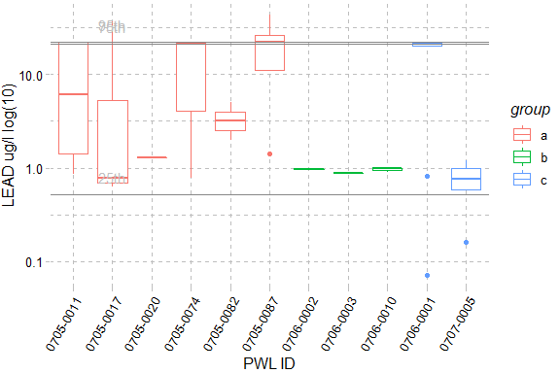

Figure 2: LEAD, The X-axis presents WI/PWL ID of the sampling locations from upstream to downstream and axis labels correspond with Table 1, Figure 1 and Figure 2. Color of the box represents the location of the WI/WPL in the watershed as indicated in the plot legend. Horizontal lines represent the 95th, 75th, and 25th percentiles of statewide data for each endpoint. The total number of reported values illustrated for each sampling location can vary due to non-detection and QA/QC procedures. Descriptions of removed records are presented in Appendix III.

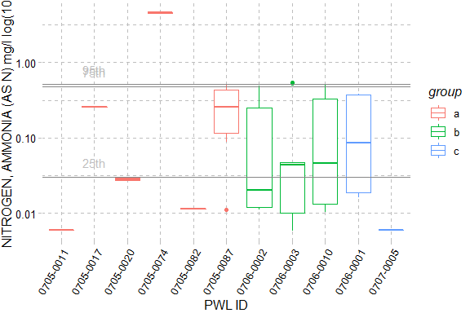

Figure 3: NITROGEN, AMMONIA (AS N), The X-axis presents WI/PWL ID of the sampling locations from upstream to downstream and axis labels correspond with Table 1, Figure 1 and Figure 2. Color of the box represents the location of the WI/WPL in the watershed as indicated in the plot legend. Horizontal lines represent the 95th, 75th, and 25th percentiles of statewide data for each endpoint. The total number of reported values illustrated for each sampling location can vary due to non-detection and QA/QC procedures. Descriptions of removed records are presented in Appendix III.

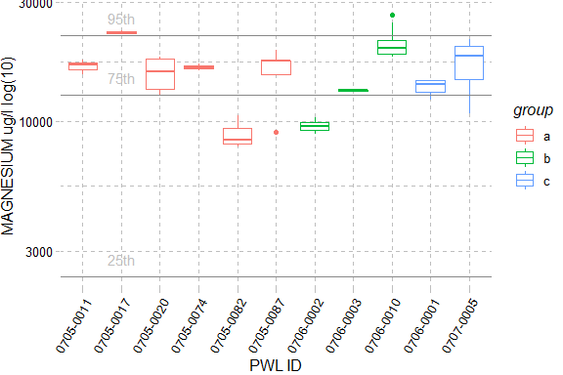

Figure 4: MAGNESIUM, The X-axis presents WI/PWL ID of the sampling locations from upstream to downstream and axis labels correspond with Table 1, Figure 1 and Figure 2. Color of the box represents the location of the WI/WPL in the watershed as indicated in the plot legend. Horizontal lines represent the 95th, 75th, and 25th percentiles of statewide data for each endpoint. The total number of reported values illustrated for each sampling location can vary due to non-detection and QA/QC procedures. Descriptions of removed records are presented in Appendix III.

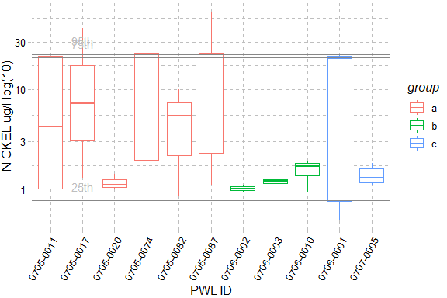

Figure 5: NICKEL, The X-axis presents WI/PWL ID of the sampling locations from upstream to downstream and axis labels correspond with Table 1, Figure 1 and Figure 2. Color of the box represents the location of the WI/WPL in the watershed as indicated in the plot legend. Horizontal lines represent the 95th, 75th, and 25th percentiles of statewide data for each endpoint. The total number of reported values illustrated for each sampling location can vary due to non-detection and QA/QC procedures. Descriptions of removed records are presented in Appendix III.

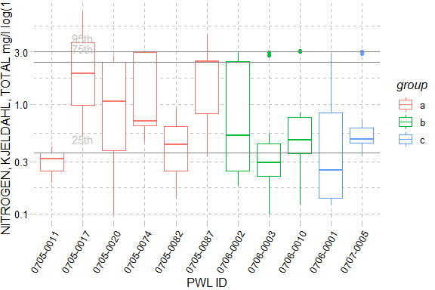

Figure 6: NITROGEN, KJELDAHL, TOTAL, The X-axis presents WI/PWL ID of the sampling locations from upstream to downstream and axis labels correspond with Table 1, Figure 1 and Figure 2. Color of the box represents the location of the WI/WPL in the watershed as indicated in the plot legend. Horizontal lines represent the 95th, 75th, and 25th percentiles of statewide data for each endpoint. The total number of reported values illustrated for each sampling location can vary due to non-detection and QA/QC procedures. Descriptions of removed records are presented in Appendix III.

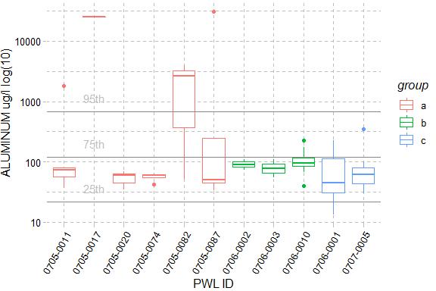

Figure 7: ALUMINUM, The X-axis presents WI/PWL ID of the sampling locations from upstream to downstream and axis labels correspond with Table 1, Figure 1 and Figure 2. Color of the box represents the location of the WI/WPL in the watershed as indicated in the plot legend. Horizontal lines represent the 95th, 75th, and 25th percentiles of statewide data for each endpoint. The total number of reported values illustrated for each sampling location can vary due to non-detection and QA/QC procedures. Descriptions of removed records are presented in Appendix III.

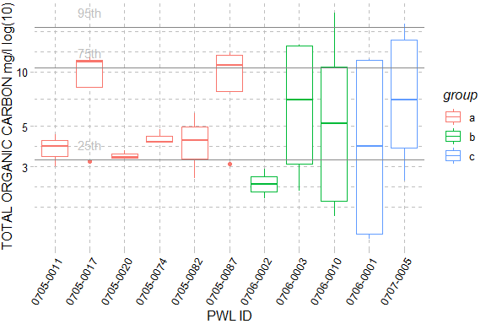

Figure 8: TOTAL ORGANIC CARBON, The X-axis presents WI/PWL ID of the sampling locations from upstream to downstream and axis labels correspond with Table 1, Figure 1 and Figure 2. Color of the box represents the location of the WI/WPL in the watershed as indicated in the plot legend. Horizontal lines represent the 95th, 75th, and 25th percentiles of statewide data for each endpoint. The total number of reported values illustrated for each sampling location can vary due to non-detection and QA/QC procedures. Descriptions of removed records are presented in Appendix III.

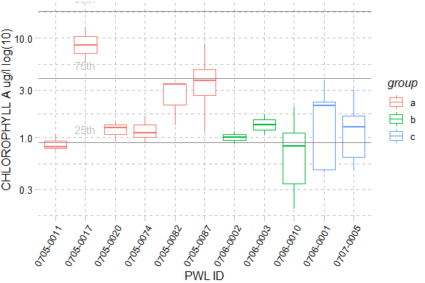

Figure 9: CHLOROPHYLL A, The X-axis presents WI/PWL ID of the sampling locations from upstream to downstream and axis labels correspond with Table 1, Figure 1 and Figure 2. Color of the box represents the location of the WI/WPL in the watershed as indicated in the plot legend. Horizontal lines represent the 95th, 75th, and 25th percentiles of statewide data for each endpoint. The total number of reported values illustrated for each sampling location can vary due to non-detection and QA/QC procedures. Descriptions of removed records are presented in Appendix III.

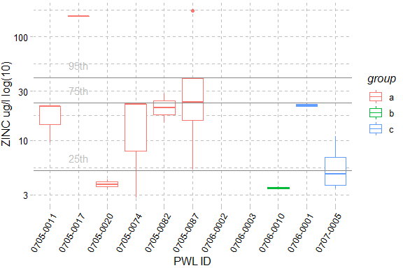

Figure 10: ZINC, The X-axis presents WI/PWL ID of the sampling locations from upstream to downstream and axis labels correspond with Table 1, Figure 1 and Figure 2. Color of the box represents the location of the WI/WPL in the watershed as indicated in the plot legend. Horizontal lines represent the 95th, 75th, and 25th percentiles of statewide data for each endpoint. The total number of reported values illustrated for each sampling location can vary due to non-detection and QA/QC procedures. Descriptions of removed records are presented in Appendix III.

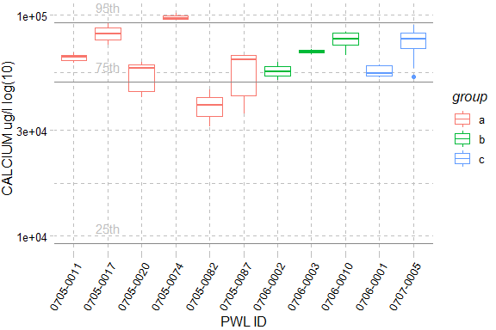

Figure 11: CALCIUM, The X-axis presents WI/PWL ID of the sampling locations from upstream to downstream and axis labels correspond with Table 1, Figure 1 and Figure 2. Color of the box represents the location of the WI/WPL in the watershed as indicated in the plot legend. Horizontal lines represent the 95th, 75th, and 25th percentiles of statewide data for each endpoint. The total number of reported values illustrated for each sampling location can vary due to non-detection and QA/QC procedures. Descriptions of removed records are presented in Appendix III.

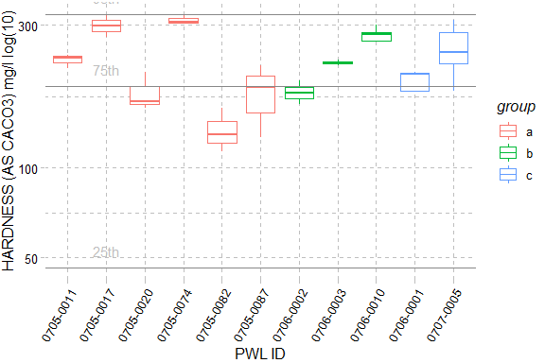

Figure 12: HARDNESS (AS CACO3), The X-axis presents WI/PWL ID of the sampling locations from upstream to downstream and axis labels correspond with Table 1, Figure 1 and Figure 2. Color of the box represents the location of the WI/WPL in the watershed as indicated in the plot legend. Horizontal lines represent the 95th, 75th, and 25th percentiles of statewide data for each endpoint. The total number of reported values illustrated for each sampling location can vary due to non-detection and QA/QC procedures. Descriptions of removed records are presented in Appendix III.

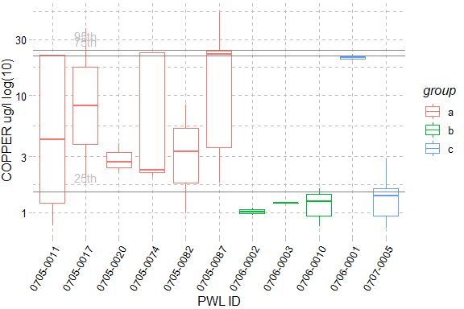

Figure 13: COPPER, The X-axis presents WI/PWL ID of the sampling locations from upstream to downstream and axis labels correspond with Table 1, Figure 1 and Figure 2. Color of the box represents the location of the WI/WPL in the watershed as indicated in the plot legend. Horizontal lines represent the 95th, 75th, and 25th percentiles of statewide data for each endpoint. The total number of reported values illustrated for each sampling location can vary due to non-detection and QA/QC procedures. Descriptions of removed records are presented in Appendix III.

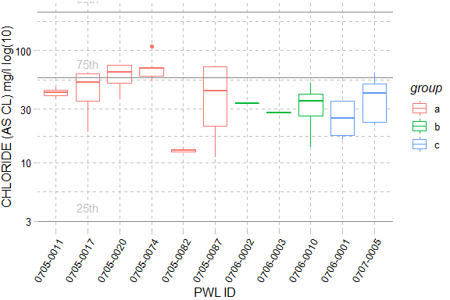

Figure 14: CHLORIDE (AS CL), The X-axis presents WI/PWL ID of the sampling locations from upstream to downstream and axis labels correspond with Table 1, Figure 1 and Figure 2. Color of the box represents the location of the WI/WPL in the watershed as indicated in the plot legend. Horizontal lines represent the 95th, 75th, and 25th percentiles of statewide data for each endpoint. The total number of reported values illustrated for each sampling location can vary due to non-detection and QA/QC procedures. Descriptions of removed records are presented in Appendix III.

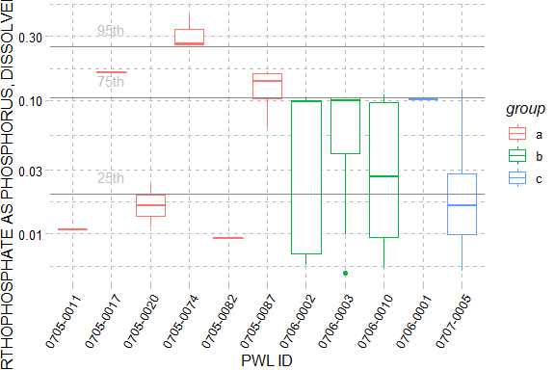

Figure 15: ORTHOPHOSPHATE AS PHOSPHORUS, DISSOLVED, The X-axis presents WI/PWL ID of the sampling locations from upstream to downstream and axis labels correspond with Table 1, Figure 1 and Figure 2. Color of the box represents the location of the WI/WPL in the watershed as indicated in the plot legend. Horizontal lines represent the 95th, 75th, and 25th percentiles of statewide data for each endpoint. The total number of reported values illustrated for each sampling location can vary due to non-detection and QA/QC procedures. Descriptions of removed records are presented in Appendix III.

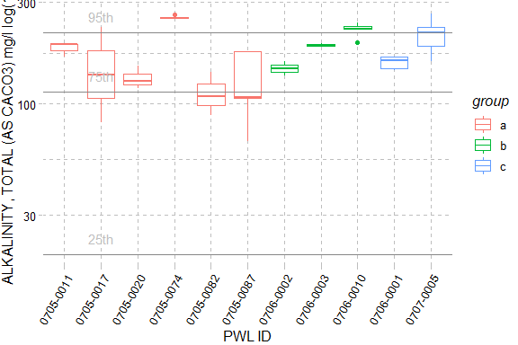

Figure 16: ALKALINITY, TOTAL (AS CACO3), The X-axis presents WI/PWL ID of the sampling locations from upstream to downstream and axis labels correspond with Table 1, Figure 1 and Figure 2. Color of the box represents the location of the WI/WPL in the watershed as indicated in the plot legend. Horizontal lines represent the 95th, 75th, and 25th percentiles of statewide data for each endpoint. The total number of reported values illustrated for each sampling location can vary due to non-detection and QA/QC procedures. Descriptions of removed records are presented in Appendix III.

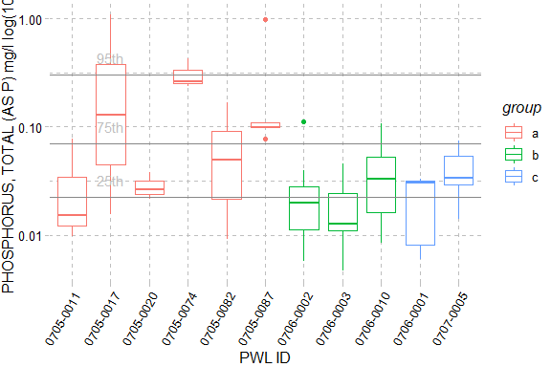

Figure 17: PHOSPHORUS, TOTAL (AS P), The X-axis presents WI/PWL ID of the sampling locations from upstream to downstream and axis labels correspond with Table 1, Figure 1 and Figure 2. Color of the box represents the location of the WI/WPL in the watershed as indicated in the plot legend. Horizontal lines represent the 95th, 75th, and 25th percentiles of statewide data for each endpoint. The total number of reported values illustrated for each sampling location can vary due to non-detection and QA/QC procedures. Descriptions of removed records are presented in Appendix III.

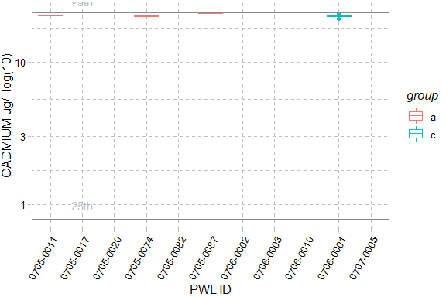

Figure 18: CADMIUM, The X-axis presents WI/PWL ID of the sampling locations from upstream to downstream and axis labels correspond with Table 1, Figure 1 and Figure 2. Color of the box represents the location of the WI/WPL in the watershed as indicated in the plot legend. Horizontal lines represent the 95th, 75th, and 25th percentiles of statewide data for each endpoint. The total number of reported values illustrated for each sampling location can vary due to non-detection and QA/QC procedures. Descriptions of removed records are presented in Appendix III.

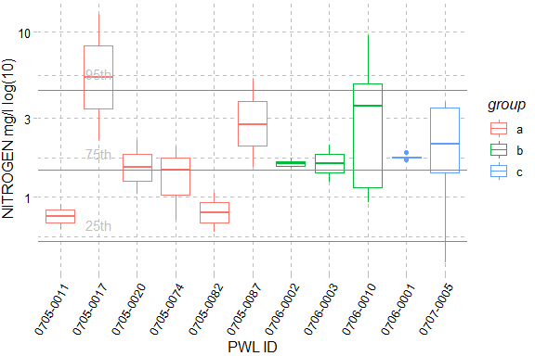

Figure 19: NITROGEN, The X-axis presents WI/PWL ID of the sampling locations from upstream to downstream and axis labels correspond with Table 1, Figure 1 and Figure 2. Color of the box represents the location of the WI/WPL in the watershed as indicated in the plot legend. Horizontal lines represent the 95th, 75th, and 25th percentiles of statewide data for each endpoint. The total number of reported values illustrated for each sampling location can vary due to non-detection and QA/QC procedures. Descriptions of removed records are presented in Appendix III.

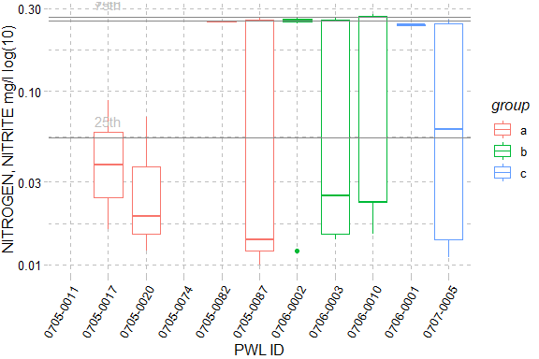

Figure 20: NITROGEN, NITRITE, The X-axis presents WI/PWL ID of the sampling locations from upstream to downstream and axis labels correspond with Table 1, Figure 1 and Figure 2. Color of the box represents the location of the WI/WPL in the watershed as indicated in the plot legend. Horizontal lines represent the 95th, 75th, and 25th percentiles of statewide data for each endpoint. The total number of reported values illustrated for each sampling location can vary due to non-detection and QA/QC procedures. Descriptions of removed records are presented in Appendix III.

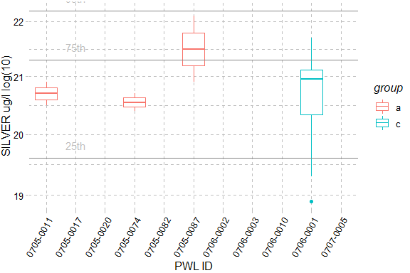

Figure 21: SILVER, The X-axis presents WI/PWL ID of the sampling locations from upstream to downstream and axis labels correspond with Table 1, Figure 1 and Figure 2. Color of the box represents the location of the WI/WPL in the watershed as indicated in the plot legend. Horizontal lines represent the 95th, 75th, and 25th percentiles of statewide data for each endpoint. The total number of reported values illustrated for each sampling location can vary due to non-detection and QA/QC procedures. Descriptions of removed records are presented in Appendix III.

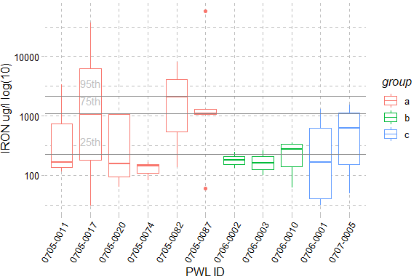

Figure 22: IRON, The X-axis presents WI/PWL ID of the sampling locations from upstream to downstream and axis labels correspond with Table 1, Figure 1 and Figure 2. Color of the box represents the location of the WI/WPL in the watershed as indicated in the plot legend. Horizontal lines represent the 95th, 75th, and 25th percentiles of statewide data for each endpoint. The total number of reported values illustrated for each sampling location can vary due to non-detection and QA/QC procedures. Descriptions of removed records are presented in Appendix III.

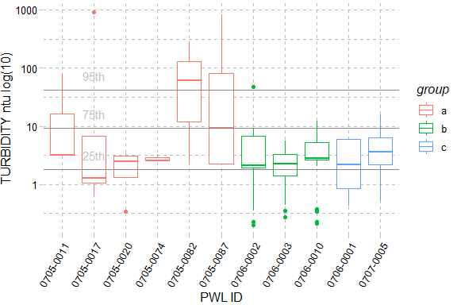

Figure 23: TURBIDITY, The X-axis presents WI/PWL ID of the sampling locations from upstream to downstream and axis labels correspond with Table 1, Figure 1 and Figure 2. Color of the box represents the location of the WI/WPL in the watershed as indicated in the plot legend. Horizontal lines represent the 95th, 75th, and 25th percentiles of statewide data for each endpoint. The total number of reported values illustrated for each sampling location can vary due to non-detection and QA/QC procedures. Descriptions of removed records are presented in Appendix III.

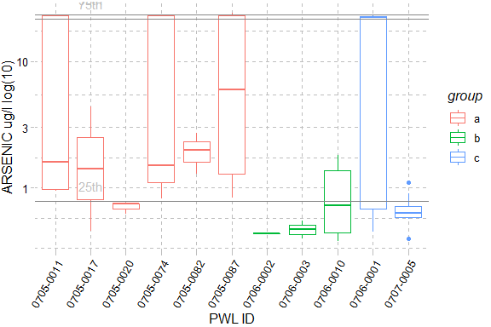

Figure 24: ARSENIC, The X-axis presents WI/PWL ID of the sampling locations from upstream to downstream and axis labels correspond with Table 1, Figure 1 and Figure 2. Color of the box represents the location of the WI/WPL in the watershed as indicated in the plot legend. Horizontal lines represent the 95th, 75th, and 25th percentiles of statewide data for each endpoint. The total number of reported values illustrated for each sampling location can vary due to non-detection and QA/QC procedures. Descriptions of removed records are presented in Appendix III.

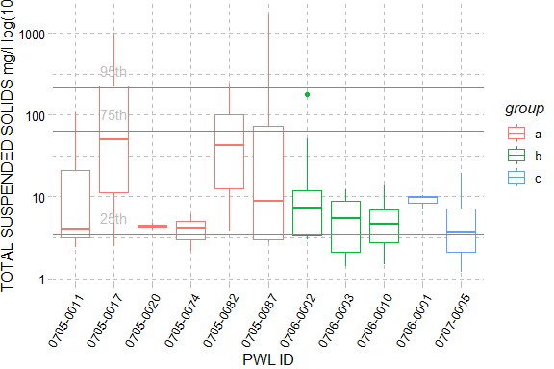

Figure 25: TOTAL SUSPENDED SOLIDS, The X-axis presents WI/PWL ID of the sampling locations from upstream to downstream and axis labels correspond with Table 1, Figure 1 and Figure 2. Color of the box represents the location of the WI/WPL in the watershed as indicated in the plot legend. Horizontal lines represent the 95th, 75th, and 25th percentiles of statewide data for each endpoint. The total number of reported values illustrated for each sampling location can vary due to non-detection and QA/QC procedures. Descriptions of removed records are presented in Appendix III.

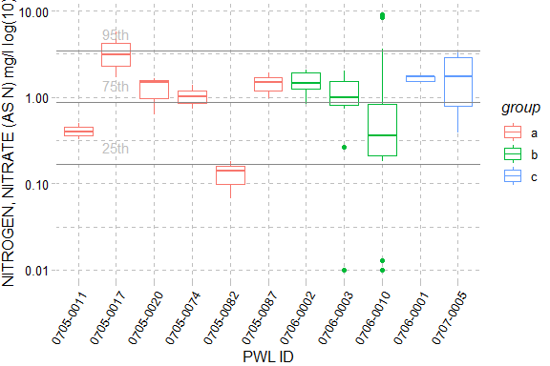

Figure 26: NITROGEN, NITRATE (AS N), The X-axis presents WI/PWL ID of the sampling locations from upstream to downstream and axis labels correspond with Table 1, Figure 1 and Figure 2. Color of the box represents the location of the WI/WPL in the watershed as indicated in the plot legend. Horizontal lines represent the 95th, 75th, and 25th percentiles of statewide data for each endpoint. The total number of reported values illustrated for each sampling location can vary due to non-detection and QA/QC procedures. Descriptions of removed records are presented in Appendix III.

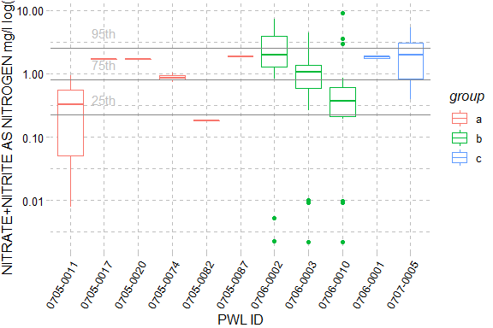

Figure 27: NITRATE+NITRITE AS NITROGEN, The X-axis presents WI/PWL ID of the sampling locations from upstream to downstream and axis labels correspond with Table 1, Figure 1 and Figure 2. Color of the box represents the location of the WI/WPL in the watershed as indicated in the plot legend. Horizontal lines represent the 95th, 75th, and 25th percentiles of statewide data for each endpoint. The total number of reported values illustrated for each sampling location can vary due to non-detection and QA/QC procedures. Descriptions of removed records are presented in Appendix III.

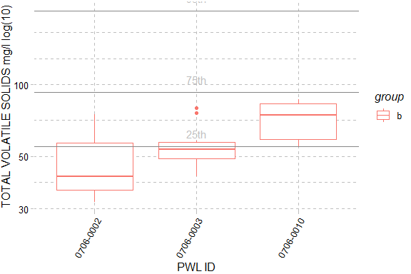

Figure 28: TOTAL VOLATILE SOLIDS, The X-axis presents WI/PWL ID of the sampling locations from upstream to downstream and axis labels correspond with Table 1, Figure 1 and Figure 2. Color of the box represents the location of the WI/WPL in the watershed as indicated in the plot legend. Horizontal lines represent the 95th, 75th, and 25th percentiles of statewide data for each endpoint. The total number of reported values illustrated for each sampling location can vary due to non-detection and QA/QC procedures. Descriptions of removed records are presented in Appendix III.

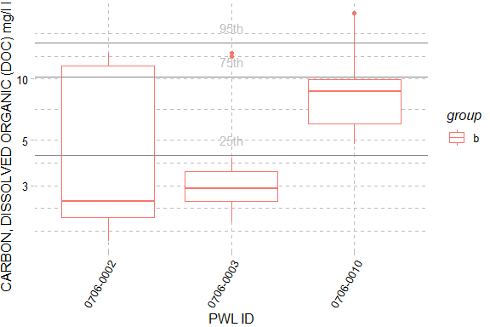

Figure 29: CARBON, DISSOLVED ORGANIC (DOC), The X-axis presents WI/PWL ID of the sampling locations from upstream to downstream and axis labels correspond with Table 1, Figure 1 and Figure 2. Color of the box represents the location of the WI/WPL in the watershed as indicated in the plot legend. Horizontal lines represent the 95th, 75th, and 25th percentiles of statewide data for each endpoint. The total number of reported values illustrated for each sampling location can vary due to non-detection and QA/QC procedures. Descriptions of removed records are presented in Appendix III.

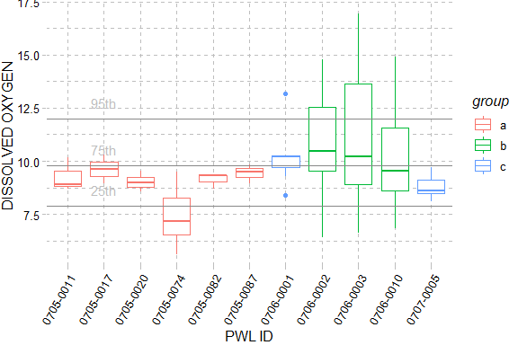

Figure 30: DISSOLVED OXYGEN, The X-axis presents WI/PWL ID of the sampling locations from upstream to downstream and axis labels correspond with Table 1, Figure 1 and Figure 2. Color of the box represents the location of the WI/WPL in the watershed as indicated in the plot legend. Horizontal lines represent the 95th, 75th, and 25th percentiles of statewide data for each endpoint. The total number of reported values illustrated for each sampling location can vary due to non-detection and QA/QC procedures. Descriptions of removed records are presented in Appendix III.

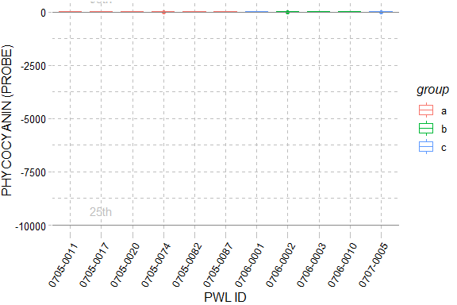

Figure 31: PHYCOCYANIN (PROBE), The X-axis presents WI/PWL ID of the sampling locations from upstream to downstream and axis labels correspond with Table 1, Figure 1 and Figure 2. Color of the box represents the location of the WI/WPL in the watershed as indicated in the plot legend. Horizontal lines represent the 95th, 75th, and 25th percentiles of statewide data for each endpoint. The total number of reported values illustrated for each sampling location can vary due to non-detection and QA/QC procedures. Descriptions of removed records are presented in Appendix III.

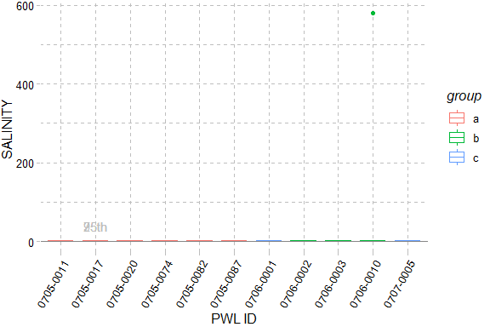

Figure 32: SALINITY, The X-axis presents WI/PWL ID of the sampling locations from upstream to downstream and axis labels correspond with Table 1, Figure 1 and Figure 2. Color of the box represents the location of the WI/WPL in the watershed as indicated in the plot legend. Horizontal lines represent the 95th, 75th, and 25th percentiles of statewide data for each endpoint. The total number of reported values illustrated for each sampling location can vary due to non-detection and QA/QC procedures. Descriptions of removed records are presented in Appendix III.

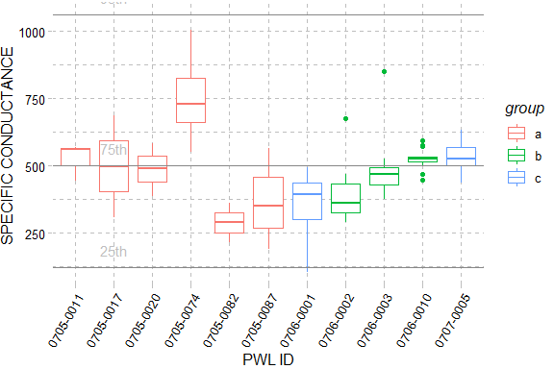

Figure 33: SPECIFIC CONDUCTANCE, The X-axis presents WI/PWL ID of the sampling locations from upstream to downstream and axis labels correspond with Table 1, Figure 1 and Figure 2. Color of the box represents the location of the WI/WPL in the watershed as indicated in the plot legend. Horizontal lines represent the 95th, 75th, and 25th percentiles of statewide data for each endpoint. The total number of reported values illustrated for each sampling location can vary due to non-detection and QA/QC procedures. Descriptions of removed records are presented in Appendix III.

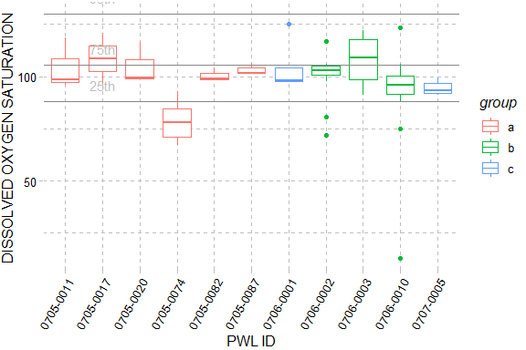

Figure 34: DISSOLVED OXYGEN SATURATION, The X-axis presents WI/PWL ID of the sampling locations from upstream to downstream and axis labels correspond with Table 1, Figure 1 and Figure 2. Color of the box represents the location of the WI/WPL in the watershed as indicated in the plot legend. Horizontal lines represent the 95th, 75th, and 25th percentiles of statewide data for each endpoint. The total number of reported values illustrated for each sampling location can vary due to non-detection and QA/QC procedures. Descriptions of removed records are presented in Appendix III.

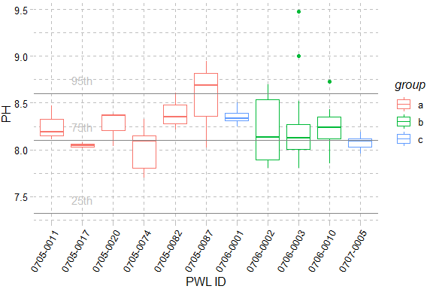

Figure 35: PH, The X-axis presents WI/PWL ID of the sampling locations from upstream to downstream and axis labels correspond with Table 1, Figure 1 and Figure 2. Color of the box represents the location of the WI/WPL in the watershed as indicated in the plot legend. Horizontal lines represent the 95th, 75th, and 25th percentiles of statewide data for each endpoint. The total number of reported values illustrated for each sampling location can vary due to non-detection and QA/QC procedures. Descriptions of removed records are presented in Appendix III.

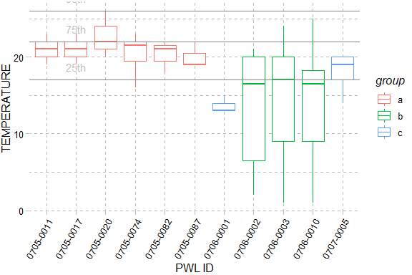

Figure 36: TEMPERATURE, The X-axis presents WI/PWL ID of the sampling locations from upstream to downstream and axis labels correspond with Table 1, Figure 1 and Figure 2. Color of the box represents the location of the WI/WPL in the watershed as indicated in the plot legend. Horizontal lines represent the 95th, 75th, and 25th percentiles of statewide data for each endpoint. The total number of reported values illustrated for each sampling location can vary due to non-detection and QA/QC procedures. Descriptions of removed records are presented in Appendix III.

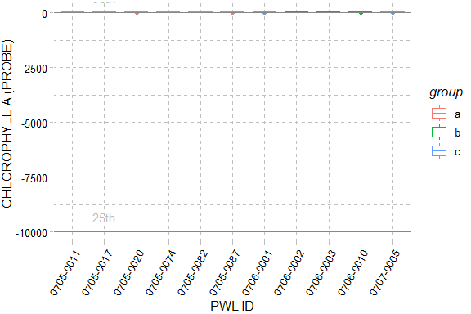

Figure 37: CHLOROPHYLL A (PROBE), The X-axis presents WI/PWL ID of the sampling locations from upstream to downstream and axis labels correspond with Table 1, Figure 1 and Figure 2. Color of the box represents the location of the WI/WPL in the watershed as indicated in the plot legend. Horizontal lines represent the 95th, 75th, and 25th percentiles of statewide data for each endpoint. The total number of reported values illustrated for each sampling location can vary due to non-detection and QA/QC procedures. Descriptions of removed records are presented in Appendix III.

# Section 1B - Benthic Macroinvertebrate Community

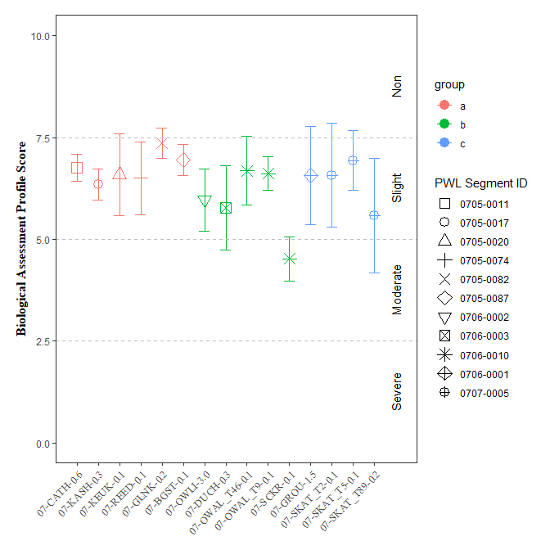

Figure 38: Biological Assessment Profile (BAP) Scores and 95% confidence intervals for benthic macroinvertebrate community assessment data for the Survey, 2019. Symbology corresponds with WI/PWL segmentation as indicated in the plot legend.

`

# Section 1C - Stream Reach Physical Characteristics

Table 3: Ranked habitat characteristics and calculated HMA for the Finger Lakes Survey, 2019. Epifaunal substrate (Epi. Cover); Embeddedness/Pool Substrate Characterization (Embed. Pool.); Velocity Depth Regime/Pool Variability (Vel/Dep Reg.); Sediment Deposition (Sed. Dep.); Channel Flow Status (Flow Status); Channel Alteration (Chan. Alt.); Riffle Frequency/Stream Sinuosity (Rif. Freq.); Left and Right Bank Stability (L.B. and R.B. Stability); Left and Right Bank Vegetation (L.B. and R.B. Veg); Width of Left and Right Bank Vegetative Zone (L.B. and R.B. Veg Zone); Habitat Model Affinity Score (HMA Score); HMA Assessment (HMA Assess.)

| **Site** | **Gradient** | **Epi.  Cover** | **Embed.   Pool.** | **Vel/Dep.   Reg.** | **Sed.   Dep.** | **Flow   Status** | **Chan.   Alt** | **Rif.   Freq** | **L.B.   Stability** | **R.B.   Stability** | **L.B.   Veg** | **R.B.  Veg** | **L.B.   Veg Zone** | **R.B.   Veg Zone** | **HMA   Score** | **HMA   Assess.** |
| --- | --- | --- | --- | --- | --- | --- | --- | --- | --- | --- | --- | --- | --- | --- | --- | --- |
| 07-BGST-0.1 | High | 8 | 17 | 19 | 20 | 18 | 18 | 18 | 9 | 9 | 9 | 4 | 10 | 1 | 87.29282 | Natural |
| 07-CATH-0.6 | High | 14 | 17 | 17 | 18 | 10 | 13 | 10 | 3 | 3 | 7 | 7 | 3 | 3 | 69.06077 | Moderate |
| 07-DUCH-0.3 | High | 17 | 18 | 18 | 18 | 18 | 18 | 19 | 9 | 9 | 9 | 9 | 8 | 9 | 98.34254 | Natural |
| 07-GLNK-0.2 | High | 12 | 18 | 19 | 20 | 13 | 8 | 18 | 8 | 4 | 2 | 2 | 1 | 1 | 67.95580 | Moderate |
| 07-GROU-1.5 | High | 20 | 17 | 19 | 18 | 17 | 19 | 19 | 9 | 9 | 9 | 8 | 9 | 5 | 96.13260 | Natural |
| 07-KASH-0.3 | High | 11 | 16 | 18 | 13 | 7 | 13 | 15 | 8 | 4 | 8 | 1 | 8 | 0 | 67.40331 | Moderate |
| 07-KEUK-0.1 | High | 14 | 15 | 19 | 14 | 16 | 14 | 19 | 9 | 9 | 9 | 9 | 9 | 9 | 91.16022 | Natural |
| 07-OWAL_T46-0.1 | High | 17 | 18 | 13 | 18 | 18 | 19 | 19 | 9 | 8 | 9 | 8 | 3 | 2 | 87.84530 | Natural |
| 07-OWAL_T9-0.1 | High | 14 | 15 | 9 | 10 | 14 | 17 | 16 | 8 | 7 | 7 | 8 | 4 | 4 | 73.48066 | Altered |
| 07-OWLI-3.0 | High | 14 | 17 | 15 | 13 | 19 | 17 | 18 | 6 | 6 | 8 | 9 | 5 | 4 | 83.42541 | Natural |
| 07-REED-0.1 | High | 16 | 17 | 12 | 7 | 10 | 20 | 16 | 10 | 6 | 9 | 9 | 5 | 5 | 77.34807 | Altered |
| 07-SCKR-0.1 | High | 15 | 16 | 6 | 16 | 7 | NA | 13 | 9 | 10 | 7 | 7 | 7 | 8 | 76.24309 | Altered |
| 07-SKAT_T2-0.1 | High | 18 | 11 | 18 | 17 | 16 | 14 | 17 | NA | 7 | 10 | NA | 9 | 9 | 90.60773 | Natural |
| 07-SKAT_T5-0.1 | High | 19 | NA | 18 | 17 | 10 | 16 | 18 | 8 | 6 | 9 | 9 | 9 | 9 | 90.05525 | Natural |
| 07-SKAT_T89-0.2 | High | 16 | 16 | 16 | 18 | 17 | 14 | 18 | 7 | 6 | 9 | 9 | 9 | 9 | 90.60773 | Natural |

# Section 1D - User Perception

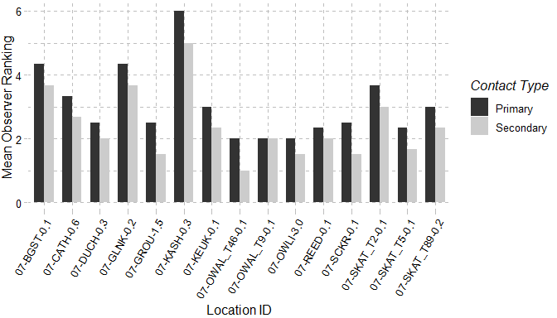

Figure 39: Mean observer ranking of recreational ability for Wallkill River sampling locations. Columns represent observer rankings for the desire to participate in 1° and 2° contact recreation. Ranking of recreation ability was performed for all locations during each site visit.

Table 4: Mean observer ranked value for factors influencing desire to participate in 1° and 2° contact recreation in the Wallkill River. Factors were ranked on a 10 scale (0 – Best/Natural; 10 Worst/Severe) according to perceived impact on a location. Ranking of recreation ability was performed for all locations during each site visit

| **Site   ID** | **Water   Clarity** | **Suspended  Phytoplankton** | **Periphyton** | **Macrophyte** | **Odor** | **Trash** | **Dishcarge   Pipes** |
| --- | --- | --- | --- | --- | --- | --- | --- |
| 07-BGST-0.1 | 6 | 0 | 1 | 1 | 2 | 0 | 0 |
| 07-CATH-0.6 | 3 | 0 | NA | NA | 0 | 0 | 0 |
| 07-DUCH-0.3 | 4 | 0 | 2 | 0 | 0 | 0 | 0 |
| 07-GLNK-0.2 | 6 | 0 | 2 | 0 | 0 | 2 | 0 |
| 07-GROU-1.5 | 2 | 0 | 3 | 0 | 0 | 0 | 0 |
| 07-KASH-0.3 | NA | NA | NA | NA | NA | NA | NA |
| 07-KEUK-0.1 | 1 | 0 | 3 | 0 | 3 | 0 | 0 |
| 07-OWAL_T46-0.1 | 0 | 0 | 2 | 0 | 2 | 0 | 0 |
| 07-OWAL_T9-0.1 | 3 | 0 | 2 | 0 | 0 | 1 | 0 |
| 07-OWLI-3.0 | 4 | 1 | 2 | 1 | 0 | 0 | 0 |
| 07-REED-0.1 | 0 | 0 | 2 | 0 | 1 | 0 | 0 |
| 07-SCKR-0.1 | 2 | 0 | 2 | 0 | 0 | 0 | 0 |
| 07-SKAT_T2-0.1 | 4 | 2 | NA | 2 | 1 | 0 | 0 |
| 07-SKAT_T5-0.1 | 0 | 0 | 2 | 0 | 0 | NA | 0 |
| 07-SKAT_T89-0.2 | 2 | 1 | 4 | 0 | 0 | 0 | 0 |

Table 5: Most frequently ranked factor influencing observer desire to participate in 1° and 2° contact recreation. Factors influencing desire to recreate were ranked and a primary factor influencing the desire to participate in 1° and 2° contact recreation was chosen during each site visit. Column values represent the factor selected most frequently at each site.

| **Sites** | **Primary** | **Secondary** |
| --- | --- | --- |
| 07-BGST-0.1 | Odor | Other, Periphyton, Water Clarity |
| 07-BGST-0.1 | Water Clarity | Other, Periphyton, Water Clarity |
| 07-CATH-0.6 | Periphyton | Periphyton, Water Clarity |
| 07-CATH-0.6 | Water Clarity | Periphyton, Water Clarity |
| 07-DUCH-0.3 | Water Clarity | Periphyton, Water Clarity |
| 07-GLNK-0.2 | Periphyton | Trash |
| 07-GLNK-0.2 | Water Clarity | Trash |
| 07-GROU-1.5 | Periphyton | Periphyton |
| 07-GROU-1.5 | Water Clarity | Periphyton |
| 07-KASH-0.3 | Periphyton | Other |
| 07-KASH-0.3 | Water Clarity | Other |
| 07-KEUK-0.1 | Odor | None, Odor, Periphyton |
| 07-KEUK-0.1 | Periphyton | None, Odor, Periphyton |
| 07-KEUK-0.1 | Water Clarity | None, Odor, Periphyton |
| 07-OWAL_T46-0.1 | None | None, Odor |
| 07-OWAL_T46-0.1 | Odor | None, Odor |
| 07-OWAL_T9-0.1 | Other | Trash, Water Clarity |
| 07-OWAL_T9-0.1 | Water Clarity | Trash, Water Clarity |
| 07-OWLI-3.0 | Water Clarity | Water Clarity |
| 07-REED-0.1 | Periphyton | Periphyton |
| 07-REED-0.1 | Water Clarity | Periphyton |
| 07-SCKR-0.1 | Other | None, Water Clarity |
| 07-SCKR-0.1 | Water Clarity | None, Water Clarity |
| 07-SKAT_T2-0.1 | Odor | Water Clarity |
| 07-SKAT_T2-0.1 | Water Clarity | Water Clarity |
| 07-SKAT_T5-0.1 | Periphyton | Periphyton |
| 07-SKAT_T5-0.1 | Proximity_to_Development_Roads | Periphyton |
| 07-SKAT_T5-0.1 | Water Clarity | Periphyton |
| 07-SKAT_T89-0.2 | Periphyton | Periphyton |
| 07-SKAT_T89-0.2 | Water Clarity | Periphyton |

# Section 1E - Sediment and Porewater Microtox® Analysis

Toxicity testing of surface waters, sediments, porewaters, and effluents are routinely performed as part of the RIBS program (<https://www.dec.ny.gov/chemical/29854.html>). Sediment toxicity was evaluated according to SOP #403-16 Microtox® Acute Toxicity Test for Sediments, Porewaters and Effluents. Testing procedures use a bioassay to assess potential acute toxicity in sediments and surface waters to aquatic life (SOP #403-16). Sediment and extracted sediment porewater samples are tested using a bioluminescent bacterium Vibrio fischeri (V. fischeri). Tests are a measure of light reduction between collected samples and a control following a 15-minute exposure period and expressed as the median effect concentration (EC50) of a sample that causes a 50% reduction in light emission from the V. fischeri. Appendix X (Fact Sheet: Acute & Chronic Toxicity Assessments of NY Streams & Rivers) describes toxicity testing procedures, Assessment criteria and results classifications.

Table 6: Wallkill River Microtox® sediment and porewater toxicity results for select locations in the Wallkill River Survey. Sediment samples were collected for toxicity testing in baseflow conditions during macroinvertebrate community collection at sampling locations.

| **Station ID** | **Sample Date** | **Sediment   Assessment** | **Porewater   Assessment** | **Porewater   EC50** | **Sediment   EC50** | **year** |
| --- | --- | --- | --- | --- | --- | --- |