Stream Survey Data Report

NYSDEC SMAS

Report Date: 2021-12-21

# General

The Fort Ann sewage treatment facility is in need of infrastructure upgrades. Data documenting concentrations of nutrients with focus on ammonia is needed to help determine what permit limits will be required when it is updated.

The Steam Monitoring and Assessment Section (SMAS) conducted targeted stream monitoring that included:

* Water Quality Measurements
* Observer Ranking of Recreational Ability

This data report includes two sections: I) an overview of the sampling events described above, and II) a site-specific data summary to present all major findings for each site. Additional sections (III, IV) include literature cited and appendices covering all references and additional source material.

The Halfway Creek site descriptions (Table ) and locations (Figure ), and sampling dates (Table ) are included below.

Table . Sampling locations.

| **Location ID** | **Group** | **Stream** | **WI/PWL ID** | **Waterbody   Classification** | **Description** | **Latitude** | **Longitude** |
| --- | --- | --- | --- | --- | --- | --- | --- |
| 10-HALF-1.4 | upstream | Halfway Creek | 1005-0013 | A(T) | 50 m below co. Rt. 16 bridge. | 43.42667 | -73.49722 |
| 10-HALF-0.3 | upstream | Halfway Creek | 1005-0013 | A(T) | 15 m off cr 16. | 43.41788 | -73.4892 |
| 10-HALF_T1-0.1 | upstream | Unnamed Tributary To Halfway Creek | 1005-0013 | A(T) | 25 m above cr 16. | 43.41706 | -73.489 |
| 10-HALF-0.2 | downstream | Halfway Creek | 1005-0013 | A(T) | 20 m above sr 4. Above fort ann discharge. | 43.41734 | -73.4872 |
| 10-HALF-0.1 | downstream | Halfway Creek | 1005-0013 | A(T) | 50 m above champlain canal (mouth. Below discharge). | 43.41663 | -73.4851 |

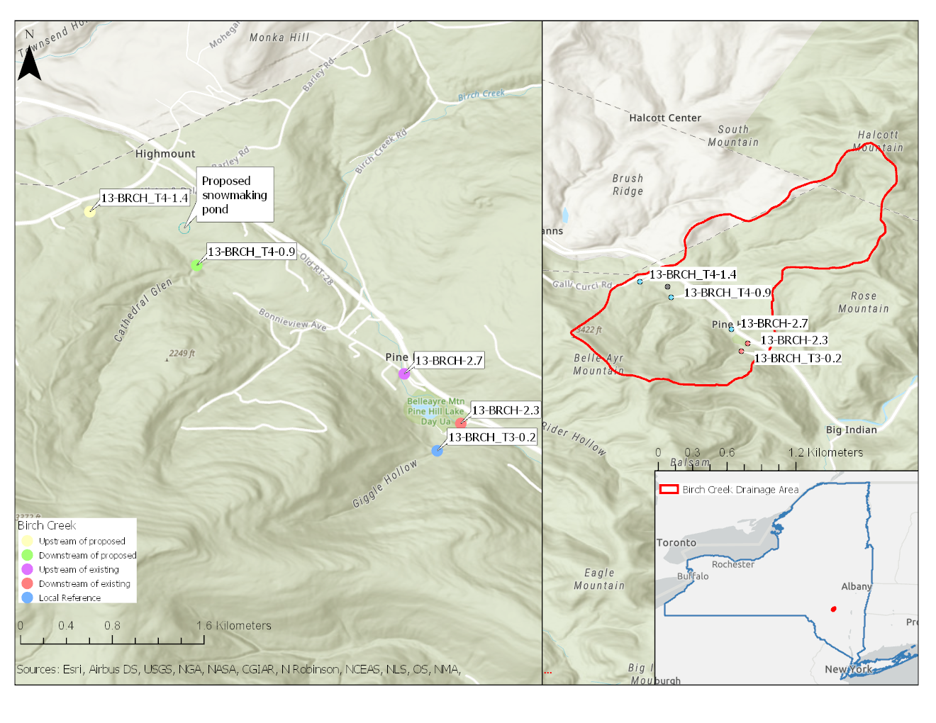

Figure . Map of sampling locations. Site names reference the Location ID and River Mile.

Table . Sampling dates and overall parameters for the study period included in this report.

| **Site** | **Year** | **Events** |
| --- | --- | --- |
| 10-HALF-0.1 | 2019 | 4 |
| 10-HALF-0.2 | 2019 | 4 |
| 10-HALF-0.3 | 2019 | 4 |
| 10-HALF-1.4 | 2019 | 4 |
| 10-HALF_T1-0.1 | 2019 | 4 |

# Section I: Overview

## Water Quality

### Water Chemistry Collection

DEC establishes water quality standards (WQS) and guidance values for many specific substances. Waters are classified for their best uses and WQS are set to protect those uses (6 NYCRR Part 703). The data presented below does not meet the minimum data requirements for a confirmed best use assessment[1] (CALM, 2021). For the best use assessment, please see [DEC Info Locator](https://gisservices.dec.ny.gov/gis/dil/) and factsheets[2] for individual WI/PWL ID segments (WI/PWL ID 1005-0013).

Ambient water chemistry sampling included in-situ and lab measured water quality analytes (Table ). A total of 23 lab-measured and 8 in-situ water quality parameters were collected. Samples were collected by SMAS using the direct grab method (SOP #210-21, section 11.6). Water samples were sent for processing using a contract lab with NYS Environmental Laboratory Approval Program (ELAP) certification.

Following sample collection, all data processing followed quality assurance/quality control (QA/QC) protocols (SOP #102-20, and #110-21). Only data meeting the highest data quality standard were reported and used in this report. For water chemistry, an evaluation of the precision, accuracy, and completeness of processed water chemistry samples after lab analyses was performed following the methods detailed in SOP #102. Appendix I includes a compilation of all rejected data flagged by the process. Analytes that fell below the minimum detection limit (MDL) were replaced with 1/2 the MDL (Helsel, 1990). Where applicable, raw chemistry results were analyzed for excursions from state WQS and summarized using R programing software (R Core Team, 2017). All accepted raw chemistry results (in-situ and lab reported) with all applicable standards and excursion determinations accompany this report as Attachment I (excel file).

A total of 23 lab-measured, and 4 in-situ water quality analytes were analyzed in this study. Out of the 448 lab-measured records and 120 in-situ water quality records, there were 0 excursions from established water quality standards (6 NYCRR Part 703).

Plots illustrating the range of analyte concentration values for each site are included below. Analytes selected for presentation were subset to those of specific interest to the study and include nitrate, nitrate + nitrite (as N), nitrite (as N), total nitrogen, ammonia, total kjeldahl nitrogen (TKN), total phosphorus, and turbidity, and in-situ parameters: dissolved oxygen, temperature, pH, and specific conductance.

**Table** . Water chemistry analytes sampled as part of the Stream Assessment Survey. Table lists sampled analytes and analytical specifications.

| **Analytes** | **Analytical  Lab** | **Method** | **Precision** | **Accuracy** | **Calibration:   Initial** | **Calibration:   Ongoing** | **Calibration:   Blanks** | **Detection   Limit** | **Reporting   Limit** |
| --- | --- | --- | --- | --- | --- | --- | --- | --- | --- |
| Alkalinity | ALS | SM 2320B | ^ | ± 20% | Daily | Every 10 | Every 10 | 1.0 mg/L | 2.0 mg/L |
| Aluminum (total) | ALS | EPA 200.8 | ^ | ± 20% | Daily | Every 10 | Every 10 | 4.0 µ/L | 50 µ/L |
| Arsenic (total) | ALS | EPA 200.8 | ^ | ± 20% | Daily | Every 10 | Every 10 | 0.3 µ/L | 1 µ/L |
| Cadmium (total) | ALS | EPA 200.8 | ^ | ± 20% | Daily | Every 10 | Every 10 | 0.03 µ/L | 1 µ/L |
| Calcium | ALS | EPA 200.7 | ^ | ± 20% | Daily | Every 10 | Every 10 | 0.1 mg/L | 1.0 mg/L |
| Chloride | ALS | EPA 300.0 | ^ | ± 20% | As needed | Every 10 | Every 10 | 0.02 mg/L | 0.2 mg/L |
| Chlorophyll A | ALS | SM 10200 H | ^ | N/A | Daily | Every 20 | Every 10 |  | 0.4 µ/L |
| Copper (total) | ALS | EPA 200.8 | ^ | ± 20% | Daily | Every 10 | Every 10 | 0.04 µ/L | 1 µ/L |
| Hardness | ALS | SM 2340C | ^ | ± 20% | Daily | Every 10 | Every 10 | 0.3 mg/L | 2.0 mg/L |
| Iron (total) | ALS | EPA 200.7 | ^ | ± 20% | Daily | Every 10 | Every 10 | 6 µ/L | 100 µ/L |
| Lead (total) | ALS | EPA 200.8 | ^ | ± 20% | Daily | Every 10 | Every 10 | 0.08 µ/L | 1 µ/L |
| Magnesium | ALS | EPA 200.7 | ^ | ± 20% | Daily | Every 10 | Every 10 | 0.04 mg/L | 1.0 mg/L |
| Nickel (total) | ALS | EPA 200.8 | ^ | ± 20% | Daily | Every 10 | Every 10 | 0.04 µ/L | 1 µ/L |
| Ammonia | ALS | D6919-09 | ^ | ± 20% | As needed | Every 10 | Every 10 | 0.008 mg/L | 0.01 mg/L |
| Total Kjeldahl Nitrogen | ALS | EPA 351.2 | ^ | ± 20% | Daily | Every 10 | Every 10 | 0.08 mg/L | 0.1 mg/L |
| Nitrate-nitrite | ALS | EPA 351.2 | ^ | ± 20% | Daily | Every 10 | Every 10 | 0.0015 mg/L | 0.002 mg/L |
| Nitrogen, Nitrate | ALS | EPA 353.2 | ^ | ± 20% | Daily | Every 10 | Every 10 | 0.02 mg/L | 0.05 mg/L |
| Nitrogen, Nitrite | ALS | EPA 351.2 | ^ | ± 20% | Daily | Every 10 | Every 10 | 0.08 mg/L | 0.1 mg/L |
| Nitrogen, Total | ALS | Calculated | ^ |  |  |  |  |  |  |
| Total Phosphorus | ALS | EPA 365.1 | ^ | ± 20% | Daily | Every 10 | Every 10 | 0.002 mg/L | 0.003 mg/L |
| Silver (total) | ALS | EPA 200.8 | ^ | ± 20% | Daily | Every 10 | Every 10 | 0.07 µ/L | 1 µ/L |
| Turbidity | ALS | EPA 180.1 | ^ | ± 10% | Daily | Every 10 | Every 10 | 0.06 NTU | 0.1 NTU |
| Zinc (total) | ALS | EPA 200.8 | ^ | ± 20% | Daily | Every 10 | Every 10 | 0.7 µ/L | 10 µ/L |
| Dissolved Oxygen | in-situ | 4500-O G | ± 1% | ± 2% | Daily | ~ | ~ | 0% | ~ |
| pH | in-situ | 4500-H+B | ± .05 SU | ± .2 SU | Weekly | ~ | ~ | 0 SU | ~ |
| Salinity | in-situ | Calculated | 0.001 ppt | ± 1% | N/A | ~ | ~ | 0% | ~ |
| Specific Conductance | in-situ | 2510 B | ± 1µs/cm | ± 1% | Weekly | ~ | ~ | 0% | ~ |
| Temperature | in-situ | 2550 B | ± 1oC | ± 1.5oC | Factory Set | ~ | ~ | 0oC | ~ |
| ^ Precision objectives are defined by results of duplicate samples as described in SOP #102-20, and #110-21. | | | | | | | | | |
| ~ Not Applicable | | | | | | | | | |

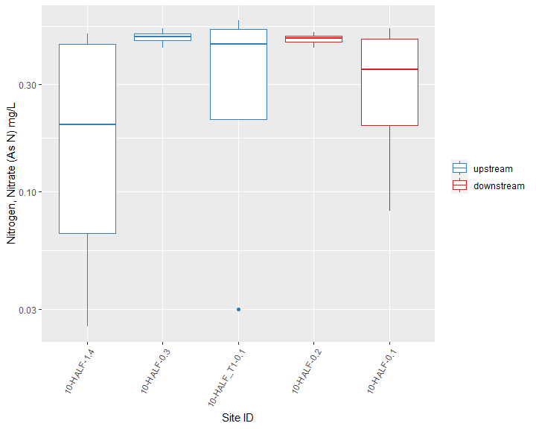

Figure . Nitrogen, Nitrate (As N), Stars at the bottom of the graph indicate an excursion of a WQS (if applicable). Axis are presented in log scale for comparison by site.

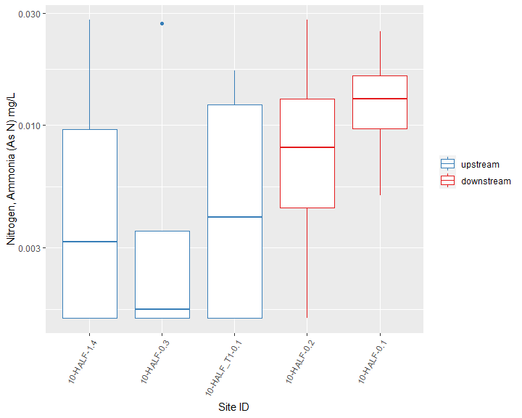

Figure . Nitrogen, Ammonia (As N), Stars at the bottom of the graph indicate an excursion of a WQS (if applicable). Axis are presented in log scale for comparison by site.

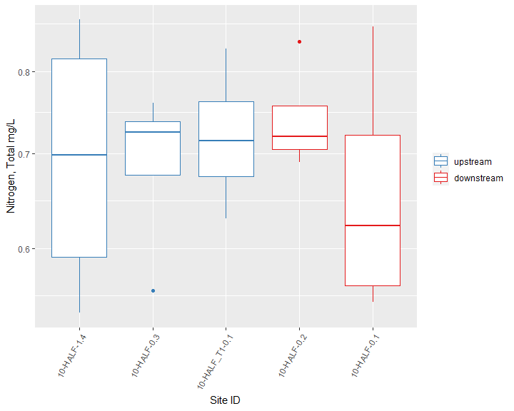

Figure . Nitrogen, Total, Stars at the bottom of the graph indicate an excursion of a WQS (if applicable). Axis are presented in log scale for comparison by site.

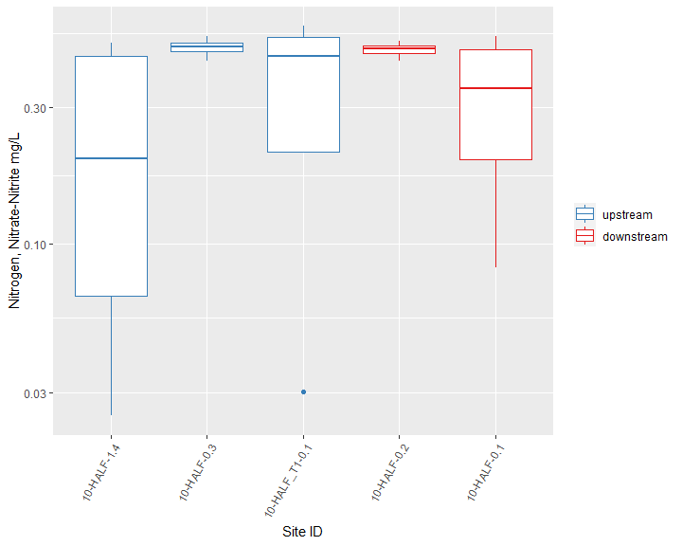

Figure . Nitrogen, Nitrate-Nitrite, Stars at the bottom of the graph indicate an excursion of a WQS (if applicable). Axis are presented in log scale for comparison by site.

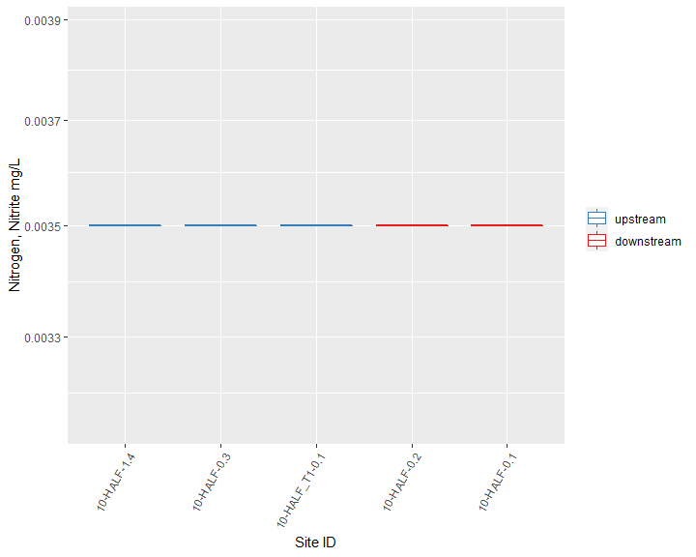

Figure . Nitrogen, Nitrite, Stars at the bottom of the graph indicate an excursion of a WQS (if applicable). Axis are presented in log scale for comparison by site.

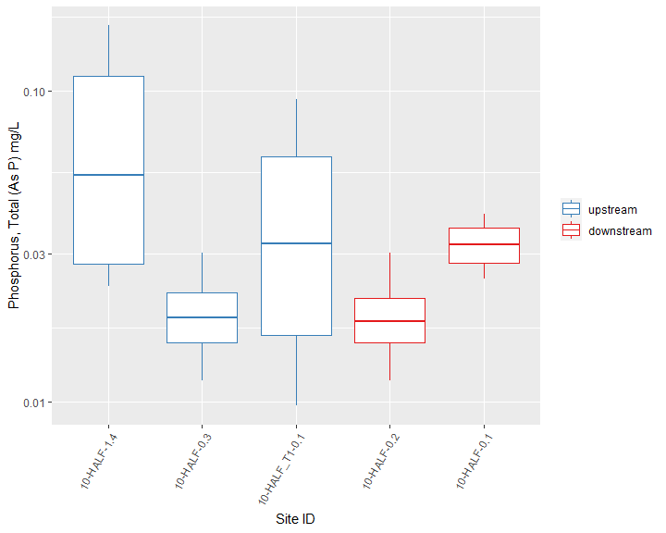

Figure . Phosphorus, Total (As P), Stars at the bottom of the graph indicate an excursion of a WQS (if applicable). Axis are presented in log scale for comparison by site.

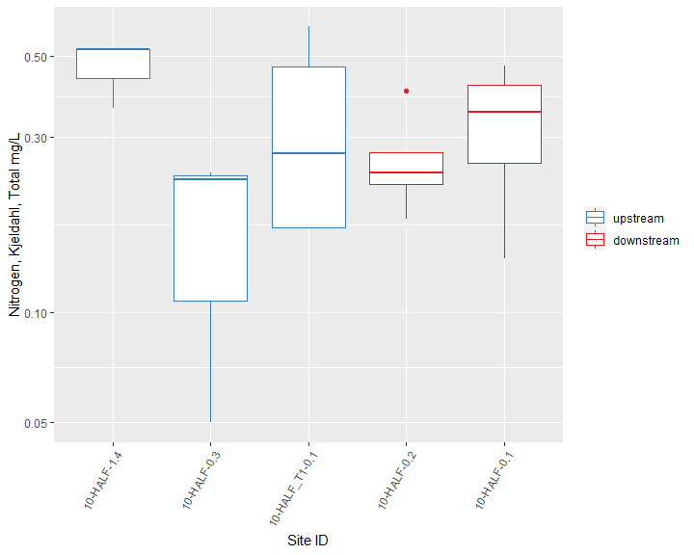

Figure . Nitrogen, Kjeldahl, Total, Stars at the bottom of the graph indicate an excursion of a WQS (if applicable). Axis are presented in log scale for comparison by site.

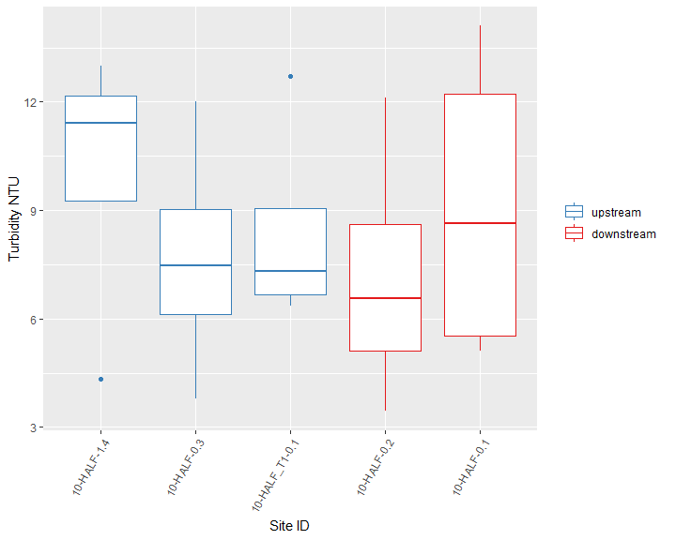

Figure . Turbidity, Stars at the bottom of the graph indicate an excursion of a WQS (if applicable). Axis are presented in log scale for comparison by site.

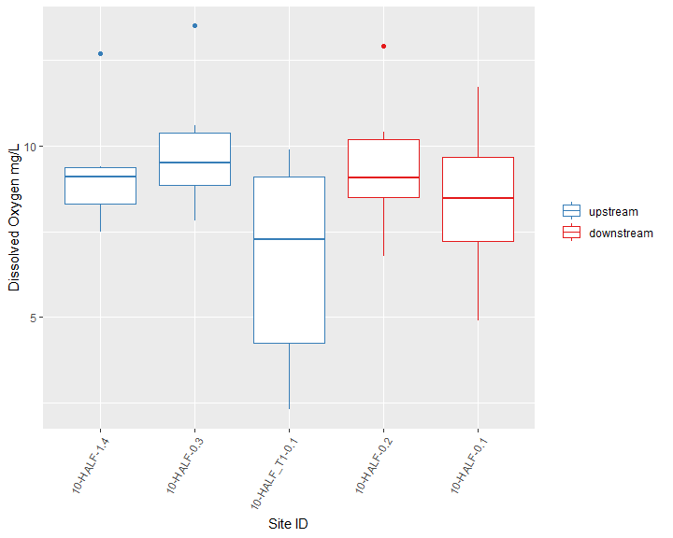

Figure . Dissolved Oxygen, Stars at the bottom of the graph indicate an excursion of a WQS (if applicable). Axis are presented in log scale for comparison by site.

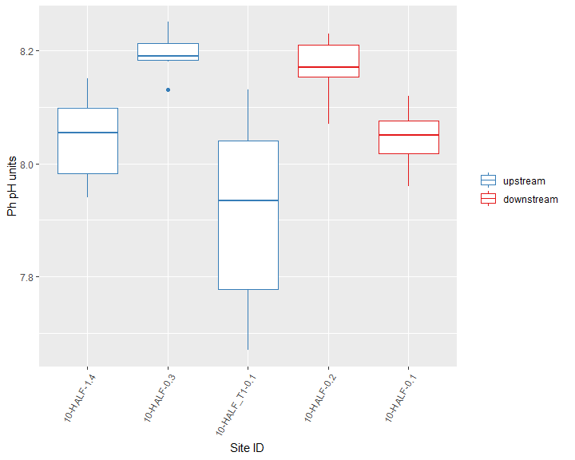

Figure . Ph, Stars at the bottom of the graph indicate an excursion of a WQS (if applicable). Axis are presented in log scale for comparison by site.

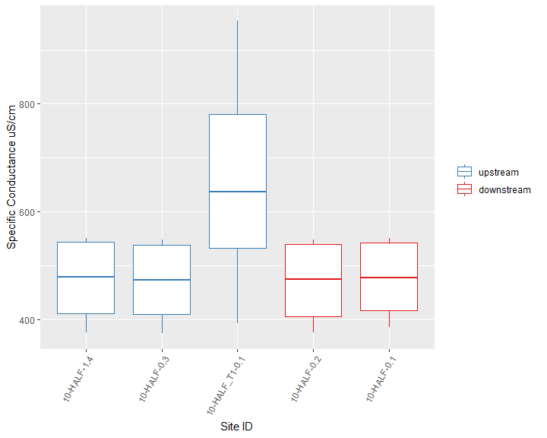

Figure . Specific Conductance, Stars at the bottom of the graph indicate an excursion of a WQS (if applicable). Axis are presented in log scale for comparison by site.

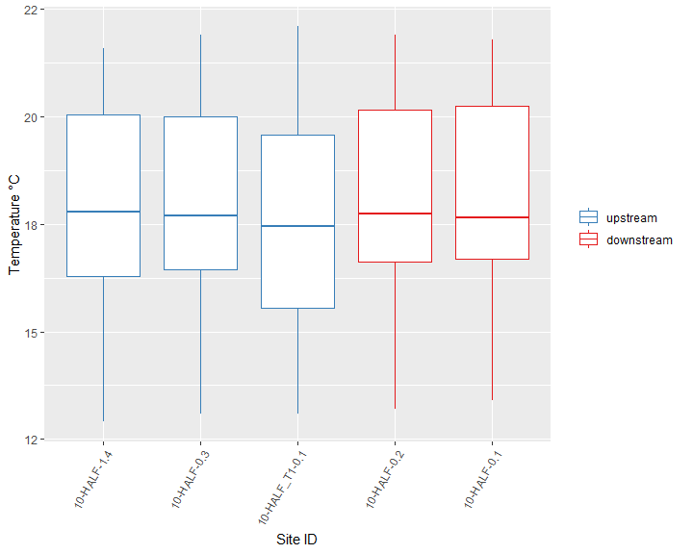

Figure . Temperature, Stars at the bottom of the graph indicate an excursion of a WQS (if applicable). Axis are presented in log scale for comparison by site.

## User Perception

Perceptions of recreational ability were ranked at all sampling locations as per standard site visit protocols (SOP #208-19). The observer (NYSDEC field staff) ranking of recreational ability is a method of evaluating impacts to recreational use of a stream segment. Impacts to recreational use have been correlated with biological impairment from nutrient enrichment and rankings above slightly impacted (rank of 3) are indicative of significant impacts to recreational ability (Smith et al., 2014). The ranking assesses primary and secondary contact recreation, as well as a user’s desire to fish.

The first two questions of the recreational use evaluation describe the observers perceived ability to participate in primary and secondary contact recreation. Results of this ranking are the primary gauge of whether the Halfway Creek sites are achieving the designated recreational uses. Figure illustrates the average observer ranking for desire to participate in primary and secondary contact recreation at each sampling location. User rankings of recreational desirability ranged from 0 (best) to 5 (worst) where,as described above, a measurable impact was related to a ranking of 3 and above (Smith et al., 2014). Results of this survey suggest observers considered the desire to participate in primary and secondary contact recreation to be slightly impacted (ranked > 3) at 0 WI/PWL segments (Figure ).

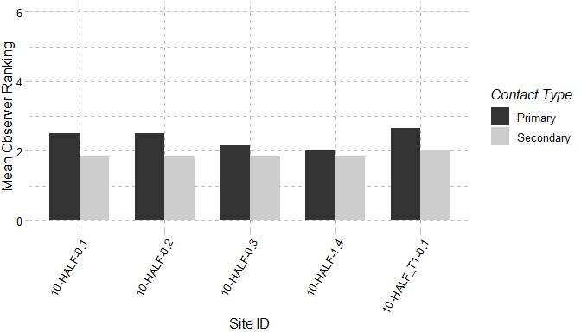

Figure . Mean observer ranking of recreational ability for each sampling location. Columns represent observer rankings for the desire to participate in primary and secondary contact recreation. Ranking of recreation ability was performed for all locations during each site visit.

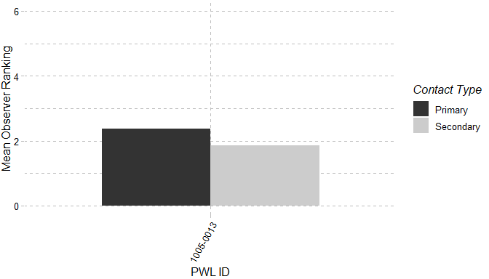

Figure . Mean observer ranking of recreational ability for sampling locations, grouped by WI/PWL. Columns represent observer rankings for the desire to participate in primary and secondary contact recreation. Ranking of recreational ability was performed for all locations during each site visit.

Additional recreational usability questions rank in-stream and stream-side factors on a scale of 0-10 (0 – Best/Natural; 10 Worst/Severe). Those factors are: 1) Water Clarity, 2) Trash, 3) Periphyton, 4) Odor, and 5) Discharge Pipes. These visual and olfactory observations help isolate negative factors influencing the user’s perception of recreational use. Table shows the mean recorded value for these factors at each sampling location and Table lists the users selection of the most dominant impediment that reduces the observer’s desire to participate in recreational activities, which can include the factors above, as well as ease of access and proximity to development.

Table . Mean observer ranked value for factors influencing desire to participate in primary and secondary contact recreation. Factors were ranked on a 10 scale (0 – Best/Natural; 10 Worst/Severe) according to perceived impact on a location. Ranking of recreational ability was performed for all locations during each site visit

| **PWL** | **Site** | **Water Clarity** | **Susp. Phyto.** | **Periphyton** | **Macro.** | **Odor** | **Trash** | **Discharge Pipes** |
| --- | --- | --- | --- | --- | --- | --- | --- | --- |
| 1005-0013 | 10-HALF-0.1 |  | 6 | 3 | 0 | 2 | 4 | 5 |
| 1005-0013 | 10-HALF-0.2 | 7 | 2 |  | 1 | 0 | 1 |  |
| 1005-0013 | 10-HALF-0.3 | 6 | 1 |  | 1 | 0 | 0 |  |
| 1005-0013 | 10-HALF-1.4 | 7 | 2 |  | 1 | 0 | 0 | 0 |
| 1005-0013 | 10-HALF_T1-0.1 | 7 | 1 |  | 2 | 1 | 0 |  |

Table . Most frequently ranked factor influencing observer desire to participate in primary and secondary contact recreation. Factors influencing desire to recreate were ranked and a primary factor influencing the desire to participate in primary and secondary contact recreation was chosen during each site visit. Column values represent the factor selected most frequently at each site.

| **PWL** | **Sites** | **Primary** | **Secondary** |
| --- | --- | --- | --- |
| 1005-0013 | 10-HALF-0.1 | Proximity to development roads | Water Clarity |
| 10-HALF-0.1 | Water clarity | Water Clarity |
| 10-HALF-0.2 | Macrophyte | Water Clarity |
| 10-HALF-0.2 | Proximity to development roads | Water Clarity |
| 10-HALF-0.2 | Water clarity | Water Clarity |
| 10-HALF-0.3 | Periphyton | Water Clarity |
| 10-HALF-0.3 | Water clarity | Water Clarity |
| 10-HALF-1.4 | Periphyton | Water Clarity |
| 10-HALF-1.4 | Water clarity | Water Clarity |
| 10-HALF_T1-0.1 | Water clarity | Water Clarity |

# Section II: Site Specific Data

Section II provides a tabular summary of all accepted results from each sampling location. Descriptive tables for each site include applicable established WQS (6 NYCRR Part 703), a summary of general chemistry and in-situ results and WQS excursion information. Water chemistry results are summarized by analyte concentration after meeting QA/QC standards. WQS excursion information identifies excursions of the applicable WQS.

### 10-HALF-1.4 | Waterbody Class: A(T) | WI/PWL ID: 1005-0013

Table . Applicable Standards: 10-HALF-1.4

| **Class** | **Parameter** | **Fraction** | **Units** | **Standard Narrative** |
| --- | --- | --- | --- | --- |
| A(T) | Ammonia | total | µg/L | NH3 + NH4+ as N; 2,000 ug/L |
| A(T) | Nitrite | total | µg/L | 1,000 ug/L |
| A(T) | Ammonia | total | µg/L | Standard is based on pH and temperature |
| A(T) | Nitrate | total | µg/L | 10,000 ug/L |
| A(T) | Nitrate-nitrite | total | µg/L | 10,000 ug/L |
| A(T) | Nitrite | total | µg/L | Standard is 100 ug/L except 20 ug/L for trout waters (T or TS). |

Table . Chemistry Measurements: 10-HALF-1.4

| **Parameter** | **Units** | **Fraction** | **Record Count** | **Mean** | **Median** | **Max** | **Min** |
| --- | --- | --- | --- | --- | --- | --- | --- |
| Alkalinity, Total (As Caco3) | mg/L | total | 4 | 171 | 172 | 222 | 118 |
| Aluminum | µg/L | total | 4 | 193.25 | 195 | 268 | 115 |
| Ammonia | µg/L | total | 16 | 9.425 | 4.1 | 28 | 1.5 |
| Arsenic | µg/L | total | 4 | 0.855 | 0.78 | 1.4 | 0.46 |
| Cadmium | µg/L | total | 4 | 0.19 | 0.19 | 0.19 | 0.19 |
| Calcium | µg/L | total | 4 | 59600 | 61050 | 75600 | 40700 |
| Chloride | mg/L | total | 3 | 90.633 | 72.5 | 146 | 53.4 |
| Chlorophyll A | µg/L | total | 4 | 1.74 | 1.79 | 2.22 | 1.16 |
| Copper | µg/L | total | 4 | 1.522 | 1.28 | 2.8 | 0.73 |
| Hardness | mg/L | total | 4 | 229.5 | 238 | 296 | 146 |
| Iron | µg/L | total | 4 | 412.25 | 380.5 | 567 | 321 |
| Lead | µg/L | total | 4 | 0.285 | 0.285 | 0.285 | 0.285 |
| Magnesium | µg/L | total | 4 | 19550 | 20100 | 27100 | 10900 |
| Nickel | µg/L | total | 4 | 1.55 | 1.55 | 2 | 1.1 |
| Nitrate | mg/L | total | 4 | 0.265 | 0.264 | 0.507 | 0.025 |
| Nitrite | mg/L | total | 4 | 0.004 | 0.004 | 0.004 | 0.004 |
| Nitrite (As N) | mg/L | total | 4 | 0.265 | 0.265 | 0.507 | 0.025 |
| Nitrogen, Kjeldahl, Total | mg/L | total | 3 | 0.467 | 0.52 | 0.52 | 0.36 |
| Nitrogen, Total | mg/L | total | 4 | 0.705 | 0.705 | 0.87 | 0.54 |
| Phosphorus | mg/L | total | 4 | 0.078 | 0.064 | 0.162 | 0.024 |
| Silver | µg/L | total | 4 | 0.075 | 0.075 | 0.075 | 0.075 |
| Turbidity | NTU | total | 4 | 10.035 | 11.4 | 13 | 4.34 |
| Zinc | µg/L | total | 3 | 1.25 | 1.25 | 1.25 | 1.25 |

Table . In-Situ Measurements: 10-HALF-1.4

| **Parameter** | **Units** | **Fraction** | **Record Count** | **Mean** | **Median** | **Max** | **Min** |
| --- | --- | --- | --- | --- | --- | --- | --- |
| Chlorophyll A (Probe) | µg/L |  | 2 | 1.24 | 1.24 | 1.78 | 0.7 |
| Chlorophyll A (Probe) | RFU |  | 2 | 0.32 | 0.32 | 0.44 | 0.2 |
| Dissolved Oxygen | mg/L | dissolved | 6 | 9.318 | 9.11 | 12.7 | 7.49 |
| Dissolved Oxygen Saturation | % |  | 6 | 98.033 | 95.75 | 130 | 78.7 |
| pH | pH units | total | 6 | 8.045 | 8.055 | 8.15 | 7.94 |
| Phycocyanin (Probe) | µg/L |  | 2 | 0.035 | 0.035 | 0.05 | 0.02 |
| Phycocyanin (Probe) | RFU |  | 2 | 0.05 | 0.05 | 0.08 | 0.02 |
| Salinity | ppt |  | 6 | 0.228 | 0.23 | 0.27 | 0.18 |
| Specific Conductance | uS/cm |  | 6 | 472.9 | 478.9 | 551 | 375.3 |
| Temperature | °C |  | 6 | 17.783 | 17.8 | 21.6 | 12.9 |

*Water Quality Standard Excursions*

There were no water quality standard excursions at this site during the sampling period.

### 10-HALF-0.3 | Waterbody Class: A(T) | WI/PWL ID: 1005-0013

Table . Applicable Standards: 10-HALF-0.3

| **Class** | **Parameter** | **Fraction** | **Units** | **Standard Narrative** |
| --- | --- | --- | --- | --- |
| A(T) | Ammonia | total | µg/L | NH3 + NH4+ as N; 2,000 ug/L |
| A(T) | Nitrite | total | µg/L | 1,000 ug/L |
| A(T) | Ammonia | total | µg/L | Standard is based on pH and temperature |
| A(T) | Nitrate | total | µg/L | 10,000 ug/L |
| A(T) | Nitrate-nitrite | total | µg/L | 10,000 ug/L |
| A(T) | Nitrite | total | µg/L | Standard is 100 ug/L except 20 ug/L for trout waters (T or TS). |

Table . Chemistry Measurements: 10-HALF-0.3

| **Parameter** | **Units** | **Fraction** | **Record Count** | **Mean** | **Median** | **Max** | **Min** |
| --- | --- | --- | --- | --- | --- | --- | --- |
| Alkalinity, Total (As Caco3) | mg/L | total | 4 | 142.75 | 145.5 | 160 | 120 |
| Aluminum | µg/L | total | 4 | 153.8 | 137.5 | 253 | 87.2 |
| Ammonia | µg/L | total | 16 | 7.95 | 1.65 | 27 | 1.5 |
| Arsenic | µg/L | total | 4 | 0.445 | 0.5 | 0.62 | 0.16 |
| Cadmium | µg/L | total | 4 | 0.19 | 0.19 | 0.19 | 0.19 |
| Calcium | µg/L | total | 4 | 49575 | 51050 | 55600 | 40600 |
| Chloride | mg/L | total | 3 | 67.367 | 73.4 | 75.5 | 53.2 |
| Chlorophyll A | µg/L | total | 4 | 1.235 | 1.265 | 1.45 | 0.96 |
| Copper | µg/L | total | 4 | 0.715 | 0.775 | 0.98 | 0.33 |
| Hardness | mg/L | total | 4 | 181.25 | 187 | 205 | 146 |
| Iron | µg/L | total | 4 | 323.5 | 295 | 506 | 198 |
| Lead | µg/L | total | 4 | 0.285 | 0.285 | 0.285 | 0.285 |
| Magnesium | µg/L | total | 4 | 13950 | 14500 | 16000 | 10800 |
| Nickel | µg/L | total | 4 | 1.01 | 0.995 | 1.1 | 0.95 |
| Nitrate | mg/L | total | 4 | 0.488 | 0.491 | 0.534 | 0.438 |
| Nitrite | mg/L | total | 4 | 0.004 | 0.004 | 0.004 | 0.004 |
| Nitrite (As N) | mg/L | total | 4 | 0.488 | 0.491 | 0.534 | 0.438 |
| Nitrogen, Kjeldahl, Total | mg/L | total | 3 | 0.173 | 0.23 | 0.24 | 0.05 |
| Nitrogen, Total | mg/L | total | 4 | 0.693 | 0.725 | 0.76 | 0.56 |
| Phosphorus | mg/L | total | 4 | 0.02 | 0.019 | 0.03 | 0.012 |
| Silver | µg/L | total | 4 | 0.075 | 0.075 | 0.075 | 0.075 |
| Turbidity | NTU | total | 4 | 7.682 | 7.465 | 12 | 3.8 |
| Zinc | µg/L | total | 3 | 4.533 | 1.25 | 11.1 | 1.25 |

Table . In-Situ Measurements: 10-HALF-0.3

| **Parameter** | **Units** | **Fraction** | **Record Count** | **Mean** | **Median** | **Max** | **Min** |
| --- | --- | --- | --- | --- | --- | --- | --- |
| Chlorophyll A (Probe) | µg/L |  | 2 | 2.12 | 2.12 | 3.64 | 0.6 |
| Chlorophyll A (Probe) | RFU |  | 2 | 0.535 | 0.535 | 0.94 | 0.13 |
| Dissolved Oxygen | mg/L | dissolved | 6 | 9.94 | 9.51 | 13.5 | 7.82 |
| Dissolved Oxygen Saturation | % |  | 6 | 104.917 | 103.85 | 138 | 81.8 |
| pH | pH units | total | 6 | 8.193 | 8.19 | 8.25 | 8.13 |
| Phycocyanin (Probe) | µg/L |  | 2 | 0.12 | 0.12 | 0.21 | 0.03 |
| Phycocyanin (Probe) | RFU |  | 2 | 0.135 | 0.135 | 0.21 | 0.06 |
| Salinity | ppt |  | 6 | 0.228 | 0.23 | 0.27 | 0.18 |
| Specific Conductance | uS/cm |  | 6 | 469.667 | 473.95 | 548 | 373.8 |
| Temperature | °C |  | 6 | 17.867 | 17.7 | 21.9 | 13.1 |

*Water Quality Standard Excursions*

There were no water quality standard excursions at this site during the sampling period.

### 10-HALF_T1-0.1 | Waterbody Class: A(T) | WI/PWL ID: 1005-0013

Table . Applicable Standards: 10-HALF_T1-0.1

| **Class** | **Parameter** | **Fraction** | **Units** | **Standard Narrative** |
| --- | --- | --- | --- | --- |
| A(T) | Ammonia | total | µg/L | NH3 + NH4+ as N; 2,000 ug/L |
| A(T) | Nitrite | total | µg/L | 1,000 ug/L |
| A(T) | Ammonia | total | µg/L | Standard is based on pH and temperature |
| A(T) | Nitrate | total | µg/L | 10,000 ug/L |
| A(T) | Nitrate-nitrite | total | µg/L | 10,000 ug/L |
| A(T) | Nitrite | total | µg/L | Standard is 100 ug/L except 20 ug/L for trout waters (T or TS). |

Table . Chemistry Measurements: 10-HALF_T1-0.1

| **Parameter** | **Units** | **Fraction** | **Record Count** | **Mean** | **Median** | **Max** | **Min** |
| --- | --- | --- | --- | --- | --- | --- | --- |
| Alkalinity, Total (As Caco3) | mg/L | total | 4 | 166.75 | 163.5 | 181 | 159 |
| Aluminum | µg/L | total | 4 | 180.8 | 163.5 | 308 | 88.2 |
| Ammonia | µg/L | total | 16 | 7.725 | 6.2 | 17 | 1.5 |
| Arsenic | µg/L | total | 4 | 0.775 | 0.675 | 1.4 | 0.35 |
| Cadmium | µg/L | total | 4 | 0.19 | 0.19 | 0.19 | 0.19 |
| Calcium | µg/L | total | 4 | 54400 | 53850 | 58500 | 51400 |
| Chloride | mg/L | total | 3 | 73.967 | 73.9 | 99.3 | 48.7 |
| Chlorophyll A | µg/L | total | 4 | 8.068 | 3.855 | 23.3 | 1.26 |
| Copper | µg/L | total | 4 | 1.182 | 1.2 | 2 | 0.33 |
| Hardness | mg/L | total | 4 | 202.5 | 198 | 225 | 189 |
| Iron | µg/L | total | 4 | 356.25 | 337 | 558 | 193 |
| Lead | µg/L | total | 4 | 0.285 | 0.285 | 0.285 | 0.285 |
| Magnesium | µg/L | total | 4 | 16250 | 15450 | 19300 | 14800 |
| Nickel | µg/L | total | 4 | 1.35 | 1.35 | 1.7 | 1 |
| Nitrate | mg/L | total | 4 | 0.382 | 0.458 | 0.579 | 0.03 |
| Nitrite | mg/L | total | 4 | 0.004 | 0.004 | 0.004 | 0.004 |
| Nitrite (As N) | mg/L | total | 4 | 0.382 | 0.458 | 0.579 | 0.03 |
| Nitrogen, Kjeldahl, Total | mg/L | total | 4 | 0.342 | 0.3 | 0.6 | 0.17 |
| Nitrogen, Total | mg/L | total | 4 | 0.722 | 0.715 | 0.83 | 0.63 |
| Phosphorus | mg/L | total | 4 | 0.044 | 0.036 | 0.094 | 0.01 |
| Silver | µg/L | total | 4 | 0.075 | 0.075 | 0.075 | 0.075 |
| Turbidity | NTU | total | 4 | 8.418 | 7.31 | 12.7 | 6.35 |
| Zinc | µg/L | total | 3 | 1.25 | 1.25 | 1.25 | 1.25 |

Table . In-Situ Measurements: 10-HALF_T1-0.1

| **Parameter** | **Units** | **Fraction** | **Record Count** | **Mean** | **Median** | **Max** | **Min** |
| --- | --- | --- | --- | --- | --- | --- | --- |
| Chlorophyll A (Probe) | µg/L |  | 2 | 4.675 | 4.675 | 8 | 1.35 |
| Chlorophyll A (Probe) | RFU |  | 2 | 1.12 | 1.12 | 1.9 | 0.34 |
| Dissolved Oxygen | mg/L | dissolved | 6 | 6.612 | 7.26 | 9.9 | 2.3 |
| Dissolved Oxygen Saturation | % |  | 6 | 70.267 | 81.9 | 105 | 22 |
| pH | pH units | total | 6 | 7.912 | 7.935 | 8.13 | 7.67 |
| Phycocyanin (Probe) | µg/L |  | 2 | 0.21 | 0.21 | 0.37 | 0.05 |
| Phycocyanin (Probe) | RFU |  | 2 | 0.225 | 0.225 | 0.37 | 0.08 |
| Salinity | ppt |  | 6 | 0.325 | 0.31 | 0.47 | 0.19 |
| Specific Conductance | uS/cm |  | 6 | 657.783 | 637.15 | 954 | 392.4 |
| Temperature | °C |  | 6 | 17.55 | 17.45 | 22.1 | 13.1 |

*Water Quality Standard Excursions*

There were no water quality standard excursions at this site during the sampling period.

### 10-HALF-0.2 | Waterbody Class: A(T) | WI/PWL ID: 1005-0013

Table . Applicable Standards: 10-HALF-0.2

| **Class** | **Parameter** | **Fraction** | **Units** | **Standard Narrative** |
| --- | --- | --- | --- | --- |
| A(T) | Ammonia | total | µg/L | NH3 + NH4+ as N; 2,000 ug/L |
| A(T) | Nitrite | total | µg/L | 1,000 ug/L |
| A(T) | Ammonia | total | µg/L | Standard is based on pH and temperature |
| A(T) | Nitrate | total | µg/L | 10,000 ug/L |
| A(T) | Nitrate-nitrite | total | µg/L | 10,000 ug/L |
| A(T) | Nitrite | total | µg/L | Standard is 100 ug/L except 20 ug/L for trout waters (T or TS). |

Table . Chemistry Measurements: 10-HALF-0.2

| **Parameter** | **Units** | **Fraction** | **Record Count** | **Mean** | **Median** | **Max** | **Min** |
| --- | --- | --- | --- | --- | --- | --- | --- |
| Alkalinity, Total (As Caco3) | mg/L | total | 4 | 142.5 | 144 | 160 | 122 |
| Aluminum | µg/L | total | 4 | 152.525 | 149.5 | 233 | 78.1 |
| Ammonia | µg/L | total | 16 | 11.475 | 8.2 | 28 | 1.5 |
| Arsenic | µg/L | total | 4 | 0.34 | 0.32 | 0.56 | 0.16 |
| Cadmium | µg/L | total | 4 | 0.19 | 0.19 | 0.19 | 0.19 |
| Calcium | µg/L | total | 4 | 49525 | 50950 | 55100 | 41100 |
| Chloride | mg/L | total | 3 | 66.4 | 72.6 | 74.2 | 52.4 |
| Chlorophyll A | µg/L | total | 4 | 1.05 | 1.04 | 1.14 | 0.979 |
| Copper | µg/L | total | 4 | 0.762 | 0.66 | 1.4 | 0.33 |
| Hardness | mg/L | total | 4 | 181.25 | 187 | 203 | 148 |
| Iron | µg/L | total | 4 | 323.5 | 290.5 | 514 | 199 |
| Lead | µg/L | total | 4 | 0.285 | 0.285 | 0.285 | 0.285 |
| Magnesium | µg/L | total | 4 | 14000 | 14500 | 16000 | 11000 |
| Nickel | µg/L | total | 4 | 0.995 | 1 | 1.1 | 0.88 |
| Nitrate | mg/L | total | 4 | 0.479 | 0.482 | 0.513 | 0.439 |
| Nitrite | mg/L | total | 4 | 0.004 | 0.004 | 0.004 | 0.004 |
| Nitrite (As N) | mg/L | total | 4 | 0.479 | 0.482 | 0.513 | 0.439 |
| Nitrogen, Kjeldahl, Total | mg/L | total | 4 | 0.265 | 0.24 | 0.4 | 0.18 |
| Nitrogen, Total | mg/L | total | 4 | 0.742 | 0.72 | 0.84 | 0.69 |
| Phosphorus | mg/L | total | 4 | 0.02 | 0.018 | 0.03 | 0.012 |
| Silver | µg/L | total | 4 | 0.075 | 0.075 | 0.075 | 0.075 |
| Turbidity | NTU | total | 4 | 7.165 | 6.56 | 12.1 | 3.44 |
| Zinc | µg/L | total | 3 | 1.25 | 1.25 | 1.25 | 1.25 |

Table . In-Situ Measurements: 10-HALF-0.2

| **Parameter** | **Units** | **Fraction** | **Record Count** | **Mean** | **Median** | **Max** | **Min** |
| --- | --- | --- | --- | --- | --- | --- | --- |
| Chlorophyll A (Probe) | µg/L |  | 2 | 1.115 | 1.115 | 1.6 | 0.63 |
| Chlorophyll A (Probe) | RFU |  | 2 | 0.27 | 0.27 | 0.4 | 0.14 |
| Dissolved Oxygen | mg/L | dissolved | 6 | 9.452 | 9.07 | 12.9 | 6.79 |
| Dissolved Oxygen Saturation | % |  | 6 | 99.867 | 101.9 | 132 | 71.4 |
| pH | pH units | total | 6 | 8.168 | 8.17 | 8.23 | 8.07 |
| Phycocyanin (Probe) | µg/L |  | 2 | 0.03 | 0.03 | 0.06 | 0 |
| Phycocyanin (Probe) | RFU |  | 2 | 0.03 | 0.03 | 0.06 | 0 |
| Salinity | ppt |  | 6 | 0.227 | 0.23 | 0.27 | 0.18 |
| Specific Conductance | uS/cm |  | 6 | 469.633 | 474.4 | 548 | 375.7 |
| Temperature | °C |  | 6 | 17.967 | 17.75 | 21.9 | 13.2 |

*Water Quality Standard Excursions*

There were no water quality standard excursions at this site during the sampling period.

### 10-HALF-0.1 | Waterbody Class: A(T) | WI/PWL ID: 1005-0013

Table . Applicable Standards: 10-HALF-0.1

| **Class** | **Parameter** | **Fraction** | **Units** | **Standard Narrative** |
| --- | --- | --- | --- | --- |
| A(T) | Ammonia | total | µg/L | NH3 + NH4+ as N; 2,000 ug/L |
| A(T) | Nitrite | total | µg/L | 1,000 ug/L |
| A(T) | Ammonia | total | µg/L | Standard is based on pH and temperature |
| A(T) | Nitrate | total | µg/L | 10,000 ug/L |
| A(T) | Nitrate-nitrite | total | µg/L | 10,000 ug/L |
| A(T) | Nitrite | total | µg/L | Standard is 100 ug/L except 20 ug/L for trout waters (T or TS). |

Table . Chemistry Measurements: 10-HALF-0.1

| **Parameter** | **Units** | **Fraction** | **Record Count** | **Mean** | **Median** | **Max** | **Min** |
| --- | --- | --- | --- | --- | --- | --- | --- |
| Alkalinity, Total (As Caco3) | mg/L | total | 4 | 122.75 | 115.5 | 160 | 100 |
| Aluminum | µg/L | total | 4 | 160.625 | 142 | 271 | 87.5 |
| Ammonia | µg/L | total | 16 | 14 | 13 | 25 | 5 |
| Arsenic | µg/L | total | 4 | 0.58 | 0.525 | 0.9 | 0.37 |
| Cadmium | µg/L | total | 4 | 0.19 | 0.19 | 0.19 | 0.19 |
| Calcium | µg/L | total | 4 | 41475 | 39400 | 53000 | 34100 |
| Chloride | mg/L | total | 3 | 55.167 | 53.2 | 60.1 | 52.2 |
| Chlorophyll A | µg/L | total | 4 | 6.148 | 2.52 | 18.6 | 0.952 |
| Copper | µg/L | total | 4 | 1.01 | 0.94 | 1.3 | 0.86 |
| Hardness | mg/L | total | 4 | 152 | 143.5 | 196 | 125 |
| Iron | µg/L | total | 4 | 320.75 | 292.5 | 501 | 197 |
| Lead | µg/L | total | 4 | 0.285 | 0.285 | 0.285 | 0.285 |
| Magnesium | µg/L | total | 4 | 11762.5 | 11000 | 15400 | 9650 |
| Nickel | µg/L | total | 4 | 1.01 | 0.98 | 1.2 | 0.88 |
| Nitrate | mg/L | total | 4 | 0.335 | 0.363 | 0.533 | 0.082 |
| Nitrite | mg/L | total | 4 | 0.004 | 0.004 | 0.004 | 0.004 |
| Nitrite (As N) | mg/L | total | 4 | 0.335 | 0.363 | 0.533 | 0.082 |
| Nitrogen, Kjeldahl, Total | mg/L | total | 4 | 0.33 | 0.355 | 0.47 | 0.14 |
| Nitrogen, Total | mg/L | total | 4 | 0.665 | 0.625 | 0.86 | 0.55 |
| Phosphorus | mg/L | total | 4 | 0.032 | 0.032 | 0.04 | 0.025 |
| Silver | µg/L | total | 4 | 0.075 | 0.075 | 0.075 | 0.075 |
| Turbidity | NTU | total | 4 | 9.123 | 8.635 | 14.1 | 5.12 |
| Zinc | µg/L | total | 3 | 1.25 | 1.25 | 1.25 | 1.25 |

Table . In-Situ Measurements: 10-HALF-0.1

| **Parameter** | **Units** | **Fraction** | **Record Count** | **Mean** | **Median** | **Max** | **Min** |
| --- | --- | --- | --- | --- | --- | --- | --- |
| Chlorophyll A (Probe) | µg/L |  | 2 | 1.8 | 1.8 | 3 | 0.6 |
| Chlorophyll A (Probe) | RFU |  | 2 | 0.445 | 0.445 | 0.78 | 0.11 |
| Dissolved Oxygen | mg/L | dissolved | 6 | 8.4 | 8.475 | 11.7 | 4.9 |
| Dissolved Oxygen Saturation | % |  | 6 | 90.683 | 96 | 127 | 48 |
| pH | pH units | total | 6 | 8.045 | 8.05 | 8.12 | 7.96 |
| Phycocyanin (Probe) | µg/L |  | 2 | 0.125 | 0.125 | 0.21 | 0.04 |
| Phycocyanin (Probe) | RFU |  | 2 | 0.14 | 0.14 | 0.21 | 0.07 |
| Salinity | ppt |  | 6 | 0.23 | 0.23 | 0.27 | 0.19 |
| Specific Conductance | uS/cm |  | 6 | 475.183 | 477.55 | 550.3 | 385.3 |
| Temperature | °C |  | 6 | 18 | 17.65 | 21.8 | 13.4 |

*Water Quality Standard Excursions*

There were no water quality standard excursions at this site during the sampling period.

# Section III: Literature Cited

# Section IV: Appendices

### Appendix I. QA/QC Results

The following tables represent all data excluded from the study, or samples that were taken during the study period but flagged for exclusion from reporting by the QA/QC methods described in SOP#110-21.

**Table** . Water chemistry analytes flagged as R (rejected) and not included in the analysis for the report.

| **Site** | **Date** | **Parameter** | **Units** | **Fraction** | **Result** | **Validated** | **Validator** | **Explanation** |
| --- | --- | --- | --- | --- | --- | --- | --- | --- |
| 10-HALF-1.4 | 2019-10-03 | Chloride | mg/L | total | 123.00 | 2020-05-11 | R | Accuracy error |
| 10-HALF-0.3 | 2019-10-03 | Chloride | mg/L | total | 80.50 | 2020-05-11 | R | Accuracy error |
| 10-HALF-0.1 | 2019-10-03 | Chloride | mg/L | total | 80.90 | 2020-05-11 | R | Accuracy error |
| 10-HALF_T1-0.1 | 2019-10-03 | Chloride | mg/L | total | 80.00 | 2020-05-11 | R | Accuracy error |
| 10-HALF-0.2 | 2019-10-03 | Chloride | mg/L | total | 79.50 | 2020-05-11 | R | Accuracy error |
| 10-HALF-1.4 | 2019-07-02 | Nitrogen, Kjeldahl, Total | mg/L | total | 0.36 | 2020-05-11 | R | Equipment Blank error |
| 10-HALF-0.3 | 2019-07-02 | Nitrogen, Kjeldahl, Total | mg/L | total | 0.32 | 2020-05-11 | R | Equipment Blank error |
| 10-HALF-0.1 | 2019-07-02 | Zinc | µg/L | total |  | 2020-05-11 | R | lab error |
| 10-HALF-1.4 | 2019-07-02 | Zinc | µg/L | total |  | 2020-05-11 | R | lab error |
| 10-HALF_T1-0.1 | 2019-07-02 | Zinc | µg/L | total |  | 2020-05-11 | R | lab error |
| 10-HALF-0.3 | 2019-07-02 | Zinc | µg/L | total |  | 2020-05-11 | R | lab error |
| 10-HALF-0.2 | 2019-07-02 | Zinc | µg/L | total |  | 2020-05-11 | R | lab error |

1. Best use assessment confirmation is based on 1) whether data are core or supplemental indicators, 2) how many years of data are available, and 3) how many samples were collected. (CALM, 2021)
2. Compilation of the state’s Integrated Report and updates to WI/PWL ID factsheets occur during even (2022, 2024) years. Best use assessments and factsheets may not immediately reflect data generated in this report.