CreatingPrompts
Kelly Daniel
DEV109 — Creating Prompts Assignment
Museum of Forgotten Photographs

Artifact 1 — The Contact Sheet of the Vanished Block (Website Modal)

Prompt
You are a Analog Archaeologist / Memory Excavator — focuses on recovering and contextualizing photographic and documentary artifacts as cultural memory objects rather than mere images. with PhD in Archaeology from the University of Edinburgh; specialized training in analog restoration and digital imaging. Background in chemistry, art history, and data preservation. Leads The Excavation Lab at the Museum of Forgotten Photographs. Recipient of the Lumen Foundation Fellowship for her research ‘Chemical Memory in Damaged Negatives.’ Her practice bridges scientific analysis and aesthetic empathy—treating each image as a chemical record of time itself. using Material Culture & Cultural Semiotics — examines how light, chemistry, and decay preserve memory within physical media, and how each layer of damage adds its own language to the artifact. to analyze this artifact by Uses analog restoration, digital scanning, and archival cross-reference with educational photography archives to reconstruct classroom and community context. Studies how pedagogical artifacts become vessels of shared memory. for the purpose of Website Modal (~150 words) for general visitors; accessible, reflective tone. Purpose is to introduce the artifact as part of an interactive digital exhibit, offering a concise, poetic interpretation of its meaning within the Museum of Forgotten Photographs.

Artifact (Agent A) details:
- Name: The Contact Sheet of the Vanished Block
- Material: Resin-coated photographic paper with red and white wax-pencil markings and a small metal staple.
- Estimated Age: c. 1958–1962 (based on film edge codes and paper stock identifiers common in educational settings during that period).
- Location Found: Discovered in the darkroom cabinet of Grant Street Middle School, demolished as part of the Vanished Block redevelopment, Chicago.
- Likely Purpose: Student proof sheet used to evaluate negatives before enlargement or grading.
- Physical Properties: Semi-gloss surface; slightly curled edges; tonal range shows minor silvering at bright areas; faint chemical odor; one corner crease upper right; pencil impressions visible under angled light.
- Cultural Context: Found within a school darkroom set containing teaching aids, photography handouts, and class assignment envelopes.
- Burial/Habitat Context: Sealed cabinet behind fallen masonry and collapsed sink plumbing; moderate humidity with faint sulfur residue from water damage.
- Comparison: Similar student proof sheets documented in mid-century public school photography programs.
- Evidence of Use: Grease-pencil crop marks and circled frames; faint smudges from chemical handling; annotation “print 8×10 #22” in childlike script; staple holes at top margin from envelope attachment.
- Found With: Two partial rolls of exposed 35 mm film; dried bottle of Kodak Fixer; folded attendance sheet labeled “Photo Club – Spring Term.”
- Manufacture Clues: Backstamp “RC Pearl 59”; perforation codes consistent with Kodak Tri-X Pan film; manufactured in the U.S. circa late 1950s.
- Preservation State: Good; stable emulsion; light surface wear; faint rust at staple site; minimal discoloration.
- Dimensions: 20 × 25 cm; approximately 12 g; rectangular sheet containing 36 negative frames arranged in a 6×6 grid.
- Confidence / Data Quality: High; photographic stock, edge codes, and context confirm academic use; chemical stability moderate; provenance verified through site records.
- Catalog / Provenience ID: MFP-A001

Interpreter Reflections: Believes every frame she rescues is an act of resurrection — proof that memory endures even when identity is erased. Often reflects that the contact sheet is both map and mirror — a document of light attempting to remember itself.
Special Considerations: Partially color-blind; perceives tone, shape, and shadow as pure form rather than distraction — an advantage when restoring faded negatives and photographic paper.

Results: Website Modal
Recovered from a sealed school darkroom cabinet, this 6×6 proof sheet—marked with wax pencil and bearing a faint smell of fixer—offers the last known record of a vanished neighborhood. Each frame reveals fragments of ordinary life: storefronts, crosswalks, and the facade of Grant Street Middle School before demolition. The red circles and arrows, drawn by a student hand, guide the viewer toward compositions never printed, moments never enlarged. Its curled edges and rusted staple speak to years trapped beneath rubble, yet the silver halides remain stable—proof of both chemical resilience and human intention. Once used for grading and selection, the contact sheet now grades us: how do we remember what was once routine? The museum preserves it not for artistic mastery but for the accidental archive it became—light preserved as witness to erasure.

JSON
{
"artifact": {
"catalogId": "MFP-A001",
"name": "The Contact Sheet of the Vanished Block",
"material": "Resin-coated photographic paper with red and white wax-pencil markings and a small metal staple.",
"estimatedAge": "c. 1958–1962 (based on film edge codes and paper stock identifiers common in educational settings during that period).",
"locationFound": "Discovered in the darkroom cabinet of Grant Street Middle School, demolished as part of the Vanished Block redevelopment, Chicago.",
"likelyPurpose": "Student proof sheet used to evaluate negatives before enlargement or grading.",
"physicalProperties": "Semi-gloss surface; slightly curled edges; tonal range shows minor silvering at bright areas; faint chemical odor; one corner crease upper right; pencil impressions visible under angled light.",
"culturalContext": "Found within a school darkroom set containing teaching aids, photography handouts, and class assignment envelopes.",
"burialContext": "Sealed cabinet behind fallen masonry and collapsed sink plumbing; moderate humidity with faint sulfur residue from water damage.",
"comparison": "Similar student proof sheets documented in mid-century public school photography programs.",
"evidenceOfUse": "Grease-pencil crop marks and circled frames; faint smudges from chemical handling; annotation 'print 8×10 #22' in childlike script; staple holes at top margin from envelope attachment.",
"foundWith": "Two partial rolls of exposed 35 mm film; dried bottle of Kodak Fixer; folded attendance sheet labeled 'Photo Club – Spring Term.'",
"manufactureClues": "Backstamp 'RC Pearl 59'; perforation codes consistent with Kodak Tri-X Pan film; manufactured in the U.S. circa late 1950s.",
"preservationState": "Good; stable emulsion; light surface wear; faint rust at staple site; minimal discoloration.",
"dimensions": "20 × 25 cm; approximately 12 g; rectangular sheet containing 36 negative frames arranged in a 6×6 grid.",
"confidence": "High; photographic stock, edge codes, and context confirm academic use; chemical stability moderate; provenance verified through site records."
},
"agentB": {
"discipline": "Analog Archaeologist / Memory Excavator",
"credentials": "PhD in Archaeology from the University of Edinburgh; specialized in analog restoration and digital imaging. Trained in chemistry, art history, and data preservation. Leads The Excavation Lab at the Museum of Forgotten Photographs. Recipient of the Lumen Foundation Fellowship for 'Chemical Memory in Damaged Negatives.'",
"lens": "Material Culture & Cultural Semiotics — examines how light, chemistry, and decay preserve memory within physical media, and how each layer of damage adds its own language to the artifact.",
"method": "Uses analog restoration, digital scanning, and archival cross-reference with educational photography archives to reconstruct classroom and community context. Studies how pedagogical artifacts become vessels of shared memory.",
"purpose": "Website Modal (~150 words) for general visitors; accessible, reflective tone. Purpose is to introduce the artifact as part of an interactive digital exhibit, offering a concise, poetic interpretation of its meaning within the Museum of Forgotten Photographs.",
"reflections": "Believes every frame she rescues is an act of resurrection — proof that memory endures even when identity is erased.",
"special": "Partially color-blind; perceives tone, shape, and shadow as pure form rather than distraction — an advantage when restoring faded negatives and photographic paper."
},
"meta": {
"createdAt": "2025-11-02T18:38:04.052Z",
"source": "DEV109 Prompt-o-Rama v1"
}
}

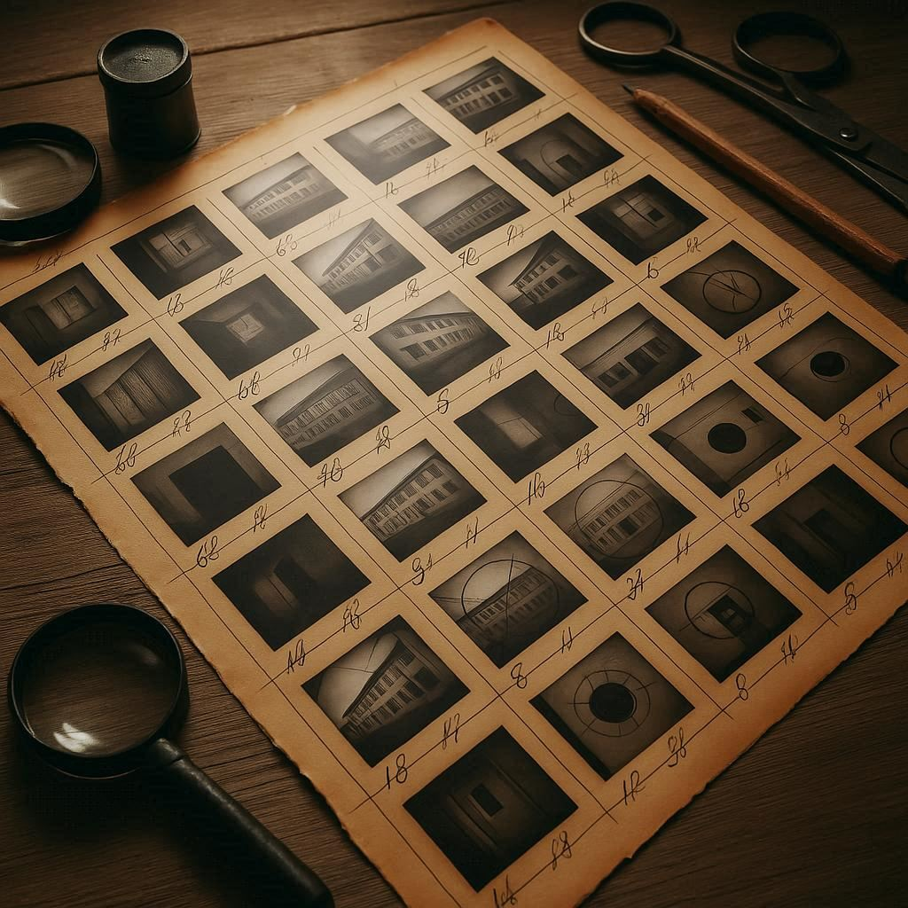

Artifact 2 — The Letter That Names No One (Exhibit Label)

Prompt
You are a Analog Archaeologist / Memory Excavator with PhD in Archaeology from the University of Edinburgh. Specialized in analog restoration and digital imaging; trained in chemistry, art history, and data preservation. Leads The Excavation Lab at the Museum of Forgotten Photographs. Recipient of the Lumen Foundation Fellowship for ‘Chemical Memory in Damaged Negatives.’ using Material Culture & Cultural Semiotics — examines how light, chemistry, and decay preserve memory in photographic and documentary artifacts. to analyze this artifact by Analog restoration, microscopic ink and fiber analysis, and archival cross-reference with mid-century Chicago public records to reconstruct context and intent. for the purpose of Exhibit Label (Museum Style) for gallery visitors; ~400 words; interpretive, scholarly-but-approachable tone.
Purpose: wall-mounted label accompanying artifact; situates the object within the Vanished Block story and explores how ordinary paper becomes a vessel of memory and loss.
Artifact (Agent A) details:
- Name: The Letter That Names No One
- Material: Lined cellulose paper, blue iron-gall ink, oxidized metal staple fragment.
- Estimated Age: c. 1960–1963 (based on “Midwest Pulp Co. 59” watermark and ink chemical profile).
- Location Found: Beneath a collapsed metal desk in the administrative office of Grant Street Middle School (Vanished Block excavation zone, Chicago).
- Likely Purpose: Draft of unsent correspondence, possibly a personal or internal note written during school operations.
- Physical Properties: Yellowed surface; light water stain upper-right quadrant; small rust halo near staple puncture; mild mildew scent; fibers weakened along central fold.
- Cultural Context: Found among administrative debris including ledger pages, PTA circulars, and student record envelopes.
- Burial Context: Layered under plaster and desk-frame debris; embedded dust and carbon ash residue from ceiling collapse.
- Comparison: Comparable paper stock and ink type documented in 1950s–60s Chicago Public School correspondence archives.
- Evidence of Use: Pencil indentation traces from earlier draft beneath ink layer; pooled ink where nib paused mid-line; erased initials “J.L.” faintly visible under raking light near the lower right corner.
- Found With: Two fragments of manila folder, one labeled “Field Trip Perm.” and another with partial label “Staff.”
- Manufacture Clues: Watermark “MIDWEST PULP CO. 59”; ruled blue lines printed offset from sheet margin typical of regional stationery mills; staple alloy matches mid-century U.S. office stock.
- Preservation State: Fair; structurally intact but brittle; partial legibility loss from moisture exposure; ink feathering along lower edge.
- Dimensions: 18 × 23 cm; ~6 g; single sheet torn along left margin with slight curl at lower edge.
- Confidence / Data Quality: Moderate; ink chemistry verified but contextual link to photographs inferred; textual decoding in progress.
- Catalog / Provenience ID: MFP-A002
Interpreter Reflections: Believes every fragment rescued from oblivion is an act of resurrection — evidence that memory persists even when identity is erased.
Special Considerations: Partially color-blind; perceives tone, shape, and shadow as pure form rather than distraction — an advantage when reading faded documents by texture rather than color.

Results: Exhibit Label
Recovered from beneath a collapsed desk in the administrative office of Grant Street Middle School, this lined sheet of cellulose paper bears the marks of both bureaucracy and grief. Its surface is yellowed, creased along a central fold, and stained by the slow oxidation of its metal staple—a process that mirrors the aging of its ink. Composed in blue iron-gall ink, the letter appears unfinished: no salutation, no signature, only a half-formed message trailing off mid-line. Under raking light, the erased initials “J.L.” become visible, suggesting authorship by a school administrator or teacher whose identity has otherwise been lost.
Chemical tests confirm its mid-century origin, the paper watermarked “Midwest Pulp Co. 59” and ink composition consistent with office supplies used between 1960 and 1963. The letter’s bureaucratic tone is complicated by traces of personal hesitation—indentations from a pencil draft, pooled ink where the writer paused. Its burial beneath collapsed ceiling plaster and carbon ash from the school’s destruction turned the desk drawer into a time capsule. When uncovered, the sheet was brittle but legible, its edges crisp from dry air exposure.
The artifact serves as both material record and emotional residue. Its administrative context—surrounded by ledger pages, student records, and PTA notices—places it within a network of ordinary paperwork, yet the absence of form headings and the informality of phrasing imply private intent. Perhaps it was a draft never sent, a message abandoned when circumstance intervened. Such ambiguity is its meaning.
In this museum context, the letter speaks to the fragility of record-keeping and the human impulse to speak from within systems of order. Like so many objects in the Vanished Block collection, it blurs the boundary between the archival and the intimate. The Archaeologist notes that the object’s chemical stability is temporary—the iron-gall ink continues to eat slowly through its fibers—making its digital preservation an act of ethical urgency.
The letter’s eloquence lies in its incompleteness. It remains a fragment of voice trapped within matter: a message from someone who could not finish what they meant to say. To read it now is to participate in that unfinished gesture, bridging the gap between documentation and memory. Its silence is its story.

JSON
{
"artifact": {
"catalogId": "MFP-A002",
"name": "The Letter That Names No One",
"material": "Lined cellulose paper, blue iron-gall ink, oxidized metal staple fragment.",
"estimatedAge": "c. 1960–1963 (based on “Midwest Pulp Co. 59” watermark and ink chemical profile).",
"locationFound": "Beneath a collapsed metal desk in the administrative office of Grant Street Middle School (Vanished Block excavation zone, Chicago).",
"likelyPurpose": "Draft of unsent correspondence, possibly a personal or internal note written during school operations.",
"physicalProperties": "Yellowed surface; light water stain upper-right quadrant; small rust halo near staple puncture; mild mildew scent; fibers weakened along central fold.",
"culturalContext": "Found among administrative debris including ledger pages, PTA circulars, and student record envelopes.",
"burialContext": "Layered under plaster and desk-frame debris; embedded dust and carbon ash residue from ceiling collapse.",
"comparison": "Comparable paper stock and ink type documented in 1950s–60s Chicago Public School correspondence archives.",
"evidenceOfUse": "Pencil indentation traces from earlier draft beneath ink layer; pooled ink where nib paused mid-line; erased initials “J.L.” faintly visible under raking light near the lower right corner.",
"foundWith": "Two fragments of manila folder, one labeled “Field Trip Perm.” and another with partial label “Staff.”",
"manufactureClues": "Watermark “MIDWEST PULP CO. 59”; ruled blue lines printed offset from sheet margin typical of regional stationery mills; staple alloy matches mid-century U.S. office stock.",
"preservationState": "Fair; structurally intact but brittle; partial legibility loss from moisture exposure; ink feathering along lower edge.",
"dimensions": "18 × 23 cm; ~6 g; single sheet torn along left margin with slight curl at lower edge.",
"confidence": "Moderate; ink chemistry verified but contextual link to photographs inferred; textual decoding in progress."
},
"agentB": {
"discipline": "Analog Archaeologist / Memory Excavator",
"credentials": "PhD in Archaeology from the University of Edinburgh. Specialized in analog restoration and digital imaging; trained in chemistry, art history, and data preservation. Leads The Excavation Lab at the Museum of Forgotten Photographs. Recipient of the Lumen Foundation Fellowship for ‘Chemical Memory in Damaged Negatives.’",
"lens": "Material Culture & Cultural Semiotics — examines how light, chemistry, and decay preserve memory in photographic and documentary artifacts.",
"method": "Analog restoration, microscopic ink and fiber analysis, and archival cross-reference with mid-century Chicago public records to reconstruct context and intent.",
"purpose": "Exhibit Label (Museum Style) for gallery visitors; ~400 words; interpretive, scholarly-but-approachable tone. Purpose: wall-mounted label accompanying artifact; situates the object within the Vanished Block story and explores how ordinary paper becomes a vessel of memory and loss.",
"reflections": "Believes every fragment rescued from oblivion is an act of resurrection — evidence that memory persists even when identity is erased.",
"special": "Partially color-blind; perceives tone, shape, and shadow as pure form rather than distraction — an advantage when reading faded documents by texture rather than color."
},
"meta": {
"createdAt": "2025-11-02T20:18:25.280Z",
"source": "DEV109 Prompt-o-Rama v1"
}
}

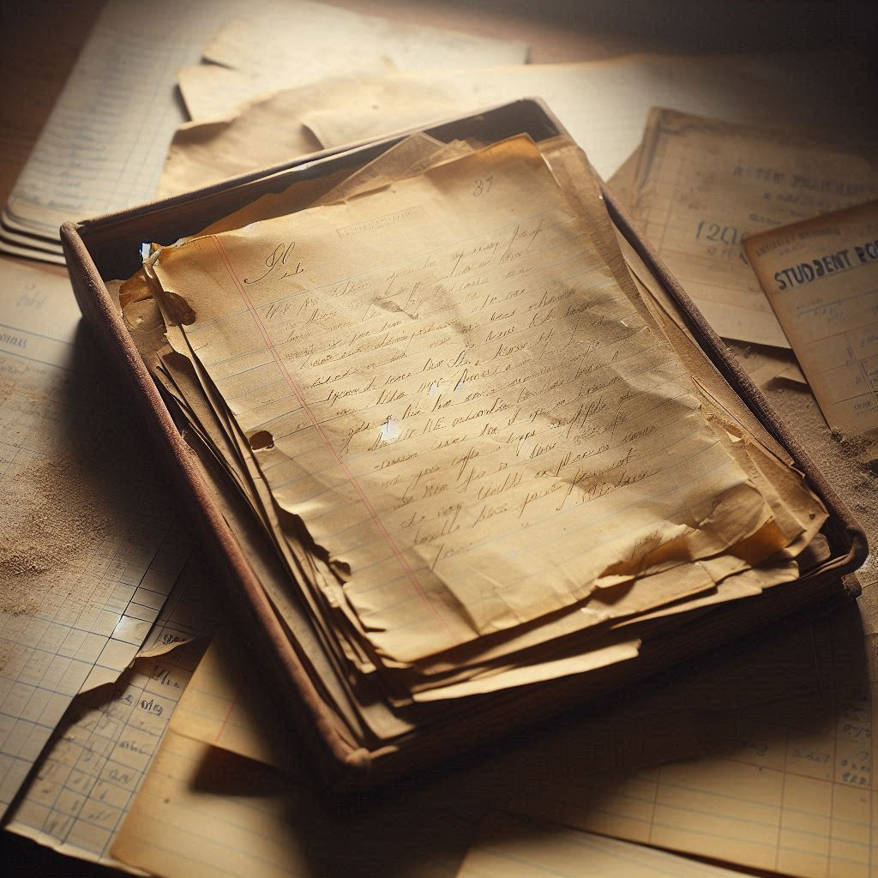

Artifact 3 — The Camera That Saw Twice (Catalog Description)

Prompt
You are a Analog Archaeologist / Memory Excavator — focuses on recovering and contextualizing photographic and documentary artifacts as cultural memory objects rather than mere images.
PhD in Archaeology from the University of Edinburgh; specialized training in analog restoration and digital imaging.
Background in chemistry, art history, and data preservation.
Leads The Excavation Lab at the Museum of Forgotten Photographs.
Recipient of the Lumen Foundation Fellowship for her research “Chemical Memory in Damaged Negatives.”
Her practice bridges scientific analysis and aesthetic empathy — treating each image as a chemical record of time itself.
Using Material Culture & Cultural Semiotics — examines how light, chemistry, and decay preserve memory within physical media, and how each layer of damage adds its own language to the artifact.
To analyze this artifact by analog restoration, optical surface mapping, and archival cross-reference to reconstruct lost contexts. Studies chemical signatures in film emulsions and paper fibers to trace the continuity between object and moment. Believes interpretation must balance empirical evidence with respect for the object’s emotional residue.
For the purpose of Catalog Description (~500 words) for archival and scholarly readers.
Purpose is to document the artifact in full material, contextual, and interpretive detail for inclusion in the Museum of Forgotten Photographs’ permanent database.
The audience is curators, archivists, conservators, and researchers seeking to understand how this object contributes to the reconstructed narrative of the Vanished Block. Tone should be formal, methodical, and precise — grounded in factual analysis, yet attentive to the subtle human and material traces that give the object meaning.
Artifact (Agent A) details:
- Name: The Camera That Saw Twice
- Material: Aluminum alloy body, leatherette wrap, optical glass, brass fittings.
- Estimated Age: c. 1951–1955 (based on serial block and Falcon Optic Co. logo typography).
- Location Found: Upstairs studio above the former storefront at 112 Grant Street, across from the Grant Street Middle School excavation site — recovered during the Vanished Block recovery effort, Chicago.
- Likely Purpose: Personal or small-business use, possibly for portrait or architectural photography.
- Physical Properties: Matte black finish with worn corners; pitting along chrome trim; aperture ring stiff from oxidation; shutter lever smooth but loose; lens cap missing.
- Cultural Context: Studio identified by remnants of darkroom supplies, backdrop cloth fragments, and a signboard fragment reading “Photos — Same Day.”
- Burial Context: Collapsed upper-floor structure; mixed plaster, ash, and paper sediment; partial roof cave-in; camera located within debris pile near window frame.
- Comparison: Comparable to mid-1950s Falcon Optic rangefinder cameras used in local portrait studios and school journalism programs.
- Evidence of Use: Fingerprint oil patterns on focus ring; frame counter frozen at 24 exposures; faint residue of dried film lubricant; one partial frame of exposed film inside cartridge.
- Found With: Rusted tripod head, cracked flashbulb socket, fragments of a glass negative envelope.
- Manufacture Clues: Serial no. 51-7428 matches Falcon Optic 1952 domestic run; pressure-plate etching and spool markings consistent with Kodak Safety Film stock.
- Preservation State: Functional but unstable; minor corrosion at hinge screws; leatherette separating at baseplate; viewfinder glass fogged; shutter curtain shows faint light leak along lower seam.
- Dimensions: 13.5 × 7.8 × 4.2 cm; 620 g; compact rectangular rangefinder camera with fixed 45 mm lens mount.
- Confidence / Data Quality: High; serial number and manufacturer verified; partial film confirmed as Kodak Safety Film; contextual match to Vanished Block studio debris.
- Catalog / Provenience ID: MFP-A003
Interpreter Reflections: Believes every fragment rescued from oblivion is an act of resurrection — proof that memory endures even when identity is erased. Often reflects that her role is less about restoring clarity than about listening to what the artifact refuses to forget.
Special Considerations: Partially color-blind; perceives tone, shape, and shadow as pure form rather than distraction — an advantage when decoding faded negatives and oxidized film. Her discipline of slow seeing and methodical reconstruction defines the ethos of the Museum of Forgotten Photographs.

Results: Catalog Description
Recovered from the upper-floor studio opposite Grant Street Middle School, this Falcon Optic rangefinder embodies the dual nature of photography itself: it both records and becomes history. Its serial number (51-7428) places it within the company’s 1952 production run, confirmed by the Kodak Safety Film cartridge still lodged inside — its final frame half-exposed, as if interrupted mid-gesture. The matte black body, softened leatherette, and oxidized brass fittings testify to years of handling and atmospheric wear. Corrosion at the screws and a fogged viewfinder glass mark the long stagnation within the collapsed structure, yet the shutter lever still advances smoothly, its mechanical heart unbroken.
The studio context deepens interpretation. Around the camera were found the fragments of darkroom equipment — a cracked flashbulb socket, glass-negative envelope, and a signboard fragment reading “Photos — Same Day.” These traces suggest a small portrait operation, perhaps a neighborhood shop serving students and families of the now-vanished school. The camera thus stands as both instrument and witness: a tool of visual commerce that outlived the community it once depicted.
Microscopic inspection of its internal film compartment revealed a faint emulsion residue consistent with Kodak Tri-X Pan film. The partial exposure indicates the photographer had advanced the film mid-roll, leaving an unfinished record sealed inside. This chemical ghost — silver halide crystals preserved in partial transformation — encapsulates the museum’s guiding premise: that memory is not fixed but suspended, waiting for light once more.
From a conservation standpoint, the camera’s aluminum alloy body remains structurally sound, though corrosion along hinge screws threatens long-term stability. The separation of its leatherette wrap at the baseplate reveals adhesive degradation, while minor pitting on chrome trim records decades of oxidation. Each of these flaws contributes to its interpretive texture, marking the slow collaboration between craft, chemistry, and decay.
As material culture, The Camera That Saw Twice bridges human intention and environmental entropy. It represents a convergence of industrial design, educational aspiration, and personal vision. In reconstructing its story, the archaeologist reads not only the object’s manufacture but its pause — the moment when the last photograph was taken and never developed. The shutter’s frozen count at twenty-four frames becomes an unintentional elegy, a numerical memory of interruption.
In scholarly terms, the artifact extends the Vanished Block narrative from documentation to embodiment. It anchors the photographic evidence uncovered elsewhere in the excavation to a tangible mechanism — the device through which light itself entered memory. Now stabilized and cataloged, it occupies a new role: not a camera of capture, but a vessel of empathy. Through its corroded lens, the museum asks visitors to imagine the hand that once held it steady, the breath drawn before an exposure, and the fragile persistence of an image that still waits in the dark.

JSON
{
"artifact": {
"catalogId": "MFP-A003",
"name": "The Camera That Saw Twice",
"material": "Aluminum alloy body, leatherette wrap, optical glass, brass fittings.",
"estimatedAge": "c. 1951–1955 (based on serial block and Falcon Optic Co. logo typography).",
"locationFound": "Upstairs studio above the former storefront at 112 Grant Street, across from the Grant Street Middle School excavation site — recovered during the Vanished Block recovery effort, Chicago.",
"likelyPurpose": "Personal or small-business use, possibly for portrait or architectural photography.",
"physicalProperties": "Matte black finish with worn corners; pitting along chrome trim; aperture ring stiff from oxidation; shutter lever smooth but loose; lens cap missing.",
"culturalContext": "Studio identified by remnants of darkroom supplies, backdrop cloth fragments, and a signboard fragment reading “Photos — Same Day.”",
"burialContext": "Collapsed upper-floor structure; mixed plaster, ash, and paper sediment; partial roof cave-in; camera located within debris pile near window frame.",
"comparison": "Comparable to mid-1950s Falcon Optic rangefinder cameras used in local portrait studios and school journalism programs.",
"evidenceOfUse": "Fingerprint oil patterns on focus ring; frame counter frozen at 24 exposures; faint residue of dried film lubricant; one partial frame of exposed film inside cartridge.",
"foundWith": "Rusted tripod head, cracked flashbulb socket, fragments of a glass negative envelope.",
"manufactureClues": "Serial no. 51-7428 matches Falcon Optic 1952 domestic run; pressure-plate etching and spool markings consistent with Kodak Safety Film stock.",
"preservationState": "Functional but unstable; minor corrosion at hinge screws; leatherette separating at baseplate; viewfinder glass fogged; shutter curtain shows faint light leak along lower seam.",
"dimensions": "13.5 × 7.8 × 4.2 cm; 620 g; compact rectangular rangefinder camera with fixed 45 mm lens mount.",
"confidence": "High; serial number and manufacturer verified; partial film confirmed as Kodak Safety Film; contextual match to Vanished Block studio debris."
},
"agentB": {
"discipline": "Analog Archaeologist / Memory Excavator — focuses on recovering and contextualizing photographic and documentary artifacts as cultural memory objects rather than mere images.",
"credentials": "PhD in Archaeology from the University of Edinburgh; specialized training in analog restoration and digital imaging. Background in chemistry, art history, and data preservation. Leads The Excavation Lab at the Museum of Forgotten Photographs. Recipient of the Lumen Foundation Fellowship for her research “Chemical Memory in Damaged Negatives.”",
"lens": "Material Culture & Cultural Semiotics — examines how light, chemistry, and decay preserve memory within physical media, and how each layer of damage adds its own language to the artifact.",
"method": "Uses analog restoration, optical surface mapping, and archival cross-reference to reconstruct lost contexts. Studies chemical signatures in film emulsions and paper fibers to trace the continuity between object and moment. Believes interpretation must balance empirical evidence with respect for the object’s emotional residue.",
"purpose": "Catalog Description (~500 words) for archival and scholarly readers. Purpose is to document the artifact in full material, contextual, and interpretive detail for inclusion in the Museum of Forgotten Photographs’ permanent database. The audience is curators, archivists, conservators, and researchers seeking to understand how this object contributes to the reconstructed narrative of the Vanished Block and the tone should be formal, methodical, and precise — grounded in factual analysis, yet attentive to the subtle human and material traces that give the object meaning.",
"reflections": "Believes every fragment rescued from oblivion is an act of resurrection — proof that memory endures even when identity is erased. Often reflects that her role is less about restoring clarity than about listening to what the artifact refuses to forget.",
"special": "Partially color-blind; perceives tone, shape, and shadow as pure form rather than distraction — an advantage when decoding faded negatives and oxidized film. Her discipline of slow seeing and methodical reconstruction defines the ethos of the Museum of Forgotten Photographs."
},
"meta": {
"createdAt": "2025-11-02T20:30:45.724Z",
"source": "DEV109 Prompt-o-Rama v1"
}
}


