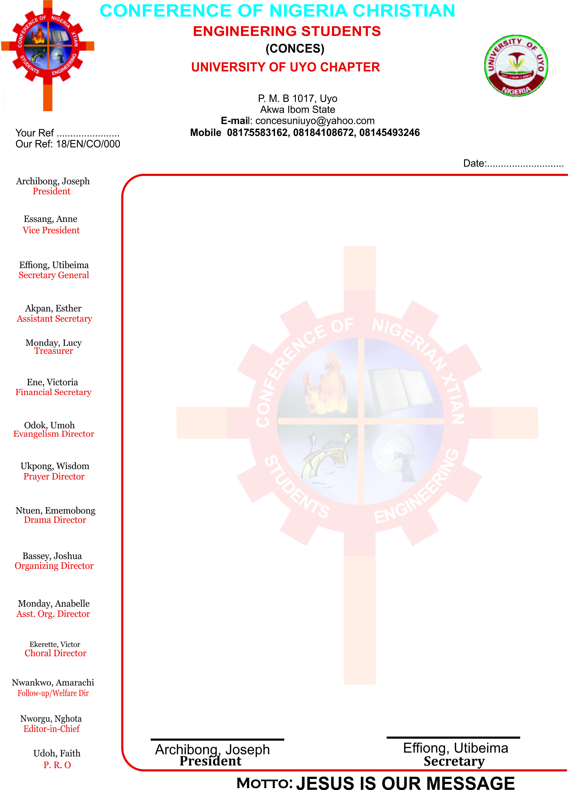

Dear Sir,

**REQUEST FOR LAUNCHING OF MAGAZINE**

Greetings to you in the name of the Lord.

The Editorial team, on behalf of the Conference of Nigeria Christian Engineering Students, humbly requests your presence at the Launching of our forth coming magazine branded 'THE BEAM' on the 14th of February 2020. We would love you to be a launcher of this year's edition tagged "the Truth".

We believe that this magazine will serve as an avenue for enlightening and motivating as many persons that will come across it.

We await your positive response. May Almighty God bless you bountifully.