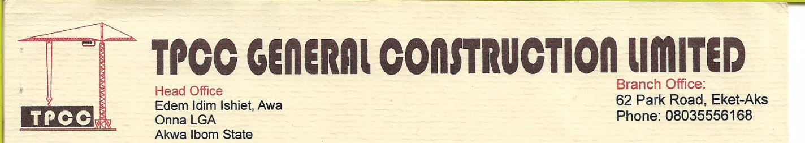

24th Januray, 2020

The Chairman

NDDC Verification Committee

Akwa Ibom State Office

Uyo.

Dear Sir,

**LETTER OF AUTHORITY TO REPSRESENT TPCC GENERAL CONSTRUCTION COMPANY LIMITED**

We hereby authorize our staff, Engr. Robert EKpenyong Daniel to represent TPCC General Construction Company Limited with respect to the NDDC projects/contracts verification exercise.

He will be identified with his staff identity card and National ID.

Please, be assured of our highest regards

Yours Faithfully,

For SEAL ENERGY & INVESTMENT COMPANY LIMITED

JESSICA