AT90USB1286 Breakout Board

J. Kelly Flanagan

Brigham Young University

kelly_flanagan@byu.edu or 801-369-0033

Please build two of these units. Materials for two are included. Lead based solder is fine and washing is fine. Feel free to contact me if any questions arise.

Please find included stencil and component layout drawing.

Bill Of Materials

C2 0.1 uF 0603 Capacitor

C4 0.1 uF 0603 Capacitor

C6 0.1 uF 0603 Capacitor

C7 0.1 uF 0603 Capacitor

C3 18 pF 0603 Capacitor

C5 18 pF 0603 Capacitor

R3 680 Ohm 0603 Resistor

R4 10 K Ohm 0603 Resistor

D1 Green 0603 LED, “C” on PCB indicates cathode

Q1 7.3728 MHz Crystal

SW1 Pushbutton

HDR1 2x3 Header

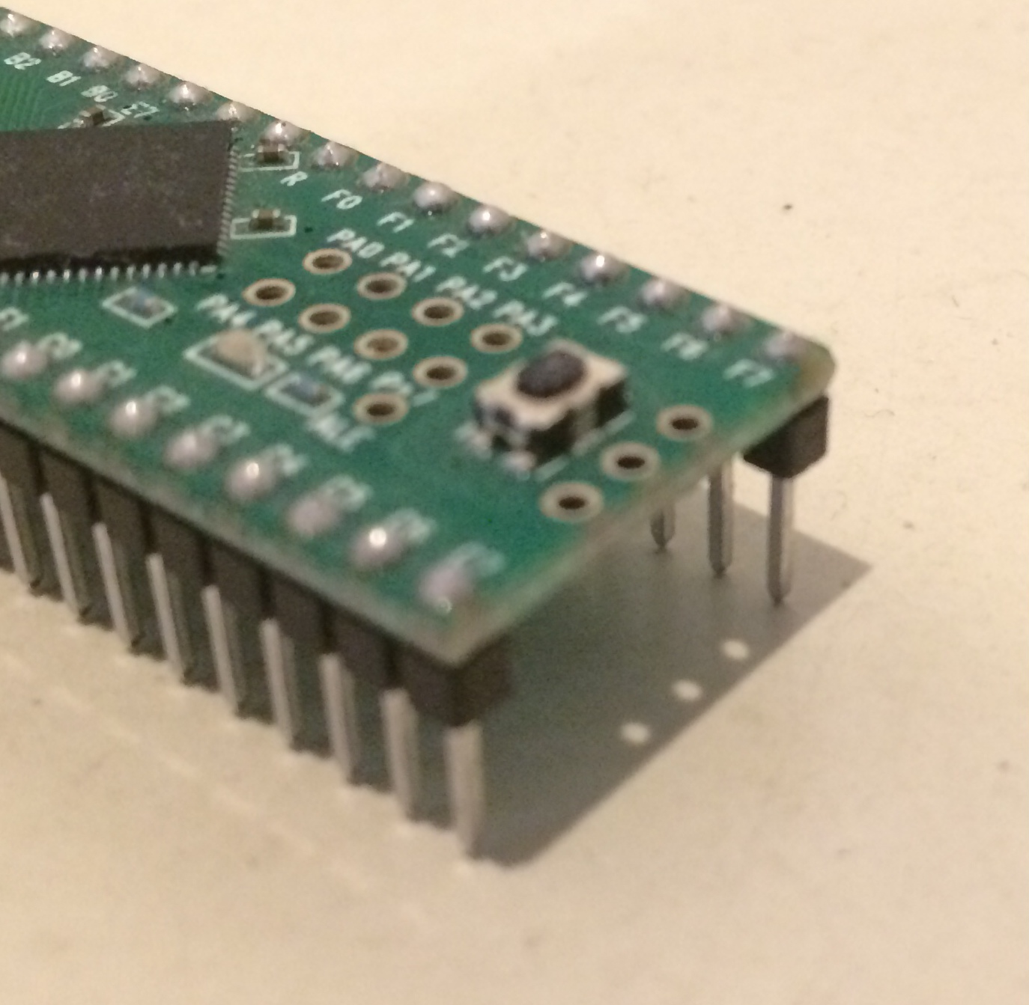IC1 AT90USB1286 MCU

2 - 1x30 pins Please note bottom mounted, see figure