Welcome to the isle
Explore a tiny, remote island filled with a wonderful forest and crazy characters.

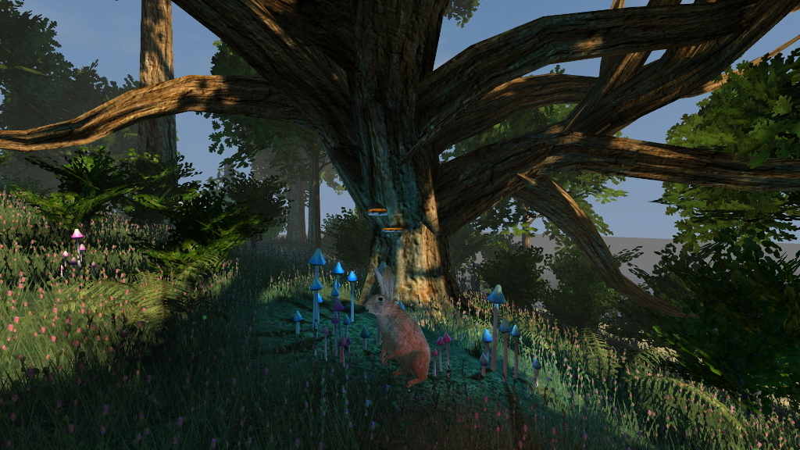

1. Keywords
mysterious, natural, magical

2. Goal
- learn in a small scale telling involving stories with crazy characters
- publish a small, finished game

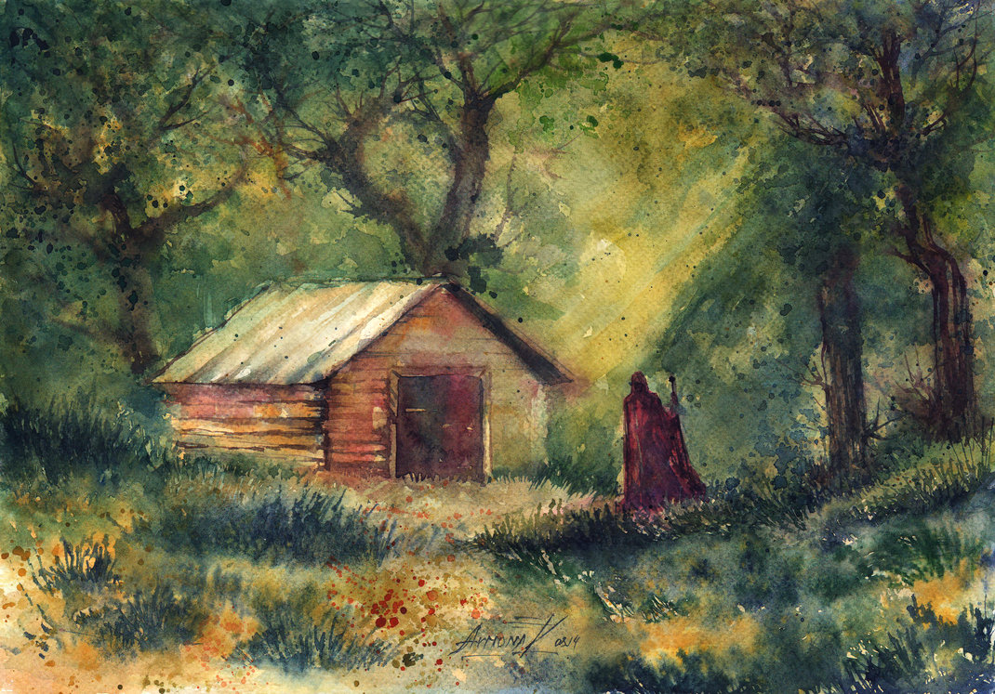 http://annaarmona.deviantart.com/

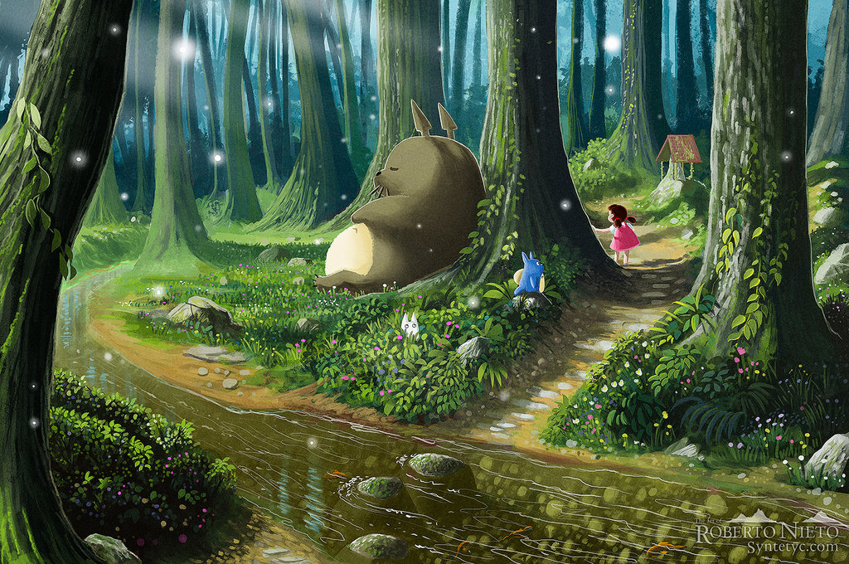 http://syntetyc.deviantart.com/
3. Characters

3.1 Eloree
keywords: crazy, lonely, mysterious

3.2 The Ghost
keywords: natural, magical, wise, mysterious

"There is pleasure in the pathless woods, there is rapture in the lonely shore, there is society where none intrudes, by the deep sea, and music in its roar; I love not Man the less, but Nature more."

