I plan on going off my previous project where the user selects an activity and enter s their weight and the minutes they preformed the activity and it will give you the calories you burned. Each activity will have an exit segue and a go back segue to return to the second scene where you can choose the activities if the user changes their minds or wants to calculate their calories burned on other activities. I will be adding MobileCoreServices, MediaPlayer, AVFoundation Frameworks to incorporate video and audio. I play on using these frame works to give the user the option to listen to ideal music for the activity they pressed and an example video of how to do the activity or how to give the user tips to do it correctly. I plan to replace the done button with an action to have these options and also to create segue from this action back to the view controller to calculate calories instead of using the done button. I am having some trouble trying to figure out how to preform the unwind segue from an action sheet and how to load a wed page for the video from an action sheet as well. I also want to clean up the flow of my app by transforming it into a tab view controller, so my main storyboard looks less messy. I plan on running this app from my iPhone.

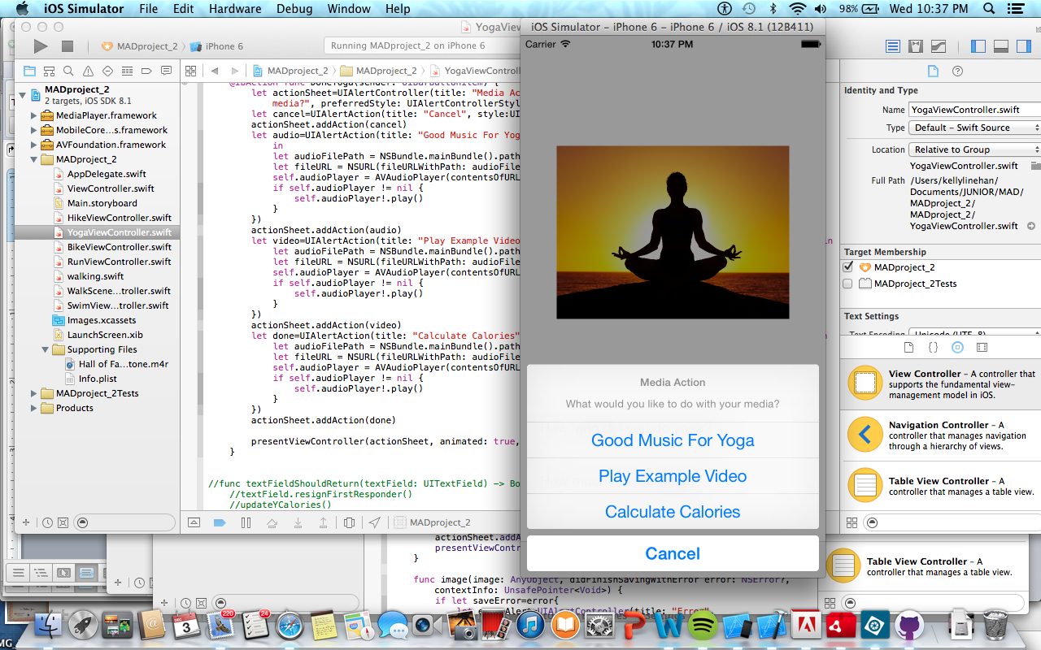

@IBAction func DoneYoga(sender: UIBarButtonItem) {

let actionSheet=UIAlertController(title: "Media Action", message: "What would you like to do with your media?", preferredStyle: UIAlertControllerStyle.ActionSheet)

let cancel=UIAlertAction(title: "Cancel", style:UIAlertActionStyle.Cancel, handler: nil)

actionSheet.addAction(cancel)

let audio=UIAlertAction(title: "Good Music For Yoga", style:UIAlertActionStyle.Default, handler: { action in

let audioFilePath = NSBundle.mainBundle().pathForResource("Meditation", ofType: "m4r")

let fileURL = NSURL(fileURLWithPath: audioFilePath!)

self.audioPlayer = AVAudioPlayer(contentsOfURL: fileURL, error: nil)

if self.audioPlayer != nil {

self.audioPlayer!.play()

}

})

presentViewController(actionSheet, animated: true, completion: nil)

}