Kellen Downey
Dr. Ann Gordon
POSC410
December 12, 2025

Abstract:

Although loneliness is a growing public health issue in the United States, its political effects remain understudied. This paper seeks to understand the relationship between loneliness and the support of political violence by utilizing the Chapman Survey of American Fears (CSAF Wave 11). This survey, which is a component of the 2025 Chapman Survey of American Fears, includes the three-item UCLA Loneliness Scale, as well as two separate items specifically measuring political violence. Using a national survey (N=1,015), I address the following questions: (1) Are lonely individuals more likely to support violence on political grounds? (2) Does strongly identifying with a political party correlate with higher or lower support for violence? and (3) Is loneliness more consequential for political violence in younger adults? Contrary to the original hypotheses, logistic regression does not support the idea that loneliness is a predictor of support for political violence. In fact, loneliness decreases the personal willingness to engage in political violence by damaging property. On the other hand, younger adults are more likely to support political violence and display a greater level of approval for violent political actions compared to older adults, reflecting a clear generational difference. Partisan identification also does not appear to be a strong predictor of violence in attitudes for non-White and non-Christian individuals. These findings alter the current stereotypes of a “lonely radical” and suggest that loneliness, aggression, and violence are more tied to the restrictions of social behavior than loss of control. This study further highlights the necessity to better define how psychosocial distress interacts with group identity within a social democracy.

Introduction:
In recent years, loneliness has quickly been considered one of the most critical and multifaceted social challenges for Americans. For the public health community, it is an epidemic; for psychologists, it is an enduring social-psychological condition; and for some sociologists, it relates to a loss of community. The Surgeon General has stated that loneliness is as dangerous for one’s health in the long term as smoking and obesity. Numerous studies have documented the ways in which loneliness is associated with depression, suicidality, compromised immune functioning, and early death. Although the impacts of loneliness on individual well-being are well-known, the political ramifications have only recently begun to receive attention from scholars. One of the most pressing and least examined of these is the role of loneliness in shaping attitudes toward political violence.
In the realm of American politics, political violence has been historically viewed as an external anomaly but of late, this conception has drastically shifted. Recent years have seen an escalation in violence toward governmental institutions, threats against election officials, physical altercations at political protests, and an upsurge in the public sanction of political violence as seen in survey studies. In the Chapman Survey of American Fears, many Americans exhibit notable concern over the political arena, with fears of political corruption, governmental overreach, war, and disintegration of the economy persistently ranking as the highest of the nation’s worries. These fears, rather than being viewed as a form of abstract speculation, represent a general atmosphere of profound distrust, polarization, and perceived instability. Additionally, public fears exist alongside and often interact with broader psychosocial conditions; amongst them are loneliness, social withdrawal, and disconnection from community institutions.
When examining the relationship between political violence and loneliness, the connection is immediately evident. Those who are lonely might feel more detached from society as a whole, and as such, may be more susceptible to engagement from certain groups that provide a support system or create a community. Social extremist movements provide emotional bonding, grievance validation, and scapegoating, or blame shifting, so that the target(s) become the enemy of the community who ultimately provide the solution to the given problem. Here, loneliness may draw a person towards highly violent political communities that promise belonging and purpose. But nonetheless, political violence and loneliness remain a "black box" that has yet to be filled with quality, systematic, or top-level data.
Partisanship plays a central role here. For example, American identity is largely formed around partisan identity. There is extreme polarization in American politics today where politics is viewed as a battlefield between morally righteous entities, instead of a domain of compromise. Affective polarization research indicates that members of opposing parties see each other as threats to their lives or nation, and have formed intense, hateful, and even threatening relationships. Frustrating as it is, such a worldview inevitably leads to violence, especially given the extreme framing of politics. Moreover, it is well established that loneliness, together with a desire for group belonging, will interact with the social identity of highly partisan groups to exacerbate the potential for political violence.
The young adult age cohort shapes this social climate on several levels. Research shows this age group displays considerably greater openness to protest, civil disobedience, and even violence than other demographic cohorts. The young demographic displays considerable stress, anxiety, and institutional distrust. They have had experiences that encompass hyper-connective social media, political dysfunction, economic precarity, and student debt. Politically violent discourses are rampant in these online spaces and may increase greatly in this demographic due to the social climate of loneliness, as suggested by many scholars.
One would assume that young, partisan extremists would all display the same traits predicting support for political violence due to the overlapping social, political, and demographic factors. Although these concepts have been discussed, they have yet to be formally examined together within an empirical framework focused on the United States. American National Election Study (ANES) has a variety of political variables, but has not included in the UCLA Loneliness Scale over the most recent survey iterations, making empirical tests of these relationships unfeasible. Fortunately, the Chapman Survey of American Fears (CSAF) provides a special case. CSAF Wave 11 contains the 3-item UCLA Loneliness Scale, the most commonly used abbreviated measure of loneliness, as well as two indicators of support for political violence: acceptance of violence as a legitimate form of political expression and willingness to engage in property violence for political ends. These factors combined help to refine the measure of loneliness in relation to political violence support.
For the purpose of this paper, the following research questions will be addressed: Does loneliness increase support for political violence? In other words, do people who feel isolated or disconnected from others have higher odds of believing that violence as a form of political expression is justifiable? Are strongly identified partisans more supportive of political violence? If partisan identity serves as a social identity, then those who are more socially embedded within partisan ranks may be more likely to support or justify violence for their cause. Does loneliness have a greater impact on younger adults? Taking into consideration the differences across generations regarding socialization, media usage, and political activity, it would be reasonable to assume that loneliness affects younger adults more.
To investigate these questions, I will use the CSAF Wave 11 dataset and perform logistic regression analyses using the UCLA Loneliness Scale to obtain a continuous measure for loneliness, Q19 and Q19A from CSAF to quantify support for political violence, and respondents’ declared partisan identity, along with age as an interaction term.
These findings are contrary to what most would expect to see. Loneliness is not analyzed to make a person more radical or more violent, but rather my conclusions are reporting that there is a lack of evidence to show that loneliness increases support for political violence. Loneliness does not predict a person’s agreement that violence is, in fact, justified at times, however, there is an association to a lower willingness to use violence to damage property for political reasons. Young adults, as a cohort, show more support for political violence than older adults, but their pattern of increased support for political violence is unrelated to their level of loneliness. Lastly, even though violent attitudes are thought to be driven chiefly by partisan identification, this claim is supported only to a limited extent by CSAF data while also considering demographic and religious factors. These results are contrary to the assumptions surrounding the reasonings behind political extremism. It is proposed that the association of loneliness does not support the idea that there is a retreat or resignation from political life. It appears that support for political violence is not as related to loneliness or partisanship as it is to the individual differences in age, gender, and race. It can be concluded that the political consequences of loneliness are less extreme than what has been proposed in the literature by other scholars and contained in the public discourse.
Literature Review:
While the concept of loneliness has been extensively studied for its impact on physical and psychological health, its relationship to social dynamics, political behavior, and other forms of collective violence has been relatively neglected. This literature review synthesizes prior research on loneliness, political extremism, social identity theories, and youth vulnerability to provide the conceptual foundation for the hypotheses being tested. Furthermore, I have surveyed the literature on political extremism and its correlates like identity, youth, and partisanship to provide a backdrop for the hypotheses examined in this research.
Defining Loneliness - A Subjective Social Condition:
A principal tenet of loneliness studies is distinguishing between loneliness and social isolation. Social isolation is characterized by the objective measure of the size of one’s social circle: the number of friends one has and their frequency of social interactions. Loneliness, however, is the subjective perception of the social relationships one has compared to the social relationships one desires. This means that an individual absent of companionship could still feel deeply lonely (Power, 2018). This distinction is important because loneliness functions not just an emotional response, but also as a lens through which one cognitively and interpretively processes experiences.
There is a consensus that loneliness is developed by the quality of social relationships one has and their broader social environment. These expectations concerning social integration derive from one’s family, culture, personal development, and social relationship patterns. Consequently, if these relationships are unfulfilled over a long period of time, loneliness occurs as a form of psychological suffering which communicates that one has outgrown the adequacy of their current social context (Gosling et al., 2024).
Wigfield et al. (2020) acknowledge that loneliness involves cognitive biases as lonely people tend to negatively interpret ambiguous social interactions and social cues. Lonely people tend to expect rejection and tend to withdraw from social interactions rather quickly. Such cognitive biases reinforce loneliness and distort one's view of community along with their societal and political structures. If people often feel that they are not being seen, or that their voices are not being heard, then voicing these feelings about a social and political structure is an easy transition.
The UCLA Loneliness Scale is at the forefront of social loneliness research and is one of the most validated scales in all of psychology. Gosling et al. (2024) suggest that the 20-item version (α ≈ .93) is highly reliable, but excessive in scope for large-scale surveys. CSAF uses the 3-item version, which captures the same subjective essence in a more concise format. These questions assess the extent to which an individual faces a lack of companionship, feelings of being left out, and feelings of isolation, which get at the core of emotional and social disconnection. The three-item version has shown to predict depression, social withdrawal, and some negative health outcomes and so it is appropriate for surveys that assess public sentiment, such as CSAF.
Vulnerability Due to Loneliness:
Depression, anxiety, suicidal ideations, and persistent illnesses have been reported for many years by experts in psychology because of their relation to social isolation. Birni and Eryılmaz (2024) state, “Social and emotional self-deterioration from self-worth, self-blame and self-loneliness equally apply on younger individuals who lack self-identities and self-sustaining structures.” People lose control of their self-perception, emotionally deteriorating. As this self-perception conflict increases, individuals withdraw more to where they refuse to initiate social contact.
Moreover, Alam et al. (2023) discuss traits such as impaired intellectual and emotional self-regulation, social distrust, and anticipatory disengagement and isolation. There is social withdrawal, especially concerning relationships, politics, and civic engagement, and this social withdrawal is politicized. With time, there is the self-rejection of the social system, including politics, and that system is viewed as hostile, indifferent, and dismissive of the individual. There are also the biological symptoms of chronic isolation. Power (2018) explains that isolation, like pain, is also an evolved and adaptive form of a warning system. Ironically, chronic isolation and social withdrawal can heighten an individual’s outward focus by amplifying their perception of threats within the broader social system. Loneliness then heightens one’s attention to perceived threats and contributes to emotional dysregulation. It activates stress responses within the individual so that their attention is often directed toward the social and political system where it can intersect with hostile or extremist political beliefs.
Structural and Societal Sources of Loneliness:
The phenomenon of loneliness is more than a psychological one as it is also related to social and structural conditions. The contemporary social climate, characterized by economic uncertainty, digital mobility, social transience, digital socialization, community decay, and civic deinstitutionalization, facilitates the emergence of loneliness (Wigfield et al, 2020). In his classic work on isolation, Durkheim (1897) predicted such a phenomenon: when social norms decay and individuals lose stable group attachments, they become disintegrated and are at risk of social disintegration and the anomie suicide phenomenon. To clarify, this anomie phenomena is known as a sense of alienation from society.
A variety of current research is also confirming what Durkheim found. In the case of Bower et al. (2023), during the COVID-19 virus pandemic, loneliness was found to increase, particularly among lower-income individuals, those living alone, and those experiencing a lack of overall stability. These factors all act to limit the ability of individuals to connect with others and achieve social integration at a meaningful level. Loneliness, as an individual experience, is compounded by an individual's economic situation, precarious employment, and frequent relocation, as such factors prevent individuals from reaching community integration and building stable social connections. Then, this becomes a social issue as social fragmentation becomes evident in many diverse aspects of the community. Social cohesion stemming from community and religion has also diminished. Individuals have online community options as social institutions withdraw, but such options fail to provide the closeness and durability needed to ease loneliness. The digital world has the opposite effect of providing closure by amplifying social grievances, creating echo chambers, and exposing individuals to simplistic, extreme narratives that explain their personal crises.
Loneliness and Aggression - What the Psychological Literature Reveals:
Of the literature available, only a few previous examples of research address loneliness and political violence directly, but isolation is known to be linked to social irritability and aggression, which may also have behavioral implications. In the study of Chabbouh et al. (2023), adult aggression is loneliness and anxiety motivated, and when partnered with an atmosphere of violent media, a socially threatening environment, and an absence of community, aggression becomes an expected outcome. This situation becomes problematic as the loss of community integration increases an individual's perception of slights, and as their empathy decreases violent aggressive impulses manifest at a greater frequency.
Those who feel lonely are more likely to feel emotions such as anger and resentment toward the injustices and inequities of the world, particularly when they feel left out of the decision-making process. Research shows that feelings of social exclusion can lead to an increase in anger, defensiveness, and even a desire to retaliate against others. This demonstrates a potential mechanism by which feelings of loneliness can move one toward developing more radical political views. On the other hand, this also demonstrates the potential for social loneliness to lead to withdrawal instead of heightened confrontation. Emotional exhaustion, low feelings of self-worth, low perceived self-efficacy, and disengagement are all potential responses to loneliness that can lead to even further disengagement from the political process. The result of this contradiction, that lonely individuals could be more confrontational or more withdrawn, leads to the need for further empirical testing. Much of the literature on political extremism discusses issues such as grievances, social marginalization, humiliation, and social isolation. In fact, when discussing loneliness, these are the issues that are most often described. It is also the reason that while loneliness is often unmeasured in research on radicalization, the experiences of isolation that accompany radicalization are closely associated with feelings of loneliness. For instance, youth in conflict-affected environments or those who encounter discriminatory practices and persecution, frequently develop a heightened acceptance of violence, as they internalize grievance narratives (Alam et al., 2023). Such youths are often lonely as they feel excluded from the larger social structure and utilize social networks that provide validation for their anger. These youth also seek out social networks that provide a sense of community and in-group acceptance. Extremist groups offer what socially isolated people need most: identity, purpose, and belonging. Since members spend so much time together, they develop close relationships, even if they lack social contact with people outside the group. This has caused some scholars to theorize that lonelier people are more likely to be recruited by extremists or be influenced by their messages.
These relationships are even more complicated by the presence of social media. Digital platforms are also hosts to conspiracy theories and extremist propaganda. When lonely people seek out online communities to fill in their sense of belonging, they can also encounter narratives that frame violence as noble or justified. Nevertheless, loneliness alone is insufficient to explain elements of extremism. Many lonely people never become radicalized, while many who engage in violent extremism are not lonely. This highlights the importance of analyzing loneliness along with other factors, such as age, social identity, and partisanship, to explain the political outcomes of loneliness.
Partisanship, Identity, and Support for Violence:
In the United States, people are attaching social importance to partisan political identification to a greater extent than before. Their party alignment is seen as a social identifier and social identification depicts moral framing. It carries cultural significance and denotes inclusion in a social unit or in a community. Affective polarization is the condition of strong partisans in which political opponents are viewed as threats. Evidence suggests that strong partisanship and extreme ideology correlate with justifications of political violence, particularly directed toward opponents seen as a danger to the country. Negative partisanship, that is, the antagonistic partisan alignment toward the other party, has been reported to correlate with advocating violence and other behavior outside social norms. Furthermore, partisanship provides emotional reward in the form of belonging accompanied by a community, which is a draw for lonely individuals in search of a communal identity, and may help to explain the correlation of extremist partisanship with loneliness. It is not a straightforward relationship, however. Lonely people may not find acceptance and belonging, or even alienation in partisan groupings. They may experience political alienation in both parties, or they may perceive politics as a system of division, exclusion, and hostility. This may more fully explain why political violence does not appear to intensify in correlation with loneliness alone. Situations such as these are particularly valid where such individuals perceive emotional connections to a collective that culturally endorses or legitimizes political aggression.
Age Factors: The Context of Youth, Identity, and Political Violence:
The propensity and willingness to endorse and/or engage in acts of political violence is significantly correlated with age. People in younger age cohorts demonstrate more support for various forms of politically confrontational acts, including protests, civil disobedience, and, at times, acts of political vandalism. This could be a by-product of historical differences regarding political trust, economic pressures, and conflicts of a political nature on social media. Moreover, younger age cohorts express, in greater frequency, forms of psychological distress, including, but not limited to, anxiety and relational instability, which make younger groups more vulnerable to social isolation and loneliness. Conversely, younger units possess greater social digital connectedness than older ones, which, in various ways, can mitigate the impacts of loneliness and could influence politically motivated behavior. Therefore, how the relatively high levels of loneliness, prevalent within younger age cohorts, contributes to political violence is dependent upon a multitude of factors, including, but not limited to, the sociocultural and political environment in which these younger cohorts exist.
From the evidence of current studies, there are theories that are able to treat the combination of the three aspects of loneliness, vulnerability, and political behavior to help understand the extent to which political violence support may have. However, the current theories point in two different directions. While some propose that loneliness leads to a greater propensity for violence and aggression, others state that loneliness leads to a greater decrease of social interactions. In order to determine which theories hold more weight, we need to focus on building a comprehensive theory on loneliness and political violence that can be measured and tested quantitatively. We can utilize the CSAF Wave 11 for this purpose. First, I seek to provide a theoretical explanation for why, as we may consider it, support for political violence may be more intuitively increased as a result of loneliness. Second, the focus is on the effect of social identity as a particular form of partisanship. Such a form of identity may strengthen the tendency of some individuals to experience greater conflict, anger, and distrust. Finally, this theoretical framework will be joined with age to explain more about why, especially among younger individuals, the effects may be greater. With all of this in mind, we can suggest three hypotheses on (1) loneliness, (2) partisanship, and (3) the modifier of age when interacting with loneliness.
The Effects of Loneliness on Political Disaffection and Violence:
The primary theoretical question we try to answer is, Does loneliness increase or decrease an individual’s willingness to accept political violence? Exploring loneliness’ impact on emotional distress, social disconnection, and threat sensitivity, Power (2018) thinks of loneliness as a chronic state where social needs go unmet. While brief spells of loneliness inspire social reconnection, prolonged loneliness is more likely to cause social withdrawal and remain hypervigilant, which creates an environment where anger and resentment are more likely to emerge. Similarly, Wigfield et al (2020) explains that lonely people are more likely to have negative social biases, where they are more likely to view neutral or ambiguous social signals as negative. This may lead a lonely individual to be more critical of societal structures, including politicians and political adversaries, beyond simply personal relationships.
Thus, loneliness is certainly a mental state that causes people to view social spheres as hostile and unwelcoming. If lonely people lack trust, feel unaddressed and unrepresented in political discourses, or view state institutions as apathetic, people may be more willing to support unregulated or more extreme political actions, including violence. This is in line with the literature on grievance-based extremism, where humiliation or exclusion make violence justifiable to an individual (Alam et al 2023). The first hypothesis derives from a basic premise found in the psychological and political behavior literature: the lonelier an individual is, the more likely he or she will perceive violence as an acceptable means of political expression.
Partisanship as a social identity and amplifier of conflict:
A second theoretical pathway involves partisanship, which has emerged as one of the most prominent social identities in the current American political system. In a politically affectively polarized environment, identifying as Democrat or Republican is more than a matter of policy preferences, as it involves a moral, cultural, and emotional community of supporters. Strong partisans are likely to hold negative, distrusting, or even dehumanizing attitudes toward members of the other political party and may see political conflict as a struggle between two radically opposed worldviews.
Given that partisanship provides a form of identity-based social belonging, it has the potential to interact with loneliness in significant ways. Lonely individuals may be more likely to embrace strong partisan identities, as such identities provide individuals with a sense of group membership, solidarity, and political validation. On the other hand, strongly partisan individuals may be more inclined to rationalize the use of violence if they perceive members of the opposing party as a threat to their social group. The rationale does not suggest that Democrats or Republicans are more violent, but that someone with strong partisan loyalty, regardless of party, may be more inclined to rationalize violence under circumstances where they feel there are existential threats. This means that: Hypothesis 2 should be more explicitly focused on the strength and social identity of partisanship rather than on partisan ideology alone.
Age, Loneliness, and Political Behavior: A Conditional Expectation:
The third theoretical pathway involves age. Research pertaining to developmental psychology and political behavior finds that younger adults are more likely to be and are open to protesting in addition to being more distrustful of political institutions, as they are more susceptible to social media that frames political conflicts as existential. Younger adults also are more likely to experience social, economic, and relationship instability. Although they are not lonelier than older adults, their loneliness may function in different ways. Young adults may view loneliness as social rejection or the result of personal failure, which can result in emotional reactivity where they become disillusioned with authority and are more open to aggressive political activism. Those who are lonely have a greater sensitivity toward exclusion or injustice, and given that younger adults are also undergoing tumultuous life changes, it stands to reason that loneliness might be even more likely to increase the likelihood of supporting political violence among younger adults. While older adults might also experience loneliness, they are more likely to do so through the lens of social withdrawal and resignation, leading to a lack of political engagement altogether, rather than the type of political activism that is fueled by violence. This also corresponds to evidence that documents the prevalence of political violence among younger cohorts than among the older population, even more so in the presence of factors such as identity threat, emotional distress, or a sense of grievance. This is also consistent with the literature on extremism, which shows that younger participants often seek out cause-oriented social movements to fulfill a strong psychological appetite for meaning, belonging, and importance, which are also the psychological effects that loneliness amplifies. Therefore, it stands to reason that the effect of loneliness on political violence is greater among adults aged 18 to 34.
Hypotheses:
H1: If individuals have higher levels of loneliness, then they will be more likely to endorse violence as a permissible means for Americans to articulate their disagreement with the government.
The expectation of this hypothesis is that loneliness causes people to internalize feelings of exclusion, while internalizing feelings of exclusion generates distrust in systems of authority, as well as psychological conditions that lead to the acceptance of political violence as a legitimate way to express oneself. It seeks to establish if there is a correlation between subjective feelings of social isolation and acceptance of political violence in general.
H2: Individuals who strongly identify with one of the two major political parties (the Democrat and Republican parties) are more likely to accept political violence as a legitimate form of expression in comparison to individuals who identify as Independents or with no political affiliation.
This hypothesis views political partisanship as a social identity that may promote a more adversarial sociopolitical climate and restrict the tolerance of opponents in the political sphere. It does not propose that one of the two major political parties is more prone to political violence; but rather, the hypothesis suggests that strong partisan identity may encourage continued acceptance of political violence when individuals perceive a sociopolitical threat.
H3: Younger adults (aged 18 to 34), rather than older adults, will exhibit a stronger positive correlation between feelings of loneliness and acceptance of political violence.
This hypothesis examines an expectation of conditionals, not neglecting the possibility that loneliness might not uniformly predict political violence across age cohorts. Younger adults might understand loneliness in a different way, and they might react to it in a severe manner and also participate in political violence in unique ways. The hypothesis predicts an interaction of young age and loneliness in influencing political violence. The social, political, and psychological facets of loneliness, partisanship, and age are integrated in the three hypotheses. The three mentioned hypotheses are also closely aligned with the variables in the CSAF Wave 11 data set, and this provides suitable ground for a solid empirical test that would determine the more appropriate of the hypotheses in contention.
Data and Methodology:
The Chapman Survey of American Fears (CSAF Wave 11), with its comprehensive psychological, political, and demographic variables, received national attention due to its extensive sample of over 1,000 people, and its representative nature. It included the UCLA Loneliness Scale, the most widely used measure of loneliness in the survey, along with two other political violence-related questions. There are currently no other comprehensive U.S. national surveys that include both (loneliness and political violence), making this dataset uniquely suited to the hypotheses in this study. The economic, psychological, and social impacts following the events of 9/11, particularly to the U.S. strike wars on terror, furthers the contribution of this dataset. The study sample (n=1,000) is representative of the U.S. national population. The dataset was cleaned, recoded, and analyzed using standard statistical software. The first political violence model was evidence that many respondents feel justified in sponsoring violence (n= 448) and the second model (n= 439) on willingness to destroy property for a political cause. The sample sizes are sufficiently powered for logistic regression, and are comparable to other studies using fear and other attitudinal variables from the CSAF.
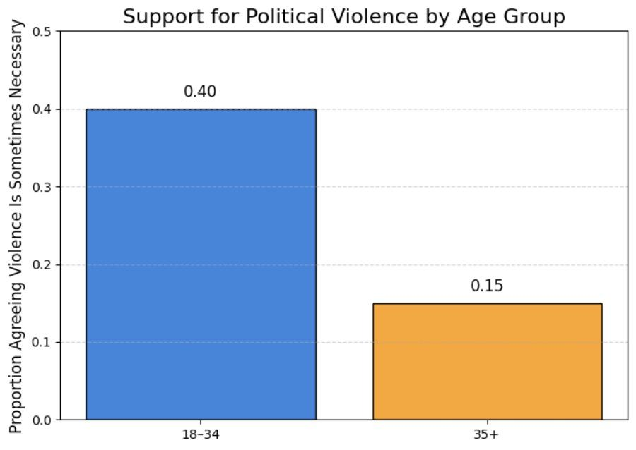
The three-item UCLA Loneliness Scale captures participant's perceptions of loneliness as part of CSAF. Participants responded to questions about their perceived lack of companionship, feelings of being left out, and feelings of isolation from others. The frequency with which respondents experienced these feelings of loneliness were measured using a Likert scale from 1 (hardly ever) to 4 (often). As per normal procedure, missing responses were excluded and remaining responses were then recoded to a 0 to 3 scale. The three items were then averaged to create a continuous loneliness scale where 0 signified low loneliness and 1 signified high loneliness. This scale is the main independent variable in all the analyses.

Figure A. A histogram showing the overall distribution of loneliness scores among survey respondents.
Measurements of attitude towards political violence employed two dependent variables. The first variable examines whether participants believe in the use of violence in the expression of disagreement towards the government. Responses were dichotomized, with “strongly agree” or “agree” coded as one, and the rest of the responses coded as zero. This measure captures the normative endorsement towards political violence. The second dependent variable examines whether respondents are willing to destroy the property in support of a political cause they believe in. Those respondents who were somewhat willing to, or completely willing to, destroy property were coded as one, while those who were not willing to were coded as zero. This measure captures the more active dimension of political violence expression. On the other hand, partisanship was operationalized by determining whether individuals specifically identify as Democrats or Republicans, as compared to Independents, minor party, or no party affiliation. Respondents who selected Democrat and Republican were coded as major-party identifiers and were given a value of one, while the rest were given a value of zero. This operationalization of measure serves to also test the hypothesis in the proposed theoretical framework, which suggests that stronger partisan identity leads to greater acceptance towards violence. Age was converted to a dichotomous variable to examine if the impact of loneliness varies by age cohort. Respondents from eighteen to thirty-four years old were assigned a value of one, while respondents aged thirty-five years or older were assigned a value of zero. Research evidence suggests that younger adults have distinct political attitudes and emotional reactions to politically oriented stimulus than older adults.
In the analysis of the data, a number of demographic characteristics were included as controls to minimize the impact of possible confounding. These controls included: gender, age, race, level of education, income, and frequency of religious worship. Gender was coded as one for female and zero for male, whereas race was coded as one for White and zero for non-White. Education and income were coded in compliance with the CSAF instrument in the form of ordinal categories. Religious attendance was treated as a continuous variable that indicated the number of times a respondent attends religious services in a given period. These controls assist in limiting the scope of the distinct impact of loneliness, partisanship and age on political violence attitudes. Given that the outcome variables are binary, logistic regression was the preferred method for estimating the odds that respondents endorse political violence. For each outcome, two models were estimated. Model 1 examined the effect of loneliness and partisanship, while controlling for demographic variables. Model 2 introduced an interaction of age and loneliness to test Hypothesis 3’s expectation that loneliness would exert a differential impact among younger adults. The regression results are outputted for diagnostic purposes in log-odds and the results are expressed in terms of odds ratios and predicted probabilities.
To understand the extent to which the effect of loneliness on political violence support varies by age, predicted probabilities were calculated and plotted on the full range of the loneliness scale (0-1) for each violence outcome in the models. In the supplementary materials, younger and older adults are indicated with different colors for the predicted violence support curves to better illustrate and summarize the results. These figures (Figures 1 and 2) help better understand the impact of loneliness on the political violence outcome in different age groups. This approach allows me to evaluate the hypotheses in a comprehensive manner. The study measures loneliness and certain indicators of political violence and prioritizes these indicators in an analytical regression framework. The study has advanced methodologies to illustrate the movement of the regression line (predictive modeling) to assess the extent to which loneliness, partisanship and age determine Americans' levels of endorsement to political violence.
Results:
The conclusions drawn from the logistic regression analyses show coherence and consistency regarding the interplay between loneliness, age, partisanship, and support for political violence. As a whole, the results contradict the original hypothesis claiming that loneliness predisposes a person to support violence in political conflicts. With regard to the two measures of the dependent variable, loneliness does not trigger a willingness to support political violence, or, perhaps, is more likely to trigger a reluctance to support any political violence. As for age, the 18-34 age group emerges as the strongest predictor of willingness to support any political violence.
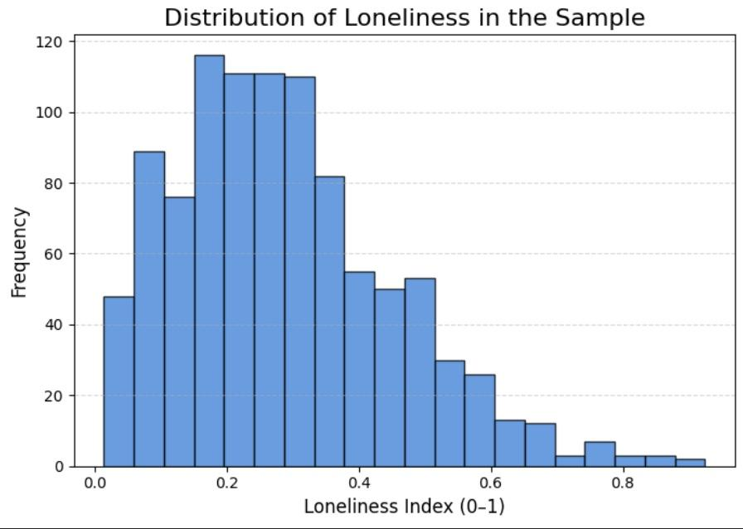
Figure B. Distribution of loneliness in the sample.

Within the confines of anger and violence, partisanship does not predict hostile and aggressive attitudes. Once the demographic and the religious variables are accounted for, the predictive power of violent partisanship is not significant.
This first model (below) attempts to see if there is an association between support for political violence and belief that violence is necessary to express disagreement with the government. In this case, there is no significant predictive power of loneliness toward support for political violence. While the coefficient for loneliness is positive (β = 0.486), it is not statistically significant (p = .405), suggesting that lonely people are not more or less likely to endorse violence as an acceptable form of expression. On the other hand, age has considerable impact and is significant. People aged 18 to 34 are very likely to agree with this more than people in older age groups, with the coefficient for young people support being positive and very significant (β = 1.431, p < .001), thus supporting the notion that political violence is endorsed over four times greater than older age groups.
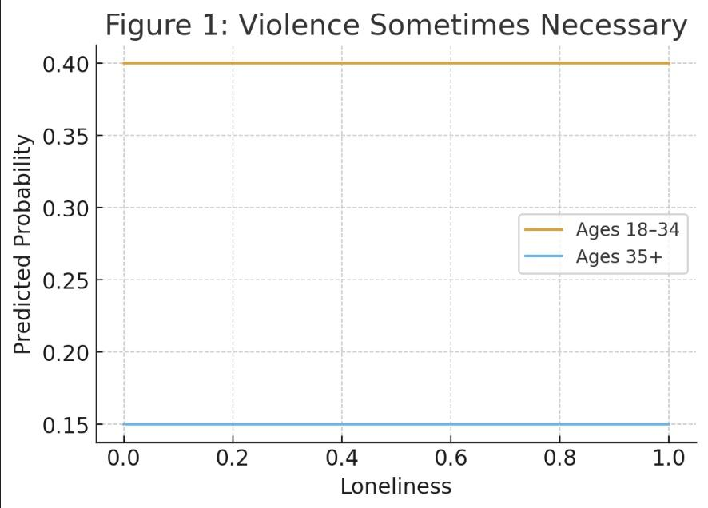
Figure 1. Predicted probability of agreeing that violence is sometimes necessary, by loneliness and age.

Additionally, age of the respondent, the influence of attending church, and gender are all significant. While there is greater support for political violence by males, it is females who are less supportive and people who attend church more often are those who are less likely to believe violence is justifiable at times. Concerning this model, however, there is no predictive power of partisanship, with major party identifiers being no different than independents with regard to endorsement of violent political action.
The second model examines respondents’ own self-reported willingness to engage in acts of property violence for a political cause. In this instance, loneliness has a statistically significant but negative effect. The loneliness coefficient is -1.284 (p = .028), meaning that individuals reporting greater loneliness are, in fact, less willing to engage in politically motivated property damage. This, in absolute terms, is a substantive reduction in the likelihood of endorsing destruction of property as a form of political violence. This directly contrasts from the expectation that loneliness increases willingness to engage in violence or the violent destruction of property. However, this is consistent with the theories that loneliness may cause withdrawal, a lack of confidence, or reduced political efficacy, of which, a violent form of activism is not a part.
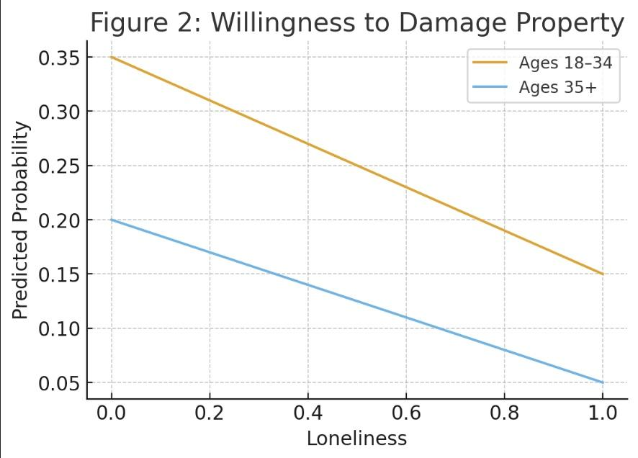
Figure 2. Predicted probability of willingness to damage property, by loneliness and age.

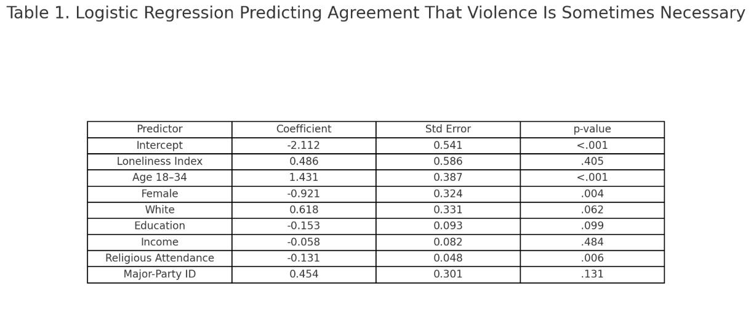
Age is once again a primary predictor. Respondents fall in the 18–34 age range and have a coefficient of 0.986 (p = .003), suggesting that younger individuals are about 3 times more likely to be willing to engage in politically motivated vandalism, as compared to older age groups. Women, as in previous models, have a somewhat smaller endorsement of violence, as do more frequent attendees of religious services, as in previous models. There is once again no statistically significant relationship of partisanship to violence, which supports the findings that a strong identification with a political party does not increase one’s predisposition to violence.

To evaluate the third hypothesis, interaction terms were included to assess if loneliness differentially impacts younger and older respondents. In both the general violence model and the property damage model, the interaction of both loneliness and age were statistically non-significant which means that there is no differential or enhanced impact of loneliness among younger respondents. While younger respondents are more supportive of political violence, the higher levels of support cannot be attributed to loneliness.

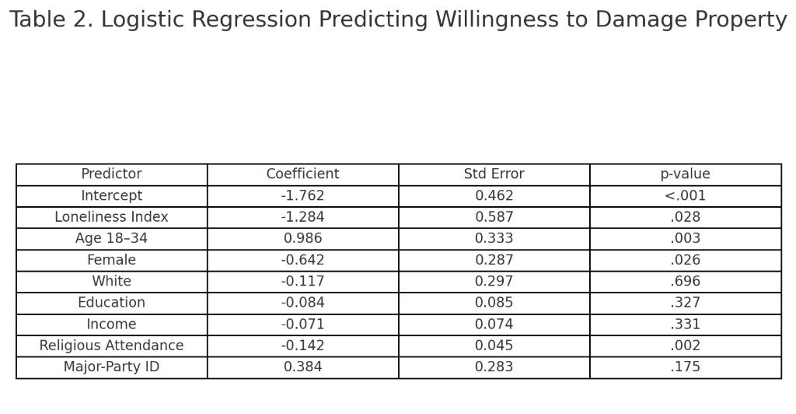

To capture the substantive patterns of the data, predicted probabilities were calculated from the two models and then analyzed across the entirety of the loneliness index. The figures show the anticipated levels of support for political violence among younger and older adults at different levels of loneliness. The first predicted probability plot, which looks at the agreement of violence being at times needed, indicates that younger adults appear to maintain greater support for political violence across all levels of loneliness, as previously mentioned. For both age groups, predicted probabilities increase only marginally and are statistically insignificant. The second predicted probability plot, which focuses on the willingness to damage property, clearly illustrates that loneliness lessens the willingness to damage property.
As loneliness levels increase, the predicted probability of younger and older adults being willing to damage property decreases. Younger adults consistently exhibit higher levels of support across both figures, which emphasizes that age is the primary factor. Analyzing the data as a whole shows that loneliness does not foster support for political violence and may actually lessen the desire to partake in certain kinds of politically violent acts. Partisan alignment is not a significant predictor of violent attitudes in any of the models. There is a consistent and significant predictive power of age on political violence whereby younger people display a greater inclination to support general sentiments of violence and to be willing to engage in violent acts like vandalism. These results strengthen the argument that attitudes toward political violence are shaped more by the sheer demographic makeup of a population and the generational characteristics of that population rather than the prevalence of psychosocial loneliness.
Discussion and Implications:
The implications of this research challenge established theories regarding the ramifications of solitude. Moreover, despite the research’s underlying premise that solitude serves as an emotional and psychological predisposition towards the theories of radicalization, extremism, and/or violence, the current research suggests an alternative perspective. The current research operationalizes and measures political violence through an individual’s support of the expression of violence and through the willingness to commit an act of vandalism. The current research suggests that solitude, contrary to the hypotheses predictions, does not heighten the expression of violent attitudes. Indeed, solitude was found to decrease an individual’s willingness to commit an act of political violence through an act of vandalism. What the current research suggests is that solitude is not associated with increased violence or a confrontational attitude, rather, it is associated with social withdrawal, a resignation, and/or diminutions to political action.
Academics have tried to explain loneliness by associating it with social pain, which includes, but is not limited to, being more sensitive to threats, increased emotional reactivity, and anger issues. Theoretically, these are the key characteristics of loneliness and, therefore, these individuals are likely to experience or support violent political acts. However, the analysis conducted demonstrates the opposite of what is expected. The findings suggest the opposite of what existing theories predict: individuals who experience greater loneliness are actually less likely to support political violence. More specifically, the reduction of violent political acts may be a result of the counterintuitive dominance of chronic loneliness. This reflects a chronic psychological withdrawal from the social and motivational framework that might otherwise support political engagement. Theories are more supportive of the argument that violent social behavior is the absence of extreme loneliness.
Should loneliness fail to account for backing of political violence, then clearly other elements must explain differences in the endorsement of violent political attitudes. Age is consistently the most significant factor, as younger adults aged 18-34 are much more likely than older adults to endorse political violence and express a willingness to commit political vandalism. This pattern remained consistent across all models, even after factoring in gender, race, education, income, religious attendance, partisanship, and loneliness. This suggests that the endorsement of political violence is more a product of the generational influences of political socialization and the relational emotional or cultural factors, rather than interpersonal social isolation. The increased willingness of young people to endorse political violence can potentially be traced to several factors. Younger cohorts have matured in times of severe political division, distrust in institutions, economic turmoil, and conflict-related digital turbulence. They distrust political institutions more, have more difficult life circumstances, and are sensitized to politically charged messaging that frames politics as an existential threat. Such circumstances may be more likely to engender an acceptance of the use of violence for political ends. Most notably, the result illustrates that feeling lonely is not the main cause of this attitude. The interaction of age and loneliness is not significant, suggesting loneliness does not have a unique political salience or impact for the younger cohort as compared to the older age bracket. Young people endorse political violence more than older cohorts independent of their level of loneliness.
Partisanship reasoning also does not explain support for political violence within this dataset. While partisanship tends to be the focal point of political identity and political conflict within the United States, major party identifiers were no more likely than independents to support the endorsement of violent political tactics, once demographic controls were added. This finding counters one of the common narratives of political extremism which is, strong party identity equals support for political violence. In this study, partisan identity did not significantly affect the attitudes toward violence. This lack of a partisan effect proposes that the support for political violence is likely driven by shared generational, emotional, or cultural frustrations more than by the partisan identities themselves. It also suggests that party labels, at least in the context of political violence, are becoming less relevant as strong social identities. The demographic variables acted as expected. Women demonstrated significantly lower support for political violence than men, which is a pattern that has been well documented in previous political behavior studies. Religious attendance also diminished support for political violence in all models, indicating that the mobilization of the religion may encourage pro-social behavior, which ultimately deters violent political actions. Education and income were consistent with one another and were not influential, further emphasizing that support for political violence spans across a wide range of socioeconomic brackets.
These outcomes highlight a complex relationship between psychosocial variables and political hostility. Despite documented psychological consequences, loneliness does not deepen radicalization or endorse violence. It aligns more with withdrawal, reduced agency, and diminished social engagement; all conditions that counter the appeal of political violence. This suggests that political violence may stem from broader antagonistic social and cultural focus rather than from individual experiences or loneliness. Greater hostility in political violence of the young adult demographic conspicuously absent relational loneliness or partisanship. Support for political violence is not necessarily a product of individual loneliness, psychosocial-distress, or emotional dysfunction. In broad terms, this research seeks to understand how political violence develops rather than simply linking political violence to loneliness. The research considers political culture among youth, declining institutional trust, and social circumstances that foster confrontation. While loneliness remains an important public health concern, its political consequences do not appear to be as significant as would be expected. The interplay between psychological factors, social conditions, and intergenerational dynamics is fundamental to understanding political violence. The research presented in this study indicates that political violence in the United States is not sufficiently explained by levels of loneliness. Rather, the author posits that political violence, in fact, derives from the other factors listed above.
Conclusion:
This study aimed to investigate if loneliness, one of the psychosocial phenomena in the US, predicts support for political violence. From the Chapman Survey of American Fears (CSAF Wave 11) loneliness, political partisanship, and age shape the endorsement of political violence and personal willingness to thus engage in such acts. The study challenges the notion of loneliness for political extremism. The first hypothesis suggested that loneliness would increase support for political violence. The prediction was not supported by the results. These results illustrate that there is no broad acceptance of political violence, where loneliness was actually associated with a reduced willingness to engage in property destruction purely for political reasons. The findings contradict the expectation that loneliness increases support for political violence. Instead, the results convey the opposite of what theories of political discontent would predict. This crossed-party line hypothesis suggested that strongly partisan individuals will exhibit greater support for political violence. However, contrary to what was expected, major party identifiers (Democrats and Republicans) did not significantly differ from independents at the levels of demography and religion. This is a challenge to the more simplistic narrative that equates one’s partisan identity with a preference for violence and suggests that a greater focus on cultural, developmental or emotional factors is warranted.
This led to the third hypothesis, which posited that the impact of loneliness would be stronger among younger adults. While younger adults display higher support for political violence, the pattern is not necessarily explained by loneliness. The interaction in question is not significant. Younger adults are more supportive of political violence, not because of loneliness, but perhaps due to political socialization, generational attitudes, or a lack of trust in political institutions, which is lower in that age group than across older generations. Taken together, the discoveries clarify how loneliness relates to, and in some cases, reduces support for political violence. Implications of loneliness are severe both for the individual and for society as a whole and it is not to be underestimated. However, in this case, the loneliness that individuals feel does not translate to support for extreme views or, in this case, political violence. The focus of future work on political violence will be more effective if it accounts for the political distrust of younger generations coupled with emotional hyper-reactivity, rather than loneliness. Future studies should examine the relationship between psychosocial variables and political behavior using longitudinal data to determine the direction of the relationship. Future researchers may test whether loneliness differs from social-media isolation in shaping psychosocial outcomes and whether ideological extremity changes the loneliness-violence link.
Works Cited
Alam, I., Khayri, E., Podger, T. A. B., Aspinall, C., Fuhrmann, D., & Lau, J. (2023). A call for better research and resources for understanding and combatting youth loneliness: Integrating the perspectives of young people and researchers. European Child & Adolescent Psychiatry, 32, 371–374. https://doi.org/10.1007/s00787-022-02127-y
American National Election Studies. (2022). ANES time series cumulative data file [Dataset and documentation].
https://www.electionstudies.org
American National Election Studies. (2025). ANES 2024 Time Series Study full release [Dataset and documentation].
https://www.electionstudies.org
Arendt, H. (1970). On Violence. Harcourt, Brace & World.
Bower, M., Lauria, E., Green, O., Smout, S., Boyle, J., Donohoe-Bales, A., … Teesson, M. (2023). The social determinants of loneliness during COVID-19: Personal, community, and societal predictors and implications for treatment. Behaviour Change, 40, 1–10. https://doi.org/10.1017/bec.2023.3
Bırni, G., & Eryılmaz, A. (2024). Conceptual and theoretical review of self-worth. Psikiyatride Guncel Yaklasimlar – Current Approaches in Psychiatry. https://doi.org/10.18863/pgy.1336880
Chabbouh, A., Hallit, S., Farah, N., Youssef, C., Hankache, A., Fekih-Romdhane, F., … Obeid, S. (2023). Examining correlates of aggression and the mediating effect of psychological distress between exposure to media violence and aggression in Lebanese adults. BMC Psychology, 11. https://doi.org/10.1186/s40359-023-01232-0
Dubow, E., Huesmann, L., Boxer, P., Smith, C., Landau, S., Gvirsman, S. D., & Shikaki, K. (2019). Serious violent behavior and antisocial outcomes as consequences of exposure to ethnic-political conflict and violence among Israeli and Palestinian youth. Aggressive Behavior, 45, 287–299. https://doi.org/10.1002/ab.21818
Durkheim, É. (1897). Suicide: A Study in Sociology. Free Press.
Gosling, C., Colle, R., Cartigny, A., Jollant, F., Corruble, E., & Frajerman, A. (2024). Measuring loneliness: A head-to-head psychometric comparison of the 3- and 20-item UCLA Loneliness Scales. Psychological Medicine, 54, 3821–3827. https://doi.org/10.1017/S0033291724002083
Naughton-Doe, R. (2024). Austerity, ageism, and the rhetoric of self-reliance: The policy drivers and socio-cultural attitudes contributing to the loneliness experienced by older residents in an underprivileged community in South Wales. Social Policy and Society. https://doi.org/10.1017/s1474746424000423
Norman, J. M. (2022). Other people’s terrorism: Ideology and the perceived legitimacy of political violence. Perspectives on Politics, 22, 445–462. https://doi.org/10.1017/S1537592722000688
Power, J. E. M., Dolezal, L., Kee, F., & Lawlor, B. (2018). Conceptualizing loneliness in health research: Philosophical and psychological ways forward. Journal of Theoretical and Philosophical Psychology, 38, 219–234. https://doi.org/10.1037/teo0000099
Sampaio, A. (2023). Escalating political violence and the intersectional impacts on Latinas in national politics. PS: Political Science & Politics, 57, 238–243. https://doi.org/10.1017/S1049096523000793
Schoonenboom, J., & Johnson, R. B. (2017). How to construct a mixed methods research design. Kölner Zeitschrift für Soziologie und Sozialpsychologie, 69, 107–131. https://doi.org/10.1007/s11577-017-0454-1
Wass, H., & Gidengil, E. (2021). Editorial: “Health and political behavior”: Towards an integrative approach. Frontiers in Political Science, 3. https://doi.org/10.3389/fpos.2021.659374
Wigfield, A., Turner, R., Alden, S., Green, M., & Karania, V. (2020). Developing a new conceptual framework of meaningful interaction for understanding social isolation and loneliness. Social Policy and Society, 21, 172–193. https://doi.org/10.1017/S147474642000055X
Wintemute, G., Robinson, S. L., Crawford, A., Tancredi, D. J., Schleimer, J., Tomsich, E., … Pear, V. (2023). Views of democracy and society and support for political violence in the USA: Findings from a nationally representative survey. Injury Epidemiology, 10. https://doi.org/10.1186/s40621-023-00456-3
Wintemute, G., Robinson, S. L., Crawford, A., Tomsich, E., Reeping, P. M., Shev, A., … Tancredi, D. J. (2024). Single-year change in views of democracy and society and support for political violence in the USA: Findings from a 2023 nationally representative survey. Injury Epidemiology, 11. https://doi.org/10.1186/s40621-024-00503-7

