/Final Research Paper
Final Research Paper

The Millennium Village Project
By
Shayla Toone, Kellen Downey, Desiree Plascencia, and Naomi Chavez

Students
Department of Political Science
University of California, Los Angeles

Prepared for the Final Paper in Political Economy of Development
Los Angeles, CA
August 9, 2024
Introduction (Shayla Toone)
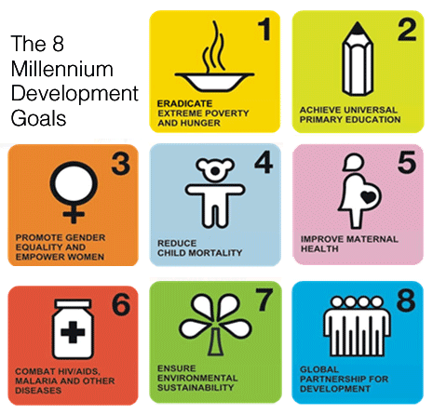
The Millennium Village Project was established in 2004 by Columbia’s Earth Institute under the United Nations, spanning 13 villages located across Africa in countries such as Mali and Nigeria, with the pilot village beginning in Kenya. The MVP was established with the fundamental purpose of reducing poverty, hunger, disease, illiteracy, environmental degradation, and discrimination against women. The Millennium Village Project consisted of 8 main goals: eradicate extreme poverty and hunger, achieve universal primary education, achieve gender equality, reduce child mortality, improve maternal health, combat HIV/AIDS and Malaria, ensure environmental sustainability, and develop global partnerships for the continuation of development.
Scientists from Columbia University assisted these villages by utilizing a variety of biophysical and socioeconomic interventions, collaborating with local governments and the community for both short and long-term success in regions of agriculture, healthcare, and infrastructure. This 10-year project aims to help the Millennial Villages to be self-governing and, if possible, self-sustaining. This report intends to analyze the success of the Millennial Village Project, with a focus on the case study of Sauri, Kenya, for further evidence of the project’s effect on the local economy.
Purpose- (Naomi Chavez)
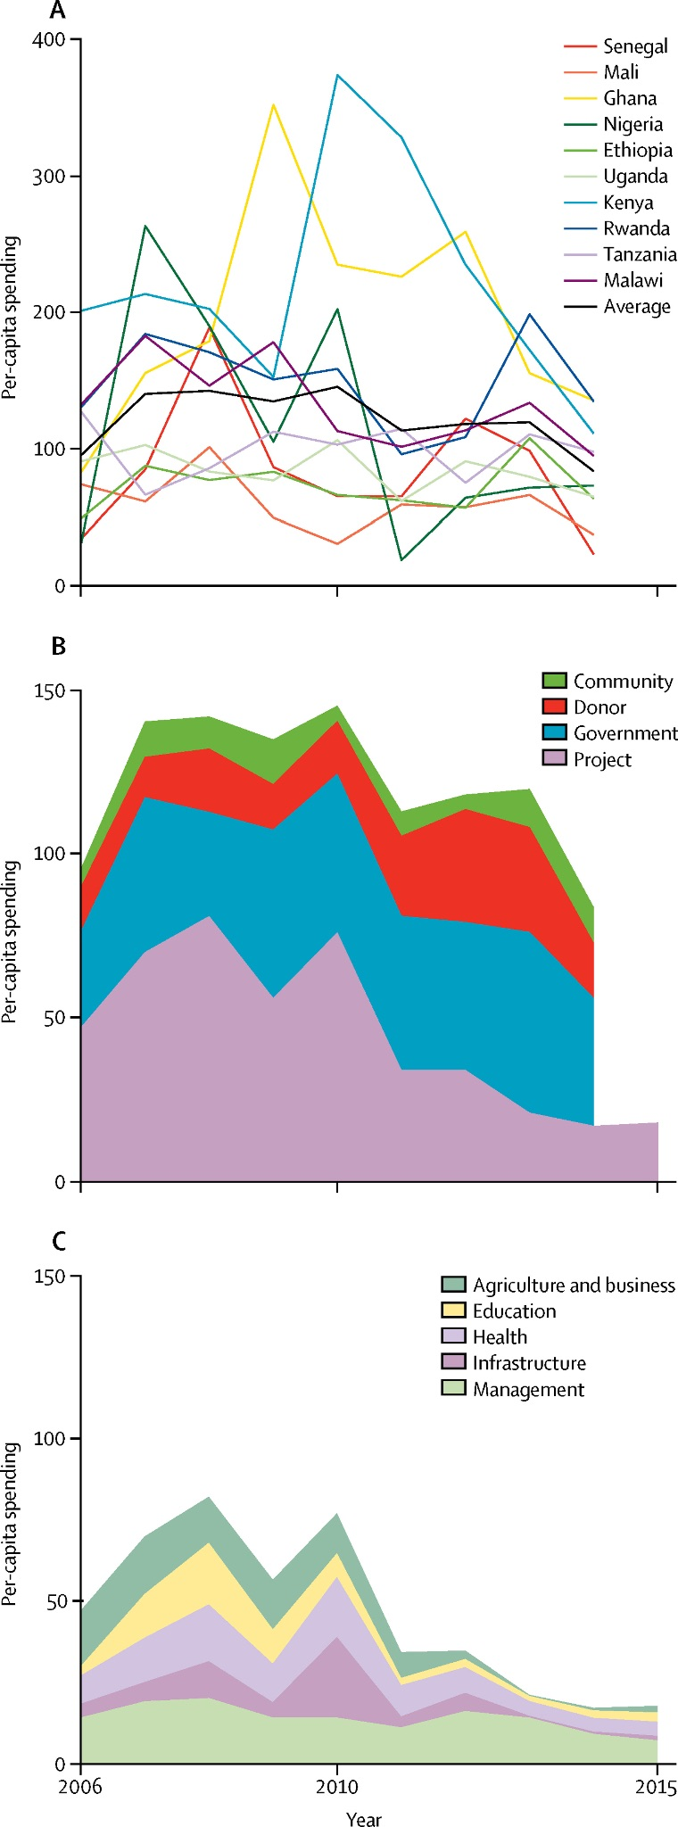
These interventions aimed to study the implementation of the Millennium Village Project in the hope of increasing children’s survival rates. The Millennium Village Project set developmental goals, such as a time limit for when they would expect a change in mortality levels. For a more realistic approach, the Millenium Village Project focused on increasing their lifespan after only three years, the purpose being to find a change between the local levels. Also, this study was specifically designed to focus on sub-Saharan African children and then expand to other areas based on the results. These areas were specifically chosen from the community due to their high rates of starvation and severe need. It was essential to focus on the small rural areas that needed focus the most, which is why they stood out from other local communities. As a result, this impact could be seen in key differences between the usage of household usage. “After three years, reductions in poverty, food insecurity, stunting, and malaria parasitaemia were reported across nine Millennium Village Sites” . Additionally, these impacts could also be seen as early as pregnancy. “The emphasis within MNCH varies, with skilled care at facility levels recommended for saving maternal lives and scale-up of community and household care for improving newborn and child survival”. These rural villages needed these interventions at desperate times, without the resources from this project, families would have been incomplete. Therefore, the purpose of the Millennium Village Project was to direct all attention towards the families, children, elders and newborns who were suffering from poverty. With the application of these projects, they were able to create change not only in the lives of many families, but also in survival rates as well.
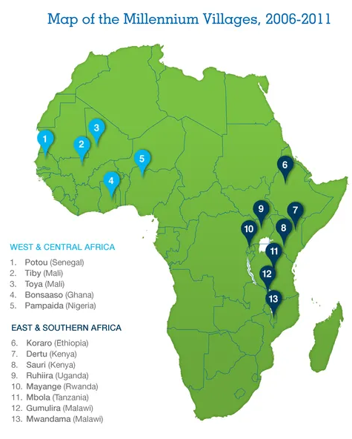
Application – (Desiree Plascencia)
The MVP targeted rural village clusters across sub-Saharan Africa, including Kenya, Uganda, Ghana, Ethiopia, and six other countries. These regions were chosen based on their high poverty levels and low human development indices. By focusing on such areas, the project aimed to showcase significant improvements that could serve as a model for scaling up development efforts continent-wide. Geographical diversity was also a consideration to further study agricultural techniques and adaptation of interventions. Collaborations with local governments, community leaders, and nongovernmental organizations were crucial in site selection – ensuring local support and sustainability. The integrated approach of the project had notable successes across its implementation sites. In agriculture, interventions led to improved food security and higher crop yields. Educational investments, including the construction of schools, contributed to higher school enrollment rates and improved educational outcomes by region. Health interventions, ranging from the establishment of health clinics to the distribution of vaccines, resulted in reduced mortality rates. Infrastructure development, including roads, water supply systems, and electricity, improved access to markets and essential services, enhancing overall well-being in the selected site. However, the MVP encountered several challenges – the sustainability of project outcomes beyond the initial funding phase was a large concern. “The project achieved around a third of the MDG-related targets and fell short on two-thirds, although with at least some progress towards most of the targets”.
Funding (Shayla Toone)
The Millennium Village Project received funding from nonprofits and private companies seeking to invest in the African villages to boost economic growth. For example, the Open Society Foundation donated over $50 million towards the project’s implementation, being one of the largest contributors to the MVP. The Millennium Village Project approximated a budget of $132 given to each person per year, which later decreased to $110 per person per year for the last half of the project, as well as communal beneficiaries to allow the villages to become self-sustaining. 27 million dollars were estimated for the total direct cost of the project’s implementation. This funding was dispersed between aspects such as household incomes, medical supplies, and infrastructure to develop the villages’ quality of life.
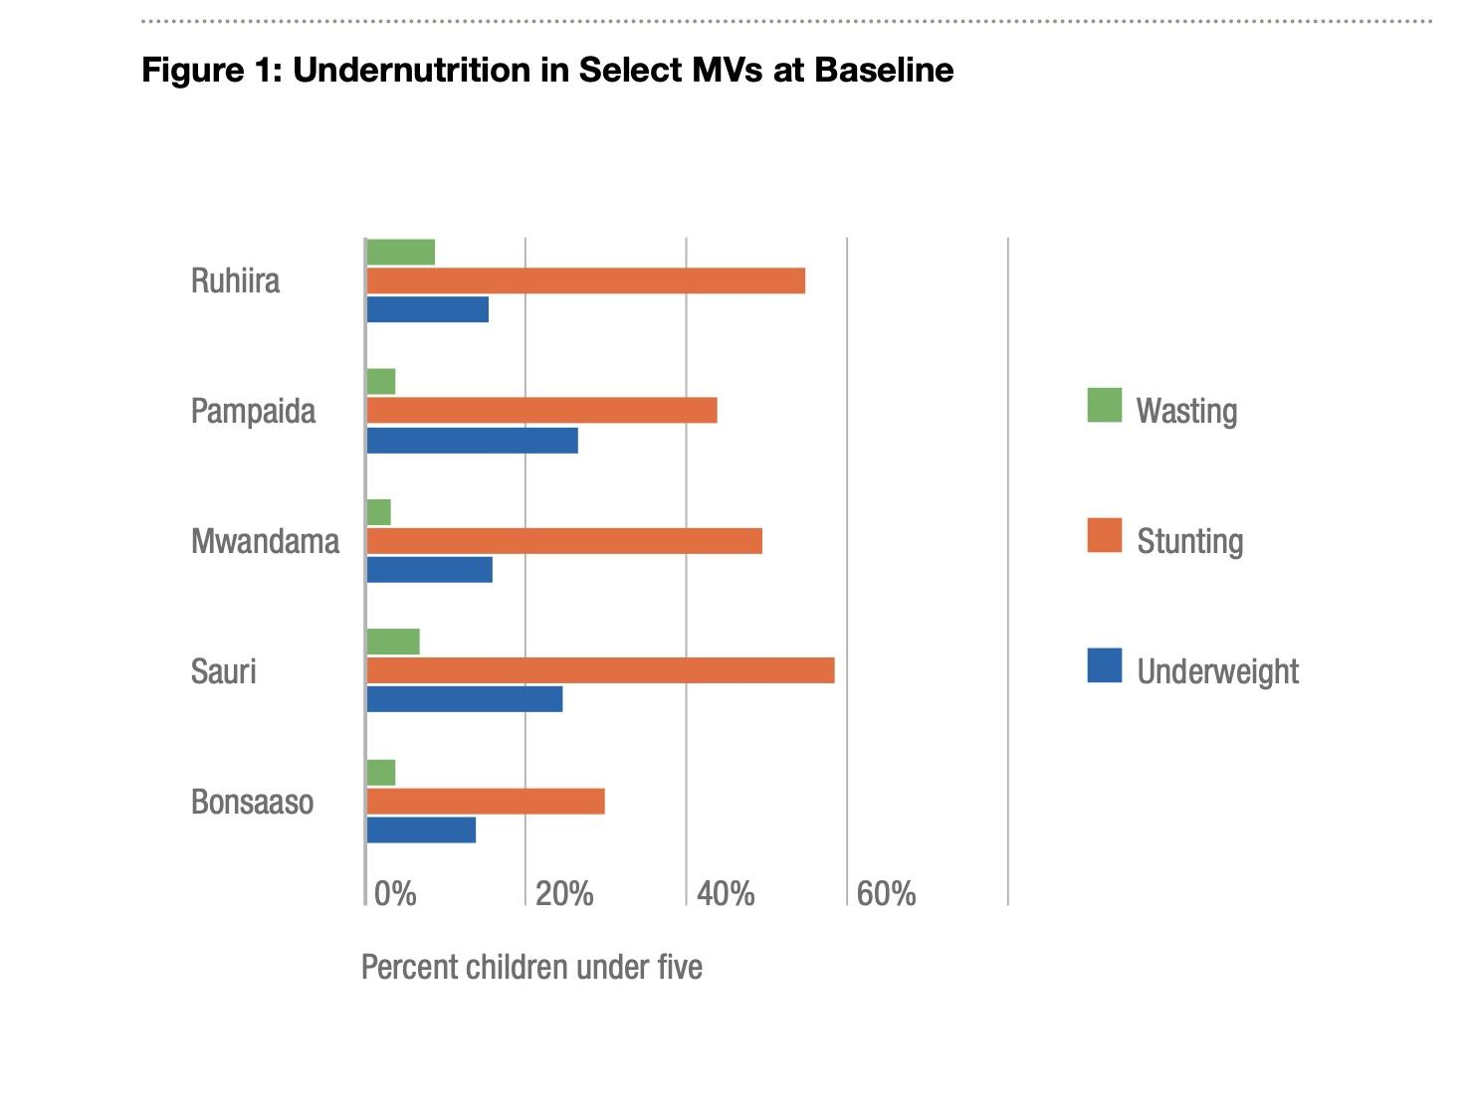
Case study: Sauri, Kenya (Shayla Toone)
The case study of Sauri, Kenya was the pilot program for the Millenium Village Project, chosen for its large population of around 65,000 people which showed promise for the implementation of the goals of the MVP and expansion by the local government. The agricultural potential of Sauri also led to this village becoming the pilot program of the Millennium Village Project, as the village has a subtropical climate with direct access to streams, rivers, and Lake Victoria. From the villages picked for the MVP, Sauri had the highest rates of underweight and malnourished children under 5 years old, making it a prioritized program to implement the project goals and increase the community's quality of life.
Prior to the implementation of the Millennium Village Project, Sauri experienced widespread poverty and hunger, as around 59% of children suffered from malnutrition and 80% of the population earned less than $1 each day. Although Sauri is the perfect climate for agricultural success, the village was producing a deficit in their main crop, maize, due to the soil being depleted from nutrients from overfarming and little use of fertilizers. Sauri lacked enough teachers for the primary school and had no access to electricity or modern toilets. There were no doctors near the village of Sauri before the implementation of the MVP, with the closest clinic being a 3 mile walk over rough terrain. The lack of access to medical services proved to be detrimental to Sauri, as over half of the adult population and around 75% of children contained Malaria parasites in their blood, proving the large presence of diseases in the village. Only 7% of the population had access to clean water, while the rest drank from river sources with bacterial contamination.
The actors involved in the Millennium Village Project of Sauri, Kenya range from local governments, NGO’s, and companies in the private sector. The Government of Kenya helped to construct primary schools and roadways in Sauri while providing water testing and HIV testing supplies to battle contamination disease prevention in the village. NGOs and international organizations gave Sauri opportunities to grow their economy in a sustainable manner as well as donating equipment and resources for development. For example, UNAIDS and the CDC supported the village by providing medical care to control the spread of HIV/AIDS and supplies to test the villagers for diseases. Heifer International donated dairy cows for the primary school’s meal program, and the company GTZ improved household kitchens with modern cookstoves. While the NGOs and local governments offered aid to boost the economic development of Sauri, companies within the private sector profited from implementing their technology in the developing village. An example of this is Ericsson telecommunications company, who introduced mobile phones to the village, giving the community the ability to easily communicate while financially gaining from the service costs. While all organizations intended to aid Sauri in its development, some companies were able to profit from the village as well.
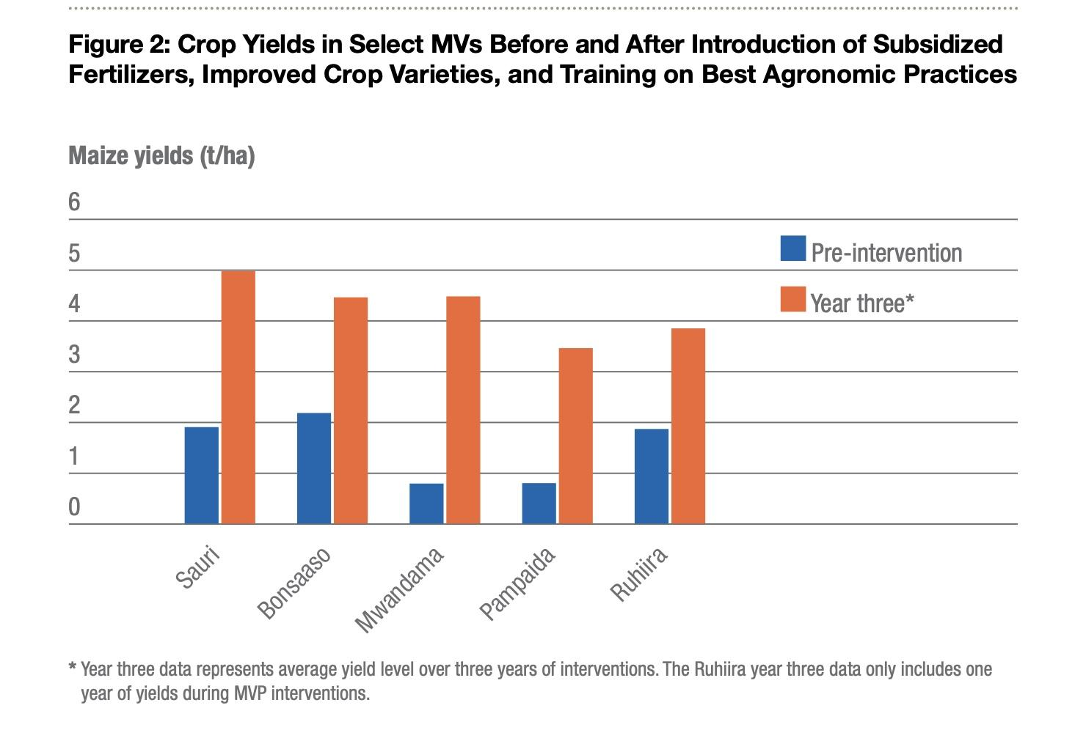
In 2006, 72.6 tons of maize seed and 3.6 tons of fellow seed were distributed to the farmers of the village. The data in the graph pictured proves that crop yields increased by 250% during the first three years and 400% over the course of the Millennium Village Project. The increase in farming profits was successful in reducing malnutrition and hunger as data concluded Sauri experienced a 24% decrease in underweight infants and a 39% decrease in malnutrition within the first three years of the project. The increase in agricultural earnings was successful in reducing malnutrition and hunger as data concluded Sauri has a 24% decrease in underweight infants and a 39% decrease in malnutrition within the first three years of the project’s implementation.
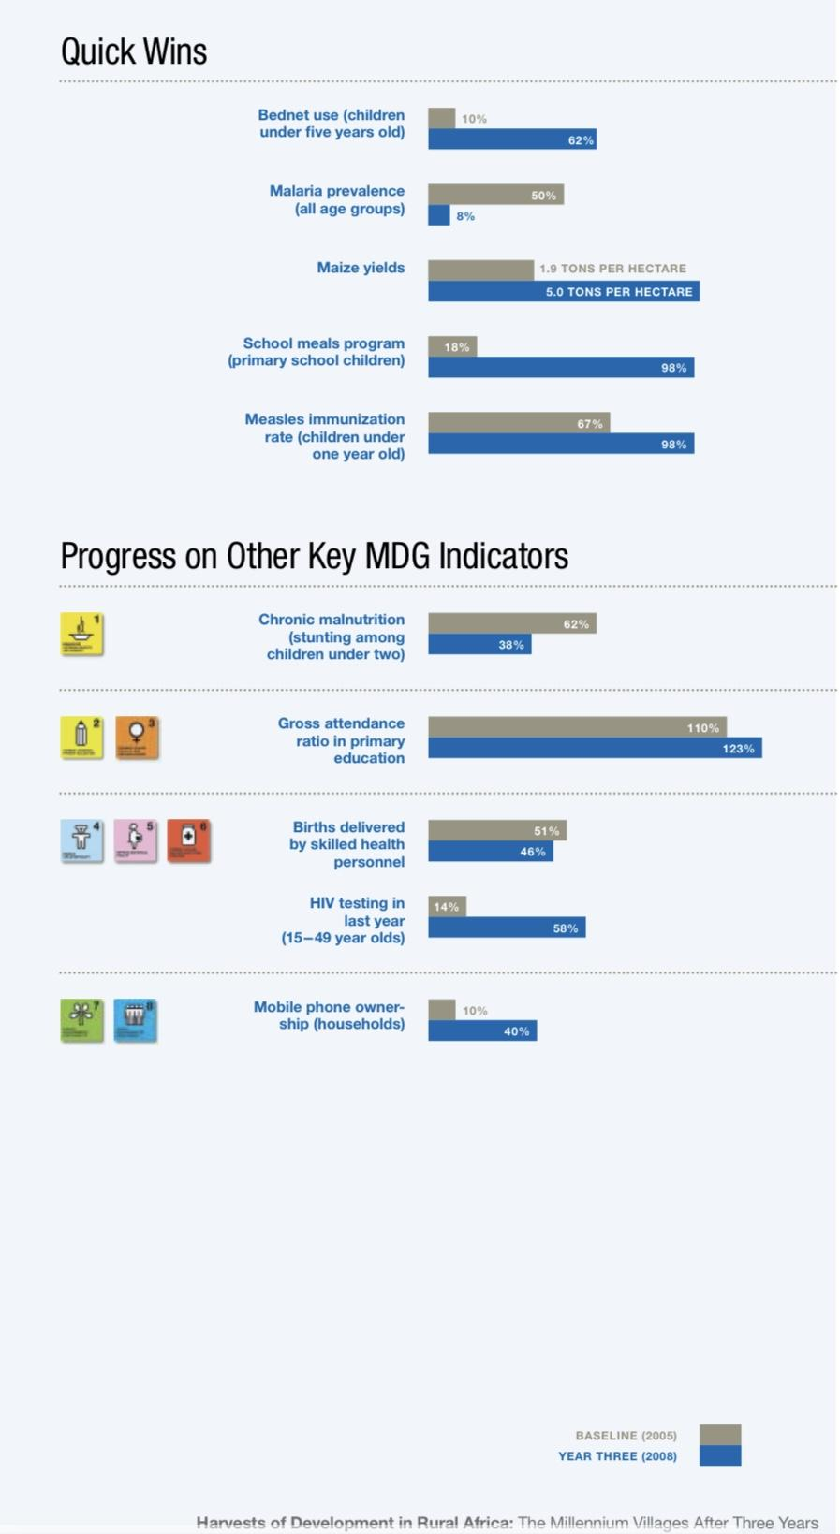
The Millenium Village of Sauri experienced an increase in access to healthcare services, as 5 clinics were renovated and constructed while over 25 healthcare workers were hired and trained. An influx of resources for the local hospital improved maternal health and villagers had access to quality health clinics with fully operational equipment. The Millenium Village Project also worked to Combat HIV/AIDS, malaria, and other diseases by increasing rates of testing by 4 times. The data in the graph included below shows that Measles immunization rates for children also increased by 30%, leading to almost all children in Sauri being vaccinated for diseases. 62% of children under 5 were sleeping under bed nets and over 32,000 insecticide-treated bed nets were donated to combat Malaria, which went down from 50% to 8% over the course of the Millennium Village Project.
Primary education in Sauri, Kenya was improved largely due to the implementation of a school food program, providing locally produced food to over 17,000 children. The decrease in hunger proved successful in increasing school attendance and academic performance, as Bar Sauri Primary School was ranked 195th in top academic performance but jumped to the top 10. Studies found that educating the girls of Kenya increased women’s empowerment inside the household, but also increased their acceptance of the political status quo. Long-term commitment of aid from the Kenyan government led to the expansion of the project to the district level, while creating a goal to implement the economic growth to a national level. Progress was reported after visiting Sauri’s education sector in 2010, which showed new computer labs, gender separated bathrooms, rainwater harvesting, livestock, and kitchens that housed food programs for the students. The Kenyan Government also extended an existing water pipe, giving the village of Sauri access to clean water.
The pilot program of Sauri was proven to have success in eradicating poverty and hunger, improving healthcare, achieving universal primary education, and promoting gender equality. But while showing success with the short-term goals outlined in the Millennium Village Project, but as with other villages, Sauri lacks the ability to maintain long-term economic growth with their current revenue for basic services. Most residents are farmers, relying on community members that work outside of the village to bring in capital. However, significant interventions were implemented to boost the economy of Sauri, Kenya to aid in self-governance and self-sustainment.
Results (Kellen Downey)
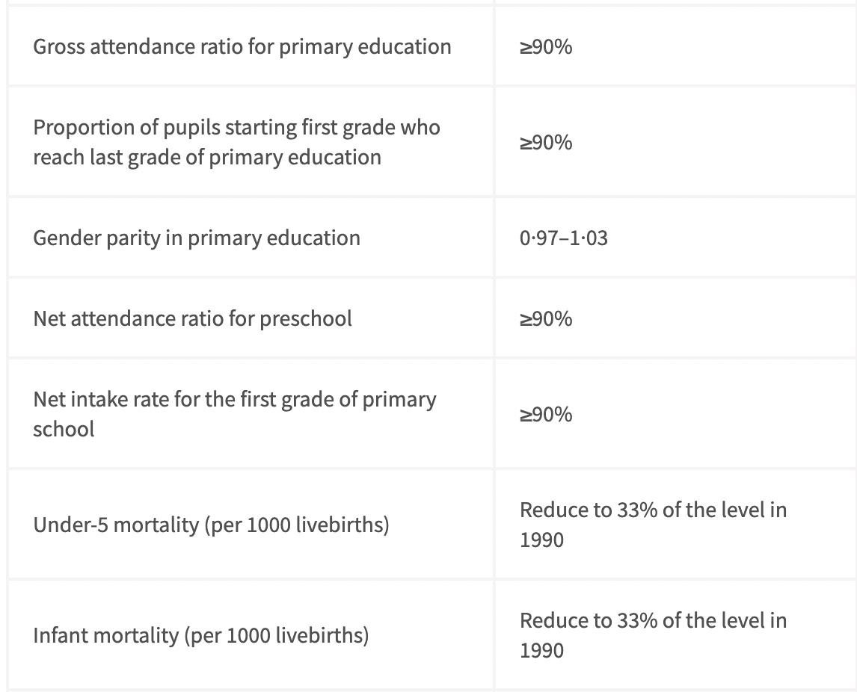
Overall, the impact of the Millennium Village Project appears only 25% successful, according to one study. Attendance markings improved with the establishment of universal primary education, and many healthcare reforms were promising, such as vaccinations and professionally delivered births. Primary school attendance improved by 7.7% for example. Conversely, the project appears to only focus on immediate goals, such as providing supplies/vaccinations or constructing schoolhouses, rather than addressing systemic issues such as economic corruption. The project lacked enough focus on the ability to construct lasting impacts and how such reforms could be funded long term. In turn, the targeted population of the project was positively impacted, but not to the hoped extent that was originally desired. This appears so due to a tapestry of systemic issues within the country which cannot be immediately repaired such as poverty. Yet, returns on investment in the realm of education appear the highest, and noting, did not set the bar very high.
The overly-ambitious project was conducted by leaders that executed their goals all at once, rather than in “small-scale interventions” which resulted in a lack of focus on circumstances which required long-term focus. According to a research article published through Oxford University, “There were income improvements that could be attributed to the Millennium Villages project, but there was no accompanying increase in consumption, and the improvements in income were insufficient to break the poverty trap. The population remains poor”. Overall, the project was successful in many ways; however, its exceedingly high ambition prevented it from being realistically sustainable.
Critique (Shayla Toone)
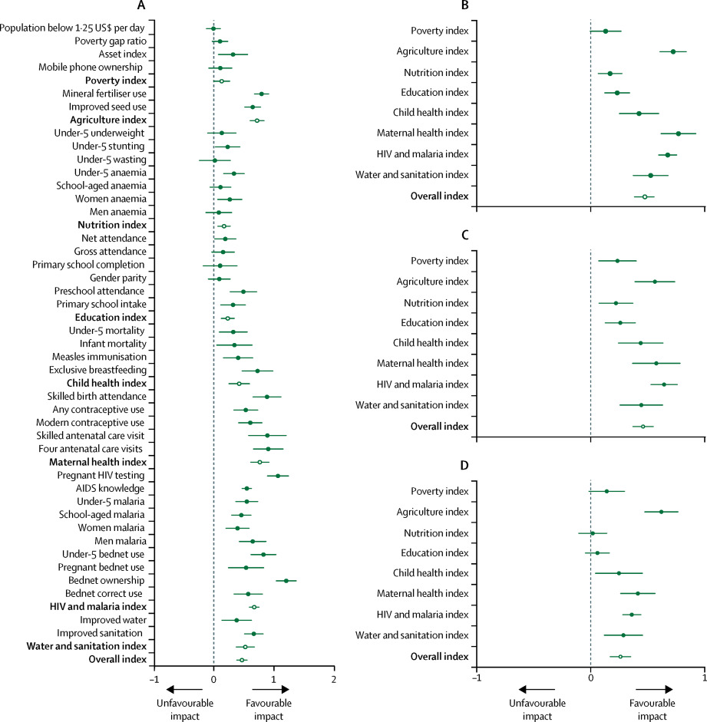
Although the case study in Sauri, Kenya proved to be successful in providing short-term solutions to the economic difficulties in the village, current research on the Millennium Village Project criticizes the overall success of the economic implementations. Prominent critiques of the Millennium Village Project include the works of Shira Mitchell, utilizing a cross-sectional survey data of 40 areas of interest to analyze the overall success of the project. This data concludes that the MVP had no significant impact on the long-term economic success of the target villages, specifically involving poverty levels. Outcomes on nutrition and education were also inconclusive at the end of the Millennium Village Project, however data on vaccines and asset ownership proved to have a significant impact on the villages.
From the information presented in this graph, the results of the Millennium Village Project were documented to appear more successful than they actually were. Mitchell concludes that from the data provided by the MVP, only ⅓ of the goals were met in the African villages. The author criticizes the ability to track the impacts of poverty in the villages and the unorganized collection of data. This project experienced difficulties in gathering and analyzing data due to language and geographical barriers which contributed to misinformation and false long-term success.
Studies conducted in 2012 by the Government of the United Kingdom concluded that in order to eradicate poverty, the Millennium Village Project must give each household a minimum of $12,000 to promote self-sustainment. Therefore, the project’s annual $132 per person per year barely amounts to a few thousand dollars over the course of the MVP’s implementation, proving to be an insufficient amount of funding to bring these villages out of poverty.
The project’s 10-year timeline proved to be unsuccessful in maintaining economic growth in the millennium villages as poverty and income are a systematic issue that require long-term influence that surpassed the scope of the Millennium Village Project. From the research presented in this report, it can be argued that the Millennium Village Project would have made a greater impact on the economic success of the villages if implemented for a longer period of time to reach the $12,000 requirement per household.
Conclusion (Shayla Toone)
The Millennium Village Project established in 2004 intended to serve the fundamental purpose of eradicating poverty and hunger, child mortality, and diseases while improving primary education, gender equality, maternal health, and environmental sustainability. These interventions were implemented over the course of 10 years across 13 developing villages in Africa that had statistically high poverty levels and low human development indices. This project was largely funded by nonprofits and NGOs who gave resources and financial aid to the target villages with an overall estimated budget of 27 million US dollars. The case study of Sauri, Kenya showed substantial success in the short-term goals of the project, improving areas of agriculture, infrastructure, healthcare, and education. However, recent studies criticize the long-term achievement of the Millennium Village Project as it did not provide enough financial resources for the villages to remain self-sustaining past the termination of the project. From the data provided in this report, it is clear that while the long-term goals of the Millennium Village Project were not met to full capacity, there was prominent short-term success in Sauri, Kenya.

“Millennium Villages Project.” Millennium Villages Project. Accessed July 19, 2024. https://www.millenniumpromise.org/millenniumvillages#MVPTimeline.
Pronyk, Paul M, et al. “The Effect of an Integrated Multisector Model for Achieving the Millennium Development Goals and Improving Child Survival in Rural Sub-Saharan Africa: A Non-Randomised Controlled Assessment.” The Lancet. Accessed May 8, 2012. https://www.thelancet.com/journals/lancet/article/PIIS0140-6736(12)60207-4/abstract.
Barnett, Chris, and Rachel Eager. “Impact Evaluation of the Millennium Villages Project in Northern Ghana .” Itad, March 22, 2012. https://www.itad.com/project/ghana-dfid-impact-evaluation-of-mvp-sada-northern-ghana-millennium-village/#:~:text=Findings,children%20sleeping%20under%20bed%20nets.
Clemens, Michael. “When Rigorous Impact Evaluation Is Not a Luxury: Scrutinizing the Millennium Villages.” Center For Global Development, October 11, 2010. https://www.cgdev.org/blog/when-rigorous-impact-evaluation-not-luxury-scrutinizing-millennium-villages.
“The Millennium Villages Project.” United Nations. Accessed July 19, 2024. https://www.un.org/esa/coordination/Alliance/Earth%20Institute%20-%20The%20Millennium%20Villages%20Project.htm.
Sachs, Jeffrey D. “Lessons from the Millennium Villages Project: A Personal Perspective - The Lancet Global Health.” The Lancet Global Health, May 2018. https://www.thelancet.com/journals/langlo/article/PIIS2214-109X(18)30199-2/fulltext.
“Millennium Villages - Sauri, Kenya.” Millenium Villages. Accessed July 19, 2024. http://mv-aid.org/mv/sauri.html.
Friedman, Willa, Michael Kremer, Edward Miguel, and Rebecca Thornton. 2016. “Education as Liberation?” Economica 83: 1–30.
“Millennium Villages Project: News from the Colombia Climate School.” State of the Planet, June 11, 2010. https://news.climate.columbia.edu/tag/millennium-villages-project/page/3/.
“Millennium Villages - Sauri, Kenya.” Millenium Villages. Accessed July 19, 2024. http://mv-aid.org/mv/sauri.html.
“The Millennium Villages Project.” United Nations. Accessed July 19, 2024. https://www.un.org/esa/coordination/Alliance/Earth%20Institute%20-%20The%20Millennium%20Villages%20Project.htm.
“Harvests for Development in Rural Africa: The Millennium Villages After Three Years .” The Earth Institute - Columbia University, 2010. https://www.earth.columbia.edu/sitefiles/file/pressroom/MVP_Report_2010FINAL.pdf.
“Millennium Villages - Sauri, Kenya.” Millenium Villages. Accessed July 19, 2024. http://mv-aid.org/mv/sauri.html.
“Harvests for Development in Rural Africa: The Millennium Villages After Three Years .” The Earth Institute - Columbia University, 2010. https://www.earth.columbia.edu/sitefiles/file/pressroom/MVP_Report_2010FINAL.pdf.
“Harvests for Development in Rural Africa: The Millennium Villages After Three Years.” The Earth Institute - Columbia University, 2010. https://www.earth.columbia.edu/sitefiles/file/pressroom/MVP_Report_2010FINAL.pdf.
“The Millennium Villages Project.” United Nations. Accessed July 19, 2024. https://www.un.org/esa/coordination/Alliance/Earth%20Institute%20-%20The%20Millennium%20Villages%20Project.htm.
Soros, George. “Scaling Up the Millennium Villages Project.” Open Society Foundations, October 3, 2011. https://www.opensocietyfoundations.org/voices/scaling-millennium-villages-project.
Soros, George. “Scaling Up the Millennium Villages Project.” Open Society Foundations, October 3, 2011. https://www.opensocietyfoundations.org/voices/scaling-millennium-villages-project.
Clemens, Michael. “New Documents Reveal the Cost of “Ending Poverty” in a Millennium Village: At Least $12,000 Per Household” Center for Global Development. Marcho 30, 2012, https://www.cgdev.org/blog/new-documents-reveal-cost-%E2%80%9Cending-poverty%E2%80%9D-millennium-village-least-12000-household.
Mitchell, Shira. “The Millennium Villages Project: a retrospective, observational, endline evaluation.” The Lancet Global Health. May, 2018, https://www.thelancet.com/journals/langlo/article/PIIS2214-109X(1830065-2/fulltext#seccestitle10.
Green, Duncan. “Thumbs up or thumbs down? Did the Millennium Villages Project Work?” From Poverty to Power. September 20, 2018, https://frompoverty.oxfam.org.uk/thumbs-up-or-thumbs-down-did-the-millennium-villages-project-work/.

