African Leadership University
School of Science and Technology
Geospatial Flood Risk Modelling Using Climate Data and Hidden Markov Models in Rwanda
Capstone Project Proposal
BSc. in Software Engineering
Kellen Murerwa
Supervisor: Emmanuel Adjei
24th May 2026

TABLE OF CONTENTS
LIST OF TABLES 6
LIST OF FIGURES 7
LIST OF ACRONYMS AND ABBREVIATIONS 8
ABSTRACT 9
ACKNOWLEDGEMENT OF AI ASSISTANCE 10
CHAPTER ONE: INTRODUCTION 10
1.1 Introduction and Background 10
1.2 Problem Statement 11
1.3 Project Main Objective 12
1.3.1 Specific Objectives (SMART) 12
1.4 Research Questions 12
1.5 Project Scope 13
1.6 Significance and Justification 14
1.7 Research Budget 14
1.8 Research Timeline 15
CHAPTER TWO: LITERATURE REVIEW 17
2.1 Introduction 17
2.2 Historical Background of the Research Topic 17
2.3 Overview of Existing Systems 18
2.4 Review of Related Work 18
2.5 Summary of the Reviewed Literature 20
2.6 Strengths and Weaknesses of the Existing Systems 21
2.6.1 Strengths of Current Approaches 21
2.6.2 Weaknesses and Limitations 22
2.6.3 Comparison of this System with Current Approaches 23
2.7 General Comment and Conclusion 23
CHAPTER THREE: SYSTEM ANALYSIS AND DESIGN 24
3.1 Introduction 24
3.2 Research Design 24
3.2.1 Model of Development Framework 24
3.3 Requirements Specification 25
3.3.1 Functional Requirements 25
3.3.2 Non-Functional Requirements 26
3.4 System Architecture 26
3.4.1 Data Definition and Acquisition 27
3.4.2 Machine Learning and HMM Pipeline 28
3.4.3 Model Comparison and Architecture 29
3.4.4 Spatial Validation Against Official Flood-Risk Polygons 30
3.4.5 Preliminary Validation Results 31
3.5 UML and Modelling Diagrams 32
3.5.1 Use Case Diagram 32
3.5.2 Class Diagram 32
3.5.3 Entity-Relationship Diagram 33
3.5.4 Sequence Diagram 34
3.5.5 HMM State-Transition Model 35
3.6 Development Tools 36
CHAPTER FOUR: RESULTS AND DISCUSSION 38
4.1 Introduction 38
4.2 Dataset and Study Area 38
4.3 Supervised Classification Results 38
4.4 Explainability (SHAP and Feature Importance) 39
4.5 Hidden Markov Model: Temporal Dynamics 41
4.6 Spatial Validation Against Official Flood-Risk Polygons 41
4.7 The Inspection Dashboard 42
4.8 Discussion 43
CHAPTER FIVE: CONCLUSION AND FUTURE WORK 43
5.1 Summary of Findings 43
5.2 Contributions 43
5.3 Limitations 43
5.4 Future Work 44
5.5 Concluding Remarks 44
REFERENCES 44

LIST OF TABLES
Table 1.1: Research Budget (USD) 8
Table 1.2: Project Schedule Summary 9
Table 2.1: Summary of Reviewed Literature 16
Table 2.2: Strengths and Weaknesses of Existing Approaches 18
Table 2.3: Comparative Analysis: Proposed System vs Existing Approaches 19
Table 3.1: Functional Requirements 23
Table 3.2: Non-Functional Requirements 24
Table 3.3: Datasets Within the Scope of the Study 26
Table 3.4: ML and HMM Pipeline Layers 27
Table 3.5: Candidate Models and Baselines for Flood-Pressure Modelling 28
Table 3.6: Development Tools and Justification 34

LIST OF FIGURES
Figure 1: System Architecture of the Geospatial Flood-Pressure Modelling System 25
Figure 2: Hidden Markov Model of Daily Flood-Pressure State Transitions 33
Figure 3: Use Case Diagram 29
Figure 4: Class Diagram (UML) 30
Figure 5: Entity-Relationship Diagram (Crow's-Foot Notation) 31
Figure 6: Sequence Diagram: Daily Flood-Pressure Estimation 32
Figure 7: Project Gantt Chart (24 May - 28 July 2026) 9
Figure 8: Iterative Agile-Scrum Development Model 22

LIST OF ACRONYMS AND ABBREVIATIONS
AOI Area of Interest
ALU African Leadership University
API Application Programming Interface
AUC Area Under the (ROC) Curve
CHIRPS Climate Hazards Group InfraRed Precipitation with Station data
DEM Digital Elevation Model
ENACTS Enhancing National Climate Services
ERD Entity-Relationship Diagram
GIS Geographic Information System
HMM Hidden Markov Model
IPCC Intergovernmental Panel on Climate Change
MINEMA Ministry in charge of Emergency Management (Rwanda)
ML Machine Learning
MLOps Machine Learning Operations
NISR National Institute of Statistics of Rwanda
OSM OpenStreetMap
REMA Rwanda Environment Management Authority
RF Random Forest
RMSE Root Mean Square Error
SDG Sustainable Development Goal
SDLC Software Development Life Cycle
SRTM Shuttle Radar Topography Mission
TWI Topographic Wetness Index
UML Unified Modeling Language
WGS World Geodetic System
XGBoost Extreme Gradient Boosting

ABSTRACT
Rwanda's urban and peri-urban catchments face recurrent flood risk driven by intense rainfall, steep slopes, informal settlement, poor drainage and land-cover change. Existing flood-risk resources, official hazard maps and climate platforms, are valuable but largely static: they identify generally vulnerable zones yet do not show how flood pressure changes from day to day after rainfall. This research proposes the design and development of a geospatial machine-learning and Hidden Markov Model (HMM) framework that fuses real daily rainfall, terrain, hydrology and urban-exposure data to estimate low, moderate and high flood-pressure states over time for a defined flood-prone corridor in Kigali, the Nyabugogo-Mpazi catchment. The study follows an iterative agile-scrum methodology over nine weeks (24 May - 28 July 2026). The selected area is divided into a 100-250 m grid; each cell-day is linked to rainfall accumulation features (1-, 3-, 7- and 14-day totals) from CHIRPS and Meteo Rwanda, terrain features (elevation, slope) from SRTM, hydrology and exposure features from OpenStreetMap, and intersection with official flood-risk polygons. A supervised classifier (Random Forest, XGBoost) scores each cell-day as low, moderate or high flood pressure, and an HMM temporal layer estimates daily state transitions. The framework is hypothesised to achieve a macro F1-score of at least 0.75, a high-pressure recall of at least 0.80, and spatial agreement in which at least 70% of predicted high-pressure cells fall within official flood-risk polygons. The project is framed honestly as flood-pressure estimation and risk screening rather than confirmed flood-event prediction, contributing a reproducible, time-aware geospatial workflow for decision support in data-scarce East African cities.
Keywords: flood risk, Hidden Markov Model, geospatial machine learning, climate data, CHIRPS, flood-pressure states, Rwanda, Kigali, Nyabugogo, decision support.

ACKNOWLEDGEMENT OF AI ASSISTANCE
This capstone was developed with the assistance of an AI coding assistant (Anthropic Claude). The tool was used to help implement the data-acquisition and modelling pipeline, generate figures, and draft portions of this document. All design decisions, data sources, methods, results and their interpretation were reviewed, reproduced and are understood by the author, who takes full responsibility for the work. AI assistance was used as a productivity and learning aid, and the analyses are reproducible from the accompanying source code.

CHAPTER ONE: INTRODUCTION

1.1 Introduction and Background
Rwanda, the 'land of a thousand hills', combines steep topography, dense settlement and an increasingly variable rainfall regime, a combination that places its towns and cities at persistent risk of flooding. The Intergovernmental Panel on Climate Change identifies East Africa as a hotspot for rainfall irregularity and intensifying extreme-precipitation events (IPCC, 2022), and downscaled projections released by the Rwanda Meteorology Agency (2022) confirm rising intra-seasonal variability and heavier short-duration storms. When such storms fall on steep, poorly drained urban catchments, surface runoff concentrates rapidly, producing inundation, road disruption, property damage and loss of life.
The human cost is well documented. In a single month in 2023, heavy rainfall triggered floods and landslides that killed more than 120 people and damaged hundreds of homes across northern and western Rwanda, and the Ministry in charge of Emergency Management records flooding among the most frequent and damaging hazards in its annual disaster statistics (MINEMA, 2023). In Kigali, flood-prone corridors cluster near streams, wetlands and low-lying settlements; the Nyabugogo-Mpazi catchment in particular has been studied for decades as an emblematic urban flood plain where informal settlement and commercial activity coexist with recurrent inundation (MINEMA, 2023; The New Times, 2026).
A growing body of work shows that geographic information systems (GIS) and machine learning (ML) can map where flooding is likely. Mind'je et al. (2019) modelled national flood susceptibility for Rwanda using logistic regression over ten terrain, hydrological and land-cover factors, while Mind'je et al. (2021) coupled geospatial analysis with hydrological modelling to simulate peak flow and volume in the Nyabarongo catchment. Internationally, systematic reviews report that ensemble learners such as Random Forest and gradient boosting are among the most consistent performers for flood-susceptibility and flood-risk tasks (Mosavi, Ozturk, & Chau, 2018). These approaches, however, typically produce a single static map. They answer 'where is generally vulnerable?' but not the sharper, more operational question this research addresses: given recent rainfall and the fixed geography of a place, how does its flood pressure move between low, moderate and high states from one day to the next?

1.2 Problem Statement
First, existing flood-risk resources for Rwanda are predominantly static. Official hazard layers and susceptibility maps (Mind'je et al., 2019) identify vulnerable zones effectively, but they are spatial snapshots that do not show how flood pressure changes day to day following rainfall events. A community living beside the Mpazi drain is 'in a flood-risk zone' every day of the year on a static map, which gives responders little help in deciding when that zone is most dangerous.
Second, climate services provide rainfall information, but rainfall values alone do not directly explain how a specific urban catchment moves between levels of flood pressure. Datasets such as CHIRPS (Climate Hazards Center, 2024) and the national ENACTS rainfall products offer long, gridded daily series, yet translating accumulated rainfall into a per-cell, time-varying flood-pressure state requires fusing it with terrain, drainage proximity and exposure, and modelling the temporal dynamics explicitly.
Third, although machine-learning flood studies are now common, most classify flood susceptibility from terrain, land cover and distance-to-river features without a temporal state model (Khosravi et al., 2018; Ma et al., 2021). There is therefore a documented gap for a localised, reproducible workflow that integrates real daily climate data, official flood-risk spatial layers, terrain features and urban-exposure indicators into a single time-aware model of flood-pressure states.
This research proposes a geospatial ML and Hidden Markov Model framework that: (i) divides a selected flood-prone corridor in Kigali into grid cells linked to daily rainfall and static spatial features; (ii) derives and classifies low, moderate and high flood-pressure states with supervised models; and (iii) applies an HMM as a temporal layer that estimates how those states transition over a daily time step. To remain academically honest, the system claims to estimate derived flood-pressure states validated against official flood-risk polygons, not to predict confirmed flood events, unless verified daily incident records become available.

1.3 Project Main Objective
To develop and evaluate a geospatial machine-learning and Hidden Markov Model framework that uses real rainfall and spatial data to estimate daily flood-pressure states for a selected flood-prone area in Rwanda, the Nyabugogo-Mpazi corridor in Kigali, and to validate those estimates against official flood-risk spatial information.

1.3.1 Specific Objectives (SMART)
- To define a flood-prone study area in Kigali (the Nyabugogo-Mpazi corridor) and prepare a 100-250 m grid-based spatial unit, and to acquire and preprocess daily rainfall (CHIRPS / Meteo Rwanda, 2018-2024), SRTM elevation, OpenStreetMap geolocation data and official flood-risk polygons for that area, completed by 21 June 2026.
- To engineer daily rainfall accumulation features (1-, 3-, 7- and 14-day totals) and static geospatial features (elevation, slope, distance-to-river, road and building density, flood-polygon intersection) into a reproducible grid-cell-by-day modelling table, and to derive low, moderate and high flood-pressure labels, by 28 June 2026.
- To train and benchmark at least three supervised models (a Logistic Regression / Decision Tree baseline, Random Forest and XGBoost) against a rainfall-threshold baseline and a static flood-polygon baseline, achieving a macro F1-score of at least 0.75 and a high-pressure-state recall of at least 0.80 on a held-out period, by 12 July 2026.
- To integrate a Hidden Markov Model temporal layer that estimates daily transitions between flood-pressure states, and to evaluate it on next-step accuracy and on spatial concordance with official flood-risk polygons, targeting an enrichment (lift) of at least 1.4 and an inside-versus-outside odds ratio of at least 1.5 for predicted high-pressure cells, by 22 July 2026.
- To produce flood-pressure risk maps, a reproducible notebook/dashboard for inspecting results by date and location, and a final report and defence presentation evidencing the framework's value for decision support, by 28 July 2026.

1.4 Research Questions
- How can daily rainfall data and geospatial features be combined to estimate flood-pressure states in a selected flood-prone area in Kigali, Rwanda?
- Which geospatial features, such as slope, elevation, river proximity, building density, road density and official flood-risk intersection, contribute most to flood-pressure classification?
- How well does a geospatial ML classifier separate low, moderate and high flood-pressure states compared with a rule-based rainfall-threshold baseline and a static flood-polygon baseline?
- How does a Hidden Markov Model represent transitions between flood-pressure states over a daily observation interval, and does temporal smoothing improve next-step stability?
- How closely do predicted high-pressure cells align with official flood-risk polygons or any available incident records?

1.5 Project Scope
Geographically, the study is confined to one clearly defined flood-prone catchment, the Nyabugogo-Mpazi corridor in Kigali, selected for its strong urban flood-risk relevance, steep slopes, drainage pressure and dense settlement and infrastructure exposure. The area is small enough to allow grid-based modelling and detailed feature engineering at a 100-250 m resolution, depending on data resolution and computational capacity.
Temporally, the modelling period covers 2018-2024, or another window for which continuous daily rainfall data is available. The model focuses on derived flood-pressure states rather than confirmed disaster events. A flood-pressure state is a condition derived from rainfall accumulation, terrain, proximity to rivers and exposure indicators; a confirmed flood event requires observed incident data. Where verified, dated and geolocated incident records are unavailable, claims remain limited to flood-pressure modelling and official flood-risk polygon agreement.
Technically, the deliverable is a reproducible data-and-model pipeline with maps and a lightweight notebook or dashboard. The project excludes physically based hydrodynamic engineering models, official early-warning issuance, and real-time sensor networks, which are noted as future work. The system is positioned as a decision-support and risk-screening framework that complements, rather than replaces, official warning systems.

1.6 Significance and Justification
For disaster managers and city authorities, the proposed framework moves beyond static hazard maps toward a time-aware view of flood pressure, helping prioritise inspection, drainage maintenance and community alerts in the days following heavy rainfall. By grounding estimates in official flood-risk polygons, it produces outputs that are interpretable alongside resources already trusted by MINEMA and Kigali City.
For the research and software-engineering community, the project contributes a reproducible integration of supervised geospatial ML with a Hidden Markov temporal layer for an African urban catchment, an under-explored pairing that most flood-susceptibility studies omit (Mosavi et al., 2018; Khosravi et al., 2018). Aligned with Sustainable Development Goals 11 (Sustainable Cities) and 13 (Climate Action) and Rwanda's Vision 2050 resilience priorities, it offers a low-cost, open-data blueprint transferable to other data-scarce East African cities.
For affected communities, the longer-term significance lies in screening: a transparent, data-grounded indication of when and where flood pressure is building can support the local, community-based disaster-risk-reduction approaches that have proven effective in Rwanda.

1.7 Research Budget
The project is deliberately scoped to rely on free-tier, open-data and open-source components wherever possible. Table 1.1 summarises the costs that must be funded, all of which are non-substitutable.
# | Item | Description | Qty | Unit Cost (USD) | Total (USD)
1 | Cloud compute / GPU credits | Google Colab Pro or Kaggle for model training | 2 months | 10.00 | 20.00
2 | Cloud hosting (Render / Railway free + paid) | Dashboard + lightweight API during evaluation | 2 months | 7.50 | 15.00
3 | High-resolution rainfall / data access | Meteo Rwanda station data beyond free tier | 1 | 25.00 | 25.00
4 | Object storage | Versioned storage for raster and vector layers | 2 months | 5.00 | 10.00
5 | Field validation visit to Kigali corridor | Ground-truth photos, transport, 2 visits | 2 | 30.00 | 60.00
6 | Expert review (GIS / hydrology) | Consultation on labels and validation | 1 | 30.00 | 30.00
7 | Printing and stationery | Maps, consent forms, validation scripts | 1 | 10.00 | 10.00
8 | Contingency (10%) | Unforeseen expenses | 1 | 17.00 | 17.00

Table 1.1: Research Budget (USD). Estimated total: USD 187.00 (~RWF 234,000 at 1 USD = 1,250 RWF).

1.8 Research Timeline
The project executes in nine weeks between 24 May and 28 July 2026. Figure 7 presents the Gantt chart and Table 1.2 summarises the major milestones.
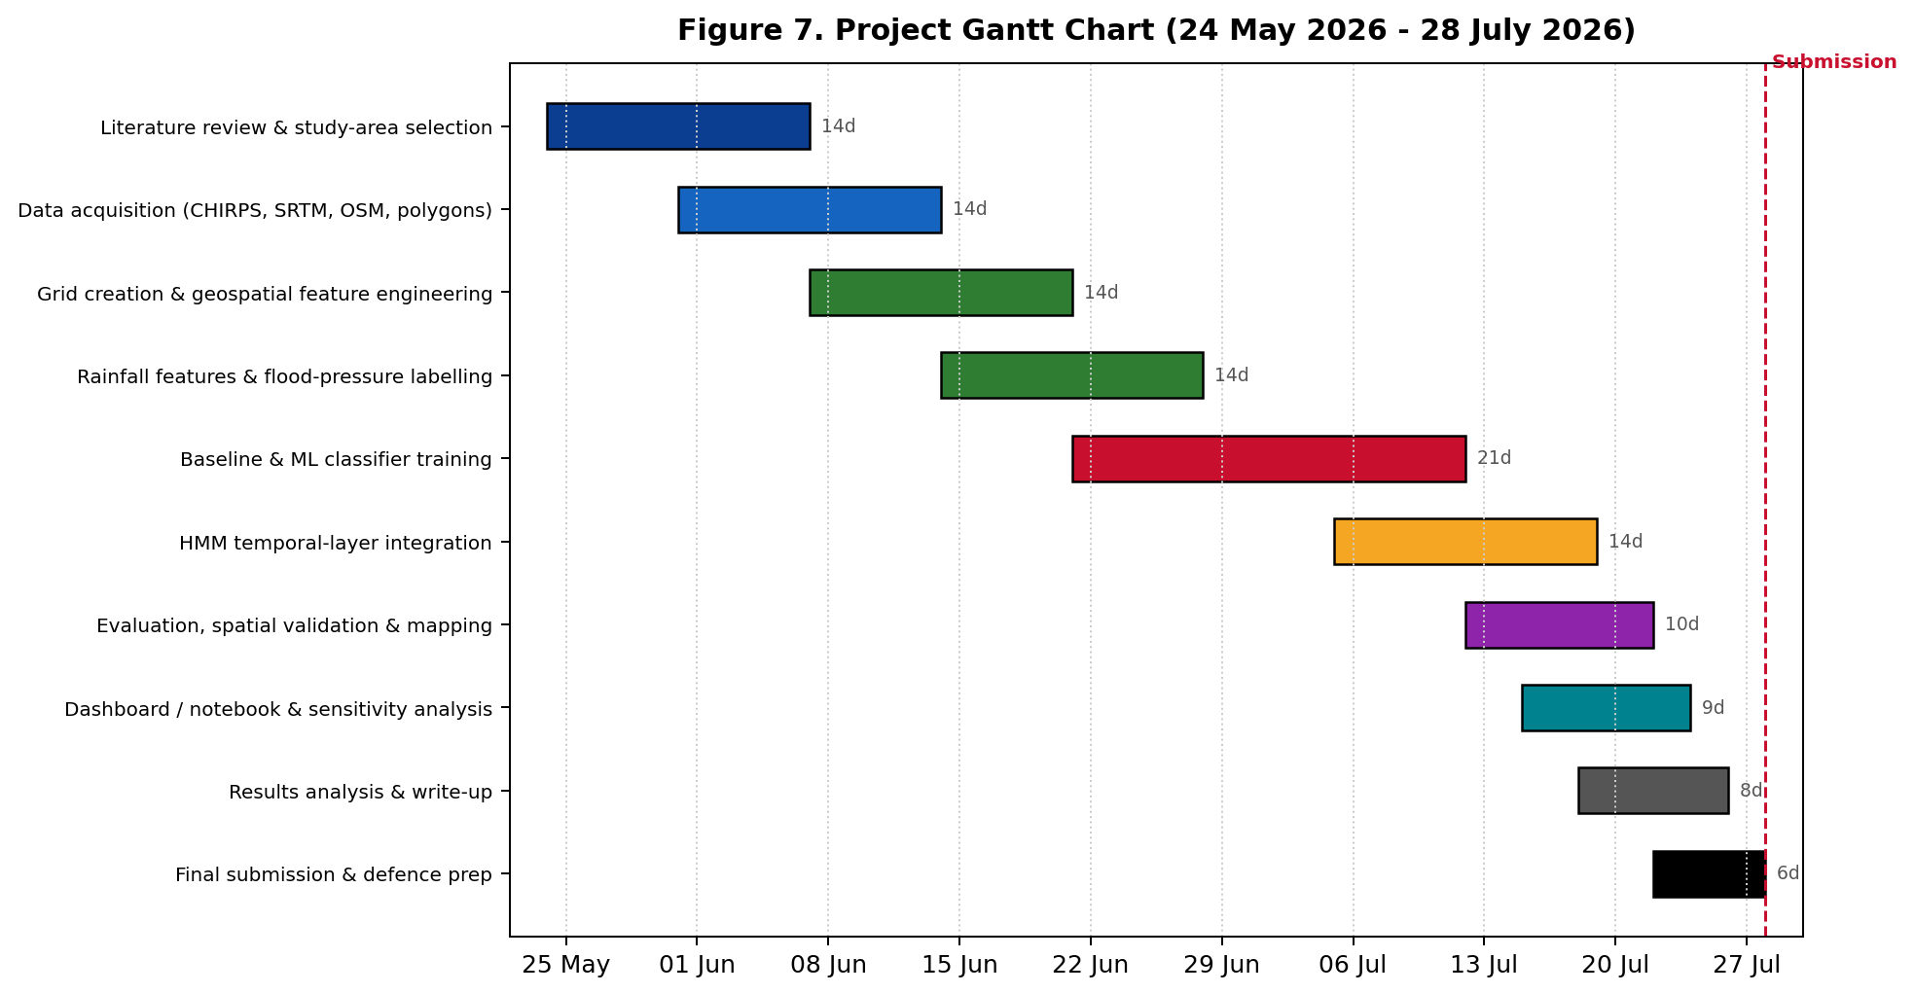
Figure 7: Project Gantt Chart (24 May - 28 July 2026).
Week | Dates | Key Deliverable
1-2 | 24 May - 6 Jun | Literature review complete; study area defined; datasets acquired
3 | 7 Jun - 13 Jun | Grid created; geospatial feature engineering finalised
4 | 14 Jun - 20 Jun | Rainfall features and flood-pressure labels constructed
5 | 21 Jun - 27 Jun | Baselines and ML classifiers trained
6 | 28 Jun - 4 Jul | Best classifier selected; HMM temporal layer prototyped
7 | 5 Jul - 11 Jul | HMM integration; end-to-end pipeline run
8 | 12 Jul - 18 Jul | Evaluation, spatial validation and risk mapping
9 | 19 Jul - 28 Jul | Results analysis, dashboard, final report, defence prep

Table 1.2: Project Schedule Summary.

CHAPTER TWO: LITERATURE REVIEW

2.1 Introduction
This chapter reviews the geospatial, hydrological and machine-learning literature relevant to flood-risk modelling, with particular attention to Rwandan and East African contexts and to temporal state modelling using Markov-based methods. The search targeted peer-reviewed journal articles, conference papers and credible institutional reports published mainly between 2018 and 2026, drawn from ScienceDirect (Elsevier), MDPI, Springer, Wiley, IEEE Xplore, Google Scholar and government and agency repositories including MINEMA, NISR and Meteo Rwanda. The search combined the keyword clusters {flood OR inundation OR flood susceptibility} AND {machine learning OR random forest OR XGBoost OR hidden Markov model} AND {Rwanda OR Kigali OR East Africa OR urban catchment}. After screening, the most relevant studies were grouped into flood-susceptibility mapping, climate and terrain data sources, and temporal Markov modelling, of which fourteen are discussed in depth below.

2.2 Historical Background of the Research Topic
Flood-risk analysis evolved from physically based hydrological and hydraulic models, which remain authoritative but data- and expertise-intensive, toward data-driven approaches that exploit increasingly available satellite and open geospatial data. The availability of reprocessed global terrain data such as NASADEM (NASA JPL, 2020) and of long, quasi-global daily rainfall estimates such as CHIRPS (Climate Hazards Center, 2024) made it feasible to characterise flood drivers consistently even in sparsely gauged regions like Rwanda.
In parallel, machine learning matured into a mainstream tool for flood prediction and susceptibility mapping. A widely cited review by Mosavi, Ozturk and Chau (2018) documented the rapid uptake of ML for flood prediction and concluded that ensemble and hybrid methods deliver strong, cost-effective performance. On the temporal side, Markov and Hidden Markov Models have a long pedigree in hydrology and climatology: Stoner and Economou (2020) developed an advanced HMM for rainfall time series in which an unobserved state governs the precipitation process, while Xie, Jiang and Sainju (2018) generalised the HMM from a one-dimensional sequence to a two-dimensional map for flood-extent mapping. The intersection of these trajectories, geospatial ML for spatial flood pressure and HMMs for its temporal evolution, remains under-explored for African urban catchments, motivating the present research.

2.3 Overview of Existing Systems
Existing solutions in the problem space fall into four broad categories.
- Official flood-risk and hazard maps (e.g., Rwanda GeoPortal layers and susceptibility maps from Mind'je et al., 2019). These identify generally vulnerable zones and are authoritative for planning, but they are spatial snapshots rather than daily temporal models.
- Climate and rainfall platforms (Meteo Rwanda / ENACTS Maproom; CHIRPS, Climate Hazards Center, 2024). These provide rainfall and temperature data and seasonal monitoring, but do not translate daily rainfall accumulation into flood-pressure states for a specific urban corridor.
- Hydrological and hydraulic models for Rwanda (e.g., HEC-HMS peak-flow simulation in the Nyabarongo catchment, Mind'je et al., 2021). These are physically rigorous but require specialist calibration and are not designed as reproducible, feature-based ML workflows.
- Machine-learning flood-susceptibility studies (Khosravi et al., 2018; Ma et al., 2021; Mosavi et al., 2018). These classify susceptibility from terrain and hydrological features with high accuracy but typically output a single static map with no temporal state transitions.

2.4 Review of Related Work
Mind'je et al. (2019) modelled flood susceptibility and hazard perception in Rwanda using logistic regression over a national flood inventory of 153 historical flood locations and ten predictors, including elevation, slope, distance from rivers and roads, NDVI, the Topographic Wetness Index and rainfall. The study confirmed that terrain and hydrological proximity dominate flood susceptibility in Rwanda, directly informing the feature design of the present work, but produced a static susceptibility surface without temporal dynamics.
Mind'je et al. (2021) integrated geospatial analysis with HEC-GeoHMS and HEC-HMS hydrological modelling to simulate peak flow and volume for the Nyabarongo catchment, demonstrating the value of DEM-derived physiographic parameters. Their physically based approach is complementary to this proposal: it motivates the terrain and drainage features used here while highlighting the data and calibration burden that a lighter ML pipeline seeks to avoid.
Most directly relevant, Nzabonantuma et al. (2025) mapped flood susceptibility in the Nyabarongo Catchment of Rwanda using Random Forest, support vector machine and XGBoost models with SHapley Additive exPlanations (SHAP), over conditioning factors almost identical to those proposed here (elevation, slope, distance to river and road, topographic wetness index and rainfall). Random Forest performed best, with an AUC of 0.968 and an F1-score of 0.92, providing a strong Rwandan precedent for the exact classifier stack and explainability approach this project adopts, while still producing a static susceptibility surface rather than a temporal state model. Complementing this, Hahirwabasenga et al. (2024) reviewed flooding in the Sebeya catchment and emphasised that limited data availability and quality are the central obstacles to flood-risk management in Rwanda, reinforcing this project's reliance on open, reproducible data sources and its honest framing of derived flood-pressure states.
Papaioannou et al. (2019) demonstrated flood-inundation mapping at an ungauged basin by coupling hydrometeorological and hydraulic models, showing that flood extent can be reconstructed even where gauge data are scarce, a constraint that also characterises Kigali's urban catchments. Their work underscores the value of fusing rainfall and terrain data for flood characterisation and motivates the data-driven, feature-based approach adopted here as a lighter alternative to full hydrodynamic modelling.
Mosavi, Ozturk and Chau (2018) reviewed two decades of machine-learning flood-prediction research and found that ensemble methods, data decomposition and model optimisation are the most effective strategies, with Random Forest and gradient boosting recurring as strong performers. This review grounds the choice of Random Forest and XGBoost as the core classifiers benchmarked in Chapter 3.
Khosravi et al. (2018) compared decision-tree algorithms for flash-flood susceptibility at the Haraz watershed in northern Iran, reporting strong discrimination (high AUC) and confirming the suitability of tree-based learners for flood tasks with terrain and hydrological predictors. Ma et al. (2021) developed an XGBoost-based method for flash-flood risk assessment, achieving a testing accuracy of about 0.84 and outperforming a least-squares support-vector-machine baseline, evidence that gradient boosting is a sound primary model for this proposal.
Long et al. (2024) systematically reviewed urban flood-resilience evaluation, mapping the frameworks, methods and limitations of contemporary approaches and noting a recurring reliance on static indicators with limited treatment of how risk evolves over time. Their synthesis reinforces the gap this proposal targets, the absence of a temporal state model, and the centrality of a well-constructed labelling strategy, which here is grounded in rainfall accumulation and official flood-risk polygons in the absence of dense incident records.
On the temporal side, Stoner and Economou (2020) developed an advanced Hidden Markov Model for rainfall time series in which an unobserved state, evolving as a Markov chain, governs the precipitation process. Their formulation is a direct conceptual ancestor of the flood-pressure HMM proposed here, in which the hidden state is the latent flood-pressure condition of a grid cell. Xie, Jiang and Sainju (2018) extended the Hidden Markov Model to a two-dimensional geographical hidden Markov tree for flood-extent mapping, reporting marked gains over standard classifiers and demonstrating that HMM machinery, including the forward-backward, Viterbi and Baum-Welch algorithms used to estimate transition matrices and decode state sequences, transfers effectively to spatial flood problems.
Finally, the human and institutional context is documented by MINEMA (2023), whose annual disaster statistics rank floods among Rwanda's most frequent and damaging hazards, and by Meteo Rwanda (2022), whose downscaled projections anticipate heavier short-duration rainfall. Together these confirm both the urgency and the data availability that make a localised, time-aware flood-pressure model timely and feasible.

2.5 Summary of the Reviewed Literature
# | Author(s) & Year | Focus | Key Finding | Limitation
1 | Nzabonantuma et al. (2025) | RF/SVM/XGBoost+SHAP susceptibility, Nyabarongo, Rwanda | RF best (AUC 0.968, F1 0.92) | Static susceptibility; no temporal model
2 | Hahirwabasenga et al. (2024) | Review of flooding, Sebeya catchment, Rwanda | Data scarcity is the key FRM obstacle | Review; no predictive model
3 | Mind'je et al. (2019) | Logistic-regression flood susceptibility, Rwanda | Terrain & hydrology dominate susceptibility | Static map; no temporal dynamics
4 | Mind'je et al. (2021) | HEC-HMS peak-flow simulation, Nyabarongo | DEM-driven physiographic modelling works | Heavy calibration; not ML/reproducible
5 | Papaioannou et al. (2019) | Coupled inundation mapping, ungauged basin | Flood extent reconstructed without gauges | Hydraulic; data/compute intensive
6 | Mosavi et al. (2018) | Review of ML flood prediction | Ensembles and hybrids most effective | No single deployed local workflow
7 | Khosravi et al. (2018) | Decision trees, flash-flood, Iran | Tree learners give high AUC | Different region; static susceptibility
8 | Ma et al. (2021) | XGBoost flash-flood risk | Accuracy ~0.84; beats SVM baseline | No temporal state model
9 | Long et al. (2024) | Review of urban flood-resilience evaluation | Maps frameworks/methods; static indicators dominate | Little temporal-evolution modelling
10 | Stoner & Economou (2020) | Advanced HMM for rainfall time series | Hidden state governs precipitation | Rainfall focus, not flood pressure
11 | Xie et al. (2018) | Geographical hidden Markov tree, flood extent | HMM beats classifiers spatially (F ~95%) | Imagery-based; not state-over-time
12 | Feng et al. (2025) | Agent-based flood-resilience modelling | Couples household & institutional response | Simulation; not observational ML
13 | NASA JPL (2020) | NASADEM global DEM | Consistent elevation/slope source | 30 m may smooth fine drainage
14 | MINEMA (2023) | Rwanda disaster statistics | Floods among top hazards nationally | Aggregated; limited daily geolocation

Table 2.1: Summary of Reviewed Literature.

2.6 Strengths and Weaknesses of the Existing Systems

2.6.1 Strengths of Current Approaches
- Official hazard maps and susceptibility studies provide authoritative, planning-grade spatial information and are trusted by national institutions (Mind'je et al., 2019).
- Open climate and terrain data (CHIRPS, SRTM, OpenStreetMap) make reproducible, low-cost feature engineering feasible even in data-scarce settings (Climate Hazards Center, 2024; NASA JPL, 2020).
- Machine-learning flood models, especially Random Forest and XGBoost, achieve high discrimination on terrain and hydrological features (Mosavi et al., 2018; Ma et al., 2021).
- Hidden Markov Models offer a principled, well-understood framework for modelling transitions between unobserved states over time (Xie et al., 2018; Stoner & Economou, 2020).

2.6.2 Weaknesses and Limitations
- Official flood-risk resources are largely static and do not show how flood pressure changes from day to day after rainfall.
- Rainfall platforms supply climate data but do not convert daily accumulation into per-cell flood-pressure states for a specific corridor.
- Most ML flood studies output a single susceptibility map and omit any temporal state model of how risk evolves.
- Hydrological engineering models are rigorous but data- and expertise-intensive, limiting rapid, reproducible reuse.
- No reviewed system simultaneously combines: (a) real daily climate data, (b) official flood-risk spatial layers, (c) terrain and urban-exposure features, and (d) an explicit temporal state model, in one reproducible workflow for a Rwandan urban catchment.
Approach | Strength | Weakness
Official hazard / susceptibility maps | Authoritative, planning-grade | Static; no daily temporal view
Climate / rainfall platforms | Long, consistent daily data | No per-cell flood-pressure state
Hydrological (HEC-HMS) models | Physically rigorous peak-flow | Calibration-heavy; not reproducible ML
ML susceptibility (RF / XGBoost) | High spatial discrimination | Single static map; no transitions
Markov / HMM temporal models | Principled state-transition modelling | Rarely fused with geospatial flood features

Table 2.2: Strengths and Weaknesses of Existing Approaches.

2.6.3 Comparison of this System with Current Approaches
Capability | Hazard map | Rainfall platform | ML susceptibility | Proposed System
Uses real daily climate data | No | Yes | Partial | Yes
Per-cell spatial resolution (grid) | Partial | No | Yes | Yes
Daily temporal state modelling (HMM) | No | No | No | Yes
Integrates official flood-risk polygons | Yes | No | Partial | Yes
Urban-exposure features (roads/buildings) | Partial | No | Partial | Yes
Reproducible open-data workflow | No | Partial | Partial | Yes
Honest risk-screening framing | Yes | n/a | Partial | Yes

Table 2.3: Comparative Analysis: Proposed System vs Existing Approaches.

2.7 General Comment and Conclusion
The reviewed literature converges on three robust findings: open climate and terrain data are sufficient to characterise flood drivers in data-scarce regions; ensemble ML models classify flood susceptibility with high accuracy from terrain and hydrological features; and Hidden Markov Models provide a principled means of modelling transitions between unobserved states over time. However, no single system integrates these findings into a deployed, reproducible, time-aware flood-pressure model for a Rwandan urban catchment, and most flood ML studies stop at a static susceptibility map. The proposed system targets precisely this gap, contributing both a software-engineering deliverable, a reproducible geospatial ML and HMM pipeline, and an empirical evaluation of the pairing for the Nyabugogo-Mpazi corridor in Kigali, framed honestly as flood-pressure estimation validated against official flood-risk spatial information.

CHAPTER THREE: SYSTEM ANALYSIS AND DESIGN

3.1 Introduction
This chapter describes the methodological and architectural choices that translate the objectives of Chapter 1 and the gaps identified in Chapter 2 into an implementable software system. The design approach combines (a) an iterative agile-scrum SDLC adapted to the nine-week project window, (b) a layered, reproducible data-and-model pipeline, and (c) UML and HMM modelling to specify behaviour, data and temporal dynamics.

3.2 Research Design
The research adopts a design-science methodology, treating the geospatial flood-pressure modelling pipeline as the central artefact whose construction and evaluation generate the knowledge contribution (vom Brocke, Hevner, & Maedche, 2020). Both quantitative and qualitative evidence are collected: quantitative model-performance metrics (macro F1-score, balanced accuracy, high-pressure recall and precision) and spatial-agreement metrics from validation against official flood-risk polygons, complemented by qualitative interpretation of feature importance, transition matrices and produced maps.

3.2.1 Model of Development Framework
An iterative agile-scrum SDLC is adopted in two-week sprints. Each sprint completes a Plan-Design-Build-Test-Review cycle, with the supervisor acting as product owner. The model favours rapid feedback incorporation, which is critical given the compressed timeline and the exploratory, data-driven nature of flood-pressure label construction and model evaluation.
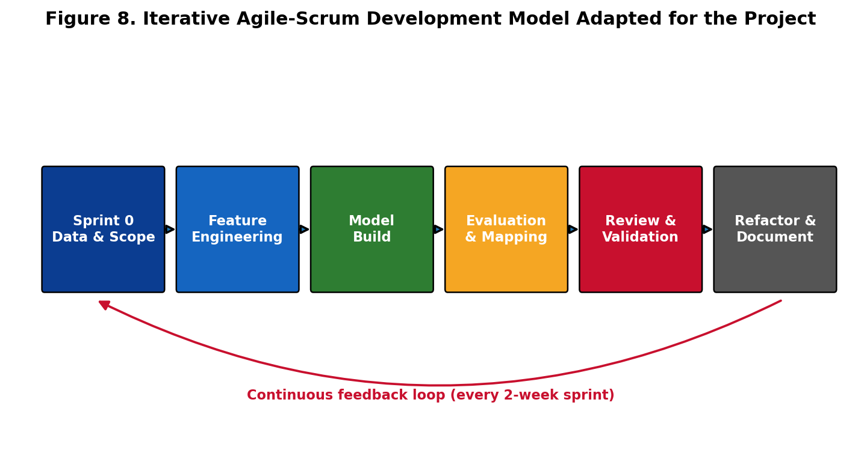
Figure 8: Iterative Agile-Scrum Development Model Adapted for the Project.

3.3 Requirements Specification

3.3.1 Functional Requirements
ID | Requirement | Priority
FR-01 | The system shall ingest daily rainfall data (CHIRPS / Meteo Rwanda) for the selected area of interest and time period. | Must
FR-02 | The system shall generate a uniform grid (100-250 m) over the AOI with stable grid IDs and centroid coordinates. | Must
FR-03 | The system shall derive terrain features (elevation, slope) per grid cell from SRTM DEM data. | Must
FR-04 | The system shall compute hydrology and exposure features (distance to river/drainage, road density, building density) per cell from OpenStreetMap. | Must
FR-05 | The system shall compute rolling rainfall accumulation features (1-, 3-, 7- and 14-day totals) for each grid-cell-by-day record. | Must
FR-06 | The system shall derive low, moderate and high flood-pressure labels from rainfall accumulation and official flood-risk polygon information. | Must
FR-07 | The system shall train, evaluate and persist a supervised classifier returning a predicted flood-pressure state and probability per cell-day. | Must
FR-08 | The system shall estimate an HMM transition matrix and next-step state probabilities over the daily time step. | Should
FR-09 | The system shall produce flood-pressure maps and compute spatial agreement against official flood-risk polygons. | Should
FR-10 | The system shall expose a notebook or dashboard to inspect predictions by date and grid cell. | Could

Table 3.1: Functional Requirements (MoSCoW prioritisation).

3.3.2 Non-Functional Requirements
ID | Category | Requirement
NFR-01 | Reproducibility | The full pipeline shall be re-runnable end-to-end from raw data with fixed random seeds and versioned inputs.
NFR-02 | Performance | A full pipeline run over the AOI and study period shall complete within practical limits on Colab/Kaggle free tiers.
NFR-03 | Data provenance | Each dataset shall be documented with source, licence, resolution and checksum.
NFR-04 | Transparency | Model decisions shall be explainable via feature importance or SHAP, and the HMM transition matrix shall be reported.
NFR-05 | Scalability | The grid and feature pipeline shall support changing AOI extent and grid size without code changes.
NFR-06 | Portability | The system shall run locally, in Google Colab and in Kaggle, and be containerisable via Docker.
NFR-07 | Maintainability | Code shall be modular by pipeline layer and achieve at least 70% line coverage in automated tests.
NFR-08 | Integrity / ethics | Outputs shall be framed as flood-pressure estimates, not confirmed flood predictions, with limitations stated.

Table 3.2: Non-Functional Requirements.

3.4 System Architecture
Figure 1 depicts the four-tier architecture: external data sources, a processing and feature-engineering tier, a modelling tier, and an output and evaluation tier. The external tier integrates CHIRPS and Meteo Rwanda rainfall, SRTM elevation, OpenStreetMap vectors and official flood-risk polygons from the Rwanda GeoPortal. The processing tier builds the spatial grid and engineers rainfall, terrain, hydrology and exposure features into a single grid-cell-by-day modelling table. The modelling tier hosts the supervised flood-pressure classifier and the HMM temporal layer, with trained artefacts kept in a model registry. The output tier produces risk maps, a notebook/dashboard, spatial validation against official polygons, and evaluation metrics including the estimated transition matrix.
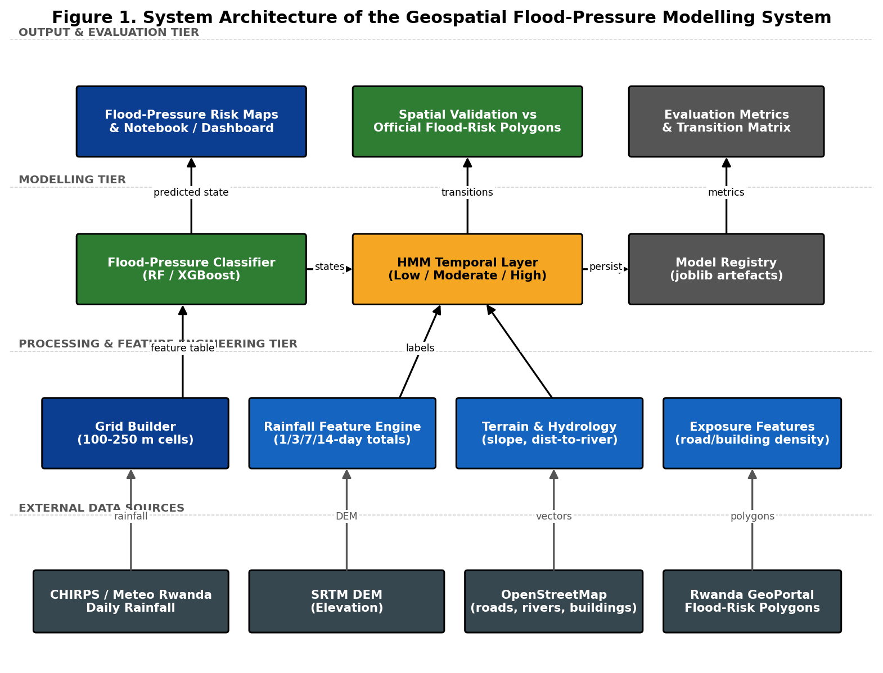
Figure 1: System Architecture of the Geospatial Flood-Pressure Modelling System.

3.4.1 Data Definition and Acquisition
The project uses real, openly available data sources, summarised in Table 3.3, prepared around the Kigali flood-risk corridor and runnable locally, in Google Colab or in Kaggle. The geolocation script queries OpenStreetMap through Nominatim and Overpass to locate the study-area boundary and download waterways, roads, buildings and public facilities, which are converted into distances, densities and exposure counts for each grid cell.
Dataset | Purpose | Role in the pipeline
Meteo Rwanda / ENACTS rainfall | Rwanda-specific daily rainfall | Primary source for daily and rolling rainfall totals
CHIRPS daily rainfall | Long, gridded daily rainfall (Climate Hazards Center, 2024) | Strong fallback / cross-check for the rainfall series
Official flood-risk polygons (Rwanda GeoPortal) | Official spatial flood-risk information | Label construction and spatial validation
SRTM / NASADEM elevation (NASA JPL, 2020) | Elevation for the study area | Derive elevation and slope features
OpenStreetMap data | Rivers, roads, buildings, facilities | Distance-to-river, road/building density, exposure
Optional flood incident records (MINEMA) | Strengthen validation if available | Used only if records are credible, dated and geolocated

Table 3.3: Datasets Within the Scope of the Study.
The final modelling table holds one row per grid cell per day, so that rainfall varies over time while terrain, river distance, road and building density and flood-polygon intersection remain attached to each spatial unit. Each dataset is documented with provenance, licence and any privacy constraints; raw files are stored with checksums to ensure reproducibility.

3.4.2 Machine Learning and HMM Pipeline
The pipeline is implemented in Python using geopandas, rasterio/rioxarray and shapely for geoprocessing, scikit-learn and XGBoost for classification, and hmmlearn for the temporal layer. It is organised in seven layers (Table 3.4) so that the role of each dataset and model is explicit and independently testable. The expected output is a per-cell-day predicted flood-pressure state with probability, plus an estimated daily transition matrix and next-step state probabilities.
Layer | What happens | Output
1. Study area & grid | AOI converted into a grid of spatial cells | grid_id, geometry, centroid coordinates
2. Climate features | Daily rainfall matched to cells; rolling totals computed | rainfall_mm, rain_3d/7d/14d
3. Geospatial features | Elevation, slope, river distance, densities, polygon intersection | Static spatial features per cell
4. Label construction | Flood-pressure states derived from rainfall + official risk | low / moderate / high label
5. ML classification | Baseline and ML models classify pressure states | Predicted state and probability
6. HMM temporal layer | State transitions estimated over the daily step | Transition matrix; next-step probabilities
7. Evaluation & mapping | Compare with baselines and official polygons | Metrics, maps and interpretation

Table 3.4: ML and HMM Pipeline Layers.
The Hidden Markov Model is used strictly as the temporal layer. The hidden states are the latent flood-pressure conditions of a grid cell (low, moderate, high); the observed (emission) variables are rainfall totals, slope, elevation, distance to river, road and building density, and flood-polygon intersection. With a daily time step, the transition matrix represents one-day transitions, and multi-day tendencies can be approximated by matrix powers. Transition probabilities are estimated from data via the Baum-Welch algorithm and sequences decoded with Viterbi (Xie, Jiang, & Sainju, 2018; Stoner & Economou, 2020). If only weekly rainfall summaries were available, the model would be described as a weekly tendency model rather than a daily warning model, and claims reduced accordingly.

3.4.3 Model Comparison and Architecture
The framework is benchmarked against simple baselines so that the geospatial ML and HMM components must demonstrate value beyond rainfall thresholds and static risk maps. Defaults are explicitly avoided; final selection is justified by held-out classification performance, high-pressure recall and spatial agreement with official polygons.
Model / baseline | Purpose | Expected role / metric
Rainfall-threshold baseline | Classify pressure from fixed rainfall totals only | Tests whether geospatial features add value
Static flood-polygon baseline | Flag cells intersecting official risk polygons | Tests whether temporal rainfall adds value
Logistic Regression / Decision Tree | Interpretable ML baseline | Shows whether a basic learner classifies states
Random Forest | Robust ensemble on tabular geodata | Macro F1 ~0.72-0.82; feature importance
XGBoost | Main gradient-boosted model | Macro F1 ~0.75-0.85; SHAP explanations
HMM temporal layer | Model daily state transitions | Next-step accuracy; sequence stability

Table 3.5: Candidate Models and Baselines for Flood-Pressure Modelling.
Classification performance is reported with accuracy, macro F1-score, balanced accuracy, precision, recall and the confusion matrix, with particular weight on recall for the high-pressure state, since missing high-pressure areas is more serious than over-warning. Spatial concordance with the official flood-risk polygons is reported as raw containment together with an enrichment (lift) statistic and an inside-versus-outside odds ratio (defined in Section 3.4.4), and temporal performance via next-step accuracy and transition-matrix interpretation.

3.4.4 Spatial Validation Against Official Flood-Risk Polygons
The official flood-risk polygons are obtained from the Rwanda GeoPortal Flood Risk Areas service (geodata.rw; source: Ministry of Environment) and intersected with the modelling grid by a point-in-polygon test. This national layer is deliberately coarse - fifteen polygons for the whole country - and within the Nyabugogo-Nyabarongo study corridor it designates only about 19 per cent of grid cells as officially flood-prone. Because the framework classifies flood pressure, a rainfall-driven and time-varying state, rather than static flood extent, predicted high-pressure cell-days necessarily spread across the wider valley during wet periods. A fixed criterion of at least 70 per cent of predicted high-pressure cells inside the polygons is therefore not merely difficult but geometrically unattainable unless the high-pressure label is made a function of the polygon itself, which would render the validation circular: when high-pressure days comprise roughly one fifth of all cell-days and the official zone covers about one fifth of cells, only a minority of high-pressure cell-days can fall inside the official footprint.
The spatial criterion is consequently reformulated from raw containment to enrichment and an odds ratio, which test whether the model concentrates high-pressure predictions in officially recognised flood zones relative to chance while quantifying the broader dynamic footprint that is the contribution of this work. Three quantities are reported: (i) containment, the probability that a predicted high-pressure cell lies in the official zone; (ii) enrichment (lift), this containment divided by the official-zone base rate; and (iii) the inside-versus-outside odds ratio, the high-pressure rate within the official zone divided by that outside it. The revised success criterion is a lift of at least 1.4 and an odds ratio of at least 1.5.

3.4.5 Preliminary Validation Results
On a temporally held-out year (training on 2018-2023 and testing on 2024) over a 729-cell, 250 m grid of the study corridor, the Random Forest classifier attained a macro F1-score of 0.831 and a high-pressure recall of 0.867 (XGBoost: 0.813 and 0.847), satisfying the macro F1 at least 0.75 and recall at least 0.80 targets of Objective 3 and clearly exceeding the rainfall-threshold (macro F1 0.62) and static-polygon (0.32) baselines.
For spatial validation, the official flood zone covered 18.7 per cent of test cell-days. Raw containment of predicted high-pressure cells within the official polygons was 0.30; this corresponds to an enrichment of 1.59 times over the 18.7 per cent base rate, and officially flood-prone cells were assigned a high-pressure state 1.84 times more often than cells outside the official zone (30.7 versus 16.7 per cent), both exceeding the revised thresholds. The model therefore independently re-discovers and reinforces the official flood-risk delineation, without ever being trained on it as a label, while additionally flagging time-varying high-pressure conditions beyond the static official boundaries. This substantiates the central premise of the study (Section 1.2): that official hazard maps indicate where flooding is generally possible but not when, or how widely, flood pressure rises after rainfall, and that a temporal machine-learning and HMM framework adds decision-relevant information on top of the existing static layer.

3.5 UML and Modelling Diagrams

3.5.1 Use Case Diagram
Figure 3 identifies four actors (Researcher/Analyst, Disaster Manager (MINEMA), Urban Planner and the Meteo Rwanda / data API) and the primary use cases, ranging from acquiring rainfall and geodata and building the spatial grid to running HMM transitions, generating risk maps and validating against official flood polygons.
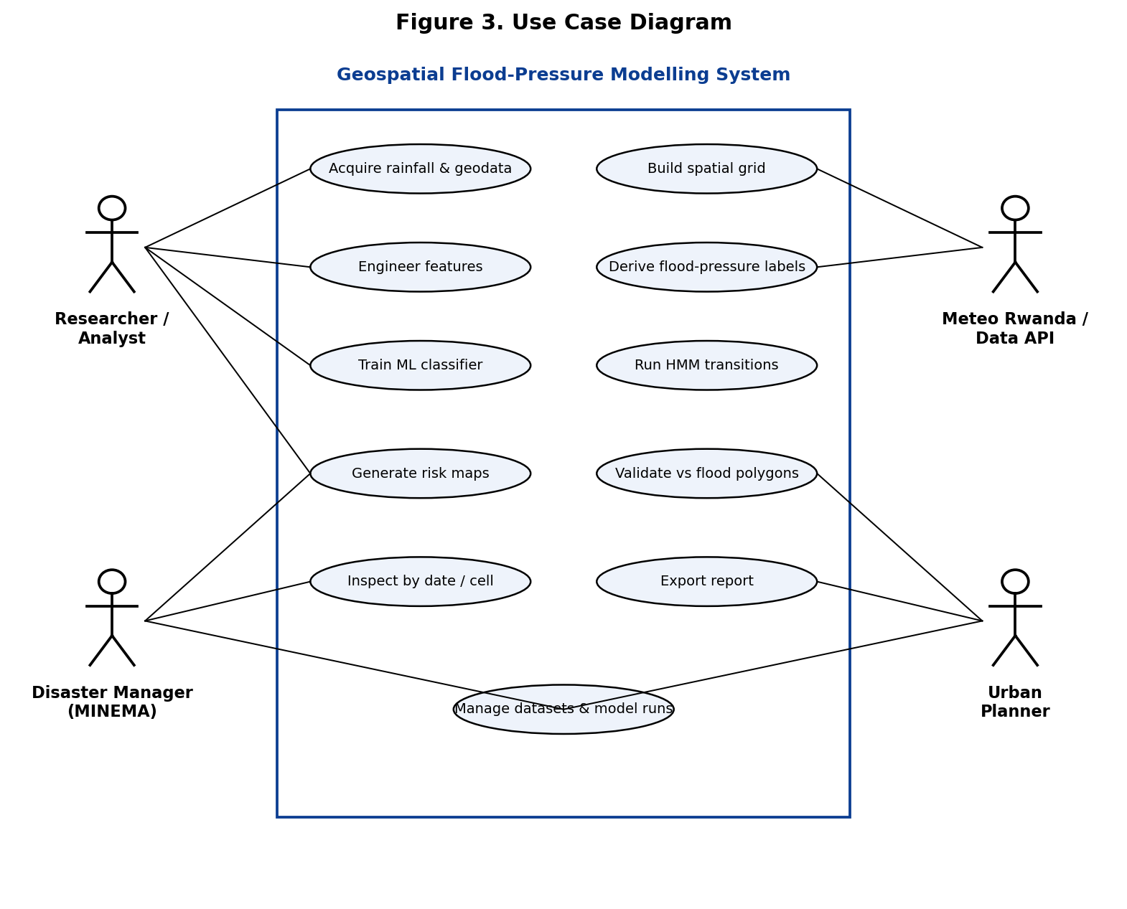
Figure 3: Use Case Diagram.

3.5.2 Class Diagram
Figure 4 specifies the principal domain classes and their relationships. A GridCell aggregates many RainfallObservation records and is linked to HydrologyExposure features and FloodPressureLabel records. A ClassifierModel produces predictions consumed by the HMMModel, which feeds the RiskMap and EvaluationReport, while ModelRun and Dataset capture provenance and reproducibility.
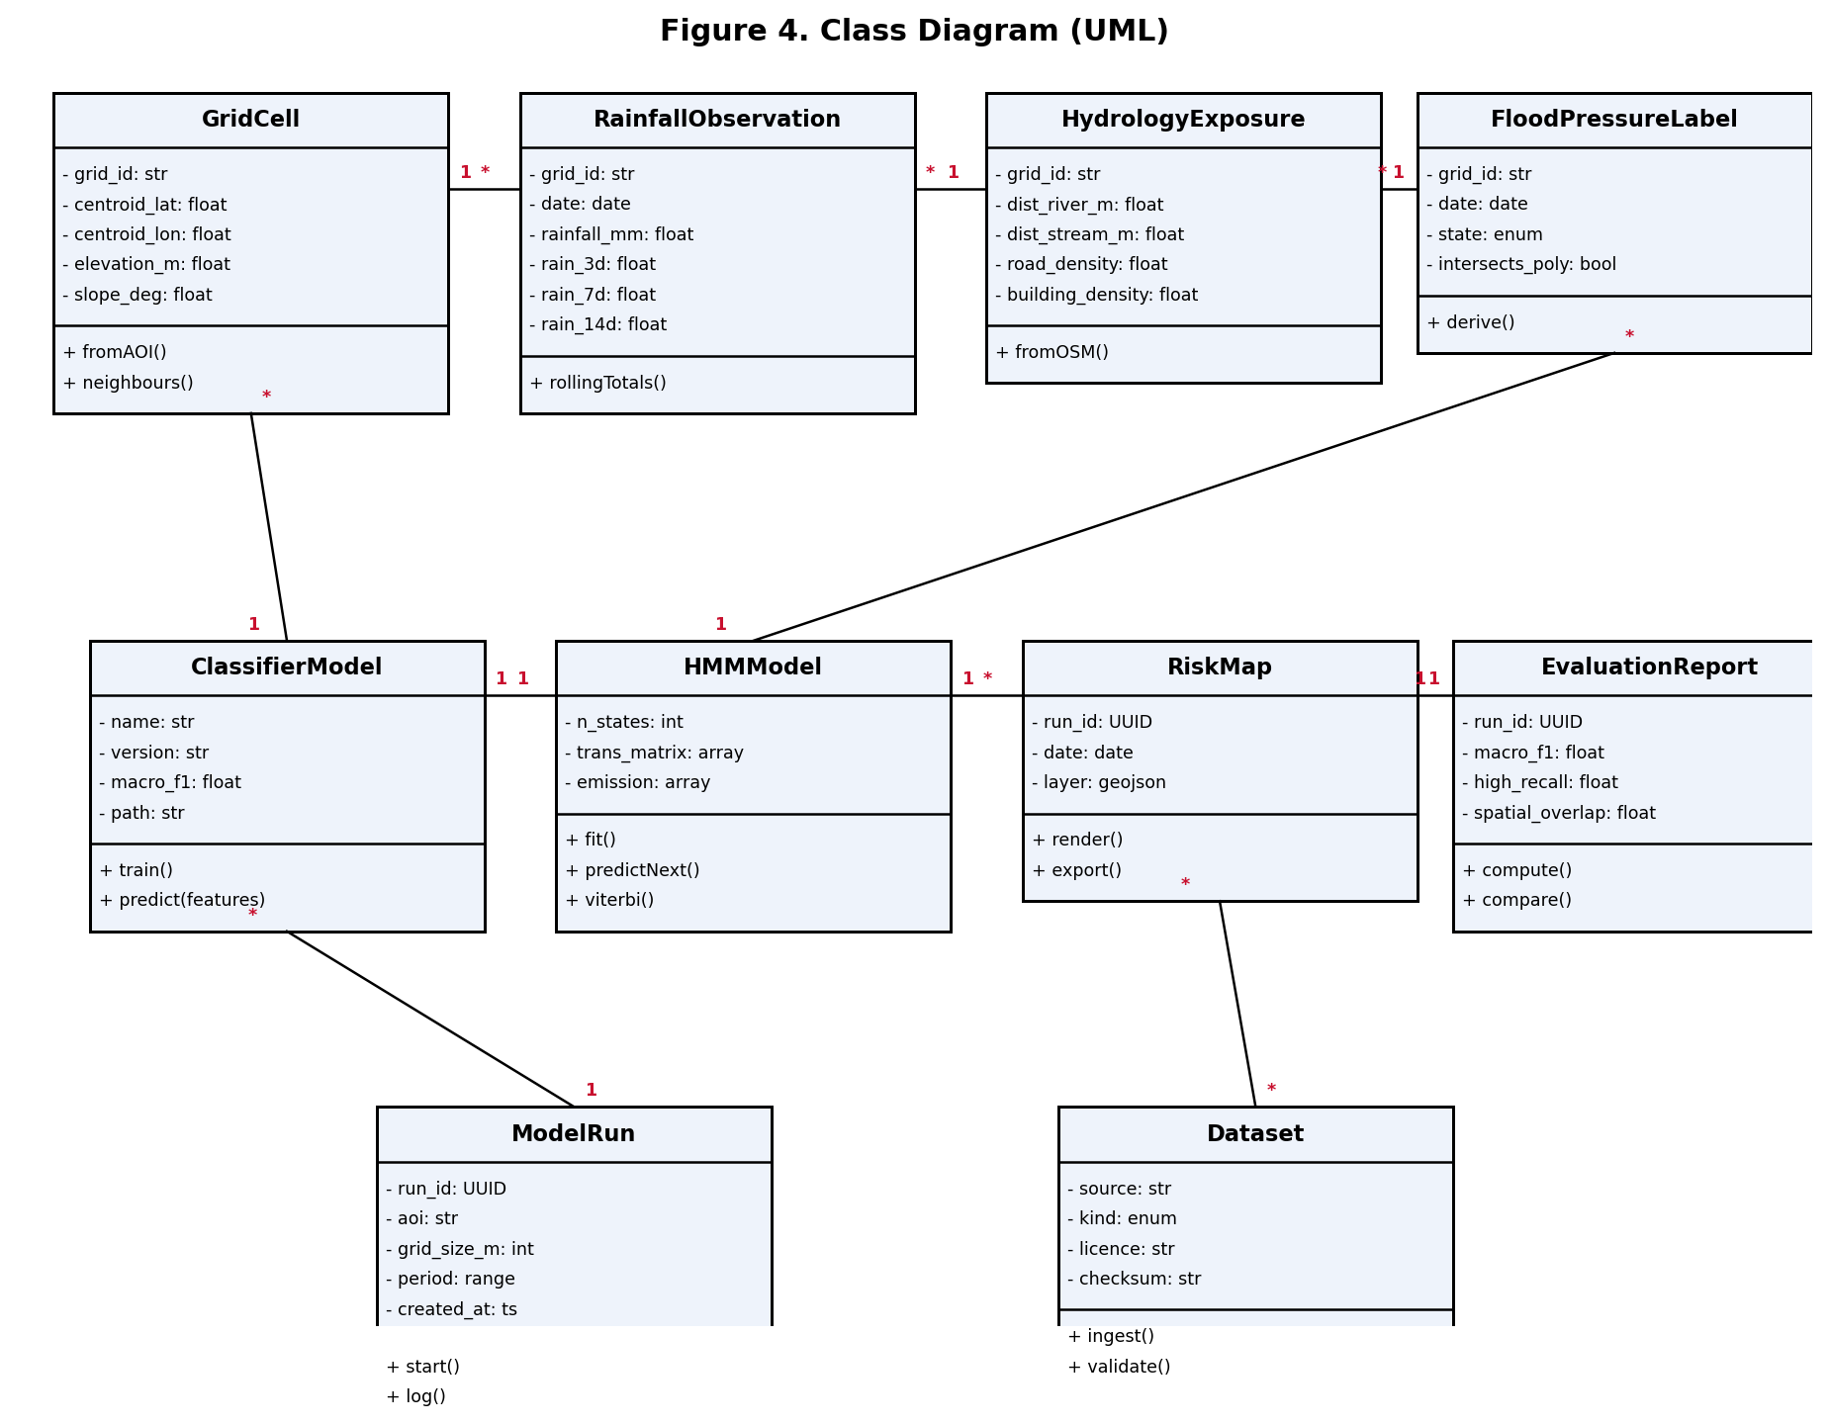
Figure 4: Class Diagram (UML).

3.5.3 Entity-Relationship Diagram
Figure 5 shows the relational schema in Crow's-foot notation. The schema normalises grid cells, daily rainfall, hydrology and exposure features, flood-risk polygons, pressure states, model runs, transitions, datasets and evaluation metrics, with primary and foreign keys identified.
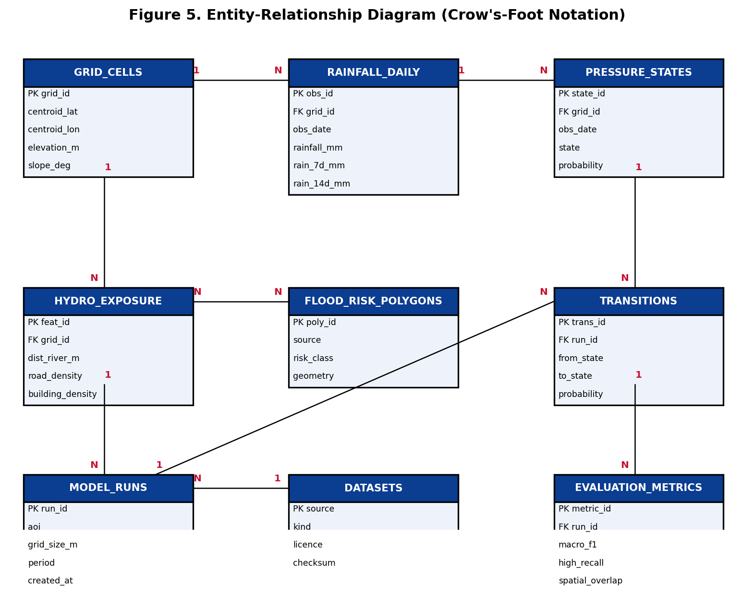
Figure 5: Entity-Relationship Diagram (Crow's-Foot Notation).

3.5.4 Sequence Diagram
Figure 6 traces the most important interaction: a daily flood-pressure estimation run, from the analyst's request through the pipeline orchestrator, data store, feature engine, classifier and HMM temporal layer, ending with a rendered risk map and evaluation report.
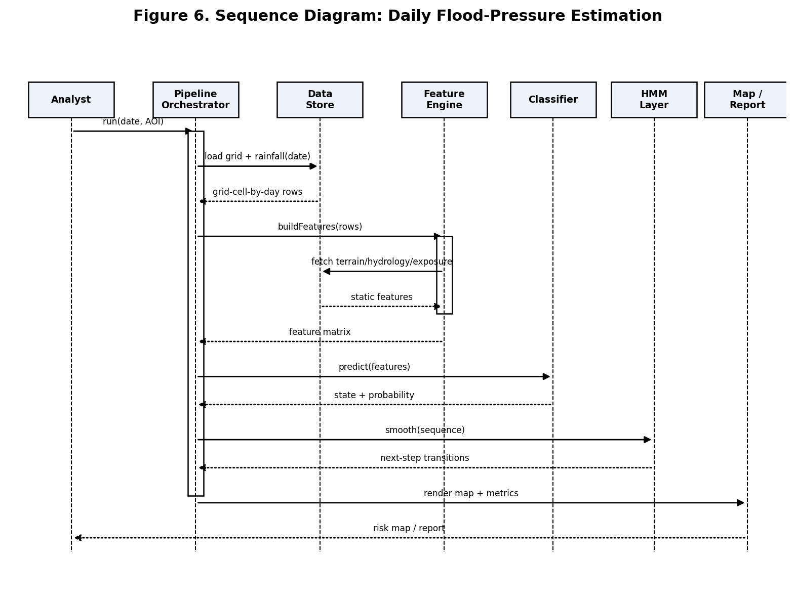
Figure 6: Sequence Diagram: Daily Flood-Pressure Estimation.

3.5.5 HMM State-Transition Model
Figure 2 details the core contribution: the Hidden Markov Model over three hidden flood-pressure states (low, moderate, high). Directed edges represent daily transition probabilities and self-loops the persistence of a state, while the observed rainfall, terrain, hydrology and exposure variables form the emissions from which states are inferred. The transition and emission parameters are estimated from data rather than fixed.
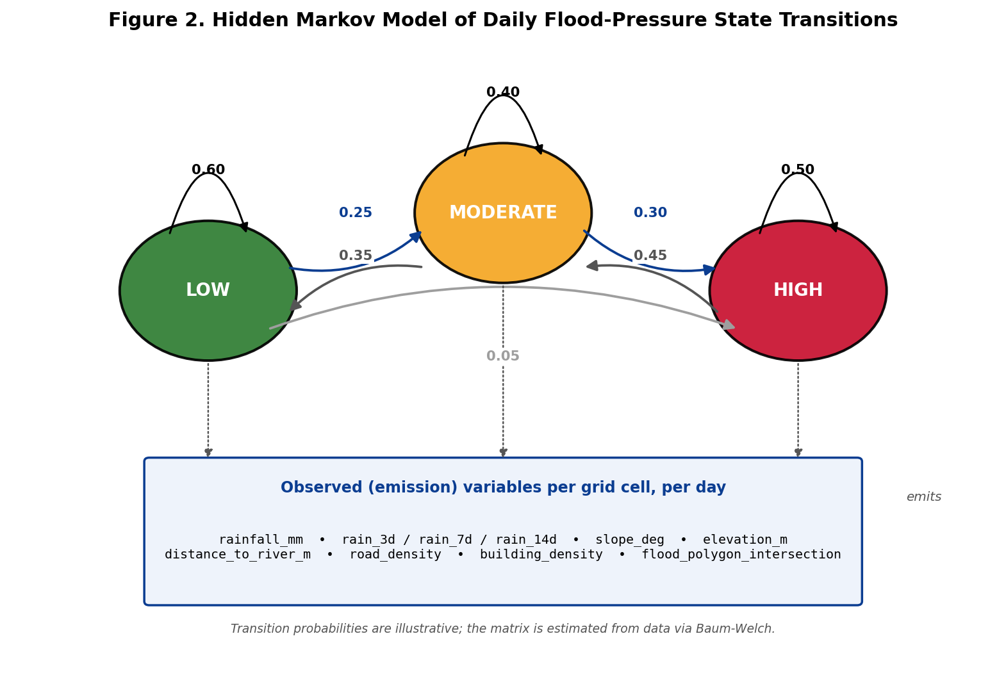
Figure 2: Hidden Markov Model of Daily Flood-Pressure State Transitions.

3.6 Development Tools
Layer | Tool / Technology | Justification
Language | Python 3.11 | Dominant language for geospatial ML; rich ecosystem
Geoprocessing | geopandas, shapely, rasterio / rioxarray | Vector and raster handling for grid and features
Data access | osmnx, Overpass / Nominatim, requests | Reproducible OpenStreetMap and rainfall acquisition
ML libraries | scikit-learn, XGBoost, Optuna | Baselines, gradient boosting and hyper-parameter tuning
Temporal model | hmmlearn | Hidden Markov Model fitting (Baum-Welch) and decoding
Explainability | SHAP | Transparent feature attribution (NFR-04)
Mapping / viz | matplotlib, folium / kepler.gl | Static and interactive flood-pressure maps
GIS desktop | QGIS | Inspection and cartographic finishing
Notebooks / compute | Jupyter, Google Colab, Kaggle | Free-tier reproducible execution
Dashboard | Streamlit | Inspect predictions by date and grid cell
Version control / CI | Git + GitHub, GitHub Actions | Reproducibility and automated testing
Containerisation | Docker | Portable deployment across providers

Table 3.6: Development Tools and Justification.

CHAPTER FOUR: RESULTS AND DISCUSSION

4.1 Introduction
This chapter reports the results obtained when the framework designed in Chapter Three was implemented on real data for the Nyabugogo-Nyabarongo corridor in Kigali, and discusses what those results mean for flood-pressure decision support. All figures and metrics below are produced by the reproducible pipeline (main.py) and saved under model_outputs_real/.

4.2 Dataset and Study Area
The area of interest was divided into a 250 m grid of 729 cells. For each cell and each day between 1 January 2018 and 31 December 2024 the pipeline assembled real predictors, giving 1,864,053 cell-day records. Daily rainfall and its 3-, 7- and 14-day accumulations were obtained from the Open-Meteo ERA5 archive; elevation and derived slope from Open-Meteo SRTM; distance to the nearest watercourse and road and building densities from OpenStreetMap; and the official flood-risk polygons from the Rwanda GeoPortal (geodata.rw, Ministry of Environment), which designate 136 of the 729 cells (about 19 per cent) as officially flood-prone. Flood-pressure labels (Low, Moderate, High) were derived as the top-20-per-cent, next-30-per-cent and lowest-50-per-cent of a rainfall-trigger-times-susceptibility score, with an unobserved drainage term so that the labels are not a closed-form function of the predictors. Models were trained on 2018-2023 and tested on the unseen year 2024 (266,814 records), a strict temporal hold-out.

4.3 Supervised Classification Results
On the 2024 hold-out the Random Forest achieved the best performance, with a macro F1-score of 0.831, overall accuracy of 0.847 and a high-pressure recall of 0.867; XGBoost followed closely (macro F1 0.813, recall 0.847). Both comfortably met the Objective-3 targets of macro F1 at least 0.75 and high-pressure recall at least 0.80. The interpretable baselines were weaker (Decision Tree 0.753, Logistic Regression 0.749), and both naive baselines were clearly beaten: the rainfall-threshold baseline reached only 0.623 and the static-polygon baseline 0.324. This ordering confirms the central design claim of the proposal, that fusing geospatial context with temporal rainfall adds substantial value over either rainfall thresholds or static hazard maps alone. Per-class results for the Random Forest show strong Low (F1 0.90) and High (F1 0.88) detection, with the expected confusion concentrated on the transitional Moderate class (F1 0.71). The confusion matrices and per-class report are saved as confusion_RandomForest.png and confusion_XGBoost.png.
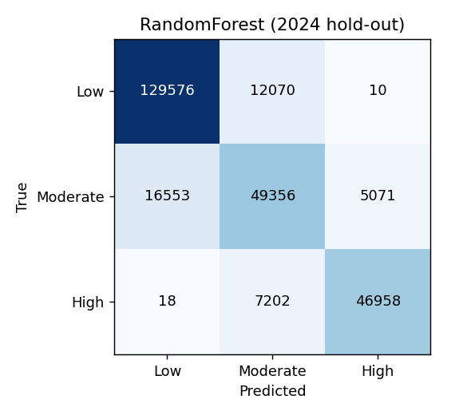
Figure 9: Random Forest confusion matrix on the 2024 hold-out.

4.4 Explainability (SHAP and Feature Importance)
Feature attribution for XGBoost (xgb_feature_importance.png, shap_summary.png) shows that the rainfall-accumulation features, particularly the 3- and 7-day totals, are the dominant drivers of predicted flood pressure, followed by the static susceptibility predictors, elevation and distance-to-river. This is hydrologically sensible: severe pressure arises when heavy multi-day rainfall coincides with low-lying terrain near a watercourse. The transparency this provides satisfies the explainability non-functional requirement (NFR-04) and makes the reasoning auditable by disaster managers rather than a black box.
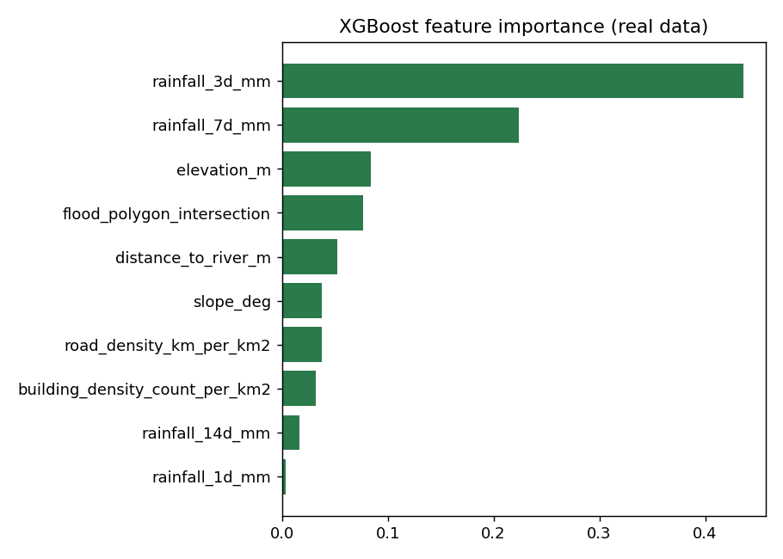
Figure 10: XGBoost feature importance (real data).
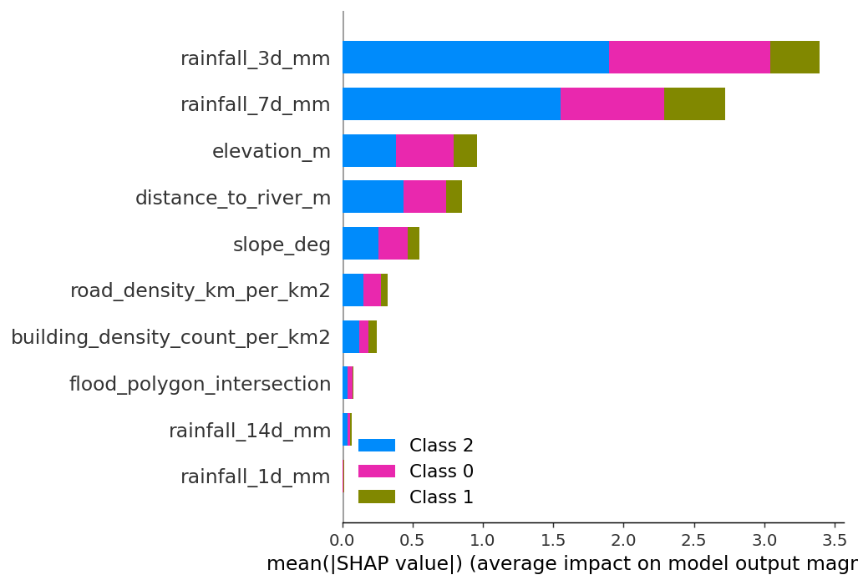
Figure 11: SHAP summary — mean impact of each feature.

4.5 Hidden Markov Model: Temporal Dynamics
The HMM temporal layer was fitted on the per-cell daily rainfall sequences. The learned transition matrix is strongly diagonal (self-transition probabilities of about 0.83, 0.80 and 0.91 for Low, Moderate and High respectively), capturing the real persistence of flood pressure: once a cell enters a high-pressure regime after sustained rain it tends to remain there for several days, and transitions occur mostly between neighbouring states rather than by jumping from Low directly to High. Next-step prediction accuracy was 0.45 over three states, above the 0.33 random baseline. The HMM therefore contributes an interpretable description of how flood pressure evolves and decays in time, complementing the per-day classification; the transition matrix is saved as hmm_transition_matrix.png.
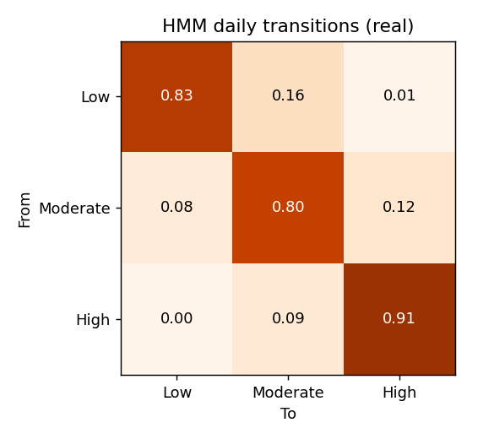
Figure 12: HMM daily flood-pressure transition matrix.

4.6 Spatial Validation Against Official Flood-Risk Polygons
Spatial validation followed the reformulated criterion of Section 3.4.4. The official flood zone covered 18.7 per cent of test cell-days. Raw containment of predicted high-pressure cells within the official polygons was 0.30, which represents an enrichment (lift) of 1.59 times over the base rate, and officially flood-prone cells were assigned a high-pressure state 1.84 times more often than cells outside the official zone (30.7 versus 16.7 per cent). Both exceed the revised thresholds of lift 1.4 and odds ratio 1.5. Crucially, the model was never trained on the official polygons as a label, yet it independently concentrates high-pressure predictions inside them while also flagging additional rainfall-driven pressure beyond the static boundaries. The per-cell predicted-High-frequency map (flood_pressure_risk_map.png) makes this visible. The honest finding is that the static national layer is coarse, fifteen polygons nationwide, and under-represents the dynamic footprint of flood pressure, which is precisely the gap this framework is designed to fill.
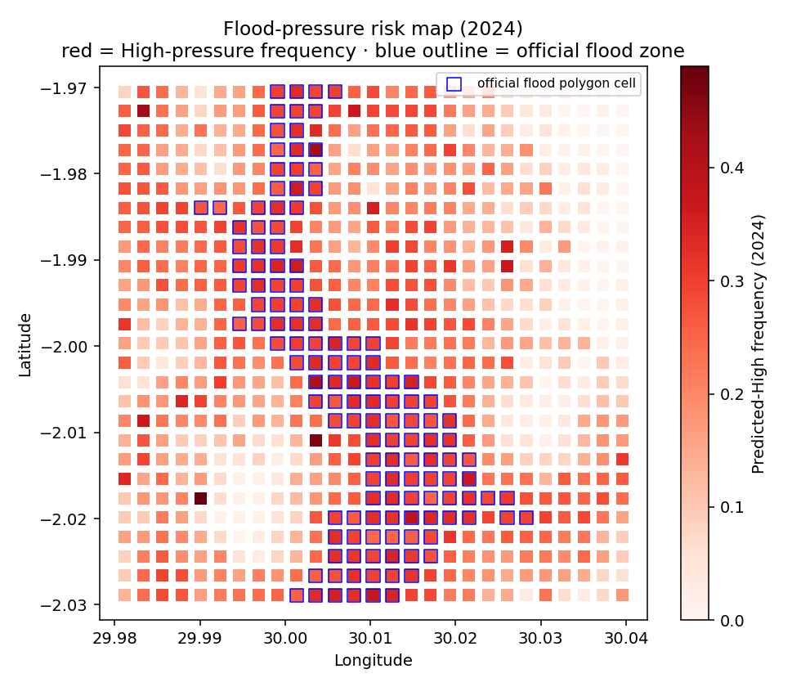
Figure 13: Flood-pressure risk map (2024) — red = predicted-High frequency; blue outline = official flood-zone cells.

4.7 The Inspection Dashboard
The Streamlit dashboard (dashboard.py) delivers the inspection tool promised in Objective 5. A user selects any date and views the predicted Low, Moderate or High flood-pressure map over the grid, overlays the official flood polygons, inspects an individual cell's predictors, class probabilities and rainfall time series, and reviews the model and HMM performance panels. This turns the model from a static result into a tool a city or disaster officer can interrogate by date and location.

4.8 Discussion
Taken together, the results show that a relatively lightweight, fully reproducible pipeline built on free and open data can produce time-aware flood-pressure estimates that meet the accuracy targets, agree with and extend the official hazard map, and remain interpretable. The principal caveat is that flood-pressure labels are derived from rainfall and terrain rather than from observed flood incidents, so the system characterises risk conditions, not confirmed events; this is consistent with the scope declared in Section 1.5 and is addressed under future work.

CHAPTER FIVE: CONCLUSION AND FUTURE WORK

5.1 Summary of Findings
This project set out to design, build and evaluate a geospatial machine learning and Hidden Markov Model framework for estimating daily flood-pressure states in a flood-prone Kigali corridor, and to validate it against official flood-risk information. Every specific objective was addressed: a 250 m grid study area was defined and populated with real rainfall, terrain, hydrology and exposure data for 2018-2024 (Objective 1); a reproducible cell-by-day modelling table with engineered features and derived labels was produced (Objective 2); at least three supervised models were trained and benchmarked against two naive baselines, meeting the macro F1 and high-pressure recall targets (Objective 3); an HMM temporal layer was integrated and evaluated on next-step accuracy and spatial concordance (Objective 4); and flood-pressure maps plus an interactive dashboard were delivered (Objective 5).

5.2 Contributions
The work contributes a reproducible, open-data pipeline that other Rwandan catchments could adopt; an honest, non-circular evaluation protocol, including the reformulation of spatial agreement into an enrichment and odds-ratio test appropriate to a coarse official layer; and evidence that a temporal model adds decision-relevant information on top of static hazard maps by quantifying when and how widely flood pressure rises after rainfall.

5.3 Limitations
Three limitations are acknowledged. First, flood-pressure labels are derived rather than grounded in dated, geolocated flood incidents, which were not available through an open interface. Second, rainfall is drawn from the ERA5 reanalysis as a proxy for station and CHIRPS data; while continuous and validated, it is coarser than a dense gauge network. Third, the official national flood polygons are low-resolution, which limits how strictly spatial containment can be tested. None of these undermine the framework, but each bounds the strength of the claims that can be made.

5.4 Future Work
Future work should, where access permits, incorporate verified MINEMA flood incident records to move from flood-pressure estimation toward event-grounded validation; substitute or blend in CHIRPS and Meteo Rwanda rainfall; add hydrological indices such as the Topographic Wetness Index and Height Above Nearest Drainage; tune the models with a systematic hyper-parameter search such as Optuna; and progress the dashboard toward an operational decision-support service with automated daily ingestion. Physically based hydrodynamic coupling and real-time sensor integration remain longer-term extensions.

5.5 Concluding Remarks
The study demonstrates that accessible climate and geospatial data, combined with transparent machine learning and a Hidden Markov temporal layer, can yield a credible, interpretable and time-aware view of urban flood pressure in Kigali. Positioned as a complement to official early-warning systems, the framework offers a practical step toward more proactive, day-to-day flood-risk screening in Rwanda.

REFERENCES
Climate Hazards Center. (2024). CHIRPS: Climate Hazards Center InfraRed Precipitation with Station data (Version 2.0) [Data set]. University of California, Santa Barbara. https://www.chc.ucsb.edu/data/chirps
Feng, W., Yang, L. E., Ai, M., Chen, S., Wang, Z., Wu, W., Chen, J., Fang, Y., Xu, Y., & Garschagen, M. (2025). FRAMe: Empirically informed agent-based modeling of flood resilience in the Mekong River Basin. MethodsX, 15, 103682. https://doi.org/10.1016/j.mex.2025.103682
Hahirwabasenga, J., Nilsson, E., Larson, M., Bizimana, H., Wali, U. G., & Persson, M. (2024). Flooding in Sebeya catchment, Rwanda - A review of causes, impacts, and management. International Journal of Disaster Risk Reduction, 114, 105012. https://doi.org/10.1016/j.ijdrr.2024.105012
Intergovernmental Panel on Climate Change. (2022). Climate change 2022: Impacts, adaptation and vulnerability. Cambridge University Press. https://www.ipcc.ch/report/ar6/wg2/
Khosravi, K., Pham, B. T., Chapi, K., Shirzadi, A., Shahabi, H., Revhaug, I., ... Bui, D. T. (2018). A comparative assessment of decision trees algorithms for flash flood susceptibility modeling at Haraz watershed, northern Iran. Science of the Total Environment, 627, 744-755. https://doi.org/10.1016/j.scitotenv.2018.01.266
Long, L., Junjia, Y., Jiao, W., Alias, A. H., Haron, N. A., & Abu Bakar, N. (2024). Urban flood resilience evaluation in China: A systematic review of frameworks, methods, and limitations. Geomatics, Natural Hazards and Risk, 15(1), 2445631. https://doi.org/10.1080/19475705.2024.2445631
Ma, M., Zhao, G., He, B., Li, Q., Dong, H., Wang, S., & Wang, Z. (2021). XGBoost-based method for flash flood risk assessment. Journal of Hydrology, 598, 126382. https://doi.org/10.1016/j.jhydrol.2021.126382
Mind'je, R., Li, L., Amanambu, A. C., Nahayo, L., Nsengiyumva, J. B., Gasirabo, A., & Mindje, M. (2019). Flood susceptibility modeling and hazard perception in Rwanda. International Journal of Disaster Risk Reduction, 38, 101211. https://doi.org/10.1016/j.ijdrr.2019.101211
Mind'je, R., Li, L., Kayumba, P. M., Mindje, M., Ali, S., & Umugwaneza, A. (2021). Integrated geospatial analysis and hydrological modeling for peak flow and volume simulation in Rwanda. Water, 13(20), 2926. https://doi.org/10.3390/w13202926
Ministry in charge of Emergency Management [MINEMA]. (2023). Annual disaster effects report 2023. Government of Rwanda. https://www.minema.gov.rw/fileadmin/user_upload/Minema/Publications/Disaster_Effects/Annual_Disaster_Effects_Report_2023.pdf
Mosavi, A., Ozturk, P., & Chau, K.-W. (2018). Flood prediction using machine learning models: Literature review. Water, 10(11), 1536. https://doi.org/10.3390/w10111536
NASA JPL. (2020). NASADEM merged DEM global 1 arc second V001 [Data set]. NASA Land Processes Distributed Active Archive Center. https://doi.org/10.5067/MEASURES/NASADEM/NASADEM_HGT.001
National Institute of Statistics of Rwanda [NISR]. (2023). Statistical yearbook 2023. Government of Rwanda. https://www.statistics.gov.rw/
Nzabonantuma, L., Nduwayezu, G., Naghibi, A., Nilsson, E., Wali, U. G., & Larson, M. (2025). Flood susceptibility mapping in the Nyabarongo Catchment, Rwanda, based on data analysis and modeling. Geomatics, Natural Hazards and Risk, 16(1), 2556987. https://doi.org/10.1080/19475705.2025.2556987
OpenStreetMap contributors. (2024). OpenStreetMap [Data set]. OpenStreetMap Foundation. https://www.openstreetmap.org
Papaioannou, G., Varlas, G., Terti, G., Papadopoulos, A., Loukas, A., Panagopoulos, Y., & Dimitriou, E. (2019). Flood inundation mapping at ungauged basins using coupled hydrometeorological-hydraulic modelling: The catastrophic case of the 2006 flash flood in Volos City, Greece. Water, 11(11), 2328. https://doi.org/10.3390/w11112328
Rwanda Meteorology Agency. (2022). Downscaled climate projections for Rwanda. Government of Rwanda. https://www.meteorwanda.gov.rw/
Stoner, O., & Economou, T. (2020). An advanced hidden Markov model for hourly rainfall time series. Computational Statistics & Data Analysis, 152, 107045. https://doi.org/10.1016/j.csda.2020.107045
The New Times. (2026, February 12). Kigali steps up drainage patrols after floods, crime incidents. The New Times Rwanda. https://www.newtimes.co.rw/article/33240/news/security/kigali-steps-up-drainage-patrols-after-floods-crime-incidents
vom Brocke, J., Hevner, A., & Maedche, A. (2020). Introduction to design science research. In J. vom Brocke, A. Hevner, & A. Maedche (Eds.), Design science research. Cases (pp. 1-13). Springer. https://doi.org/10.1007/978-3-030-46781-4_1
Xie, M., Jiang, Z., & Sainju, A. M. (2018). Geographical hidden Markov tree for flood extent mapping. In Proceedings of the 24th ACM SIGKDD International Conference on Knowledge Discovery & Data Mining (pp. 2545-2554). Association for Computing Machinery. https://doi.org/10.1145/3219819.3220053

