Illustrated Excel 365/2021 | Module 6: End of Module Project 1

# Quinn Retail Services

## MANAGE WORKBOOK DATA

### GETTING STARTED

* Save the file **IL_EX365_2021_EOM6-1_*FirstLastName*_1.xlsx** as **IL_EX365_2021_EOM6-1_*FirstLastName*_2.xlsx**

Edit the file name by changing “1” to “2”.

If you do not see the **.xlsx** file extension, do not type it. The file extension will be added for you automatically.

* To complete this Project, you will also need the following files:

Support_EX365_2021_EOM6-1_Jan-May.xlsx

Support_EX365_2021_EOM6-1_Logo.png

* With the file **IL_EX365_2021_EOM6-1_*FirstLastName*_2.xlsx** open, ensure that your first and last name is displayed in cell B6 of the Documentation worksheet.

If cell B6 does not display your name, delete the file and download a new copy.

### PROJECT STEPS

1. Ladonna Raymond is an account manager for Quinn Retail Services, a national merchandising company headquartered in Cincinnati, Ohio. Ladonna is using an Excel workbook to analyze sales for June and July of this year. She asks you to update the workbook and make the data easier to interpret so that she can share it with other Quinn employees.  
   Go to the *Links* worksheet. Ladonna wants to add a picture to the background of the *Links* worksheet to add visual interest. Insert the picture **Support_EX365_2021_EOM6-1_Logo.png** as the worksheet background.
2. Ladonna wants to add hyperlinks to the *Links* worksheet to make it easier to navigate and find information. Format cell C4 as a hyperlink that links to the file **Support_EX365_2021_EOM6-1_Jan-May.xlsx**. Add **Workbook with semiannual data** as the ScreenTip text. Format cell C5 as a hyperlink that links to the cell **A1** of the *June Sales* worksheet. Format cell C7 as a hyperlink that links to the **www.quinn.cengage.com** website. Format cell C8 as a hyperlink that links to the **info@quinn.cengage.com** email address.
3. Ladonna decides she does not want to provide her email address in the workbook. Remove the hyperlink from cell C10, while keeping the "Ladonna Raymond" text.
4. Go to the *June Sales* worksheet. Ladonna occasionally wants to focus on the billing data for the first full week of June. Set up a custom view by hiding rows 12–50. Select cell G1 and then create a custom view using **Week1** as the name. Display the *June Sales* worksheet using the custom view Weeks1-4, which Ladonna already created, to redisplay all of the data.
5. The *June Sales* worksheet has the same structure as the *July Sales* worksheet. Ladonna wants to apply the same formatting to both worksheets. Group the *June Sales* and *July Sales* worksheets. Fill the merged cell B2 with the Green, Accent 3 fill color. Ungroup the worksheets.
6. On the *June Sales* worksheet, freeze the rows so that rows 1–3 always appear at the top of the worksheets when scrolling.
7. For the June billings, Ladonna wants to display subtotals for each region. Sort the June Billings data in ascending order by *Region*. Add subtotals to the *Billed* column at each change in the *Region*. Use the Sum function and display the summary below the data.
8. Ladonna wants to display the subtotals directly to the right of the subtotal heading. Hide column E, which does not contain information Ladonna needs to display with the subtotals.
9. Go to the *July Sales* worksheet. Ladonna still has to verify the Paid amounts for the July billings. She asks you to secure the rest of the *July Sales* worksheet data so that no one can change it. Unlock the *Paid* data (the range G4:G52) so that Ladonna can change it later. Protect the *July Sales* worksheet so that users can unprotect it without a password. Also allow users to select locked and unlocked cells.
10. To help Ladonna find the workbook after she saves and closes it, add the text **June and July Sales** to the Title document property.
11. Prepare the workbook for distribution by marking it as final.

Your workbook should look like the Final Figures on the following pages. Save your changes, close the workbook, and then exit Excel. Follow the directions on the website to submit your completed project.

### Final Figure 1: Links Worksheet

Microsoft product screenshot reprinted with permission from Microsoft Incorporated. Copyright © 2020 Cengage Learning. All Rights Reserved.

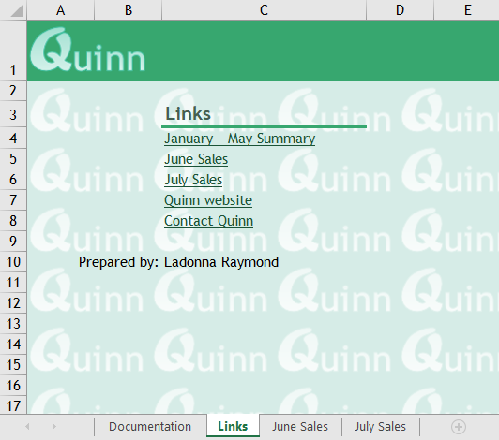

### Final Figure 2: June Sales Worksheet

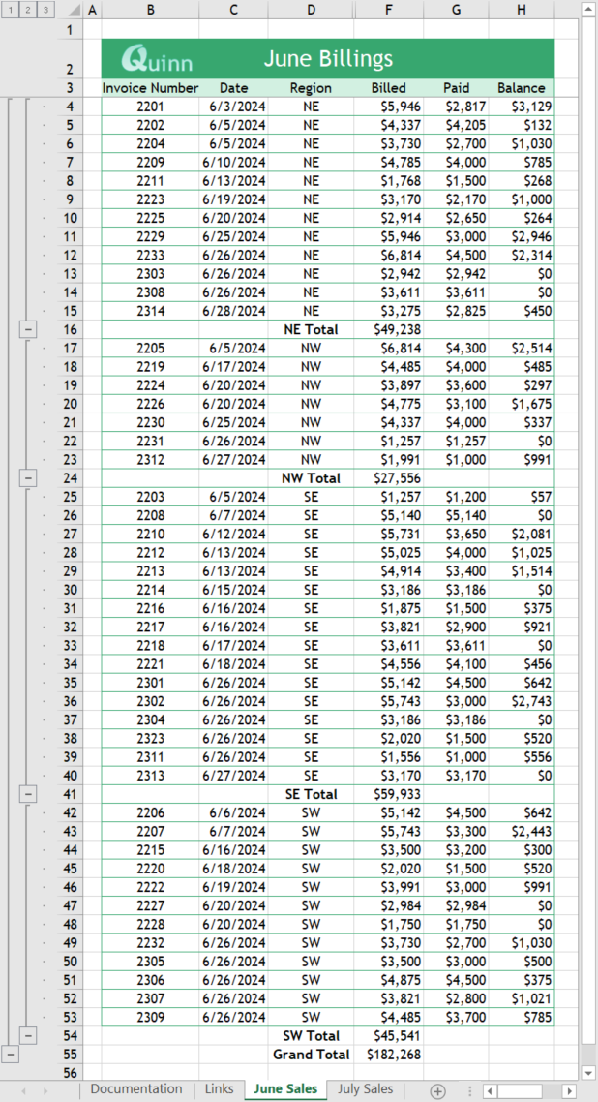

### Final Figure 3: July Sales Worksheet

