Illustrated Excel 365/2021 | Module 6: End of Module Project 2

# Flores & Falk Law Offices

## MANAGE WORKBOOK DATA

### GETTING STARTED

* Open the file **IL_EX365_2021_EOM6-2_*FirstLastName*_1.xlsx**, available for download.
* Save the file **IL_EX365_2021_EOM6-2_*FirstLastName*_1.xlsx** as **IL_EX365_2021_EOM6-2_*FirstLastName*_2.xlsx**

Edit the file name by changing “1” to “2”.

If you do not see the **.xlsx** file extension, do not type it. The file extension will be added for you automatically.

* To complete this Project, you will also need the following files:

Support_EX365_2021_EOM6-2_August.xlsx

* With the file **IL_EX365_2021_EOM6-2_*FirstLastName*_2.xlsx** open, ensure that your first and last name is displayed in cell B6 of the Documentation worksheet.

If cell B6 does not display your name, delete the file and download a new copy.

### PROJECT STEPS

1. Oscar Sanchez manages the main office of the Flores & Falk law firm in Las Vegas, Nevada. The firm has branch offices in three other cities in the state. Staff members have entered invoice data in an Excel workbook, which Oscar is now analyzing. He asks for your help in making the data more secure and easier to understand.  
   Go to the *Summary* worksheet and then unprotect the worksheet so that you can update it.
2. Oscar hid one worksheet to keep the data private but wants to make a formatting change to that worksheet and one other in the workbook. Unhide the *August Billings* worksheet, and then group the *August Billings* and *September Billings* worksheets. Fill merged cell B2 with the Aqua, Accent 5 shading color to match the formatting of the *Summary* worksheet. Ungroup the worksheets.
3. Return to the *Summary* worksheet. Oscar wants to focus on the revenue from entertainment law cases (an area the law firm wants to expand) and be able to display only the totals for each category. Hide rows 3:8 and rows 15:37 to display data from only the Entertainment category of cases. Select cell G1 and then create a custom view using **Entertainment** as the name. Display the *Summary* worksheet using the All_Categories custom view.
4. Group rows 4:6 so that you can hide and display Corporate revenue details. Also group rows 10:12, rows 16:18, rows 22:24, rows 28:30, and rows 34:36. Collapse the outline to display only the name and totals for the Corporate, Entertainment, Int. Property, Real Estate, and Tax categories. Leave the Family category expanded. Unlock the Family data (range B16:D18) so that it can be changed later.
5. To prepare for printing, insert a page break so that row 27 prints on a new page.
6. Unhide the *August Billings* worksheet to display it. Oscar will verify the data on this worksheet by comparing it to the original, unformatted data in another workbook. He wants to use a hyperlink to access the other workbook quickly. In cell J3, add a hyperlink that links to the **Support_EX365_2021_EOM6-2_August.xlsx** workbook. Hide the *August Billings* worksheet to keep the data private.
7. Go to the *September Billings* worksheet, which lists September invoices sorted by invoice number. Oscar wants to display the billed amounts by client type. Sort the September billings data in ascending order by Client Type values. Add subtotals to the worksheet at each change in the Client Type. Use the Sum function to total Billed values and display the summary below the data.
8. Protect the *September Billings* worksheet so that users can unprotect it without a password. Allow users to select locked and unlocked cells on the protected worksheet.
9. Add **Billings** in the Categories document property so that Oscar can find the workbook easily when he is searching for files.
10. Oscar plans to share the workbook with members of the law firm advisors, though some of them use earlier versions of Excel. Check the compatibility of the workbook with earlier versions of Excel, and then copy the Compatibility Report to a new worksheet. Rename the worksheet using **Compatibility Report** as the name.
11. Because the workbook contains sensitive data, protect the workbook as follows:
    1. Protect the workbook structure using **Oscar** as the password.
    2. Mark the workbook as final. (*Hint*: Click OK when prompted to confirm.)

Your workbook should look like the Final Figures on the following pages. The Compatibility Report worksheet has intentionally not been shown. [Compatibility Reports are not available on Excel for Mac, so Mac users can ignore this.] Save your changes, close the workbook, and then exit Excel. Follow the directions on the website to submit your completed project.

Depending on your version of Excel, cell B4 in the Compatibility Report worksheet may contain different text.

### Final Figure 1: Summary Worksheet

Microsoft product screenshot reprinted with permission from Microsoft Incorporated. Copyright © 2020 Cengage Learning. All Rights Reserved.

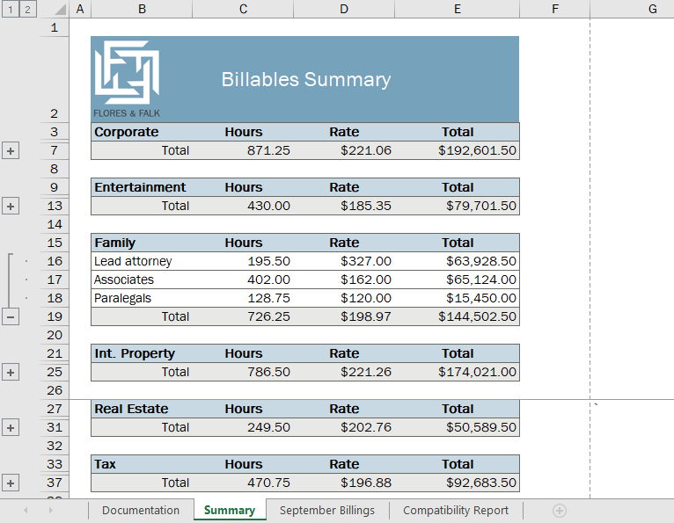

### Final Figure 2: September Billings Worksheet

