**Callout**

Design Document

Team 11

Dylan Brashear, Will Enright, Sean Kelley, Austin Wirth

**Table of Contents**

1. [Purpose](https://docs.google.com/document/d/1bs5PovR-h8_96oxpThZK3ifzHrza2AVkgGTPdLScf9E/edit#heading=h.pdbyhs99rc8y)
   1. [Functional Requirements:](https://docs.google.com/document/d/1bs5PovR-h8_96oxpThZK3ifzHrza2AVkgGTPdLScf9E/edit#heading=h.xmy38kbafkzj)
2. [Design Outline](https://docs.google.com/document/d/1bs5PovR-h8_96oxpThZK3ifzHrza2AVkgGTPdLScf9E/edit#heading=h.3wwd8xtcnxlu)
   1. [High level overview](https://docs.google.com/document/d/1bs5PovR-h8_96oxpThZK3ifzHrza2AVkgGTPdLScf9E/edit#heading=h.uk6o04h7bdos)
3. [Design Issues](https://docs.google.com/document/d/1bs5PovR-h8_96oxpThZK3ifzHrza2AVkgGTPdLScf9E/edit#heading=h.k5w92zorndo6)
4. [Design Details](https://docs.google.com/document/d/1bs5PovR-h8_96oxpThZK3ifzHrza2AVkgGTPdLScf9E/edit#heading=h.fz86jx8vx2xb)
   1. [Class Diagrams](https://docs.google.com/document/d/1bs5PovR-h8_96oxpThZK3ifzHrza2AVkgGTPdLScf9E/edit#heading=h.p60ecp6w7d9r)
      1. [Description of Classes](https://docs.google.com/document/d/1bs5PovR-h8_96oxpThZK3ifzHrza2AVkgGTPdLScf9E/edit#heading=h.62ipt5l6vejo)
   2. [Student Menu Interface](https://docs.google.com/document/d/1bs5PovR-h8_96oxpThZK3ifzHrza2AVkgGTPdLScf9E/edit#heading=h.j9dtke45wyzu)
   3. [Club Menu Interface](https://docs.google.com/document/d/1bs5PovR-h8_96oxpThZK3ifzHrza2AVkgGTPdLScf9E/edit#heading=h.9ml6g2ftlspp)
   4. [Client-Server Interaction](https://docs.google.com/document/d/1bs5PovR-h8_96oxpThZK3ifzHrza2AVkgGTPdLScf9E/edit#heading=h.a88vndvhmct7)
   5. [UI Mockup](https://docs.google.com/document/d/1bs5PovR-h8_96oxpThZK3ifzHrza2AVkgGTPdLScf9E/edit#heading=h.1cmhjndjei46)

Purpose

Our system has two kinds of users; organizations and students. The purpose is to enable students to find organizations that suit their interests, and to enable organizations to reach out to students.

**Functional Requirements:**

* As a user I want to…
  + be able to search for clubs by name **- 20**
  + see upcoming events on the calendar **- 40**
  + be able to filter different clubs on the calendar **- 10**
  + be able to give information about clubs I like **- 30**
  + be able to set clubs as favorites **- 10**
  + be able to see clubs by category **- 20**
  + be able to easily navigate the app **- 100**
* As an organization I want to…
  + be able to add my club to an Institution **- 40**
  + be able to add events to the calendar **- 20**
  + be able to display information about my club **- 10**
  + be able to add admins who can edit the page **- 20**
  + have a secure club page **- 10**
* As a developer I want to…
  + ensure the validity of added clubs - **10**
  + be able to remove illegitimate clubs **- 10**
  + make data persist **- 10**

Design Outline

The system we are designing is a client-server system. We are using a client-server system to allow clients to store and access information about students and organizations.  The client is broken up into two classifications: student, and organization.

* Client
  + Student
    - Can join clubs
    - Can request a list of clubs based on interests
  + Organization
    - Can edit their club description, and add photos
    - Can invite students to their club
* Server
  + - Handles interactions between students and organizations
    - Maintains a list of organizations, and which students belong to which
    - Allows new organizations and students to be added

A student client would send information to the server about interests and preferences. The database server would send information back to the student client about clubs that tailor to their interests. An organization client would send information describing their club to the database server. An organization client would also be able to send messages to student clients about upcoming events through the server.

**High level overview**

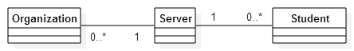

Design Issues

**Issue 1:** Database Selection

Option 1: MySQL

        Option 2: SQLite

        Option 3: Microsoft Database Management

We decided to choose Option 2 as it is the database standard for Android, and we have a little prior experience using it.

**Issue 2:** Platform Selection

Option 1: iOS

        Option 2: Android

        Option 3: Windows Phone

        Option 4: Web Application

We decided to choose option 2, as it will serve the most users while still being able to finish the project given the current scope.

**Issue 3:** Club Verification

Option 1: Administrators only can add new clubs

        Option 2: Any user can add clubs

        Option 3: A user can add clubs with a barrier to entry

We decided to choose option 3, as we don’t have the resources at the time to go with option 1, and option 2 allows for too much misuse.

**Issue 4:** Message Type

Option 1: Push Notification

        Option 2: Email Notification

        Option 3: SMS Notification

We chose option 1 because it is the simplest, and also the most convenient for the user.  No personal data such as email address or phone number must be entered.

**Issue 5:** User account data storage

Option 1: Store student information on our database

Option 2: Store student information on user’s phone

Option 3: Use a third party such as Google account or Facebook

We chose option 2 because student information such as club preferences are singular to the students, so this will be kept on their respective devices.

Design Details

**Class Diagrams**

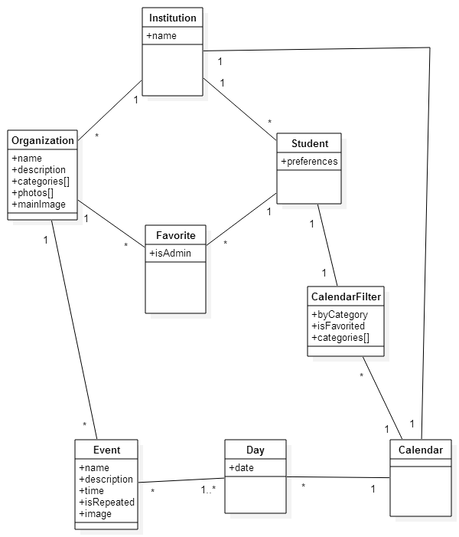

**Description of Classes**

* Student
  + This class represents the user.
  + Each user is a part of a single institution.
  + Students have a list of favorite organizations (presumably the ones the are a part of).
  + A student has a personalized filter on the calendar, so that they see only events that they may be interested in attending.
* Favorite
  + This class links users and organizations. It also makes the distinction between a normal user and one of the organizations admins, which changes the functionality available.
* Institution
  + This class represents universities.
  + Students and organizations are attached to a single Institution in order to keep things organized and relevant for users.
* Organization
  + This class represents organizations.
  + Each organizations has any number of students who have favorited it.
  + Each organization belongs to a single institution.
  + Organizations contain their name and description to display to users.
  + Organizations may also have pictures to show themselves off.
* Event
  + This class represents individual events that an organization is hosting.
  + Each Event has a name and description.
  + An event can be set to occur periodically (ie: weekly, monthly).
  + Events are assigned to specific days that they occur.
  + An Event may have an image attached to it.
* Day
  + This class breaks down the calendar into units of 24 hours.
  + A Day can contain any number of events.
  + All Days are contained in the Calendar.
* Calendar
  + This class contains all of the days, with their events, to be displayed to the user.
* CalendarFilter
  + This class specifies a user defined filter for the calendar.
  + The filter will decide what events appear on the calendar.
  + Presently, options are to choose a number of organization categories to display events from or to display events from only favorited organizations.

**Student Menu Interface**

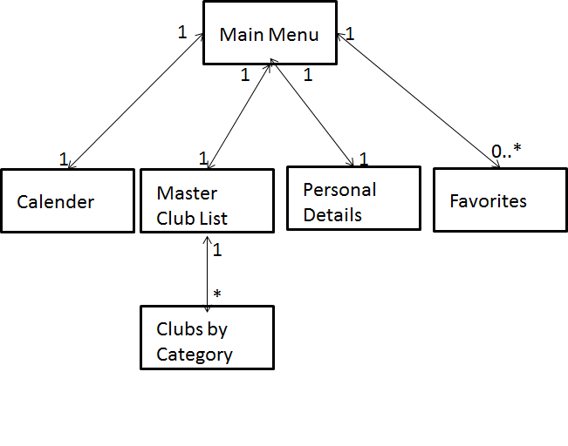

We have two kinds of users: students and clubs. The diagram represents how a student will navigate the menu on their phone. On the homepage there will be a main menu, containing most of the additional sub categories within the app. These sub categories include the Calendar, the Master Club List, A Personal Details page, and a Favorites page. The Master Club List will then have an additional sub category containing all the different types of clubs e.g. Sports, Philanthropy, Religion etc.

**Club Menu Interface**

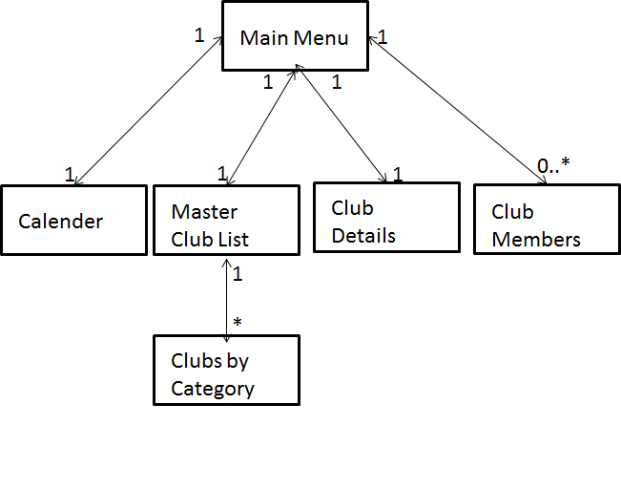We have two kinds of users: students and clubs. The diagram represents how a club will navigate the menu on their phone. On the homepage there will be a main menu, containing most of the additional sub categories within the app. These sub categories include the Calendar, the Master Club List, a Club Details page, and a Club Members page. Again, the Master Club List will then have an additional sub category containing all the different types of clubs e.g. Sports, Philanthropy, Religion etc.

**Client-Server Interaction**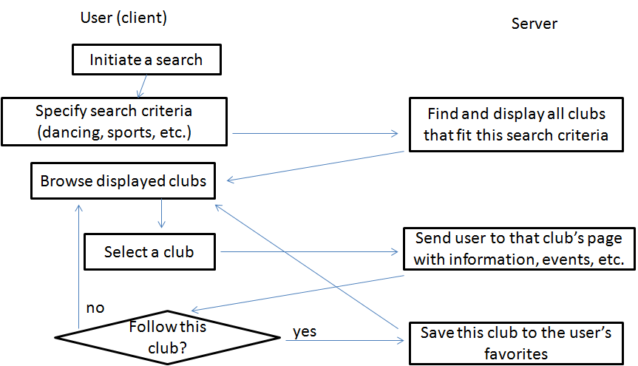

This diagram illustrates the interaction between the client and the server as a user attempts to look for clubs relevant to their interests.

**UI Mockup**

