Justification for the inclusion of habitat covariates in spatiotemporal index standardization

Johnson, K.F.1,2,*, Thorson, J.T.2, and Punt, A.E.1

1School of Aquatic and Fishery Sciences, University of Washington, Box 355020, Seattle, WA 98195, USA

2Fisheries Resource Assessment and Monitoring Division, Northwest Fisheries Science Center, National Oceanic and Atmospheric Administration, 2725 Montlake Blvd. E., Seattle, WA 98112, USA

*Correspondence to K.F. Johnson: tel: 206 860 2465; fax: 206 860 3394; email: kelli.johnson@noaa.gov

To be submitted to *Fisheries Research* for the CAPAM special issue on spatial models.

# Abstract

A key question in the management of marine fishes and invertebrates is what is the current, relative abundance? Design-based estimators, which make inferences according to the randomness of the sampling protocol, have classically been relied upon to provide an index of abundance. More recently, the use of spatiotemporal models has increased because of their ability to account for spatial heterogeneity and improve precision relative to design-based estimators. In theory, the inclusion of habitat covariates (e.g., depth) should also improve precision. We used a simulation experiment to evaluate the bias and precision of abundance estimates and their associated model parameters when the true process was and was not governed by a habitat covariate. In general, indices of abundance were estimated without bias regardless of the estimated bias in other parameters, including habitat covariates. Variance parameters governing the spatial and spatiotemporal processes of the presence-absence model were more biased and less precise than those that governed the catch-rate model. Estimates of the former were often imprecise and with bias that was correlated with bias in the habitat covariate. Results suggest that habitat covariates can improve the precision of abundance estimates and should routinely be included in future index-standardization models.

Keywords: Gaussian random field; habitat covariate; index of abundance; index standardization; spatiotemporal model

# Highlights

* 1
* 2
* 3

# Introduction

The successful management of marine fishes depends, at least in part, on knowledge of trends in abundance. Catch rates can be used to inform trends in abundance. However, catch rates by themselves are seldom proportional to abundance and need to be standardized (Maunder and Punt, 2004). Standardization can account for factors such as differences among vessels in fishing power (Helser et al., 2004; Robins et al., 1998), the depth or location at which fish are caught (Bigelow and Maunder, 2007; Cao et al., 2017), and sampling intensity (Cochran, 1977). The resulting index, with the variation not associated to changes in abundance removed, can be used directly by management or as input when fitting a stock assessment model.

Habitat, both abiotic (e.g., depth and sediment type) and biotic (e.g., presence of coral or algae), is a fundamental driver of local abundance. For example, subsurface poleward flow defines habitat for Pacific hake (*Merluccuius productus*) in the California Current ecosystem (Agostini et al. 2006). Flatfish distributions in the eastern Bering Sea are related to temperature, which acts as a proxy for the presence of the cold pool (Kotwicki et al. 2005; Mueter and Litzow, 2008; Spencer, 2008). Some habitat conditions, such as water levels of wetlands, which offer essential breeding, rearing, and feeding grounds for many species, can vary seasonally and within a season (Johnson et al., 2005). Habitats can also vary spatially, such as depth, and the most complex habitats vary spatially and temporally (Hinton and Maunder, 2004). The collection of data typically occurs across multiple habitat types, and including habitat covariates is most important when habitats vary within other included model stratifications (e.g., distance to rocky outcrop for darkblotched rockfish; Shelton et al., 2014). Unfortunately, habitat information is not always available for all sampling locations, or even stratifications of the raw data, thus limiting its inclusion in traditional index-standardization models.

Recently, spatiotemporal models have been advocated for as a way to standardize catch-rate data because of their ability to estimate less biased and more precise indices than either design-based or model-based approaches (Shelton et al., 2014; Thorson et al., 2015a). The smoothed surface representing spatial variation in catch rates (i.e., densities) assumes that densities at nearby sites are more similar than densities farther apart (i.e., spatial autocorrelation). Spatial autocorrelation can arise from exogenous or endogenous processes, where the former stems from spatial autocorrelation in underlying covariates (Koenig, 1999) and the latter stems from life-history characteristics (Levins, 1969). This autocorrelation, once thought of as a nuisance, can have strong predictive power regardless of its generating process (Bahn and McGill, 2007; Doorman, 2007). For example, a spatiotemporal model applied to bottom trawl survey-data for 28 groundfish species off the US west coast generated smaller levels of uncertainty than a model-based approach (Thorson et al., 2015b).

Spatiotemporal models can incorporate information on habitat using covariates. However, the statistical gains from the explicit inclusion of habitat in a model that already accounts for spatiotemporal effects has yet to be tested. Here, we used an existing geostatistical index-standardization model (Thorson and Barnett, 2017) to estimate the effect of depth on the density of Alaska plaice (*Pleuronectes quadrituberculatus*) in the eastern Bering Sea and condition a simulation experiment on the resulting estimates. Alaska plaice is one of four shallow-water flatfishes commonly found in the eastern Bering Sea (Zhang et al., 1998). Biological processes that coincide with depth at least partially regulate their distribution (Barbeaux and Hollowed, 2018), more so than temperature because of their physiological response mechanism that enables them to tolerate cold conditions (Knight et al., 1991). The simulation facilitated the exploration of statistical properties of the model when the true densities were and were not governed by a habitat covariate (nominally termed “depth” although the results apply to any habitat covariate). Quantitative descriptions of relationships between marine species and habitat covariates such as those presented here provide partial explanations for species distributions, but perhaps more importantly, simulation results provide inference on when we can best estimate those relationships when the truth is uncertain.

# Methods

## Vector-autoregressive spatiotemporal (VAST) model

Vector-autoregressive spatiotemporal (VAST; Thorson and Barnett, 2017; www.github.com/James-Thorson/VAST) models predict variation in density for multiple locations () across time () and can accommodate multiple categories facilitating the inclusion of multiple species or age classes (see Thorson and Barnett, 2017). However, we considered only a single category for all age groups and fit the model to data for just one species. Year-specific indices of abundance can then be calculated by weighting estimated densities by the area of the spatial domain.

The approach utilized by VAST accommodates zero observations and is often referred to as a delta- or hurdle-model (Martin et al., 2005). The probability distribution for each catch-rate data point () is decomposed into two components, the probability of encounter, , and the expected catch rate given the species is encountered, , at location and year of the th sample.

The probability of encounter, the first model component,

, Eq. 1

was modelled using a linear relationship between , which is the predictor for observation at location in year , and a year-specific intercept, , and covariates. Habitat covariates, , can be included as an array of covariates that explain variation in density for time *t* and location *s*, making the estimated impact of density covariates. Here, we investigated the use of a single covariate, depth, and thus, .

Spatial, , and spatiotemporal, , variation at location follow spatially correlated stochastic processes represented by zero-mean Gaussian random fields that were modelled using stochastic partial differential equations (Lindgren et al., 2011). These spatial fields facilitate the modelling of environmental and biological factors that are not directly included in the model but affect the density of the modelled species. The expected value, variance, and covariance at a set of fixed locations (), where and are the easting and northing for each location, followed multivariate normal (MN) distributions, and . Locations in were determined by applying a k-means clustering algorithm to the empirical data. The resulting mesh, computed using the R-INLA software (Lindgren and Rue, 2015), was comprised of 100 knots distributed across the spatial domain such that their density was proportional to the density of the samples. The covariance matrices, and , which model the covariance between location and ( is ?), were specified using a Matérn function, , with smoothness ( fixed at 1.0. The decorrelation distance (), which is the distance at which spatial correlation decreases to 10%; the Bessel function (); and geometric anisotropy, which is the tendency for correlations to decline faster in one direction than another, were estimated. Anisotropy was specified using a two-dimensional matrix () with a determinant of 1.0.

Positive catch rates, the second model component, were modelled using the following equation:

, Eq. 2

that is defined similarly to Eq. 1, except using different subscripts.

The probability of the data is a combination of the two components using:

, Eq. 3

where x …. See Appendix B for an alternative to the conventional delta-model (Thorson, 2017).

Parameter estimation was facilitated by maximizing the marginal likelihood of the fixed effects (intercepts, decorrelation distances, anisotropy parameters, and residual variation in positive catch rates) given the fitted data. The marginal likelihood was approximated using the Laplace approximation (Skaug and Fournier, 2006), which approximates the multidimensional integral of the joint likelihood (i.e., the product of the probability of random effects, given the fixed effects, and the probability of the data, given random and fixed effects), using Template Model Builder (Kristensen et al., 2016). Additionally, a non-linear minimization routine available in the R statistical environment (R Core Team, 2018) was used to identify the maximum-likelihood estimate of the fixed effects given the gradient of the approximated marginal likelihood with respect to all fixed effects.

Bias correction needs to be included in the methods section (Thorson and Kristensen, 2016).

## Empirical data

Alaska plaice are a lightly harvested flatfish that primarily resides on the eastern Bering Sea continental shelf. No targeted commercial fishery exists for them, and they are primarily caught as bycatch in the yellowfin sole (*Limanda aspera*) fishery (Zhang et al., 1998; Wilderbuer and Nichol, 2017). Their distribution overlaps with that of yellowfin sole’s primarily from April to June in continental slope waters during the spawning season (Swartzman et al., 1992) even though the center of the their overall distribution occurs northwest of yellowfin sole’s (citation). Reason why depth governs their distribution, or why we care.

Data for Alaska plaice in the Eastern Bering Sea Trawl Survey were obtained from the Alaska Fisheries Science Center. The survey operates annually, utilizing a fixed-station design focused on sampling groundfish and invertebrates (Lauth and Conner, 2016). Data provided an observed measure of biomass-per-unit area and depth for each sampled location. Alaska plaice are thought to be adequately sampled in the survey such that something about an unbiased estimate of their relative biomass. Blah blah blah.

Two models were fit to the empirical data. The first model ignored habitat covariates and blah blah. The second model included depth and estimated what did it estimate.

## Simulation

Simulations were based on fits of the spatiotemporal index-standardization model to arrowtooth flounder data from the eastern Bering Sea trawl survey for groundfish and invertebrates operated by the Alaska Fisheries Science Center (Lauth and Conner, 2016). The fixed-station survey data were standardized by area swept and provided Depths were subsequently standardized to have a mean of zero and a standard deviation of one. These data were used to fit two models, one with depth as a fixed effect and one that did not include depth. Estimates were then used to simulate data sets, where each data set had the same annual sample size and utilized the same sampling locations as the fitted data.

Write a paragraph regarding the specifications of the simulation model. All marginal variances of the spatial fields were simulated using a value of 0.5 regardless of their estimated value.

The simulated data were fit to the same two spatiotemporal index-standardization models used to fit the empirical data. The overall design was factorial, where the true process was and was not governed by depth and the estimation process did and did not include depth, leading to two misspecified and two correctly specified combinations of the operating model and estimation method. Should alternative configurations be investigated, such as looking at a range of depth effect covariates or spatial range parameters?

JTT: What do I do when estimated parameters are degenerate? Should those runs be removed, or should I fix the value at zero and re-run the model?

How do I test if the depth covariate is “significant” or the amount of variation that it explains? Does this involve likelihood ratio tests between models with and without the covariate?

Model performance was measured using relative error () and the median absolute error (), where and are estimated values and true values from the operating model, respectively. Additionally, the difference between the log ratio of the estimated index in the first and last year and the log ratio of the true index in the first and last year was investigated to assess bias in the estimated trend. The best model of the two investigated was chosen using Akaike information criterion (AIC; Burnham and Anderson, 2002). Performance was assessed using 100 replicates per operating model and estimation method combination.

# Results

## Fit to eastern Bering Sea trawl survey

Including depth as a fixed-effect led to a model that better fit data on Alaska plaice density in the eastern Bering Sea than a model that did not include habitat (ΔAIC of -18.48). Depth effects were negative for both model components (Table 1), though the interpretation of the effect for the first model component is contingent on all other coefficients and must be interpreted in terms of an odds ratio (Thorson, 2017).

The resulting estimated indices of abundance were similar between the estimation methods (Figure x). The similarity is a direct result of all parameters other than those that estimated depth effects being indistinguishable (i.e., all parameters fell within the bounds of the 95% confidence intervals from both estimation methods).The marginal standard deviation of the spatial field for the first model component was the most different, in absolute terms, between the two methods.

## Habitat covariate effects

Habitat covariates for both model components were estimated without bias regardless of whether or not the operating model was governed by depth (points are centred on the crosshairs in Figure 2). Surprisingly, estimated depth effects were small, if not zero, when the true effect was zero but it was wrongly included in the estimation method. The spread of the estimates increased with increasing variability in the spatial field, particularly for the misspecified estimation method, but the MAE of the depth effects only slightly increased with increasing variability in the spatial field.

## Estimated trend in abundance

The estimated trend in the index of abundance was unbiased (Figure 3). Model misspecification did not lead to an increase bias as would be expected. Instead, model misspecification led to tradeoffs in the bias of other parameters. Specifically, the bias in the marginal variance of the spatial field for the first model component was correlated the bias in the spatial range when the true process was governed by depth and depth was not included in the estimation method (inset in lower left panel of Figure 4).

# Discussion

The inclusion of environmental covariates in index-standardization models …

1. Summary of basic, most-important results.
2. The main goal in standardizing data meant to serve as a relative index of abundance is to remove the variation in the data that is not attributable to changes in the true population size. Unfortunately, the bias in the index will often decrease but the variance will increase as the number of covariates are increased (Maunder and Punt, 2004).
3. The exact mechanism regulating Alaska plaice distribution with depth remains unknown.
   1. Why depth would regulate the distribution of Alaska plaice.
   2. Overall trend and recent increasing trend were similar to that estimated for the 2017 stock assessment (Wilderbuer and Nichol, 2017).
4. Limitations of this study
5. Next steps
   1. Poisson-link
   2. Non-linear effects (Sadykova et al., 2017).
   3. How many covariates can you add that do not truly govern the population before the estimation of the true population will be biased? Here, we investigated one and the mean estimate was zero, which is true. Unfortunately, leaving out covariates is not as straightforward.
6. Conclusion

* Depth was a significant factor in the standardization of cockfish (*Callorhinchus callorynchus*) catch rates (Bernasconi et al., 2015).
* Alaska plaice and yellowfin sole have the potential to move to arctic conditions (from sub-arctic) with the decrease in summer sea-ice that is projected (Hollowed et al., 2013).
* Simple linear or quadratic relationship may be a poor approximation of the impact of habitat on density (Harris, 2015) but the inclusion of an additional spatiotemporal effect can accommodate remaining nonlinear and unmeasured habitat associations (Shelton et al., 2014).

# Acknowledgements

The views expressed herein are those of the authors and do not necessarily reflect the views of the National Oceanic and Atmospheric Administration or its sub-agencies. The authors thank x, x, and x for their helpful feedback and two anonymous reviewers for their comments, all of which improved the manuscript.

# Funding

KFJ was funded in part by a grant from Washington Sea Grant, University of Washington, pursuant to National Oceanic and Atmospheric Administration Award No. NA15OAR4170181. Other funding?

References

Agostini, V.N., Francis, R.C., Hollowed, A.B., Pierce, S.D., Wilson, C., and Hendrix, A.N. 2006. The relationship between Pacific hake (*Merluccius productus*) distribution and poleward subsurface flow in the California Current System. Canadian Journal of Fisheries and Aquatic Sciences, 63: 2648-2659. 10.1139/f06-139.

Bahn, V., and McGill, B.J. 2007. Can niche-based distribution models outperform spatial interpolation?. Global Ecology and Biogeography, 16(6): 733-742. 10.1111/j.1466-8238.2007.00331.x.

Barbeaux, S.J., and Hollowed, A.B. 2018. Ontogeny matters: climate variability and effects on fish distribution in the eastern Bering Sea. Fisheries Oceanography, 27: 1-15. 10.1111/fog.12229.

Bigelow, K.A., and Maunder, M.N. 2007. Does habitat or depth influence catch rates of pelagic species? Canadian Journal of Fisheries and Aquatic Sciences, 64(11): 1581-1594. 10.1139/f07-115.

Burnham, K.P., and Anderson, D.R. 2002. Model Selection and Multimodel Inference: A Practical Information-Theoretic Approach. Springer-Verlag New York, Inc. New York, NY.

Cao, J., Thorson, J.T., Richards, A., and Chen, Y. 2017. Spatiotemporal index standardization improves the stock assessment of northern shrimp in the Gulf of Maine. Canadian Journal of Fisheries and Aquatic Sciences, 74: 1781-1793. 10.1139/cjfas-2916-0137.

Cochran, W.G. 1977. Sampling Techniques, 3rd edition. John Wiley and Sons. 428 pp.

Doorman, C.F. 2007. Effects of incorporating spatial autocorrelation into the analysis of species distribution data. Global Ecology and Biogeography, 16(2): 129-138. 10.1111/j.1466-8238.2006.00279.x.

Helser, T.E., Punt, A.E., and Methot, R.D. 2004. A generalized linear mixed model analysis of a multi-vessel fishery resource survey. Fisheries Research, 70(2-3): 251-264. 10.1016/j.fishres.2004.08.007.

Hinton, M.G., and Maunder, M.N. 2004. Status of striped marlin in the eastern Pacific Ocean in 2002 and outlook for 2003-2004. Inter-American Tropical Tuna Commission, Stock Assessment Report No. 4: 287-310.

Johnson, W.C., Millett, B.V., Gilmanov, T., Voldseth, R.A., Guntenspergen, G.R., and Naugle, D.E. 2005. Vulnerability of northern prairie wetlands to climate change. BioScience, 55(10): 863-872. 10.1641/0006-3568(2005)055[0863:VONPWT]2.0.CO;2.

Knight, C.A., Cheng, C.C., and DeVries, A.L. 1991. Adsorption of alpha-helical antifreeze peptides on specific ice crystal surface planes. Biophysical Journal, 59(2): 409-418. 10.1016/S0006-3495(91)82234-2.

Koenig, W.D. 1999. Spatial autocorrelation of ecological phenomena. Trends in Ecology and Evoloution, 14(1): 22-26. 10.1016/S0169-5347(98)01533-X.

Kotwicki, S, Buckley, T.W., Honkalehto, T., and Walters, G. 2005. Variation in the distribution of walleye pollock (*Theragra chalcogramma*) with temperature and implications for seasonal migration. Fishery Bulletin, 103(4): 574-587.

Kristensen, K., Nielsen, A., Berg, C.W., Skaug, H., and Bell, B.M. 2016. TMB: Automatic differentiation and laplace approximation. Journal of Statistical Software, 70(5): 1-21. 10.18637/jss.v070.i05.

Lauth, R.R., and Conner, J. 2016. Results of the 2013 eastern Bering Sea continental shelf bottom trawl survey of groundfish and invertebrate resources. U.S. Department of Commerce, NOAA Technical Memorandum, NMFS-AFSC-331, pp 155. Seattle, WA. 10.7289/V5/TM-AFSC-331.

Levins, R. 1969. Some demographic and genetic consequences of environmental heterogeneity for biological control. Bulletin of the Entomological Society of America, 15(3): 237-240. 10.1093/besa/15.3.237.

Lindgren, F., Rue, H., and Lindström, J. 2011. An explicit link between Gaussian fields and Gaussian Markov random fields: the stochastic partial differential equation approach. Journal of the Royal Statistical Society: Series B (Statistical Methodology), 73(4): 423-498. 10.1111/j.1467-9868.2011.00777.x.

Lindgren, F., and Rue, H. 2015. Bayesian spatial modelling with R-INLA. Journal of Statistical Software, 63(19): 1-25. 10.18637/jss.v063.i19.

Martin, T.G., Wintle, B.A., Rhodes, J.R., Kuhnert, P.M., Field, S.A., Low-Choy, S.J., Tyre, A.J., and Possingham, H.P. 2005. Zero tolerance ecology: improving ecological inference by modelling the source of zero observations. Ecology Letters, 8(11): 1235-1246. 10.1111/j.1461-0248.2005.00826.x.

Mueter, F.J., and Litzow, M.A. 2008. Sea ice retreat alters the biogeography of the Bering Sea continental shelf. Ecological Applications, 18(2): 309-320. 10.1890/07-0564.1.

R Core Team. 2018. R: A Language and Environment for Statistical Computing. R Foundation for Statistical Computing, Vienna, Austria. https://www.R-project.org/.

Robins, C.M., Want, Y.G., and Die, D. 1998. The impact of global positioning systems and plotters on fishing power in the northern prawn fishery, Australia. Canadian Journal of Fisheries and Aquatic Sciences, 55(7): 1645-1651. 10.1139/f98-037.

Skaug, H.J., and Fournier, D.A. 2006. Automatic approximation of the marginal likelihood in non-Gaussian hierarchical models. Computational Statistics and Data Analysis, 51(2): 699-709. 10.1016/j.csda.2006.03.005.

Spencer, P.D. 2008. Density-independent and density-dependent factors affecting temporal changes in spatial distributions of eastern Bering Sea flatfish. Fisheries Oceanography, 17(5): 396-410. 10.1111/j.1365-2419.2008.00486.x.

Swartzman, G., Huang, C., and Kaluzny, S. 1992. Spatial analysis of Bering Sea groundfish survey data using generalized additive models. Canadian Journal of Fisheries and Aquatic Sciences, 49: 1366-1378.

Thorson, J.T. 2017. Three problems with the conventional delta-model for biomass sampling data, and a computationally efficient alternative. Canadian Journal of Fisheries and Aquatic Sciences, 00: 00-00. 10.1139/cjfas-2017-0266.

Thorson, J.T., Scheuerell, M.D., Shelton, A.O., See, K.E., Skaug, H.J., and Kristensen, K. 2015a. Spatial factor analysis: a new tool for estimating joint species distributions and correlations in species range. Methods in Ecology and Evolution, 6(6): 627-637. 10.1111/2041-210X.12359.

Thorson, J.T., Shelton, A.O., Ward, E.J., and Skaug, H.J. 2015b. Geostatistical delta-generalized linear mixed models improve precision for estimated abundance indices for West Coast groundfishes. ICES Journal of Marine Science, 72(5): 1297-1310. 10.1093/icesjms/fsu243.

Thorson, J.T., and Kristensen, K. 2016. Implementing a generic method for bias correction in statistical models using random effects, with spatial and population dynamics examples. Fisheries Research, 175: 66-74. 10.1016/j.fishres.2015.11.016.

Thorson, J.T., and Barnett, L.A.K. 2017. Comparing estimates of abundance trends and distribution shifts using single- and multispecies models of fishes and biogenic habitat. ICES Journal of Marine Science, 74(5): 1131-1321. 10.1093/icesjms/fsw193.

Wilderbuer, T.K., and Nichol, D.G. 2017. Assessment of the Alaska plaice stock in the Bering Sea and Aleutian Islands. North Pacific Fisheries Management Council, Seattle, WA.

Zhang, C.I., Wilderbuer, T.K., and Walters, G.E. 1998. Biological characteristics and fishery assessment of Alaska plaice (*Pleuronectes quadrituberculatus*) in the eastern Bering Sea. Marine Fisheries Review, 60(4): 16-27.

# Tables

Table . Parameter names and their corresponding symbols used for the spatiotemporal index-standardization model. Two versions of the model, one without and one with fixed-effect covariates for depth, were fit to empirical data collected by the Alaska Fisheries Science Center during the eastern Bering Sea trawl survey on Alaska plaice (*Pleuronectes quadrituberculatus*). A value of NA means that the parameter or index value was not estimated. Estimates of standard error (se) are given in parentheses.

|  |  |  |  |  |
| --- | --- | --- | --- | --- |
| Name | Symbol | Dimension | Est. w/o depth (se) | Est. w/ depth (se) |
| Sample |  |  |  |  |
| Location |  |  |  |  |
| Year |  |  |  |  |
| Vessel |  |  |  |  |
| Catch data |  |  |  |  |
| Marginal spatial variation in |  |  | 3.007 | 2.978 |
| Marginal spatial variation in |  |  | 1.204 | 1.193 |
| Marginal spatiotemporal variation in |  |  | 1.240 | 1.236 |
| Marginal spatiotemporal variation in |  |  | 0.613 | 0.612 |
| Depth effect for |  |  | NA | 1.223 |
| Depth effect for |  |  | NA | 0.168 |
| Add more rows |  |  |  |  |

Table . Median absolute relative error (MARE) of fixed-effect parameters.

Insert table.

# Figures

Insert map here.

Figure . Map of the study area.

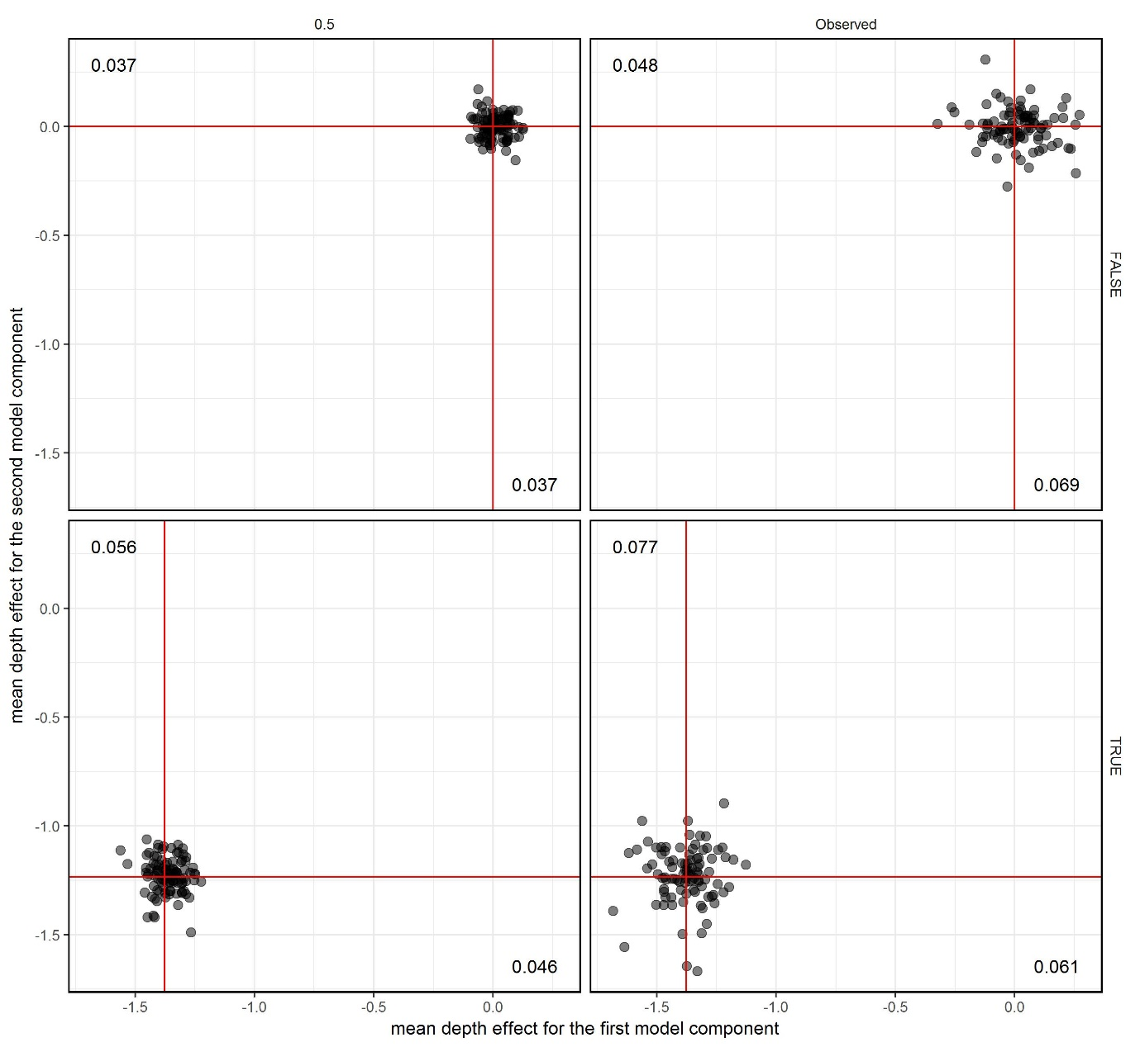

Figure . Estimated depth effects for each model component (presence absence model on x-axis and catch-rate model on y-axis). The true effect size was either zero (top row) or the value estimated from fitting a model to empirical data collected in the eastern Bering Sea on Alaska plaice. The true marginal standard deviation of the spatial and spatialtemporal fields was either set according to the empirically estimated value (right column) or to 0.5 (left column), where latter was smaller. Points represent a single replicate of an estimation method that included depth fit to simulated data. The median absolute error (estimated – true) for each parameter is printed near each respective axis. Unbiased results are located on the red cross-hairs.

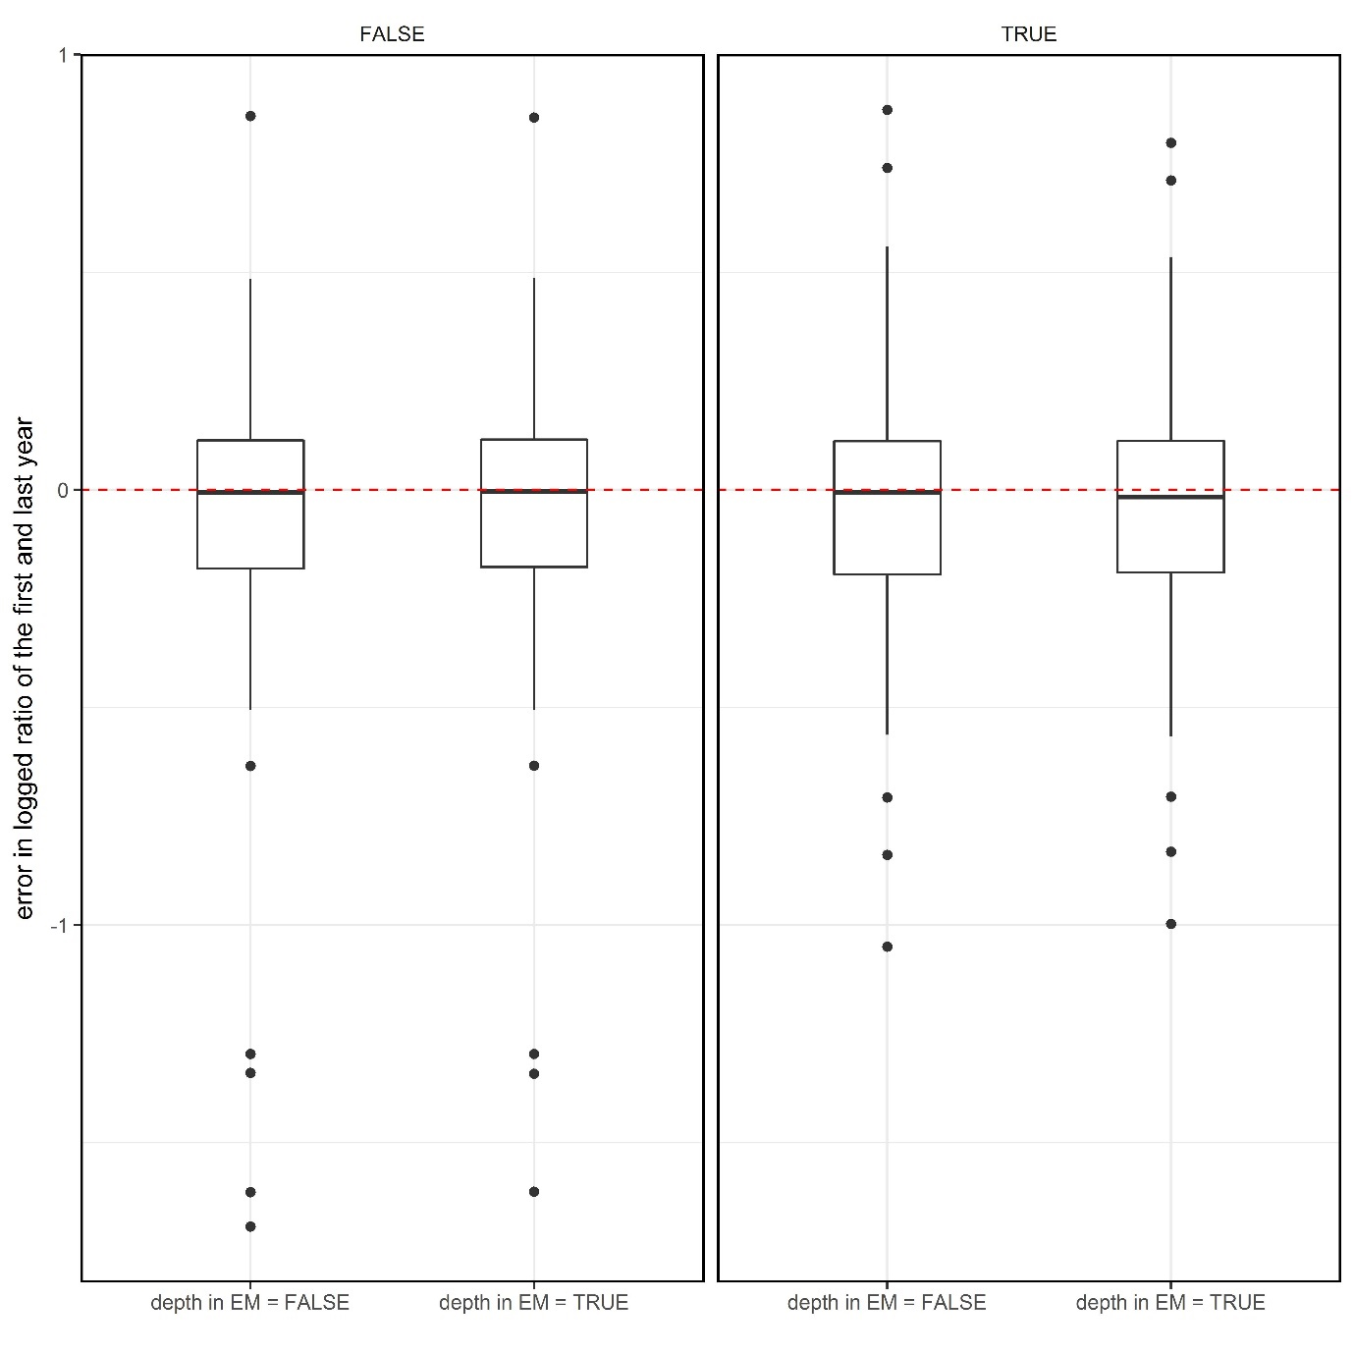

Figure . Boxplots of the error in the log ratio of the first and last years of the index of abundance when the operating model did not include depth (left panel) and when it did include depth (right panel) for two estimation methods (x-axis), one with fixed-effects for depth and one that did not fit to the depth data. The red, dashed line indicates the location of unbiased estimates. Whiskers depict 1.5 times the first and third quartiles and outliers are represented using points.

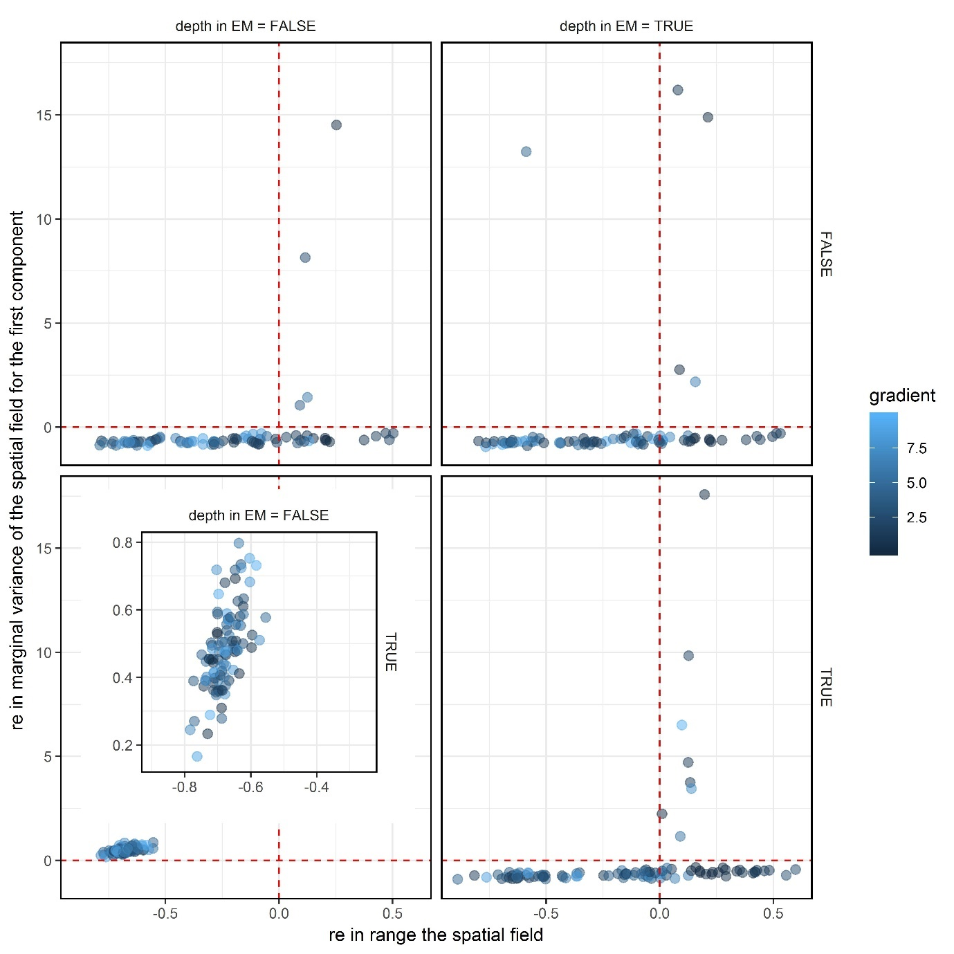

Figure . Relative error in the marginal variance of the spatial field for the first model component versus the relative error in the range of the spatial field for this same model component when the true model used to generate the dynamics included depth (bottom row) and did not include depth (top row) and when the estimation method included depth (right column) and did not include depth (left column). The red, dashed lines indicate the location of unbiased results. Colors indicate the maximum gradient of the model run. The inset in the lower, left panel is just a magnified version of that panel to show the correlation between the bias in the parameters.

# Appendix B: Comparing the conventional delta-model with the compound Poisson-Gamma model

The “delta-model” is the most common method used to analyse sampling data that typically include both zeros and non-zero densities (e.g., counts or weights per area) in the field of fisheries science (Maunder and Punt, 2004; Zuur et al., 2009). Delta-models have two parts that assume the zero and non-zero data are generated from separate processes, and densities can be estimated by combining the expected probability of an encounter and the expected density given a successful encounter. Another method, more popular in meteorology, is the compound Poisson-Gamma (CPG) model that can simultaneously support zeros and positive quantities (Foster and Bravington, 2013; Lecomte et al., 2013; Smyth, 1996; Thorson, 2017).

Recently, Thorson (2017) suggested the “Poisson-link” model for fisheries data that is similar to the CPG model, but allows for a closed-form solution to the likelihood calculation. Like the delta-method, the CPG and the Poisson-link model also have two parts, the density of groups and the average mass per group, but they are correlated through their mutual dependence on group density whereas the two parts of the delta-model are independent. The correlation allows for better fits to the data because variation in catch rates can be informed by knowledge of encounter probabilities. Thorson (2017) suggested that the Poisson-link model was more computationally efficient than the CPG model and provided theoretical justification for its use over the delta-method, but the resulting confidence intervals of extrapolated estimates of abundance were similar for most regions between the Poisson-link and the delta-method.

Here, simulations were used to compare the properties of the delta-method and the Poisson-link method. Complete this paragraph.

# Methods

Data from the eastern Bering Sea on arrowtooth flounder (*Atheresthes stomias*) were used to fit delta-method and Poisson-link index-standardization models. The resulting estimates were then used to conduct a simulation where the operating models were based on these fits to the empirical data. Data was simulated from the two operating models and then fit to an estimation method that matched the operating model. An additional sensitivity was conducted that excluded the depth covariate from the fitting process.

More details here.

# Results

Mean estimated depth effects from the empirical data were smaller in the Poisson-link model as compared to the delta-model (lines in Figure A1). The effects for the second component were smaller in magnitude than the first component and the first component of the delta-model was the largest estimated mean effect. Effect sizes are not directly comparable across the two model types because the delta-method uses a logit-link function making the yearly-effect size dependent on the yearly intercept as well. When these estimated depth effects were used to simulate data, the delta-model estimated the effects with greater precision and less bias than the Poisson-link model.

In general, both model types estimated the trend of the index of abundance without bias regardless of whether or not they included effects for depth. The error in the logged ratio of the first compared to the last year between the true values as those estimated from the estimation method were smaller and more precise for the delta-model than the Poisson-link model (Figure A2).

Many of the model parameters were estimated with bias or were more variable than expected, but none of the bias or variance was correlated with bias in the estimated indices (Figure A2). For example, the marginal standard deviation of the spatial process in the first model component was estimated with bias in both model types (Figure A2). The parameter was negatively biased with the Poisson-link model regardless of whether or not depth was included as a covariate in the estimation process. Conversely, the parameter was positively biased when depth was not included in the delta-method model and negatively biased when depth was included. The parameter was estimated as degenerate in at least some of the replicates for all models except the delta-method without depth.

# Discussion

The Poisson-link model was less biased than the delta-model when the models were wrongly specified. Nevertheless, this bias in parameter estimates did not affect the bias in the trend of the estimated index of abundance.

# References

Foster, S.D., and Bravington, M.V. 2013. A Poisson-Gamma model for analysis of ecological non-negative continuous data. Environmental and Ecological Statistics, 20(4): 533-552.

Lecomte, J-P., Benoît, H.P., Ancelet, S., Etienne, M-P., Bel, L., and Parent, E. 2013. Compound Poisson-gamma vs. delta-gamma to handle zero-inflated continuous data under a variable sampling volume. Methods in Ecology and Evolution, 4(12): 1159-1166. 10.1111/2041-210X.12122.

Maunder, M.N., and Punt, A.E. 2004. Standardizing catch and effort data: a review of recent approaches. Fisheries Research, 70(2-3): 141-159. 10.1016/j.fishres.2004.08.002.

Smyth, G.K. 1996. Regression analysis of quantity data with exact zeroes. *In* Proceedings of the Second Australia-Japan Workshop on Stochastic Models in Engineering, Technology and Management, Gold Coast, Australia. pp 17-19.

Thorson, J.T. 2017. Three problems with the conventional delta-model for biomass sampling data, and a computationally efficient alternative. Canadian Journal of Fisheries and Aquatic Sciences, 00(00): 00-00. 10.1139/cjfas-2017-0266.

Zuur, A.F., Ieno, E.N., Walker, N.J., Saveliev, A.A., and Smith, G.M. 2009. Mixed Effects Models and Extensions in Ecology with R. 1st ed. Springer Science+Business Media, New York, New York.

Tables

Figures

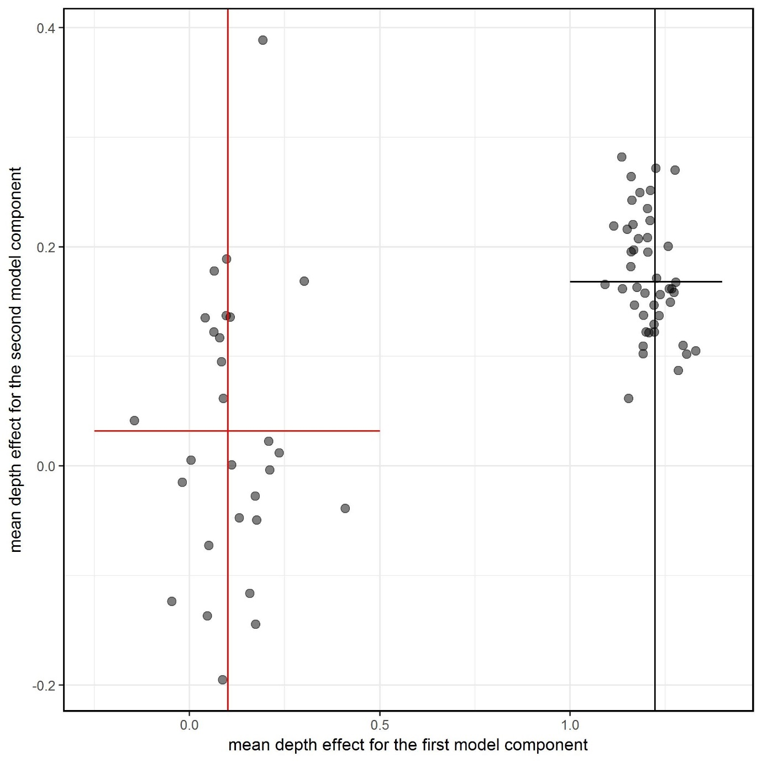

Figure A. Mean estimated depth covariates for each part of the model (presence absence model on x-axis and catch-rate model on y-axis), where the true value depended on fits to the empirical data by the Poisson-link model (red cross-hair) and delta-method (black cross-hair). Points represent a single replicate of an estimation method fit to simulated data.

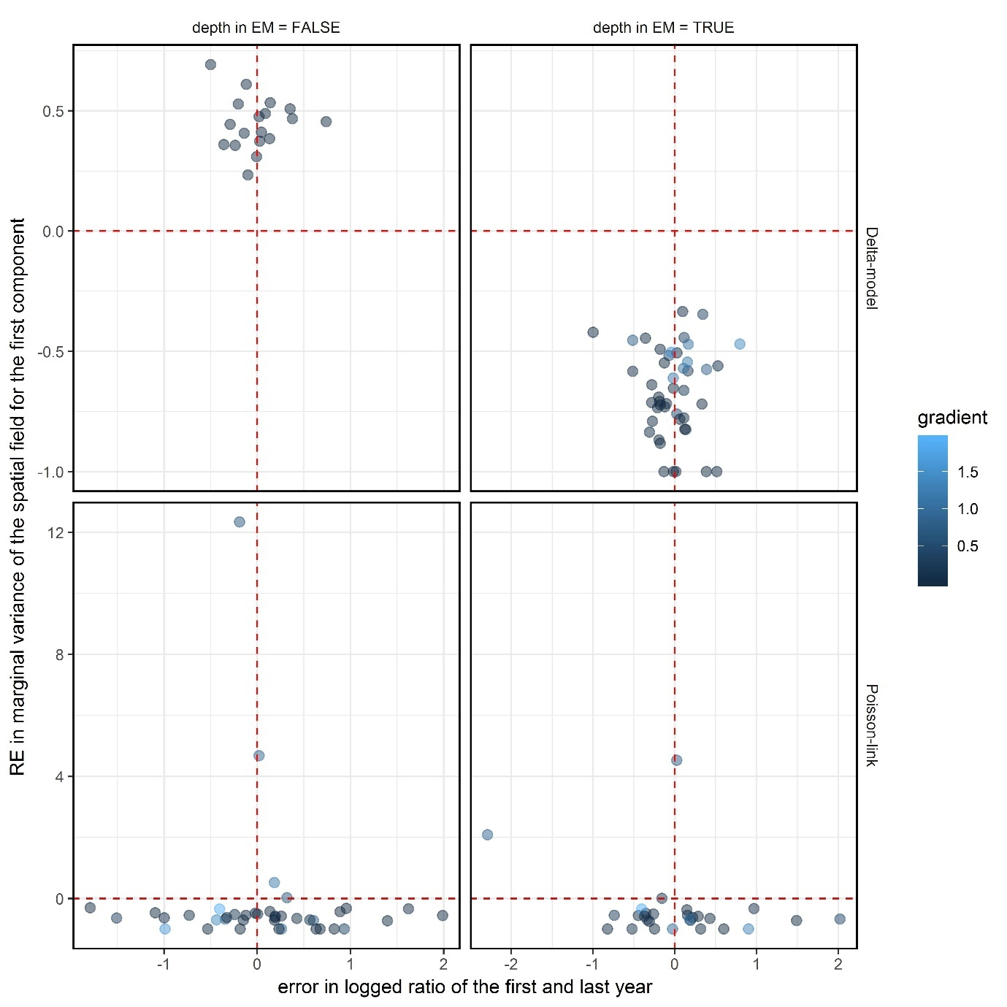

Figure A. Relative error (RE) in the marginal variance of the spatial field for the first component for each model type (rows) vs. the error in the logged ratio of the first and last year of the indices of abundance. Two model types were investigated, the delta-model (top row) and the Poisson-link model (bottom row), with and without a covariate for depth (columns). Points should fall on the intersection of the red, dashed lines if they are unbiased and their color reflects the maximum gradient. Note that the axes are not the same across the panels.