Option 1) Using gradients in productivity to inform stock structure: a case study in Alaskan waters

Option 2) Blurred boundaries: quantifying mismatches between stock productivity and management boundaries for three groundfish species in Alaskan waters

Kelli F. Johnson1*, André E. Punt1, James T. Thorson2, and Kerim A. Aydin3

1School of Aquatic and Fishery Sciences, University of Washington, Box 355020, Seattle, WA 98195-5020, USA

2Northwest Fisheries Science Center, National Marine Fisheries Service, NOAA, 2725 Montlake Blvd. East, Seattle, WA 98112-2097, USA

3Alaska Fisheries Science Center, National Marine Fisheries Service, NOAA, 7600 Sand Point Way N.E., Seattle, WA 98115-6349, USA

*Corresponding author: tel: +1 206 543 4270; fax: +1 206 685 7471; email: kfjohns@uw.edu

# Abstract

Todo: write abstract

# Keywords

Aleutian Islands, Alaska, Atka mackerel, Gulf of Alaska, Gompertz model, Pacific cod, random field, stock structure, walleye pollock

# Introduction

The first step in the management of natural resources is to determine the management unit, which will depend on the management objectives. Unfortunately, management objectives are not static, therefore it follows that management units should evolve in tandem with changing management objectives (Begg and Waldman, 1999; Reiss *et al.*, 2009). Furthermore, environments are not static. Species ranges are predicted to shift with respect to depth and latitude as oceans warm in response to climate change (Perry *et al*., 2005; Dulvy *et al*., 2008; Nye *et al*., 2009), potentially increasing the mismatch between default, often political, and biological stock boundaries.

Management objectives for commercially fished marine species typically prioritize optimizing long-term sustainable yields, while conserving biological characteristics that facilitate such optimal yields (Hilborn and Walters, 1992; Punt *et al*., 2006). To achieve the previous, fisheries managers must design, politically justify, and implement restraints on fishing activities. Output from stock assessment models provides scientific advice to fisheries managers regarding the current status of the management unit (stock) and how it may potentially respond to future management measures. A major assumption of stock assessment models is that fish within the stock are homogeneous (i.e., similar growth, natural mortality, risk of fishing, etc.) (Waldman, 2005; Rothschild and Jiao, 2011). Thus, geographic boundaries of fish stocks should be defined using a method based on population dynamics (life-history) parameters (Carvalho and Hauser, 1995; Begg and Waldman, 1999; Quinn and Deriso, 1999).

Life-history parameters (growth, survival, age-at-maturation, fecundity, distribution, and abundance) tend to reflect the specific environment inhabited by a stock due to their sensitivity to both environmental and anthropocentric influences (Begg *et al*., 1999). Furthermore, even though life-history parameters do not provide direct information about the genetic composition of the stock, phenotypic variation results from the interaction between genotypes and their environment, thus providing a proxy for genetic structure (Campana *et al*., 1995). In short, using easy to measure life-history data to delineate stock boundaries can provide a good starting point for more advanced stock identification techniques (e.g. behavioural, biochemical, cytogenetics, immunological, meristic, morphometric, parasitic, protein electrophoresis, scale morphology, otoliths, serological, stable isotopes, tag-recovery, etc.), while being cost effective and efficient (Begg *et al*., 1999; Smedbol and Stephenson, 2001).

Almost all fish species exhibit complex spatial structure in their population dynamics (Conover *et al*., 2006; Cope and Punt, 2009). Consequently, understanding stock structure becomes increasingly important when stocks of a given species are differentially exploited (Altukhov, 1981; Ricker, 1981). Fisheries that reduce stocks to low levels for extended periods of time can lead to reduced genetic diversity, which can ultimately lead to lowered adaptability, population productivity, and persistence (Lacy, 1987; Lande, 1993; Hauser *et al*., 2002). Matching stocks with biological units helps minimize the risk of depleting distinct stocks (Frank and Brickman, 2000; Laikre *et al*., 2005; Sterner, 2007) and helps maintain stable stock complexes (Schindler, 2010).

Currently, no single method, whether it be based on life-history parameters, genetics, otolith structure, parasitic composition, etc., properly identifies all stocks. Several techniques require a substantive amount of costly data, necessitating a balance between accuracy and efficiency (Hilborn and Walters, 1992). Thus, techniques that use data routinely collected for assessment and management purposes (i.e., life-history parameters) can be advantageous. Unfortunately, fisheries data are subject to both observation and process error, which can complicate analyses.

State-space models can simultaneously estimate process and observation error making them ideal for ecological data. Their use in ecology began with time-series data for single populations (Staples, Taper, and Dennis, 2004; Dennis *et al*., 2006) and later extended into two-dimensional space for movement data (Jonsen, Myers, and Flemming, 2003) and multiple subpopulations (Ward *et al*., 2010) and species (Mattsson *et al*., 2013). Multivariate time-series analysis is one way to detect patterns of correlation and synchrony across multiple scales (Ward *et al*., 2010) and can provide inferences on stock structure based on ecological differences across stocks. Unfortunately these models rely on the user to specify hypothesized stock structures (i.e., manually grouping the data according to hypothesized stock structures). Additionally, parameter estimates from non-spatial population models tend to be biased (Thorson *et al*., In review), making it necessary to explicitly include space. Accounting for space can be accomplished by replacing relevant, scalar, life-history parameters with spatial or spatio-temporal random effects (Cressie and Wikle, 2011; Gelman *et al*., 2013). Subsequently, spatially-explicit estimates of productivity can be used to help inform stock structure.

Here we quantify spatial differences in productivity for three species, walleye pollock (*Theragra chalcogramma*; hereafter referred to as pollock), Pacific cod (*Gadus macrocephalus*; hereafter referred to as cod), and Atka mackerel (*Pleurogrammus monopterygius*; hereafter referred to as mackerel) in the north east Pacific Ocean using spatially-explicit Gompertz population dynamics models, implemented within a state-space formulation. Pollock, cod, and mackerel were chosen because of their ecological and commercial importance in the Bering Sea Aleutian Island and Gulf of Alaska (GOA) large marine ecosystems. Pollock and cod represent the two largest fisheries by weight in all of Alaska (1,310,330 and 329,040 (t), respectively; st.nmfs.noaa.gov). Furthmore, pollock and mackerel are the main prey for cod, comprising approximately 19% and 27% of total cod stomach contents, respectively (Ortiz, 2007). Pollock and mackerel are also the two most common prey species (frequency of occurrence (FO) 46.4% and 39.6%, respectively) of the federally endangered Steller sea lion (*Eumetopias jubatus*; SSL), with cod being the fourth most common (FO = 16.1%) (Sinclair and Zeppelin, 2002). The method should be useful to researchers looking to inform stock structures of species for which fisheries-independent data exists yet precise structures remain unclear.

# Materials and methods

## Study area

The study area included the Aleutian Islands (AIs; 170° E to 170° W), a portion of the Southern Bering Sea (BS) (165° W to 170° W along the north side of the AIs), and the GOA (132°40’ W to 170° W) (Figure 1). The AIs are an extensive archipelago comprised of 14 large and hundreds of small volcanic islands, characterized by a relatively narrow continental shelf, crossed by numerous deep passes. Conversely, the GOA is characterized by a semi-enclosed basin, with a relatively shallow shelf that varies in width from 5 km in the southeast to more than 200 km in the north.

## Data

Survey data were collected by the Alaska Fisheries Science Center of the National Marine Fisheries Service from 1982 to 2012 during the triennial GOA and AIs bottom trawl surveys. These data are used to provide estimates of absolute or relative abundance (A’mar *et al*., 2013; Aydin *et al*., 2013), define distributions, and inform biological parameters of groundfish and crab to the North Pacific Fishery Management Council (NPFMC).

Surveys employed a stratified random sampling design, with grids determined by NPFMC regulatory areas, which were further divided into depth strata. The AI surveys covered depths up to 500 m along the north side of the AIs from Unimak Pass (165° W) westward to Samalga Pass (170° W) and on both sides of the AIs from Samalga Pass to Stalemate Bank (170° E) (von Szalay *et al*., 2011). The GOA survey covered depths up to 1000 *m* from Samalga Pass to Dixon Entrance (54°30’ N, 132°40’ W) (Raring *et al*., 2011). Surveys in the AIs were conducted in 1983, 1986, 1991, 1994, 1997, 2000, 2002, 2004, 2006, 2010, and 2012. Surveys in the GOA were conducted in 1984, 1987, 1990, 1993, 1996, 1999, 2001, 2003, 2005, 2007, 2009, 2011, and 2013. The analysis was restricted to data collected after 1989 and east of 140° W because of the lack of standardized gear and effort measurements prior to 1990 (Munro and Hoff, 1995) and because of the Southeast Alaska Outside Trawl Closure, respectively (Figure 1).

Tows of 15 min (estimated on-bottom duration) at speeds of 3 knots were conducted at each sampled station. For each tow, species composition of the catch was determined and species-specific catch per unit effort (*CPUE*) was calculated as the weight of the catch (kg) divided by the area swept (ha) for a given trawl (Figure 2). Global positioning (GPS) locations for each trawl were projected using the Albers equal-area conic projection, an equal area map projection.

## Spatial fields

Spatial data were defined as realizations of a stochastic process indexed by space

$Y\left(s\right)≡ \left\{y\left(s\right), s∈D\right\}$, Eq. 1

where the domain, Ɗ, is a fixed subset of ℝd (here d = 2) and the set, *s $\left(s_{1}, …, s_{n}\right)$* , indicates the spatial units at which the measurements were taken. The data $y= \left\{y\left(s_{1}\right), …, y\left(s_{n}\right)\right\}$ were point-referenced nonzero *CPUE* measurements of a continuous random process, modelled using the stochastic partial differential equation (SPDE) approach proposed by Lindgren *et al*. (2011). SPDEs use sparse covariance matrices, which facilitate modeling space as a continuous process without the “big *n* problem” (Jona-Lasinio *et al*., 2012; *et al*., 2012; Banerjee *et al*., 2004) caused by dense covariance matrices.

Assuming that

$y_{s_{i}} \sim N(η_{s_{i}}, σ_{e}^{2})$, Eq. 2

where $σ_{e}^{2}$ is the variance of the mean measurement error, or nugget effect, and $η_{s_{i}}$ is the mean response

$η_{s_{i}}= α+ \sum_{m=1}^{M}{β_{m}x_{ms_{i}}}+ξ_{s_{i}}$, Eq. 3

where $α+ \sum_{m=1}^{M}{β_{m}x_{ms_{i}}}$ is the large-scale component composed of an intercept, $α$, and coefficients $β=(β_{1}, …, β_{M})$, which quantify the effects of the covariates $x=(x_{1}, …, x_{M})$, and $ξ_{s_{i}}$ is the $s_{i}$ realization of the latent Gausian Field (GF), it follows that $e_{i}$ is independent of $e_{j}$ when $i≠j$.

Triangulation of Ɗ facilitates the transformation of the GF to a discretely-indexed Gaussian Markov random field (GMRF)

$ξ\left(s\right)= \sum_{g=1}^{G}{φ_{g}}(s){\tilde{ξ}}_{g}$, Eq. 4

where *G* is the total number of vertices in the triangulation, { $φ_{g}\}$ is the set of basis functions, and ${\tilde{\{ξ}}_{g}\}$ are the non-zero distributed weights. Basis functions were chosen such that $φ_{g}$ was 1 at vertex *g* and 0 everywhere else (Lindgren *et al*., 2011). GMRFs are characterized by a multivariate Normal distribution with mean **μ** = (μ­1, …, μn)′ and a spatially-structured covariance matrix Σ, whose generic element is defined as

Σi,j = Cov(θi, θj) = . Eq. 5

Here, $σ_{ϑ}^{2}$ is the variance component for $i,j=1, …, n$ and $ϑ(Δ_{i,j})$ is the (isotropic) Matérn spatial covariance function (Cressie, 1993), which depends on the Euclidean distance between the locations $Δ_{i,j}=\left\|s_{i}-s_{j}\right\|$. A GF with a Matérn covariance function

$ϑ\left(Δ_{i,j}\right)= \frac{1}{Γ\left(λ\right)2^{λ-1}}{(κΔ_{i,j})}^{λ}Κ_{λ}(κΔ_{i,j})$, Eq. 6

provides an exact solution to the SPDE, which can be approximated using a finite element representation (Eq. 4). Here, $Κ_{λ}$ is the modified Bessel function of second kind and order $λ>0$ (here $λ=1$) measuring the degree of smoothness. The range ($r$),

$r= \frac{\sqrt{8λ}}{κ}$, Eq. 7

was defined as the distance at which the spatial correlation is approximately 0.1, using κ>0 as a scaling parameter, according to Lindgren *et al*. (2011; see Section 2).

## Gompertz model

Population dynamics for each species were modelled using a spatial equivalent of the log-linear stochastic Gompertz model,

${log⁡(D}_{t})= Ω+ρ\log\left(D_{t-1}\right)+ Ε_{ EQ t}$, Eq. 8

where $D_{t}$ is the density at all spatial locations [x,y] in year *t*, ρ is the strength of density dependence, Ω is the intercept represented by a GMRF

Ω ~ *MVN*(α**1**, ΣΩ) Eq.

where α**1** is a vector and α is the mean productivity of the GMRF, and $Ε_{ EQ t}$ is a GMRF

Εt ~ *MVN*(0, ΣΕ) Eq. 10

representing the spatial variation in process error in year *t*. ΣΩ and ΣΕ­ are defined as above (Eq. 5) with independent marginal variance components ( $σ_{Ω}^{2}$ and $σ_{Ε}^{2}$ respectively) but equal Matérn spatial covariance functions.

The model has a stationary distribution

${log⁡(D}_{equilibrium})\sim N\left(\frac{Ω}{1- ρ},\frac{τ^{2}}{1- ρ^{2}} \right)$ Eq. 11

when $\left|ρ\right|<1$. Initial conditions, representing the population when *t*=1, were specified using the following equation:

${log⁡(D}_{1})= \frac{Ω}{1- ρ}+ϕ1+ Ε_{1}$, Eq. 12

where ϕ**1** is the log-ratio of expected abundance in the initial year (*t*=1) and the median of the stationary distribution for abundance at equilibrium.

## Estimation procedure

Data were assumed to follow a lognormal distribution

$\log\left({CPUE}_{t}\right)\sim N(\log\left(D_{t}\left[x_{t}, y_{t}\right]\right), σ_{e}^{2})$, Eq. 13

where, $D_{t}[x_{t}, y_{t}]$ is the predicted density at a given vertex *i* located at the points [*x*, y] on the triangulation network (Figure 3), $σ_{e}$ is the standard deviation of the observation error, and ${CPUE}_{t}$ are the *CPUE* observations located in the triangulation vertex *i* in year *t*. $D_{t+1}$ and ${CPUE}_{t+1}$ are statistically-independent of $D_{t-1}$ and ${CPUE}_{t-1}$ conditional on a fixed value for $D_{t}$ and ${CPUE}_{t}$.

GMRF matrices were computed using functions available in the INLA package (Rue *et al*., 2014; Illian *et al*., 2012) implemented in the R statistical software environment (R Core Team, 2014). A single triangulation network (Figure 3), created via the *inla.mesh.2d* function, was used to facilitate the comparisons across species. Nodes for the triangulation network were specified using locations of the raw data, with nodes added and removed according to arguments controlling the tradeoff between variance and precision. Subsequently, INLA was used to calculate the precision matrix of the GMRF

$Q=λ^{2}(κ^{4}G_{0}+κ^{2}G_{1}+G_{2})$ Eq. 14

The three sparse precision matrices ( $G_{0}, G_{2}, G_{2})$ were then passed to Template Model Builder (TMB) (Kristensen *et al*., 2013), the software program used for parameter estimation. TMB uses the integrated nested Laplace approximation (Skaug and Fournier, 2006) to calculate the marginal likelihood of the fixed-effect parameters integrated across all random fields, while also calculating the gradient of the marginal likelihood via automatic differentiation. Fixed effects were then subsequently optimized using traditional tools in R by maximizing the log-marginal likelihood. Confidence intervals were calculated using the delta-method.

## Model selection

Stock delineations were based on a partitioning routine that recursively partitioned the data into successively smaller groups with binary splits based on a single predictor variable, known as a Regression Tree (RT). Splits for predictor variables were examined using an exhaustive search procedure until the best splits were found, defined as values of the predictor variable that maximize the homogeneity of the two resulting groups with respect to the response variable (i.e., maximizing the between-group sum of squares, as in an analysis of variance). Once the best splits were found, RTs were pruned to collapse the weakest links by minimizing the cross-validated error (Hastie *et al*., 2001). Here, the response variable was Ω and the predictor was longitude. Analyses were performed using the rpart package (Therneau *et al*., 2014) implemented in R.

# Results

The triangulation matrix had 187 vertices, with each species using a different number of vertices based on locations of trawls with non-zero CPUE measurements (Table 1).

Density dependence was weakest for pollock (ρ= 0.73, se = 0.11), stronger for cod (ρ= 0.54, se = 0.13), and oscillatory for mackerel (ρ= -0.25, se = 0.09).

Mean productivity was highest for mackerel (α= 1.09, se = 0.26), followed by pollock (α= 0.48, se = 0.22), and lowest for cod (α= 0.28, se = 0.14).

Talk about spatial variation in productivity.

* Plot the spatial variation in productivity for each species, with lines delineating the stocks on the spatial map.
* Where was ΕΩ the highest, inshore, near the passes?
* Was the variation similar for each group

Partitioning grouped cod and pollock into two distinct stocks, while mackerel was best grouped as a single stock (Table 2).

# Discussion

Todo: Write discussion

Spatial mismatches were identified between stock boundaries currently used by the PFMC and boundaries based on life-history characteristics for all three species (cod, pollock, and mackerel).

Each species is managed differently with cod being managed as four stocks: i) eastern BS, ii) AI, iii) GOA, and iv) ?; pollock being comprised of two stocks: i) eastern BS and 2) GOA; and mackerel being comprised of two stocks: i) BS/AI (with the total allowable catch being split between three management units in the AI) and ii) GOA.

pollock based on larval drift (Bailey *et al*., 1997), allozyme frequencies (Grant and Utter, 1980), and genetic differences (Mulligan *et al*., 1992; Bailey *et al*., 1997).

Mackerel is closed to directed fishing in the GOA and most parts of the AIs, with GOA catches well below the acceptable biological catches (ABC) since 2006 (Lowe, 2013).

political often default, and biological stock boundaries is not new nor isolated. In fact the mismatch is often offered as an explanation on the lack of recovery for iconic stocks such as the North Sea cod ().

The methods described here offer an alternative way to classify stock structure using life-history characteristics for species of which survey data is available.

Genetic data sufficient to delineate between stock boundaries is often not available (Reiss *et al*., 2009).

Similarities does not imply population connectivity

Similarities may be indicative of matched responses to similar fishing pressure.

May not be the best method for mackerel because adult mackerel are less common than juvenilles, if not absent, from the standardized eastern BS bottom trawl survey (Lauth and Acuna, 2009).

# Acknowledgements

This publication was partially funded by the Joint Institute for the Study of the Atmosphere and Ocean (JISAO) under NOAA Cooperative Agreement NA10OAR4320148, Contribution No. ????. The authors thank Jim Ianelli, Martin Renner, the guest editor, and two anonymous reviewers for providing helpful comments, which improved this manuscript.

# References

A’mar, T., Aydin, K., Conners, M. E., Conrath, C., Dalton, M., Davis, O., Dorn, M., Echave, K., Friday, N., Green, K., Hanselman, D., Heifetz, J., Hulson, P. J., Ianelli, J., Jones, D., Jaenicke, M., Lowe, S., Lunsford, C., Meyer, S., McGilliard, C., Nichol, D., Ormseth, O. A., Palsson, W., Rodgveller, C. J., Rumble, J., Shotwell, K., Slater, L., Spalinger, K., Spencer, P., Spies, I., Stewart, I., Stichart, M., Stockhausen, W., Stram, D., TenBrink, T., Tribuzio, C., Turnock, J. 2013. Stock assessment and fishery evaluation report for the groundfish resources of the Gulf of Alaska. North Pacific Fisheries Management Council, Anchorage, AK.

Altukhov, Y. P. 1981. The stock concept from the viewpoint of population genetics. Can. J. Fish. Aquat. Sci. 38: 1523-1538. doi: 10.1139/f81-205.

Aydin, K., Barbeaux, S. J., Conners, M. E., Conrath, C., Dalton, M., DiCosimo, J., Echave, K., Hanselman, D., Hoff, J., Honkalehto, T., Hulson, P. J., Ianelli, J., Kotwicki, S., Lowe, S., Lunsford, C., McKelvey, D., Nichol, D., Ormseth, O. A., Palsson, W., Rodgveller, C. J., Rooper, C. N., Spencer, P., Spies, I., Stockhausen, W., TenBrink, T., Thompson, G., Tribuzio, C., Wilderbuer, T., Williamson, N. 2013. Stock assessment and fishery evaluation report for the groundfish resources of the Bering Sea/Aleutian Islands region. North Pacific Fisheries Management Council, Anchorage, AK.

Bailey, K. M., Stabeno, P. J., Powers, D. A. 1997. The role of larval retention and transport features in mortality and potential gene flow of walleye pollock. J. Fish. Biol. 51(Suppl A): 135-154.

Banerjee, S., Carlin, B. P., Gelfand, A. E. 2004. Hierarchical Modeling and Analysis for Spatial Data. Crc Press.

Begg, G. A., Hare, J. A., Sheehan, D. D. 1999. The role of life history parameters as indicators of stock structure. Fish. Res. 43(1-3): 141-163. doi: 10.1016/S0165-7836(99)00071-5.

Begg, G. A., Waldman, J. R. 1999. An holistic approach to fish stock identification. Fish. Res. 43(1-3): 35-44. doi: 10.1016/S0165-7836(99)00065-X.

Botsford, L. W, Castilla, J. C., Peterson, C. H. 1997. The management of fisheries and marine ecosystems. Science 277: 509-515. doi: 10.1126/science.277.5325.509.

Campana, S. E., Gagné, J. A., McLaren, J. W. 1995. Elemental fingerprinting of fish otoliths using ID-ICPMS. Mar. Ecol. Prog. Ser. 122: 115-120.

Carvalho, G. R., Hauser, L. 1995. Molecular genetics and the stock concept in fisheries. *In* Molecular Genetics in Fisheries. *Edited by* G. R. Carvalho and T. J. Pitcher. Chapman and Hall, London, UK. pp. 55-79.

Conover, D. O., Clarke, L. M., Munch, S. B., Wagner, G. N. 2006. Spatial and temporal scales of adaptive divergence in marine fishes and the implications for conservation. J. Fish Bio. 69: 21-47. doi: 10.1111/j.1095-8649.2006.01274.x.

Cope, J. M., Punt, A. E. 2009. Drawing the lines: resolving fishery management units with simple fisheries data. Can. J. Fish. Aquat. Sci. 66(8): 1256-1273. doi: 10.1139/F09-084.

Cressie, N. A. C. 1993. Statistics for Spatial Data. Wiley, NY.

Cressie, N., Wikle, C. K. 2011. Statistics for Spatio-Temporal Data. John Wiley & Sons, Inc., Hoboken, New Jersey.

Dulvy, N. K., Rogers, S. I., Jennings, S., Stelzenmüller, V., Dye, S. R., Skjoldal, H. R. 2008. Climate change and deepening of the North Sea fish assemblage: a biotic indicator of warming seas. J. Appl. Eco. 45(4): 1029-1039.

Frank, K., Brickman, D. 2000. Allee effects and compensatory population dynamics within a stock complex. Can. J. Fish. Aquat. Sci. 57(3): 513-517. doi: 10.1139/f00-024.

Gelman, A., Carlin, J. B., Stern, H. S., Dunson, D. B., Vehtari, A., Rubin, D. B. 2013. Bayesian Data Analysis. CRC Press.

Grant, W. S., Utter, F. M. 1980. Biochemical variation in walleye pollock *Theragra chalcogramma*: population structure in the southeastern Bering Sea and Gulf of Alaska. Can J. Fish. Aquat. Sci. 37: 1093-1100.

Hastie, T., Tibshirani, R., Friedman, J. H. 2001. The Elements of Statistical Learning: Data Mining, Inference, and Prediction. Springer-Verlag, New York.

Hauser, L., Adock, G. J., Smith, P. J., Bernal Ramírez, J. H., Carvalho, G. R. 2005. Loss of microsatellite diversity and low effective population size in an overexploited population of New Zealand snapper (*Pagrus auratus*). PNAS 99(18): 11742-11747. doi: 10.1073/pnas.172242899.

Hilborn, R., Walters, C. J. 1992. Quantitative Fisheries Stock Assessment: Choice, Dynamics, and Uncertainty. Chapman and Hall, New York.

Illian, J. B., Sørbye, S. H., Rue, H. 2012. A toolbox for fitting complex spatial point process models using integrated nested Laplace approximation (INLA). The Annals of Applied Statistics, 6:1499-1530.

Jona-Lasinio, G., Mastrantonio, G. Pollice, A. 2012. Discussing the “big n problem”. Statistical Methods and Applications, 22(1):97-112.

Kristensen, K. Thygesen, U. H., Andersen, K. H., Beyer, J. E. 2013. Estimating spatio-temporal dynamics of size-structured populations. Can. J. Fish. Aquat. Sci. 71:326-336.

Lacy, R. C. 1987. Loss of genetic diversity from managed populations: interacting effects of drift, mutation, immigration, selection, and population subdivision. Conserv. Biol. 1(2): 143-158.

Laikre, L., Palm, S., Ryman, N. 2005. Genetic population structure of fishes: implications for coastal zone management. Ambio 34: 111-119.

Lande, R. 1993. Risks of population extinction from demographic and environmental stochasticity and random catastrophes. Am. Nat. 142(6): 911-927.

Lauth, R. R., Acuna, E. 2009. Results of the 2008 eastern Bering Sea continental shelf bottom trawl survey of groundfish and invertebrate resources. U.S. Dep. Commer., NOAA Tech. Memo., NMFS-AFSC-195, pp. 229.

Lindgren, F., Rue, H., Lindstrӧm, J. 2011. An explicit link between Gaussian fields and Gaussian Markov random fields: the stochastic partial differential equation approach [with discussion]. J. of the Royal Statistical Society B, 73(4):423-498.

Lowe, S. A. 2013. Assessment of the Atka mackerel stock in the Gulf of Alaska. North Pacific Fisheries Management Council, Anchorage, AK.

Mulligan, T. J., Chapman, R. W., Brown, B. L. 1992. Mitochondrial DNA analysis of walleye pollock, *Theragra chalcogramma*, from the eastern Bering Sea and Shelikof Strait, Gulf of Alaska. Can. J. Fish. Aquat. Sci. 49: 319-326.

Munro, P. T., Hoff, R. Z. 1995. Two demersal trawl surveys in the Gulf of Alaska: implications of survey design and methods. U.S. Dep. Commer., NOAA Tech. Memo. NMFS-AFSC-50, 139 p.

Nye, J. A., Link, J. S. 2009. Changing spatial distribution of fish stocks in relation to climate and population size on the Northeast United States continental shelf. Mar. Ecol. Prog. Ser. 393: 111-129.

Ortiz, I. 2007. Ecosystem dynamics of the Aleutian Islands. Doctoral dissertation, University of Washington. uri: http://hdl.handle.net/1773/5370.

Perry, A. L., Low, P. J., Ellis, J. R., Reynolds, J. D. 2005. Climate change and distribution shifts in marine fishes. Sci. 308(5730): 1912-1915.

Punt, A. E., Cope, J. M., Haltuch, M. A. 2006. Reference points and decision rules in U.S. federal fisheries: west coast groundfish experiences. Am. Fish. Soc. Symp. 49: 587–600.

Quinn, T. J., II, Deriso, R. B. 1999. Quantitative Fish Dynamics. Oxford University Press, New York, NY.

R Core Team. 2014. R: a language and environment for statistical computing. R Foundation for Statistical Computing, Vienna, Austria. URL http://www.R-project.org/.

Raring, N. W., von Szalay, P. G., Shaw, F. R., Wilkins, M. E. 2011. Data Report: 2001 Gulf of Alaska bottom trawl survey. U.S. Dep. Commer., NOAA Tech. Memo. NMFS-AFSC-225, 179 p.

Reiss, H., Hoarau, G., Dickey-Collas, M., Wolff, W. J. 2009. Genetic population structure of marine fish: mismatch between biological and fisheries management units. Fish Fish. 10(4): 361-395. doi: 10.1111/j.1467-2979.2008.00324.x.

Ricker, W. E. 1981. Changes in the average size and average age of pacific salmon. Can. J. Fish. Aquat. Sci. 38: 1636-1656.

Rothschild, B. J., Jiao, Y. 2011. Characterizing uncertainty in fish stock assessments: the case of the southern New England-mid-Atlantic winter flounder. Trans. Am. Fish. Soc. 140(3): 557-569.

Rue, H., Martino, S., Lindgren, F., Simpson, D., Riebler, A. 2014. INLA: functions which allow to perform full Bayesian analysis of latent Gaussian models using Integrated Nested Laplace Approximation. R package version 0.0-1392038736.

Schindler, D. E., Hilborn, R., Chasco, B., Boatright, C. P., Quinn, T. P., Rogers, L. A., Webster, M. S. 2010. Population diversity and the portfolio effect in an exploited species. Nat. 465: 609-612. doi: 10.1038/nature09060.

Sinclair, E. H., Zeppelin, T. K. 2002. Seasonal and spatial differences in diet in the western stock of Steller sea lions (*Eumetopias jubatus*). J. Mammal. 83: 973-990.

Skaug, H., Fournier, D. 2006. Automatic approximation of the marginal likelihood in non-Gaussian hierarchical models. Computational Statistics & Data Analysis, 51:699-709.

Smedbol, R. K., Stephenson, R. 2001. The importance of managing within-species diversity in cod and herring fisheries of the north-western Atlantic. J. Fish Bio. 59: 109-128.

Sterner. T. 2007. Unobserved diversity, depletion and irreversibility The importance of subpopulations for management of cod stocks. Ecol. Econ. 61: 566-574. doi: 10.1016/j.ecolecon.2006.05.015.

Therneau, T., Atkinson, B., Ripley, B. 2014. rpart: Recursive Partitioning and Regression Trees. R package version 4.1-8. http://CRAN.R-project.org/package=rpart

von Szalay, P. G., Rooper, C. N., Raring, N. W., Martin, M. H. 2011. Data Report: 2010 Aleutian Islands bottom trawl survey. U.S. Dep. Commer., NOAA Tech. Memo. NMFS-AFSC-215, 153 p.

Waldman, J. R. 2005. Definition of stocks: an evolving concept. *In* Stock Identification Methods: Applications in Fishery Science. *Edited by* S. X. Cadrin, K. D. Friedland, and J. R. Waldman. Elsevier Inc., Burlington, MA. pp 7-16.

Ward, E. J., Chirakkal, H., González-Suárez, M., Aurioles-Gamboa, D., Holmes, E. E., Gerber, L. 2010. Inferring spatial structure from time-series data: using multivariate state-space models to detect metapopulation structure of California sea lions in the Gulf of California, Mexico. J. of Applied Ecology, 47: 47–56.

Wilkins, M. 2009. Bottom trawl survey of groundfish resources in the Aleutian Islands region. Alaska Fisheries Science Center, Seattle, WA.

# Tables

Todo: result tables

Table 1. Summary statistics.

Table 2. Stock definitions based on partitioning the spatial variation in ΣΩ for each species.

|  |  |  |  |  |
| --- | --- | --- | --- | --- |
| **name** | **n** | $${\overline{Ε}}_{Ω}$$ | **dev** | **complexity** |
| Pacific cod | 56 | -0.04 | 7.41 | 0.55 |
| >=-178.12 | 43 | -0.18 | 1.09 | 0.07 |
| <-178.12 | 13 | 0.46 | 2.21 | 0.01 |
| walleye pollock | 60 | -0.00 | 1.02 | 0.56 |
| >=-149.82 | 11 | -0.21 | 0.03 | 0.01 |
| <-149.82 | 49 | 0.04 | 0.42 | 0.16 |
| Atka mackerel | 64 | -0.01 | 36.30 | 0.15 |

# Figures

Todo: Add remaining figures

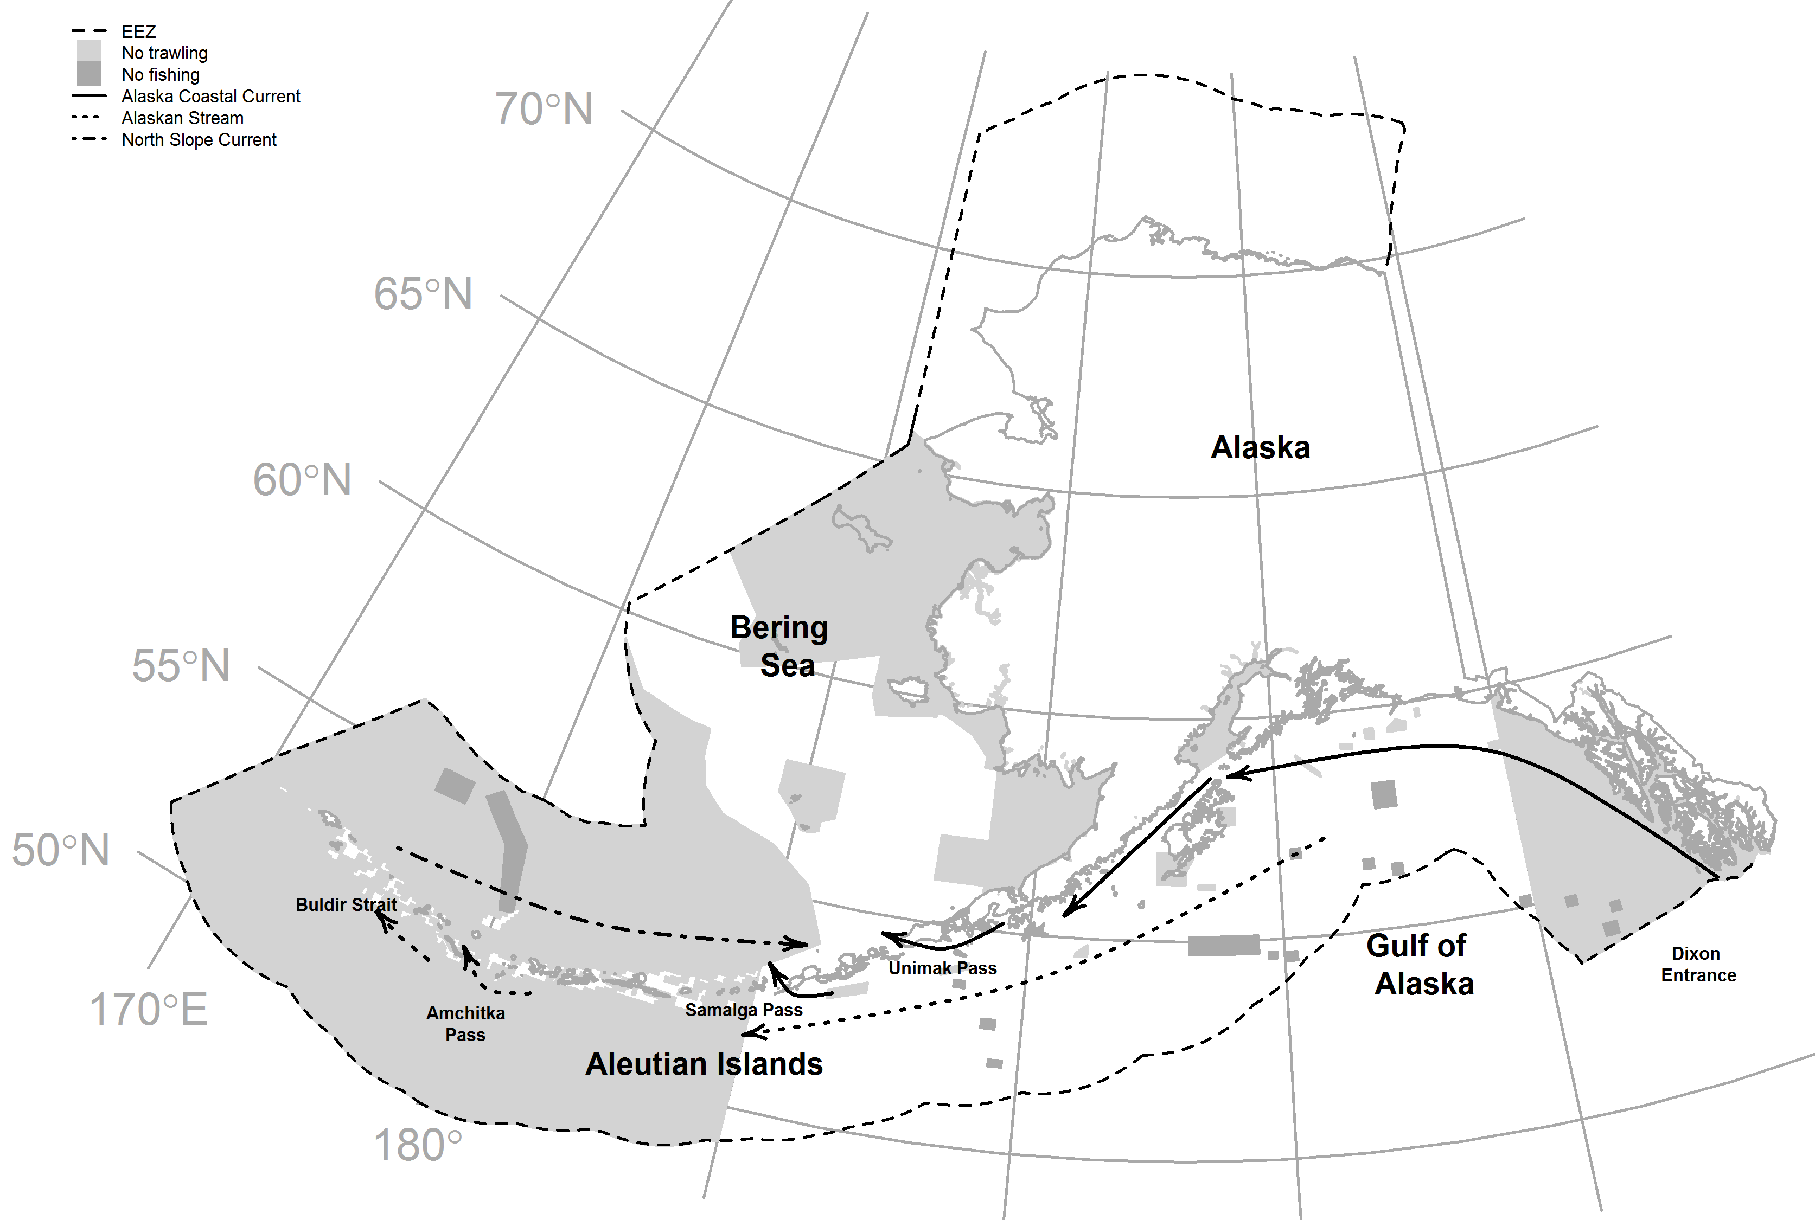

Figure 1. Map of the study area with major currents. Dashed boundary line marks the United States Exclusive Economic Zone (EEZ). The light gray polygon near Dixon Entrance demarks the Southeast Alaska Outside Trawl Closure.

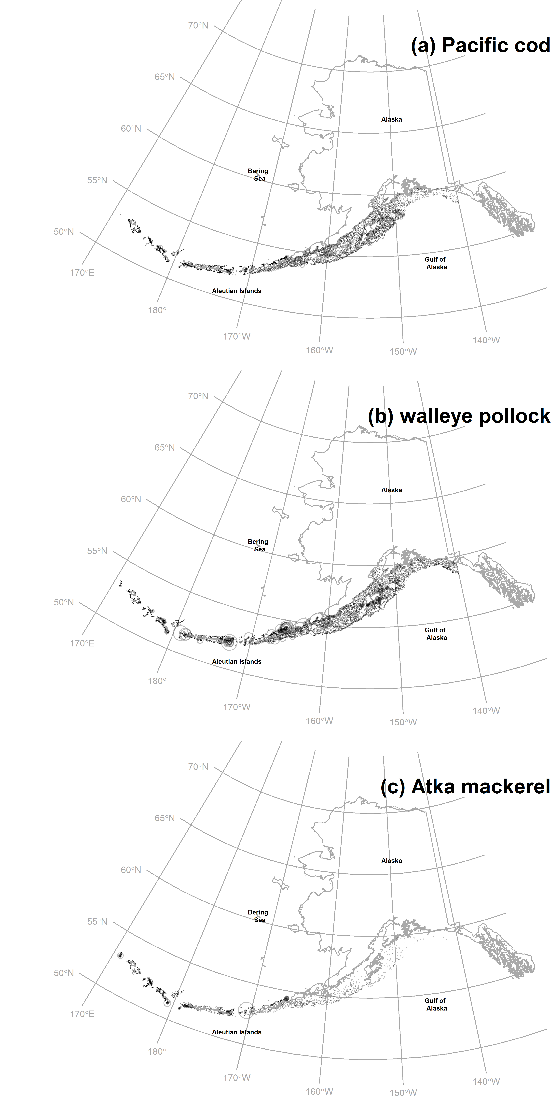

Figure 2. Log catch per unit effort (CPUE, kg ha-1) for (a)Pacific cod, (b) walleye pollock, and (c) Atka mackerel for all years (1990-2013). Point size is proportional to the maximum observed CPUE for a given species and points are shown with transparency to depict areas with higher sampling effort.

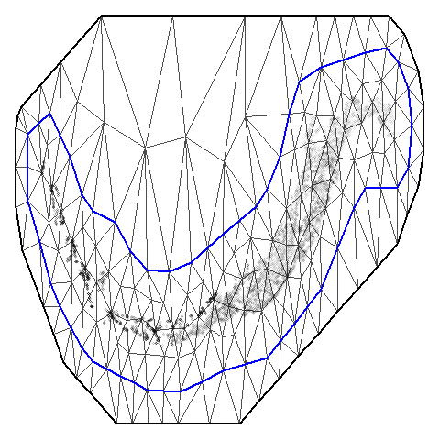

Figure 3. The triangulation matrix used to represent a continuous Gaussian Random Field (GF) using a Gaussian Markov Random Field (GMRF). The blue line represents the border defining the “inner” more precise nodes, while the black line represents the “outer” border defining the boundary. Points are of all species for all years, represented using transparency to visualize areas with a high density.

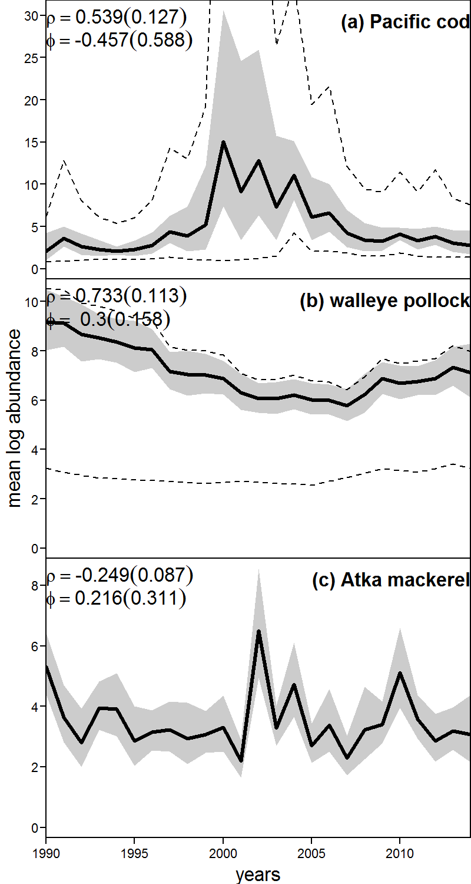

Figure 4. Estimated mean log biomass for each species across the Aleutian Islands and the Gulf of Alaska. Parameter estimates along with their standard errors, in parentheses, are given for density dependence (ρ) and the log-ratio of expected abundance in the initial year (*t*=1) and the median of the stationary distribution for abundance at equilibrium (ϕ). Dashed lines display the mean abundance for each hypothesized stock.

# Appendix

Log normal likelihood function:

$$Likelihood= \frac{1}{2σ_{obs}^{2}}\sum_{i}{{(ln{Obs}_{i}-ln{Pred}_{i})}^{2}}$$

Normal likelihood function:

$$L\left(y_{i} | β,σ^{2}\right)= \frac{1}{{(2πσ^{2})}^{1/2}}exp⁡(\frac{-{(y_{i}-{pred}_{i})}^{2}}{2σ^{2}})$$