Using gradients in productivity to inform population structure for a managed species: a case study using Pacific cod in Alaska

Kelli F. Johnson1*, André E. Punt1, and James T. Thorson2

1School of Aquatic and Fishery Sciences, University of Washington, Box 355020, Seattle, WA 98195-5020, USA

2Fisheries Resource Analysis and Monitoring Division,Northwest Fisheries Science Center, National Marine Fisheries Service, NOAA, 2725 Montlake Blvd. East, Seattle, WA 98112-2097, USA

*Corresponding author: tel: +1 206 543 4270; fax: +1 206 685 7471; email: kfjohns@uw.edu

# Running title: using productivity to inform population structure

Word count: (summary); (main text); (acknowledgements); (references); (tables and figure legends)

Count: (tables); (figures); (references)

# Summary

1. Set the context and need

2. Indicates the approach and methods

3-5. Main results

6. Wider implications and relevance too management or policy

7. **Synthesis and applications** synthesize the key messages and should be generic, seminal, and accessible to non-specialists.

Keywords: fisheries; *Gadus microcephalus*; Gaussian random field; Gompertz model; Integrated nested Laplace approximation (INLA); population structure; random field; spatial modelling

# Introduction

The first step in the management of natural resources is to determine the management unit, which will depend on the management objectives. Management objectives for commercially fished marine species typically prioritize optimizing long-term sustainable yields, while conserving biological characteristics that facilitate such optimal yields (Hilborn and Walters 1992; Punt *et al*. 2006). Moreover, it is increasingly being recognized that the sustainability of many populations depends on maintaining biological diversity, allowing complementary patterns to flourish under various environmental regimes (Hilborn *et al*. 2003, Kerr, Cadrin, & Secor 2010; Schindler *et al*. 2010). Therefore, it may be necessary to define management units on a much finer scale than the current norm.

Historically, management units of commercially fished marine species were defined by the boundaries of the statistical reporting system. In many cases, these boundaries, which were politically based and set on scales of hundreds to thousands of kilometers, still stand (for examples see Reiss *et al*. 2009). Consequences of mismatches between management units and biological diversity are now being realized and the results can be alarming. For instance, the collapse of Atlantic cod (*Gadus morhua*) and its subsequent lack of recovery of is hypothesized to be partially dependent on a mismatch between management units and subpopulation structure (Frank and Brickman 2000; Ames 2004; Sterner, 2007). Widespread declines of Atlantic salmon (*Salmo salar*), particularly in the southern portion of its historical range, are also attributed the management of multiple subpopulations as a single population, leading to the loss of distinct spawning components followed by a decreased ability to respond to environmental pressures (Parrish *et al.* 1998).

Mismatches work to undermine the sustainability of the social-ecological system regardless of the direction of the disparity. Including multiple populations in a single management unit can conceal reductions of the more vulnerable populations leading to reduced genetic diversity and ultimately lowered population adaptability, productivity, and persistence (Lacy 1987; Lande 1993; Hauser *et al*., 2002). Whereas, including only a portion of the population in the management unit can lead to biased estimates of its status given that productivity is often assumed to be directly related to spawning stock biomass, (Frisk *et al*. 2008; Ying *et al*. 2011).

Successful management depends on knowing how fishing mortality is distributed across each, potentially localized, population and how each will react (Altukhov 1981; Ricker 1981). Most often, scientific harvest advice is derived from mathematical models fit to data, i.e., assessment models, which generate estimates of population status and acceptable levels of fishing mortality based on management defined reference points (Hilborn and Walters 1992; Walters and Martell 2004). Assessment accuracy tends to decrease when spatial structure is ignored and subpopulations are assessed as if they are one population, with worsening results as the biological characteristics (e.g., growth, natural mortality, risk of fishing, etc.) of the subpopulations diverge (Waldman 2005; Rothschild and Jiao 2011). Therefore, management units that match biological homogeneity can help minimize the risk of depleting distinct spawning units (Laikre *et al*. 2005).

Unfortunately, no single method for defining management units simultaneously optimizes all management goals and several techniques require a substantive amount of costly data, necessitating a balance between accuracy and efficiency (Begg *et al*. 1999; Begg and Waldman 1999; Smedbol and Stephenson 2001). Phenotypic variation, resulting from the interaction between genotypes and their environment, can provide an indirect measurement of genetic isolation (Campana *et al*. 1995) and may be more applicable to the time scale at which fisheries management currently operates on (e.g., yearly quotas) than genetic variation (Begg *et al*. 1999). Minimally, management units should be informed by methods which delineate boundaries based on those population dynamics parameters which are assumed to be homogenous in assessment models (Carvalho and Hauser 1995; Quinn and Deriso 1999; Cope and Punt 2009). Thus, techniques that use data routinely collected for assessment and management purposes (i.e., life-history parameters such as growth, survival, age-at-maturation, fecundity, distribution, and abundance) can be advantageous. Unfortunately, proper interpretation of fisheries data requires accounting for both observation and process error, which can complicate analyses.

State-space models can simultaneously estimate process and observation error making them ideal for ecological data. Their use in ecology began with time-series data for single populations (Millar and Meyer 2000; Staples, Taper, and Dennis 2004; Dennis *et al*. 2006) and later extended into two-dimensional space for movement data (Jonsen, Myers, and Flemming 2003) and multiple subpopulations (Ward *et al*. 2010) and species (Mattsson *et al*. 2013). Multivariate time-series analysis is one way to detect patterns of correlation and synchrony across multiple scales, providing inferences on population structure based on ecological differences (Ward *et al*. 2010). Previously developed methods rely on *a priori* specification of hypothesized population structures (i.e., manually grouping the data based on hypothesized subpopulations) and utilize model selection criteria to choose the arrangement that best fits the data. Unfortunately, when population processes are miss-specified (i.e., assuming a wrong subpopulation structure which can lead to spatial variation in parameters) estimates of key parameters may be biased (Thorson *et al*. 2015) and estimates of standard errors may be overly optimistic (Dormann 2007). Accounting for space can be accomplished by replacing relevant life-history parameters with their spatial random effects equivalents (Cressie and Wikle 2011; Gelman *et al*. 2013).

Here, we quantify spatial differences in productivity for Pacific cod, *G. macrocephalus* (hereafter referred to as cod), in the northeast Pacific Ocean using a spatially-explicit state-space Gompertz population dynamics model (Thorson *et al*. 2015) and use differences to inform management units. Cod is both commercially and ecologically important in the Bering Sea Aleutian Island and Gulf of Alaska (GOA) large marine ecosystems, and thus ensuring its sustainability is of interest to multiple stakeholders. The Alaska cod fishery represents the second largest fisheries by weight in all of Alaska (318,870 t in 2013; afsc.noaa.gov) and cod is one of the five most common prey species (16.1% frequency of occurrence) of the federally endangered Steller sea lion, *Eumetopias jubatus* (Sinclair and Zeppelin 2002). The method outlined below should be useful to researchers looking to inform management units of populations for which fisheries-independent data exists yet precise structures remain unclear.

# Materials and methods

## Study area

The study area included the Aleutian Islands (AIs; 170° E to 170° W), a portion of the southern Bering Sea (BS; 165° W to 170° W along the north side of the AIs), and the GOA (132°40’ W to 170° W) (Fig. 1). The AIs are an extensive archipelago comprised of 14 large and hundreds of small volcanic islands, characterized by a relatively narrow continental shelf, crossed by numerous deep passes. The narrow shelf drops off into the Aleutian and Bowers Basins along its northern boundary and into the Aleutian Trench along its southern boundary. Conversely, the GOA is characterized by a semi-enclosed basin, with a relatively shallow shelf that varies in width from 5 km in the southeast to more than 200 km in the north.

## Data

Fishery-independent data were collected by the Alaska Fisheries Science Center from 1982 to 2015 during the triennial GOA and AIs bottom trawl surveys. These data are used by the North Pacific Fishery Management Council (NPFMC) to provide estimates of abundance, define distributions, and inform biological parameters of groundfish and invertebrate species (A’mar *et al*. 2013; Aydin *et al*. 2013).

Surveys employed a stratified random sampling design, with grids determined by NPFMC regulatory areas, which were further divided into depth strata. The majority of sampling locations in the most recent years were placed at or near locations used in previous years by randomly sampling without replacement from previously sampled locations. New sampling locations were sometimes needed to fulfil the requirement of two locations per strata. The AI surveys covered depths up to 500 m along the north side of the AIs from Unimak Pass (165° W) westward to Samalga Pass (170° W) and on both sides of the AIs from Samalga Pass to Stalemate Bank (170° E) (von Szalay *et al*. 2011). The GOA survey covered depths up to 1000 *m* from Samalga Pass to Dixon Entrance (54°30’ N, 132°40’ W) (Raring *et al*. 2011). Surveys in the AIs were conducted in 1983, 1986, 1991, 1994, 1997, 2000, 2002, 2004, 2006, 2010, 2012, and 2014. Surveys in the GOA were conducted in 1984, 1987, 1990, 1993, 1996, 1999, 2001, 2003, 2005, 2007, 2009, 2011, 2013, and 2015. The analysis was restricted to data collected after 1989 because of the lack of standardized gear and effort measurements (Munro and Hoff 1995) and east of 140° W because of the Southeast Alaska Outside Trawl Closure (Fig. 1).

Tows of 15 min (estimated on-bottom duration) at speeds of 3 knots were conducted at each sampled station (Raring *et al*. 2011; von Szalay *et al*. 2011). For each tow, species composition of the catch was determined for all identifiable specimens and species-specific catch per unit effort (*CPUE*) was calculated as the weight of the catch (kg) divided by the area swept (ha) for a given trawl (Fig. 2). Global positioning (GPS) locations for each trawl were projected using the Albers equal-area conic projection, an equal area map projection.

## Spatial fields

Spatial data were defined as realizations of a stochastic process indexed by space

, Eq. 1

where the domain, Ɗ, is a fixed subset of ℝd (here d = 2) and the set, ***s*** , indicates the georeferenced locations at which measurements were taken. The data were point-referenced nonzero *CPUE* measurements of a continuous random process, modelled using the stochastic partial differential equation (SPDE) approach proposed by Lindgren *et al*. (2011). SPDEs use sparse inverse-covariance matrices, which facilitate modeling space as a continuous process without the “big *n* problem” (Banerjee *et al*. 2004; Jona-Lasinio *et al*. 2012; Lasinio *et al*. 2013).

The SPDE method can handle multiple distributions, but assuming that

, Eq. 2

where is the standard deviation of the mean measurement error, or nugget effect, and is the mean response, then

, Eq. 3

where is the large-scale component composed of an intercept, , and coefficients , which quantify the effects of the measured covariates , and is the realization of the latent Gaussian Random Field (GRF).

Triangulation of Ɗ facilitates the transformation of the GRF to a discretely-indexed Gaussian Markov Random Field (GMRF)

, Eq. 4

where *G* is the total number of vertices in the triangulation, { is the set of basis functions, and are the non-zero distributed weights. Basis functions were chosen such that was 1 at vertex *g* and 0 everywhere else (Lindgren *et al*., 2011). GMRFs are characterized by a multivariate Normal distribution with mean **μ** = (μ­1, …, μn)′ and a spatially-structured covariance matrix Σ, whose generic element is defined as

Σi,j = Cov(θi, θj) = . Eq. 5

Here, is the variance component for and is the (isotropic) Matérn spatial covariance function (Cressie, 1993), which depends on the Euclidean distance between the locations *i* and *j*, . A GRF with a Matérn covariance function

Eq. 6

provides an exact solution to the SPDE, which can be approximated using a finite element representation (Eq. 4). Here, is the modified Bessel function of second kind and order (here, ) measuring the degree of smoothness. The range (),

, Eq. 7

was defined as the distance at which the spatial correlation is approximately 0.1, using κ>0 as a scaling parameter, according to Lindgren *et al*. (2011; see Section 2).

The triangulation mesh had 185 vertices with vertices located closer in space where the density of non-zero CPUE measurements was higher (Fig. 2). The same triangulation mesh was used for all years, even though fisheries-independent surveys were never conducted across the entire study area in a single year (Fig. 3).

## Gompertz model

Population dynamics were modelled using a spatially explicit Gompertz model (Thorson *et al*. 2015). The Gompertz model has been used extensively in applied and theoretical investigations, …, and the spatial model specifies per-capita productivity as a log-linear function of local density,

, Eq. 8

where is the density at all spatial locations [x,y] in year *t*, ρ is the strength of density dependence, Ω is the intercept represented by a GMRF

Ω ~ *MVN*(α**1**, ΣΩ) Eq. 9

where α**1** is a vector and α is the mean productivity of the GMRF, and is a GMRF

Εt ~ *MVN*(0, ΣΕ) Eq. 10

representing the spatial variation in process error in year *t*. ΣΩ and ΣΕ­ are defined as above (Eq. 5) with independent marginal variance components ( and respectively) but equal Matérn spatial covariance functions.

The model has a stationary distribution

Eq. 11

when . Initial conditions, representing the population when *t*=1, were specified using the following equation:

, Eq. 12

where ϕ**1** is the log-ratio of expected abundance in the initial year (*t*=1) and the median of the stationary distribution for abundance at equilibrium. is statistically-independent of , conditional on a fixed value for .

## Estimation procedure

Data were assumed to follow a lognormal distribution

, Eq. 13

where, is the predicted density at a given vertex *i* located at the points [*x*, y] on the mesh in year *t* (Fig. 2), is the standard deviation of the observation error, and is the *CPUE* observation located at the vertex *i* in year *t*. was of positive length, including zero, where missing data occurred one of two ways: i) no observations at vertex *i* in year *t* or ii) no trawl was conducted at vertex *i* in year *t*.

GMRF matrices were computed using functions available in the INLA package (Rue *et al*. 2014; Illian *et al*. 2012) implemented in the R statistical software environment (R Core Team 2015). A single triangulation network (Fig. 2), created via the inla.mesh.2d function, was used. The triangulation network was set to extend past all observed points to reduce boundary effects and to form “regular” triangles based on the available data while minimizing tradeoffs between variance and precision. Subsequently, INLA was used to calculate the precision matrix of the GMRF

. Eq. 14

The three sparse precision matrices ( were then passed to Template Model Builder (TMB) (Kristensen *et al*. 2013), an R package for fitting random effects models to data. TMB uses the integrated nested Laplace approximation (Skaug and Fournier 2006) to calculate the marginal likelihood of the fixed-effect parameters integrated across all random fields, while also calculating the gradient of the marginal likelihood via automatic differentiation. Fixed effects were then subsequently optimized using traditional tools in R by maximizing the marginal log likelihood. Confidence intervals were calculated using the delta-method (see Thorson *et al*. 2015 for alternative estimation methods).

## Management unit boundaries

Delineations between management units were based on regression trees, which partitioned the data into successively smaller groups using binary splits based on a single predictor variable. Splits for predictor variables were examined using an exhaustive search procedure that worked to maximize the homogeneity of the resulting groups with respect to the response variable (i.e., maximizing the between-group sum of squares). Once the best splits were found, regression trees were pruned to collapse the weakest links by minimizing the cross-validated error (Hastie *et al*. 2001). Here, the response variable was Ω and the predictor was longitude. Regression trees were created using the rpart package in R (Therneau *et al*. 2014).

# Results

On average, the yearly mean CPUE was higher in the GOA compared to the AIs, but an increased number of non-zero CPUE measurements were consistently collected in the AIs compared to the GOA (Fig. 3).

Density dependence was estimated as compensatory, although the strength of ρ was relatively weak (0.703, se = 0.108; Fig. 4). Current biomass estimates for the entire study area are greater than the theoretical equilibrium biomass, with the initial biomass (*t*=1) estimated at approximately 134% of its equilibrium potential (Fig. 4). Productivity was relatively lower in the GOA than the AIs, with the highest productivity estimated in the far reaches of the AIs (Fig. 5). Productivity was also relatively high near Unimak and Samalga Passes (Fig. 5).

Partitioning algorithms grouped cod into two distinct management units based on 152° 15' 24.463" W (Figs. 5 and 6). Further potential stock boundaries were noted at 178° 35' 0.679"W, 158° 59' 12.633" W, and 170° 41' 9.642" W, although none of the splits significantly improved the cross validated error enough to warrant their inclusion in the final stock structure.

* Sentence regarding differences in trend for 2 proposed stocks, Fig. 4 – this is exciting because they seem to have different trends!
* Sentence/figure comparing these trends with trends arising with more splits – only if you feel like you want to bulk up your results section
* Estimates of process error

# Discussion

The majority of stock assessment models assume data comes from a single management unit, thus life-history characteristics that characterize the population demographics of a management unit should be homogeneous across space. Yet here, a spatially explicit Gompertz population dynamics model provides support for rejecting the hypothesis that cod exhibit homogeneous life-history characteristics throughout the GOA. More specifically, local estimates of productivity vary with longitude, leading to patches of high and low productivity within the study area (GOA and AIs) that do not align with current management measures.

Using quantitative analyses to test hypotheses regarding synchrony in population dynamics between multiple datasets (i.e., sampling locations or species) is not new (Moran 1953; Ives *et* al. 2003). Methods range from simple analyses of correlation between datasets (Casselman *et al*. 1981) to using complex state-space models that explicitly account for both process and environmental error along with model selection (e.g. Akaike information criteria) to determine the relative support for various grouping structures (Ward *et al*. 2010; Flesch 2014). A potential problem with these approaches is that as the number of time-series increases, the number of testable hypothesis exponentially increases and it assumes the *a priori* determined set of hypotheses includes the correct hypothesis prior to exploring the data (Cook and Campbell 1979). In this study we alleviate this problem by fitting a single model, the spatial Gompertz model, which replaces traditional scalar functions (productivity and process error) with random fields, followed by algorithmic methods to discover the relationship between space and productivity. Thus, this approach potentially allows non-omniscient observers to discover relationships that may be hidden or previously not thought of.

Identifying spatial variation in life-history characteristics does not reveal the biological mechanisms or environmental factors leading to the patterns, but it can provide inference to potentially important drivers of the variation and which factors should be studied. The separation of stocks here seems to be linked to oceanographic features in the study area.

* Oceanography of AI and GOA
* Tagging studies (e.g., Shimada and Kimura 1994) have demonstrated significant migration both within and between the EBS, AI, and Gulf of Alaska (GOA). Migration does not always mean similar population dynamics.
* Increasing the use of spatial models, such as the one used here, may increase scientists ability to understand ecological processes, such as population dynamics, which are deeply dependent on space (Legendre 1993; Kareiva *et al*. 1990).
* Similarity to atlantic cod
* Current management
  + discrete stocks in the eastern BS and AI (Canino et al. 2005; Cunningham et al. 2009; Canino et al. 2010; Spies 2012).
  + Until relatively recently (2013) cod was managed as just two stocks in Alaska, the Bering Sea Aleutian Island and GOA. Currently, cod in Alaska is managed as three stocks: i) Bering Sea (not included in this study), ii) AIs, and iii) GOA. The historical stock boundary, used by the NPFMC, to delineate between the AI and GOA stocks of 170° W does not align with the stock boundary found in this study (152° 15' 24.463" W). In part, 170° W is used because of its approximate alignment with the known ecological boundary at Samalga Pass (169° 28' 58" W). Samalga Pass demarks the last area in the AIs with a strong freshwater signal from the Alaskan Coastal Current (Ladd *et al*. 2005). Furthermore, at Samalga Pass the AI shelf narrows and the Alaskan Stream, the major boundary current of the western AIs, moves shoreward (Favorite 1967).
* Benefits
  + Benefit of getting better estimates of life-history parameters if they really do vary with space (Thorsen *et al*. 2015). Provide justification for their variation ().
  + Don’t need data from every year
  + Stock definition methods based on life-history parameters often require synchronous sampling of the hypothesized stocks, a requirement that is not necessary here. For instance, Cope and Punt () had to restrict their analysis to only locations that were sampled every year, significantly limiting the breadth of their analysis.
  + Benefit of state-space models – observation and process: state-space models that although also seen as a step forward, with their ability to account for process and observation error, can lead to biased estimates of the strength of density dependence, particularly when indices of abundance appear oscillatory (Thorsen *et al*. 2015).
  + Models that partitioned space may have generated biased estimates of life-history parameters falsely leading scientists to believe that life-history parameters were or were not homogeneous between two different areas.
  + Obtain an estimate for the mean population growth while accounting for local variation
  + Using life-history characteristics to classify stocks has many important advantages. Data is often available either from idependent surveys conducted by the management agency or fishery data. Simple methods may only require a single year of data.
  + Genetic data sufficient to delineate between stock boundaries is often not available (Reiss *et al*. 2009).
  + Making the assumption that process noise is neglible and can be ignored, as done when using generalized linear models, one will underestimate true uncertainty in population trends. Confidence interval coverage in SSM improves with time-series length (Humbert et al., 2009), estimates of precision do not increase with only one or two decades of data, instead much longer time series are needed to augment precision (Flesch 2014; Hinrichsen and Holmes 2010; Ward *et al*. 2010).
* Downfalls of the method
  + Need lots of data
  + Species with inherently patchy distributions lead to an increased rate of non-convergence unless the mesh is extremely coarse.
  + Unequal vulnerability to gear between Japanese and US fleets limited our analysis from 1990 to present, furthermore data from the Bering Sea, although it was spatially adjacent and is also managed by the NPFMC, was not included because of different sampling mechanisms. If stocks can be found intermixing in space, sampling at a consistent time each year will limit the variation in dispersal leading to more robust results. The timing should relate to spawning times, which will in turn assist in representing population characteristics because of the limited dispersal and isolation of spawners which contribute to distinct populations although they may feed together.
  + Similarities does not imply population connectivity
  + Similarities may be indicative of matched responses to similar fishing pressure.
  + May not be the best method for mackerel because adult mackerel are less common than juvenilles, if not absent, from the standardized eastern BS bottom trawl survey (Lauth and Acuna 2009).
* political often default, and biological stock boundaries is not new nor isolated. In fact the mismatch is often offered as an explanation on the lack of recovery for iconic stocks such as the North Sea cod ().
* Environments are not static. Species ranges are predicted to shift with respect to depth and latitude as oceans warm in response to climate change (Perry *et al*. 2005; Dulvy *et al*. 2008; Nye *et al*. 2009), potentially increasing the mismatch between status quo and biologically defined stock boundaries.
* Almost all marine fish species exhibit complex spatial structures (Withler *et al.* 2001; Conover *et al*. 2006; Cowen, Paris, and Srinivasan 2006).
* Principal component analysis can be used to correlate the estimated Euclidean distance separating hypothesized populations from each other (Colton *et al*. 2014), but the results depend on model output, which may be biased if the management units included in the model do not represent biologically homogenous populations as assumed.

Conclusion: observed population structures invalidate current management policies. Indeed, one prerequisite for sustainable management is the matching of biological processes and management action (Reiss *et al*. 2009). The results from the present study clearly indicate that the population of cod in Alaska is not homogenous. Disregard of stock structure and ineffective fisheries management can lead to dramatic changes in the biological attributes and productivity rates, as well as the genetic diversity of the species. In view of this, and given the considerable commercial value of Alaskan cod fisheries, studies into the effects of oceanographic features on cod distribution and their population structure need to be continued. They also need to be taken into account in any future cod management strategy.

# Acknowledgements

This publication was partially funded by the Joint Institute for the Study of the Atmosphere and Ocean (JISAO) under NOAA Cooperative Agreement NA10OAR4320148, Contribution No. ????. KFJ was partially supported for this work by a grant from Washington Sea Grant, University of Washington, pursuant to NOAA Award No. NA14OAR4170078. The authors thank Kerim Aydin, James Ianelli, and Martin Renner for providing helpful comments, which greatly improved this manuscript.

# References

A’mar, T., Aydin, K., Conners, M.E., Conrath, C., Dalton, M., Davis, O., Dorn, M., Echave, K., Friday, N., Green, K., Hanselman, D., Heifetz, J., Hulson, P.J., Ianelli, J., Jones, D., Jaenicke, M., Lowe, S., Lunsford, C., Meyer, S., McGilliard, C., Nichol, D., Ormseth, O. A., Palsson, W., Rodgveller, C.J., Rumble, J., Shotwell, K., Slater, L., Spalinger, K., Spencer, P., Spies, I., Stewart, I., Stichart, M., Stockhausen, W., Stram, D., TenBrink, T., Tribuzio, C., & Turnock, J. (2013) *Stock assessment and fishery evaluation report for the groundfish resources of the Gulf of Alaska*. North Pacific Fisheries Management Council, Anchorage.

Altukhov, Y.P. (1981) The stock concept from the viewpoint of population genetics. *Canadian Journal of Fisheries and Aquatic Sciences*, **38**, 1523-1538.

Ames, E.P. (2004) Atlantic cod stock structure in the Gulf of Maine. *Fisheries*, **29**(1), 10-28.

Aydin, K., Barbeaux, S.J., Conners, M.E., Conrath, C., Dalton, M., DiCosimo, J., Echave, K., Hanselman, D., Hoff, J., Honkalehto, T., Hulson, P. J., Ianelli, J., Kotwicki, S., Lowe, S., Lunsford, C., McKelvey, D., Nichol, D., Ormseth, O.A., Palsson, W., Rodgveller, C. J., Rooper, C.N., Spencer, P., Spies, I., Stockhausen, W., TenBrink, T., Thompson, G., Tribuzio, C., Wilderbuer, T., & Williamson, N. (2013) *Stock assessment and fishery evaluation report for the groundfish resources of the Bering Sea/Aleutian Islands region*. North Pacific Fisheries Management Council, Anchorage.

Bailey, K.M., Stabeno, P.J., & Powers, D.A. (1997) The role of larval retention and transport features in mortality and potential gene flow of walleye pollock. *Journal of Fish Biology*, **51**(Suppl A), 135-154.

Banerjee, S., Carlin, B.P., Gelfand, A.E. (2004) *Hierarchical Modeling and Analysis for Spatial Data*. Crc Press, Boca Raton.

Begg, G.A., Hare, J.A., & Sheehan, D.D. (1999) The role of life history parameters as indicators of stock structure. *Fisheries Research*, **43**(1-3), 141-163.

Begg, G.A., & Waldman, J.R. (1999) An holistic approach to fish stock identification. *Fisheries Research*, **43**(1-3), 35-44.

Botsford, L.W, Castilla, J.C., & Peterson, C.H. (1997) The management of fisheries and marine ecosystems. *Science,* **277**, 509-515.

Campana, S.E., Gagné, J.A., & McLaren, J.W. 1995. Elemental fingerprinting of fish otoliths using ID-ICPMS. *Marine Ecology Progress Series*, **122**, 115-120.

Carvalho, G.R., & Hauser, L. (1995) Molecular genetics and the stock concept in fisheries. *In* *Molecular Genetics in Fisheries*, (eds G.R. Carvalho & T.J. Pitcher), pp. 55-79, Chapman and Hall, London.

Casselman, J.M. Collins, J.J., Crossman, E.J., Ihssen, P.E., & Spangler, G.R. (1981) Lake whitefish (*Coregonus clupeaformis*) stocks of the Ontario waters of Lake Huron. *Canadian Journal of Fisheries and Aquatic Sciences*, **38**, 1772-1789.

Colton, A.R., Wilberg, M.J., Coles, V.J., and Miller, T.J. (2014) An evaluation of the synchronization in the dynamics of blue crab (*Callinectes sapidus*) populations in the western Atlantic. Fisheries Oceanography **23**(2), 132-146.

Conover, D.O., Clarke, L.M., Munch, S.B., & Wagner, G.N. (2006) Spatial and temporal scales of adaptive divergence in marine fishes and the implications for conservation. *Journal of Fish Biology*, **69**, 21-47.

Cook T.D., & Campbell, D.T. (1979) *Quasi-experimentation: design and analysis issues for field settings*. Houghton Mifflin, Boston.

Cope, J.M., & Punt, A.E. (2009) Drawing the lines: resolving fishery management units with simple fisheries data. *Canadian Journal of Fisheries and Aquatic Sciences*, **66**(8), 1256-1273.

Cowen, R.K., Paris, C.B., & Srinivasan, A. (2006). Scaling of connectivity in marine populations. *Science*, **311**(5760), 522-527.

Cressie, N.A.C. (1993) *Statistics for Spatial Data.* Wiley, NY.

Cressie, N., Wikle, C.K. (2011) *Statistics for Spatio-Temporal Data.* John Wiley & Sons, Inc., Hoboken.

Dennis, B., Ponciano, J.M., Lele, S.R., Taper, M.L., & Staples, D.F. (2006) Estimating density dependence, process noise, and observation error. *Ecological Monographs*, **76**, 323-341.

Dormann, C.F. 2007. Effects of incorporating spatial autocorrelation into the analysis of species distribution data. *Global Ecology and Biogeography*, **16**(2), 129-138.

Dulvy, N.K., Rogers, S.I., Jennings, S., Stelzenmüller, V., Dye, S.R., & Skjoldal, H.R. (2008) Climate change and deepening of the North Sea fish assemblage: a biotic indicator of warming seas. *Journal of Applied Ecology*, **45**(4), 1029-1039.

Favorite, F. (1967) The Alaskan stream. *International North Pacific Fisheries Communication Bulletin*, **21,** 1-20.

Flesch, A.D. (2014) Spatiotemporal trends and drivers of population dynamics in a declining Sonoran Desert predator. *Biological Conservation*, **175**, 110-118.

Frank, K., & Brickman, D. (2000) Allee effects and compensatory population dynamics within a stock complex. *Canadian Journal of Fisheries and Aquatic Sciences*, **57**(3): 513-517.

Frisk, M.G., Miller, T.J., Martell, S.J., & Sosebee, K. (2008) New hypothesis helps explain elasmobranch “outburst” on Georges bank in the 1980s. *Ecological Applications,* **18**(1), 234-245.

Gelman, A., Carlin, J.B., Stern, H.S., Dunson, D.B., Vehtari, A., & Rubin, D.B. (2013) *Bayesian Data Analysis*. CRC Press, Boca Raton.

Grant, W.S., & Utter, F.M. (1980) Biochemical variation in walleye pollock *Theragra chalcogramma*: population structure in the southeastern Bering Sea and Gulf of Alaska. *Canadian Journal of Fisheries and Aquatic Sciences*, **37**, 1093-1100.

Hastie, T., Tibshirani, R., & Friedman, J.H. (2001) *The Elements of Statistical Learning: Data Mining, Inference, and Prediction*. Springer-Verlag, New York.

Hauser, L., Adock, G.J., Smith, P.J., Bernal Ramírez, J.H., & Carvalho, G.R. (2005) Loss of microsatellite diversity and low effective population size in an overexploited population of New Zealand snapper (*Pagrus auratus*). *Proceedings of the National Academy of Sciences*, **99**(18), 11742-11747.

Hilborn, R., & Walters, C.J. (1992) *Quantitative Fisheries Stock Assessment: Choice, Dynamics, and Uncertainty*. Chapman and Hall, New York.

Hilborn, R., Quinn, T.P., Schindler, D.E., & Rogers, D.E. (2003) Biocomplexity and fisheries sustainability. *Proceedings of the National Academy of Sciences*, **100**(11), 6564-6568.

Hinrichensen, R.A., Holmes, E.E. (2010) Using multivariate state-space models to study spatial structure and dynamics, *In* Spatial Ecology, (eds S. Cantrell, C. Cosner, & S. Ruan), pp 145-166, Chapman and Hall, Boca Raton.

Illian, J.B., Sørbye, S.H., & Rue, H. (2012) A toolbox for fitting complex spatial point process models using integrated nested Laplace approximation (INLA). *The Annals of Applied Statistics*, **6**, 1499-1530.

Ives, A., Dennis, B., Cottingham, K., & Carpenter, S. (2003) Estimating community stability and ecological interactions from time-series data. *Ecological Monographs*, **73**, 301-330.

Jona-Lasinio, G., Mastrantonio, G., & Pollice, A. (2012) Discussing the “big n problem”. *Statistical Methods and Applications*, **22**(1), 97-112.

Jonsen, I.D., Myers, R.A., & Flemming, J.M. (2003) Meta-analysis of animal movement using state-space models. *Ecology*, **84**, 3055-3063.

Kerr, L.A., Cadrin, S.X., & Secor, D.H. (2010) The role of spatial dynamics in the stability, resilience, and productivity of an estuarine fish population. *Ecological Applications*, **20,** 497-507.

Kristensen, K. Thygesen, U.H., Andersen, K.H., & Beyer, J.E. (2013) Estimating spatio-temporal dynamics of size-structured populations. *Canadian Journal of Fisheries and Aquatic Sciences*, **71**, 326-336.

Lacy, R.C. (1987) Loss of genetic diversity from managed populations: interacting effects of drift, mutation, immigration, selection, and population subdivision. *Conservation* *Biology*, **1**(2), 143-158.

Ladd, C., Hunt, G.L., Mordy, C.W., Salo, S.A., & Stabeno, P.J. (2005) Marine environment of the eastern and central Aleutian Islands. *Fisheries Oceanography*, **14**, 22-38.

Laikre, L., Palm, S., & Ryman, N. (2005) Genetic population structure of fishes: implications for coastal zone management. *Ambio* **34**, 111-119.

Lande, R. (1993) Risks of population extinction from demographic and environmental stochasticity and random catastrophes. *American Naturalist*, **142**(6), 911-927.

Lasinio, G.J., Mastrantonio, G., & Pollice, A. 2013. Discussing the “big *n* problem”. *Statistical Methods And Applications*, **22**(1), 97-112.

Lauth, R.R., & Acuna, E. (2009) Results of the 2008 eastern Bering Sea continental shelf bottom trawl survey of groundfish and invertebrate resources. U.S. Dep. Commer., NOAA Tech. Memo., NMFS-AFSC-195.

Lindgren, F., Rue, H., & Lindstrӧm, J. (2011) An explicit link between Gaussian fields and Gaussian Markov random fields: the stochastic partial differential equation approach [with discussion]. *Journal of the Royal Statistical Society B*, **73**(4), 423-498.

Lowe, S.A. (2013) *Assessment of the Atka mackerel stock in the Gulf of Alaska*. North Pacific Fisheries Management Council, Anchorage.

Mattsson, B.J., Zipkin, E.F., Gardner, B., Blank, P.J., Sauer, J.R., & Royle, J.A. (2013) Explaining local-scale species distributions: relative contributions of spatial autocorrelation and landscape heterogeneity for an avian assemblage. *PLoS ONE*, **8**(2), e55097.

Millar, R.B., & Meyer, R. (2000) Bayesian state-space modeling of age-structured data: fitting a model is just the beginning. *Canadian Journal of Fisheries and Aquatic Sciences* **57**(1), 43-50.

Moran, P.A.P. (1953) The statistical analysis of the Canadian Lynx cycle. *Australian Journal of Zoology*, **1**(3), 291-298.

Mulligan, T.J., Chapman, R.W., & Brown, B.L. (1992) Mitochondrial DNA analysis of walleye pollock, *Theragra chalcogramma*, from the eastern Bering Sea and Shelikof Strait, Gulf of Alaska. *Canadian Journal of Fisheries and Aquatic Sciences*, **49**, 319-326.

Munro, P.T., & Hoff, R.Z. (1995) *Two demersal trawl surveys in the Gulf of Alaska: implications of survey design and methods*. U.S. Dep. Commer., NOAA Tech. Memo. NMFS-AFSC-50.

Nye, J.A., & Link, J.S. (2009) Changing spatial distribution of fish stocks in relation to climate and population size on the Northeast United States continental shelf. *Marine Ecology Progress Series*, **393**, 111-129.

Parrish, D.L., Behnke, R.J., Gephaard, S.R., McCormick, S.D., & Reeves, G.H. 1998. Why aren’t there more Atlantic salmon (*Salmo salar*)? *Canadian Journal of Fisheries and Aquatic Sciences*, **555**, 281-287.

Perry, A.L., Low, P.J., Ellis, J.R., & Reynolds, J.D. (2005) Climate change and distribution shifts in marine fishes. *Science*, **308**(5730), 1912-1915.

Punt, A.E., Cope, J.M., & Haltuch, M.A. (2006) Reference points and decision rules in U.S. federal fisheries: west coast groundfish experiences. *American Fisheries Society Symposium*, **49**, 587–600.

Quinn, T.J., II, & Deriso, R.B. (1999) *Quantitative Fish Dynamics.* Oxford University Press, New York.

R Core Team. (2015) R: a language and environment for statistical computing. R Foundation for Statistical Computing, Vienna.

Raring, N.W., von Szalay, P.G., Shaw, F.R., & Wilkins, M.E. (2011) *Data Report: 2001 Gulf of Alaska bottom trawl survey*. U.S. Dep. Commer., NOAA Tech. Memo. NMFS-AFSC-225.

Reiss, H., Hoarau, G., Dickey-Collas, M., & Wolff, W.J. (2009) Genetic population structure of marine fish: mismatch between biological and fisheries management units. *Fish and Fisheries*, **10**(4), 361-395.

Ricker, W.E. (1981) Changes in the average size and average age of pacific salmon. *Candian Journal of Fisheries and Aquatic Sciences*, **38**, 1636-1656.

Rothschild, B.J., & Jiao, Y. (2011) Characterizing uncertainty in fish stock assessments: the case of the southern New England-mid-Atlantic winter flounder. *Transactions of the American Fisheries Society*, **140**(3), 557-569.

Rue, H., Martino, S., Lindgren, F., Simpson, D., & Riebler, A. (2014) INLA: functions which allow to perform full Bayesian analysis of latent Gaussian models using Integrated Nested Laplace Approximation. R package version 0.0-1392038736.

Schindler, D.E., Hilborn, R., Chasco, B., Boatright, C.P., Quinn, T.P., Rogers, L.A., & Webster, M.S. (2010) Population diversity and the portfolio effect in an exploited species. *Nature*, **465**(3), 609-612.

Sinclair, E.H., & Zeppelin, T.K. (2002) Seasonal and spatial differences in diet in the western stock of Steller sea lions (*Eumetopias jubatus*). *Journal of Mammology*, **83**, 973-990.

Skaug, H., & Fournier, D. (2006) Automatic approximation of the marginal likelihood in non-Gaussian hierarchical models. *Computational Statistics & Data Analysis*, **51**, 699-709.

Smedbol, R.K., & Stephenson, R. (2001) The importance of managing within-species diversity in cod and herring fisheries of the north-western Atlantic. *Journal of Fish Biology*, **59**, 109-128.

Staples, D.F., Taper, M.L., & Dennis, B. 2004. Estimating population trend and process variation for PVA in the presence of sampling error. *Ecology*, **85**, 923-929.

Sterner. T. (2007) Unobserved diversity, depletion and irreversibility: the importance of subpopulations for management of cod stocks. *Ecological Economics,* **61**, 566-574.

Therneau, T., Atkinson, B., & Ripley, B. (2014) rpart: Recursive Partitioning and Regression Trees. R package version 4.1-8. http://CRAN.R-project.org/package=rpart

Thorson, J.T., Skaug, H.J., Kristensen, K., Shelton, A.O., Ward, E.J., Harms, J.H., & Benante, J.A. (2015) The importance of spatial models for estimating the strength of density dependence. *Ecology*, **96**, 1202-1212.

von Szalay, P.G., Rooper, C.N., Raring, N.W., & Martin, M.H. (2011) *Data Report: 2010 Aleutian Islands bottom trawl survey*. U.S. Dep. Commer., NOAA Tech. Memo. NMFS-AFSC-215.

Waldman, J.R. (2005) *Definition of stocks: an evolving concept. In Stock Identification Methods: Applications in Fishery Science*, (eds S.X. Cadrin, K.D. Friedland, & J.R. Waldman), pp 7-16, Elsevier Inc., Burlington.

Walters, C.J., & Martell, S.J.D. (2004) *Fisheries Ecology and Mangement*. Princeton University Press, Princeton.

Ward, E.J., Chirakkal, H., González-Suárez, M., Aurioles-Gamboa, D., Holmes, E.E., & Gerber, L. (2010) Inferring spatial structure from time-series data: using multivariate state-space models to detect metapopulation structure of California sea lions in the Gulf of California, Mexico. *Journal of Applied Ecology*, **47**, 47–56.

Withler, R.E., Beacham, T.D., Schulze, A.D., Richards, L.J., & Miller, K.M. (2001) Co-existing populations of Pacific Ocean perch, *Sebastes alutus*, in Queen Charlotte Sound, British Columbia. *Marine Biology*, **139**, 1-12.

Wilkins, M. (2009) *Bottom trawl survey of groundfish resources in the Aleutian Islands region*. Alaska Fisheries Science Center, Seattle.

Ying, Y., Chen, Y., Longshan, L., & Gao, T. (2011) Risks in ignoring fish population spatial structure in fisheries management. *Canadian Journal of Fisheries and Aquatic Sciencies*, **68**, 2101-2120.

Table 1. Table one goes below this.

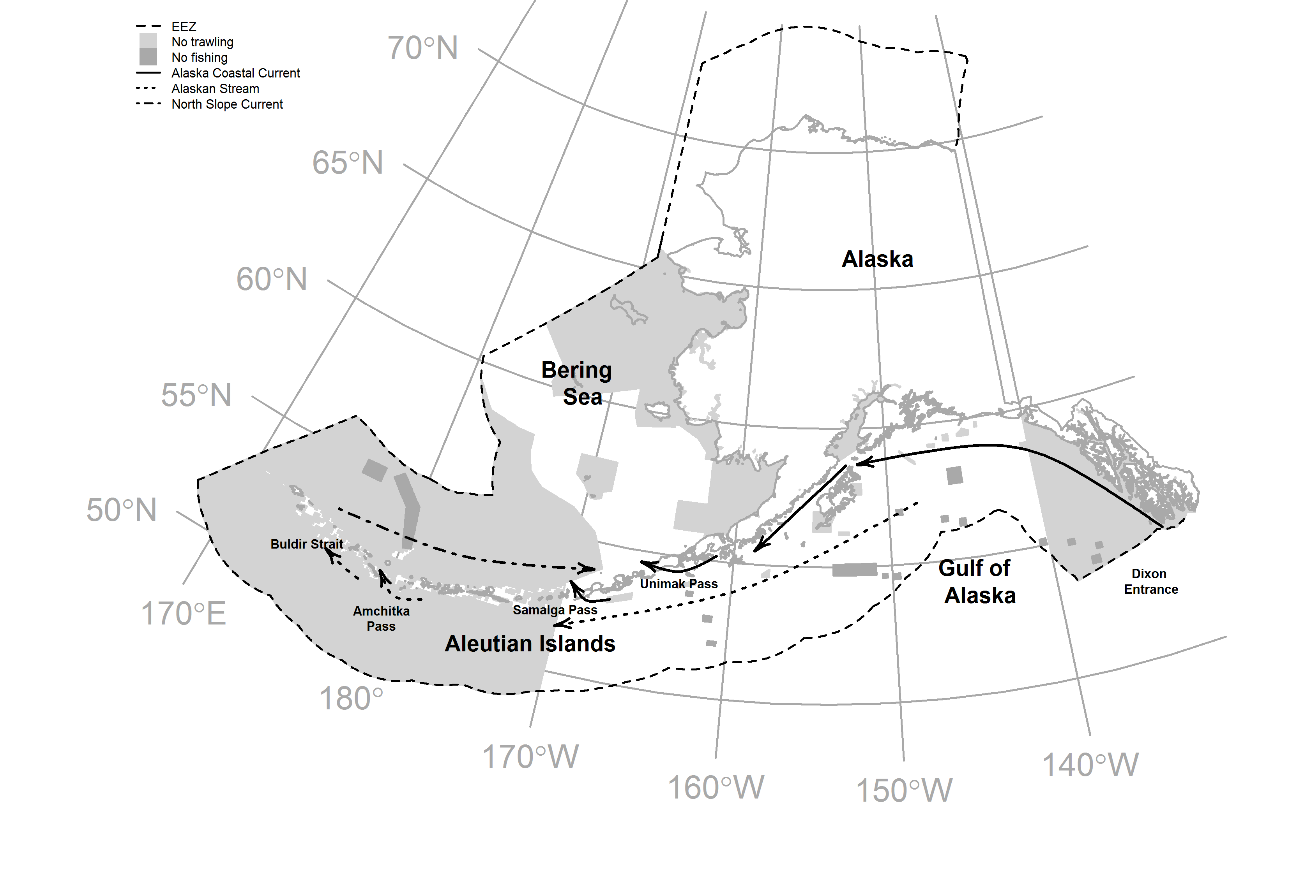

Fig. 1. Map of the study area with major currents. Solid arrows indicate ? and dashed arrows indicate ?. Dark gray polygons indicate areas where fishing is not allowed and light gray polygons indicate areas where fishing is allowed but restricted to non-trawl gear. The light gray polygon near Dixon Entrance demarks the Southeast Alaska Outside Trawl Closure. The dashed line polygon outlines the United States Exclusive Economic Zone (EEZ).

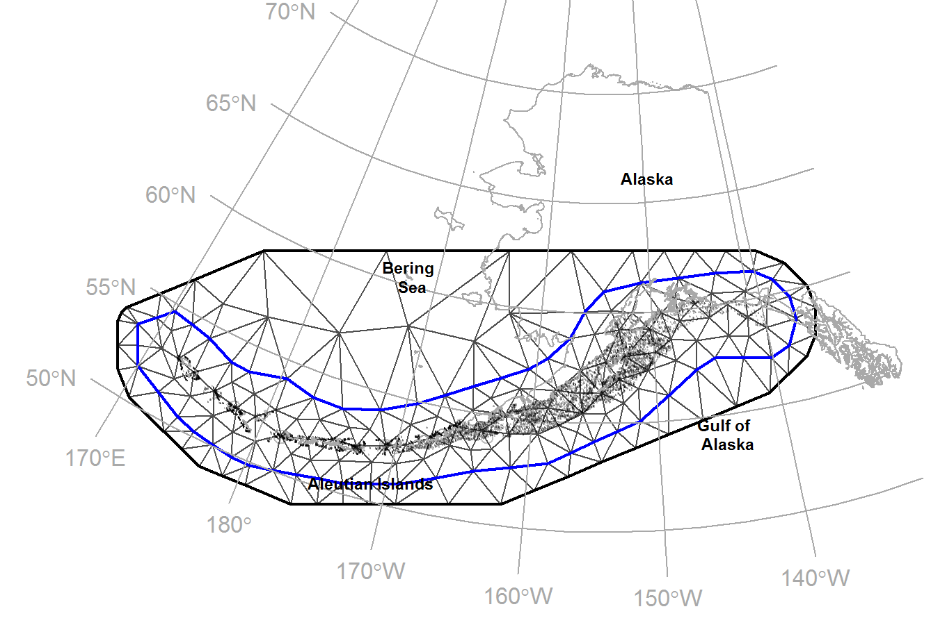

Fig. 2. Catch per unit effort (CPUE, kg ha-1) for Pacific cod for all years (1990-2013). Point size is proportional to the maximum observed CPUE and points are shown with transparency to depict areas with higher sampling effort. Black lines display the triangulation mesh used to approximate a continuous Gaussian Random Field (GRF) using a Gaussian Markov Random Field (GMRF). The blue line represents the border defining the “inner” more precise nodes, while the thick black line represents the “outer” border defining the boundary.

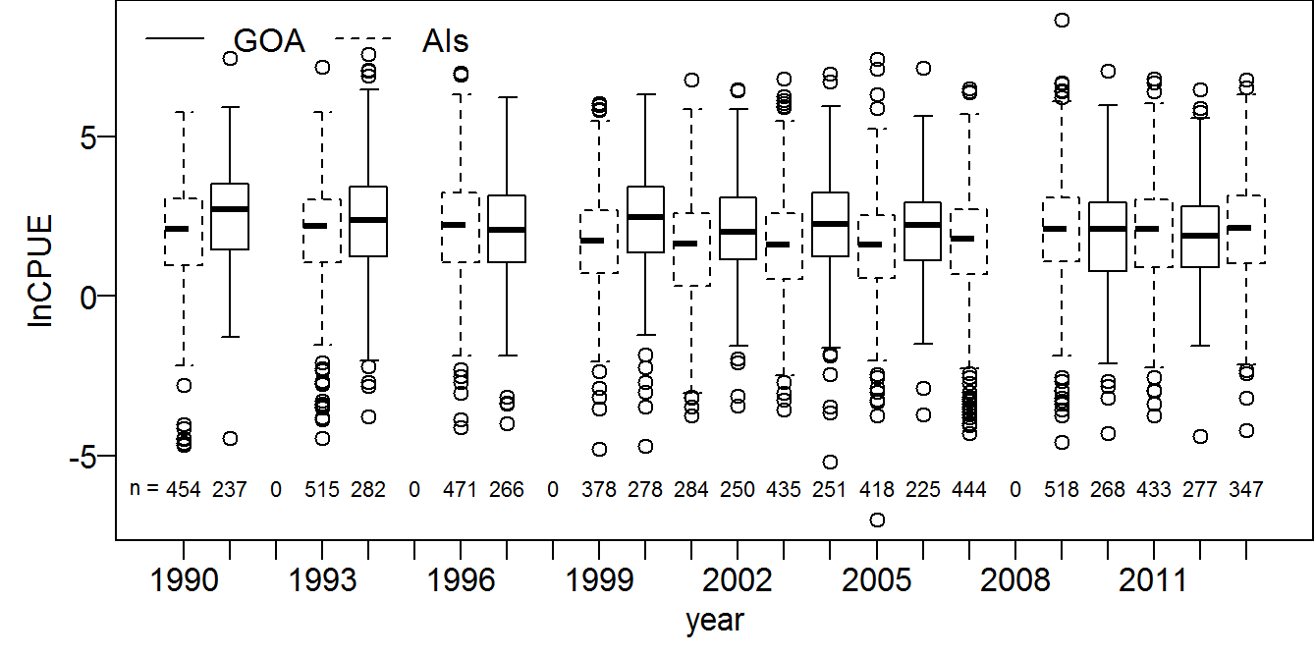

Fig. 3. Yearly variation in non-zero catch per unit effort (CPUE, kg ha-1) measurements on the natural log scale for Pacific cod between stations sampled in the Gulf of Alaska (solid lines) and Aleutian Islands (dashed line).

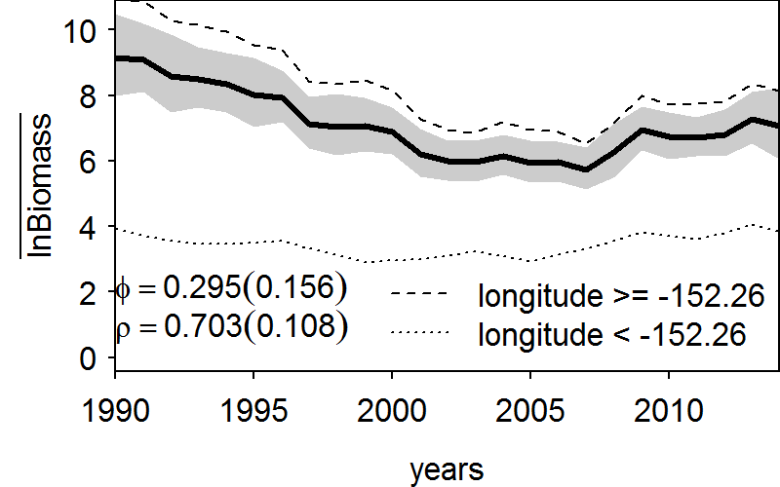

Fig. 4. Estimated mean natural log biomass for the entire study area (i.e., Aleutian Islands and the Gulf of Alaska). Parameter estimates along with their standard errors, in parentheses, are given for i) density dependence (ρ) and ii) the log-ratio of expected abundance in the initial year (*t*=1) and the median of the stationary distribution for abundance at equilibrium (ϕ). Dashed lines display the mean log biomass for each hypothesized stock.

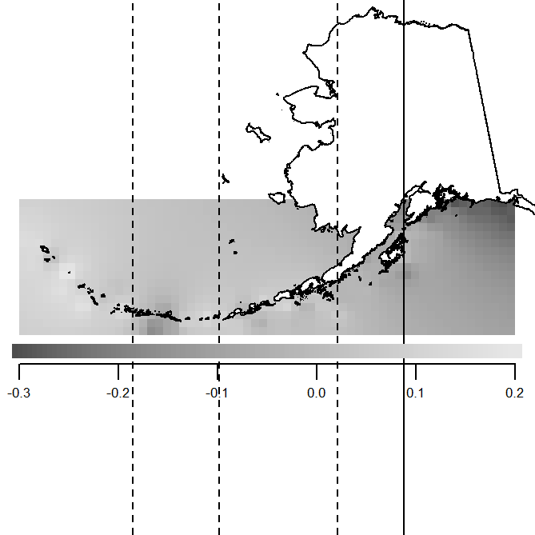

Fig. 5. Spatial variation in productivity (EΩ) displayed using inverse distance weighting, where colors are proportional to the estimated value. Vertical solid line demarks hypothesized stock boundary and vertical dashed lines demark hypothesized stocks which were pruned from the final regression tree.

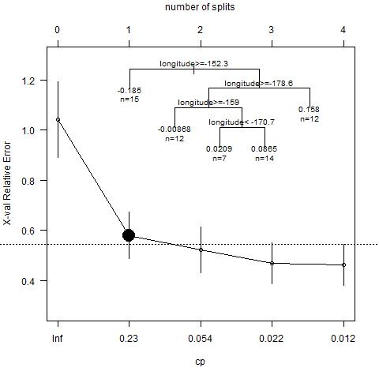

Fig. 6. Cross validated relative error versus a complexity parameter (cp) to determine optimal pruning, where splits define distinct stock boundaries. The large black dot represents the best number of splits, with the location of each split displayed in the upper left inset. Regression trees worked to partition the variation (minimize the within group variation) in ΣΩ across a longitudinal gradient.