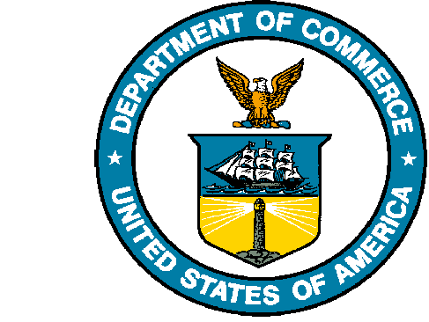
UNITED STATES DEPARTMENT OF COMMERCE

National Oceanic and Atmospheric Administration
NATIONAL MARINE FISHERIES SERVICE
Northwest Fisheries Science Center
2725 Montlake Boulevard East
Seattle, WA 98112-2097

August 20, 2014

Dr. Lorenzo Ciannelli
Oregon State University
105 CEOAS Admn Bldg
Corvallis, OR 97330
541.737.3142, lciannel@ceoas.oregonstate.edu

Dear Dr. Ciannelli:

Per your request for station, catch, and estimated biomass per transect data from US waters (defined as below 48.5 degrees N latitude) of the Pacific Hake Integrated Acoustic and Trawl Surveys between 2007 and 2013, I have compiled the following:

2014-05_FinalData.xlsx

This file has multiple tabs with relevant data:
Hauls – Haul data associated with the catch information
Catch – Species composition, counts, and raw weights (not extrapolated if subsampled) for each haul
Biomass – Unkriged biomass estimates in metric tons for each transect and the transect coordinates
Notes-Definitions – Any notes and definitions for fields and tabs

Please Note:
The biomass estimates are raw weights associated directly with a transect. Adding up the numbers will not add up to the official estimates provided to stock assessors for each year, as additional analysis is conducted to provide coastwide estimates.

Sincerely,

Alicia Billings
Northwest Fisheries Science Center
2032 Marine Science Drive
Newport, OR 97365
541.867.0507, Alicia.Billings@noaa.gov

