Using knowledge of ecology, economics, and equity to improve fisheries management by reducing bycatch: Transdiciplinary modelling of the US West Coast fixed gear sablefish fishery

Kelli F. Johnson1, Sarah Klain2, Ana K. Spalding3, Nadine Heck4, and Todd Lee5

1School of Aquatic and Fishery Sciences, University of Washington, Box 355020 Seattle, WA 98195-5020, USA

2Institute for Resources Environment and Sustainability, University of British Columbia, Vancouver BC V6T 1Z4, Canada

3Smithsonian Tropical Research Institute, Apartado Postal 0843-03092, Panamá, República de Panamá

4Institute of Marine Sciences, University of California, 1156 High St., Santa Cruz, CA 95064, USA

5Northwest Fisheries Science Center, NOAA, 2725 Montlake Boulevard East, Seattle, WA 98112, USA

**Abstract**

Abstract.

**Keywords:** bycatch, catch share, fishery-independent data, governance, groundfish, individual transferable quota (ITQ), risk pool

**I. Introduction**

Too often, it is forgotten that the main task of fisheries managers is to regulate fishermen not fish. Regulatory mechanisms to limit fisheries can involve regulating when, where, how, and how much fishermen can catch. Outcomes can depend, sometimes non-linearly, on multiple factors and combinations of regulations can lead to outcomes unachievable by any single regulation (Deacon, 2012; Ono *et al*., 2013). Therefore, appropriate solutions to fisheries management problems are contextual, highly dependent on human behaviour, and are embedded in complex biological systems (Hilborn, 2007; Kaplan *et al*., 2010). An ecosystem approach to fisheries management (EAFM) attempts to account for the entire ecosystem, including humans, and recognizes that the effects of fishing extend well beyond the targeted fish population. EAFM typically require an interdisciplinary approach and the definition of additional management goals compared to traditional single-species management (citation). Consequently, governance organizations are increasingly advocating for accounting for all sources of fishing mortality, including retained, discarded, and unobserved mortalities of all age- and length-classes and species (NOAA, 2007; FAO, 2009; NMFS, 2011).

Traditional management approaches, such as gear restrictions, time and area closures, and limits on total allowable catch (TAC) have the potential to reduce the catch of non-target species or non-marketable age- and length-classes of target species (hereafter referred to as bycatch), but fail to provide incentives for fishermen to behave sustainably (citation; Abbott and Wilen, 2009). Furthermore, success is highly contextual and economic equity and sustainability is arguable. The reduction of bycatch may not be internally consistent with the activities of a fishing industry, where the main goal is facilitating profit maximization for individual fishermen, due to avoidance costs or reduced catches of targeted species (Abbott and Wilen 2009, Singh and Weninger 2009). Heterogeneity in bycatch rates can lead to heightened costs and increased risks implicit in everyday harvesting decisions (Androkovich and Stollery 1994, Herrera 2005, Holland 2010). Furthermore, bycatch rates are highly influenced by technology and ex-vessel prices**.** Taxes on bycatch, which promote internal incentives for environmentally sustainable behaviour, create no guarantee that bycatch limits will be met and may overly constrain the fishery when bycatch rates are uncertain (Singh and Weninger, 2009). Conversely, managers argue that individual transferable quota (ITQ) systems can create incentives for fishermen to avoid catching species for which quota is scarce (choke species), while keeping the total catch below the TAC (Holland and Jannot, 2012). … (citation). Theoretically under an ITQ system time and area closures as a measure to reduce bycatch would be self-regulated because of limiting TAC of overfished species.

ITQ fisheries are subject to their own problems: i) volatile quota markets (citation), ii) social justice issues regarding allocation (citation), iii) prohibitive entry costs to new fishermen (citation), iv) consolidation of the fishery resource (citation), and v) economic inefficiency when bycatch TAC is limiting (Abbott and Wilen, 2009). In particular, TAC’s for overfished species often limit the ability of fishermen to attain their portion of the TAC for profitable species, potentially reducing the overall yield from the fishery or constraining fishing to a limited area in efforts to avoid bycatch. If fishermen unintentionally catch their entire share of choke species, they are forced to either stop fishing for the season or obtain additional quota from a highly valued and expensive market (Labrum and Oberhoff, 2012).

**Biology or behaviour** Effective management to reduce bycatch requires that the drivers of bycatch be understood. Bycatch is driven in part by the biology of both the target catch and the bycatch through aspects such as habitat preferences, migratory behaviour, and schooling behaviour. Historically, area closures are often informed by catch-per-unit-effort analyses using fishery observer and fishery-independent data which provide insight into ‘hotspots’ (areas of high bycatch or high abundance of bycatch species) that fishermen should avoid (citation). Furthermore, models involving fishery-dependent data led to insights on how ‘hotspots’ do not always lead to high bycatch indicating that fishermen knowledge can play a part in the abundance or lack thereof of bycatch (Jannot and Holland, 2013).

The US West Coast groundfish fishery is a federally managed mixed stock fishery, encompassing over 90 species, including Pacific cod (*Gadus macrocephalus*), sablefish (*Anoplopoma fimbria*), Pacific whiting (*Merluccius productus*), and many flatfish and rockfish species in the waters of California, Oregon, and Washington. In 2000, the fishery was declared an economic disaster. Two years later the Pacific Fisheries Management Council (PFMC) closed major portions of the shelf to bottom trawling and declared eight species overfished: lingcod (*Ophiodon* elongatus), bocaccio (*Sebastes paucispinis*), pacific ocean perch (POP; *Sebastes alutus)*, cowcod (Sebastes *levis*), widow rockfish (*Sebastes entomelas*), darkblotched rockfish (*Sebastes crameri*), yelloweye rockfish (*Sebastes ruberrimus*), and Pacific whiting (NMFS 2002). In addition to the implementation of formal rebuilding plans for the overfished species, the fishery underwent many management changes, including putting into practice a multispecies ITQ system in 2011.

Currently, the market-based ITQ system, which assigned initial percentages of the total harvest shares across fishery participants based on historical fishing, works along with harvest guidelines, trip and landing limits, spatial closures, and geographic gear restrictions in an effort to create a sustainable fishery. As of 2009, 8 species remained overfished (only Pacific whiting has recovered) with catches being highly variable in space and time. In response to risk of harvesting choke species, and within the context of top-down governance framework of ITQ management plans, fishery participants along the West Coast of the United States joined efforts to form so-called “risk pools” or associations that would enable them to share their quota for choke species, thus distributing risk across participants. Studies in Common Pool Resource (CPR) management found that individuals who are members of cooperatives are more likely to subordinate self interest for the sake of managing a resource in the community’s interest (Fehr and Leibbrandt, 2010). Fishery cooperatives often fulfill a similar function as a manager of a firm as they control aspects of members’ actions in order to achieve an outcome that is superior for the group (Deacon, 2012). Furthermore, they act as a kind of mutual insurance company by mitigating individuals’ risk of exceeding bycatch TAC in some situations.

* Implementation of ITQ in 2011 versus monthly limits
  + In 2011, the Pacific Fisheries Management Council (PFMC) implemented an ITQ system in the Pacific groundfish limited entry trawl fishery (citation). Individual allocation of quota pounds (QP; allowable catch (lbs) based on total allowable catch and quota share) for 28 targeted groundfish stocks and several bycatch species, including Pacific halibut and overfished rockfish species was allocated based on recent catch history (citation).

The West Coast groundfish fishery is a highly studied system (citation), yet several questions remain regarding the human dimension of the fishery in terms of the unexpected outcomes of management, fisher behaviour, decision making and governance structures, and their impacts on the fishery. Thus far, the majority of the literature on catch shares focuses on initial allocation methods, social implications, and economic viability of catch shares and fails to assess how the life-history characteristics of fish species can influence biological, economic, and social outcomes of the fishery. Additionally, there is a need to investigate how the life-history of choke species influences the formation of risk pools within an ITQ fishery. Furthermore, although not always explicit in resource management plans, it is increasingly recognized that species conservation efforts must take into account the balance between the conservation of the resource and the social and economic needs of people.

* Sablefish background

Using a transdiciplinary methodological and analytical approach that combines social, economic, and biological data, this analysis aims to investigate the outcomes of the creation of “risk pools” and how species biology affects economic viability in the US West Coast groundfish fishery. The question is especially compelling because it incorporates a perspective on governance, namely non-governmental organization (NGO) involvement, which cannot be evaluated by using only economic and biological data. In this paper, first we explore the connection between ecological aspects of the fishery and the formation, in space, of risk pools along the US West Coast; specifically evaluating (A.1) whether there is a link between the spatial abundance of overfished species and the creation of risk pool associations. Second, we assess the outcomes of risk pools in terms of existing ecological and economic data, looking at whether participation in a risk-pool helps to achieve a greater percent attainment of the yearly TAC for target species. We hypothesize i) that risk-pools will have a higher probability of establishment closer to areas with higher abundances of choke species, ii) risk-pool members will have higher economic revenue compared to non risk-pool members, and iii) vessels participating in risk-pools will have a higher probability of landing 100% of their allotted TAC for target species than non risk-pool vessels.

* Results of this paper focus on how economic data can be used to improve knowledge of bycatch and build upon years of established methods to reduce the amount of bycatch in targeted fisheries, which will hopefully increase managers ability to implement and EAFM and economic efficiency.
* Quantifying bycatch between management regimes
* Incorporating social information can help managers predict outcomes of proposed management frameworks.

**II. Methods**

**Fishery-dependent data**

Records containing information from less than three vessels were supressed to protect confidentiality.

**Fishery-independent data**

The Northwest Fisheries Science Center (NWFSC) Shelf-Slope survey collects annual data on hundreds of fish species along the US West Coast. Generally, four commercial fishing vessels per year, although 2012 involved 2 contracts to a single vessel, are contracted to conduct standardized bottom trawl surveys at depths of 55 to 1280 m from Cape Flattery, Washington (48° 10’N) to the US-Mexico border (32° 30’N) (Figure 1; Bradburn *et al*. 2011). The entire survey area is typically covered twice per year using a stratified random sampling design (based on three depth categories), with sampling extending from late May to late July for the first pass and from mid-August to late October for the second pass (Table 2). Collected data are used as the primary source of information for most groundfish stock assessments within the PFMC. Specifically, to obtain information on relative indexes of abundance, spatially resolved (trawl mid-point) species-specific catches are analysed using delta generalized linear mixed-effects models (delta-GLMMs) which can account for vessel ‘catchability’, spatiotemporal variability, and uncertainty arising from small sample sizes or extreme catch events (Thorson and Ward, 2013).

nine distinct port groups (spatial strata): i) Astoria and Tillamook; ii) Brookings and Crescent City; iii) Coos Bay; iv) Eureka; v) Fort Bragg; vi) Monterey and Morro Bay; vii) Newport; iix) San Francisco and Bodega Bay; and iv) Washington (Figure 1). Spatial strata were defined using latitudinal breaks corresponding with fishing out of major ports on the West coast and prominent biogeographic features at Cape Blanco, OR (42° 50’N) and Cape Mendocino, CA (40° 26’N). Yearly summary statistics for each species, i) number of trawls with positive catch divided by the total number of trawls and ii) mean CPUE, were tabulated for spatial strata using QGIS (QGIS Development Team 2014), an open source GIS desktop application.

The abundance and location of six rockfish species were evaluated as potential constraints to the sablefish fishery: canary (*Sebastes* *pinniger*), Pacific Ocean perch (POP; *S. alutus*), yelloweye (*S.* *ruberrimus*), bocaccio (*S.* *paucispinis*), darkblotched (*S. crameri*), and widow (*S. entomelas*). Canary, POP, and yelloweye are currently listed as overfished, and at 23 (Wallace and Cope, 2011), 19 (Hamel and Ono, 2011), and 21 % (Taylor and Wetzel, 2011) of unfished biomass according to the most recent assessment. Bocaccio, darkblotched, and widow are not currently overfished, but have reached as low 18 (Field, 2013), 19 (Gertseva and Thorson, 2013), and 40 % (He *et al*., 2011) of unfished biomass during the last decade. Although cowcod (*S. levis*), was declared overfished in 2000, the bycatch of cowcod is not included in this analysis because spatial management (Rockfish Conservation Areas) have been successful in decreasing their bycatch and as a species they represent the smallest (sometimes zero) percent of bycatch within the sablefish fishery (NMFS, 2004).

**Economic data**

Data sources include landing receipt data (referred to as fish tickets) and additional information collected by the National Oceanic and Atmospheric Administration’s Economic Data Collection Program (EDC). Fish tickets were completed by fish-buyers in each port, for each vessel offload. Fish tickets represent aggregated sales receipts for market categories or species. Additionally, state officials conducted species-composition sampling for several market categories. The data is maintained on the Pacific Coast Fisheries Information Network (PacFIN) regional database by the Pacific States Marine Fisheries Commission. Furthermore, annual economic data for each vessel participating in the ITQ fishery is collected by the EDC. All economic data was aggregated such that no value represented fewer than 3 entities, and no one entity represented 90% of any individual statistic (NOAA, 2007). Consequently, landings (lb), number of vessels, ex-vessel value, average vessel characteristics, average crew characteristics, average variable and fixed costs, average net revenue, and number of fish buyers, provided for 2009 to 2012 for each port or species group, were not orthogonal. Species groups consisted of nine categories based on biology and data aggregation restrictions: i) Dover sole; ii) flatfish; iii) Petrale sole; iv) sablefish; v) thornyheads; vi) rockfish; vii) sharks, skates, and rays; viii) Pacific whiting; and ix) other groundfish. Landings and revenue data were assigned to port group based on where the species group was landed. In contrast, vessel characteristics were assigned to the port group where the vessel earned its highest ex-vessel revenue for each given year.

**Statistical analysis**

We used generalized additive mixed modelling framework (GAMMs; Wood, 2006) to analyse the data. GAMMs allow predictors to be fitted with parametric and nonparametric smoothing terms, including nonlinear and non-monotonic functions. Mixed models, or random effects, were required to accommodate the temporal correlation inherent in the data (todo: citation). Additionally, random effects could be used to account for spatial correlation between the port groups, but this was not investigated here. All analyses were performed using the gamm4 package (Wood and Scheipl, 2014) in R, a freely available statistical software (R Core Team, 2014).

Nine strata were defined by latitudinal breaks corresponding with fishing out of major ports on the West Coast, the requirement of a sufficient number of positive tows in each strata:year combination, and the boundaries of survey design changes (South of 48°30’, 46°30’, 45°, 44°, 43°, 41°30’, 40°30’, 39°, and 37° northern latitudinal boundaries).

Specifically, the response variable, percent yearly attained TAC, was fit to several biological, economic, and social predictor variables,

$g\left(E\left[y_{s,p,i}\right]\right)= β_{0}+β_{1}x_{s,p,i}+s\left(m_{s,p,i}\right)+ ε_{s,p,i}.$ Eq. 1

The model given in equation 1 consists of the logit link function *g* of the expected value for the response variable of species *s* in port group *p* in year *i*. ε were assumed to follow an autocorrelated error structure dependent on year and portgroup and follow a binomial distribution. Predictor variables were modelled using a linear relationship, unless *a priori* the relationship was thought to be nonlinear, which invoked the use of the smoothing operator *s*.

Fixed effect predictor variables included vessel count, revenue corrected by landings, an indicator variable for before and after the implementation of catch shares, buyer count, horsepower, number of vessels that participate in a risk pool where membership includes a law binding agreement, fixed costs, variable costs, total revenue, fuel capacity, vessel length, and a two metrics for relative abundance of choke and or targeted species. Both percent occurrence (tows with positive catch / total number of tows) and mean catch per unit effort (CPUE) were calculated for each species group and each overfished species as measures of their relative abundance. Not all possible fixed effects were included in each model run, as some are highly correlated. Choke species relevant to each modelled species were based on historical records of bycatch (Rogers and Pikitch 1992). Akaike’s Information Criterion (AICc) was used to select the best model from an *a priori* hypothesized set of models (Burnham and Anderson 2002).

**Literature review**

Location, access to, and participation in risk pools was investigated using a literature search. Search keywords included: risk pools, The Nature Conservancy, California risk pool, fishing cooperatives West coast, and ITQs. Documents were analysed in terms of information about existing risk pools, number of participating vessels, rules and regulations, and governance structures.

**III. Results**

**West Coast risk pool**

Formal risk pools were found to exist in both California and Washington, though we cannot confirm that lesser known risk pools do not exist in the state of Oregon (Figure 1). The California risk pool, spear headed by the Nature Conservancy (TNC), is comprised of members from two fishing associations, the Fort Bragg Groundfish Association based in Fort Bragg and the Central California Seafood Marketing Association based in Morro Bay (The Nature Conservancy 2014). In 2011, 14 individual members participated in the California risk pool (FBGA *et al*., 2011) and together managed the fishing rights to over 10 million pounds of groundfish (The Nature Conservancy, 2014). Conversely, in Washington, only a single formal risk pool exists, known as the Ilwaco Co-op. The Ilwaco risk pool is much smaller, and is composed of just four fishing vessels that hold quota share for West Coast groundfish. Each risk pool has its own origin and complex dynamic structure that constitute an important area for further research.

Membership in the California risk pool is based on formal agreements between risk pool participants and the TNC, broadly overseen by an advisory committee that is comprised of one representative from each fishing association and one representative from TNC. Membership in the risk pool is subject to annual renewal and members both develop and enforce regional fishing plans that contain fishing prescriptions designed to minimize the risk of catching overfished species. Practices include a web-based tool, Ecatch, designed to capture vessel logbook information, visualize and query data, and easily share information across risk pool participants. Similar software platforms, such as Fish Hub, have emerged and cover a range of task associated with fishery data.

**GAMMs**

GAMMs were run for flatfish and dover sole. These species were chosen based on data availability and their economic importance in the fishery. Flatfish showed a decreasing trend in landings and buyer count over time (Figure 2). Dover sole showed a similar trend, though to a somewhat lesser extent (Figure 3). The percent attained of the TAC decreased over time for both species, though more so for Dover sole (Figure 4).

Results from the GAMM for Dover sole indicates a significant relationship for the intercept and for number of vessels (Table 2). Number of vessels was only included as a measure of standardization, as it makes intuitive sense that more vessels lead to a higher percent attainment of the TAC. Thus, model results are not helpful for predicting which variables increase the percent attainment of target species.

Additional results are not included because of the limitation of data aggregation and the desire to rerun the analysis with the full data set and with species that are more meaningful, as per communication with Todd Lee.

**IV. Discussion**

* In 2011, correlation between fishermens' allocated QP of bycatch species and catch was low (Holland2012).

The measure of risk pool (number of vessels in a risk pool) was not an accurate predictor of percent attainment of TAC. Furthermore, other metrics included in preliminary runs were also not good predictors of percent attainment of TAC. Thus, the remainder of the discussion will focus on social implications of catch shares.

TNC entered the West Coast groundfish fishery prior to the management change to an ITQ fishery, with the intent on not harvesting their purchased quota. Currently, instead of holding their quota they lease out quota pounds to members of the California risk pool, in return for having a say in how fishing occurs, mainly what practices are used. In turn TNC has helped implement a geographic information system that combines the best available science and technology with fishermen’s knowledge, historical fishery data, and habitat information to identify zones that contain overfished species as well as areas with voluntary closures. According to TNC, , the California Risk Pool has reduced bycatch of overfished species, increased harvest of target species, and improved the tracking and sharing of fishing information (The Nature Conservancy 2014). Risk pool managers found that the overall trawl-based groundfish fleet caught more than 30% of TAC for overfished species, in contrast to 2.1% for the California Risk Pool (FBGA et al. 2011). Results that were not apparent in our analysis.

Outcomes of risk pools depend on fishing behaviour, social networks (information sharing), locally developed fishing plans and their enforcement. Furthermore, outcomes of the fishery depend to a large extent on how many fish are available. Thus, we plan on moving forward with the analysis to combine measures of biology, economics, and social capacity to inform managers when and where risk pools should be formed and how information regarding life history and abundance can inform policy.

**VI. References**

Abbott, J. K., and Wilen, J. E. 2009. Regulation of fisheries bycatch with common-pool output quotas. Journal of Environmental Economics and Management, 57:195-204. doi: 10.1016/j.jeem.2008.04.003.

Algert, R. 2013. Morro Bay Community Quota Fund.

Androkovich, R. A., and Stollery, K. R. 1994. A stochastic dynamic programming model of bycatch in fisheries. Marine Resource Economics, 9: 19-30.

Boyce, J. R. 1996. An economic analysis of the fisheries bycatch problem. Journal of Environmental Economics and Management, 31: 314-336.

Bradburn, M. J., Keller, A., and Horness, B. H. 2011. The 2003 to 2008 U.S. West Coast bottom trawl surveys of groundfish resources off Washington, Oregon, and California: estimates of distribution, abundance, length, and age composition. U.S. Dept. of Comm., NOAA Tech. Memo., NMFS-NWFSC-114, 323 p.

Burnham, K. P., Anderson, D. R. 2002. Model Selection and Multi-Model Inference: A Practical Information-Theoretic Approach. Springer.

Deacon, R. T. 2012. Fishery management by harvester cooperatives. Review of Environmental Economics and Policy, 6: 258-277.

Fehr, E., and Leibbrandt, A. 2010. A Field Study on Cooperativeness and Impatience in the Tragedy of the Commons. University of Chicago: Department of Economics.

Field, J. C. 2013. Status of bocaccio, *Sebastes paucispinis*, in the Conception, Monterey and Eureka INPFC areas as evaluated for 2013. Pacific Fishery Management Council, Portland, OR.

FBGA (Fort Bragg Groundfish Association), Central Coast Sustainable Groundfish Assocaition, and The Nature Conservancy. 2012. Fort Bragg - Central Coast Risk Pool Summary Report 2011.

Gertseva, V. V., and Thorson, J. T. 2013. Status of the darkblotched rockfish resources off the continental U.S. Pacific Coast in 2013. Pacific Fishery Management Council, Portland, OR.

Gibbons, M., Limoges, C., Nowotny, H., Schwartzman, S., Scott, P., and Trow, M. 1994. The New Production of Knowledge: The Dynamics of Science and Research in Contemporary Societies. Sage, London.

Hamel, O. S., and Ono K. 2011. Stock assessment of Pacific Ocean Perch in waters off of the U.S. West Coast in 2011. Pacific Fishery Management Council, Portland, OR.

He, X., Pearson, D. E., Dick, E. J., Field, J. C., Ralston, S., and MacCall, A. D. 2011. Status of the widow rockfish resource in 2011. Pacific Fishery Management Council, Portland, OR.

Herrera, G. E. 2005. Stochastic bycatch, informational asymmetry, and discarding. Journal of Enviornmental Economics and Management, 49: 463-483. doi: 10.1016/j.jeem.2004.05.007.

Hilborn, R. 2007. Managing fisheries is managing people: what has been learned? Fish and Fisheries, 8: 285-296.

Holland, D. S. 2010. Markets, pooling and insurance for managing bycatch in fisheries. Ecological Economics, 70: 121-133. doi: 10.1016/j.ecolecon.2010.08.015.

Holland, D. S., and J Wiersma. 2010. Free form property rights for fisheries: The decentralized design of rights-based management through groundfish 'sectors' in New England. Marine Policy, 34:1076-1081.

Holland, D. S., and Jannot, J. E. 2012. Bycatch risk pools for the US West Coast Groundfish Fishery. Ecological Economics, 78:132-147. doi: 10.1016/j.ecolecon.2012.04.010.

Jannot, J. E., and Holland, D. S. 2013. Identifying ecological and fishing drivers of bycatch in a U.S. groundfish fishery. Ecological Applications, 23:1645-1658. http://dx.doi.org/10.1890/12-2225.1

Kaplan, I. C., Levin, P. S., Burden, M., and Fulton, E. A. 2010. Fishing catch shares in the face of global change: a framework for integrating cumulative impacts and single species management. Canadian Journal of Fisheries and Aquatic Sciences, 67: 1968-1982.

Labrum, K. , and Oberhoff, D. 2012. Fort Bragg - Central Coast Risk Pool Annual Summary Report. Pacific Fisheries Management Council, Portland, OR.

NMFS (National Marine Fisheries Service). 1999. Ecosystem-based fishery management. A report to Congress by the Ecosystems Principles Advisory Panel. U.S. Dept. Commer., Silver Spring, MD.

NMFS (National Marine Fisheries Services). 2002. Fisheries off West Coast States and in the Western Pacific; Pacific Coast Groundfish Fishery; Annual Specifications and management Measures; Trip Limit Adjustments; Correction; Rules and Regulations. 4 October 2002. Federal Register 67: 62204-62212.

NMFS (National Marine Fisheries Services). 2004. West Coast Groundfish Observer Program data report and summary analyses for 2001-2003 coverage of sablefish-endorsed fixed-gear permits. NOAA, Northwest Fisheries Science Center, 2725 Montlake Blvd E, Seattle, WA.

NOAA (National Oceanic and Atmospheric Administration). 2007. Magnuson-Stevens Fishery Conservation and Management Act amended through January 12, 2007. U.S. Dept. Commer., Silver Spring, MD.

NRC (National Research Council). 1999. Sustaining marine fisheries. National Academy Press, Washington, DC.

Ono, K., Holland, D. S., Hilborn, R. 2013. How does species association affect mixed stock fisheries management? A comparative analysis of the effect of marine protected areas, discard bans, and individual fishing quotas. Canadian Journal of Fisheries and Aquatic Sciences, 70: 1792-1804.

Pacific Fishery Management Council. 2011. Constraining Species Risk Pooling in the Pacfic IFQ - Concepts, Insights, and Suggested Policy Adjustments. Pacific Fishery Management Council, Portland, OR.

R Core Team. 2014. R: a language and environment for statistical computing. R Foundation for Statistical Computing, Vienna, Austria.url: http://www.R-project.org/.

Rogers, B., and Pikitch, E. K. 1992. Numerical definition of groundfish assemblages caught off the coasts of Oregon and Washington using commercial fishing strategies. Canadian Journal of Fisheries and Aquatic Science, 49: 2648-2656.

Singh, R., and Weninger, Q. 2009. Bioeconomies of scope and the discard problem in multiple-species fisheries. Journal of Environmental Economics and Management, 58:72-92. doi:10.1016/j.jeem.2008.08.005.

Taylor, I. G., and Wetzel, C. 2011. Status of the U.S. yelloweye rockfish resource in 2011(Update of 2009 assessment model). Pacific Fishery Management Council, Portland, OR.

The Nature Conservancy. 2014. California Risk Pool: A Co-management Model to advance fisheries Resource Stewardship. The Nature Conservancy.

Thorson, J. T., and Ward, E. J. 2013. Accounting for space-time interactions in index standardization models. Fisheries Research, 147: 426-433. doi: 10.1016/j.fishres.2013.03.012.

Wallace, J. R., and Cope, J. M. 2011. Status update of the U. S. canary rockfish resource in 2011. Pacific Fishery Management Council, Portland, OR.

Wood, S. N., Scheipl, F. 2014. gamm4: Generalized additive mixed models using mgcv and lme4. R package version 0.2-3. http://CRAN.R-project.org/package=gamm4

Wood, S. N. 2006. Generalized Additive Models: An Introduction with R. Chapman and Hall/CRC Press, Boca Raton, FL.

**VII. Outlook**

1. Is there a significant difference in the percent attainment of yearly TAC among risk pool and   
 non-risk pool members?

* more data is needed

2. Risk pools form within a social-ecological system. Future research could identify key enabling social and biological factors that contribute to their formation.

* Is there a correlation among existing annual fishery-independent data (e.g., relatively high presence of “choke” species) and the number of risk-pool participant vessels, conditioned by gear type, vessel size, and vessel length
* What are the key social factors? Are pre-existing community-based fishery organizations a necessary condition for forming risk pools?

3. What are the dynamics among members in the risk-pools?

* What are the incentives to join or leave a risk pool;
* What are perceived benefits and challenges of risk pools among risk pool members and non risk pool members?
* What are the dynamics between risk-pool and non-risk pool participants in the fishery (e.g. information sharing with fishermen outside risk pool, intention to reach out to non risk pool members in case the risk pool reached deficit for overfished species, would they buy TAC for those species from other fishers?);

4. What are perceived benefits and challenges of the co-management governance   
 arrangement?

* How is power shared among the members on the management board?
* What are perceived benefits and challenges of the co-management arrangement?
* What outcomes have been achieved due to the co-management approach?

**IX. Tables**

Table 1. Factors that affect the relative benefits of maintaining individual bycatch quotas as compared to creating a risk pool (Holland and Jannot, 2012).

|  |  |
| --- | --- |
| **Favors maintaining individual quotas** | **Favors risk pool** |
| Species caught frequently | Species only rarely caught |
| Low variance, normally distributed catch events | High variance, positively skewed catch events |
| High number of fishing events per vessel | Low number of fishing events per vessel |
| Bycatch risk correlated with expected profits | Bycatch risk uncorrelated with expected profit |
| Bycatch risk heterogeneous across vessels | Bycatch risk homogenous across vessels |
| Real-time information sharing not useful for avoidance | Real-time information sharing useful for avoidance |

Table 2. Samples sizes (number of tows) among vessels contracted for the NWFSC Shelf-Slope bottom trawl survey by year and strata during the analysed period (2009-2012).

WRITE CODE TO GENERATE TABLE

Table 2. Results from GAMM for Dover sole. Meaningful parameters are not significant.

|  |  |  |  |  |
| --- | --- | --- | --- | --- |
|  | Estimate | Std. Error | t value | Pr($>∣$ t $∣$) |
| (Intercept) | -3.48 | 0.18 | -19.25 | 0.00 |
| Vessel count | 0.06 | 0.01 | 5.17 | 0.00 |
| Before & after implementation | -0.30 | 0.17 | -1.75 | 0.10 |
| Risk pool participation | -0.07 | 0.06 | -1.05 | 0.31 |

**X. Figures**

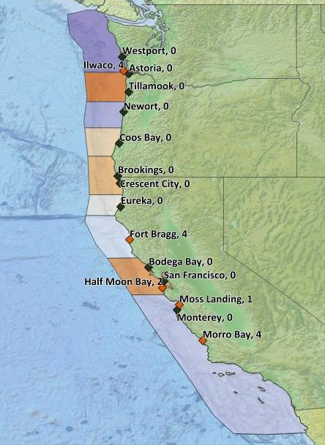

Figure 1. Geographical extent of the survey area. Latitudinal lines depict strata used to separate between port groups. Unique port groups from north to south include: i) Washington; Astoria and Tillamook; Newport; Coos Bay; Brookings and Crescent City; Eureka; Fort Bragg; San Francisco and Bodega Bay; and Monterey and Morro Bay. Numbers next to the name of a given port group indicate the number of vessels that participate in a risk pool for that port group.

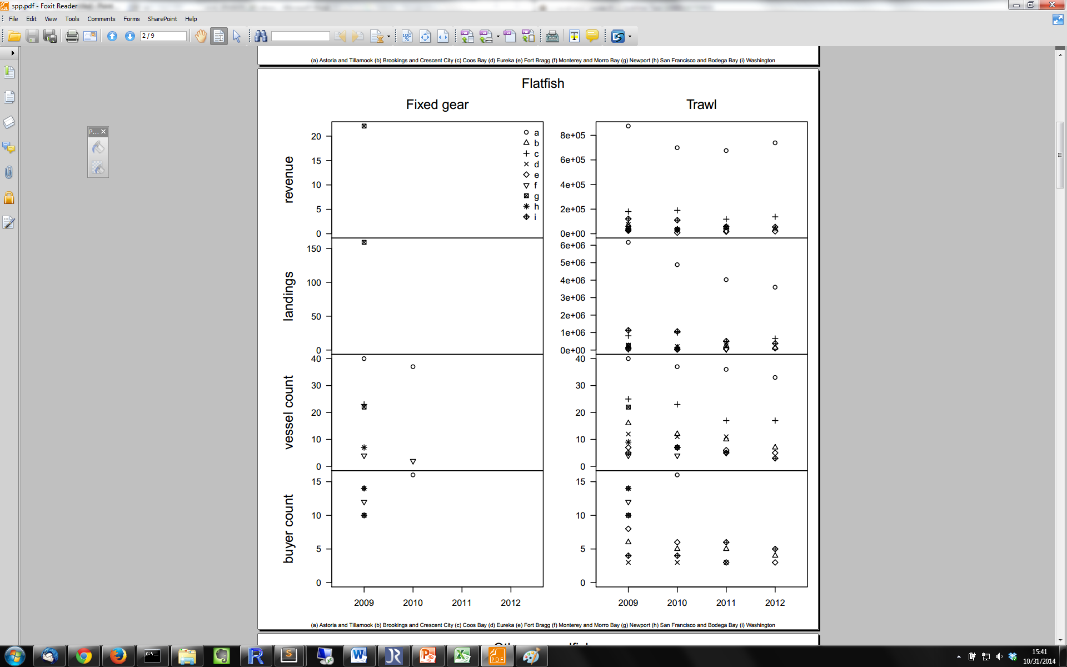

Figure 2. Trends in predictor variables for flatfish from 2009 to 2012.

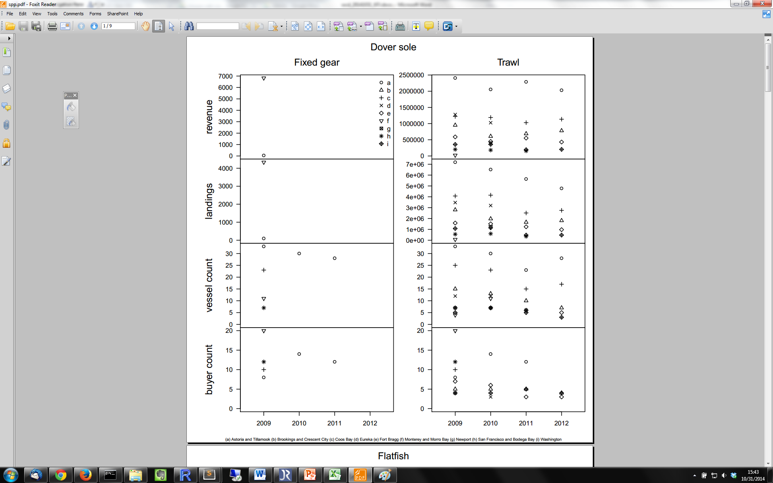

Figure 3. Trends in predictor variables for dover sole from 2009 to 2012.

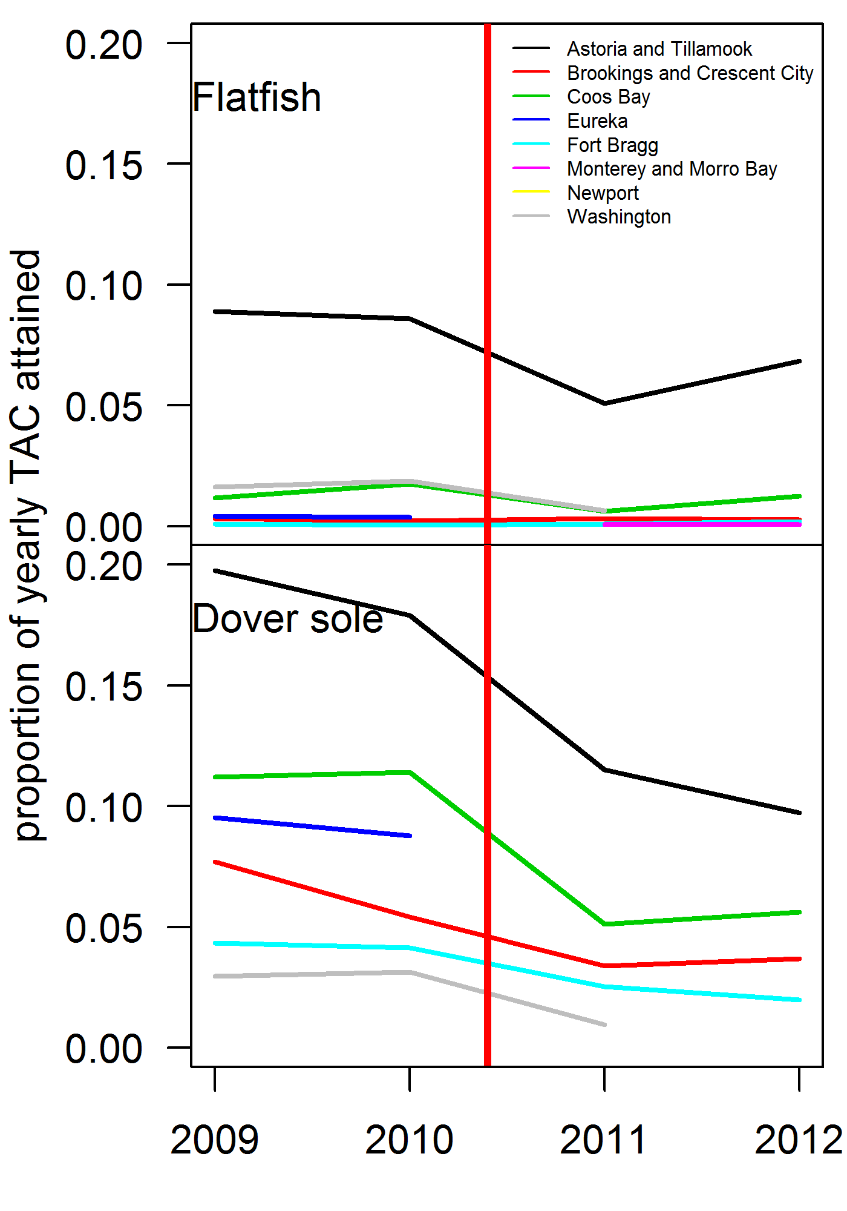

Figure 4. Percent attained of the yearly TAC for both Dover sole and flatfish in the West Coast groundfish fishery.

Figure . Results from the best GAMM for dover sole.