Using transdisciplinary science to improve fisheries management: ecology, economics, and equity in the US West Coast sablefish fishery

Kelli F. Johnson1, Sarah Klain2, Ana K. Spalding3,4, Nadine Heck5, and Todd Lee6

1School of Aquatic and Fishery Sciences, University of Washington, Box 355020 Seattle, WA 98195-5020, USA

2Institute for Resources Environment and Sustainability, University of British Columbia, Vancouver BC V6T 1Z4, Canada

3Smithsonian Tropical Research Institute, Apartado Postal 0843-03092, Panamá, República de Panamá

4School for Public Policy, Oregon State University, 318 Fairbanks Hall, Corvallis, OR 97331

5Institute of Marine Sciences, University of California, 1156 High St., Santa Cruz, CA 95064, USA

6Northwest Fisheries Science Center, NOAA, 2725 Montlake Boulevard East, Seattle, WA 98112, USA

**Abstract**

Support for ecosystem based management is far reaching, and guidance on how to achieve an ecosystem approach to fisheries management is extensive. However, designing effective management depends on understanding how fishermen will behave under such systems. Fishermen will develop strategies under particular management regimes, where decision-making processes are governed by goals and constraints. To understand potential changes in landings of bycatch under two management regimes ((a) bi-monthly total allowable catches and (b) individual transferable quotas), retrospective data from the US West Coast sablefish fishery were used to model impacts of economic and ecological drivers on gear choice ((a) trawl or (b) fixed gear (i.e., pot and long-line)) and make inferences regarding fishermen behaviour. Results indicate fishermen may have a higher propensity to switch gears, potentially in an economically inefficient manner, when total allowable catch limits for bycatch species are constraining. Furthermore, ecological processes are strong drivers of bycatch and thus also gear choice when fishermen have the ability to switch gears. ECONOMICS. Hence, the economic, ecological, and equitable advantages of rights based management may be different when seen from the perspective of each discipline. Knowledge of these dynamics is essential for effective fisheries management and an emphasis should be placed on collecting information that facilitates quantifying trade-offs and outcomes of fisheries management through a transdisciplinary lens.

**Keywords:** bycatch, catch share, governance, individual transferable quota (ITQ), risk pool, transdisciplinary

**Introduction**

Regulatory mechanisms to limit fisheries can involve regulating when, where, how, and how much fishermen can catch. Outcomes of these regulatory mechanisms can depend, sometimes non-linearly, on multiple factors, and combinations of mechanisms can lead to outcomes unachievable by any single mechanism (Deacon, 2012; Ono *et al*., 2013). Additionally, in assessing outcomes, it is often forgotten that the main task of fishery managers is to regulate fishermen, not fish. Consequently, appropriate solutions to fisheries management problems are contextual, dependent on human behaviour, and embedded in complex social-ecological systems (Hilborn, 2007; Kaplan *et al*., 2010).

Ecosystem based fisheries management (EBFM) attempts to account for the entire ecosystem, including humans, and recognizes that the effects of fishing extend well beyond the targeted fish population (Pikitch *et al*., 2004). According to Hilborn (2011), there are three ‘core’ aspects of EBFM: (a) the prevention of ecosystem-wide overfishing; (b) reduction of bycatch and discards, where the Magnuson-Stevens Fishery Conservation and Management Act (MSA) defines bycatch as “fish which are harvested in a fishery but which are not sold or kept for personal use, and includes economic discards and regulatory discards” (16 U.S.C. § 1802(2)); and (c) terminating habitat-destroying fishing methods. Implementation of (a) remains difficult as the definition of what constitutes ecosystem-wide overfishing remains unclear (Samhouri *et al*., 2010; Large *et al*., 2013). Conversely, literature suggests that regulatory mechanisms focused on (b) may be increasingly straightforward compared to regulatory mechanisms focused on (a) and (c), specifically by means of gear modifications, avoidance incentives, spatial or temporal closures, or some combination thereof (Hall and Mainprize, 2005).

Bycatch taxes are known for promoting internal incentives for environmentally sustainable behaviour, but fail to guarantee that bycatch limits will be observed and may overly constrain the fishery when bycatch rates are uncertain (Herrera, 2005; Singh and Weninger, 2009). Conversely, total allowable catch (TAC) policies guarantee that bycatch limits are observed but promote inefficiency when quota for profitable species remains unfilled (Androkovich and Stollery, 1994; Holland, 2010; Patrick and Benaka, 2013). Additionally, open access TAC policies incentivize the ‘race to fish’, which often lead to increasing marginal costs and decreased safety (Criddle and Macinko, 2000; Emery et al., 2014). Individual transferable quotas (ITQs), where fishermen are allocated shares of the TAC, are thought to reduce bycatch by encouraging fishermen to change their behaviour in a way that reduces catches of species for which quota is scarce (Casey, 1995; Hall *et al*., 2000; Holland and Jannot, 2012). Thereby eliminating the need for mandated time and area closures, which theoretically become increasingly self-regulated as quota becomes scarcer.

Depending on the management regime fishermen can rectify imbalances between catches and quota through markets, rollover allowances, deemed value payments, exchanges, retrospective balancing, surrendering of catch, or discarding, with markets being the least flexible option but having the lowest risk of overexploitation (Sanchirico *et al*., 2006). Theoretically, market prices should reflect differences between expected price and cost on a per fish basis and efficient markets are generally characterized by a large number of buyers and sellers, low transaction costs, and readily available price information (Fama, 1970; Stavins, 1995; Swinkels, 1999). Unfortunately, quota markets tend to be very thin and exhibit high transaction costs (Holland, 2013; Holland *et al.*, 2015). Risk pools, where fishermen pool their quota of non-target species, offer a potential means to mitigate financial risk and reduce transaction costs of quota markets while maintaining a high probability that catches will not exceed TACs.

Trawl fisheries, often multispecies in nature and characterized by gear with imperfect selection properties, are known for being difficult to manage in terms of avoiding bycatch (Andrew and Pepperell, 1992; Kennelly, 1995). The chance that fishermen’s catches align with the proportions of species quota is almost non-existent. Fortunately, fishermen usually have at least a limited ability to control the ratio of species caught within their net (Beverton and Holt, 1957; Campbell and Nicholl, 1994; Quirijns *et al*., 2008), but most management systems fail to provide incentives or the flexibility to do so (Branch *et al*., 2006; Abbott and Wilen, 2009). Under the MSA, minimizing bycatch is required by law and an improved understanding of the contextual responses of fishermen (e.g., risk pool formation and gear switching) to regulations and fish behaviour, has the potential to increase management efficiency.

Factors related to economics, ecology, and equity were used in an attempt to understand choices regarding gear type, a major driver of bycatch rates, while landing sablefish (*Anoplopoma fimbria*) in the US West Coast groundfish fishery (Table 1). Mixed effects models were used to quantify changes in the yearly percentage of port specific landings caught using trawl versus fixed gear (pots and longline). Results provide insights relevant to the design and implementation of ITQ policies and have the potential to increase managers’ ability to implement EBFM while increasing economic efficiency. Additional information regarding challenges of data assimilation across multiple disciplines is also highlighted.

*History of the US West Coast sablefish fishery*

Today, sablefish is one of the most valuable fisheries in the US West Coast groundfish fishery, a federally managed multispecies fishery encompassing over 90 species but primarily targeting demersal species such as sablefish, Dover sole (*Microstomus pacificus*), shortspine thornyhead (*Sebastolobus alascanus*), Petrale sole (*Eopsetta jordani*), and Pacific whiting (Pacific hake, *Merluccius productus*). Reconstructed sablefish landings go back to the early 1900s, with the California Department of Fish and Wildlife documenting some of the first records in 1908. Prior to 1960, landings were primarily caught using hook and line (Figure 1), with later increases in the 1970s attributed to the development of a pot fishery, mainly comprised of foreign vessels (McDevitt, 1986). With the implementation of the MSA and the creation of the Pacific Fisheries Management Council (PFMC) Groundfish Fishery Management Plan (GMP), management authority switched from individual coastal states to the federal government, with the first federal regulation being coast-wide trip limits implemented in October of 1982 (Johnson *et al*., 2015).

Increasing effort and a decreasing stock size led to the implementation of seasonal management, gear specific allocations, and limited entry (LE) permits. By 1994, the fishery was apportioned 90.6% to the LE permit program, further split 58 – 42% between the LE trawl and the LE fixed gear sectors, and 9.4% to an open access fishery, for vessels that did not qualify for the LE program based on landing requirements met between July 11, 1984 and August 1, 1988. One permit was issued per vessel, though each permit could hold multiple gear endorsements. Additionally, management was divided at 36° N, with TACs being higher in the north as compared to the south.

Increasing concerns for fishermen safety associated with decreasing season lengths, just five days in 1996, led to a three-tier quota system based on historical landings. Seasons were still necessary such that the tiers did not represent an ITQ system, which were not allowed under the MSA moratorium on new ITQ programs. An exception to the moratorium was made for the sablefish fixed gear LE permit fishery on August 2, 2001 (PFMC, 2001), and despite the 2002 expiration of the moratorium, the trawl fishery was managed primarily through vessel bimonthly cumulative landing limits and spatial closures until 2011.

In 2011, an ITQ system was introduced for all participants of the US West Coast LE groundfish trawl fishery, with allocations based on historical landings. Currently, the ITQ system includes bycatch quotas for Pacific halibut (*Hippoglossus stenolepis*), an internationally managed species, five overfished species: (a) bocaccio (*S. paucispinis*; Field, 2013); (b) cowcod (*S. levis*; Dick and MacCall, 2014); (c) darkblotched rockfish (*S. crameri*; Gertseva and Thorson, 2013); (d) Pacific ocean perch (POP, *S. alutus*; Hamel and Ono, 2011); and (e) yelloweye rockfish (*S. ruberrimus*; Taylor and Wetzel, 2011). Quota share allocations for most bycatch species were based on bycatch rates applied to quota shares of target species (PFMC and NMFS, 2010). Furthermore, in 2011, bycatch quota became binding, whereas previously fishermen could continue fishing as long as all species for which they had reached their quota were discarded. Thus, incentives to reduce bycatch were potentially made stronger and individuals’ concerns about risk regarding reaching bycatch quotas led to the formation of multiple formal and informal risk pools, though risk pools were not required to publicly disclose information on rules, membership, or outcomes.

North of 36° N, gear switching was and still is allowed under a permit stacking program. Vessels can fish for their entire quota, of up to three permits, using any gear for which they hold an endorsement. As of 2013, 40 vessels holding sablefish endorsements have stacked permits with 164 permits issued in total (PFMC and NMFS, 2014). Six permits have endorsements for multiple gear types: four longline and pot, one pot and trawl, and one longline and trawl.

**Methods**

*Fishery-dependent data*

Landings and ex-vessel revenue data were obtained from the Pacific Fisheries Information Network (PacFIN) regional database, a compilation of sales receipts (i.e., fish-tickets) collected during the delivery of fish to processing plants in Washington, Oregon, and California (Pacific States Marine Fisheries Commission, Portland, OR, www.psmfc.org/pacfin). The PacFIN database contains information on landings by gear and market category, where sablefish represent a market category. Data on vessel characteristics were obtained from the Economic Data Collection (EDC) program, a mandatory component of the US West Coast groundfish trawl catch share program (www.nwfsc.noaa.gov/research/divisions/fram/economic). Since 2009, all catch share participants have been required to provide information on operating costs, revenue, and vessel characteristics including: (a) length, (b) horsepower, (c) market value, (d) fuel capacity, (e) days at sea, (f) fishing speed, (g) variable and fixed costs, and (h) net revenue.

PacFIN and EDC data were aggregated according to nine strata, defined by latitudinal breaks (46°30’N, 45°N, 44°N, 43°N, 41°30’N, 40°30’N, 39°N, and 37°N; Figure 2) which correspond with fishing out of major ports and prominent biogeographic features at Cape Blanco, OR (42° 50`N) and Cape Mendocino, CA (40° 26`N): (a) Washington, (b) Astoria and Tillamook, (c) Newport, (d) Coos Bay, (e) Brookings and Crescent City, (f) Eureka, (g) Fort Bragg, (h) San Francisco and Bodega Bay , and (i) Monterey and Morro Bay. Landings and ex-vessel revenue were summed by the port group at which they were landed and EDC data was summed or averaged by port group for which the vessel had the highest ex-vessel revenue for that year. In the cases where there were not enough observations to ensure confidentiality, such that no value represented fewer than 3 entities, and no one entity represented 90% of any individual statistic, the data was withheld from the analysis (16 U.S.C. § 1881a).

*Fishery-independent data*

The Northwest Fisheries Science Center (NWFSC) Shelf-Slope survey collects annual data on hundreds of fish species along the US West Coast (Bradburn *et al*. 2011). Contracted commercial fishing vessels conduct standardized bottom trawl surveys at depths of 55 to 1280 m from Cape Flattery, Washington (48° 10’N) to the US-Mexico border (32° 30’N). Typically the survey contracts four vessels per year, although 2012 involved 2 contracts to a single vessel. The entire survey area is usually covered twice per year using a stratified random sampling design (based on three depth categories), with sampling extending from late May to late July for the first pass and from mid-August to late October for the second pass. Data are used as the primary source of abundance information for most PFMC groundfish stock assessments. Specifically, relative indexes of abundance are generated using the spatially resolved (trawl mid-point) species-specific catches and delta generalized linear mixed-effects models (delta-GLMMs), which can account for vessel ‘catchability’, spatiotemporal variability, and uncertainty arising from small sample sizes or extreme catch events (Thorson and Ward, 2013).

Relative indexes of abundance by port group for sablefish and four overfished species were estimated using delta-GLMMs implemented with an open source software package (Thorson and Ward, 2013) in the R statistical software environment (R Core Team, 2015). Although cowcod is currently declared overfish, it was not included because spatial management (Rockfish Conservation Areas) have been successful in decreasing instances of bycatch and as a species they represent the smallest (sometimes zero) percent of bycatch within the sablefish fishery (NMFS, 2004). Delta-GLMMs facilitate the inclusion of vessel:year interactions as random effects, which is necessary because vessels were not consistent across years (Helser *et al*., 2004). Gamma error structures were used for model components representing positive catches and a Bernoulli error structure was assumed for all presence/absence components. Stratum, vessel, and year effects were investigated, leading to five model structures for each species: (a) strata and year as fixed effects and the interaction of year and vessel as random effects; (b) strata and year and the interaction between strata and vessel as fixed effects; (c) strata and year as fixed effects and the interactions between year and vessel and strata and vessel as random effects; (d) strata and year as fixed effects; and (e) strata and year as fixed effects with correlated interactions between year and vessel and strata and vessel. Additionally, all models included survey pass as a covariate to account for incomplete sampling during the second pass of the 2013 survey where stations south of 37°N were not sampled. Model goodness of fit was evaluated using Bayesian posterior predictive checks and model selection was performed using deviance information criterion (Spiegelhalter *et al*., 2002).

*Statistical analysis*

Generalized linear mixed effect models (Pinheiro and Bates, 2000) were used to provide inference regarding the drivers of gear switching in the US West Coast sablefish fishery. GLMMs are extensions of linear models with an added random component, , which provides the flexibility needed to model the statistical means of the hierarchical data, which lack independence, and their variance and covariance. Using matrix notation,

, Equation 1

is the vector representing the dependent variable, represents the fixed portion of the model such that denotes the () design matrix of fixed effects and denotes a vector of length holding the fixed intercept and slopes, is the vector of length holding the random intercept and slopes, is the (), and is normally distributed with a mean of zero and a variance of . Here, allowed for variations among port groups. Temporal random effects could have been included to account for correlation between years, though this was not investigated here.

The dependent variable, percent of landings caught by the trawl gear, was bounded between zero and one, thus a Beta distribution was deemed appropriate. The Beta distribution is a continuous distribution with finite support on [0, 1], and is governed by two shape parameters, and :

Equation

where is a normalization constant defined via Euler’s Γ function, . The Beta distribution cannot model non-uniform densities (i.e., a Beta(1, 1) is equivalent to a uniform distribution) with any probability mass at zero or one. The data included a non-negligible number of ones, thus a one-inflated Beta distribution, a mixed continuous-discrete distribution with an additional parameter that allows ones as y values, was used (Ferrari and Cribari-Neto, 2004).

Fixed effect predictor variables pertained to mean characteristics of trawl vessels for each port group and were modelled using linear relationships: (a) fuel consumption, (b) speed, (c) crew size, (d) fixed costs, (e) variable costs, (f) index of abundance for each modelled species, and (g) an indicator variable for before or after the 2011 implementation of catch shares. Not all fixed effects were included in each model run, as some are highly correlated and degrees of freedom were limited because of the short time series available (i.e., EDC data collection began in 2009). Analyses were performed using the *gamlss* package (Rigby and Stasinopoulos, 2005) in R (R Core Team, 2015).

Akaike’s Information Criterion (AIC) is a measure of model goodness of fit and can be used when the *a priori* hypothesized set of models are fitted to the same data set (Burnham and Anderson, 2002). The model with the lowest AIC provides the most parsimonious representation of the data and models with differences of less than two are seen as having similar fits. Given the small available sample sizes, AICc which provides a greater penalty for extra parameters was used to prevent overfitting:

Equation

where denotes the sample size, is the number of parameters in model , and is the maximized likelihood of model .

**Results**

Results are limited to the eight most southern port groups because data for Washington was suppressed each year to protect confidentiality.

**Discussion**

* In 2011, correlation between fishermens' allocated QP of bycatch species and catch was low (Holland2012).
* Unexplained decrease in number of sablefish landings occurring in Washington state since 2002 (PFMC and NMFS, 2014).
* Looking at things from the margins. Establish the worst and best case scenarios that fishermen can perform under the combination of management available to them and decide if the outcome will be sustainable within the fishery.
* Lack of data on sociological indicators made it a problem to analyse economics, biology, and equity in a single framework.
* Drivers of change outside of the governmental system may be more influential than what is typically accounted for.
* If information was available on risk pools we hypothesize i) that risk-pools will have a higher probability of establishment closer to areas with higher abundances of species for which quota is limiting, ii) risk-pool members will have higher economic revenue compared to non risk-pool members, and iii) vessels participating in risk-pools will have a higher probability of landing 100% of their allotted TAC for target species than non risk-pool vessels.
* The question is especially compelling because it incorporates a perspective on governance, namely non-governmental organization (NGO) involvement, which cannot be evaluated by using only economic and biological data.
* whether there is a link between the spatial abundance of overfished species and the creation of risk pool associations.
* whether participation in a risk-pool helps to achieve a greater percent attainment of the yearly TAC for target species.
* Incorporating social information can help managers predict outcomes of proposed management frameworks.
* Implementing EBFM requires clear societal goals, identification of alternative ways of achieving those goals, and interdisciplinarily evaluating societal trade-offs inherent in each alternative (McConkey, 1983).
* Bycatch reduction may not be internally consistent with the activities of a fishing industry, where the main goal is facilitating profit maximization for individual fishermen, due to avoidance costs or reduced catches of targeted species (Abbott and Wilen 2009, Singh and Weninger 2009).
* Risk pools often fulfil a similar function as a manager of a firm as they control aspects of members’ actions while achieving outcomes that are superior for the group (Deacon, 2012).
* When fishing strategies are highly variable among participants, adverse selection may increase thereby decreasing the potential advantages of risk pools. Studies in Common Pool Resource (CPR) management find individuals who are members of cooperatives are more likely to subordinate self-interest for the sake of managing a resource in the community’s interest (Fehr and Leibbrandt, 2010). With gear specific bycatch rates that can vary spatially and temporally, it is not always clear when risk pools are advantageous compared to a competitive quota market. Thus, how risk pools are designed and choices available to fishermen may impact their success (Holland and Jannot, 2012).
* ITQ fisheries are subject to their own problems (Copes, 1986): i) prohibitive entry costs (Copes and Charles, 2004), ii) social justice issues regarding allocation (McCay, 1995; Ecotrust, 2004), iii) resource consolidation (Dewees, 1998; Eythórsson, 2000), iv) high costs of enforcement (Copes, 1986), v) volatile quota markets (Newell *et al*., 2005), and vi) economic inefficiency (Branch, 2008; Abbott and Wilen, 2009). Furthermore, it remains uncertain whether or not ITQ policies facilitate EBFM as an increasing amount of emphasis is placed on single species TACs and less attention is placed on integrated issues, even when implemented in a multispecies fishery (Gibbs, 2009; Brewer, 2011).

TNC entered the West Coast groundfish fishery prior to the management change to an ITQ fishery, with the intent on not harvesting their purchased quota. Currently, instead of holding their quota they lease out quota pounds to members of the California risk pool, in return for having a say in how fishing occurs, mainly what practices are used. In turn TNC has helped implement a geographic information system that combines the best available science and technology with fishermen’s knowledge, historical fishery data, and habitat information to identify zones that contain overfished species as well as areas with voluntary closures. According to TNC, , the California Risk Pool has reduced bycatch of overfished species, increased harvest of target species, and improved the tracking and sharing of fishing information (The Nature Conservancy 2014). Risk pool managers found that the overall trawl-based groundfish fleet caught more than 30% of TAC for overfished species, in contrast to 2.1% for the California Risk Pool (FBGA et al. 2011). Results that were not apparent in our analysis.

Outcomes of risk pools depend on fishing behaviour, social networks (information sharing), locally developed fishing plans and their enforcement. Furthermore, outcomes of the fishery depend to a large extent on how many fish are available. Thus, we plan on moving forward with the analysis to combine measures of biology, economics, and social capacity to inform managers when and where risk pools should be formed and how information regarding life history and abundance can inform policy.

**Outlook**

1. Risk pools form within a social-ecological system. Future research could identify key enabling social and biological factors that contribute to their formation.

* What are the key social factors? Are pre-existing community-based fishery organizations a necessary condition for forming risk pools?

2. What are the dynamics among members in the risk-pools?

* What are the incentives to join or leave a risk pool;
* What are perceived benefits and challenges of risk pools among risk pool members and non risk pool members?
* What are the dynamics between risk-pool and non-risk pool participants in the fishery (e.g. information sharing with fishermen outside risk pool, intention to reach out to non risk pool members in case the risk pool reached deficit for overfished species, would they buy TAC for those species from other fishers?);

3. What are perceived benefits and challenges of the co-management governance   
 arrangement?

* How is power shared among the members on the management board?
* What are perceived benefits and challenges of the co-management arrangement?
* What outcomes have been achieved due to the co-management approach?

**Acknowledgements**

This publication was partially funded by the Joint Institute for the Study of the Atmosphere and Ocean (JISAO) under NOAA Cooperative Agreement No. ??, Contribution No. ?? and The National Science Foundation under ??. KFJ was partially supported for this work by the National Marine Fisheries-Sea Grant Population Dynamics Fellowship (?). SK was partially supported for this work by ??. AKS was partially supported for this work by ??. NH was partially supported for this work by ??. The authors thank ??, ??, and ?? for their comments on earlier versions of the manuscript and the organizers and participants of the 2014 Transdisciplinary Academy in Marine Resource Sustainability for discussions and advice prior to the completion of this manuscript.

**References**

Abbott, J. K., and Wilen, J. E. 2009. Regulation of fisheries bycatch with common-pool output quotas. Journal of Environmental Economics and Management, 57:195-204.

Algert, R. 2013. Morro Bay Community Quota Fund.

Andrew, N. L., and Pepperell, J. G. 1992. The by-catch of shrimp trawl fisheries. Oceanography and Marine Biology: An Annual Review, 30: 527-565.

Androkovich, R. A., and Stollery, K. R. 1994. A stochastic dynamic programming model of bycatch in fisheries. Marine Resource Economics, 9: 19-30.

Beverton, R. J. H., and Holt, S. J. 1957. On the dynamics of exploited fish populations. Fisheries Investigations Series II, Ministry of Agriculture, Fisheries, and Food, 19: 1-533.

Boyce, J. R. 1996. An economic analysis of the fisheries bycatch problem. Journal of Environmental Economics and Management, 31: 314-336.

Bradburn, M. J., Keller, A., and Horness, B. H. 2011. The 2003 to 2008 U.S. West Coast bottom trawl surveys of groundfish resources off Washington, Oregon, and California: estimates of distribution, abundance, length, and age composition. U.S. Dept. of Comm., NOAA Tech. Memo., NMFS-NWFSC-114, 323 pp.

Branch, T. A. 2008. How do individual transferable quotas affect marine ecosystems? Fish and Fisheries, 10: 39-57.

Branch, T. A., Hilborn, R., Haynie, A. C., Fay, G., Flynn, L., Griffiths, J., Marshall, K. N., *et al*. 2006. Fleet dynamics and fishermen behaviour: lessons for fisheries managers. Canadian Journal of Fisheries and Aquatic Sciences, 63: 1647-1668.

Brewer, J. F. 2011. Paper fish and policy conflict: catch shares and ecosystem-based management in Maine’s groundfishery. Ecology and Society, 16: 15.

Burnham, K. P., and Anderson, D. R. 2002. Model Selection and Multimodel Inference: A Practical Information-Theoretic Approach. Springer. 488 pp.

Campbell, H. F., and Nicholl, R. B. 1994. Can purse seiners target yellowfin tuna? Land Economics, 70: 345-354.

Casey, K. E., Dewees, C. M., Turris, B. R., and Wilen, J. E. 1995. The effects of individual vessel quotas in the British Columbia Halibut Fishery. Marine Resource Economics, 110: 211-230.

Copes, P. 1986. A critical review of the individual quota as a device in fisheries management. Land Economics, 62: 278-291.

Copes, P., and Charles, A. 2004. Socioeconomics of Individual Transferable Quotas and community-based fishery management. Agricultural and Resource Economics Review, 33: 171-181.

Criddle, K. R., and Macinko, S. 2000. A requiem for the IFQ in US fisheries? Marine Policy, 24: 461-469.

Crowder, M. J. 1978. Beta-binomial anova for proportions. Applied Statistics, 27: 34-37.

Deacon, R. T. 2012. Fishery management by harvester cooperatives. Review of Environmental Economics and Policy, 6: 258-277.

Dewees, C. M. 1998. Effects of individual quota systems on New Zealand and British Columbia fisheries. Ecological Applications, 8: S113-S138.

Dick, E. J., and MacCall, A. D. 2014. Status and productivity of cowcod, *Sebastes levis*, in the Southern California Bight, 2013. Pacific Fishery Management Council, Portland, OR.

Ecotrust. 2004. Catch-22 conservation, communities, and the privatization of B.C. fisheries: an economic, social, and ecological impact study. Ecotrust Canada, Vancouver, BC.

Emery, T. J., Hartmann, K., Green, B. S., Gardner, C., and Tisdell, J. 2014. Does ‘race to fish’ behaviour emerge in an individual transferable quota fishery when the total allowable catch becomes non-binding? Fish and Fisheries, 15: 151-169.

Eythórsson, E. 2000. A decade of ITQ-management in Icelandic fisheries: consolidation without consensus. Marine Policy, 24: 483-492.

Fama, E. 1970. Efficient capital markets: a review of theory and empirical work. Journal of Finance, 25: 383-417.

Fehr, E., and Leibbrandt, A. 2010. A field study on cooperativeness and impatience in the tragedy of the commons. Journal of Public Economics, 95: 1144-1155.

Ferrari, S. L. P. and Cribari-Neto. F. 2004. Beta regression for modelling rates and proportions. Journal of Applied Statistics, 31: 799-815.

Field, J. C. 2013. Status of bocaccio, *Sebastes paucispinis*, in the Conception, Monterey and Eureka INPFC areas as evaluated for 2013. Pacific Fishery Management Council, Portland, OR.

FBGA (Fort Bragg Groundfish Association), Central Coast Sustainable Groundfish Assocaition, and The Nature Conservancy. 2012. Fort Bragg - Central Coast Risk Pool Summary Report 2011.

Gertseva, V. V., and Thorson, J. T. 2013. Status of the darkblotched rockfish resources off the continental U.S. Pacific Coast in 2013. Pacific Fishery Management Council, Portland, OR.

Gibbs, M. T. 2009. Individual transferable quotas and ecosystem-based fisheries management: it’s all in the T. Fish and Fisheries, 10: 470-474.

Hall, M. A., Alverson, D. L., and Metuzals, K. I. 2000. By-catch: problems and solutions. Marine Pollution Bulletin, 41: 204-219.

Hall, S. J., and Mainprize, B. M. 2005. Managing by-catch and discards: how much progress are we making and how can we do better. Fish and Fisheries, 6: 134-155.

Hamel, O. S., and Ono K. 2011. Stock assessment of Pacific Ocean Perch in waters off of the U.S. West Coast in 2011. Pacific Fishery Management Council, Portland, OR.

Herrera, G. E. 2005. Stochastic bycatch, informational asymmetry, and discarding. Journal of Enviornmental Economics and Management, 49: 463-483.

Hilborn, R. 2007. Managing fisheries is managing people: what has been learned? Fish and Fisheries, 8: 285-296.

Hilborn, R. 2011. Future directions in ecosystem based fisheries management: A personal perspective. Fisheries Research, 108: 235-239.

Holland, D. S. 2010. Markets, pooling and insurance for managing bycatch in fisheries. Ecological Economics, 70: 121-133.

Holland, D. S. 2013. Making cents out of barter data from the British Columbia groundfish ITQ market. Marine Resource Economics, 28: 311-330.

Holland, D. S., and Wiersma, J. 2010. Free form property rights for fisheries: The decentralized design of rights-based management through groundfish 'sectors' in New England. Marine Policy, 34:1076-1081.

Holland, D. S., and Jannot, J. E. 2012. Bycatch risk pools for the US West Coast Groundfish Fishery. Ecological Economics, 78:132-147.

Holland, D. S., Thunberg, E., Agar, J., Crosson, S., Demarest, C., Kasperski, S., Perruso, L., *et al*. 2015. US catch share markets: a review of data availability and impediments to transparent markets. Marine Policy, 57: 103-110.

Jannot, J. E., and Holland, D. S. 2013. Identifying ecological and fishing drivers of bycatch in a U.S. groundfish fishery. Ecological Applications, 23:1645-1658. http://dx.doi.org/10.1890/12-2225.1

Johnson, K. F., Rudd, M. R., Pons, M. Axelrud, C. A., Lee, Q., Hurtado-Ferro, F., Haltuch, M. A., *et al*. 2015. Status of the U.S. sablefish resource in 2015. Pacific Fisheries Management Council. Portland, Oregon. 243 pp.

Kaplan, I. C., Levin, P. S., Burden, M., and Fulton, E. A. 2010. Fishing catch shares in the face of global change: a framework for integrating cumulative impacts and single species management. Canadian Journal of Fisheries and Aquatic Sciences, 67: 1968-1982.

Kennelly, S. J. 1995. The issue of bycatch in Australia’s demersal trawl fisheries. Reviews in Fish Biology and Fisheries, 5: 213-234.

Labrum, K., and Oberhoff, D. 2012. Fort Bragg - Central Coast Risk Pool Annual Summary Report. Pacific Fisheries Management Council, Portland, Oregon.

Large, S. I., Fay, G., Friedland, K. D., and Link, J. S. 2013. Defining trends and thresholds in responses of ecological indicators to fishing and environmental pressures. ICES Journal of Marine Science, 70: 755-767.

McCay, B. J. 1995. Social and ecological implications of ITQs: an overview. Ocean and Coastal Management, 28: 3-22.

McConkey, D. D. 1983. How to manage by results. 4th ed., American Management Association, New York. 301 p.

McDevitt, S. A. 1986. A summary of sablefish catches in the northeast Pacific Ocean, 1956-84. NOAA Technical Memo. NFMS F/NWC-101.

Newell, R. G., Sanchirico, J. N., and Kerr, S. 2005. Fishing quota markets. Journal of Environmental Economics and Management, 49: 437-462.

NMFS (National Marine Fisheries Services). 2004. West Coast Groundfish Observer Program data report and summary analyses for 2001-2003 coverage of sablefish-endorsed fixed-gear permits. NOAA, Northwest Fisheries Science Center, 2725 Montlake Blvd E, Seattle, WA.

NRC (National Research Council). 1999. Sustaining marine fisheries. National Academy Press, Washington, DC.

Ono, K., Holland, D. S., and Hilborn, R. 2013. How does species association affect mixed stock fisheries management? A comparative analysis of the effect of marine protected areas, discard bans, and individual fishing quotas. Canadian Journal of Fisheries and Aquatic Sciences, 70: 1792-1804.

PFMC. 2001. Permit stacking, season extension, and other modifications to the limited entry fixed gear sablefish fishery (Amendment 14). Portland, OR.

PFMC. 2011. Constraining species risk pooling in the Pacfic IFQ - concepts, insights, and suggested policy adjustments. Pacific Fishery Management Council, Portland, OR.

PFMC and NMFS. 2010. Groundfish fishery management plan amendment 20 (trawl rationalization). Portland, OR.

PFMC and NFMS. 2014. Pacific coast groundfish limited entry fixed gear sablefish permit stacking program review. Pacific Fishery Management Council, Portland, OR.

Patrick, W. S., and Benaka, L. R. 2013. Estimating the economic impacts of bycatch in U.S. commercial fisheries. Marine Policy, 38: 470-475.

Pikitch, E. K., Santora, C., Babcock, E. A., Bakun, A., Bonfil, R., Conover, D. O., Dayton, P., *et al*. 2004. Ecosystem-based fishery management. Science, 305: 346-347.

Pinheiro, J. C., and Bates, D. M. 2000. Mixed Effects Models in S and S-plus. Springer-Verlag, New York, New York. 528 pp.

Quirijns, F. J., Poos, J. J., and Rijnsdorp, A. D. 2008. Standardizing commercial CPUE data in monitoring stock dynamics: accounting for targeting behaviour in mixed fisheries. Fisheries Research, 89: 1-8.

R Core Team. 2015. R: a language and environment for statistical computing. R Foundation for Statistical Computing, Vienna, Austria.url: http://www.R-project.org/.

Rigby, R. A., and Stasinopoulos, D. M. 2005. Generalized additive models for location, scale and shape, (with discussion). Journal of Applied Statistics, 54: 507-554.

Rogers, B., and Pikitch, E. K. 1992. Numerical definition of groundfish assemblages caught off the coasts of Oregon and Washington using commercial fishing strategies. Canadian Journal of Fisheries and Aquatic Science, 49: 2648-2656.

Samhouri, J. F., Levin, P. S., and Ainsworth, C. H. 2010. Identifying thresholds for ecosystem-based management. Plos One 5: e8907.

Sanchirico, J. N., Holland, D., Quigley, K., and Fina, M. 2006. Catch-quota balancing in multispecies individual fishing quotas. Marine Policy, 30: 767-785.

Singh, R. K., and Weninger, Q. R. 2009. Bioeconomies of scope and the discard problem in multiple-species fisheries. Journal of Environmental Economics and Management, 58: 72-92.

Spiegelhalter, D. J., Best, N. G., Carline, B. P., and van der Linde, A. 2002. Bayesian measures of model complexity and fit. Journal of the Royal Statistical Society: Series B (Statistical Methodology), 64: 583-639.

Stavins, R. N. 1995. Transaction costs and tradeable permits. Journal of Environmental Economics and Management, 29: 133-148.

Swinkels, J. M. 1999. Asymptotic efficiency for discriminatory private value auctions. The Review of Economic Studies, 66: 509-528.

Taylor, I. G., and Wetzel, C. 2011. Status of the U.S. yelloweye rockfish resource in 2011(Update of 2009 assessment model). Pacific Fishery Management Council, Portland, OR.

The Nature Conservancy. 2014. California Risk Pool: A Co-management Model to advance fisheries Resource Stewardship. The Nature Conservancy.

Thorson, J. T., and Ward, E. J. 2013. Accounting for space-time interactions in index standardization models. Fisheries Research, 147: 426-433.

Need to cite:

Gordon, H. S. 1954. The economic theory of a common property resource: the fishery. Journal of Political Economy, 62: 124-142.

Schaefer, M. B. 1957. Some considerations of population dynamics and economics in relation to the management of the commercial marine fisheries. Journal of the Fisheries Research Board of Canada, 14: 669-681.

Scott, A. 1955. The fishery: the objectives of sole ownership. Journal of Political Econmy, 63: 116-124.

Table 1. Gear specific bycatch rates while targeting sablefish in the US West Coast groundfish fishery. Table 1 from Jenkins and Garrison (2012).

|  |  |  |  |
| --- | --- | --- | --- |
| Overfished species  (2004 status) | Bycatch ratio  (kg of bycatch species caught per 100 kg of retained target catch) | | |
| Trawl | Longline | Pot |
| Bocaccio | 0-0.001 | 0 | 0 |
| Canary | 0.009-0.010 | 0.070 | 0 |
| Cowcod | 0 | 0 | 0 |
| Darkblotched | 2.196-6.291 | 0.068 | 0.033 |
| Pacific ocean perch | 1.706-1.471 | 0.006 | 0.003 |
| Widow | 0.013-0.140 | 0 | 0.001 |
| Yelloweye | 0-0.004 | 0.037 | 0 |

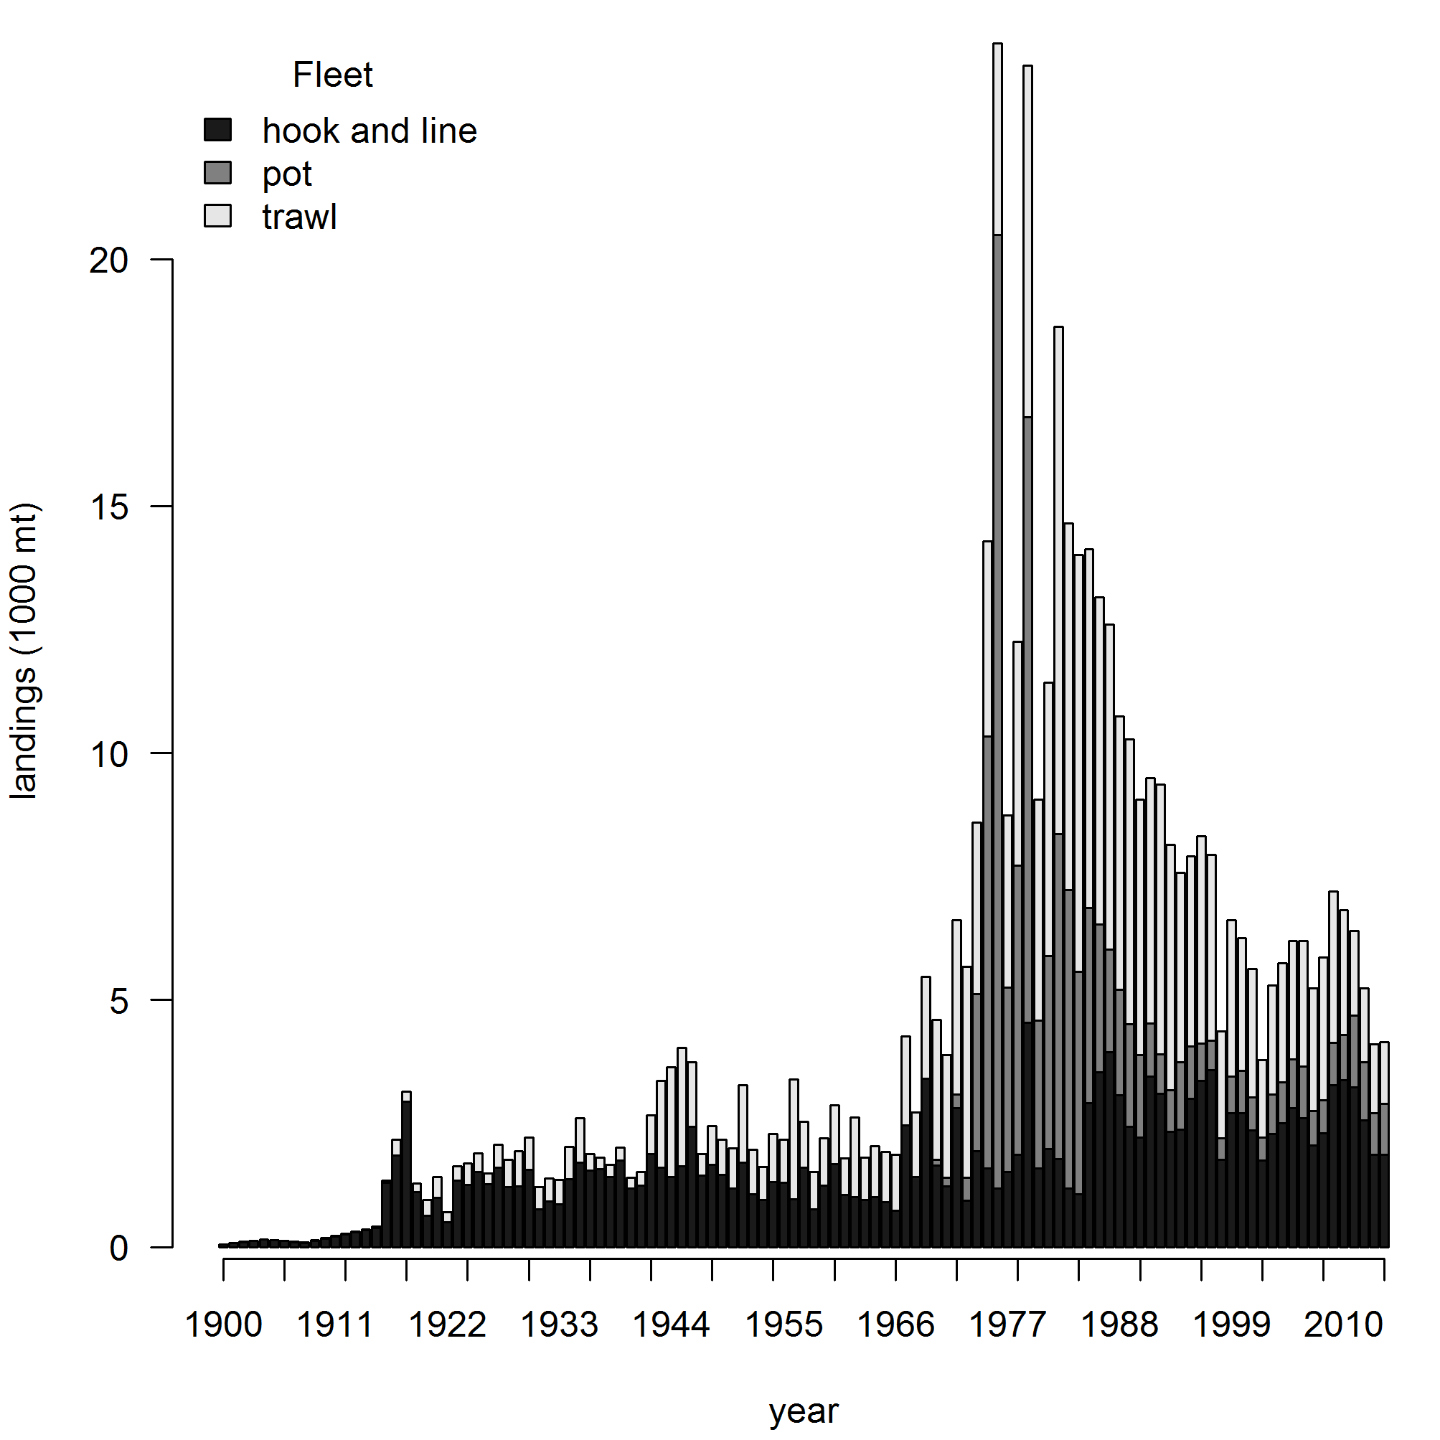

Figure 1. Reconstructed sablefish landings from 1900 to 2014. Landings include those from foreign vessels, which are largely responsible for the peak landings in 1976 and 1979. Fleet names indicate gear type.

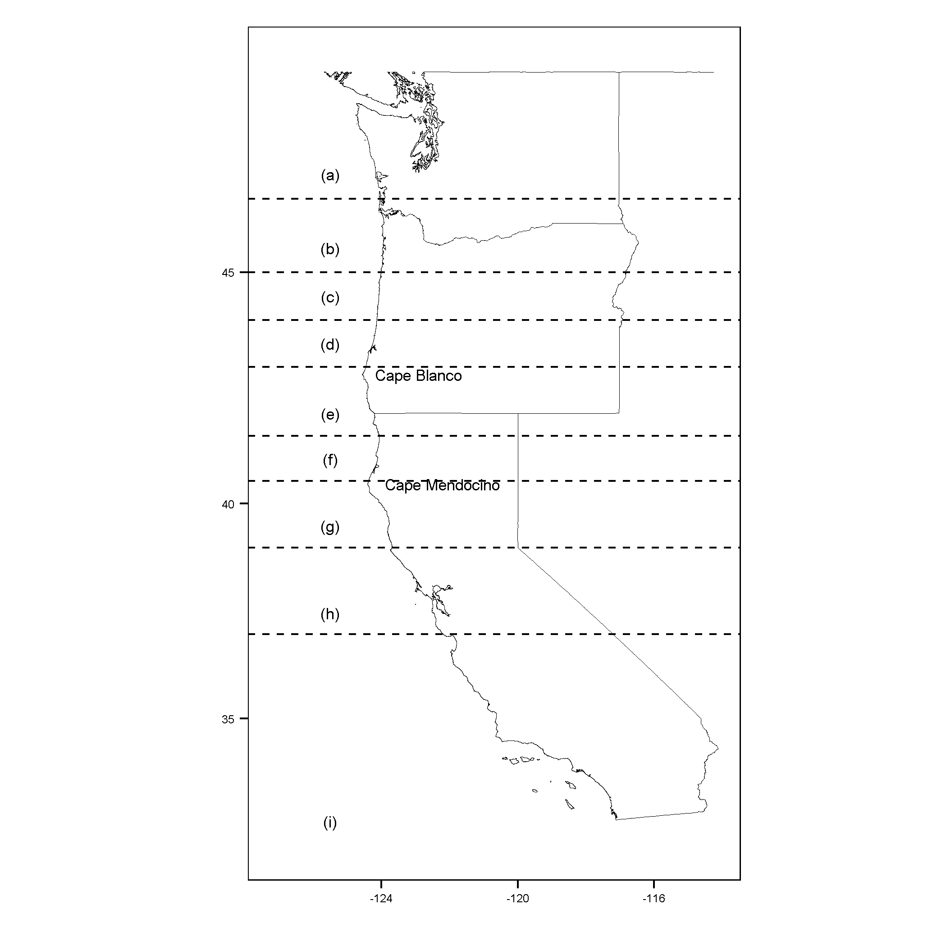

Figure 2. The geographical extent of the survey area with dashed latitudinal lines depicting strata used to separate between port groups. Unique port groups from north to south include: (a) Washington; (b) Astoria and Tillamook; (c) Newport; (d) Coos Bay; (e) Brookings and Crescent City; (f) Eureka; (g) Fort Bragg; (h) San Francisco and Bodega Bay; and (i) Monterey and Morro Bay.

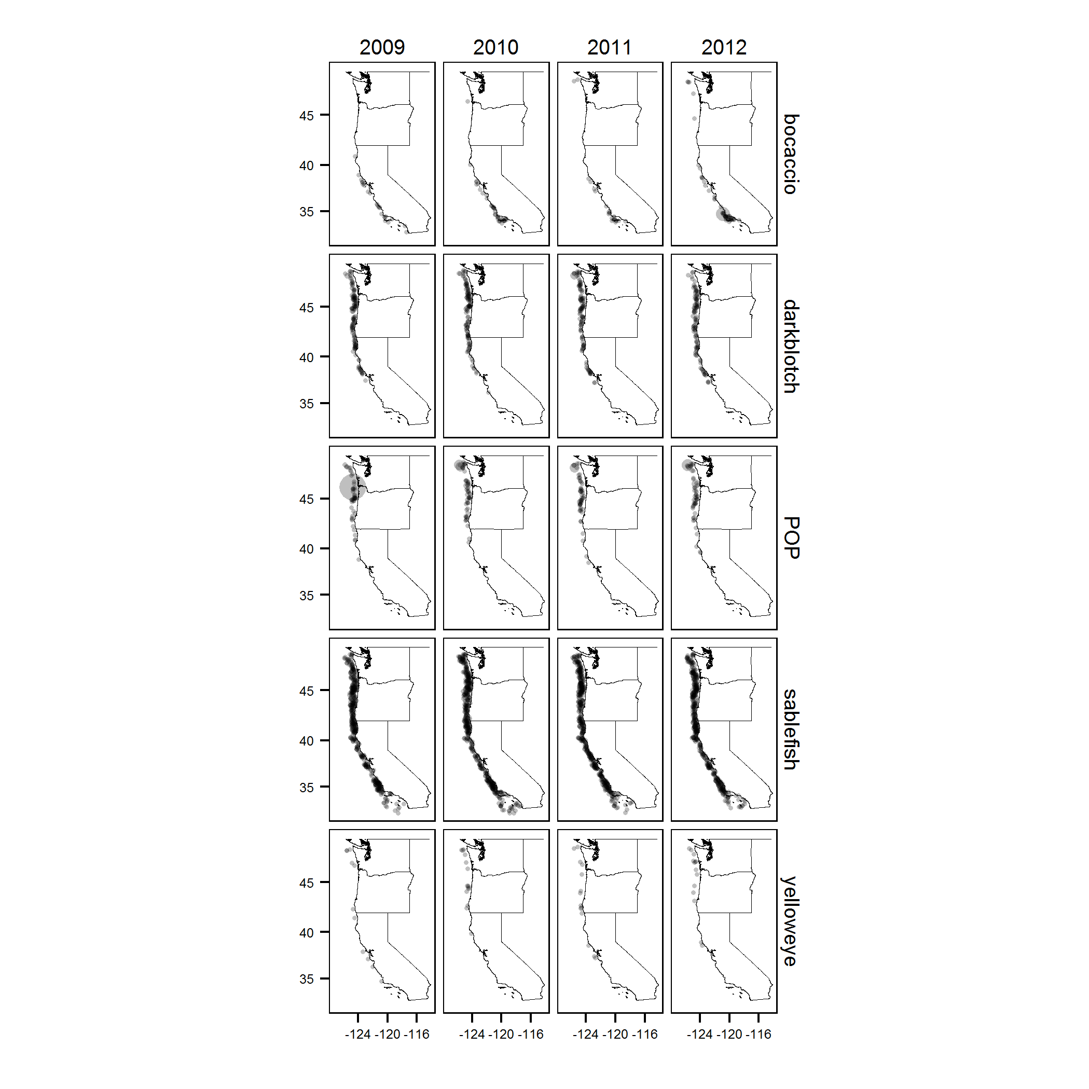

Figure . Positive survey tows from 2009 to 2012 for bocaccio, darkblotched rockfish, Pacific ocean perch (POP), sablefish, and yelloweye rockfish where the size of each transparent circle is proportional to the weight of that species in each tow.