Quantifying drivers of gear choice in the US West Coast sablefish fishery to improve future fisheries management

Kelli F. Johnson1*, Sarah Klain2, Ana K. Spalding3,4, and Nadine Heck5

1School of Aquatic and Fishery Sciences, University of Washington, Box 355020 Seattle, WA 98195-5020, USA

2Institute for Resources Environment and Sustainability, University of British Columbia, Vancouver BC V6T 1Z4, Canada

3Smithsonian Tropical Research Institute, Apartado Postal 0843-03092, Panamá, República de Panamá

4School of Public Policy, Oregon State University, 318 Fairbanks Hall, Corvallis, OR 97331, USA

5Institute of Marine Sciences, University of California, 1156 High St., Santa Cruz, CA 95064, USA

*Corresponding author: tel (+1 206 543 4270); fax (+1 616 8689); email (kfjohns@uw.edu)

Abstract

Reducing catch of non-target individuals and species (i.e., bycatch) remains a global fisheries management priority, and is consistently listed as one of several impediments towards achieving sustainable fisheries. Switching fishing gear for another gear type with a lower rate of bycatch is often listed as the most feasible method to reduce bycatch. However, fishers are faced with many decisions and it is often difficult to predict under what circumstances they switch gear type when the management framework allows for them to do so. Here, we explored the effects of biological, economic, and societal factors on gear choice using statistical models. The approach was applied to fishery-independent and -dependent data available for the United States West Coast sablefish fishery. Cluster analysis identified five major changes in gear type since the enforcement of the first federal regulations in 1982: 1986, 1990, 1996, 2004, and 2010. Generalized additive models were developed to quantify the effects of biological, economic, and social factors. The application of the model approach highlights the major difficulties of integrating data across multiple disciplines and why it is important to verify all model assumptions. Results are contrasted with those from models that violate model assumptions to demonstrate the importance of knowing how data were collected and the societal context within which data generation occurred. This research provides a framework for quantifying gear choice in other fisheries, and highlights the need for collecting data on local governance structures, such as membership in and/or rules of risk pools, enabling the quantification of socio-economic drivers of fisher behaviour.

Keywords: bycatch, catch share, governance, individual transferable quota (ITQ), risk pool, transdisciplinary

Outline

1. Introduction
   1. Uncertainty in fisheries management
   2. Behavioural responses of fishers to management frameworks
   3. Reducing bycatch, an international fisheries management goal
   4. Methods to reduce bycatch, including gear switching
   5. Goals of this analysis
2. Methods
   1. Overview
   2. Case-study background
   3. Determining dominant transition points
      1. Cluster analysis
      2. Catch data
      3. Literature search
   4. Generalized model
      1. Dependent variable
      2. Statistical background of model and variables
      3. Drivers and variables using Ostrom’s social-ecological system framework for common pool resources (Ostrom, 2009)
         1. resource units
         2. resource system
         3. governance system
         4. users.
      4. Variables
         1. Variables were selected based on their relevance to potential drivers and their availability.
         2. Resource unit variables
            1. NFMS data
            2. Survey details
         3. Resource system variables
            1. EDC data
         4. Governance system variables
            1. Formal
            2. Informal
         5. User variables
            1. EDC data
            2. Number of trips
         6. Aggregation of data to a single spatial resolution
3. Results
   1. Dominant transitions between gear choices
      1. Cluster analysis
      2. Literature search
         1. 2011 – implementation of ITQ program
         2. 2011 – gear switching
   2. Drivers of choosing to use trawl gear
      1. General trends
      2. Model selection
      3. Comparison of results to models that ignore violated assumptions
4. Discussion
5. Acknowledgements
6. References
7. Tables
8. Figures
9. Supplementary
   1. Comparison of GAMLSS to models where assumptions are violated

Timeline

2016-01-26 Send revision to Nadine, Ana, Sarah, AEP, Lorenzo, Mary, and Kathryn for input

2016-02-15 Submit revision

1 Introduction

Uncertainty is a universal challenge of resource management. Management questions often pertain to large complex systems making controlled and replicated experiments impossible. Therefore, complete elimination of uncertainty will never be possible. While terms differ among disciplines, uncertainties can be broadly assigned into three broad categories: (a) environmental variation, referring to the natural variability of ecosystems; (2) scientific uncertainty, which arises due to imperfect observations and modelling of ecosystem dynamics; and (3) implementation uncertainty, pertaining to imprecisions in the application of management actions (Mehta *et al*., 1999). In fisheries management, each type of uncertainty can act to undermine the effectiveness of a management framework, yet (3) has received far less attention than (1) and (2) (Fulton *et al*., 2011b). Reducing (3) relies on increasing our ability to predict fisher’s responses to management frameworks, which can be done by: (a) reviewing fishermen behaviour under similar management frameworks and (b) using logic to infer what fishers will do under untried management policies. Here, we focus on developing methods for (a) to increase the quality of management advice and potentially reduce discrepancies between predicted and realized policy benefits.

Fisher behaviour develops in response to both long- and short-term decisions, which are highly contextual (Hart and Pitcher, 1998; Hunt, 2005). For example, long-term choices can include decisions about capital investments, such as purchasing a new vessel, whereas short-term choices can include decisions about a fishing trip, such as whether or not to go fishing. Choices are guided by information on environmental factors, risk tolerance, personal experience, economic expectations, management constraints, etc. (Steelman and Wallace, 2001; van Putten *et al*., 2012). Furthermore, choices are typically made in relation to multiple objectives, involve factors with varying levels of uncertainty, and may depend on the actions of other fishers (Allen and McGlade, 1987). Therefore, fisher behaviour will be driven by much more than just economic objectives (e.g., profit maximization), and policies that fail to account for complexities arising from socioeconomic and cultural contexts may fail to reach objectives (Mahon *et al*., 2008).

Reducing catch of non-target species and individuals (i.e., bycatch) is a globally held goal of fisheries management (FAO, 1995; NMFS, 1998). Literature suggests that regulatory mechanisms to reduce bycatch are potentially straightforward and achievable by means of gear modifications, avoidance incentives, spatial or temporal closures, or some combination thereof (Hall and Mainprize, 2005). Regrettably, strategies that offer potential decreases in bycatch may impair other aspects of sustainable fisheries or fisher livelihoods (Lewison et al., 2011; Senko et al., 2014, Teh et al., 2015). For instance, mandated gear substitutions can be prohibitively costly and per-unit taxes on bycatch, payable by individual fishers, promote them to engage in environmentally sustainable behaviour, but fail to place a hard cap on bycatch limits and may overly constrain the fishery when bycatch rates are highly variable (Herrera, 2005; Singh and Weninger, 2009). Additionally, total allowable catch (TAC) policies that do place a hard cap on the amount of bycatch caught also promote inefficiency when profitable quota remains unfilled (Androkovich and Stollery, 1994; Holland, 2010; Patrick and Benaka, 2013).

Fishermen typically favour incentive-based methods to reduce bycatch (e.g., economic incentives to increase catch utilization) over input (e.g., gear restrictions) or output (e.g., daily trip limits) controls. For example, changing social norms motivated small-scale fishers of Baja California Sur, Mexico to spatially shift their effort to reduce bycatch of loggerhead sea turtles (Peckham *et al*., 2007), and a desire to fish in parts of the Barents Sea closed because of high bycatch rates prompted trawl fishers to voluntarily adopt gear modifications (Isaksen *et al*., 1992). Unfortunately, most management systems fail to provide incentives or the necessary flexibility for fishers to alter their behaviour (Branch et al., 2006; Abbott and Wilen, 2009). Individual transferable quotas (ITQs), where fishers are allocated shares of the TAC, are theorized to reduce the need for input control measures by encouraging fishers to change their behaviour in a way that reduces catch of species for which quota is scarce (Casey, 1995; Hall et al., 2000; Holland and Jannot, 2012). Regrettably, it is difficult for managers to determine *a priori* how fishers will behave if given the opportunity to alter their behaviour.

Incentive led changes in fisher behaviour can often be predicted when thought about in isolation, particularly with respect to economic incentives, but in reality other factors work to strengthen or counteract incentives (Eliasen *et al*., 2013). For instance, Jenkins and Garrison (2013) predicted that, if allowed, fishers in the US West Coast multispecies groundfish fishery targeting sablefish would substitute trawls for pots leading to reductions in bycatch and increased profits. They also hypothesized that without incentives most fishers using trawl gear would likely not permanently convert to pots or longlines. Unfortunately, economic incentives for switching declined (i.e., the price per pound of sablefish caught using fixed gear (pots and longlines) decreased from ? to ?) the very year management allowed gear switching within the fishery and perceived reductions in bycatch were not incentive enough for fishers to convert from trawl gear to fixed gear. Consequently, reductions in bycatch due to gear switching were not realized. We hypothesize that the development of future incentives can be informed from historical trends in fisher behaviour, and use fishers fishing with trawl gear within the US West Coast groundfish fishery as a case study.

This study used cluster analyses and generalized additive models (GAMs) to better understand fisher behaviour regarding gear choice using key economic, ecological, and socio-cultural drivers, such as fish price, relative abundance, and the presence of an ITQ management framework. The study focused on the United States (US) West Coast sablefish (*Anoplopoma fimbria*) fishery. This fishery underwent major management changes in 2011, with the implementation of an ITQ system and the endorsement of gear switching, i.e., from trawl to longline and/or pot gears, where bycatch rates of overfished species are gear specific (citation, Table 1). While an important socio-ecological assessment (Jenkins and Garrison, 2013) was instrumental in guiding the newly implemented regulations it remains unclear what, if any, of the predicted benefits were realized and if retrospective analyses suggest similar drivers of fishers behaviour as those foreshadowed by stakeholders during the investigative socio-ecological assessment. The objectives of this study are therefore to: (1) identify and contextualize major changes in fisher behaviour; (2) develop a framework to quantify drivers of fisher behaviour using a wide variety of data collected across multiple disciplines; and (3) discuss challenges of interdisciplinary research, particularly with regard to quantifying socio-economic factors.

2 Methods

2.1 Overview

Multiple methods were used to understand fisher behaviour in this case study: (1) major shifts in gear choices were identified using cluster analysis and (2) GAMs were used to quantitatively identify likely drivers of gear choice given the results of (1). Data included information collected from both fishery-dependent and -independent sources and involved information on ecological, economic, and social aspects of the fishery. Several steps were taken prior to (1) and (2) to organize and integrate the data for its effective use. Where applicable, methods of integration are detailed below in conjunction with descriptions of each associated analysis.

2.2 Case-study background

The US West Coast sablefish fishery is part of a federally-managed multispecies (90+) groundfish fishery operating from the US-Canada border in the north to the US-Mexico border in the south (PFMC, 2014). Groundfish harvests occur both commercially through limited entry (LE), open access (OA), and tribal programs, and recreationally through targeted and incidental take. All tribal fisheries are located off the coast of Washington, where tribes have a federal treaty right to fish in their “usual and accustomed” fishing areas (citation). The groundfish fishery primarily targets demersal species such as sablefish, Dover sole (*Microstomus pacificus*), shortspine thornyhead (*Sebastolobus alascanus*), Petrale sole (*Eopsetta jordani*), and Pacific whiting (Pacific hake, *Merluccius productus*). Prior to 1982 management was under the jurisdiction of each respective coastal state (i.e., Washington, Oregon, and California). With the implementation of the Magnuson-Stevens Act in 197x and the creation of the Pacific Fisheries Management Council (PFMC) Groundfish Fishery Management Plan in 19xx, management authority switched to the PFMC, a stakeholder body that formally advises the federal government. The first federal regulation of coast-wide trip limits was implemented in October of 1982.

Today, sablefish is one of the most valuable groundfish stocks managed by the PFMC, with value reaching $44.7 million in 2011 (PacFIN, 2015). Sablefish are also caught within areas managed by the Department of Fisheries and Oceans Canada and the North Pacific Fisheries Management Council, but the research presented here focuses on the portion of the fishery that operates under the PFMC (i.e., Washington to California). Sablefish were mainly caught using hook and line prior to 1960, with the first records of catch documented by the California Department of Fish and Wildlife in 1908 (Figure 1; Johnson *et al*., 2015). Later increases in catch in the 1970s are attributed to the development of a pot fishery comprised of mainly foreign vessels. Trawl landings also date back to the early 1900s, though trawl landings rarely exceeded those by hook and line until the late 1960s.

The sablefish fishery encounters several bycatch species, including Pacific halibut (*Hippoglossus stenolepis*), an internationally managed species, and five overfished species (Table 1): (1) bocaccio (*S. paucispinis*; Field, 2013); (2) cowcod (*S. levis*; Dick and MacCall, 2014); (3) darkblotched rockfish (*S. crameri*; Gertseva and Thorson, 2013); (4) Pacific ocean perch (POP, *S. alutus*; Hamel and Ono, 2011); and (5) yelloweye rockfish (*S. ruberrimus*; Taylor and Wetzel, 2011). Prior to 2011, discarding was allowed, thus bycatch allowable catch limits were non-binding. An ITQ program was implemented for the LE nearshore trawl groundfish fishery in 2011 which apportioned bycatch TACs to individual vessels based on bycatch rates applied to target species TACs, made an allowance for gear switching to any fishing gear legal within the groundfish fishery, and made all TACs binding (PFMC and NMFS, 2010).

Legal gears for sablefish off the US west coast include: (a) hook and line, or longlines, which typically encompass a mechanically deployed weighted mainline approximately 50 ft in length with baited hooks on shorter lines spaced every 40 in; more generally hook and line can include one or more hooks attached to one or more stationary or mobile lines; (b) pot, or fish traps, which are biodegradable pots typically 54 in in diameter deployed on the seafloor at 120-150 ft intervals using a trotline; and (c) bottom trawls, meaning a trawl with a net footrope that comes into contact with the seabed. Vessels using trawl gear target multiple species, though when sablefish are caught captains are typically targeting members of the DTS (i.e., Dover sole, thornyhead (shortspine and longspine), and sablefish) complex, whereas vessels using fixed-gear (non-trawl gear) are primarily targeting only sablefish. Most vessels targeting sablefish operate out of Washington and Oregon, fishing primarily north of Monterey, CA.

Fishing opportunities exist year round, depending on gear type, and over time regulations have been created with the intent of spreading the harvest throughout the year (see results section for more details; Table 3). Recently, processing of the landings mainly occurs onshore by relatively few (i.e., less than four) processing plants. Communities significantly involved in commercial fishing are relatively equally distributed throughout Washington, Oregon, and California (40, 30, and 52 respectively), although the community of Astoria/Warrenton, Oregon is by far the most prominent community in terms of commercial catch landings (Sepez *et al*., 2006).

Market prices are largely driven by …

The harvesting of groundfish, including but not limited to sablefish, is linked with human wellbeing in a number of ways. Fishing contributes to job satisfaction, quality of life, local ecological knowledge, human capacity building, etc. The current community faces issues common with other fisheries (e.g., ageing of the fleet and infrastructure) and through interactions with other economic- and socially-important species (e.g., forage fish, salmon, sea birds, and marine mammals). More social information on the fishery here ...

2.3 Determination of dominant transition points

Reported landings by gear type (Johnson *et al*., 2015) were used to determine transitions in the dominant gear type used to land sablefish in the US West Coast groundfish fishery from 1900 to 2014. Here, landings are defined as fish brought to shore, where landings plus discards equal catch, and gear types included: trawls, pots, and longlines. Bray-Curtis measures of distance were computed on the proportions of yearly landings caught by each gear type. Proportions were used to give greater weight to differences in composition rather than absolute differences, which could be affected by yearly catch limits. Differences of one indicate complete dissimilarity and differences of zero occur when proportions are completely similar between years. Hierarchical clustering was performed on the Bray-Curtis measures for years starting in 1982, the first year of federal management, to determine dominant transition points. Clusters were defined using nearest neighbour-chain algorithms, which minimize variance using a “complete” “bottom up”, or agglomerative, criterion. Analyses were performed within the R statistical environment (R Core Team, 2015) using the vegdist function of the vegan package (Oksanen *et al*., 2015) and the hclust function of the stat package (R Core Team, 2015), respectively. Resulting dendrograms were plotted within R (R Core Team, 2015) and groups were defined using the average silhouette width (cluster::silhouette; Maechlet *et al*., 2014). Silhouette width is a measure of the degree of membership of an object to its cluster based on the average distance between the given object and all objects of the cluster to which it belongs compared to the same measure computed for the next closest cluster. Average silhouette width provided a measure of clustering validity, where the highest value indicates the optimum number of clusters (Rousseeuw, 1987).

Two dimensional Nonmetric Multidimensional Scaling (NMDS) was used to better view which years were dominated by any one gear type, where years closer to one another are more similar in terms of proportions of landings by gear type. Analyses were performed using the metaMDS function in the vegan package (Oksanen *et al*., 2015) and ordination plots, or scatterplots of the NMDS results, were plotted within R (R Core Team, 2015).

Years of relatively equal catches by each gear type were determined using the Simpson Index of Diversity, computed via the diversity function of the vegan package (Oksanen *et al*., 2015). Measures of diversity were computed for all years (i.e., 1900 to 2014) but dominant transitions were only identified for those years with a measure of evenness below the mean since 1982.

Years defined as transitions were used to guide a literature review of PFMC documents, non-governmental organization reports, and peer-reviewed literature to characterize the identified transitions between dominant gear types. Results were also used to inform potential variables in the subsequent GAMs, particularly with regard drivers pertaining to the governance system.

2.4 Generalized additive models

Generalized additive models for location, scale, and shape (GAMLSS; Rigby and Stasinopoulos, 2005) were used to identify covariates that could explain the observed patterns in “attainment” since 2009. Here, attainment refers to the proportion of the annual catch limit assigned to the LE shoreside trawl sablefish sector landed in a “port group” by LE trawl permit holders while fishing with bottom trawls (see below for the definition of port group). Each year the LE shoreside trawl sector is assigned 58% of the total annual catch limit assigned to the LE sector, which has typically been 90.6% of the annual catch limit assigned to north of 36° N latitude after accounting for set asides (i.e., research, incidental bycatch from non-groundfish fisheries, and tribal). Prior to 2011, annual catch limits were defined as optimum yields, but the same percentages were used to partition limits among sectors. Attainment may not add up to one across all port groups within a year because some quota may have been left “on the table” for various reasons. Furthermore, beginning in 2011 LE shoreside trawl fishermen could fish for any portion of their sablefish allocation using any gear legal within the groundfish fishery and attainment only included landings caught using bottom trawls. Patterns in attainment were only investigated since 2009 because of limitations in data availability for independent variables (see below).

GAMLSS extends the traditional generalized additive framework (Hastie and Tibshirani, 1990), allowing the conditional distribution of the response variable, given a set of covariates, to be modelled with a variety of distributions, including ones outside of the exponential family, and parameters other than the mean to be modelled with their own covariates and associated link functions. For instance, GAMLSS can accommodate zero-inflated distributions, such as the zero-inflated beta distribution, and include covariates for the mean, precision, and extent of zero-inflation parameters. Analyses were conducted using the gamboostLSS package (Mayr *et al*., 2012; Hofner and Fenske, 2014) in R, as described in Schmid *et al*. (2013). gamboostLSS extends the GAMLSS framework to accommodate random effects, providing the flexibility needed to model statistical means of hierarchical data, which lack independence, and a boosting framework that utilizes gradient boosting algorithms to fit the model while simultaneously performing variable selection. Specifically, gamboostLSS utilizes component-wise gradient boosting to optimize an arbitrary differentiable objective function, producing a sparse solution with respect to all parameters, eliminating the need to use variable selection techniques which are known to be biased and unstable (Ripley, 2004; Whittingham *et al*., 2006). The gradient is used to iteratively compute estimates of parameters related to the mean and subsequently the precision, where the model is initialized to not depend on any of the predictors. Non-linear predictor-response relationships were modelled using penalized regression splines, allowing for the inclusion of non-linear relationships without *a priori* specified functional forms. Categorical predictors were modelled using dummy coded binary variables.

Recent literature on the issue of whether to transform the response variable (e.g., arcsine squareroot transformation) or use a distribution, on the observed scale, when working with proportion data, favours using either the binomial or beta distribution with a logit link function (Warton and Hui, 2011; Schmid *et al*., 2013; Herpigny and Gosselin, 2015). Here, a beta distribution was deemed appropriate because the dependent variable, attainment, included decimal values and was bounded on the interval [0, 1], with zero observations at the boundaries (Crowder, 1978, Smithson and Verkuilen, 2006; Schmid *et al*., 2013). The beta distribution is a continuous distribution with finite support on [0, 1] and is governed by two shape parameters, $μ$ and $ϕ$, $f\left(y;μ,ϕ\right)= \frac{Γ\left(ϕ\right)}{Γ\left(μϕ\right)Γ\left((1-μ)ϕ\right)}y^{μϕ-1}{\left(1-y\right)}^{(1-μ)ϕ-1}$, where μ is the mean of $y$, $ϕ>0$ is the precision parameter and $Γ(·)$ is the gamma function (Ferrari and Cribari-Neto, 2004). The variance of $y$ is given by ${μ(1-μ)}/{(1+ϕ)}$, which is a scaled version of binomial variance, $μ(1-μ)$, allowing for more variation that would be expected by a binomial model (i.e., “overdispersion”). A logit link function, $\ln{({μ_{x}}/{\left(1-μ_{x}\right)})}$, was used for all parameters related to μ and a log link function was used for all parameters related to $ϕ$. The logit link facilitates the interpretation of parameters in terms of the odds ratio, same as a traditional logistic regression model.

Independent variables included: (a) continuous fixed effects, (b) categorical fixed effects, and (c) random effects where year was considered random. All continuous fixed effect covariates were z transformed, $(x_{i}-mean(x))/sd(x$), so the mean of each variable was zero and the ranges were roughly similar (i.e., between -3 and 3). The means and standard deviations used for the transformation were from all data included in the analysis. Fixed effects were hypothesized to be large-scale factors that influence sectors within a fishery, such as markets and management frameworks. Here, we refer to these large-scale factors as ‘drivers’ and the metrics by which to measure or identify the drivers as ‘variables’. We used the four subsystems defined in Ostrom’s (2009) social-ecological system framework for common pool resources to guide the identification of possible drivers of fisher behaviour: (1) resource systems (e.g., a marine protected area), (2) resource units (e.g., fish), (3) governance systems (e.g., TAC or ITQ frameworks), and (4) users (e.g., fishers and cannery operators). Variables (described below) were selected based on relationships to the drivers identified using Ostrom’s (2009) four subsystems, data availability, and hypothesized significance to this case study (Table 2).

Resource system. Landings and ex-vessel revenue data from the US West Coast groundfish fishery were retrieved from the Pacific Fisheries Information Network (PacFIN) regional database, a compilation of sales receipts (i.e., fish-tickets) collected during the delivery of fish to processing plants in Washington, Oregon, and California (Pacific States Marine Fisheries Commission, Portland, OR, www.psmfc.org/pacfin). The database contains information on landings by permit type, gear, and market category, where sablefish represent a market category. PacFIN data were provided as port specific measures summed by port group ((1) Washington, (2) Astoria and Tillamook, (3) Newport, (4) Coos Bay, (5) Brookings and Crescent City, (6) Eureka, (7) Fort Bragg, (8) San Francisco and Bodega Bay, and (9) Monterey and Morro Bay) at which they were landed. Data were not provided in instances where confidentiality could not be ensured, such when a value represented fewer than 3 entities and one entity represented 90% of any individual statistic (16 U.S.C. § 1881a).

User. Data on vessel characteristics were retrieved from the Economic Data Collection (EDC) program, a mandatory component of the US West Coast groundfish fishery since 2009 (West Coast Fisheries Economics Program, NOAA Fisheries, Seattle, WA, www.nwfsc.noaa.gov/research/divisions/fram/economic). The database contains information on vessel characteristics by permit type and gear from 2009 to present. EDC data were provided as port-specific measures averaged by port group (same nine groups as above). Each year, vessel-specific data were assigned to a single port group based on the port group for which that vessel had the highest ex-vessel revenue in that year, even though vessels may have delivered to multiple port groups in that year. No data were provided when confidentiality could not be ensured, using the same measures of confidentiality as the PacFIN data described above.

Resource unit. Relative indexes of abundance for each overfished species and sablefish were included as an indicator of that species’ ecological status. Spatially-explicit relative indexes of abundance were estimated using delta generalized linear mixed-effects models (delta-GLMMs), which can account for vessel “catchability”, spatiotemporal variability, and uncertainty arising from small sample sizes or extreme catch events. Analyses were implemented with an open source software package (Thorson and Ward, 2013) in R. Cowcod was not included, even though it is currently declared overfished, because spatial management (Rockfish Conservation Areas) has been successful in decreasing instances of bycatch and as a species cowcod has the smallest (sometimes zero) rate within the sablefish fishery (NMFS, 2004).

Data used to fit the delta-GLMMs included spatially-resolved (trawl mid-point) fishery-independent species-specific catches collected by the Northwest Fisheries Science Center (NWFSC) Shelf-Slope survey, which collects annual data on hundreds of fish species along the US West Coast (Bradburn *et al*. 2011). Contracted commercial fishing vessels conduct standardized bottom trawl surveys at depths of 55 to 1280 m from Cape Flattery, Washington (48° 10’N) to the US-Mexico border (32° 30’N). Typically the survey contracts four vessels per year, although 2012 involved two contracts to a single vessel. The entire survey area is usually covered twice per year using a stratified random sampling design (based on three depth categories), with sampling extending from late May to late July for the first pass and from mid-August to late October for the second pass. Data are used as the primary source of abundance information for most PFMC groundfish stock assessments.

Delta-GLMMs facilitate the inclusion of vessel:year interactions as random effects, which is necessary because vessels were not consistent across years (Helser *et al*., 2004). Gamma error structures were used for model components representing positive catches and Bernoulli error structures were assumed for all presence/absence components. Stratum, vessel, and year effects were investigated, leading to five model structures for each species: (a) stratum and year as fixed effects and the interaction of year and vessel as random effects; (b) stratum and year and the interaction between strata and vessel as fixed effects; (c) stratum and year as fixed effects and the interactions between year and vessel and stratum and vessel as random effects; (d) stratum and year as fixed effects; and (e) stratum and year as fixed effects with correlated interactions between year and vessel and strata and vessel. Strata were defined according to latitudinal breaks (46°30’N, 45°N, 44°N, 43°N, 41°30’N, 40°10’N, 39°N, and 37°N; Figure 2) which correspond with fishing out of major ports (see nine major ports as listed above), prominent biogeographic features at Cape Blanco, OR (42° 50`N) and Cape Mendocino, CA (40° 30’N), and the north-south PFMC management boundary (40°10’N). Additionally, all models included survey pass as a covariate to account for incomplete sampling during the second pass of the 2013 survey when stations south of 37°N were not sampled. Model goodness of fit was evaluated using Bayesian posterior predictive checks (Spiegelhalter *et al*., 2002). Parameter support was judged by visually inspecting the overlap of the posterior distribution with zero and by summing the log density for both the Gamma and Bernoulli components, integrating over all parameters.

Governance system. Restricted access measures to permits and quota were of particular interest because of their role in shifting effort and allowing fishers to change or modify their gear. Transitions in the governance system were identified by a literature search, which was itself guided by results of several analyses (see above for details): hierarchical clustering, NMDS, and Simpson’s Diversity Index. Consequently, the included time series (2009 to 2013) had the potential to be divided into distinct phases marked by particular formal governance events (Table 3).

3 Results

3.1 Dominant transitions

Two years (1991 and 2005) were identified as transition points where the dominant gear used to land sablefish in the US West Coast groundfish fishery changed (Figure 3). Transition points were also identified in 1987, 1997, and 2011, though these changes represent smaller shifts (Figure 3). For each group of years identified by transition points the mean proportion of yearly landings caught using hook and line gear steadily increased with time, whereas those landed using trawl gear decreased. An extensive literature review guided by the cluster analysis indicated that in general market factors and access regulations played the biggest roles in determining the dominant gear type used to land sablefish (Table 3).

In 1987, the PFMC implemented separate sablefish allocations and trip limits for trawl and non-trawl gears at 52 and 48 % and 8,000 and 5,000 lbs, respectively. In 1991, trip limits were implemented for rockfish at 25,000 lb, where no more than 5,000 of the total could be from bocaccio. Furthermore, 1991 marked the year in which the allowable biological catch of bocaccio decreased for the first time (from 6,100 to 1,100 mt) and continued to decrease until 2002 (Field, 2013). The sablefish endorsement was created in 1997, limiting the LE fixed gear sablefish fishery to those fishers with a history of sablefish landings using fixed gear. The LE fixed gear sablefish fishery was constrained to waters north of 36° N latitude. Fishers who did not qualify for the endorsement were only allowed to fish in the open access daily trip limit fishery, where limits were specific to areas north and south of 36° N latitude. From 1997 to 2004, landings for live sablefish increased linearly almost every year.

In 2005, the proportion of landings caught using pot gear was higher than all previous years since 1994. The groundfish fishery underwent major changes starting in 2004 when three processing plants bought 60% of the groundfish quota and 98% of the Pacific whiting quota. Additionally, more changes occurred in 2011, when an ITQ system was implemented for the US West Coast groundfish LE trawl fishery, which includes vessels targeting sablefish.

In general, since 1900 the fishery has seen an increase in evenness among gear types (Figure 4). The Simpson Diversity Index, calculated for landings by gear type, identified four periods where a single gear type dominated the landings since 1982 (Figure 4): (a) 1982-1984, (b) 1989-1993, (c) 1997-1999, and (d) 2008. Analyses focused on differences since 1982, because 1982 marks the first year of federal management regulations for the fishery. Each year range identified indicates years where differences among landings for each gear type were the highest (i.e., one gear dominating the fishery).

3.2 Generalized models

Sablefish were found ubiquitously up and down the US West Coast with infrequent large tows only being observed north of central California (Figure 5). The spatial distribution of darkblotched rockfish were the most similar to sablefish, whereas cowcod had the least spatial overlap with sablefish (Figure 5). The relative abundance of sablefish south of 36° N latitude is estimated at approximately one quarter of that found north of 36° N, and thus in 1997, with the implementation of sablefish endorsements, management for sablefish became spatially-explicit (see above). Consequently, data from the port group “Monterey and Morro Bay” were excluded from all further analyses because the locations span the latitudinal line used for management. Relative indexes of abundance were typically larger for all species in the northern half of the coast compared to the southern half (Figure 6).

Statistical analyses were based on 40 total observations from eight port groups between 2009 and 2013 (Table 3). The distribution of the response variable was better fit by a beta distribution, with a mean of 0.083 and variance of 0.0035, than a standard normal distribution (Figure 4).

Fourteen fixed effect predictor variables were included in the generalized additive model (Table 2) and one random effect variable (year). Five fixed effects were selected in the final model representing the mean: port group, fixed costs, fuel, darkblotched rockfish, and days at sea. A linear relationship was estimated for number of days at sea (slope = 0.0305). Whereas all other continuous predictors were estimated to be non-linear and were subsequently fit using a spline with three degrees of freedom. Fixed costs and fuel followed a decreasing exponential relationship with the mean (Figure 7). Darkblotched rockfish followed a dome shaped relationship with the mean, but there were very few estimates in the upper tail (Figure 7). Newport and San Francisco and Bodega Bay had means estimated at values lower all than other port groups and Astoria and Tillamook had the highest estimate (Table 5). Port group was the only variable chosen for the relationship between predictors and precision (Table 5).

Random effects were included for year, where each year had a maximum of five observations. Astoria and Tillamook and Brookings and Crescent City were the only two port groups with observations for each of the five years. A separate random intercept was fit per year, with the largest effect being estimated for 2013 (Table 6).

4 Discussion

5 Acknowledgements

This publication was partially funded by the Joint Institute for the Study of the Atmosphere and Ocean (JISAO) under NOAA Cooperative Agreement No. ??, Contribution No. ?? and The National Science Foundation (NSF) under ??. KFJ was partially supported for this work by a grant from Washington Sea Grant, University of Washington, pursuant to National Ocean and Atmospheric Administration Award No. NA14OAR4170078. SK was partially supported for this work by the Social Sciences and Humanities Research Council of Canada Grant F12-04439. AKS was partially supported for this work by the Smithsonian Tropical Research Institute and the Panamanian National Secretariat for Science, Technology and Innovation. NH was partially supported for this work by a Coastal SEES NSF grant. The authors thank Erin Steiner and Beth Horness for providing data, Todd Lee for his initial insights, and the organizers and participants of the 2014 Transdisciplinary Academy in Marine Resource Sustainability for discussions and advice prior to the completion of this manuscript. The views expressed herein are those of the authors and do not necessarily reflect the views of NOAA or any of its sub-agencies.

6 References

Abbott, J. K., and Wilen, J. E. 2009. Regulation of fisheries bycatch with common-pool output quotas. Journal of Environmental Economics and Management, 57:195-204.

Allen, P. M., and McGlade, J. M. 1987. Modelling complex human systems: a fisheries example. European Journal of Operational Research, 30: 147-167.

Andrew, N. L., and Pepperell, J. G. 1992. The by-catch of shrimp trawl fisheries. Oceanography and Marine Biology: An Annual Review, 30: 527-565.

Androkovich, R. A., and Stollery, K. R. 1994. A stochastic dynamic programming model of bycatch in fisheries. Marine Resource Economics, 9: 19-30.

Bellman, M. A., and Heery, E. 2013. Discarding and fishing mortality trends in the U.S. west coast groundfish demersal trawl fishery. Fisheries research, `147: 115-126.

Beverton, R. J. H., and Holt, S. J. 1957. On the dynamics of exploited fish populations. Fisheries Investigations Series II, Ministry of Agriculture, Fisheries, and Food, 19: 1-533.

Bjorkland, R., Dunn, D. C., McClure, M. M., Jannot, J. J., Bellman, M. A., Gleason, M., and Schiffers, K. 2015. Spatiotemporal patterns of rockfish bycatch in US west coast groundfish fisheries: opportunities for reducing incidental catch of depleted species. Canadian Journal of Fisheries and Aquatic Sciences, doi: 10.1139/cjfas-2014-0242.

Bradburn, M. J., Keller, A., and Horness, B. H. 2011. The 2003 to 2008 U.S. West Coast bottom trawl surveys of groundfish resources off Washington, Oregon, and California: estimates of distribution, abundance, length, and age composition. U.S. Dept. of Comm., NOAA Tech. Memo., NMFS-NWFSC-114, 323 pp.

Branch, T. A., Hilborn, R., Haynie, A. C., Fay, G., Flynn, L., Griffiths, J., Marshall, K. N., *et al*. 2006. Fleet dynamics and fishermen behaviour: lessons for fisheries managers. Canadian Journal of Fisheries and Aquatic Sciences, 63: 1647-1668.

Burnham, K. P., and Anderson, D. R. 2002. Model Selection and Multimodel Inference: A Practical Information-Theoretic Approach. Springer. 488 pp.

Campbell, H. F., and Nicholl, R. B. 1994. Can purse seiners target yellowfin tuna? Land Economics, 70: 345-354.

Casey, K. E., Dewees, C. M., Turris, B. R., and Wilen, J. E. 1995. The effects of individual vessel quotas in the British Columbia Halibut Fishery. Marine Resource Economics, 110: 211-230.

Crowder, M. J. 1978. Beta-binomial anova for proportions. Applied Statistics, 27: 34-37.

Deacon, R. T. 2012. Fishery management by harvester cooperatives. Review of Environmental Economics and Policy, 6: 258-277.

Dick, E. J., and MacCall, A. D. 2014. Status and productivity of cowcod, *Sebastes levis*, in the Southern California Bight, 2013. Pacific Fishery Management Council, Portland, OR.

Dickey-Collas, M., Payne, M. R., Trenkel, V. M., and Nash, R. D. M. 2014. Hazard warning: model misuse ahead. ICES Journal of Marine Science, 71: 2300-2306.

Eliasen, S. Q., Papadopoulou, K.-N., Vassilopoulou, V., and Catchpole, T. L. 2013. Socio-economic and institutional incentives influencing fishers’ behaviour in relation to fishing practices and discard. ICES Journal of Marine Science, 71: 1298-1307.

FAO. 1995. Code of conduct for responsible fisheries. Food and Agriculture Organization of the United Nations. Rome, Italy. 41 p.

FAO. 2010. Report of the FAO/UNEP expert meeting on impacts of destructive fishing practices, unsustainable fishing, and illegal, unreported and unregulated (IUU) fishing on marine biodiversity and habitats. Food and Agriculture Organization of the United Nations. Rome, Italy. 32 p.

Fama, E. 1970. Efficient capital markets: a review of theory and empirical work. Journal of Finance, 25: 383-417.

Fehr, E., and Leibbrandt, A. 2010. A field study on cooperativeness and impatience in the tragedy of the commons. Journal of Public Economics, 95: 1144-1155.

Ferrari, S. L. P. and Cribari-Neto. F. 2004. Beta regression for modelling rates and proportions. Journal of Applied Statistics, 31: 799-815.

Field, J. C. 2013. Status of bocaccio, *Sebastes paucispinis*, in the Conception, Monterey and Eureka INPFC areas as evaluated for 2013. Pacific Fishery Management Council, Portland, OR.

Fulton, E. A., Link, J. S., Kaplan, I. C., Savina-Rolland, M., Johnson, P., Ainsworth, C., Horne, P., Gorton, R., Gamble, R. J., Smith, A. D. M., and Smith, D. C. 2011a. Lessons in modelling and management of marine ecosystems: the Atlantis experience. Fish and Fisheries, 12: 171-188.

Fulton, E. A., Smith, A. D. M, Smith, D. C., and van Putten, I. E. 2011b. Human behaviour: the key source of uncertainty in fisheries management. Fish and Fisheries, 12: 2-17.

Gertseva, V. V., and Thorson, J. T. 2013. Status of the darkblotched rockfish resources off the continental U.S. Pacific Coast in 2013. Pacific Fishery Management Council, Portland, OR.

Hall, M. A., Alverson, D. L., and Metuzals, K. I. 2000. By-catch: problems and solutions. Marine Pollution Bulletin, 41: 204-219.

Hall, S. J., and Mainprize, B. M. 2005. Managing by-catch and discards: how much progress are we making and how can we do better. Fish and Fisheries, 6: 134-155.

Hamel, O. S., and Ono K. 2011. Stock assessment of Pacific Ocean Perch in waters off of the U.S. West Coast in 2011. Pacific Fishery Management Council, Portland, OR.

Hart, P. J. B., and Pitcher, T. J. 1998. Conflict, consent and cooperation: the utility of an evolutionary perspective on individual human behaviour in fisheries management. Eds: Pitcher, T. J., Pauly, D., and Hart. P. In: Reinventing Fisheries Management. Kluwer Academic Publishers, Dordrecht, Netherlands, 215-225.

Heery, E., and Cope, J. M. 2014. Co-occurrence of bycatch and target species in the groundfish demersal trawl fishery of the U.S. west coast; with special consideration of rebuilding stocks. Fishery Bulletin, 112: 36-48.

Herpigny, B., and Gosselin, F. 2015. Analyzing plant cover class data quantitatively: customized zero-inflated beta distributions show promising results. Ecological Informatics, 26: 18-26.

Herrera, G. E. 2005. Stochastic bycatch, informational asymmetry, and discarding. Journal of Enviornmental Economics and Management, 49: 463-483.

Hilborn, R. 2007. Managing fisheries is managing people: what has been learned? Fish and Fisheries, 8: 285-296.

Holland, D. S. 2010. Markets, pooling and insurance for managing bycatch in fisheries. Ecological Economics, 70: 121-133.

Holland, D. S. 2013. Making cents out of barter data from the British Columbia groundfish ITQ market. Marine Resource Economics, 28: 311-330.

Holland, D. S., and Jannot, J. E. 2012. Bycatch risk pools for the US West Coast Groundfish Fishery. Ecological Economics, 78:132-147.

Holland, D. S., Thunberg, E., Agar, J., Crosson, S., Demarest, C., Kasperski, S., Perruso, L., *et al*. 2015. US catch share markets: a review of data availability and impediments to transparent markets. Marine Policy, 57: 103-110.

Hunt, L. M. 2005. Recreational fishing site choice models: insights and future opportunities. Human Dimensions of Wildlife, 10: 153-172.

Isaksen, B., Valdemarsen, J. W., Larsen, R. B., and Karlsen, L. 1992. Reduction of fish by-catch in shrimp trawl using a rigid separator grid in the aft belly. Fisheries Research, 13: 335-352.

Jannot, J. E., and Holland, D. S. 2013. Identifying ecological and fishing drivers of bycatch in a U.S. groundfish fishery. Ecological Applications, 23:1645-1658.

Jenkins, L. D., and Garrison, K. 2013. Fishing gear substitution to reduce bycatch and habitat impacts: an example of social-ecological research to inform policy. Marine Policy, 38: 293-303.

Johnson, K. F., Rudd, M. R., Pons, M. Axelrud, C. A., Lee, Q., Hurtado-Ferro, F., Haltuch, M. A., *et al*. 2015. Status of the U.S. sablefish resource in 2015. Pacific Fisheries Management Council. Portland, Oregon. 243 pp.

Kaplan, I. C., Levin, P. S., Burden, M., and Fulton, E. A. 2010. Fishing catch shares in the face of global change: a framework for integrating cumulative impacts and single species management. Canadian Journal of Fisheries and Aquatic Sciences, 67: 1968-1982.

Kennelly, S. J. 1995. The issue of bycatch in Australia’s demersal trawl fisheries. Reviews in Fish Biology and Fisheries, 5: 213-234.

Komoroske, L. M., and Lewison, R. L. 2015. Addressing fisheries bycatch in a changing world. Frontiers in Marine Science, 2. doi: 10.3389/fmars.2015.00083.

Levins, R. 1966. The strategy of model building in population biology. American Scientist, 54: 421-431.

Lewison, R. L., Soykan, C. U., Cox, T., Peckham, H., Pilcher, N., LeBoeuf, N., McDonald, S., Moore, J., Safina, C., and Crowder, L. 2011. Ingredients for addressing the challenges of fisheries bycatch. Bulletin of Marine Science, 87: 235-250.

Little, A. S., Needle, C. L., Hilborn, R., Holland, D. S., and Marshall, C. T. 2015. Real-time spatial management approaches to reduce bycatch and discards: experiences from Europe and the United States. Fish and Fisheries, 16: 576-602.

Maechler, M., Rousseeuw, P., Struyf, A., Hubert, M., and Hornik, K. 2014. cluster: cluster analysis basics and extensions. R package version 1.15.3.

Mahon, R., McConney, P., and Roy, R. N. 2008. Governing fisheries as complex adaptive systems. Marine Policy, 32: 104-112.

Manson, J. Kosaka, R., Mamula, A., and Speir, C. 2012. Effort changes around a marine reserve: the case of the California Rockfish Conservation Area. Marine Policy, 36: 1054-1063.

Mayr, A., Fenske, N., Hofner, B., Kneib, T., and Schmid, M. 2012. Generalized additive models for location, scale and shape for high dimensional data – a flexible approach based on boosting. Journal fo the Royal Statistical Society, Series C, 61: 403-427.

Mehta, L., Leach, M., Newell, P., Scoones, I., Sivaramakrishnan, K., and Way, S.-A. 1999. Exploring understandings of institutions and uncertainty: new directions in natural resource management. Institute of Development Studies, University of Sussex, Brighton, UK.

Newell, R. G., Sanchirico, J. N., and Kerr, S. 2005. Fishing quota markets. Journal of Environmental Economics and Management, 49: 437-462.

NMFS. 1998. Managing the nation’s bycatch. Programs, activities, and recommendations for the National Marine Fisheries Service. United States Department of Commerce, NOAA, National Marine Fisheries Service, Silver Springs, MD. 174 p.

NMFS. 2004. West Coast Groundfish Observer Program data report and summary analyses for 2001-2003 coverage of sablefish-endorsed fixed-gear permits. NOAA, National Marine Fisheries Service, Northwest Fisheries Science Center, 2725 Montlake Blvd E, Seattle, WA.

Ono, K., Holland, D. S., and Hilborn, R. 2013. How does species association affect mixed stock fisheries management? A comparative analysis of the effect of marine protected areas, discard bans, and individual fishing quotas. Canadian Journal of Fisheries and Aquatic Sciences, 70: 1792-1804.

Ostrom, E. 2009. A general framework for analysing sustainability of social-ecological systems. Science, 325: 419-422.

Patrick, W. S., and Benaka, L. R. 2013. Estimating the economic impacts of bycatch in U.S. commercial fisheries. Marine Policy, 38: 470-475.

PFMC. 2001. Permit stacking, season extension, and other modifications to the limited entry fixed gear sablefish fishery (Amendment 14). Pacific Fisheries Management Council, Portland, OR.

PFMC. 2014. Pacific coast groundfish fishery management plan. Pacific Fisheries Management Council, Portland, OR.

PFMC and NMFS. 2010. Groundfish fishery management plan amendment 20 (trawl rationalization). Pacific Fisheries Management Council, Portland, OR.

PFMC and NFMS. 2014. Pacific coast groundfish limited entry fixed gear sablefish permit stacking program review. Pacific Fishery Management Council, Portland, OR.

PacFIN. 2015. PacFIN (Facific Fisheries Information Network). Pacific States Marine Fisheries Commission, Portland, OR. www.psmfc.org.

Peckham, S. H., Diaz, D. M., Walli, A., Ruiz G., Crowder, L. B., and Nichols, W. J. 2007. Small-scale fisheries bycatch jeopardizes endangered Pacific loggerhead turtules. PLoS ONE, 2: e1041.

Pinheiro, J. C., and Bates, D. M. 2000. Mixed Effects Models in S and S-plus. Springer-Verlag, New York, New York. 528 pp.

Oksanen, J., Blanchet, F. G., Kindt, R., Legendre, P., Minchin, P. R., O’Hara, R. B., Simpson, G. L., Solymos, P., Stevens, M. H. H., and Wagner, H. 2015. vegan: community ecology package. R package version 2.2-2/r2945. http://R-Forge.R-project.org/projects/vegan.

Quirijns, F. J., Poos, J. J., and Rijnsdorp, A. D. 2008. Standardizing commercial CPUE data in monitoring stock dynamics: accounting for targeting behaviour in mixed fisheries. Fisheries Research, 89: 1-8.

R Core Team. 2015. R: a language and environment for statistical computing. R Foundation for Statistical Computing, Vienna, Austria.url: http://www.R-project.org/.

Rigby, R. A., and Stasinopoulos, D. M. 2005. Generalized additive models for location, scale and shape, (with discussion). Journal of Applied Statistics, 54: 507-554.

Ripley, R. D. 2004 Selecting amongst large classes of models. In: Adams, N., Crowder, M., Hand, D. J., Stephens, D. Methods and Models in Statistics. London, Imperial College Press, 155-170 p.

Rousseeuw, P. J. 1987. Silhouettes: a graphical aid to the interpretation and validation of cluster analysis. Journal of Computation and Applied Mathematics, 20: 53-65.

Sanchirico, J. N., Holland, D., Quigley, K., and Fina, M. 2006. Catch-quota balancing in multispecies individual fishing quotas. Marine Policy, 30: 767-785.

Schmid, M., Wickler, F., Maloney, K. O., Mitchell, R., Fenske, N., and Mayr, A. 2013. Boosted Beta regression. PLoS ONE, 8: e61623.

Senko, J., White, E. R., Heppell, S. S., Gerber, L. R. 2014. Comparing bycatch mitigation strategies for vulnerable marine megafauna. Animal Conservation, 17: 5-18.

Sepez, J., Norman, K., Poole, A., and Tilt, B. 2006. Fish scales: scale and method in social science research for North Pacific and West Coast fishing communities. Human Organization, 65: 280-293.

Singh, R. K., and Weninger, Q. R. 2009. Bioeconomies of scope and the discard problem in multiple-species fisheries. Journal of Environmental Economics and Management, 58: 72-92.

Smithson, M., and Verkuilen, J. 2006. A better lemon squeezer? Maximum-likelihood regression with beta-distributed dependent variables. Psychological Methods, 11: 54.

Spiegelhalter, D. J., Best, N. G., Carline, B. P., and van der Linde, A. 2002. Bayesian measures of model complexity and fit. Journal of the Royal Statistical Society: Series B (Statistical Methodology), 64: 583-639.

Stavins, R. N. 1995. Transaction costs and tradeable permits. Journal of Environmental Economics and Management, 29: 133-148.

Steelman, T. A., and Wallace, R. 2001. Property rights and property wrongs: why context matters in fisheries management. Policy Science, 34: 357-379.

Swinkels, J. M. 1999. Asymptotic efficiency for discriminatory private value auctions. The Review of Economic Studies, 66: 509-528.

Taylor, I. G., and Wetzel, C. 2011. Status of the U.S. yelloweye rockfish resource in 2011 (Update of 2009 assessment model). Pacific Fishery Management Council, Portland, OR.

Teh, L. S. L, Teh, L. C. L., Hines, E., Junchompoo, C., and Lewison, R. L. 2015. Contextualising the coupled socio-ecological conditions of marine megafauna bycatch. Ocean and Coastal Management, 116: 449-465.

TNC (The Nature Conservancy). 2014. California Risk Pool: A Co-management Model to advance fisheries Resource Stewardship. The Nature Conservancy.

Thorson, J. T., and Ward, E. J. 2013. Accounting for space-time interactions in index standardization models. Fisheries Research, 147: 426-433.

van Putten, I. E., Kulmala, S., Thébaud, O., Dowling, N., Hamon, K. G., Hutton, T., and Pascoe, S. 2012. Theories and behavioural drivers underlying fleet dynamics models. Fish and Fisheries, 13: 216-235.

Warton, D. I., and Hui, F. K. C. 2011. The arcsine is asinine: the analysis of proportions in ecology. Ecology, 92: 3-10.

Whittingham, M. J., Stephens, P. A., Bradbury, R. B., Freckleton, R. P. 2006. Why do we still use stepwise modelling in ecology and behaviour? Journal of Animal Ecology, 75: 1182-1189.

Table 1. Gear-specific bycatch rates of seven rockfish species declared overfished in 2004 (some have since been rebuilt) by trawl, longline, and pot gear in the US West Coast sablefish fishery. Calculated bycatch ratios are specific to areas north of 40° 10’ N. latitude and depths greater than 150 fm. The table is reproduced with permission from Jenkins and Garrison (2013).

|  |  |  |  |  |
| --- | --- | --- | --- | --- |
| Rockfish species | 2015 status | Bycatch ratio  (kg of bycatch per 100 kg of retained target catch) | | |
| Trawl | Longline | Pot |
| Bocaccio | overfished | 0-0.001 | 0 | 0 |
| Canary rockfish | rebuilt | 0.009-0.010 | 0.070 | 0 |
| Cowcod | overfished | 0 | 0 | 0 |
| Darkblotched | overfished | 2.196-6.291 | 0.068 | 0.033 |
| Pacific ocean perch | overfished | 1.706-1.471 | 0.006 | 0.003 |
| Widow | rebuilt | 0.013-0.140 | 0 | 0.001 |
| Yelloweye | overfished | 0-0.004 | 0.037 | 0 |

Table 2. Hypothesized drivers of fisher behaviour with respect to gear choice within the US West Coast sablefish fishery. Variables are linked to drivers and belong to a given system according to Ostrom’s (2009) social-ecological system framework for common pool resources. All dollars are reported in USD. Groupings from factor analysis are reported along with their associated eigenvalues in parenthesis. Only factors with an eigenvalue greater than one were carried forward to the generalized linear mixed effect models.

|  |  |  |  |  |
| --- | --- | --- | --- | --- |
| variable | driver | system | source | interpretation |
| bocaccio | ecosystem | resource units | NWFSC survey |  |
| darkblotched rockfish | ecosystem | resource units | NWFSC survey |  |
| Pacific ocean perch | ecosystem | resource units | NWFSC survey |  |
| yelloweye rockfish | ecosystem | resource units | NWFSC survey |  |
| fuel ($) |  |  |  |  |
| ITQ | management | governance |  |  |

Table 3. Governance phases.

Insert a table with the year and major sablefish management change or groundfish characteristic.

Table 4. Mean economic and vessel characteristics for trawl vessels in the US West Coast sablefish fishery. Values are summarized by port group, where some sample sizes (n) are less than the total number of years (2009 to 2013) to protect data confidentiality. Vessels were assigned to port groups based on the port for which they had the highest ex-vessel revenue in that year.

|  |  |  |  |  |  |  |
| --- | --- | --- | --- | --- | --- | --- |
| Port group | n | Fixed costs | Variable costs | Crew | Fuel | Speed |
| Astoria & Tillamook | 5 | 88462.96 | 328568.67 | 1.90 | 264.76 | 3.29 |
| San Francisco & Bodega Bay | 3 | 46217.42 | 115772.62 | 1.90 | 376.27 | 2.37 |
| Coos Bay | 2 | 63002.37 | 136119.23 | 2.14 | 251.68 | 2.15 |
| Brookings & Crescent City | 5 | 69382.86 | 254627.59 | 2.06 | 330.00 | 2.11 |
| Eureka | 2 | 78531.76 | 274664.05 | 2.02 | 222.92 | 2.13 |
| Fort Bragg | 2 | 120302.23 | 224171.79 | 2.13 | 299.09 | 3.28 |
| Washington | 4 | 235739.89 | 476719.73 | 2.35 | 366.90 | 3.13 |
| Newport | 2 | 141720.11 | 280039.80 | 2.00 | 402.78 | 2.67 |

Table 5. Estimated port group effects for the mean ($μ$) and precision ($ϕ$) parameters. Parameters are reported for when all other covariates are held at their mean, with Astoria and Tillamook being the reference port.

|  |  |  |
| --- | --- | --- |
| port group | $$μ$$ | $$ϕ$$ |
| Newport | -1.05 | -0.11 |
| Coos Bay | -0.88 | -0.16 |
| Brookings and Crescent City | -0.75 | 0.16 |
| Astoria and Tillamook | 0.79 | 1.04 |
| Eureka | -0.33 | 0.23 |
| Fort Bragg | -0.58 | 0.19 |
| San Francisco and Bodega Bay | -1.72 | -0.81 |

Table 6. Estimates of random intercepts for each year.

|  |  |
| --- | --- |
| year | random effect |
| 2009 | 0.058 |
| 2010 | -0.032 |
| 2011 | -0.079 |
| 2012 | -0.125 |
| 2013 | 0.090 |

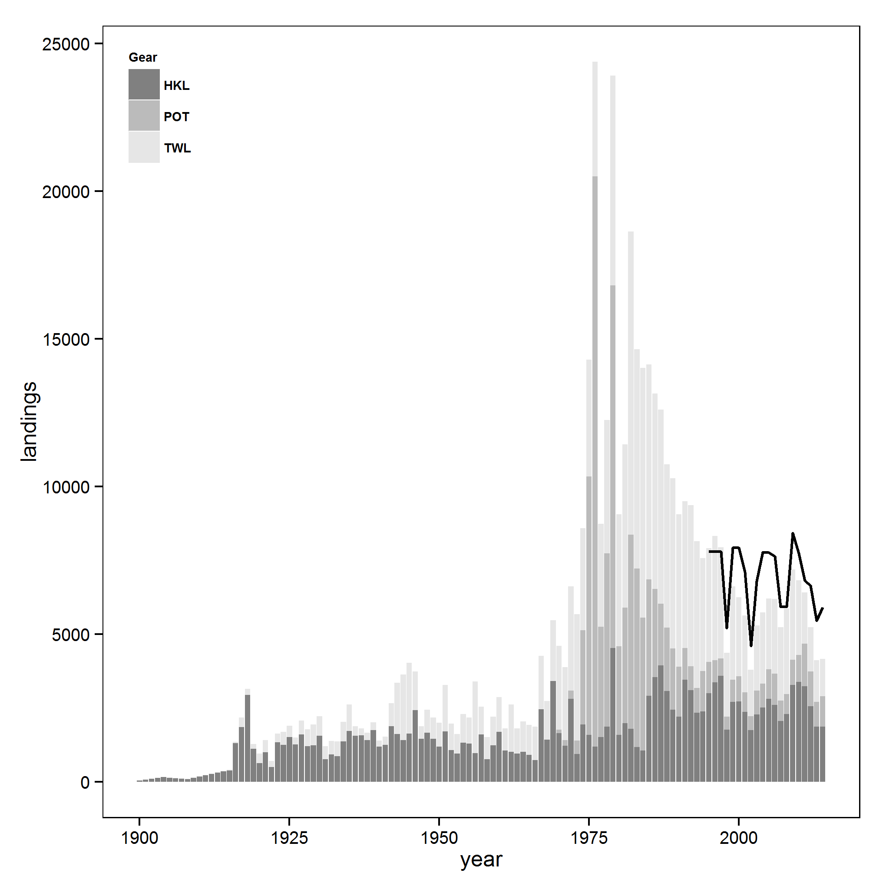

Figure 1. Reconstructed sablefish landings (mt; total catches less discards) from 1900 to 2014 by gear type: hook and line, pot, and trawl for all fisheries. Landings include those from foreign vessels, which are largely responsible for the peak landings in 1976 and 1979. Black line indicates the optimum yield or annual catch limit for all gear types and all areas from 1995 to 2014.

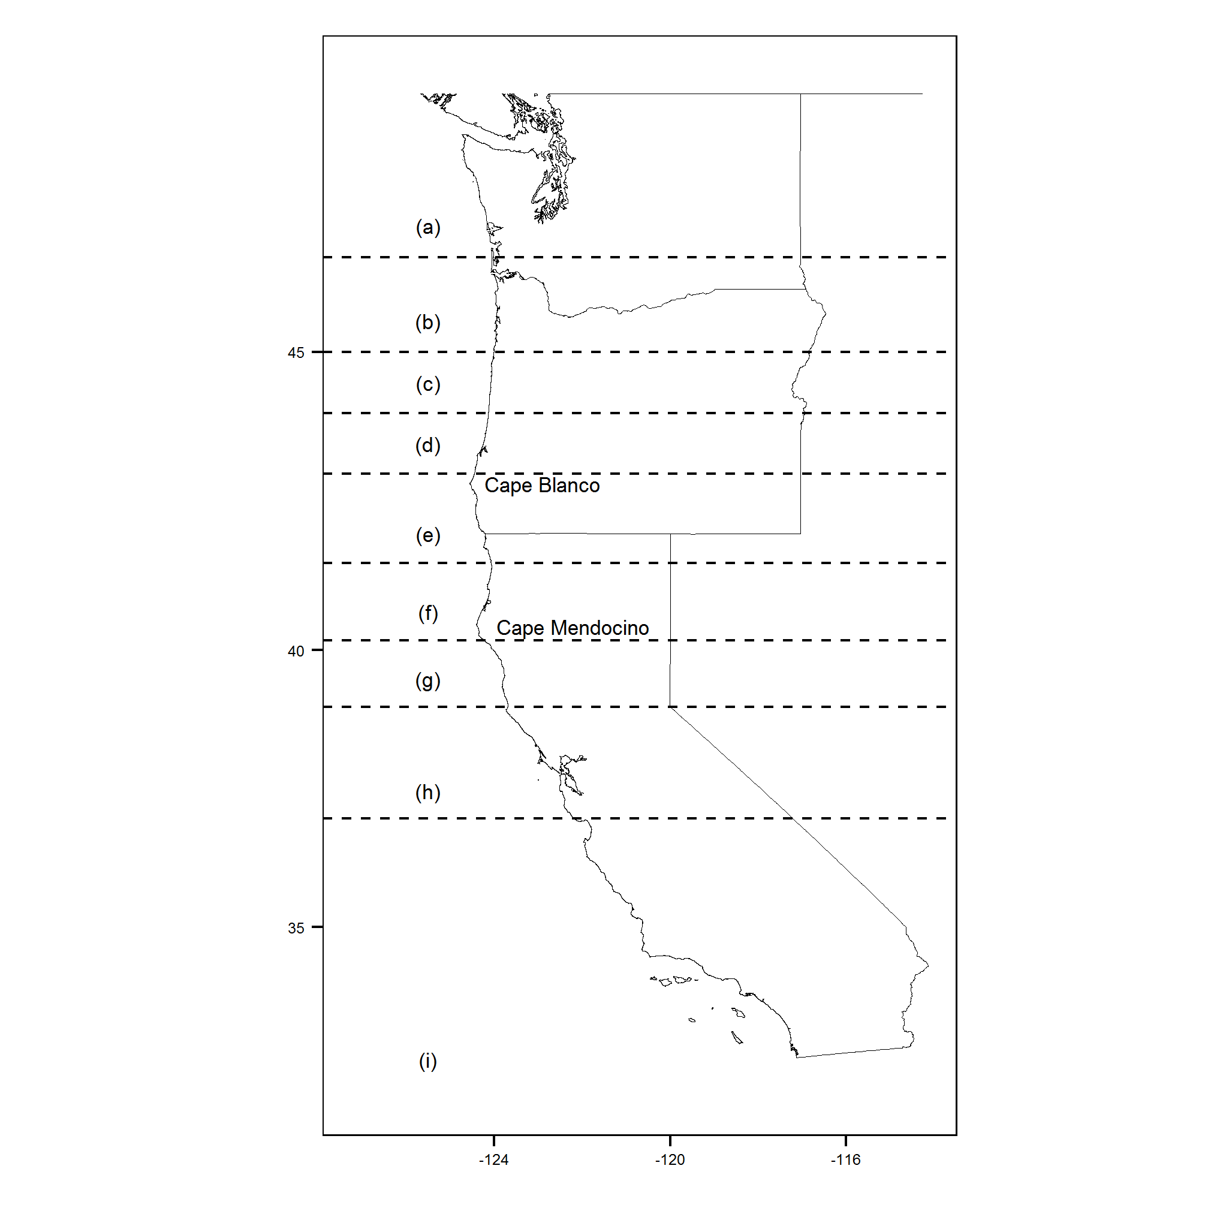

Figure 2. The geographical extent of the survey area with dashed latitudinal lines depicting strata used to separate between port groups. Unique port groups from north to south include: (a) Washington; (b) Astoria and Tillamook; (c) Newport; (d) Coos Bay; (e) Brookings and Crescent City; (f) Eureka; (g) Fort Bragg; (h) San Francisco and Bodega Bay; and (i) Monterey and Morro Bay.

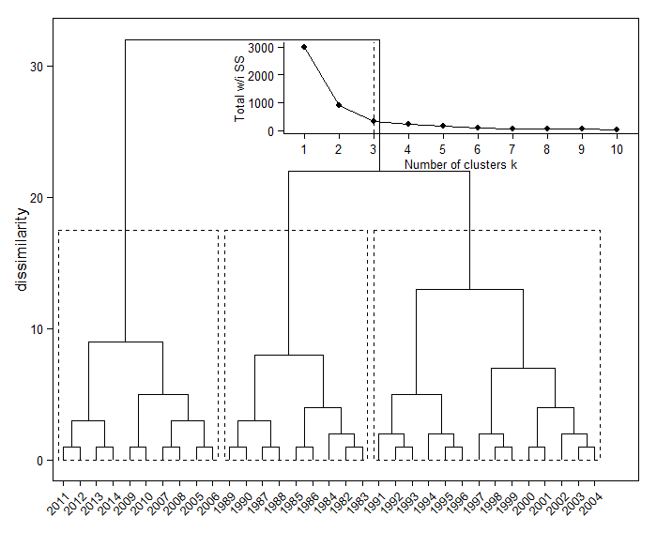

Figure 3. A dendrogram derived from a hierarchical clustering algorithm applied to gear-specific landings from the US West Coast sablefish fishery. Upper inset shows the total within group sum of squares (SS) as a function of the number of clusters, with a dashed line at the optimal number of clusters. Optimal clustering is denoted by dashed black boxes.

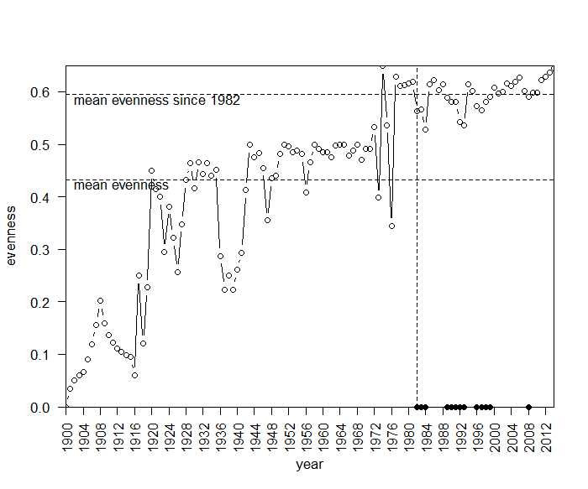

Figure 4. Simpson diversity index of landings by gear type for the US West Coast sablefish fishery. Higher values indicate increasing evenness among landings from each gear type. Landings by gear type were summed across all port groups for a given year. Vertical dashed line at 1982 indicates the first year that federal management regulations were implemented in the fishery. Horizontal dashed lines indicate mean evenness for a given range of years: 1900 to present (lower) and 1982 to present (upper). Black marks on the x axis indicate years where the evenness is below the mean evenness since 1982.

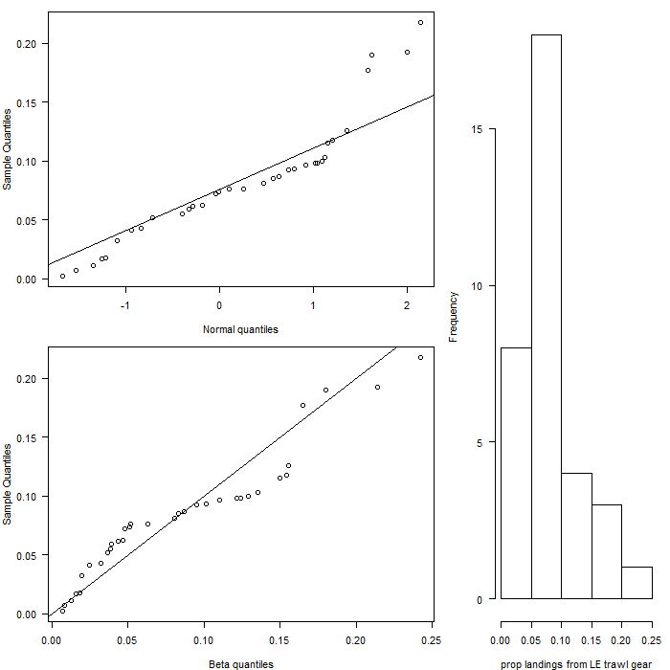

Figure 4. Comparisons between sample and theoretical quantiles for a standard normal distribution (upper) and a beta distribution with mean of 0.083 and variance of 0.0035 (lower). Histogram displays the frequency of proportions of port specific sablefish landings caught using trawl gear within the limited entry (LE) groundfish trawl fishery (right).

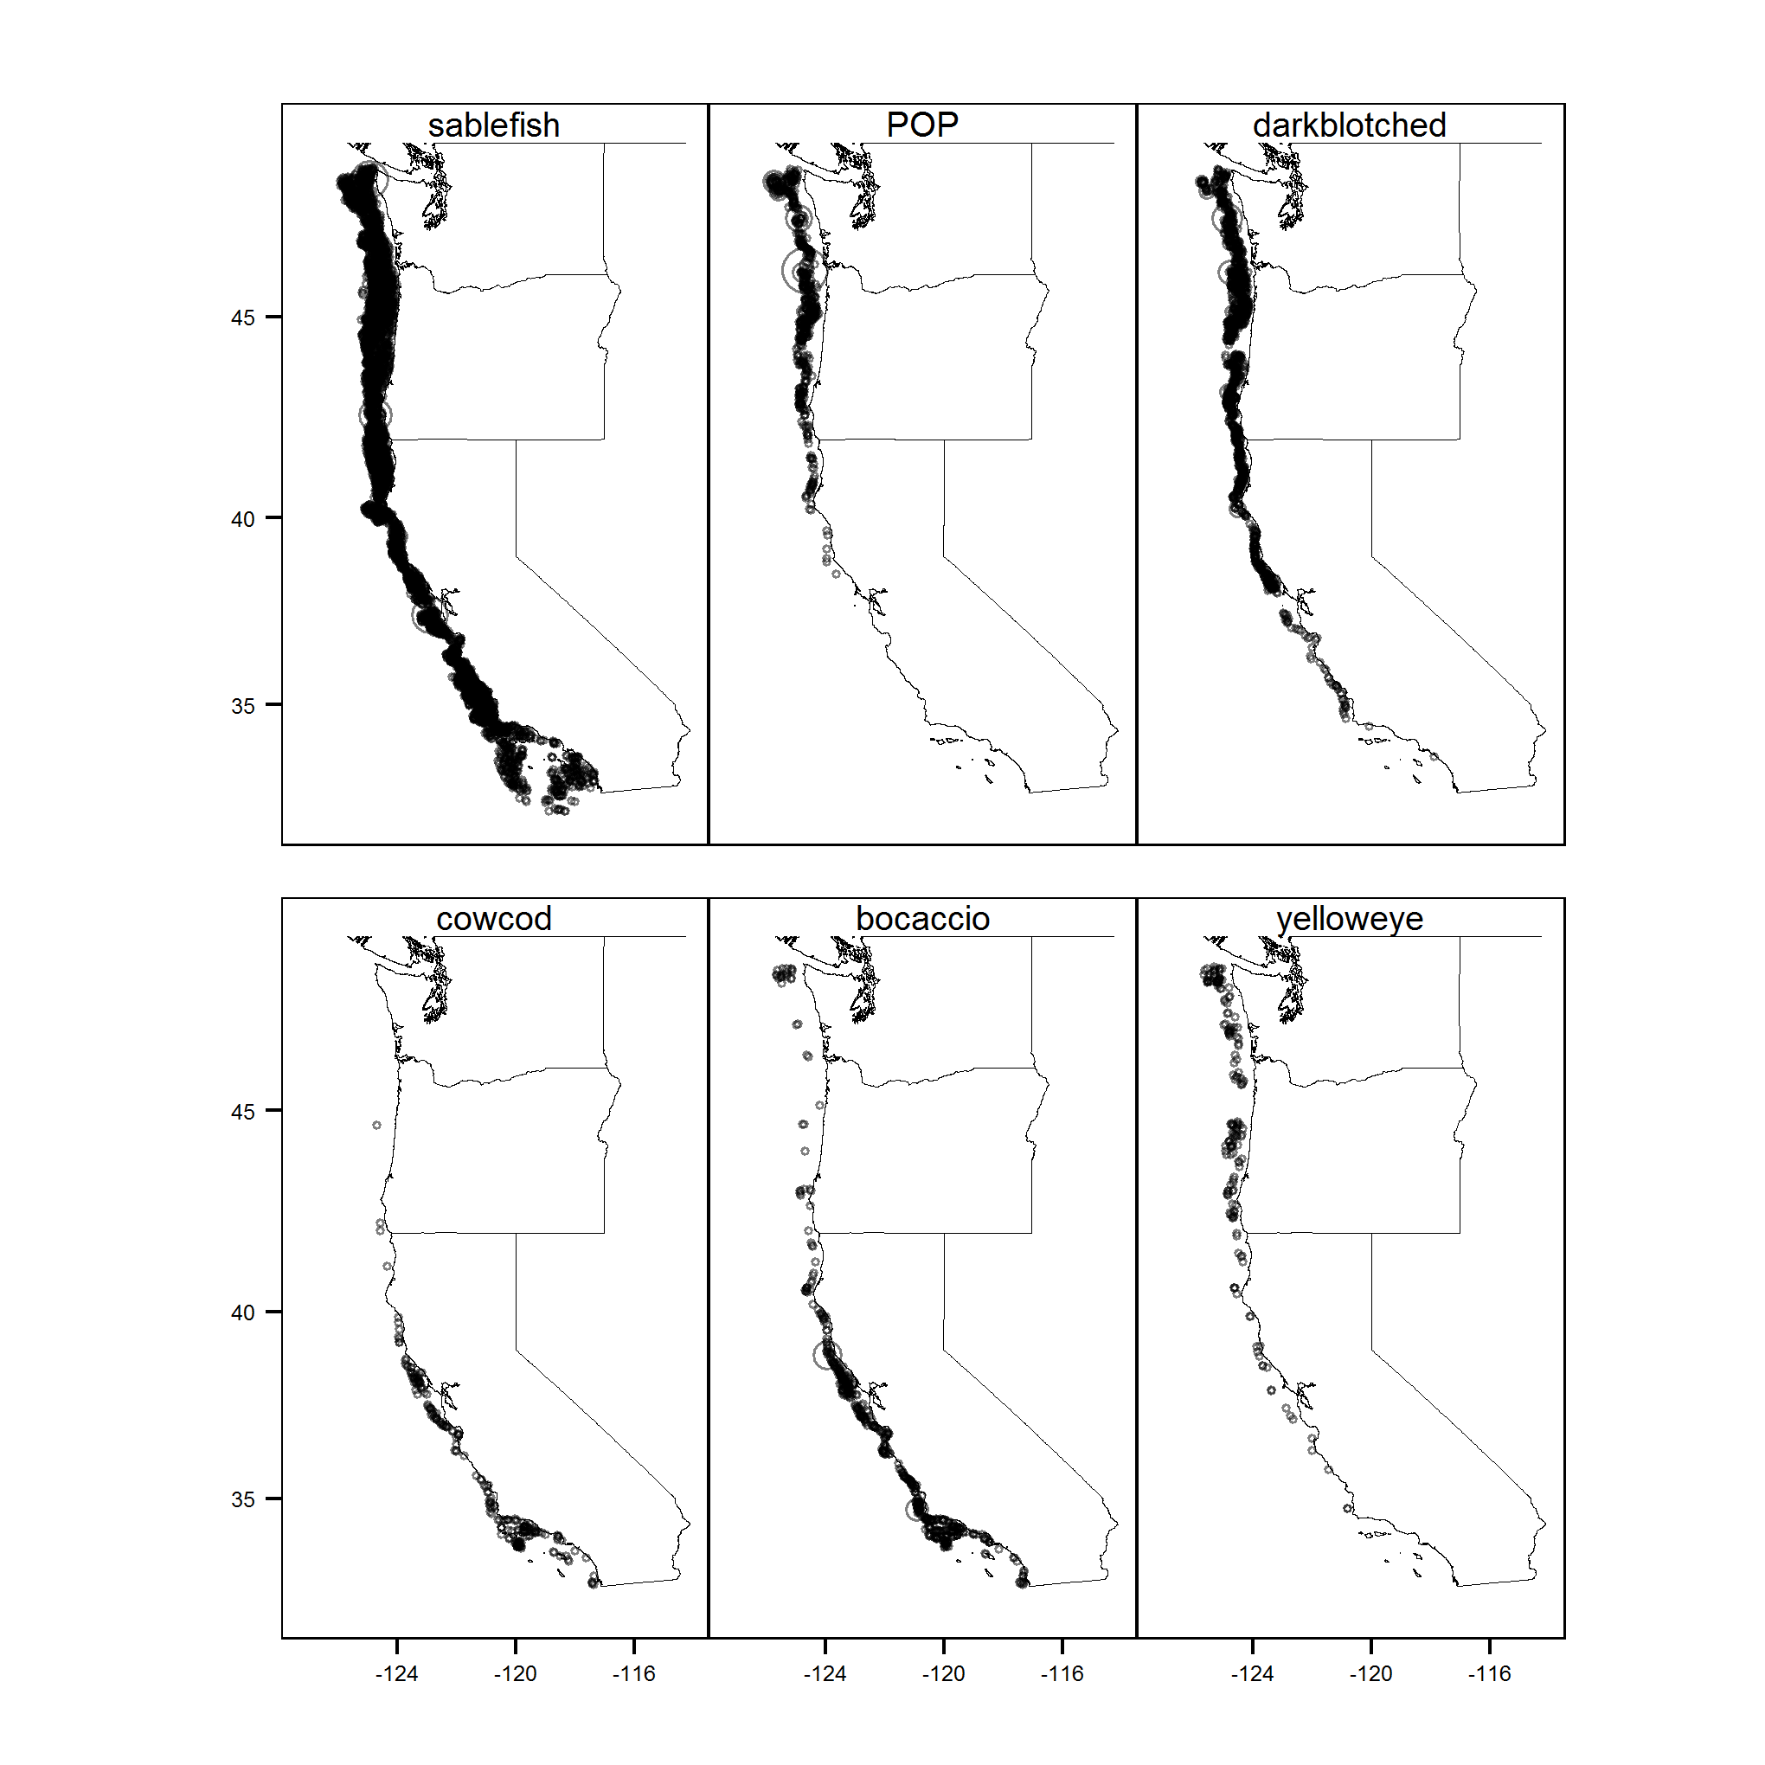

Figure 5. Positive tows (kg) from the Northwest Fisheries Science Center Shelf-slope survey from 2003 to 2014. Panels display data for a single species across all years, where the size of the transparent circle is relative to the species specific weight in a given tow. From left to right, top to bottom, species are: sablefish, Pacific ocean perch (POP), darkblotched rockfish, cowcod, boacaccio, and yelloweye rockfish.

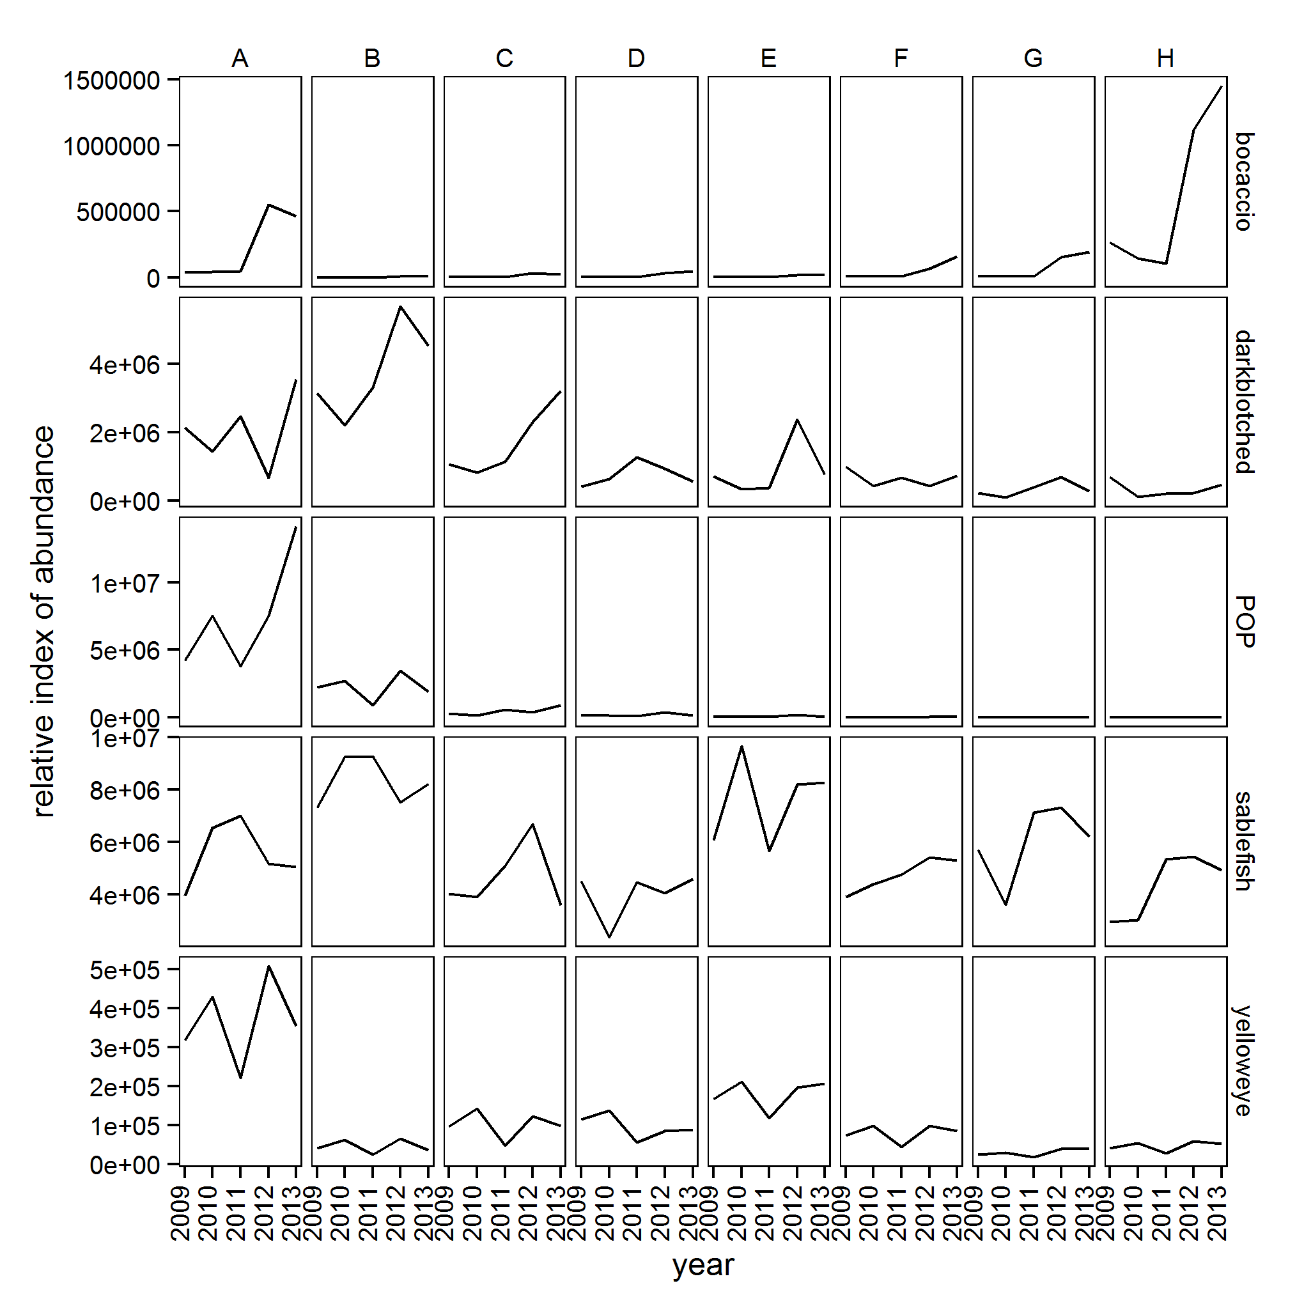

Figure 6. Species-pecific relative indexes of abundances per port group estimated from delta-generalized linear mixed effects models fit to data from the Northwest Fisheries Science Shelf-slope survey trawl. Eight port groups (columns) along the US West Coast were included: (A) Washington, (B) Astoria and Tillamook, (C) Newport, (D) Coos Bay, (E) Brookings and Crescent City, (F) Eureka, (G) Fort Bragg, and (H) San Francisco and Bodega Bay. Results are presented for four overfished species and sablefish (rows). Indices were generated using data from 2002 to 2014, but results are only shown for 2009 to 2013 because those represent the years for­­ which economic data was also available.

­­­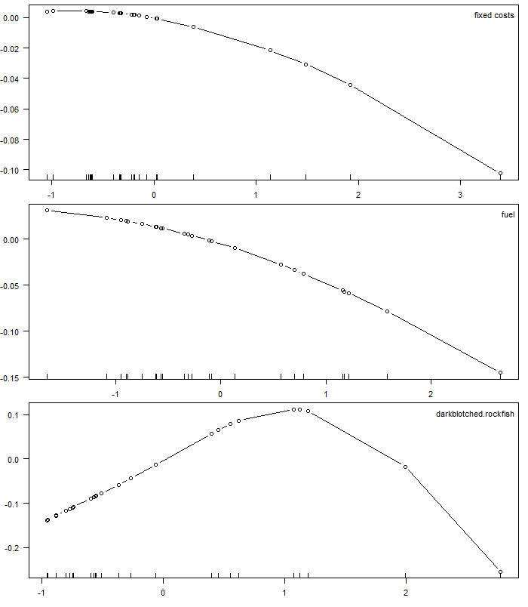

Figure 7. Function estimates for fixed costs (top), fuel (middle), and darkblotched rockfish (bottom) effects on the mean of the proportion of sablefish limited entry trawl allowable catch caught using trawl gear by the limited entry trawl permit holders. Rug marks on axes indicate observed levels for each predictor value.