Quantifying drivers of gear choice in the US West Coast sablefish fishery to improve future fisheries management

Kelli F. Johnson1*, Sarah Klain2, Ana K. Spalding3,4, and Nadine Heck5

1School of Aquatic and Fishery Sciences, University of Washington, Box 355020 Seattle, WA 98195-5020, USA

2Institute for Resources Environment and Sustainability, University of British Columbia, Vancouver BC V6T 1Z4, Canada

3Smithsonian Tropical Research Institute, Apartado Postal 0843-03092, Panamá, República de Panamá

4School of Public Policy, Oregon State University, 318 Fairbanks Hall, Corvallis, OR 97331, USA

5Institute of Marine Sciences, University of California, 1156 High St., Santa Cruz, CA 95064, USA

*Corresponding author: tel (+1 206 543 4270); fax (+1 616 8689); email (kfjohns@uw.edu)

Abstract

Reducing catch of non-target individuals and species (i.e., bycatch) remains a global fisheries management priority, and is consistently listed as one of several impediments towards achieving sustainable fisheries. Switching fishing gear for another gear type with a lower rate of bycatch is often listed as the most feasible method to reduce bycatch. However, fishers are faced with many decisions and it is often difficult to predict under what circumstances they will switch gear type when the management framework allows for them to do so. Here, we explored the effects of biological, economic, and societal factors on gear choice using statistical models. The approach was applied to fishery-independent and -dependent data available for the United States West Coast groundfish fishery, with an emphasis on bycatch in the Limited Entry trawl sector while targeting sablefish (*Anoplopoma fimbria*). Cluster analysis identified two major changes in gear type since the enforcement of the first federal regulations in 1982: 1991 and 2005. Generalized additive models were developed to quantify the effects of biological, economic, and social factors. The application of the model approach highlights the major difficulties of integrating data across multiple disciplines and why it is important to include data from such disciplines when analysing human choices. This research provides a framework for quantifying drivers of fisher behaviour regarding gear choice in other fisheries, and highlights the need for collecting data on local governance structures, such as membership in and/or rules of risk pools, enabling the quantification of socio-economic drivers of fisher behaviour.

Keywords: bycatch, catch share, governance, individual transferable quota (ITQ), risk pool, transdisciplinary

Timeline

2016-01-27 Send revision to Nadine, Ana, Sarah, Lorenzo, Mary, and Kathryn for input

2016-02-10 Receive comments

2016-02-15 Send final revision to Nadine, Ana, Sarah, and Andre

2016-02-20 Submit revision

1 Introduction

Uncertainty is a universal challenge of resource management. Management questions often pertain to large complex systems making controlled and replicated experiments impossible. Therefore, complete elimination of uncertainty will never be possible. While terms differ among disciplines, uncertainties can be broadly assigned into three broad categories: (a) environmental variation, referring to the natural variability of ecosystems; (2) scientific uncertainty, which arises due to imperfect observations and modelling of ecosystem dynamics; and (3) implementation uncertainty, pertaining to imprecisions in the application of management actions (Mehta *et al*., 1999). In fisheries management, each type of uncertainty can act to undermine the effectiveness of a management framework, yet (3) has received far less attention than (1) and (2) (Fulton *et al*., 2011b). Reducing (3) relies on increasing our ability to predict fisher’s responses to management frameworks, which can be done by: (a) reviewing fisher behaviour under similar management frameworks and (b) using logic to infer what fishers will do under untried management policies. Here, we focus on developing methods for (a) to increase the quality of management advice and potentially reduce discrepancies between predicted and realized policy benefits.

Fisher behaviour develops in response to both long- and short-term decisions, which are highly contextual (Hart and Pitcher, 1998; Hunt, 2005). For example, long-term choices can include decisions about capital investments, such as purchasing a new vessel, whereas short-term choices can include decisions about a fishing trip, such as whether or not to go fishing. Choices are guided by information on environmental factors, risk tolerance, personal experience, economic expectations, management constraints, etc. (Steelman and Wallace, 2001; van Putten *et al*., 2012). Furthermore, choices are typically made in relation to multiple objectives, involve factors with varying levels of uncertainty, and may depend on the actions of other fishers (Allen and McGlade, 1987). Therefore, fisher behaviour will be driven by much more than just economic objectives (e.g., profit maximization), and policies that fail to account for complexities arising from socioeconomic and cultural contexts may fail to reach objectives (Mahon *et al*., 2008).

Reducing catch of non-target species and individuals (i.e., bycatch) is a globally held goal of fisheries management (FAO, 1995; NMFS, 1998). Literature suggests that regulatory mechanisms to reduce bycatch are potentially straightforward and achievable by means of gear modifications, avoidance incentives, spatial or temporal closures, or some combination thereof (Hall and Mainprize, 2005). Regrettably, strategies that offer potential decreases in bycatch may impair other aspects of sustainable fisheries or fisher livelihoods (Lewison et al., 2011; Senko et al., 2014, Teh et al., 2015). For instance, mandated gear substitutions can be prohibitively costly and per-unit taxes on bycatch, payable by individual fishers, promote them to engage in environmentally sustainable behaviour, but fail to place a hard cap on bycatch limits and may overly constrain the fishery when bycatch rates are highly variable (Herrera, 2005; Singh and Weninger, 2009). Additionally, total allowable catch (TAC) policies that do place a hard cap on the amount of bycatch caught also promote inefficiency when profitable quota remains unfilled (Androkovich and Stollery, 1994; Holland, 2010; Patrick and Benaka, 2013).

Fishers typically favour incentive-based methods to reduce bycatch (e.g., economic incentives to increase catch utilization) over input (e.g., gear restrictions) or output (e.g., daily trip limits) controls. For example, changing social norms motivated small-scale fishers of Baja California Sur, Mexico to spatially shift their effort to reduce bycatch of loggerhead sea turtles (Peckham *et al*., 2007), and a desire to fish in parts of the Barents Sea closed because of high bycatch rates prompted trawl fishers to voluntarily adopt gear modifications (Isaksen *et al*., 1992). Unfortunately, most management systems fail to provide incentives or the necessary flexibility for fishers to alter their behaviour (Branch et al., 2006; Abbott and Wilen, 2009). Individual transferable quotas (ITQs), where fishers are allocated shares of the TAC, are theorized to reduce the need for input control measures by encouraging fishers to change their behaviour in a way that reduces catch of species for which quota is scarce (Casey, 1995; Hall et al., 2000; Holland and Jannot, 2012). Regrettably, it is difficult for managers to determine *a priori* how fishers will behave if given the opportunity to alter their behaviour.

Incentive led changes in fisher behaviour can often be predicted when thought about in isolation, particularly with respect to economic incentives, but in reality multiple factors work in concert to strengthen or counteract incentives (Eliasen *et al*., 2013). For instance, Jenkins and Garrison (2013) predicted that, if allowed, fishers in the United States (US) West Coast Limited Entry (LE) groundfish fishery targeting sablefish (*Anoplopoma fimbria*) would substitute trawls for pots leading to reductions in bycatch and increased profits. They also hypothesized that without incentives most fishers using trawl gear would likely not permanently convert to pots or longlines. The US West Coast groundfish fishery underwent major management changes in 2011, with the implementation of an ITQ system and the endorsement of gear switching. Unfortunately, economic incentives to switch gears declined (i.e., the ex-vessel price per pound of sablefish caught using posts decreased from 3.49 to 2.83 USD (PacFIN, 2015)) in 2012. Consequently, predicted reductions in bycatch due to gear switching were not fully realized. We hypothesize that the development of future incentives to encourage gear switching can be informed by historical trends in fisher behaviour, and use fishers targeting sablefish within the US West Coast LE trawl fishery as a case study.

This study used cluster analyses and generalized additive models (GAMs) to better understand fisher behaviour when targeting sablefish in the US West Coast LE groundfish fishery. Hypothesized drivers include variables related to economic, ecological, and socio-cultural causes, such as fixed costs, relative abundance, and the presence of an ITQ management framework. A socio-ecological assessment (Jenkins and Garrison, 2013) was helpful in increasing support for gear switching by identifying stakeholder concerns prior to the implementation of the ITQ system, but it remains unclear if fishers changed their behaviour and if so, did they change in alignment with predictions? The objectives of this study are therefore to: (1) identify and contextualize major changes in the behaviour of fishers targeting sablefish within the US West Coast LE groundfish fishery; (2) develop a framework to quantify drivers of fisher behaviour using a wide variety of data collected across multiple disciplines; (3) provide results relevant to managers wishing to develop incentive based methods to alter fisher behaviour, and (4) discuss challenges of interdisciplinary research, particularly with regard to quantifying socio-economic factors.

2 Methods

2.1 Overview

Multiple methods were used to understand fisher behaviour in this case study: (1) major shifts in gear choices were identified using cluster analysis and (2) GAMs were used to quantitatively identify likely drivers of gear choice given the results of (1). Data included information collected from both fishery-dependent and -independent sources and involved information on ecological, economic, and social aspects of the fishery. Several steps were taken prior to (1) and (2) to organize and integrate the data for its effective use. Where applicable, methods of integration are detailed below in conjunction with descriptions of each associated analysis.

2.2 Case-study background

The US West Coast sablefish fishery is part of a federally-managed multispecies (90+) groundfish fishery operating from the US-Canada border in the north to the US-Mexico border in the south (PFMC, 2014). Groundfish harvests occur both commercially through lLE, open access, tribal, and recreational (targeted and incidental take) sectors. The LE sector is restricted to fishers holding a LE permit, where permits, issued in 1993, provide an endorsement to fish with either trawl or fixed gear (such as longlines, traps, or pots) and endorsement eligibility was based on catch history as of September 16, 1999. The open access fishery, which is not really open but restricted to vessels with historical participation in the fishery prior to November 5, 1999 not eligible for a LE permit, is managed using cumulative trip limits, size limits, seasons, gear restrictions (prohibiting trawl gear), and closed areas. All tribal fisheries are located off the coast of Washington, where tribes have a federal treaty right to fish in their “usual and accustomed” fishing areas (citation). All sectors are subject to annual catch limits and area- and gear-specific restrictions. The groundfish fishery primarily targets demersal species such as sablefish, Dover sole (*Microstomus pacificus*), shortspine thornyhead (*Sebastolobus alascanus*), Petrale sole (*Eopsetta jordani*), and Pacific whiting (Pacific hake, *Merluccius productus*). Prior to 1982 management was under the jurisdiction of each respective coastal state (i.e., Washington, Oregon, and California). With the implementation of the Magnuson-Stevens Conservation and Management Act in 1976 and the creation of the Pacific Fisheries Management Council (PFMC) Groundfish Fishery Management Plan in 1982, management authority switched to the PFMC, a stakeholder body that formally advises the federal government. The first federal regulation of coast-wide trip limits was implemented in October of 1982.

Today, sablefish is one of the most valuable groundfish stocks managed by the PFMC, with gross revenue reaching $44.7 million (USD) in 2011 (PacFIN, 2015). Sablefish are also caught within areas managed by the Department of Fisheries and Oceans Canada and the North Pacific Fisheries Management Council, but the research presented here focuses on the portion of the fishery that operates under the PFMC (i.e., Washington to California). Sablefish were mainly caught using hook and line prior to 1960, with the first records of catch documented by the California Department of Fish and Wildlife in 1908 (Figure 1; Johnson *et al*., 2015). Later increases in landings in the 1970s are attributed to the development of a pot fishery comprised of mainly foreign vessels. Trawl landings also date back to the early 1900s, though trawl landings rarely exceeded those by hook and line until the late 1960s.

The sablefish fishery encounters several bycatch species, including Pacific halibut (*Hippoglossus stenolepis*), an internationally managed species, and five overfished species (Table 1): (1) bocaccio rockfish (*S. paucispinis*; Field, 2013); (2) cowcod rockfish (*S. levis*; Dick and MacCall, 2014); (3) darkblotched rockfish (*S. crameri*; Gertseva and Thorson, 2013); (4) Pacific ocean perch (POP, *S. alutus*; Hamel and Ono, 2011); and (5) yelloweye rockfish (*S. ruberrimus*; Taylor and Wetzel, 2011). Prior to 2011, discarding was allowed, thus bycatch allowable catch limits were non-binding. An ITQ program was implemented for the LE trawl groundfish fishery in 2011 which apportioned bycatch TACs to individual vessels based on bycatch rates applied to target species TACs, made an allowance for gear switching to any fishing gear legal within the groundfish fishery, and made all TACs binding (PFMC and NMFS, 2010). An ITQ program was simultaneously implemented for the US West Coast Pacific hake fishery, a midwater trawl fishery with shore-based, mothership, and catcher/processor sectors.

Legal gears for sablefish off the US west coast include: (a) hook and line, or longlines, which typically encompass a mechanically deployed weighted mainline approximately 50 ft in length with baited hooks on shorter lines spaced every 40 in; more generally hook and line can include one or more hooks attached to one or more stationary or mobile lines; (b) pot, or fish traps, which are biodegradable pots typically 54 in in diameter deployed on the seafloor at 120-150 ft intervals using a trotline; and (c) bottom trawls, meaning a trawl with a net footrope that comes into contact with the seabed. Vessels using trawl gear target multiple species, though when sablefish are caught captains are typically targeting members of the DTS (i.e., Dover sole, thornyhead (shortspine and longspine), and sablefish) complex, whereas vessels using fixed-gear (non-trawl gear) are primarily targeting only sablefish. Most vessels targeting sablefish operate out of Washington and Oregon, fishing primarily north of Monterey, CA.

Fishing opportunities exist year round, depending on gear type, and over time regulations have been created with the intent of spreading the harvest throughout the year (see results section for more details; Table 5). Recently, processing of the landings mainly occurs onshore by relatively few (i.e., less than four) processing plants. Communities significantly involved in commercial fishing are relatively equally distributed throughout Washington, Oregon, and California (40, 30, and 52 respectively), although the community of Astoria/Warrenton, Oregon is by far the most prominent community in terms of commercial catch landings (Sepez *et al*., 2006).

Market prices are largely driven by …

The harvesting of groundfish, including but not limited to sablefish, is linked with human wellbeing in a number of ways. Fishing contributes to job satisfaction, quality of life, local ecological knowledge, human capacity building, etc. The current community faces issues common with other fisheries (e.g., ageing of the fleet and infrastructure) and through interactions with other economic- and socially-important species (e.g., forage fish, salmon, sea birds, and marine mammals). ...

2.3 Determination of dominant transition points

Reported landings by gear type (Johnson *et al*., 2015) were used to determine transitions in the dominant gear type used to land sablefish in the US West Coast groundfish fishery from 1900 to 2014. Here, landings are defined as fish brought to shore, where landings plus discards equal catch, and gear types included: trawls, pots, and longlines. Bray-Curtis measures of distance were computed on the proportions of yearly landings caught by each gear type. Proportions were used to give greater weight to differences in composition rather than absolute differences, which could be affected by yearly catch limits. Differences of one indicate complete dissimilarity and differences of zero occur when proportions are completely similar between years. Hierarchical clustering was performed on the Bray-Curtis measures for years starting in 1982, the first year of federal management, to determine dominant transition points. Clusters were defined using nearest neighbour-chain algorithms, which minimize variance using a “complete” “bottom up”, or agglomerative, criterion. Analyses were performed within the R statistical environment (R Core Team, 2015) using the vegdist function of the vegan package (Oksanen *et al*., 2015) and the hclust function of the stat package (R Core Team, 2015), respectively. Resulting dendrograms were plotted within R (R Core Team, 2015) and groups were defined using the average silhouette width (cluster::silhouette; Maechlet *et al*., 2014). Silhouette width is a measure of the degree of membership of an object to its cluster based on the average distance between the given object and all objects of the cluster to which it belongs compared to the same measure computed for the next closest cluster. Average silhouette width provided a measure of clustering validity, where the highest value indicates the optimum number of clusters (Rousseeuw, 1987).

Two dimensional Nonmetric Multidimensional Scaling (NMDS) was used to better view which years were dominated by any one gear type, where years closer to one another are more similar in terms of proportions of landings by gear type. Analyses were performed using the metaMDS function in the vegan package (Oksanen *et al*., 2015) and ordination plots, or scatterplots of the NMDS results, were plotted within R (R Core Team, 2015).

Years of relatively equal catches by each gear type were determined using the Simpson Index of Diversity, computed via the diversity function of the vegan package (Oksanen *et al*., 2015). Measures of diversity were computed for all years (i.e., 1900 to 2014) but dominant transitions were only identified for those years with a measure of evenness below the mean since 1982.

Years defined as transitions were used to guide a literature review of PFMC documents, non-governmental organization reports, and peer-reviewed literature to characterize the identified transitions between dominant gear types. Results were also used to inform potential variables related to fisher behaviour.

2.4 Generalized additive models

Generalized additive models for location, scale, and shape (GAMLSS; Rigby and Stasinopoulos, 2005) were used to identify covariates that could explain observed patterns in “attainment” since 2009. Here, attainment refers to the proportion of the northern (north of 36°N latitude) annual catch limit for sablefish assigned to the LE shoreside trawl sector landed in a “port group” by LE trawl permit holders while fishing with bottom trawls. Historically, LE trawl permit holders fished exclusively with trawl gear, but beginning in 2011 they could fish using any gear legal within the groundfish fishery. The original intent was to compare drivers between a model investigating attainment using trawl gear and a model investigating attainment using fixed gear, but due to insufficient data for the latter conclusions will be based on estimated effects of drivers of fisher behaviour when using trawl gear and potential incentives that could be implemented to encourage gear switching should that be a future management goal. Patterns in attainment were investigated since 2009 because of limitations in data availability for independent variables.

Landings data were retrieved from the Pacific Fisheries Information Network (PacFIN) regional database, a compilation of sales receipts (i.e., fish-tickets) collected during the delivery of fish to processing plants in Washington, Oregon, and California (Pacific States Marine Fisheries Commission, Portland, OR, www.psmfc.org/pacfin). The database contains information on landings by permit type, gear, and market category, where sablefish represent a market category. Landings of sablefish from US West Coast LE trawl permit holders were provided as yearly landings by port group and gear type ((1) Washington, (2) Astoria and Tillamook, (3) Newport, (4) Coos Bay, (5) Brookings and Crescent City, (6) Eureka, (7) Fort Bragg, (8) San Francisco and Bodega Bay, and (9) Monterey and Morro Bay). The data was pre-processed to the port group level prior to its release. This pre-processing was performed to ensure the confidentiality of vessel specific information. Data were masked (i.e., not provided) when a value represented less than 3 vessels or one vessel represented 90% of any individual statistic (16 U.S.C. § 1881a). Port groups were based on spatial proximity of ports and the ability to minimize missing information. Data from the port group “Monterey and Morro Bay” were excluded from the following analyses because the port locations span 36°N latitude, the latitudinal line used for management (see below for details; Figure 2).

GAMLSS extends the traditional generalized additive framework (Hastie and Tibshirani, 1990), allowing the conditional distribution of the response variable, given a set of covariates, to be modelled with a variety of distributions, including ones outside of the exponential family, and parameters other than the mean to be modelled with their own covariates and associated link functions. For instance, GAMLSS can accommodate zero-inflated distributions, such as the zero-inflated beta distribution, and include covariates for the mean, precision, and extent of zero-inflation parameters. Analyses were conducted using the gamboostLSS package (Mayr *et al*., 2012; Hofner and Fenske, 2014) in R (R Core Team, 2015), as described in Schmid *et al*. (2013). gamboostLSS extends the GAMLSS framework to accommodate random effects, providing the flexibility needed to model statistical means of hierarchical data, which lack independence, and a boosting framework that utilizes gradient boosting algorithms to fit the model while simultaneously performing variable selection. Specifically, gamboostLSS utilizes component-wise gradient boosting to optimize an arbitrary differentiable objective function, producing a sparse solution with respect to all parameters, eliminating the need to use variable selection techniques which are known to be biased and unstable (Ripley, 2004; Whittingham *et al*., 2006). The gradient is used to iteratively compute estimates of parameters related to the mean and subsequently the precision, where the model is initialized to not depend on any of the predictors. Non-linear predictor-response relationships were modelled using penalized regression splines, allowing for the inclusion of non-linear relationships without *a priori* specified functional forms. Categorical predictors were modelled using dummy coded binary variables.

Recent literature on the issue of whether to transform the response variable (e.g., arcsine squareroot transformation) or use a distribution, on the observed scale, when working with proportion data, favours using either the binomial or beta distribution with a logit link function (Warton and Hui, 2011; Schmid *et al*., 2013; Herpigny and Gosselin, 2015). Here, a beta distribution was deemed appropriate because the dependent variable, attainment, included decimal values and was bounded on the interval [0, 1], with zero observations at the boundaries (Crowder, 1978, Smithson and Verkuilen, 2006; Schmid *et al*., 2013). The beta distribution is a continuous distribution with finite support on [0, 1] and is governed by two shape parameters, $μ$ and $ϕ$, $f\left(y;μ,ϕ\right)= \frac{Γ\left(ϕ\right)}{Γ\left(μϕ\right)Γ\left((1-μ)ϕ\right)}y^{μϕ-1}{\left(1-y\right)}^{(1-μ)ϕ-1}$, where μ is the mean of $y$, $ϕ>0$ is the precision parameter and $Γ(·)$ is the gamma function (Ferrari and Cribari-Neto, 2004). The variance of $y$ is given by ${μ(1-μ)}/{(1+ϕ)}$, which is a scaled version of binomial variance, $μ(1-μ)$, allowing for more variation that would be expected by a binomial model (i.e., “overdispersion”). A logit link function, $\ln{({μ_{x}}/{\left(1-μ_{x}\right)})}$, was used for all parameters related to μ and a log link function was used for all parameters related to $ϕ$. The logit link facilitates the interpretation of parameters in terms of the odds ratio, same as a traditional logistic regression model.

Independent variables included: (a) continuous fixed effects, (b) categorical fixed effects, and (c) random effects where year was considered random. All continuous fixed effect covariates were z transformed, $(x_{i}-mean(x))/sd(x$), so the mean of each variable was zero and the ranges were roughly similar (i.e., between -3 and 3). The means and standard deviations used for the transformation were from all data included in the analysis.

Fixed effects were hypothesized to be large-scale factors that influence fishery sectors, such as markets and management frameworks. Here, we refer to these large-scale factors as “drivers” and the metrics by which to measure or identify the drivers as “variables”. We used the four subsystems defined in Ostrom’s (2009) social-ecological system framework for common pool resources to guide the identification of possible drivers of fisher behaviour: (1) resource systems (e.g., a marine protected area), (2) resource units (e.g., fish), (3) governance systems (e.g., TAC or ITQ frameworks), and (4) users (e.g., fishers, cannery operators, and non-governmental organizations). Resource units can be thought of as part of the resource system, while the governance system defines rules for the users, but all drivers interact and are likely to have a major impact on management outcomes. Here, the resource system is the California Current Large Marine Ecosystem (CCLME), the resource units are sablefish managed by the PFMC, the governance system is that defined by the PFMC, and the users are individuals involved in the groundfish fishery, which includes both fishers and non-fishers. Variables (described below) were selected based on their relationship to identified drivers, data availability, and hypothesized significance to this case study (Table 2).

*Resource system*. The resource system can be thought of as the biophysical system from which the resource units are extracted. The CCLME extends from southern British Columbia, Canada to Baja California, Mexico, and is characterized as a productive wind-driven upwelling system. Significant spatial differences in wind fields, and thus the transport of surface waters, are related to prominent geographic barriers (Figure 2; Hickey, 1998): Astoria Canyon (46°15’N), Cape Blanco (42°50’N), Cape Mendocino (40°26’N), and Point Conception (34°27’N). Dynamics south of Point Conception were not investigated.

*Resource unit*. Resource units relate to characteristics of the extracted good(s), where the good can either be consumed or used in the exchange for other goods. Availability of sablefish, the resource unit, was characterized by yearly specific estimates of local abundance. Estimates were derived from catch per unit effort data, provided by the Northwest Fisheries Science Center (NWFSC) Shelf-Slope survey, which collects annual data on hundreds of fish species along the US West Coast (Bradburn *et al*. 2011). Catch per unit effort data can be summarized using multiple methods (e.g., mean, stratified mean, or generalized linear model), but only generalized linear models can account for stratified and unbalanced sampling designs as well as fish behaviour (e.g., schooling) (Thorson and Ward, 2013). Simpler models can lead to invalidated assumptions and incorrect estimates of local abundance.

Delta-generalized linear mixed-effects models (delta-GLMMs) were used to standardize the CPUE data and provide local indexes of abundance. Delta-GLMMs separate the model into two components: (1) the probability of encountering the species and (2) the rate of detection given an encounter. The expected value of each model component can be approximated as a function of fixed and/or random effects, where the equation for each model need not be the same. Both models always include a “year” effect to estimate yearly change in abundance and typically include “area” and “vessel” effects to account for differences in such things as habitat type (e.g., shelf or slope), sampling effort, and vessel “catchability”. Interactions can also be included, as well as uncorrelated and correlated random effects (see Thorson and Ward (2013) for more details). Here, we investigated five model structures to account for year, vessel, stratum, and pass effects. A vessel effect was investigated to account for multiple vessels being used per year. The survey typically contracts four commercial fishing vessels per year to conduct the standardized bottom trawls, although in 2012 two contracts were given to a single vessel. A stratum effect was investigated to account for stratification of the random sampling design across three depth categories ((1) 55 to 183 m, (2) 184 to 549 m, (3) 550 to 1280 m) and hypothesized differences in the biophysical system (Figure 2; see Resource system above). A pass effect was included to account for the sampling area being covered twice per year (late May to late July for the first pass and from mid-August to late October for the second pass) and the incomplete sampling that occurred during the second pass of the 2013 survey when stations south of 37°N were not sampled. We investigated five model structures to determine which treatment of spatial, temporal, and vessel interactions were supported by the data: (a) stratum and year as fixed effects, (b) stratum and year and the interaction between strata and vessel as fixed effects, (c) stratum and year as fixed effects and the interaction between year and vessel as random effects, (d) stratum and year as fixed effects and the interactions between year and vessel and stratum and vessel as random effects, (e) stratum and year as fixed effects with correlated interactions between year and vessel and strata and vessel as random effects. Additionally, all models included survey pass.

Data used to fit the delta-GLMMs included spatially-resolved (i.e., trawl mid-point locations) fishery-independent species-specific catches collected from Cape Flattery, Washington (48° 10’N) to the US-Mexico border (32° 30’N) between the years of 2003 and 2014 (Figure 3). Data are used as the primary source of abundance information for most PFMC groundfish stock assessments. Analyses were implemented with an open source software package (Thorson and Ward, 2013) in R (R Core Team, 2015), which uses a Bayesian hierarchical modelling framework. The probability of non-zero catch events were modelled using logistic regression and the density of catch given a non-zero catch event was modelled using a Gamma distribution. Priors included a weakly informative gamma prior on the squared inverse coefficient of variation for catch given that catch was non-zero (Gamma(0.001, 0.001)), bounded uniform priors on all fixed effect parameters, and a conjugate inverse-Wishart prior on the covariance matrix, which leads to a prior assumption of no correlation, when correlated random effects were included in the model.

Estimates of local abundance were calculated by multiplying the posterior distribution for the probability of a non-zero catch event, the probability density of catch given a non-zero catch event, and area for each stratum. Medians of the posterior distributions from the model that best fit the data were used for subsequent analyses. Each year of provided data (2003 to 2014) were used to inform trends in local abundance, but only abundances from 2009 to 2013 were included in subsequent analyses to match time series of additional data described below. Each model was checked for convergence by visually inspecting each sampling chain for appropriate levels of mixing and the overlap of posterior distributions with zero. Converged models were assessed for goodness of fit using Bayesian posterior predictive checks (Spiegelhalter *et al*., 2002) and Bayesian Information Criteria (BIC) was used to select the model that best fit the data (Schwarz, 1987).

*Governance system*. The governance system includes both processes and institutions that define rules shaping resource user behaviour. Therefore, the governance system can create situations in which fishers choose to pursue one fishery, or fishery sector, over another. Restricted access measures to quota and permits were of particular interest because of their role in shifting effort and allowing fishers to change or modify their gear.

In May of 2001 the PFMC initiated the West Coast Groundfish Observer Program with the goal of improving estimates of bycatch and discard. Since then observers have been mandated to cover 10-100% of all fishing trips taken by US West Coast LE trawl permit holders. Observer data helps inform time and area closures, trip and cumulative landing limits, and bycatch rates included in stock assessments used to generate rebuilding plans for overfished species. We used delta-GLMMs to provide estimates of local bycatch species abundance (as detailed above for sablefish) and characterize the potential for interactions between catches of the resource unit and management to protect bycatch species. Indexes of abundance were not generated for cowcod rockfish, even though it is currently declared overfished, because spatial management policies (Rockfish Conservation Areas) implemented in 2002 have been successful in decreasing instances of their bycatch within the LE trawl sector of the US West Coast groundfish fishery (NMFS, 2004). Additionally, bycatch rates of cowcod while targeting sablefish are small (typically zero; Table 1) and thus not hypothesized to be a large driver of fisher behaviour.

Bycatch rates of yelloweye rockfish are higher for longline gear than pot or trawl gear (Table 1), when targeting sablefish, and therefore local abundances of yelloweye rockfish are hypothesized to be a driver of gear choice. Unfortunately, data provided by the NWFSC Shelf-Slope trawl survey are not informative about yelloweye rockfish abundance off the coasts of Oregon and California (i.e., only one positive tow south of Cape Mendocino in 2010). Visual surveys indicate that yelloweye rockfish are present in these areas, at least in some locations off the coast of California (Taylor and Wetzel, 2011). Consequently, we could not generate estimates of yelloweye rockfish abundance to determine the effect of local abundance on fisher behaviour. Estimates of local abundance were included for bocaccio rockfish, darkblotched rockfish, and Pacific ocean perch. Zero positive tows were observed for bocaccio rockfish and darkblotched rockfish in the deepest depth strata (550 to 1280 m) and therefore investigated models for these species included just two depth strata, but were otherwise the same as those investigated for sablefish and Pacific ocean perch.

The PFMC implements many formal rules-in-use pertaining to the LE trawl sector. Annual catch limits, “optimum yield” prior to the ITQ program, define sector-specific harvest limits, where limits account for scientific uncertainty, conservation objectives, and socio-economic concerns. Consequently, fishers are limited in the amount of the resource unit they can catch on a yearly basis. Annual catch limits for sablefish have generally decreased since 2009 (Figure 1) and therefore we included the annual catch limit of sablefish assigned to the US West Coast LE trawl sector as an offset (i.e., divided the response variable, sablefish landings, by the annual catch limit assigned to that sector) to account for differences outside of the control of fishers. More specifically, since 1997 the annual catch limits (defined as optimum yields prior to 2011) for sablefish have been spatially explicit, in that differential proportions of the total annual catch limit are assigned to the areas north and south of 36°N latitude based on estimates of the available abundance in each region. The relative abundance of sablefish south of 36°N latitude is estimated at approximately one quarter of that found north of 36°N latitude (Johnson *et al*., 2015). The LE trawl sector is assigned 58% of the total annual catch limit assigned to the LE sector, which has typically been 90.6% of the annual catch limit assigned to north of 36° N latitude after accounting for set asides (i.e., research, incidental bycatch from non-groundfish fisheries, and tribal). We choose to focus on fisher behaviour north of 36°N latitude because the majority of sablefish are landed in this region and the data availability for the southern region was limited.

Additional rules-in-use pertain to vessel length, where harvesting capacity is assumed to increase geometrically with length and LE permits are endorsed for the vessel length. Amendment 6 to the PFMC Groundfish Management Plan allowed for the combination of permits, where a point system was used to calculate a new effective length based on total permit holdings, but permits cannot be combined if the effective length is greater than 5 ft of the true vessel length. Therefore, vessel length was included in the model to characterize differences in capacity and how rules regarding capacity affect fisher behaviour.

Many headlines reported increases in fixed-gear sablefish landings following the initiation of the ITQ program in 2011. Prior to 2011 permit holders in the LE trawl sector were not allowed to target sablefish using gear types other than trawls and therefore any landings from fixed gear would represent an increase for this sector. In general, results from hierarchical clustering did not indicate a significant change in sablefish landings by gear type across sectors between 2009 and 2013 (

Figure 4). Consequently, a binary variable was included to represent the implementation of an ITQ system within the LE trawl sector, but an interaction between year and ITQ implementation was not investigated (Table 2).

Organizations other than federal and state governments were also hypothesized to play a role in fisher behaviour. As quota for overfished species became more limiting (i.e., smaller trip limits and small quota shares) concern developed for the risk of exceeding limits with a single tow. Consequently, fishers investigated the use of and some formed risk pools, where bycatch quotas are pooled and made available to members. Membership in a risk pool was hypothesized to be a driver of fishermen behaviour because risk pools may provide a substantial reduction the in risk of exceeding bycatch quota and thereby potentially extending the time a fisher can engage in fishing to fulfil quota for profitable target species. Unfortunately, information on risk pool membership, informal or formal, was not available and could not be included in the model.

*Resource user*. Resource users include individuals that utilize the resource unit, which can extend beyond individual fishers. We focused on three basic drivers related to the resource unit (Table 2): number of users, economic importance, and technology. Data was provided by the Economic Data Collection (EDC) program, a mandatory component of the US West Coast groundfish fishery since 2009 (West Coast Fisheries Economics Program, NOAA Fisheries, Seattle, WA, www.nwfsc.noaa.gov/research/divisions/fram/economic). The database contains information on vessel characteristics by permit type and gear from 2009 to present.

EDC data were provided as port-specific averages or sums (same port groups as above), where vessels were assigned to a single port group based on the port group for which that vessel had the highest ex-vessel revenue in that year, even though vessels may deliver to multiple port groups. Data were masked to protect confidentiality using the same rules defined above (see Table 3 for the number of missing year x port group combinations). Data include (see Table 2 for hypothesized relationships between behaviour and variables): (a) average daily fuel use (gal∙day-1), (b) average fixed costs (USD), which included expenses for processing equipment, vessel equipment, insurance premiums, and moorage, (c) average variable costs (USD) , which includes expenses for bait, captain salary, communications, crew salary, association dues, food, freight, fuel and lubrication, ice, licenses, observers, offloading, supplies, travel, and trucking, (d) number of fish buyers, (e) average crew size, excluding the captain; (f) number of vessels delivering to the port group, (g) average horsepower of main engine (hp), (h) average fuel capacity (gal), (i) and average towing speed while fishing (kn).

3 Results

3.1 Dominant transitions

Hierarchical cluster analyses, along with average silhouette width, identified two years (1991 and 2005) as transition points among the dominant gear type used to land sablefish in the US West Coast groundfish fishery (Figure 4). For each group of years identified by dominant transition points the mean proportion of yearly landings caught using hook and line gear steadily increased with time, whereas mean proportion of landings from trawl gear decreased. In 2005, the proportion of landings caught using pot gear was higher than all previous years since 1994 (Figure 5). Less dominant transition points were also identified in 1987, 1997, and 2011, though these changes represent smaller insignificant shifts with a dissimilarity metric of less than 0.04 (Figure 4). In 1987 the dominant gear changed from pots, which clearly dominated in the late 80’s, to trawl gear (Figure 5).

In general, since 1900 the fishery has seen an increase in evenness among gear types (Figure 6). The Simpson Diversity Index, calculated for landings by gear type, identified four periods where a single gear type dominated the landings since 1982 (Figure 6): (a) 1982-1984, (b) 1989-1993, (c) 1997-1999, and (d) 2008. Analyses focused on differences since 1982, because 1982 marks the first year of federal management regulations for the fishery. Each year range identified indicates years where differences among gear-specific landings were the highest (i.e., one gear dominating the fishery).

3.2 Generalized models

Raw data from the NWFSC Shelf-Slope trawl survey collected from 2003 to 2014 indicate sablefish were found ubiquitously up and down the US West Coast with infrequent large tows only observed north of central California (Figure 3). The spatial footprint of darkblotched rockfish was the most similar to sablefish, whereas cowcod rockfish had the least spatial overlap with sablefish (Figure 3). Relative indexes of abundance for sablefish and bocaccio rockfish were larger in the stratum between Cape Mendocino and Point Conception than the two northern stratum (Figure 8). Whereas relative indexes of abundance for darkblotched rockfish and Pacific ocean perch were higher in the two northern stratum than the southern stratum (Figure 8). Estimating an index of abundance was not feasible for yelloweye rockfish because the species was not well sampled by the NWFSC Shelf-Slope trawl survey (Taylor and Wetzel, 2011).

GAMs were fit to 34 observations from eight port groups between 2009 and 2013 (Table 3; Figure 7). All port groups reported landings of sablefish caught within the US West Coast LE trawl sector using trawl gear during this time but only two port groups, Astoria and Tillamook and Brookings and Crescent City, provided data for all five years. Additionally, all port groups reported landings of sablefish caught within the US West Coast LE trawl sector using fixed gear after the implementation of catch shares (2011), but only one port group, Astoria and Tillamook, provided data for all three years. Data were available from the port group Monterey and Morro Bay for every year by gear combination except for trawl gear in 2010, but the port group was not included in the analysis because the ports included in the group span the north south management line (36°N latitude) used for sablefish.

Eighteen fixed effect variables (Table 2) and one random effect variable (year) were tested for their ability to predict trends in attainment. Variable selection was performed during the model fitting process, eliminating the need to run multiple models and perform model selection. Two fixed effects were selected for the relationship between the mean and predictor variables: port group and number of vessels. A linear relationship was estimated for the relationship between attainment and number of vessels (slope = 0.03). San Francisco and Bodega Bay had an estimated mean attainment lower all than other port groups and Astoria and Tillamook had the highest estimate (Table 4). Port group and crew size (non-linear with 3 degrees of freedom) were chosen for the relationship between predictors and the precision parameter (Table 4; Figure 9). Random effects were not included in the model.

4 Discussion

Management success depends on reducing management uncertainty and thereby increasing the likelihood that predicted management outcomes are realized. Fishers are subject to a number of drivers that can and do affect their behaviour, and knowledge of these drivers are important when devising future incentives hoped to change their behaviour. This case study of the LE trawl sector of the US West Coast groundfish fishery serves as an example of how retrospective analyses of fisher behaviour can be used to inform future fisheries management. Of the eighteen potential variables included in the modelling framework, the variable “port group” explained the most variation in both the mean and precision parameters related to the attainment of sablefish north of 36°N latitude. We found that fisher choice differs between port groups. Unfortunately, this analysis could not tell us why fisher behaviour differs between port groups, only that additional variables related to resource units, resource users, governance system, and the resource system should be investigated and that incentives based on variables that were investigated may fail to change fisher behaviour. Multiple additional variables related to any one of Ostrom’s (2009) driver categories could be included in the modelling framework, a major benefit of using GAMLSS coupled with the boosting algorithm, which simultaneously performs model fitting and model selection, additional data were not available.

A number of factors potentially limit fishers’ ability to switch gears: resistance to change, lack of economic incentives, incompatibility between vessels and gear, operator experience, and safety of the vessel and crew (Jenkins and Garrison, 2012). Thus, when given a choice (i.e., allowed to within the management framework) not all fishers will choose to switch gears even if it makes sense economically. Variables for fixed and variable costs were included in the modelling framework but neither could explain variation in attainment, nor did economic variables adjusted for net revenue (results not shown). Although bycatch reduction is best for sustainable fisheries, avoidance costs or reduced catches of target species suggest that bycatch reductions may not be internally consistent with facilitating profit maximization for individual fishers (Abbott and Wilen, 2009; Singh and Weninger, 2009). Results should be interpreted in light of several considerations, and not that economics fail to play a role in gear choice. It is possible that we have yet to see the economics of gear switching play out given that selling ones quota shares was only recently allowed.

The framework developed here should not be thought of as an end but a beginning to understanding drivers of fisher behaviour, in this case study and others. Future work could use more complex index standardization tools, such as geostatistical models that remove the need to *a priori* specify area and depth stratums by modelling the entire spatial field using Gaussian Markov Random Fields (Thorson *et al*., 2015). Gaussian Markov Random Fields are computationally expensive, but are consistently gaining use in the field of fisheries research. Results from geostatistical models could potentially be linked to data from individual vessels, should that be available or modelled by someone who has access to the confidential data, generating local indexes of abundances specific to visited fishing locations in a given year. Which leads into the perhaps more important issue of assigning vessel characteristics to port group based on the port of highest ex-vessel revenue may not coincide with port of landing and vessel specific data should be investigated in future models.

Future methods could account for seasonal changes in bycatch rates, as fishers may alter their location when the risk of bycatch is higher for species like darkblotched rockfish, which exhibit quarterly differences in both survey and fishery bycatch rates (Jannot and Holland, 2013). For species like bocaccio rockfish, where bycatch rates are constant among gear types and estimated covariates are not significant, it is likely that developing management based incentives to limit their bycatch will be more difficult than for species with variable bycatch rates among gear types. We hypothesize that results would be similar for cowcod, given that spatial closures have been successful in decreasing their bycatch rates. Although one should note that those spatial closures came at some cost to fishers, i.e., increased distances from ports to offshore areas where sablefish are typically targeted and increased fishery exit rates in some areas (Manson et al., 2012). As the time series lengthens it may be feasible to test interactions between shifts in policy and ecological covariates, providing further information on potential reasons for changes in fisher behaviour or lack thereof.

Quota share allocations for each overfished species were assigned based on bycatch rates applied to allocated quota shares of targeted species. Thus a fisherman who historically targeted sablefish using trawl gear would have received a very small quota share of yelloweye. With the moratorium on selling quota shares and binding TACs for overfished species, this fisherman could potentially be limited in his/her ability to switch to using longlines, which has a higher bycatch rate for yelloweye than trawl gear, unless he or she could find additional quota pounds for purchase. It appears as though fishers are risk averse now that TACs are binding, as correlation between allocated quota pounds of bycatch species and catch are low (Holland 2012). Risk pools may mitigate the risk of fishers not being able to find additional quota pounds, and their existence and/or membership rules may be a significant driver of gear choice (Fehr and Leibbrandt, 2010). Unfortunately, within the US West Coast groundfish fishery, risk pools are not required to publicly disclose information on rules, membership, or outcomes and thus it was not feasible to include the number of risk pool participants per port group in this analysis.

Currently, The Nature Conservancy (TNC) owns quota shares within the US West Coast groundfish fishery and leases quota pounds to members of the California risk pool, in return for having a say in how fishing occurs. In turn TNC has helped implement a geographic information system combining science and technology with fishers’ knowledge, historical data, and habitat information to identify zones that contain overfished species in near real-time as well as implemented voluntary spatial closures of high risk areas when combined quota for overfished species becomes limited (Bjorkland et al., 2015). According to TNC, since initiating the California Risk Pool, members have experienced reduced bycatch of overfished species, increased harvest of target species, and improved the tracking and sharing of fishing information (TNC, 2014).

While risk pools might reduce bycatch and discards for its members, they pose multiple challenges for fisheries including: the assignment of each individual’s risk of overfishing into a single pool and implementing spatial-temporal closures that are focused on reducing bycatch and may not be optimized for all target species in a multispecies fishery or for fisher equity among sectors (Bjorkland et al., 2015). Additionally, risk pools can potentially result in unequal social and economic impacts through inclusion/exclusion policies potentially creating an imbalance in the fishery in terms of access to social networks, information, and income potential between members and non-members. So far, it remains unknown if risk pools are socially just or create a kind of elite group (Deacon, 2012) and if their formation motivates the “race to fish” thereby undermining the ITQ system (Holland and Jannot, 2012). Unfortunately, we were not able to determine if participation in risk pools led to changes in fisher behaviour and consequently bycatch of overfished species because of the lack of data.

In the absence of complete and perfect information, quantitative models could be supplemented with qualitative information obtained from fisheries and industry reports on adaptive responses to the bycatch problem. Future work could focus on validating the framework through port specific fisher surveys, with questions specifically related to decision-making processes that could then be related to the findings of the model. Once decision-making strategies were identified, a subset of the surveyed fishers could be interviewed to gain in-depth understanding of the various adaptive strategies they use to improve their economic gains (recognizing it is dependent on the existence of a sustainable fishery). Additionally, now that fishers are allowed to switch gears, a more informed scenario analysis could be conducted. While this would likely add an unnecessary amount of information to an already complex, federally-mandated, fisheries management policy, it could contribute to an informal system of information sharing of best practices aimed at supporting and improving social and ecological fisheries sustainability. Furthermore, refining the methods defined in Jenkins and Garrison (2012) may increase their applicability to other fisheries.

A literature review guided by the cluster analysis indicated that in general market factors and access regulations played the biggest roles in determining the dominant gear type used to land sablefish (Table 5). In 1987, the PFMC implemented separate sablefish allocations and trip limits for trawl and non-trawl gears at 52 and 48 % and 8,000 and 5,000 lbs, respectively. In 1991, trip limits were implemented for rockfish at 25,000 lb, where no more than 5,000 of the total could be from bocaccio rockfish. Furthermore, 1991 marked the year in which the allowable biological catch of bocaccio rockfish decreased for the first time (from 6,100 to 1,100 mt) and continued to decrease until 2002 (Field, 2013). The sablefish endorsement was created in 1997, limiting the LE fixed gear sablefish fishery to those fishers with a history of sablefish landings using fixed gear. The LE fixed gear sablefish fishery was constrained to waters north of 36° N latitude. Fishers who did not qualify for the endorsement were only allowed to fish in the open access daily trip limit fishery, where limits were specific to areas north and south of 36° N latitude. From 1997 to 2004, landings for live sablefish increased linearly almost every year.

ITQ systems are consistently promoted for their ability to increase resource stewardship by transferring ownership to individual fishers. Results did not indicate a dominant shift in gear choice after the implementation of catch shares in 2011. The reason for this lack of change remains unknown but could have occurred because of bycatch constraints (i.e., bycatch rates are gear specific and fishers may be constrained by species for which they do not have quota if they switch gears), a flooded market and decreasing price per pound, a lack of knowledge about where to fish with a new gear type as catch rates of sablefish will more than likely be both gear- and location-specific, or some other factor. Economic data were available on vessels using fixed gear, which could have helped tease apart some of the hypotheses, but they were not included in the analysis because of limited sample sizes given confidentiality constraints. Nevertheless, the framework presented here offers those with access to the full data set to model changes at the vessel level which would perhaps provide increased insight on the drivers of gear switching beyond the fact the political environment allowed for it.

Results demonstrate that fishers can adapt their behaviour, within certain constraints. As outlined above, additional information is needed to determine the extent to which fishers are willing to form associations or adopt alternative (federally allowed) governance structures. However, it is clear that incorporating information beyond traditional ecological data (e.g., crew size) can help managers elicit the drivers of fisher behaviour. Methods that integrate knowledge from multiple disciplines into a single study build on traditional disciplinary research and highlight the need to account for socio-cultural and –economic factors inherent in fishery management issues (Komoroske and Lewison, 2015). Models, such as that presented here, contribute to a more complete and in-depth understanding of fisherman behaviour and response to management, offering a framework to assess changes in fisher behaviour and their potential impact on bycatch within other fisheries.

5 Acknowledgements

This publication was partially funded by the Joint Institute for the Study of the Atmosphere and Ocean (JISAO) under NOAA Cooperative Agreement No. ??, Contribution No. ?? and The National Science Foundation (NSF) under ??. KFJ was partially supported for this work by a grant from Washington Sea Grant, University of Washington, pursuant to National Ocean and Atmospheric Administration Award No. NA14OAR4170078. SK was partially supported for this work by the Social Sciences and Humanities Research Council of Canada Grant F12-04439. AKS was partially supported for this work by the Smithsonian Tropical Research Institute and the Panamanian National Secretariat for Science, Technology and Innovation. NH was partially supported for this work by a Coastal SEES NSF grant. The authors thank Erin Steiner and Beth Horness for providing data, Todd Lee for his initial insights, and the organizers and participants of the 2014 Transdisciplinary Academy in Marine Resource Sustainability for discussions and advice prior to the completion of this manuscript. The views expressed herein are those of the authors and do not necessarily reflect the views of NOAA or any of its sub-agencies.

6 References

Abbott, J. K., and Wilen, J. E. 2009. Regulation of fisheries bycatch with common-pool output quotas. Journal of Environmental Economics and Management, 57:195-204.

Allen, P. M., and McGlade, J. M. 1987. Modelling complex human systems: a fisheries example. European Journal of Operational Research, 30: 147-167.

Andrew, N. L., and Pepperell, J. G. 1992. The by-catch of shrimp trawl fisheries. Oceanography and Marine Biology: An Annual Review, 30: 527-565.

Androkovich, R. A., and Stollery, K. R. 1994. A stochastic dynamic programming model of bycatch in fisheries. Marine Resource Economics, 9: 19-30.

Bellman, M. A., and Heery, E. 2013. Discarding and fishing mortality trends in the U.S. west coast groundfish demersal trawl fishery. Fisheries research, `147: 115-126.

Beverton, R. J. H., and Holt, S. J. 1957. On the dynamics of exploited fish populations. Fisheries Investigations Series II, Ministry of Agriculture, Fisheries, and Food, 19: 1-533.

Bjorkland, R., Dunn, D. C., McClure, M. M., Jannot, J. J., Bellman, M. A., Gleason, M., and Schiffers, K. 2015. Spatiotemporal patterns of rockfish bycatch in US west coast groundfish fisheries: opportunities for reducing incidental catch of depleted species. Canadian Journal of Fisheries and Aquatic Sciences, doi: 10.1139/cjfas-2014-0242.

Bradburn, M. J., Keller, A., and Horness, B. H. 2011. The 2003 to 2008 U.S. West Coast bottom trawl surveys of groundfish resources off Washington, Oregon, and California: estimates of distribution, abundance, length, and age composition. U.S. Dept. of Comm., NOAA Tech. Memo., NMFS-NWFSC-114, 323 pp.

Branch, T. A., Hilborn, R., Haynie, A. C., Fay, G., Flynn, L., Griffiths, J., Marshall, K. N., *et al*. 2006. Fleet dynamics and fishermen behaviour: lessons for fisheries managers. Canadian Journal of Fisheries and Aquatic Sciences, 63: 1647-1668.

Burnham, K. P., and Anderson, D. R. 2002. Model Selection and Multimodel Inference: A Practical Information-Theoretic Approach. Springer. 488 pp.

Campbell, H. F., and Nicholl, R. B. 1994. Can purse seiners target yellowfin tuna? Land Economics, 70: 345-354.

Casey, K. E., Dewees, C. M., Turris, B. R., and Wilen, J. E. 1995. The effects of individual vessel quotas in the British Columbia Halibut Fishery. Marine Resource Economics, 110: 211-230.

Crowder, M. J. 1978. Beta-binomial anova for proportions. Applied Statistics, 27: 34-37.

Deacon, R. T. 2012. Fishery management by harvester cooperatives. Review of Environmental Economics and Policy, 6: 258-277.

Dick, E. J., and MacCall, A. D. 2014. Status and productivity of cowcod, *Sebastes levis*, in the Southern California Bight, 2013. Pacific Fishery Management Council, Portland, OR.

Dickey-Collas, M., Payne, M. R., Trenkel, V. M., and Nash, R. D. M. 2014. Hazard warning: model misuse ahead. ICES Journal of Marine Science, 71: 2300-2306.

Eliasen, S. Q., Papadopoulou, K.-N., Vassilopoulou, V., and Catchpole, T. L. 2013. Socio-economic and institutional incentives influencing fishers’ behaviour in relation to fishing practices and discard. ICES Journal of Marine Science, 71: 1298-1307.

FAO. 1995. Code of conduct for responsible fisheries. Food and Agriculture Organization of the United Nations. Rome, Italy. 41 p.

FAO. 2010. Report of the FAO/UNEP expert meeting on impacts of destructive fishing practices, unsustainable fishing, and illegal, unreported and unregulated (IUU) fishing on marine biodiversity and habitats. Food and Agriculture Organization of the United Nations. Rome, Italy. 32 p.

Fama, E. 1970. Efficient capital markets: a review of theory and empirical work. Journal of Finance, 25: 383-417.

Fehr, E., and Leibbrandt, A. 2010. A field study on cooperativeness and impatience in the tragedy of the commons. Journal of Public Economics, 95: 1144-1155.

Ferrari, S. L. P. and Cribari-Neto. F. 2004. Beta regression for modelling rates and proportions. Journal of Applied Statistics, 31: 799-815.

Field, J. C. 2013. Status of bocaccio, *Sebastes paucispinis*, in the Conception, Monterey and Eureka INPFC areas as evaluated for 2013. Pacific Fishery Management Council, Portland, OR.

Fulton, E. A., Link, J. S., Kaplan, I. C., Savina-Rolland, M., Johnson, P., Ainsworth, C., Horne, P., Gorton, R., Gamble, R. J., Smith, A. D. M., and Smith, D. C. 2011a. Lessons in modelling and management of marine ecosystems: the Atlantis experience. Fish and Fisheries, 12: 171-188.

Fulton, E. A., Smith, A. D. M, Smith, D. C., and van Putten, I. E. 2011b. Human behaviour: the key source of uncertainty in fisheries management. Fish and Fisheries, 12: 2-17.

Gertseva, V. V., and Thorson, J. T. 2013. Status of the darkblotched rockfish resources off the continental U.S. Pacific Coast in 2013. Pacific Fishery Management Council, Portland, OR.

Hall, M. A., Alverson, D. L., and Metuzals, K. I. 2000. By-catch: problems and solutions. Marine Pollution Bulletin, 41: 204-219.

Hall, S. J., and Mainprize, B. M. 2005. Managing by-catch and discards: how much progress are we making and how can we do better. Fish and Fisheries, 6: 134-155.

Hamel, O. S., and Ono K. 2011. Stock assessment of Pacific Ocean Perch in waters off of the U.S. West Coast in 2011. Pacific Fishery Management Council, Portland, OR.

Hart, P. J. B., and Pitcher, T. J. 1998. Conflict, consent and cooperation: the utility of an evolutionary perspective on individual human behaviour in fisheries management. Eds: Pitcher, T. J., Pauly, D., and Hart. P. In: Reinventing Fisheries Management. Kluwer Academic Publishers, Dordrecht, Netherlands, 215-225.

Heery, E., and Cope, J. M. 2014. Co-occurrence of bycatch and target species in the groundfish demersal trawl fishery of the U.S. west coast; with special consideration of rebuilding stocks. Fishery Bulletin, 112: 36-48.

Herpigny, B., and Gosselin, F. 2015. Analyzing plant cover class data quantitatively: customized zero-inflated beta distributions show promising results. Ecological Informatics, 26: 18-26.

Herrera, G. E. 2005. Stochastic bycatch, informational asymmetry, and discarding. Journal of Enviornmental Economics and Management, 49: 463-483.

Hickey, B. M. 1998. Coastal oceanography of Western North America from the tip of Baja California to Vancouver Island. In Brink, K. H., and Robinson, A. R. (eds). The Sea, Vol. 11. Wiley and Sons, Inc., New York, pp 345-393.

Hilborn, R. 2007. Managing fisheries is managing people: what has been learned? Fish and Fisheries, 8: 285-296.

Holland, D. S. 2010. Markets, pooling and insurance for managing bycatch in fisheries. Ecological Economics, 70: 121-133.

Holland, D. S. 2013. Making cents out of barter data from the British Columbia groundfish ITQ market. Marine Resource Economics, 28: 311-330.

Holland, D. S., and Jannot, J. E. 2012. Bycatch risk pools for the US West Coast Groundfish Fishery. Ecological Economics, 78:132-147.

Holland, D. S., Thunberg, E., Agar, J., Crosson, S., Demarest, C., Kasperski, S., Perruso, L., *et al*. 2015. US catch share markets: a review of data availability and impediments to transparent markets. Marine Policy, 57: 103-110.

Hunt, L. M. 2005. Recreational fishing site choice models: insights and future opportunities. Human Dimensions of Wildlife, 10: 153-172.

Isaksen, B., Valdemarsen, J. W., Larsen, R. B., and Karlsen, L. 1992. Reduction of fish by-catch in shrimp trawl using a rigid separator grid in the aft belly. Fisheries Research, 13: 335-352.

Jannot, J. E., and Holland, D. S. 2013. Identifying ecological and fishing drivers of bycatch in a U.S. groundfish fishery. Ecological Applications, 23:1645-1658.

Jenkins, L. D., and Garrison, K. 2013. Fishing gear substitution to reduce bycatch and habitat impacts: an example of social-ecological research to inform policy. Marine Policy, 38: 293-303.

Johnson, K. F., Rudd, M. R., Pons, M. Axelrud, C. A., Lee, Q., Hurtado-Ferro, F., Haltuch, M. A., *et al*. 2015. Status of the U.S. sablefish resource in 2015. Pacific Fisheries Management Council. Portland, Oregon. 243 pp.

Kaplan, I. C., Levin, P. S., Burden, M., and Fulton, E. A. 2010. Fishing catch shares in the face of global change: a framework for integrating cumulative impacts and single species management. Canadian Journal of Fisheries and Aquatic Sciences, 67: 1968-1982.

Kennelly, S. J. 1995. The issue of bycatch in Australia’s demersal trawl fisheries. Reviews in Fish Biology and Fisheries, 5: 213-234.

Komoroske, L. M., and Lewison, R. L. 2015. Addressing fisheries bycatch in a changing world. Frontiers in Marine Science, 2. doi: 10.3389/fmars.2015.00083.

Levins, R. 1966. The strategy of model building in population biology. American Scientist, 54: 421-431.

Lewison, R. L., Soykan, C. U., Cox, T., Peckham, H., Pilcher, N., LeBoeuf, N., McDonald, S., Moore, J., Safina, C., and Crowder, L. 2011. Ingredients for addressing the challenges of fisheries bycatch. Bulletin of Marine Science, 87: 235-250.

Little, A. S., Needle, C. L., Hilborn, R., Holland, D. S., and Marshall, C. T. 2015. Real-time spatial management approaches to reduce bycatch and discards: experiences from Europe and the United States. Fish and Fisheries, 16: 576-602.

Maechler, M., Rousseeuw, P., Struyf, A., Hubert, M., and Hornik, K. 2014. cluster: cluster analysis basics and extensions. R package version 1.15.3.

Mahon, R., McConney, P., and Roy, R. N. 2008. Governing fisheries as complex adaptive systems. Marine Policy, 32: 104-112.

Manson, J. Kosaka, R., Mamula, A., and Speir, C. 2012. Effort changes around a marine reserve: the case of the California Rockfish Conservation Area. Marine Policy, 36: 1054-1063.

Mayr, A., Fenske, N., Hofner, B., Kneib, T., and Schmid, M. 2012. Generalized additive models for location, scale and shape for high dimensional data – a flexible approach based on boosting. Journal fo the Royal Statistical Society, Series C, 61: 403-427.

Mehta, L., Leach, M., Newell, P., Scoones, I., Sivaramakrishnan, K., and Way, S.-A. 1999. Exploring understandings of institutions and uncertainty: new directions in natural resource management. Institute of Development Studies, University of Sussex, Brighton, UK.

Newell, R. G., Sanchirico, J. N., and Kerr, S. 2005. Fishing quota markets. Journal of Environmental Economics and Management, 49: 437-462.

NMFS. 1998. Managing the nation’s bycatch. Programs, activities, and recommendations for the National Marine Fisheries Service. United States Department of Commerce, NOAA, National Marine Fisheries Service, Silver Springs, MD. 174 p.

NMFS. 2004. West Coast Groundfish Observer Program data report and summary analyses for 2001-2003 coverage of sablefish-endorsed fixed-gear permits. NOAA, National Marine Fisheries Service, Northwest Fisheries Science Center, 2725 Montlake Blvd E, Seattle, WA.

Ono, K., Holland, D. S., and Hilborn, R. 2013. How does species association affect mixed stock fisheries management? A comparative analysis of the effect of marine protected areas, discard bans, and individual fishing quotas. Canadian Journal of Fisheries and Aquatic Sciences, 70: 1792-1804.

Ostrom, E. 2009. A general framework for analysing sustainability of social-ecological systems. Science, 325: 419-422.

Patrick, W. S., and Benaka, L. R. 2013. Estimating the economic impacts of bycatch in U.S. commercial fisheries. Marine Policy, 38: 470-475.

PFMC. 2001. Permit stacking, season extension, and other modifications to the limited entry fixed gear sablefish fishery (Amendment 14). Pacific Fisheries Management Council, Portland, OR.

PFMC. 2014. Pacific coast groundfish fishery management plan. Pacific Fisheries Management Council, Portland, OR.

PFMC and NMFS. 2010. Groundfish fishery management plan amendment 20 (trawl rationalization). Pacific Fisheries Management Council, Portland, OR.

PFMC and NFMS. 2014. Pacific coast groundfish limited entry fixed gear sablefish permit stacking program review. Pacific Fishery Management Council, Portland, OR.

PacFIN. 2015. PacFIN (Facific Fisheries Information Network). Pacific States Marine Fisheries Commission, Portland, OR. www.psmfc.org.

Peckham, S. H., Diaz, D. M., Walli, A., Ruiz G., Crowder, L. B., and Nichols, W. J. 2007. Small-scale fisheries bycatch jeopardizes endangered Pacific loggerhead turtules. PLoS ONE, 2: e1041.

Pinheiro, J. C., and Bates, D. M. 2000. Mixed Effects Models in S and S-plus. Springer-Verlag, New York, New York. 528 pp.

Oksanen, J., Blanchet, F. G., Kindt, R., Legendre, P., Minchin, P. R., O’Hara, R. B., Simpson, G. L., Solymos, P., Stevens, M. H. H., and Wagner, H. 2015. vegan: community ecology package. R package version 2.2-2/r2945. http://R-Forge.R-project.org/projects/vegan.

Quirijns, F. J., Poos, J. J., and Rijnsdorp, A. D. 2008. Standardizing commercial CPUE data in monitoring stock dynamics: accounting for targeting behaviour in mixed fisheries. Fisheries Research, 89: 1-8.

R Core Team. 2015. R: a language and environment for statistical computing. R Foundation for Statistical Computing, Vienna, Austria.url: http://www.R-project.org/.

Rigby, R. A., and Stasinopoulos, D. M. 2005. Generalized additive models for location, scale and shape, (with discussion). Journal of Applied Statistics, 54: 507-554.

Ripley, R. D. 2004 Selecting amongst large classes of models. In: Adams, N., Crowder, M., Hand, D. J., Stephens, D. Methods and Models in Statistics. London, Imperial College Press, 155-170 p.

Rousseeuw, P. J. 1987. Silhouettes: a graphical aid to the interpretation and validation of cluster analysis. Journal of Computation and Applied Mathematics, 20: 53-65.

Sanchirico, J. N., Holland, D., Quigley, K., and Fina, M. 2006. Catch-quota balancing in multispecies individual fishing quotas. Marine Policy, 30: 767-785.

Schmid, M., Wickler, F., Maloney, K. O., Mitchell, R., Fenske, N., and Mayr, A. 2013. Boosted Beta regression. PLoS ONE, 8: e61623.

Schwarz, G. E. 1978. Estimating the dimension of a model. Annals of Statistics, 6: 461-464.

Senko, J., White, E. R., Heppell, S. S., Gerber, L. R. 2014. Comparing bycatch mitigation strategies for vulnerable marine megafauna. Animal Conservation, 17: 5-18.

Sepez, J., Norman, K., Poole, A., and Tilt, B. 2006. Fish scales: scale and method in social science research for North Pacific and West Coast fishing communities. Human Organization, 65: 280-293.

Singh, R. K., and Weninger, Q. R. 2009. Bioeconomies of scope and the discard problem in multiple-species fisheries. Journal of Environmental Economics and Management, 58: 72-92.

Smithson, M., and Verkuilen, J. 2006. A better lemon squeezer? Maximum-likelihood regression with beta-distributed dependent variables. Psychological Methods, 11: 54.

Spiegelhalter, D. J., Best, N. G., Carline, B. P., and van der Linde, A. 2002. Bayesian measures of model complexity and fit. Journal of the Royal Statistical Society: Series B (Statistical Methodology), 64: 583-639.

Stavins, R. N. 1995. Transaction costs and tradeable permits. Journal of Environmental Economics and Management, 29: 133-148.

Steelman, T. A., and Wallace, R. 2001. Property rights and property wrongs: why context matters in fisheries management. Policy Science, 34: 357-379.

Swinkels, J. M. 1999. Asymptotic efficiency for discriminatory private value auctions. The Review of Economic Studies, 66: 509-528.

Taylor, I. G., and Wetzel, C. 2011. Status of the U.S. yelloweye rockfish resource in 2011 (Update of 2009 assessment model). Pacific Fishery Management Council, Portland, OR.

Teh, L. S. L, Teh, L. C. L., Hines, E., Junchompoo, C., and Lewison, R. L. 2015. Contextualising the coupled socio-ecological conditions of marine megafauna bycatch. Ocean and Coastal Management, 116: 449-465.

TNC (The Nature Conservancy). 2014. California Risk Pool: A Co-management Model to advance fisheries Resource Stewardship. The Nature Conservancy.

Thorson, J. T., and Ward, E. J. 2013. Accounting for space-time interactions in index standardization models. Fisheries Research, 147: 426-433.

Thorson, J. T., Shelton, A. O., Ward, E. J., and Skaug, H. J. 2015. Geostatistical delta-generalized linear mixed models improve precision for estimated abundance indices for West Coast groundfishes. ICES Journal of Marine Science, 72: 1297-1310.

van Putten, I. E., Kulmala, S., Thébaud, O., Dowling, N., Hamon, K. G., Hutton, T., and Pascoe, S. 2012. Theories and behavioural drivers underlying fleet dynamics models. Fish and Fisheries, 13: 216-235.

Warton, D. I., and Hui, F. K. C. 2011. The arcsine is asinine: the analysis of proportions in ecology. Ecology, 92: 3-10.

Whittingham, M. J., Stephens, P. A., Bradbury, R. B., Freckleton, R. P. 2006. Why do we still use stepwise modelling in ecology and behaviour? Journal of Animal Ecology, 75: 1182-1189.

Table 1. Gear-specific (trawl, longline, and pot) bycatch rates when targeting sablefish along the US West Coast of seven groundfish species. These seven species were of specific interest in Jenkins and Garrison (2013) because in 2004 each species was in an overfished state as determined by the Pacific Fisheries Management Council. Both canary rockfish and widow rockfish have since been rebuilt, while the remaining five species are still estimated to be in an overfished state. Calculated bycatch ratios (kg of bycatch per 100 kg of sablefish) were estimated from data provided by the West Coast Groundfish Observer Program during April to October of 2004 in areas north of 40°10’N latitude and depths greater than 150 fm. Bycatch ratios for trawl gear are supplied as a range because the denominator (kg of retained catch) was only available as a yearly sum, whereas the denominator used for longline and pot ratios was summed over April to October (i.e., the same time data was collected for bycatch species). The table is reproduced with permission from Jenkins and Garrison (2013).

|  |  |  |  |  |
| --- | --- | --- | --- | --- |
| Rockfish species | 2015 status | Bycatch ratio  (kg of bycatch per 100 kg of retained target catch) | | |
| Trawl | Longline | Pot |
| bocaccio rockfish | overfished | 0-0.001 | 0 | 0 |
| canary rockfish | rebuilt | 0.009-0.010 | 0.070 | 0 |
| cowcod rockfish | overfished | 0 | 0 | 0 |
| darkblotched rockfish | overfished | 2.196-6.291 | 0.068 | 0.033 |
| Pacific ocean perch | overfished | 1.706-1.471 | 0.006 | 0.003 |
| widow rockfish | rebuilt | 0.013-0.140 | 0 | 0.001 |
| yelloweye rockfish | overfished | 0-0.004 | 0.037 | 0 |

Table 2. Hypothesized drivers of fisher behaviour within the US West Coast LE trawl fishery. Variables are linked to drivers, where drivers are categorized into one of four systems according to Ostrom’s (2009) social-ecological system framework for common pool resources: (1) resource system (RS), (2) resource unit (RU), (3) governance system (GS), and (4) user (U). Data sources include: Northwest Fisheries Science Center (NWFSC) Shelf-Slope Trawl Survey conducted from 2003 to 2014, Economic Data Collection (EDC) survey provided by the West Coast Fisheries Economic Program from 2009 to 2013, and Pacific Fisheries Information Network (PacFIN) archives provided by Pacific States Marine Fisheries Commission from 2009 to 2013, results from the hierarchical cluster analysis (cluster), and information found in the literature (lit). Crew size is the average crew size excluding the captain. Data were provided at varying spatial resolutions leading to multiple pre-processing tasks (see text) and some variables were hypothesized to be drivers but information was lacking (“avail”), either spatially or temporally (see text).

|  |  |  |  |  |  |  |
| --- | --- | --- | --- | --- | --- | --- |
| variable (unit) | system | driver | source | resolution | interpretation | avail. |
| sablefish (mt) | RU | num. avail. | NWFSC | trawl locations | RU abundance can influence catch rates | yes |
| bocaccio rockfish (mt) | GS | bio. policy | NWFSC | trawl locations | potential for bycatch | yes |
| cowcod rockfish (mt) | GS | bio. policy | NWFSC | trawl locations | potential for bycatch | no |
| darkblotched rockfish (mt) | GS | bio. policy | NWFSC | trawl locations | potential for bycatch | yes |
| Pacific ocean perch (mt) | GS | bio. policy | NWFSC | trawl locations | potential for bycatch | yes |
| yelloweye rockfish (mt) | GS | bio. policy | NWFSC | trawl locations | potential for bycatch | no |
| NGOa cooperative | GS | organization | lit | California | rules defined w/o gov. authority | no |
| ITQb (factor) | GS | prop. right | cluster | coast wide | ability to switch gears with the implementation of an ITQ program | yes |
| allowable catch limit (lb) | GS | rules in use | PFMC | north 36ºN lat. | to account for increased landings because of higher limits | yes |
| vessel length (ft) | GS | rules in use | EDC | port group | LE permits transfer is limited by vessel size and thus landings are also limited by vessel size, also larger vessels can fish farther offshore and smaller vessels may be more likely to switch gears to fish in near-shore RCAsc | yes |
| fuel (gal∙day-1) | U | econ. dependence | EDC | port group |  | yes |
| fixed costs (USD) | U | econ. dependence | EDC | port group |  | yes |
| variable costs (USD) | U | econ. dependence | EDC | port group |  | yes |
| buyers (individuals) | U | num. users | EDC | port group |  | yes |
| crew size (individuals) | U | num. users | EDC | port group | increased transaction costs with more crew | yes |
| num. of vessels | U | num. users | EDC | port group | to account for more landings because of more permits | yes |
| engine (hp) | U | technology | EDC | port group | ability to steam to more distant grounds | yes |
| vessel fuel capacity (gal) | U | technology | EDC | port group | ability to steam to more distant grounds | yes |
| vessel fishing speed (kn) | U | technology | EDC | port group | towing speed may be an indicate target species and those targeting fish other than sablefish will be less likely to switch gears | yes |

aNon-governmental organization (NGO)

bIndividual Transferable Quota (ITQ)

cRockfish Conservation Area (RCA)

Table 3. Mean economic and vessel characteristics for trawl vessels in the US West Coast sablefish fishery. Values are summarized by port group, where some sample sizes (n) are less than the total number of years (2009 to 2013) to protect data confidentiality. Vessels were assigned to port groups based on the port for which they had the highest ex-vessel revenue in that year.

|  |  |  |  |  |  |  |
| --- | --- | --- | --- | --- | --- | --- |
| Port group | n | Fixed costs (USD) | Variable costs (USD) | Crew | Fuel (gal) | Speed (kn) |
| Astoria & Tillamook | 5 | 88463 | 328569 | 1.90 | 264.76 | 3.29 |
| San Francisco & Bodega Bay | 3 | 46217 | 115773 | 1.90 | 376.27 | 2.37 |
| Coos Bay | 2 | 63002 | 136120 | 2.14 | 251.68 | 2.15 |
| Brookings & Crescent City | 5 | 69383 | 254628 | 2.06 | 330.00 | 2.11 |
| Eureka | 2 | 78532 | 274664 | 2.02 | 222.92 | 2.13 |
| Fort Bragg | 2 | 120302 | 224172 | 2.13 | 299.09 | 3.28 |
| Washington | 4 | 235740 | 476720 | 2.35 | 366.90 | 3.13 |
| Newport | 2 | 141720 | 280040 | 2.00 | 402.78 | 2.67 |

Table 4. Estimated port group effects for the mean ($μ$) and precision ($ϕ$) parameters. Parameters are reported for when all other covariates are held at their mean, and values are reported relative to the reference port, Astoria and Tillamook. Port groups are listed geographically in order from north to south.

|  |  |  |
| --- | --- | --- |
| port group | μ | ϕ |
| Washington | -0.98 | 0.09 |
| Newport | -0.82 | 0.09 |
| Brookings and Crescent City | -0.71 | 0.14 |
| Astoria and Tillamook | 0.85 | 0.02 |
| Coos Bay | -0.45 | 0.13 |
| Eureka | -0.51 | 0.14 |
| San Francisco and Bodega Bay | -1.63 | -0.16 |

Table 5. Governance phases.

Insert a table with the year and major sablefish management change or groundfish characteristic.

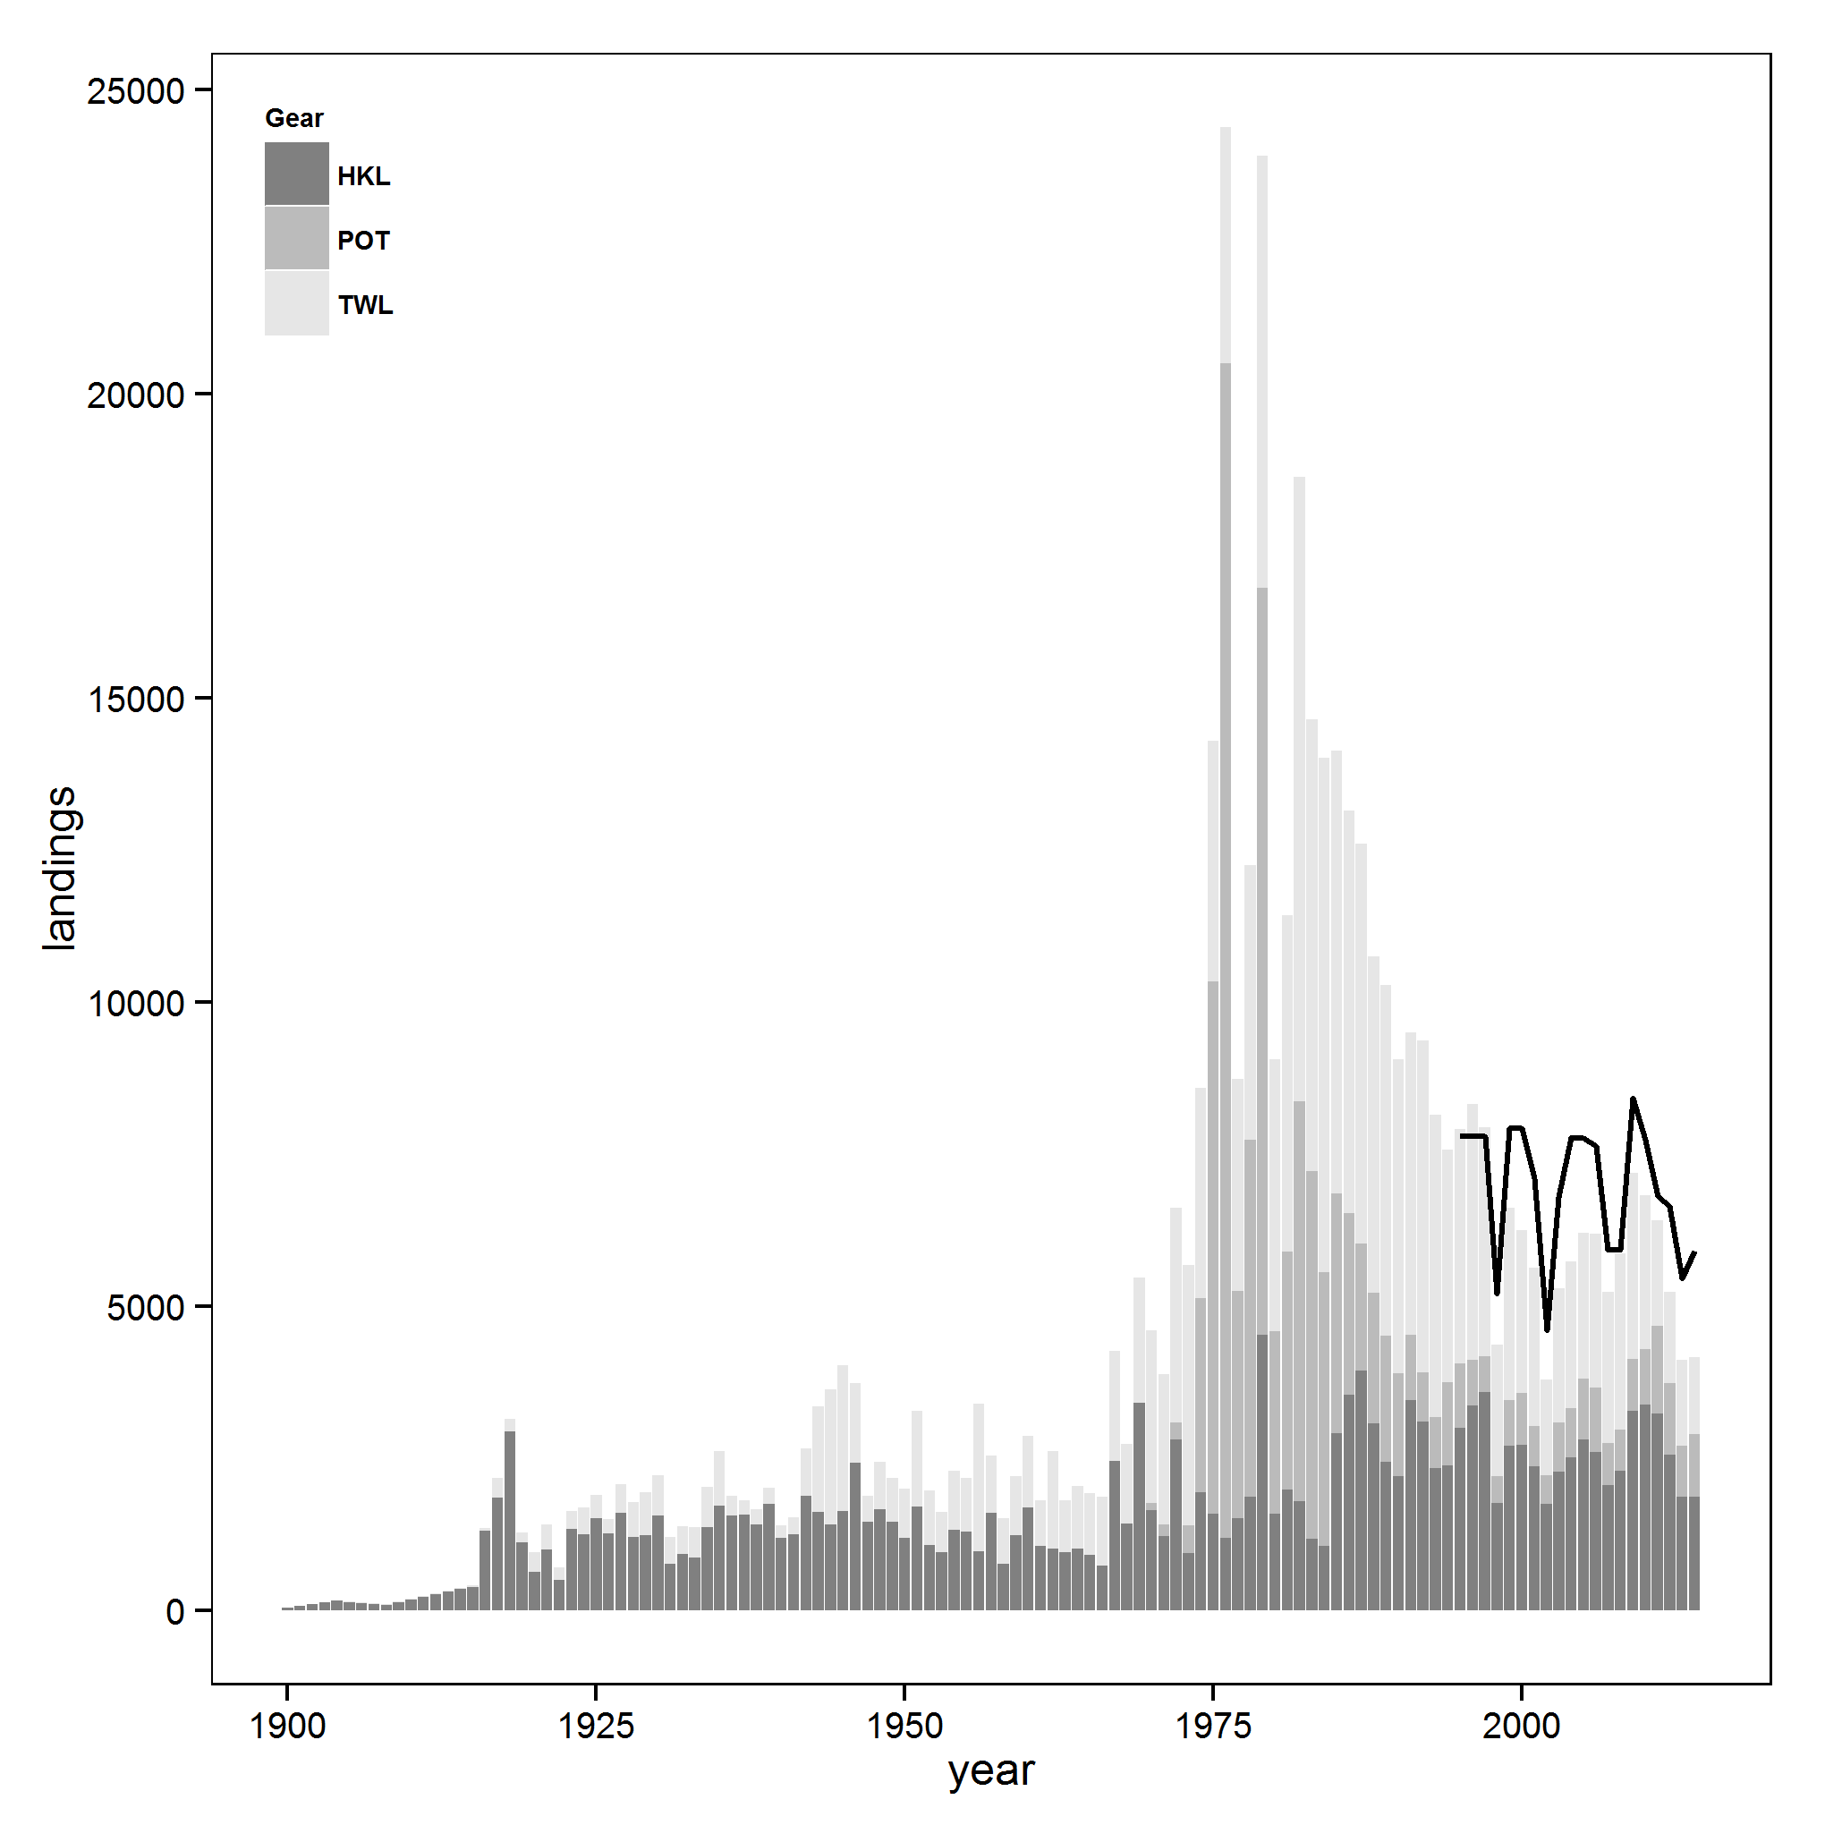

Figure 1. Reconstructed sablefish landings (mt; total catches less discards) from 1900 to 2014 by gear type: hook and line, pot, and trawl for all fisheries. Landings include those from foreign vessels, which are largely responsible for the peak landings in 1976 and 1979. Black line indicates the harvest guideline (1995-1997), optimum yield (1998-2010), or annual catch limit (2011-2014) for all gear types and all areas from 1995 to 2014.

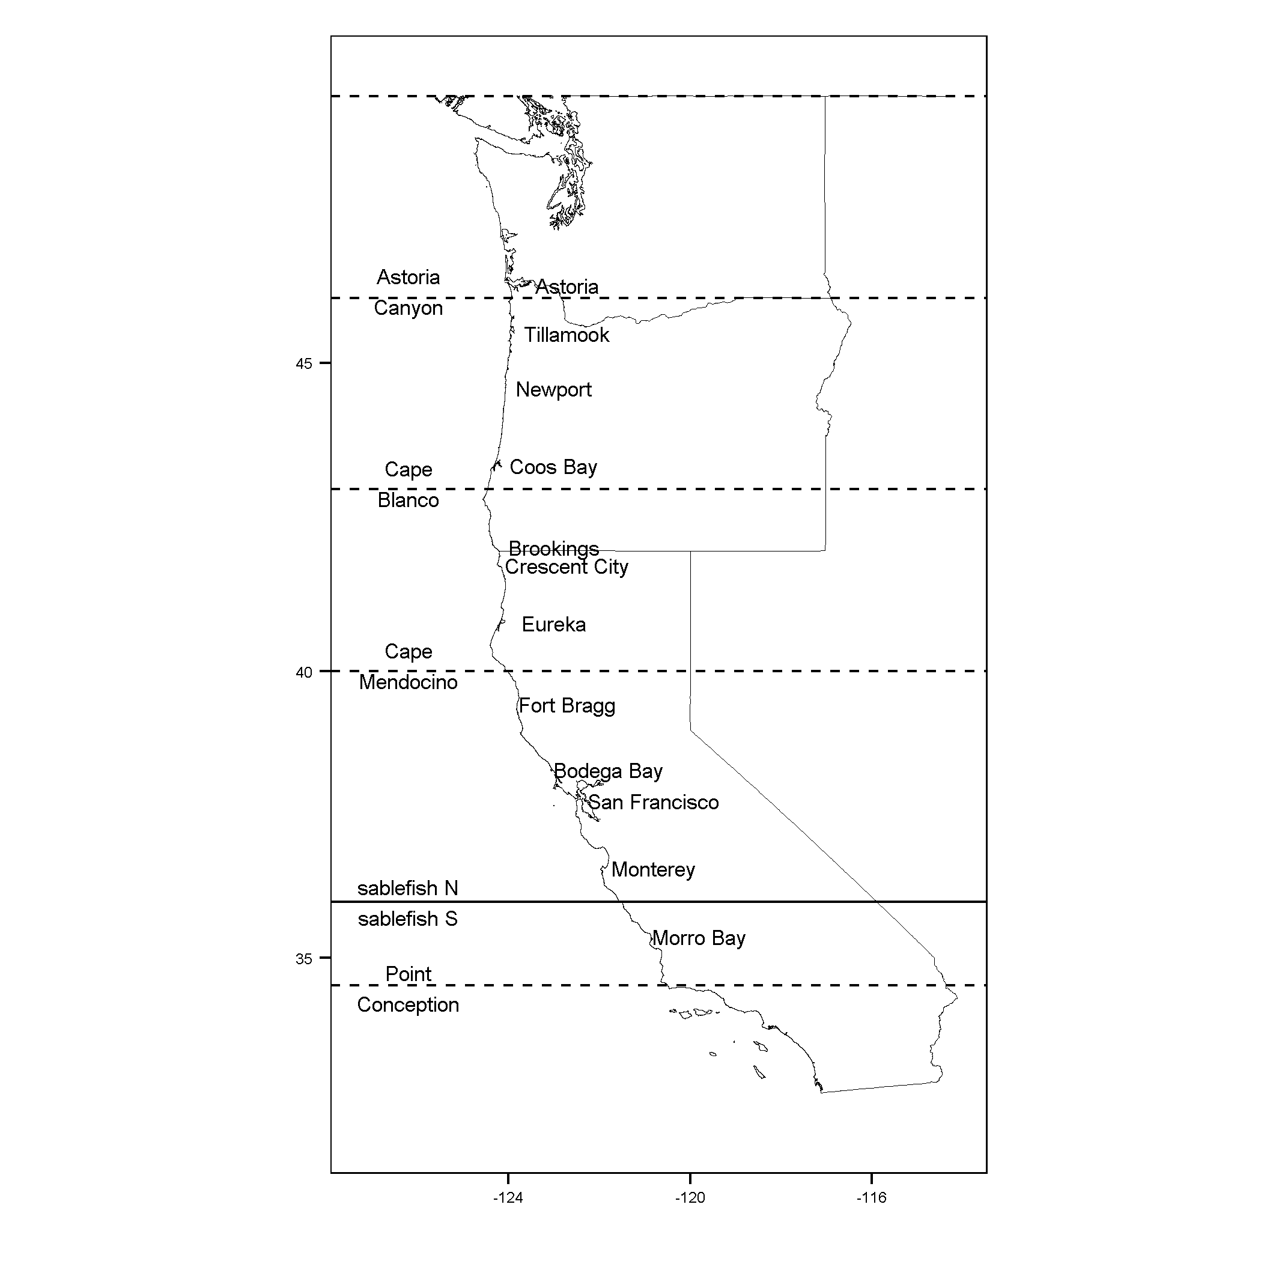

Figure 2. The geographical extent of the US West Coast groundfish fishery with dashed latitudinal lines depicting stratum used to separate between major biogeographical features: (A) Astoria Canyon, (B) Cape Blanco, (C) Cape Mendocino, and (D) Point Conception. Unique port groups from north to south include: (a) Washington; (b) Astoria and Tillamook; (c) Newport; (d) Coos Bay; (e) Brookings and Crescent City; (f) Eureka; (g) Fort Bragg; (h) San Francisco and Bodega Bay; and (i) Monterey and Morro Bay. The port group Monterey and Morro Bay was excluded from the analysis because the data span the north south management line use for sablefish quota allocations at 36°N latitude.

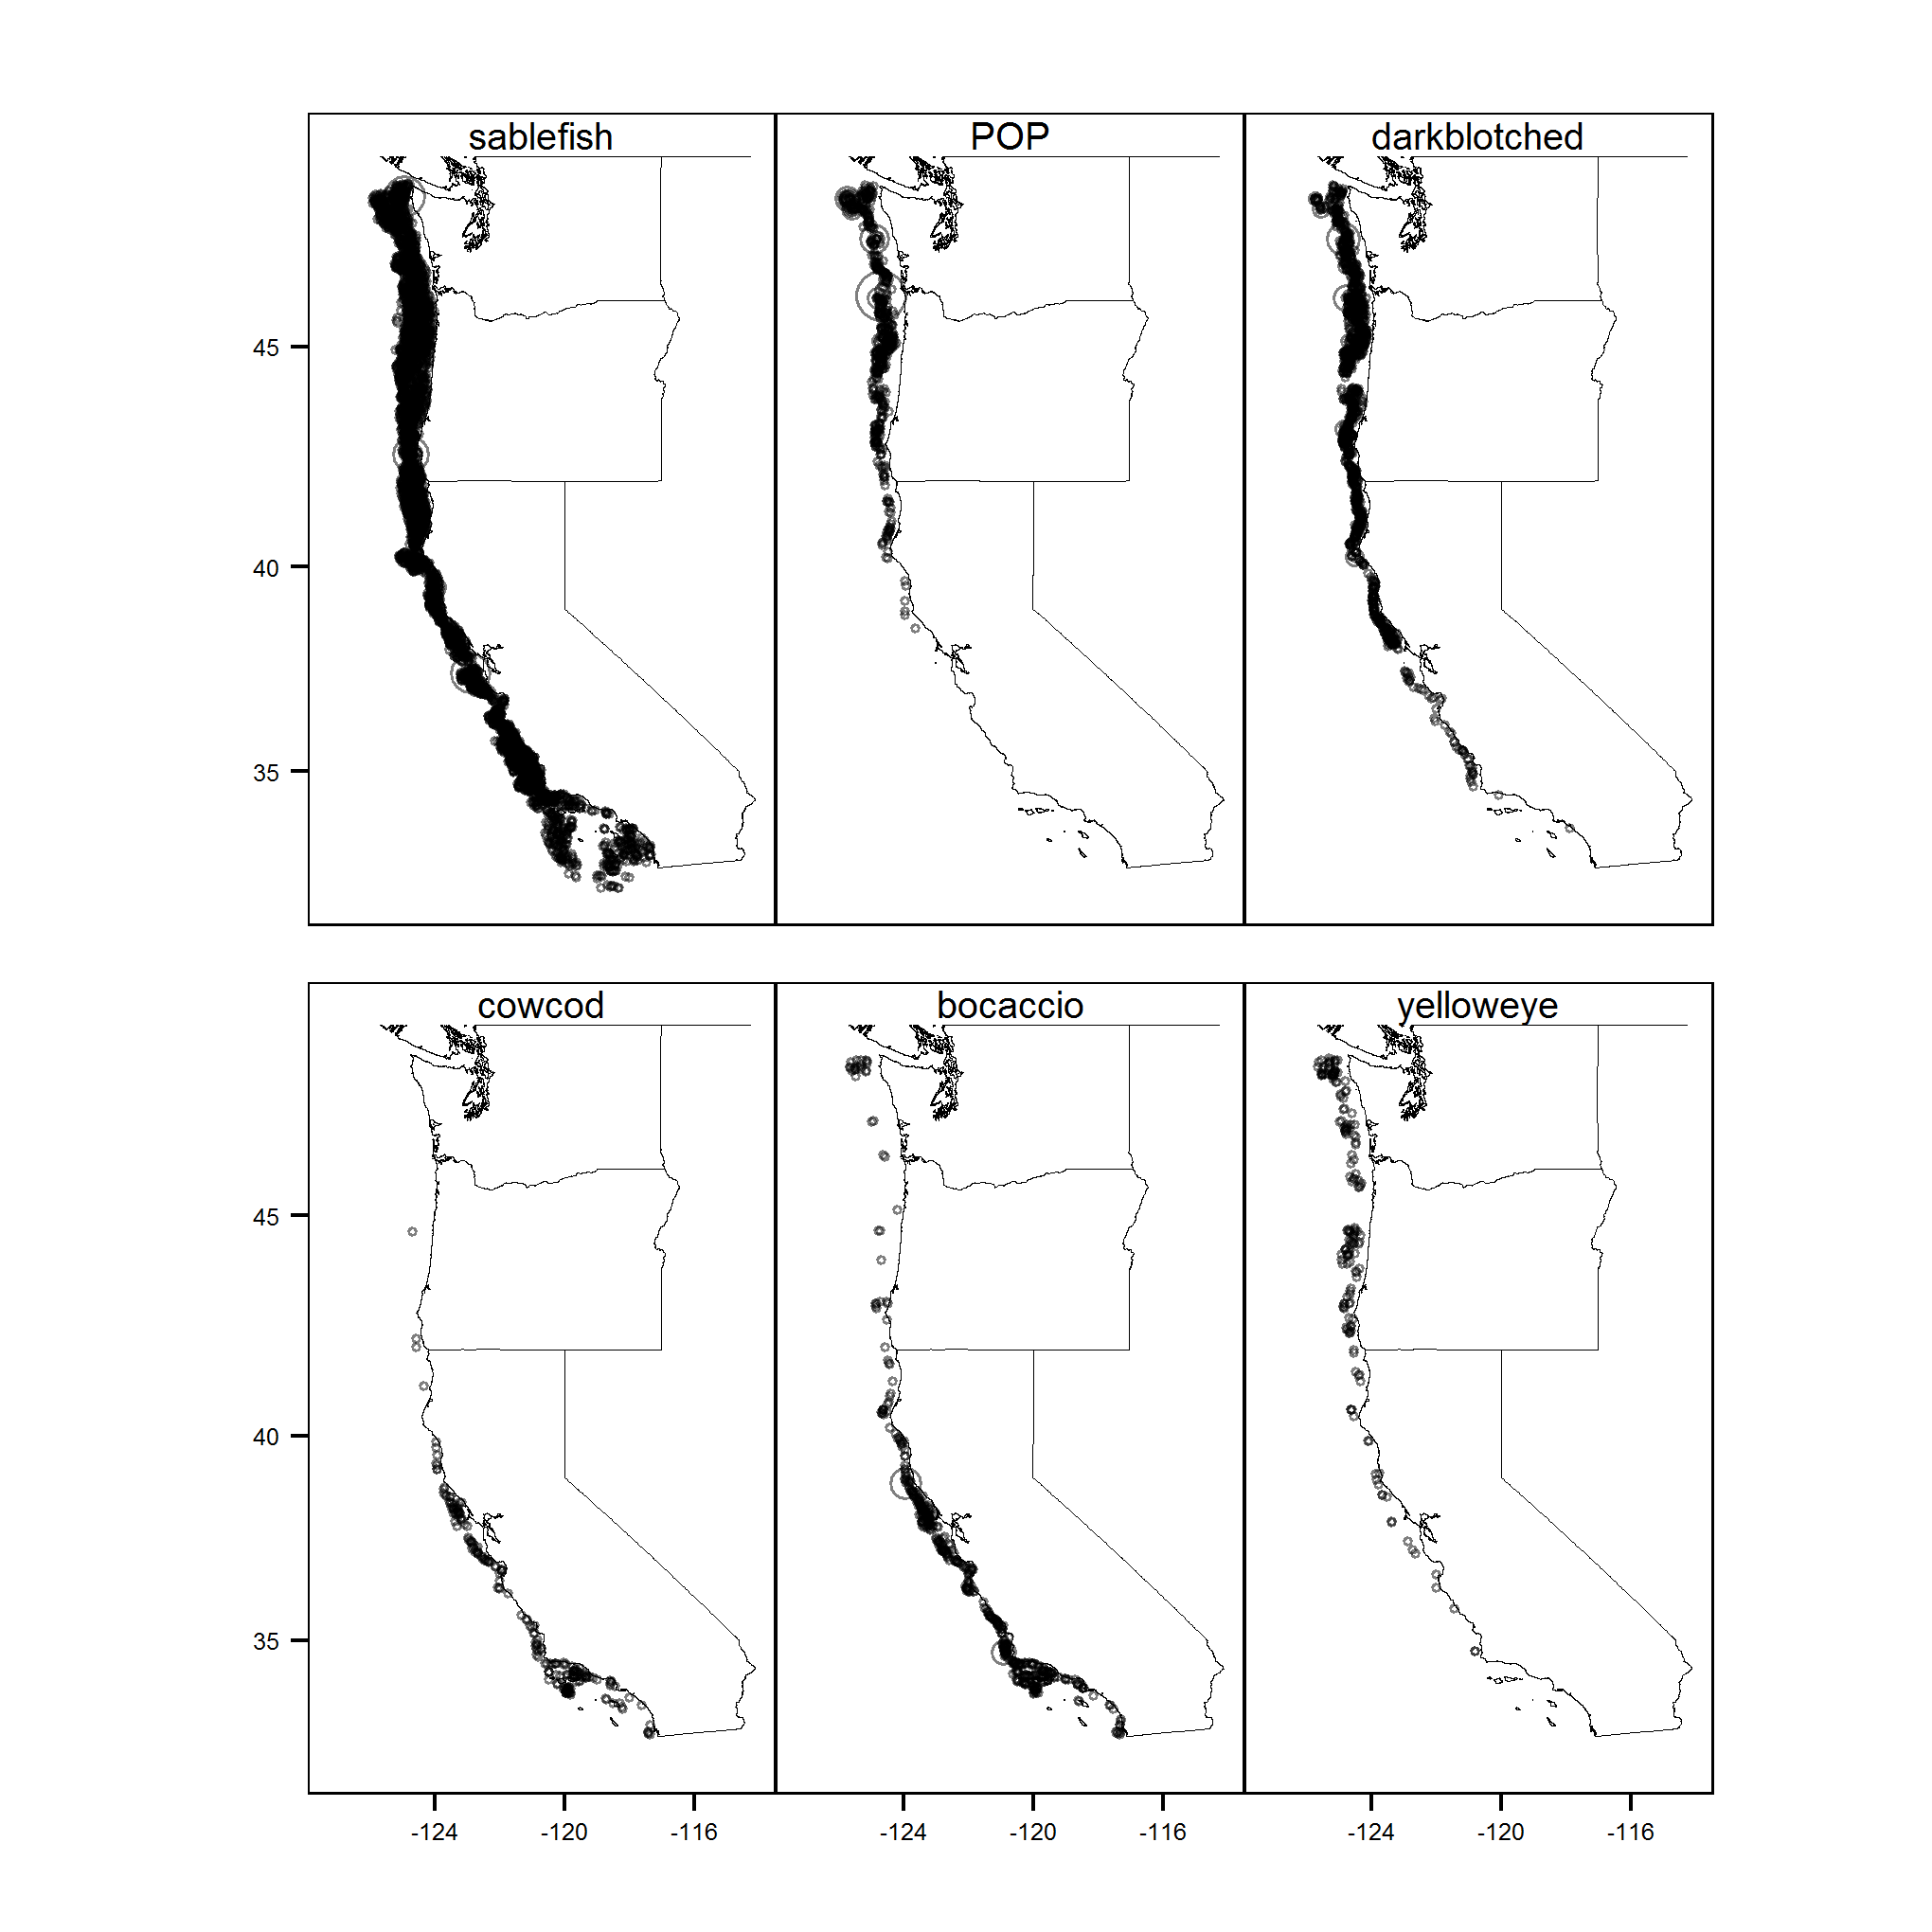

Figure 3. Positive tows (kg) from the Northwest Fisheries Science Center Shelf-Slope survey from 2003 to 2014. Panels display data for a single species across all years, where the size of the transparent circle is relative to the species specific weight in a given tow. From left to right, top to bottom, species are: sablefish, Pacific ocean perch (POP), darkblotched rockfish, cowcod rockfish, boacaccio rockfish, and yelloweye rockfish.

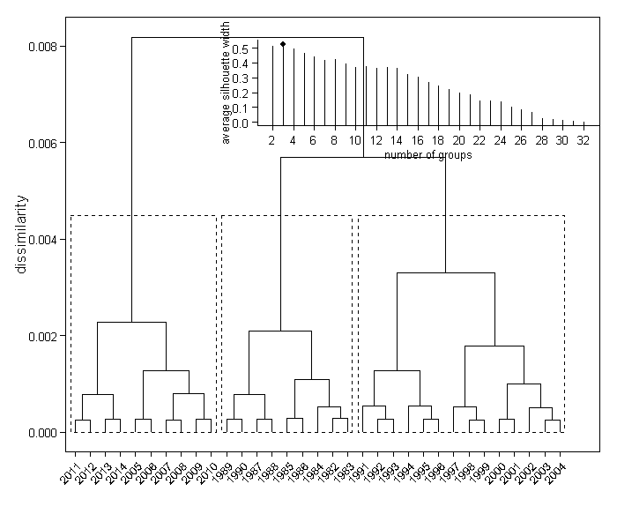

Figure 4. A dendrogram derived from a hierarchical clustering algorithm applied to gear-specific landings from the US West Coast sablefish fishery. Upper inset shows the average silhouette width used to determine the optimal number of clusters (3). Optimal clustering is denoted by dashed black boxes.

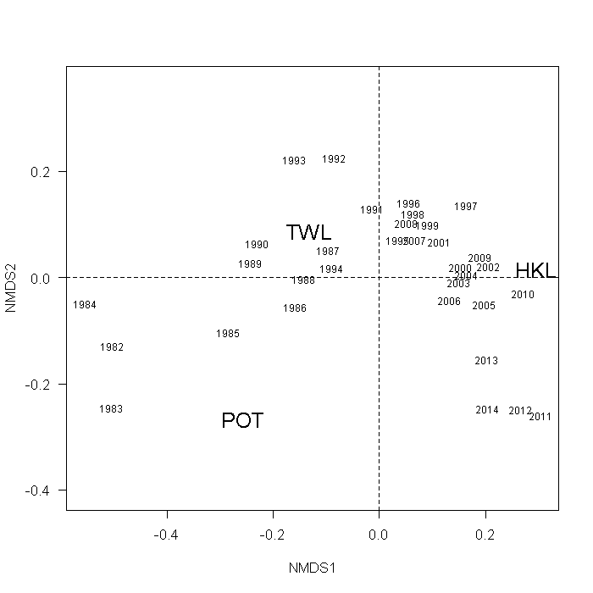

Figure 5. Two-dimensional non-metric multidimensional scaling (NMDS) results of the proportion of sablefish landings caught by gear type from 1982 to 2014. Gear types include pots (POT), hook and line (HKL), and trawl (HKL) gears.

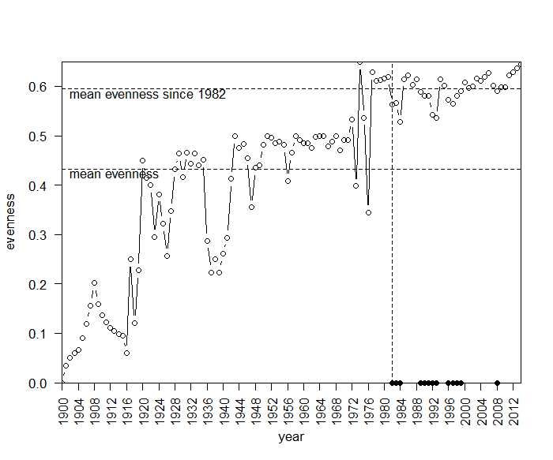

Figure 6. Simpson diversity index of landings by gear type for the US West Coast sablefish fishery. Higher values indicate increasing evenness among landings from each gear type. Landings by gear type were summed across all port groups for a given year. Vertical dashed line at 1982 indicates the first year that federal management regulations were implemented in the fishery. Horizontal dashed lines indicate mean evenness for a given range of years: 1900 to present (lower) and 1982 to present (upper). Black marks on the x axis indicate years where the evenness is below the mean evenness since 1982.

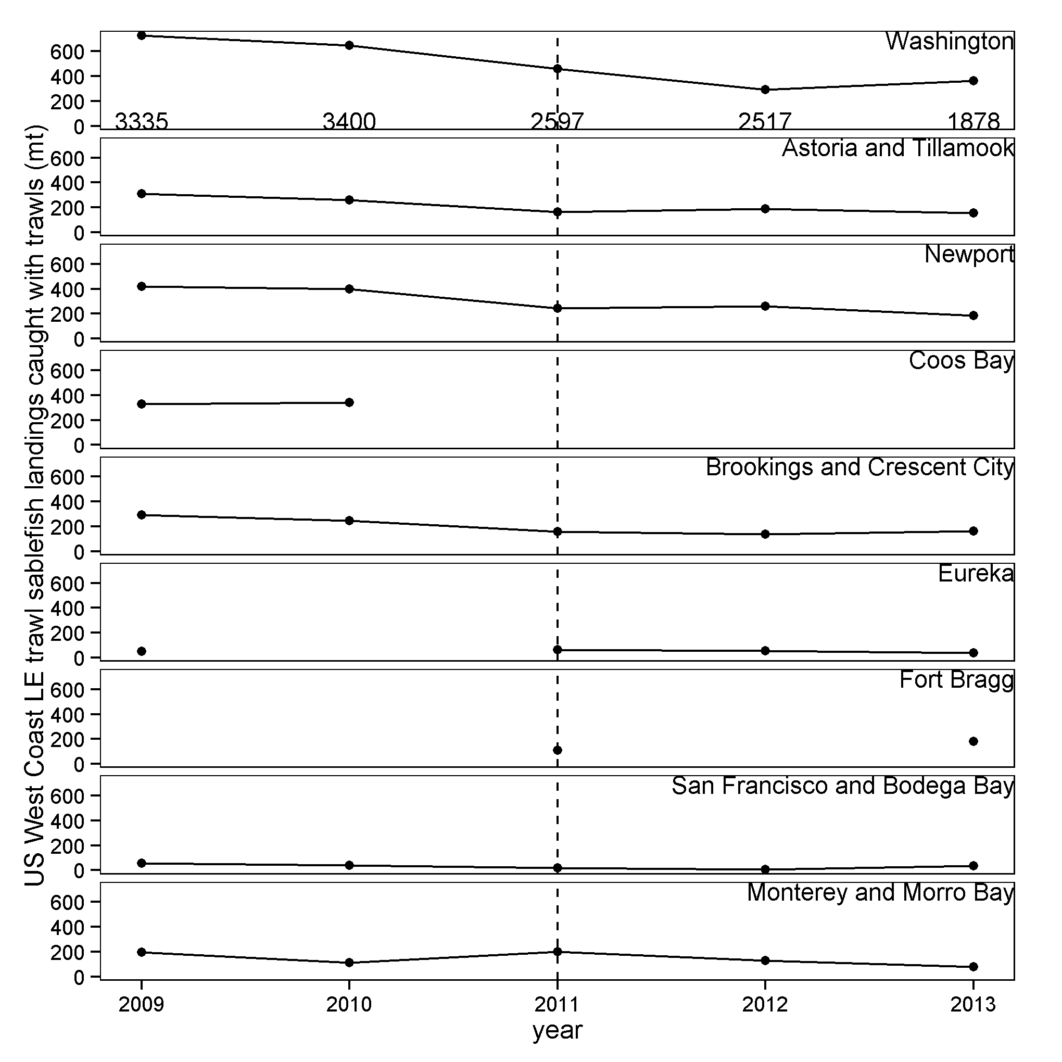

Figure 7. Landings (catch minus discards; mt) of sablefish caught by the Limited Entry (LE) trawl sector of the US West Coast groudfish fishery using trawl gear from 2009 to 2013 by port group (rows). Port groups are listed geographically from north (top) to south (bottom). Numerical values on the x-axis of the top row are annual catch limits (optimal yields prior to 2011) assigned to the LE trawl sector of the US West Coast groundfish fishery fishing north of 36°N latitude and the vertical dashed line indicates the implementation of an individual transferable quota system. Missing data points had reported landings but data were withheld to protect vessel confidentiality.

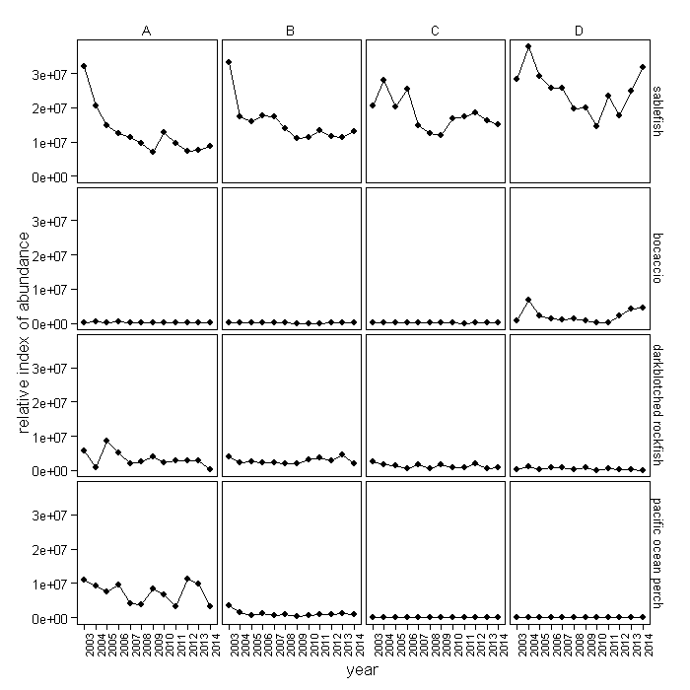

Figure 8. Species-specific relative indexes of abundances by latitudinal stratum estimated from delta-generalized linear mixed effects models fit to data from the Northwest Fisheries Science Shelf-Slope survey trawl. Three latitudinal stratum (columns) were included, representing prominent biogeophysical features along the US West Coast: (A) Astoria Canyon (46°15’N), (B) Cape Blanco (42°50’N), (C) Cape Mendocino (40°26’N), and (D) Point Conception (34°27’N). Results are presented for three overfished species (bocaccio rockfish (“bocaccio”), darkblotched rockfish (“darkblotched”), and Pacific ocean perch (POP)) and sablefish (rows). Indices were generated using data from 2003 to 2014, but results are only shown for 2009 to 2013 because those represent the years for­­ which economic data was also available.

­­­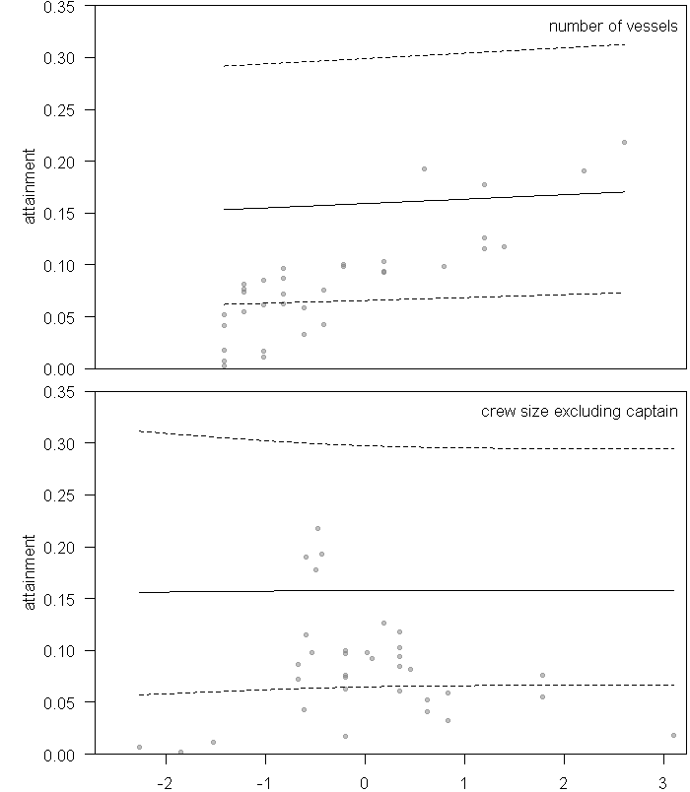

Figure 9. Marginal prediction intervals (90%; dashed lines) for number of vessels and crew, where each variable relates to the mean and precision parameters, respectively. Predictions are attainment within a port group, where attainment is the proportion of the annual catch limit of sablefish assigned to the Limited Entry trawl sector of the US West Coast groundfish fishery landed in a port group by trawl gear. Rug marks on axes indicate observed levels for each predictor value.

Appendix 1

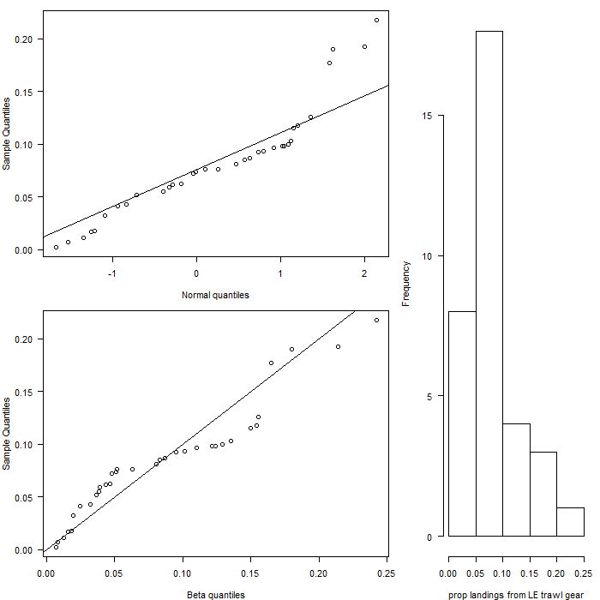

A1 1. Comparisons between sample and theoretical quantiles for a standard normal distribution (upper) and a beta distribution with mean of 0.083 and variance of 0.0035 (lower). Histogram displays the frequency of proportions of port specific sablefish landings caught using trawl gear within the limited entry (LE) groundfish trawl fishery (right). The distribution of the response variable was better fit by a beta distribution, with a mean of 0.083 and variance of 0.0035, than a standard normal distribution.

Convergence diagnostics of delta-GLMMs for index of abundance data regarding each modelled species.