Kelli Nakamura

2/20/2021

IT FDN 103 A

Assignment 06

SQL Views

# Introduction

In this paper, I will be explaining when to use SQL views the differences and similarities between a view, function, and stored procedure.

# SQL Views

SQL views are saved select statements which allow you to run a simple Select statement using just the view name after creating the view, rather than rewriting the entire script every time. In Figure 1, you can easily see the differences between the length of the select statement used in creating the view versus running the select statement script to extract the data from the view. You can create reporting views to extract data for reporting purposes, which is extremely helpful and efficient when you need to run complex Select statements, or when you know the same SQL query will be ran more frequently. Base views are also saved select statements but are created for each table to show all data from the table. Base views should be created every time a table is created. A picture containing graphical user interface

***Figure 1: Example of a script creating a view and then selecting the data from the view***

# View, Function, and Stored Procedure

SQL views, functions, and stored procedures are all stored SQL statements with an associated name. Functions and stored procedures allow the use of parameters, while the view does not. In place of the parameters, you would use the Where clause in your view. Additionally, when creating functions, you can write the script to return a single value as an expression, which is not possible with a view or stored procedure. While the script for a view, function, and stored procedure are similar, there are small differences in the script (Figure 2).

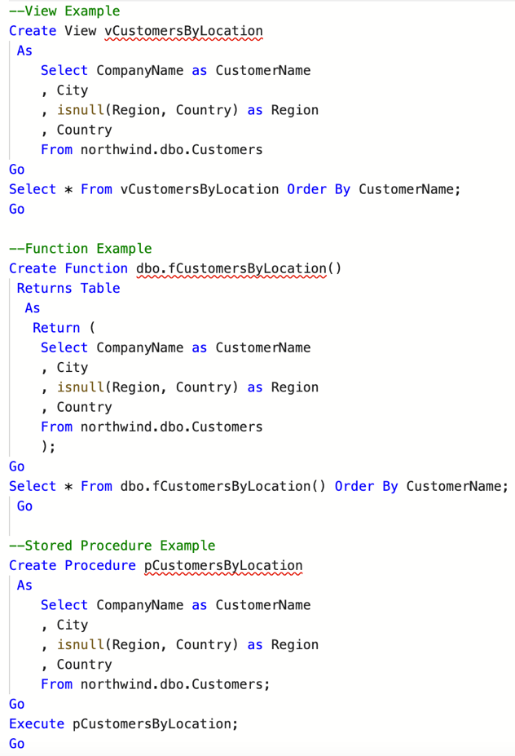

***Figure 2: Example of SQL view, function, and stored procedure scripts***

In the example, you can see that the function requires “Returns Table” and “Return” within the script, whereas the view and procedure just require the create statement along with the select statement. Additionally, the Select statement is used to extract the result set from the view or function, whereas you would use the Execute statement for stored procedures.

# Summary

In summary, views are extremely helpful and allow for efficiency and at minimum, a base view should be created for every table within the database. To provide for efficiency in extracting data, especially with complex statements, views, functions, or stored procedures can be created but the author should be aware of the small differences between the three options.