Agentic AI and OpenClaw: Why It Matters for Doctors
Prompter: Dr KL Cheung
April 2026

Agentic AI and OpenClaw: Why It Matters for Doctors
Prompter: Dr KL Cheung
Artificial intelligence is already part of daily professional life. Many doctors have used a chatbot to summarise a paper, draft an email, or explain a guideline in simpler language. The newer development is more important. Some systems do more than answer questions. They can search for information, use software tools, carry out several steps, and return a draft or result that is closer to completed work. This is the basic idea behind agentic AI. A chatbot mainly generates replies. An agent can also take actions through tools, usually within limits set by the user.[1,2]
That difference matters because much of clinical work is not one question followed by one answer. It is a string of small tasks: finding the right document, comparing sources, drafting a reply, organising the result, and deciding what should happen next. Agentic AI is attracting attention because it may help with part of that chain instead of only producing fluent text.

Beyond the chatbot
Major technical groups now describe AI agents in broadly similar terms. OpenAI defines agents as systems that can independently accomplish tasks on a user’s behalf, rather than simple chatbots that only produce one-off replies.[1] Anthropic makes a similar distinction between fixed workflows and agents that can decide which tool to use and what step should come next.[2] The change is therefore not simply better text generation. It is the combination of planning, memory, tool use, and the ability to continue across multiple steps.
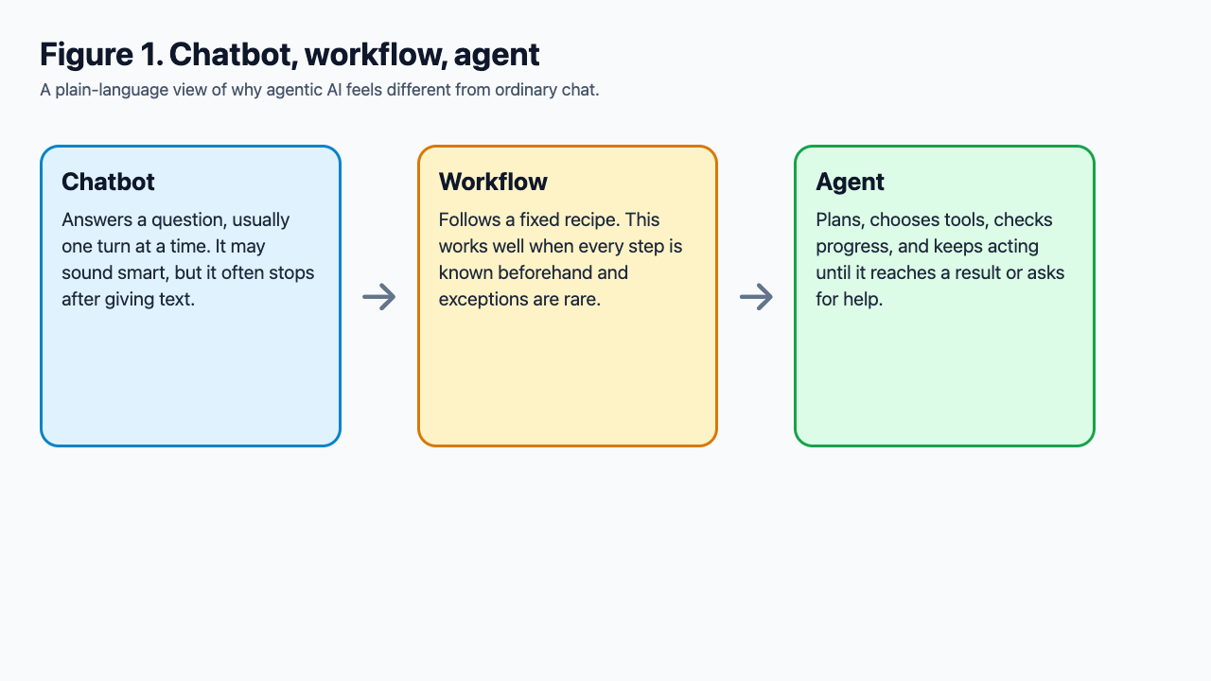
Figure 1. Chatbot, workflow, and agent. Original figure created for this article. Concept source pages: OpenAI practical guide to building agents (https://openai.com/business/guides-and-resources/a-practical-guide-to-building-ai-agents/) and Anthropic Building Effective AI Agents (https://www.anthropic.com/research/building-effective-agents).
For doctors, this matters because clinical life is full of fragmented digital work. We move between messages, references, calendars, notes, audit files, rosters, and hospital systems throughout the day. A useful agent may help by gathering information, drafting a summary, or preparing the next step with less manual switching. In the near term, that may matter more than any grand claim about fully autonomous clinical intelligence.

Why OpenClaw is getting attention
OpenClaw has become a visible example of this new direction because it makes the idea easy to understand. Its official site describes an open-source personal AI assistant that runs on the user’s own machine and works through familiar chat apps such as WhatsApp, Telegram, Discord, Slack, Signal, and iMessage.[3] Its launch post describes it as an open agent platform that runs on your machine and works from the chat apps you already use.[4] This helps explain why it has attracted attention. It makes the agent feel less like another website and more like an assistant sitting inside familiar tools.
OpenClaw is only one example. Other systems emphasise different things. Hermes Agent focuses on memory, reusable skills, scheduling, and cross-platform automation.[5] OpenManus is more a builder’s framework.[6] Manus is a hosted product for longer delegated tasks in a controlled virtual environment, while Perplexity is strongest when the main job is research, synthesis, and clean deliverables with little setup.[7-9] In Hong Kong, Manus has appeared in university-facing tool directories, while Perplexity has become more visible through HKT promotions for Perplexity Pro.[10,11] The wider point is that AI is moving from chat-only interfaces towards systems that can carry out multi-step work. 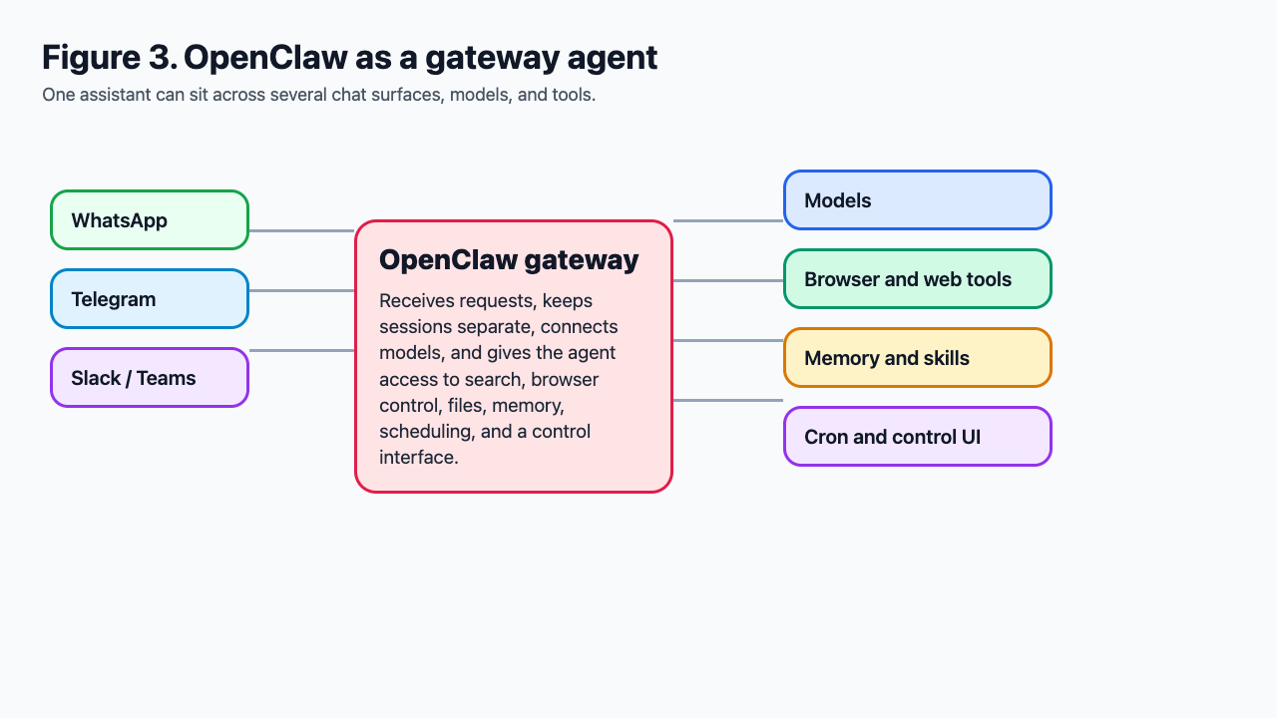

Useful is not enough
The strengths of AI agents are easiest to see in information-heavy and repetitive work. A doctor might ask an agent to collect recent guidance on a topic, draft a journal club note, prepare teaching slides, summarise a meeting, compare two policies, or organise travel for a conference. In personal life, the same type of system might handle reminders, routine messages, or trip planning. The attraction is simple: less manual work and fewer small interruptions.
But usefulness is not the same as accuracy, and accuracy is not the same as dependability. A tool may save time and still be wrong. It may work once and fail in a slightly different context. It may produce a polished note that leaves out something important. In medicine, those distinctions matter. WHO has warned that large multimodal and generative AI systems may be useful across care, education, administration, and research, but can also produce inaccurate, biased, or incomplete output and worsen automation bias if poorly governed.[12] NIST has likewise stressed that agentic systems raise added security and evaluation problems because they can act through tools and may exploit weaknesses in the surrounding environment or even the benchmark itself.[13,14]
The practical message for clinicians is straightforward. Utility asks whether the tool saves time or mental effort. Accuracy asks whether the content is correct for the task at hand. Reliability asks whether the system remains safe and dependable across repeated use. Current agents may do reasonably well on the first question before they do well enough on the other two.

Which agent for which job?
For clinicians, the main differences between current products are less about raw capability than about where the system runs, how much supervision it needs, and what kind of work it is designed to do. OpenClaw is attractive to users who want more local control and are comfortable running the system themselves.[3,4] Hermes Agent is closer to a persistent personal assistant with memory, scheduled jobs, reusable skills, and subagents, which may suit users who want one agent to work across several channels over time.[5] OpenManus is more a builder’s framework than a polished end-user product.[6] Manus is a hosted worker for longer delegated tasks inside a controlled virtual computer.[7] Perplexity is strongest when the main need is research, synthesis, and polished deliverables.[8,9] For most doctors, the real question is not which product is best in general, but which one fits the task, the sensitivity of the data, and the amount of supervision available.

The doctor’s second shift
The most realistic uses for doctors are administrative and organisational. Agents can monitor a literature topic, prepare a morning digest, draft a departmental memo, tidy rough notes into a report, generate patient information text for review, or assemble background material for audit and quality-improvement work. In Hong Kong practice, plausible examples include preparing a teaching summary, organising audit material, producing bilingual patient instructions for clinician review, or listing follow-up actions after a committee meeting. These are small jobs, but they fill the doctor’s second shift: the invisible work that continues after the clinical shift has ended.
Direct evidence for fully agentic systems in clinical care is still limited. However, early studies of adjacent tools such as ambient scribes and AI-assisted inbox work give a sense of where workflow support may help. In Stanford studies, ambient AI scribes and AI-generated inbox replies were associated with lower perceived burden or reduced documentation time in some settings, although benefits were variable and not always accompanied by measurable time savings.[15-17] In emergency medicine specifically, early work suggests potential value in documentation support, but trust and accuracy remain important limitations.[18] That is probably the right frame for agentic AI in clinical work today. It is best seen as supervised assistance for documentation, communication, preparation, and workflow support rather than autonomous clinical judgement.
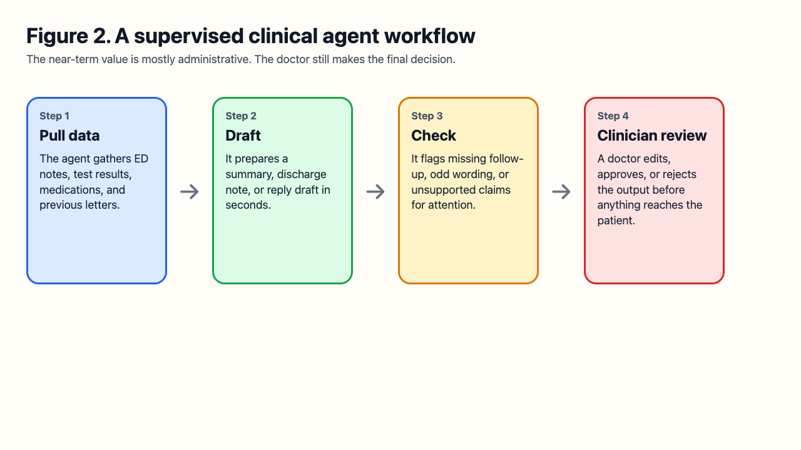
Figure 3. A supervised clinical agent workflow. Original figure created for this article. Concept source pages: WHO guidance on large multi-modal models in health (https://www.who.int/publications/i/item/9789240084759) and JMIR emergency department ambient scribe study (https://formative.jmir.org/2026/1/e80401).
A realistic near-term workflow would be this: the agent gathers recent notes, test results, medication changes, and relevant guidance, prepares a draft summary or discharge instruction, flags missing follow-up points, and then stops for clinician review. That is very different from allowing an unsupervised model to diagnose, prescribe, or decide disposition. The first is becoming plausible for selected low-risk tasks. The second still demands caution.

The cautious horizon
The long-term attraction of agentic AI is automation without constant prompting. A mature agent might quietly monitor inboxes, prepare routine summaries, track incomplete tasks, or assemble the first draft of a clinic or departmental workflow before anyone asks. For busy doctors, that may mean less routine administrative burden. Even so, the more capable the system becomes, the more important governance becomes. Permissions, privacy boundaries, logging, human approval, and audit trails are necessary safeguards if these systems are to be used safely.
Agentic AI and OpenClaw therefore deserve attention, but not because they promise an autonomous doctor. They matter because they suggest a practical model for supervised digital assistance. For clinicians, the immediate value is likely to be practical rather than dramatic: less clerical work, faster first drafts, and better handling of scattered information. That is useful, but only if the systems are used with clear limits, proper oversight, and careful attention to privacy and accuracy. For now, the most credible role is as a supervised administrative or documentation assistant, not an independent clinical decision-maker.

References
[1] OpenAI. A practical guide to building agents. 2025. Available from: https://openai.com/business/guides-and-resources/a-practical-guide-to-building-ai-agents/ Accessed 22 Apr 2026.
[2] Anthropic. Building Effective AI Agents. 2024 Dec 19. Available from: https://www.anthropic.com/research/building-effective-agents Accessed 22 Apr 2026.
[3] OpenClaw. OpenClaw — Personal AI Assistant. Available from: https://openclaw.ai/ Accessed 22 Apr 2026.
[4] Steinberger P. Introducing OpenClaw. OpenClaw Blog. 2026 Jan 29. Available from: https://openclaw.ai/blog/introducing-openclaw Accessed 22 Apr 2026.
[5] Nous Research. Hermes Agent documentation. Available from: https://hermes-agent.nousresearch.com/docs/ Accessed 22 Apr 2026.
[6] OpenManus. Open-source framework for building AI agents. Available from: https://openmanus.github.io/ Accessed 22 Apr 2026.
[7] Manus. Welcome - Manus Documentation. Available from: https://manus.im/docs/introduction/welcome Accessed 22 Apr 2026.
[8] Perplexity. Introducing Perplexity Deep Research. 2025 Feb 14. Available from: https://www.perplexity.ai/hub/blog/introducing-perplexity-deep-research Accessed 22 Apr 2026.
[9] Perplexity. Introducing Perplexity Labs. 2025 May 29. Available from: https://www.perplexity.ai/hub/blog/introducing-perplexity-labs Accessed 22 Apr 2026.
[10] Hong Kong Metropolitan University. ZoomIt tool page mentioning Manus. Available from: https://www.hkmu.edu.hk/oetools/zoomit/ Accessed 22 Apr 2026.
[11] HKT/csl. HKT x Perplexity Pro promotion. 2025. Available from: https://www.hkcsl.com/en/hkt-perplexitypro-launch-2025/ Accessed 22 Apr 2026.
[12] World Health Organization. Ethics and governance of artificial intelligence for health: Guidance on large multi-modal models. 2025 Mar 25. Available from: https://www.who.int/publications/i/item/9789240084759 Accessed 22 Apr 2026.
[13] National Institute of Standards and Technology. AI Agent Standards Initiative. 2026. Available from: https://www.nist.gov/caisi/ai-agent-standards-initiative Accessed 22 Apr 2026.
[14] Hamin M, Edelman B. Cheating on AI Agent Evaluations. NIST CAISI. 2026. Available from: https://www.nist.gov/caisi/cheating-ai-agent-evaluations Accessed 22 Apr 2026.
[15] Baxter SL, Apathy NC, Cross DA, Sinsky CA, Hribar MR, Longhurst CA, et al. Artificial intelligence-generated draft replies to patient inbox messages. JAMA Netw Open. 2024;7(3):e243201. Available from: https://pmc.ncbi.nlm.nih.gov/articles/PMC10955355/
[16] Ma SP, Liang AS, Shah SJ, Smith M, Jeong Y, Devon-Sand A, et al. Ambient artificial intelligence scribes: utilization and impact on documentation time. J Am Med Inform Assoc. 2025. Available from: https://pmc.ncbi.nlm.nih.gov/articles/PMC11756633/
[17] Crittenden M, Liang AS, Shah SJ, Smith M, Jeong Y, Crowell T, et al. Ambient artificial intelligence scribes: physician burnout and perspectives on usability and documentation burden. J Am Med Inform Assoc. 2025. Available from: https://pmc.ncbi.nlm.nih.gov/articles/PMC11756571/
[18] Lo A, Oh YK, Kim K, et al. Emergency physician perceptions of ambient AI scribe for real-time clinical documentation in the emergency department: a pilot study. JMIR Form Res. 2026;10:e80401. Available from: https://formative.jmir.org/2026/1/e80401

