**Exercise_Inheritance**

Create an Information System for an insurance company with the following functionality:

1. Prints all stored insurances (life and health) for all customers.
2. Prints all stored insurances (life and health) for a given customer.
3. Prints details and type of for a given insurance .

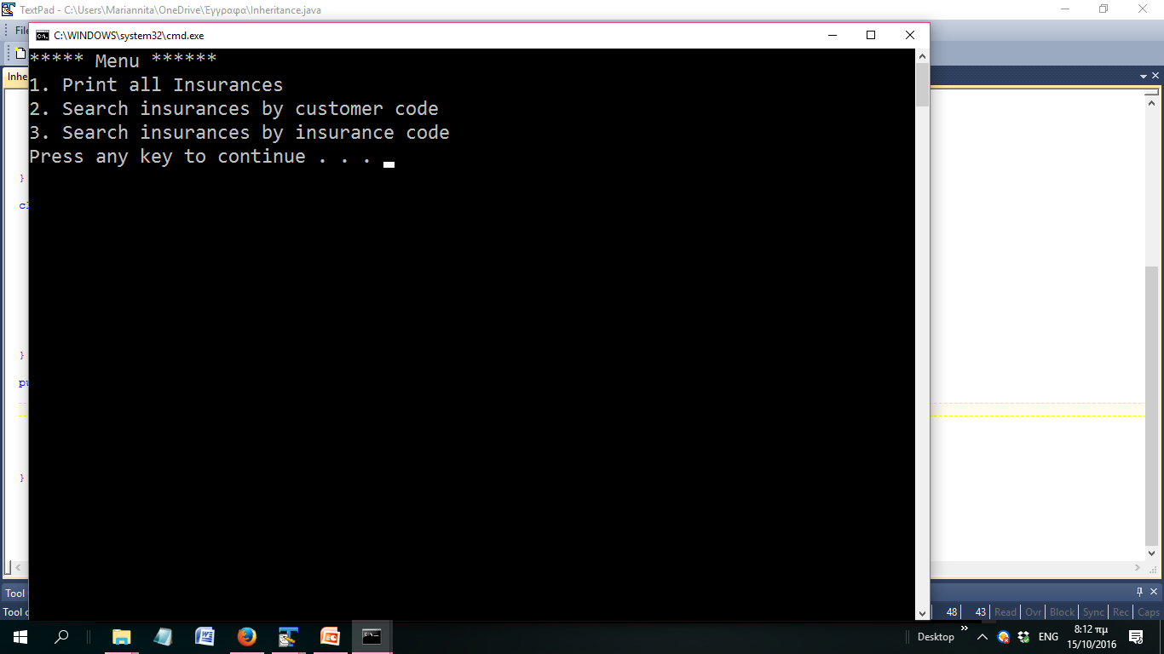

* Run this menu until customer inserts “0”
* If an insurance or customer code does not exists do not exit program but inform him that the code is not valid and give him the chance to insert a new one

**Customer Class**

* + Described by : customer’s code (auto-increment) name, year of birth and sex (male / female)
  + Contains methods:
    - Getters/setters
    - toString()

Each generated Customer object should be stored in an array (length=10).

**Insurance Class**

* Described by: insurance code (auto-increment ) , duration and customer. (The instance variables declared as private)
* Contains methods:
  + Setters/getters
  + toString ()
  + method for calculating insurance_cost returning:
    - A fixed price of 100 euro:
  + method for printing all stored insurances
  + method for printing a particular insurance (argument : insurance code)

Each generated Insurance object should be stored in an array (length=10).

**Life Class**

* + Extending Insurance class and further described by:
    - the amount the customer decides to invest.
    - Getters/setters
    - toString()
  + Cost calculation : 100 euro plus 5 for every Customer’s year and 5% of the invested amount

Each generated Life object should be stored in an array (length=10).

**Health Class**

* + Extending Insurance class and further described by:
    - the medical expense the customer wants.
    - Getters/setters
    - toString()
  + The cost calculation is 100 euro plus 7 for every Customer’s year and , 50 euros if he is a man and 2,5 % of medical expense

Each generated Health object should be stored in an array (length=10).