

Experimental and theoretical probability
  - Authors: Kelly Findley, Ian Whitacre, & Sebnem Atabas

Pre-Planning

LEARNING GOALS
- Day 1
  - Understand probability as a numeric value representing the likelihood of a possibility.
  - Calculate the probability of something using the “how many out of how many” formula when all possibilities are equally likely.
  - Recognize that the “how many out of how many” formula doesn’t work when all possibilities are not equally likely.
  - Understand sample space as the collection of all possibilities and define terms (e.g., clean and sloppy) to describe when possibilities are all equally likely or not.
- Day 2
  - Be familiar with vocabulary terms “trial” and “experiment.”
  - Calculate experimental probability and use it to make predictions for the frequency of a possibility happening.
  - Associate more trials with more consistent or trustworthy results.
- Day 3
  - Distinguish outcome (building-block possibilities in a trial) from event (collection of one or more outcomes we have an interest in).
  - Define the complement of an event as the collection of left-over outcomes not included in that event.
  - Distinguish Theoretical probability (the probability of an event based on all of the information) from Experimental probability (the probability of an event based on some of the information).
- Day 4
  - Recognize that experimental results with limited data may cloud our ability to see the sample space as clean or sloppy. In other words, distributions may be “disguised” with limited data, but become more “exposed” with lots of data.
  - Use theoretical probabilities to make predictions when all information is known, otherwise use experimental probabilities.
- Day 5
  - Distinguish simple event (event involving one trial) from compound event (event involving two or more trials)
  - Recognize how to define a clean sample space when working with compound trials.
  - Calculate theoretical probabilities from compound trials to make predictions
- Day 6
  - Begin to distinguish clean sample space vs. sloppy in terms of “paths” vs. “landing points.”
  - Reason about compound events using probability trees.
- Day 7
  - Organize compound trial data in tables
  - Calculate experimental probabilities from data tables and use those probabilities to make predictions
- Days 8-9
  - Develop an awareness of plinko as a tool to simulate results with a set theoretical probability and set number of trials
  - Apply theoretical probabilities to make predictions involving compound trials (e.g., connect a ball bouncing right 16 times out of 20 as most likely to happen with a theoretical probability of 0.80)
  - Recognize that there is variability/uncertainty in making exact predictions with probability.
  - Use experimental results to predict theoretical probability within a system
  - Recognize that experimental probability approaches theoretical probability as number of trials increases

Standards Addressed
- CCSS.Math.Content.7.SP.C.5
Understand that the probability of a chance event is a number between 0 and 1 that expresses the likelihood of the event occurring. Larger numbers indicate greater likelihood. A probability near 0 indicates an unlikely event, a probability around 1/2 indicates an event that is neither unlikely nor likely, and a probability near 1 indicates a likely event. [DAY 1]
- CCSS.Math.Content.7.SP.C.6
Approximate the probability of a chance event by collecting data on the chance process that produces it and observing its long-run relative frequency, and predict the approximate relative frequency given the probability. For example, when rolling a number cube 600 times, predict that a 3 or 6 would be rolled roughly 200 times, but probably not exactly 200 times. [DAYS 2, 4]
- CCSS.Math.Content.7.SP.C.7.a
Develop a uniform probability model by assigning equal probability to all outcomes, and use the model to determine probabilities of events. For example, if a student is selected at random from a class, find the probability that Jane will be selected and the probability that a girl will be selected. [DAYS 2, 4]
- CCSS.Math.Content.7.SP.C.7.b
Develop a probability model (which may not be uniform) by observing frequencies in data generated from a chance process. For example, find the approximate probability that a spinning penny will land heads up or that a tossed paper cup will land open-end down. Do the outcomes for the spinning penny appear to be equally likely based on the observed frequencies? [DAYS 2, 4, (5)]
- CCSS.Math.Content.7.SP.C.8.a
Understand that, just as with simple events, the probability of a compound event is the fraction of outcomes in the sample space for which the compound event occurs. [DAYS 5, 6, 7, (8, 9)]
- CCSS.Math.Content.7.SP.C.8.b
Represent sample spaces for compound events using methods such as organized lists, tables and tree diagrams. For an event described in everyday language (e.g., "rolling double sixes"), identify the outcomes in the sample space which compose the event. [DAYS 5, 6, 7, (8, 9)]
- ***CCSS.Math.Content.7.SP.C.8.c
Design and use a simulation to generate frequencies for compound events. For example, use random digits as a simulation tool to approximate the answer to the question: If 40% of donors have type A blood, what is the probability that it will take at least 4 donors to find one with type A blood? [Partially addressed in DAYS 8, 9 as well as optional advanced activity at the end]

Curriculum Alignment
GoMath Grade 7, Modules 12-13 (9 days)

Prior Knowledge
- Using decimal notation to the hundredths place and converting from a decimal to a percentage and vice-versa
- Converting simple fractions (e.g., 2/5, 16/20) to decimals or percentages
- We strongly encourage teachers to lead a lesson immediately before this sequence to refresh students’ reasoning with fractions. Suggestions include naming/handing out fractions (e.g., 3/15, 1/8, 7/9) and asking students to place them on a number line from 0 to 1. Encourage students to share their reasoning and agree or revise one another’s placements. Students may also benefit from converting simple fractions to decimals/percentages. This lesson should not get too nitty-gritty, but rather focus on developing students’ number sense with simple fractions (predominately denominators less than 10)

Materials
- Technology: 2:1 or 1:1 laptop, chromebook, or iPad
- PhET sim: “Plinko Probability” (https://phet.colorado.edu/en/simulation/plinko-probability)
- 2:1 Cups (ideally paper cups)
- Approximately 120 beads of each of the following colors: red, green, yellow, blue, and purple (adjustments to colors or counts may be made)
- 1:1 or 2:1 Pennies (or other coins)
- Dice (2 dice per group of 2-3 students; dice of different colors is helpful, but not critical)
- Activity sheets

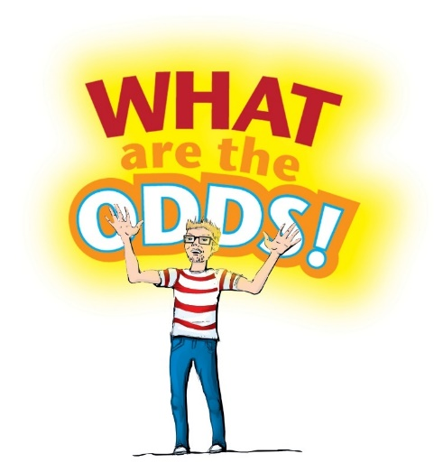
Day 1
Welcome to…
“What are the Odds!” We’ll be playing various games over the next couple weeks here on the show, and I’ll be depending on YOU to put your math knowledge into action! Before playing our first game, let’s start with a basic warm-up to get things rolling.

The Challenge Round

- Consider the following occurrences and put a 1 next to the MOST LIKELY possibility and put a 6 next to the LEAST LIKELY possibility. (if you finish early, try ranking the other items from 2 to 5!)

- ___ Tossing a coin and getting heads

- ___ Winning the Mega Millions Lottery when buying one ticket

- ___ Rolling a number greater than 2 using a six-sided dice

- ___ Pulling a red marble out of a bin with 99 red marbles and 1 blue marble

- ___ Rolling a number that is NOT 5 using a six-sided dice

- ___ Pulling a red marble out of a bin with 20 red marbles and 5 blue marbles

- Discuss with a neighbor about where each of these six possibilities will fall on the PROBABILITY scale from 0 to 1. Then write the letter of the possibility on the probability scale below

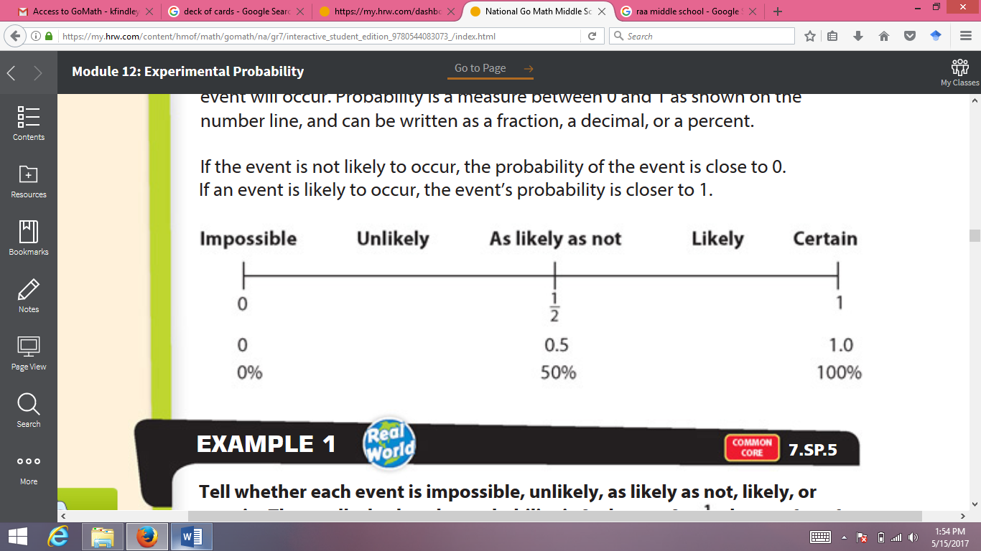
It’s time to play…

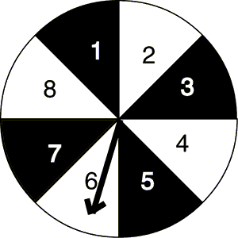
Wheel
Of
Fortunate
PREDICTIONS!


Welcome to WHEEL OF FORTUNATE PREDICTIONS!
Look at the two wheels below. You win a prize when the spinner lands on a space with a star. But does one wheel give you a higher probability of landing on a star. Let’s get started!
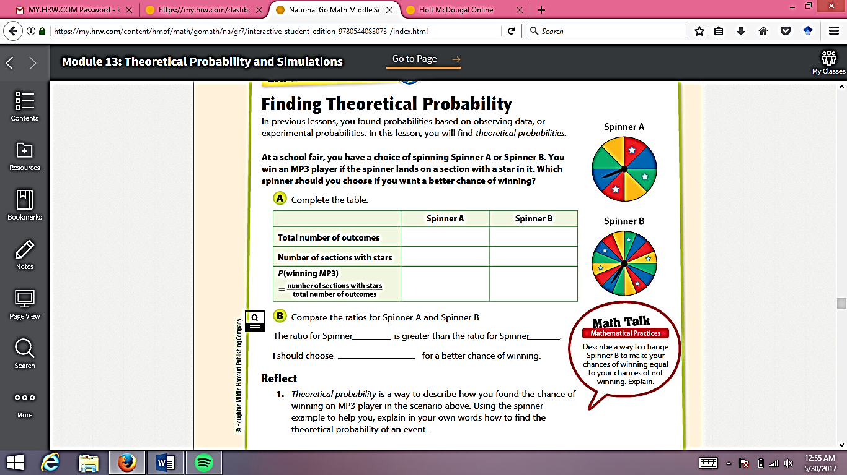


- What do you think the probability of landing on a star is for each of these wheels? Show your work below

Spinner A | Spinner B

Final Conclusion: Does one spinner give you a better chance of winning the prize? Why?

- Now consider these two spinner wheels
Spinner X  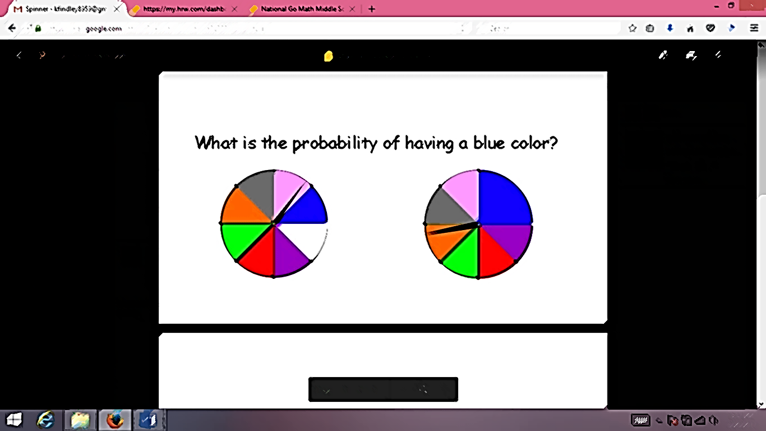  How many possibilities are there for each spin of Spinner X?  Do you think all possibilities are equally likely, or are some more likely than others? Explain.  What is the probability of spinning black (the darkest piece) on the first try? | Spinner Y  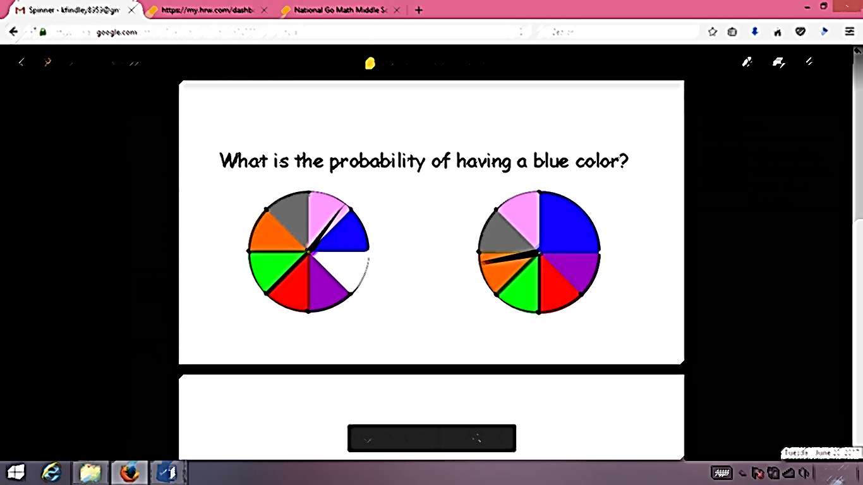  How many possibilities are there for each spin of Spinner Y?  Do you think all possibilities are equally likely, or are some more likely than others? Explain.  What is the probability of spinning black (the darkest piece) on the first try?

We call the SAMPLE SPACE the collection of all possibilities
Sometimes the sample space is full of equally likely possibilities and sometimes it isn’t!
What might we label these two kinds of sample spaces?

________________ Sample Space _________________ Sample Space
Possibilities are equally likely Possibilities are NOT equally likely

Day 2
It’s time to play…

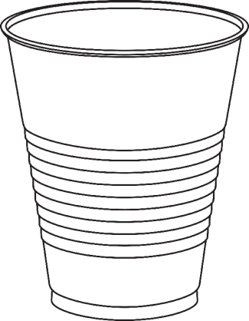
CUP
MASTER

Before we get started, consider the following…
When you toss a plastic cup, what are all the ways it could land? Create a sample space of all possibilities.



Let me explain the rules…
- Get into groups.. Your teacher will give each group a cup.
- PREDICT the frequencies for each possibility if we tossed the cup 20 times
- Complete 20 TRIALS (tosses) and fill in the actual frequencies on the table
Possibility | Predicted Frequencies | Actual  Frequencies

The EXPERIMENTAL PROBABILITY of a possibility is the number of trials that gave us that possibility divided by the total number of trials completed.

- What is the experimental probability for each of our possibilities? Write as a fraction AND as a percent
Possibility | Experimental Probability

Now that we have experimental probabilities, let’s test our new predictions!

- First, PREDICT how many times we’ll see each possibility if we toss the cup 100 times.

Possibility | Predicted Frequencies | Actual Frequencies | Experimental Probability

- NOW, complete 100 tosses and record your results in the table above
- Then calculate the experimental probabilities for each possibility using the 100 trials.
Wait for your teacher before moving on

- Now that we used the results from our 100 trials to come up with experimental probabilities, are they different than the ones we calculated with 20 trials?

- Is this a clean or sloppy sample space? Why do you think so? How confident are you?

- If we were to play the game Cup Master on a gameshow and a cup tossing machine tossed the cup 1000 times, how would you predict how many of each outcome would happen?

Day 3 (teacher notes for intro activity)
The introduction should define the terms “outcome,” “event,” and “complement.”
For the teacher:
In probability, outcomes are the simplest possibilities when we do a trial. They represent the basic elements of a sample space. Outcomes are mutually exclusive, meaning that one and only one outcome can happen when we complete a simple trial.
Note: Outcomes may or may not be equally likely. However, in formal probability, the term “sample space” is typically reserved for a set of equally likely outcomes, or at least that is how sample space is typically defined in secondary mathematics classes. We have decided to use the terms “clean” and “sloppy” sample spaces (or whatever terms your class chose) to distinguish these two situations. You will not see these terms in textbooks though. The GoMath book only discusses samples spaces with equally likely outcomes, but we feel exploring both types is important for students.
An event is a collection of one or more outcomes. An event is something we are interested in, and an event is something we define, not something that inherently exists. Events may not be mutually exclusive, meaning that multiple events we have defined could happen when completing a simple trial. It is also possible that no event we have defined could happen when we complete a simple trial.
Ask students to share all the things they associate with the word: outcome. Create a word-wall on the whiteboard. Do the same thing with the word event.
Explain that in mathematics, these words have special meanings that may be a little confusing.
Outcomes are the building-block possibilities when we complete a trial. When we complete one trial, one and only one outcome will occur.
An Event is a group of one or more outcomes that we are interested in. We define events, but we don’t define outcomes.
Introduce the “Beads in a Bag” activity.
Explain to students that we are playing a game where we pull out one bead from the bag without looking. Ask students to name the specific outcomes. Suitable answers would be “pulling a Red 1, pulling a Blue 3, pulling a Red 4, etc.”
Also ask students to define events we might be interested in. Suitable answers would be “pulling a red bead, pulling a 1, pulling a bead with an odd number, pulling a bead that is not yellow, pulling a blue 1 or a green 3, etc.”
Challenge students by asking if “pulling a red 1” could also be defined as an event. (the answer is yes).
Finally, brainstorm about the word complement.
How do we use that word normally? Students will likely bring up “saying something nice to someone.” Ask students what it means if they were to hear, “those two people complement each other well because they’re different”? Drive at the meaning of “balance” with complement. Two things complement each other well when they balance.
Define complement of an event as the set of left-over outcomes not included in that event.

Day 3
It’s time to play…
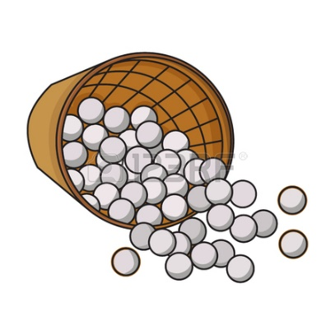
BEAD Snatchers!

Let me explain the rules…

- Your teacher has three cups full of different combinations of colored beads.
- For each event described, decide which cup you should pull from to have the highest probability of making that event
- Show your work for each event and be able to explain it to your classmates.
- At the end, we’ll do some bead draws to see who had the best predictions!

Here are the contents of each cup
- Cup 1 – 30 green, 20 red, 40 blue, 10 yellow
- Cup 2 – 15 green, 20 red, 5 blue, 10 yellow
- Cup 3 – 30 green, 70 red, 70 blue, 30 yellow

- Which cup should you pull from if you want to draw a red?

- Which cup should you pull from if you want to draw a blue?

- Which cup should you draw from if you want the complement of drawing green?

- Which cup should you draw from if you want to draw red or yellow?

- Which two cups should you combine if you want to increase your probability of drawing red?

The MYSTERY Cup!

The Mystery cup has 100 beads in it, but color mix is unknown. We are particularly interested in knowing how many yellows are in the cup. We’re going to sample 10 beads at a time.
Record the number of yellows in each sample of 10 and record the percentage of yellow for each sample as well.

Draw | Frequency | Percentage

Can you use experimental probability to predict the number of yellows in the cup?

Defining
Theoretical Probability and Experimental Probability

Day 4 (Quiz Day)
It’s time to play…
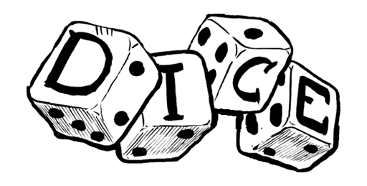
FOR YOUR LIFE!

Before we get started, consider the following…

- How many OUTCOMES are possible when you toss one dice?

- Remember that we call the collection of all possible outcomes the SAMPLE SPACE. Write the sample space for tossing one dice below.

___ ___ ___ ___ ___ ___

- Do you think this is a clean sample space or an sloppy sample space? Why?

- Let’s try rolling one dice a few times and let’s see what happens! Try rolling 40 times with your partner and record your results in the space below.

- What happened? Do you think this is a clean or sloppy sample space?

Sometimes, the theoretical probability doesn’t perfectly align with the experimental probability!

Distributions can either be ______________ or _______________ depending on how much data we’ve collected

Draw an example of each type of distribution below.

- When making predictions about how many times we’ll get each of the numbers 1 through 6 when rolling one dice, should we use theoretical probabilities or experimental probabilities?

Day 5
It’s time to continue playing…

FOR YOUR LIFE! Compound Edition!

In probability, a simple event is…

In probability, a compound event is…

THINK-PAIR-SHARE
How should we define the sample space for rolling TWO dice together? Do you think it is clean or sloppy?



- Get two dice from your teacher
- Consider each event to its complement and check the option you believe is more likely
- You don’t need to roll the dice to pick a comparison, but doing a few rolls might help you think about your choice!

EVENT COMPARISONS!
EVENTS COMPLEMENTS

___ Roll total of 7 or higher ___ Roll total of 6 or lower

___ Roll total of 5, 6, 7, or 8 ___ Roll total of 2, 3, 4, 9, 10, 11, or 12

___ Roll total of 2, 4, 6, 8, 10, 12 ___ Roll total of 3, 5, 7, 9, 11

LET’S ROLLLLL!
Now roll your two dice 50 times and record how many times you get each result below

2 | 3 | 4 | 5 | 6 | 7 | 8 | 9 | 10 | 11 | 12
Now, record the experimental probability for each roll total in the space below (as a percentage)

- What did you find from your experimental probabilities?

- Do you think the sample space could be clean? Is it possible it could just be in disguise?

Let’s think about the theoretical probabilities

Use this space to record all of the possible ways to get each roll total (2 and 12 have been filled in)
2 | 3 | 4 | 5 | 6 | 7 | 8 | 9 | 10 | 11 | 12
1,1 |  |  |  |  |  |  |  |  |  | 6,6
Then record the theoretical probabilities in the space below

- What pattern do you see here?

- Is there a clean sample space we could record for rolling two dice?

- If you were to play the game again, which do you think you should use to make your choices, the experimental probabilities or the theoretical probabilities?

Day 6
It’s time to play…


Let me explain the rules…
- We’re traveling through the woods, and each time we hit a fork in the road, we have the choice of going left or right
- To make that choice, we’ll flip a fair coin. If it lands head, we’ll go right, and if it lands tails, we’ll go left
- The following picture shows the different path options we have and different destinations possible
- Using your coin, try making your journey through the woods several times
  - TIP! Remember that heads means go to the right from the perspective of the traveler (if you were to turn your paper upside-down).
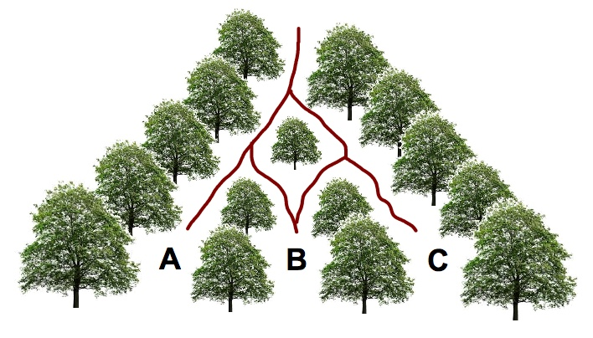
Simulate moving through the woods 5 or more times and use the space below to record what happened each time.

- Let’s call the destinations A, B, and C the sample space. Is this a clean or sloppy sample space? How do you know?

- What is the theoretical probability of ending at each destination?

- Is there another way we could define the sample space?

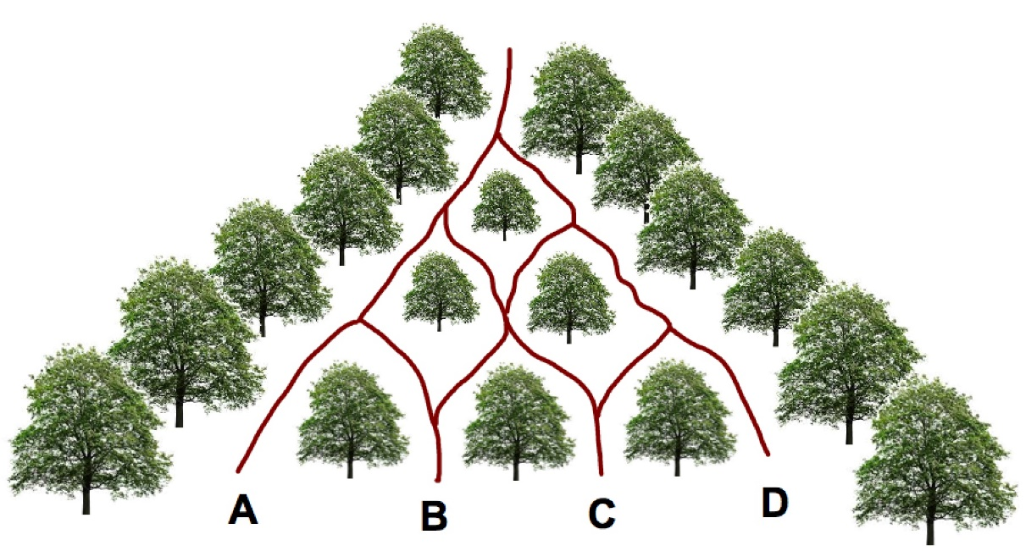

- How could we define the sample space for this version?

- What is the probability of ending at each of the four destinations?

Day 7 (Quiz Day)

It’s time to play…
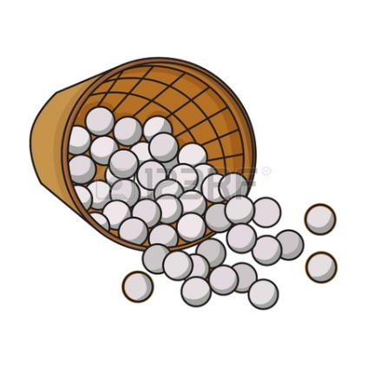

BEAD Snatchers 2.0!

Let me explain the rules…

- Your teacher has two cups full of different combinations of colored beads. The first has red and blue beads, and the second has green, yellow, and purple beads.
- Each student will have at least one opportunity to pull out a bead from each cup, show it to the class, and then replace the beads back into their respective cups
- We will record the class results on the board!

Fill in the class results in this table

 | Green | Yellow | Purple
Red
Blue

- What is the experimental probability of drawing a red and a green?

- If you had to predict the colors of the next pull, what would you guess and why?

- Consider the claim that there are equally as many reds as blues in cup 1, and there are equally as many greens, yellows, and purples in cup 2. Does this data support that or not?

- Let’s say that the class down the hall also did this activity, but they recorded results from 200 pulls. Can you use your experimental probabilities to make an estimate for how many of those pulls resulted in a Yellow and Blue?

Day 8
It’s time to play…


Open Play:
Open up Plinko Probability and go to the Lab screen. Then play around for a few minutes.
What do you notice?

What is the sample space in Plinko? Is it clean or sloppy?


Let me explain the rules…
- Hit the refresh button and set rows to 10. Pick one person to be the host and the other(s) to be the contestant(s).
- Have the host pick a winning bin number (between 0-10)
- Write down the Winning Bin: _____ (share this with the contestant!)
- The contestant(s) should pick a probability value that they think will give them the best chance of landing a ball in the winning bin number
- Record the contestant’s choice for the probability value here: _____
- Run 10 balls down the board and record the bin numbers each one falls in
Ball | Bin |  | Ball | Bin
1 |  |  | 6
2 |  |  | 7
3 |  |  | 8
4 |  |  | 9
5 |  |  | 10

- Now switch and have someone else be the host
- Write down the Winning Bin: _____
- Contestant’s choice for the probability value: _____
- Run 10 balls down the pyramid and record the bin numbers each one falls in

Ball | Bin |  | Ball | Bin
1 |  |  | 6
2 |  |  | 7
3 |  |  | 8
4 |  |  | 9
5 |  |  | 10

Coming back together:
- Who landed a ball in the winning bin the most? Strategies to being successful?


More…
Hit the refresh! Set rows to 20. Have the host pick a winning bin number (between 0-20)
Write down the Winning Bin: _____ (share this with the contestant!)
The contestant(s) should pick a probability value that they think will give them the best chance of landing a ball in the winning bin number
Contestant’s choice for the probability value: _____
Run 10 balls down the board and record the bin numbers each one falls in

Ball | Bin |  | Ball | Bin
1 |  |  | 6
2 |  |  | 7
3 |  |  | 8
4 |  |  | 9
5 |  |  | 10

Now switch and have someone else be the host
Write down the Winning Bin: _____
Contestant’s choice for the probability value: _____
Run 10 balls down the pyramid and record the bin numbers each one falls in

Ball | Bin |  | Ball | Bin
1 |  |  | 6
2 |  |  | 7
3 |  |  | 8
4 |  |  | 9
5 |  |  | 10

Coming Back Together:
- Let’s say that we had a weighted coin (a coin that is weighted to favor landing a certain way) that landed heads 80% of the time. If we flipped it 100 times, what would be our BEST GUESS for the number of times it will land heads?

- Using the same strategy from #3, what would be the BEST GUESS for the number of times the ball should bounce right off a peg across 20 trials with the binary probability value your group used last?

- Did the ball land in the “best guess” bin consistently (say more than half the time)? Can you explain why?

Day 9
Partner Talk:
- Recalling the previous lesson, talk with your partner to remind yourself what the binary probability value represents in the Plinko game.


It’s time to play…

OPPOSITE
Hit Reset and set rows to 10. Have one person in your group be the host and the other(s) to be the contestant(s). (Only Host can look at the screen for this game!!!)
Have the host set a secret probability value that won’t be revealed to the contestant(s)
The host will run 10 balls down the pyramid and tell the contestant(s) which bin it landed in. The contestant(s) will try to predict the probability value after filling in the bin # for all 10 balls.
Round 1
Ball | Bin |  | Ball | Bin
1 |  |  | 6
2 |  |  | 7
3 |  |  | 8
4 |  |  | 9
5 |  |  | 10

Prediction: = _____ Actual: = ______ % Error ($\frac{actual-prediction}{actual}$): ______
Round 2 (Switch roles)
Ball | Bin |  | Ball | Bin
1 |  |  | 6
2 |  |  | 7
3 |  |  | 8
4 |  |  | 9
5 |  |  | 10

Prediction: = ______ Actual: = ______ % Error ($\frac{actual-prediction}{actual}$): _____

Coming back together:
- Who was closest? What were the winning strategies?

- How can we predict the probability value more accurately?

Focused Play:
Hit Refresh and pick a binary probability value. This will be your theoretical probability
Theoretical Probability = _____
Find the experimental probability by finding the total number of times the balls bounce to the right off of a peg, then dividing that number by the total number of pegs hit.
HINT: the bin number a ball lands in IS the # of times the ball bounced right.

Round 1
Set rows to 10
Ball | # Right
1
2
3
4
5

Theoretical probability: ____ Experimental probability: ____ % Error ($\frac{actual-prediction}{actual}$): ____

Round 2
Set rows to 20
Ball | # Right
1
2
3
4
5

Theoretical probability: ____ Experimental probability: ____ % Error ($\frac{actual-prediction}{actual}$): ____

Round 3
Set rows to 25
Ball | # Right |  | Ball | # Right
1 |  |  | 5
2 |  |  | 6
3 |  |  | 7
4 |  |  | 8

Theoretical probability: ____ Experimental probability: ____ % Error ($\frac{actual-prediction}{actual}$): ____

Coming back together:
- If one classmate computed an experimental probability from 100 trials and another classmate computed an experimental probability from 1000 trials, who would you trust more to predict the theoretical probability? Why?

Advanced Probability Activity (OPTIONAL)
The following activity serves as an introduction to p-values. This goes beyond the 7th grade standards and could be used at the end of the sequence or towards the end of the year if there are empty days to fill.


It’s time to play…
Are
You
Psychic?


Let me explain the situation…
- Madame Marta claims to be psychic
- We decided to put her to the test with a standard card deck by asking her to guess whether the next card would be red or black. She correctly guessed the color of 8 out of 10 cards

- Do you think Madame Marta is psychic? Why or why not?

Open Play:
Open up Plinko Probability and go to the Lab screen. Then play around for a few minutes and write down…
Interesting things you notice

Something you wonder about

- Think back to when we played “Into the Woods.” Do you see a connection between how we navigated the forks in the road and how the ball moves through the Plinko board? (hint: limit number of rows to 2 or 3)

- If we set the binary probability to something higher than 0.5, what happens? Is it like “Into the Woods” anymore?

- Set rows to 3 and binary probability to 0.5. Using experimental probability, how likely is a ball to land in bin 3? (try doing at least 100 trials)

- Set rows back to 10. How is Plinko Probability similar to guessing the color of cards in a standard playing deck?

- Do you have any ideas about how we can use Plinko Probability to consider Madame Marta’s claim to be psychic?

