電通二乙微處理器實驗 實驗結報

實驗名稱 | Lab10
組別 | 11 | 組員 | 彭俐嘉

- 實驗目的
(1) MCS 控制 LED 閃爍
(2) 上傳A0資料

- 實驗步驟
(1) MCS 新增on/off，控制器/顯示器各一個
(2) 新增 Integer顯示頻道，id “Temp”

- 程式碼
(1) 控制燈泡開關，電阻回傳資料
#include <LWiFi.h>
#include <WiFiClient.h>
#include "MCS.h"

// Assign AP ssid / password here
#define _SSID "LIGA"
#define _KEY "00000000"

// Assign device id / key of your test device
MCSDevice mcs("Dsa8r4zU", "qogCiu0J1gi1BwEr");

// Assign channel id
// The test device should have 2 channel
// the first channel should be "Controller" - "On/Off"
// the secord channel should be "Display" - "On/Off"
MCSControllerOnOff led("ledControl");
MCSDisplayOnOff remote("ledremote");
MCSDisplayInteger Temp("ledaa");

#define LED_PIN 7

void setup() {
// setup Serial output at 9600
Serial.begin(9600);

// setup LED/Button pin
pinMode(LED_PIN, OUTPUT);

// setup Wifi connection
while (WL_CONNECTED != WiFi.status())
{
Serial.print("WiFi.begin(");
Serial.print(_SSID);
Serial.print(",");
Serial.print(_KEY);
Serial.println(")...");
WiFi.begin(_SSID, _KEY);
}
Serial.println("WiFi connected !!");

// setup MCS connection
mcs.addChannel(led);
mcs.addChannel(remote);
mcs.addChannel(Temp);

while (!mcs.connected())
{
Serial.println("MCS.connect()...");
mcs.connect();
}
Serial.println("MCS connected !!");

// read LED value from MCS server
while (!led.valid())
{
Serial.println("read LED value from MCS...");
led.value();
}
Serial.print("done, LED value = ");
Serial.println(led.value());
digitalWrite(LED_PIN, led.value() ? HIGH : LOW);
}

void loop() {
// call process() to allow background processing, add timeout to avoid high cpu usage
Serial.print("process(");
Serial.print(millis());
Serial.println(")");
mcs.process(100);

// updated flag will be cleared in process(), user must check it after process() call.
if (led.updated())
{
Serial.print("LED updated, new value = ");
Serial.println(led.value());
digitalWrite(LED_PIN, led.value() ? HIGH : LOW);
if (!remote.set(led.value()))
{
Serial.print("Failed to update remote");
Serial.println(remote.value());
}

}
Temp.set(analogRead(A0)); //把A0 data 丟到 temp data channel
Serial.print("input value: ");
Serial.println(analogRead(A0)); //顯示A0 data
delay(1000); //每秒上傳一次
// check if need to re-connect
while (!mcs.connected())
{
Serial.println("re-connect to MCS...");
mcs.connect();
if (mcs.connected())
Serial.println("MCS connected !!");
}
}

- 實驗結果及分析

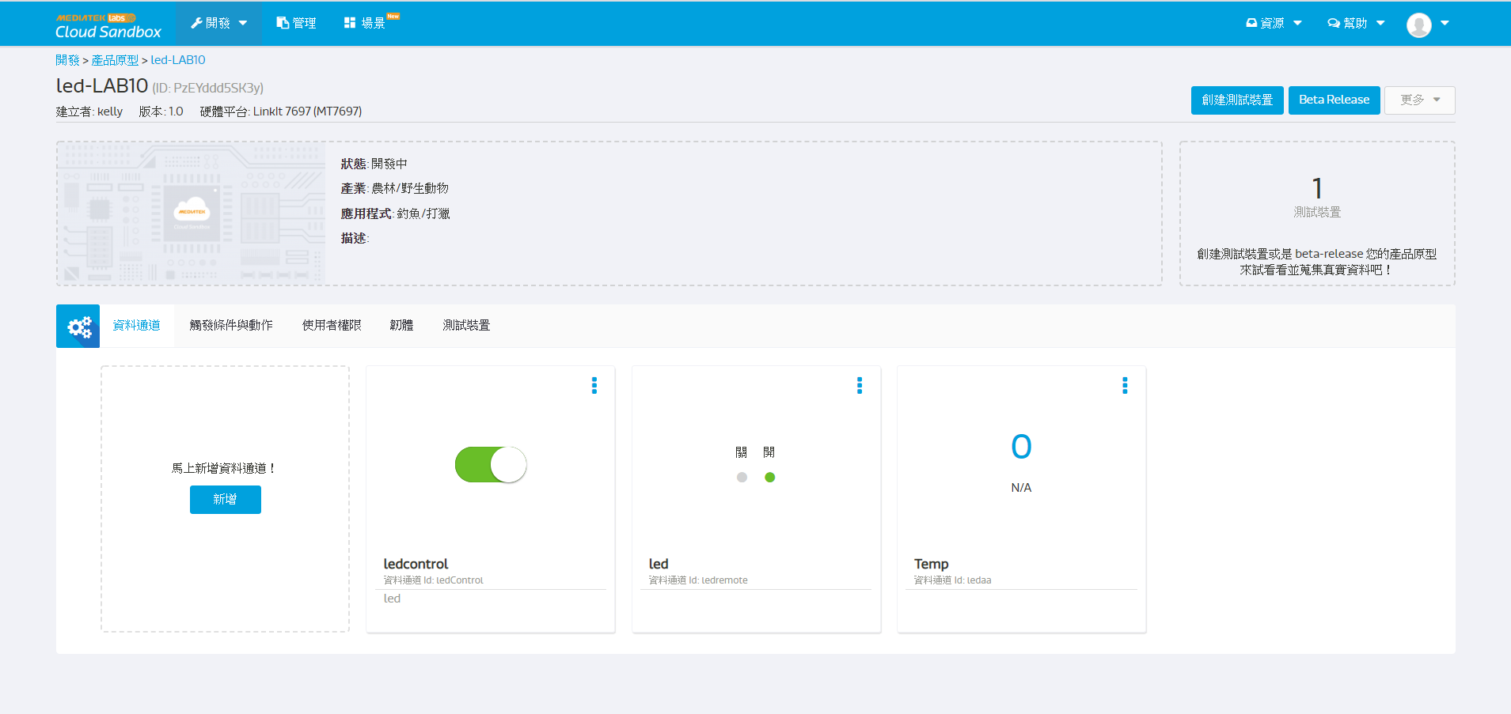

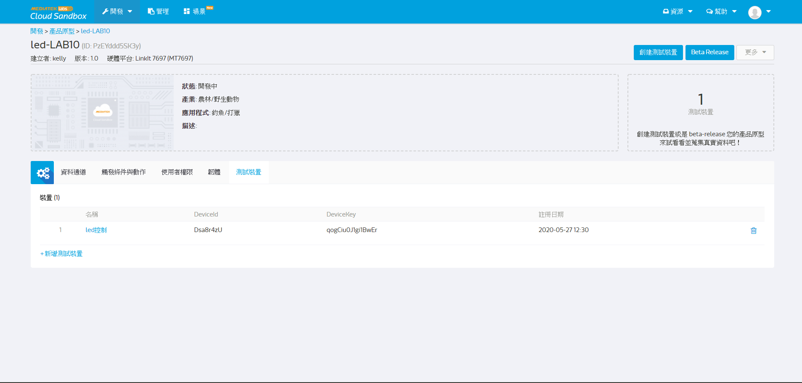

- 心得討論
沒想到Arduino可以跟雲端相連，由遠端控制和讀取資料，也能增加許多元件一起運用，Arduino真的是一個很廣大也很厲害的硬體，又有許多軟體可以和它一起使用，真的很厲害!

- 修正電路圖

- 修正程式碼

