電通二乙微處理器實驗 實驗結報

實驗名稱 | Lab11
組別 | 11 | 組員 | 彭俐嘉

- 實驗目的
(1) DHT-11 可以一直量測溫度
(3) 將溫溼度傳到MCS上

- 實驗步驟
(1) 輸入Temperature的Data channel name、Data channel Id、Data type、Unit 再按Save
(2) 輸入Humidity的Data channel name、Data channel Id、Data type、Unit 再按Save
(3) 改LED的範例程式，加上DHT的程式

- 程式碼
#include <LWiFi.h>
#include <WiFiClient.h>
#include "MCS.h"
#include "DHT.h"
#define DHTPIN 2
#define DHTTYPE DHT11
DHT dht(DHTPIN, DHTTYPE);

// Assign AP ssid / password here
#define _SSID "LIGA"
#define _KEY "00000000"

// Assign device id / key of your test device
MCSDevice mcs("DjHOHrZc", "KTSBd0HKrMoGATqA");

// Assign channel id
// The test device should have 2 channel
// the first channel should be "Controller" - "On/Off"
// the secord channel should be "Display" - "On/Off"

MCSDisplayFloat temperature("temperature");
MCSDisplayFloat humidity("humidity");

#define LED_PIN 7

void setup() {
// setup Serial output at 9600
Serial.begin(9600);
Serial.println(F("DHTxx test!"));
dht.begin();

// setup LED/Button pin
pinMode(LED_PIN, OUTPUT);

// setup Wifi connection
while(WL_CONNECTED != WiFi.status())
{
Serial.print("WiFi.begin(");
Serial.print(_SSID);
Serial.print(",");
Serial.print(_KEY);
Serial.println(")...");
WiFi.begin(_SSID, _KEY);
}
Serial.println("WiFi connected !!");

// setup MCS connection

mcs.addChannel(temperature);
mcs.addChannel(humidity);

while(!mcs.connected())
{
Serial.println("MCS.connect()...");
mcs.connect();
}
Serial.println("MCS connected !!");

}
void loop() {
// call process() to allow background processing, add timeout to avoid high cpu usage
Serial.print("process(");
Serial.print(millis());
Serial.println(")");
mcs.process(100);

// updated flag will be cleared in process(), user must check it after process() call.
float h = dht.readHumidity();

float t = dht.readTemperature();

if(!temperature.set(t))
{
Serial.print("Failed to update remote");
Serial.println(temperature.value());
}
if(!humidity.set(h))
{
Serial.print("Failed to update remote");
Serial.println(humidity.value());
}

// check if need to re-connect
while(!mcs.connected())
{
Serial.println("re-connect to MCS...");
mcs.connect();
if(mcs.connected())
Serial.println("MCS connected !!");
}
}

- 實驗結果及分析

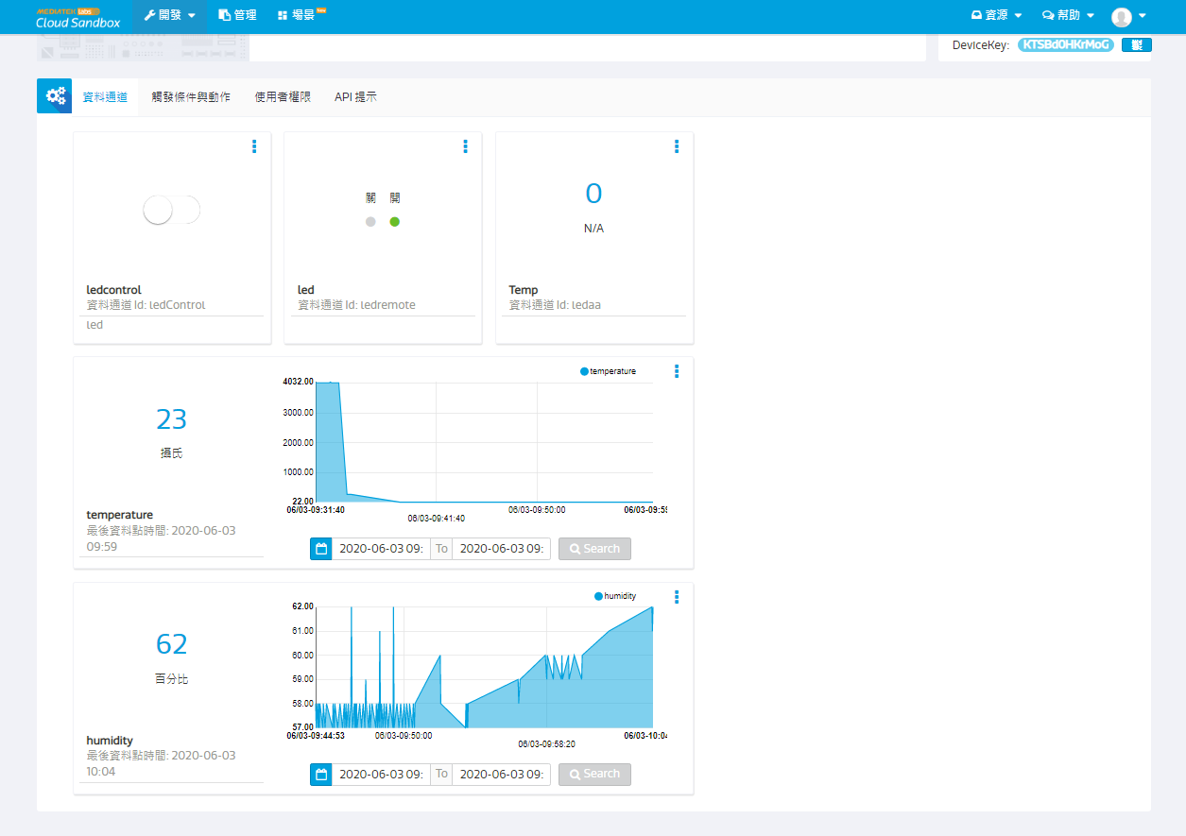

- 心得討論
因為在家練習了很多次，老師也教得很仔細，就稍微改一下就成功了，第一次成功的這麼快，超開心的!!!
- 修正電路圖
- 修正程式碼

