First R Markdown Word Document

## Combining Code and Text

* You might want to include both the code chunk and code output in your final document like below:

numbers <- c(1, 4, 6, 7)  
sum(numbers)

## [1] 18

* Sometimes you may prefer to simply include the output from your code:

## [1] 18

## Plotting In R Markdown

* The inclusion of plots in your reports can really enhance their effectiveness.

### Scatterplot

* This scatterplot was created using the **cars** dataset from the *datasets* package.

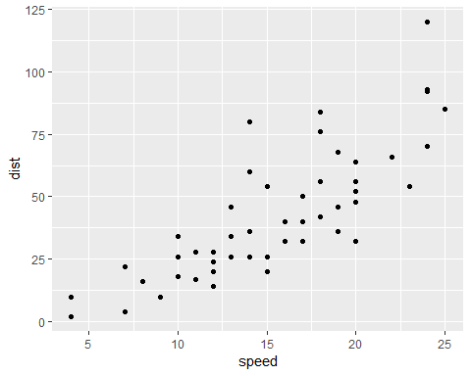

Scatterplot of Cars Dataset