2/22

**National Margarita Day**

The famous drink was invented around the 1930s, but frozen margaritas were invented later in 1970’s when an inventive bartender converted a soft serve ice cream unit into a frozen margarita machine. Whether you like them frozen or on the rocks, be sure to celebrate #margaritamonday this afternoon (after work of course!)

2/23

**National Banana Bread Day**

Banana bread first became a standard feature of American cookbooks with the popularization of baking soda and baking powder in the 1930s. It appeared in Pillsbury's 1933 Balanced Recipes cookbook, and later gained more acceptance with the release of the original Chiquita Banana's Recipe Book in 1950.

2/24

**National Tortilla Chip Day**

Even though tortilla chips have always been considered to be Mexican food, known as tostadas, they were first mass-produced in Los Angeles in the late 1940s. Rebecca Webb Carranza receives credit for making the crisp chips popular. She and her husband operated a deli and tortilla factory in Los Angeles. When the tortilla manufacturing machine discarded the misshapen tortilla, Carranza realized they could be cut into triangles and fried. She then sold them for a dime a bag at the El Zarape Tortilla Factory. Carranza received the Golden Tortilla Award in 1994 for her contribution to the Mexican food industry.

2/25

**National Pistachio Day**

Did you know that the Queen of Sheba (present-day Yemen), the monarch who’s famed for giving King Solomon a caravan of precious gifts, is said to be a pistachio fanatic? Legend has it that the Queen loved pistachios so much that she demanded — yes, demanded — that all of her kingdom’s pistachios be reserved for her and her court? Her “pistachio greed” reached a point that she made it illegal for commoners to grow pistachio trees! Aren’t we so lucky that we can all enjoy our beloved pistachios today without the fear of getting arrested?

source:<https://saffronandmore.com.au/fun-fact-queen-of-shebas-pistachio-greed/>

2/26

**National Pig Day**

In 1972 two sisters, Ellen Stanley and Mary Lynne Rave founded National Pig Day. Ellen taught in Lubbock, Texas, and Mary lived in Beaufort, North Carolina. According to Mary Lynne Rave, the purpose of National Pig Day is “to accord the pig its rightful, though generally unrecognized, place as one of man’s most intellectual and domesticated animals.”

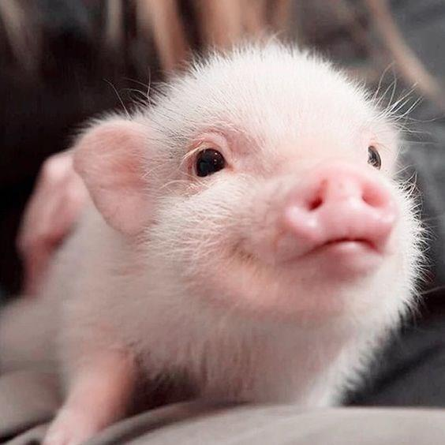

3/2

**National Dr. Seuss Day / National Read Across America Day**

Dr. Seuss’s birthday is celebrated on March 2 and it celebrates both the birthday of Theodor Seuss Geisel and the National Education Association to endorse the importance of reading. A lesser-known fact about Dr. Seuss is that he created the word "nerd". The first documented use of the word was in the 1950 book he wrote titled “If I Ran the Zoo” about a boy named Gerald McGrew who visits a zoo and ponders what it would be like if he ran it.

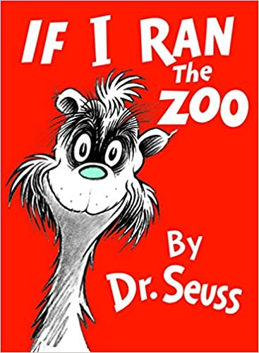

3/3

**National Mulled Wine Day**

Mulled wine was invented by the Romans but the recipe has stayed mostly the same over time, consisting primarily of red wine and cinnamon sticks, sometimes with clove, nutmeg and other spices. A great drink for cold weather, this warm wine beverage is enjoyed in many countries (especially those with colder winters), though it can have different names. In Germany the beverage is referred to as Glühwein, while in Italy it is known as vin brulé. In France, the same beverage is called vin chaud. However you say it, it is important when preparing to have patience, as it must be heated very slowly and carefully to avoid burning off the alcohol (alcohol starts to burn off at 167 degrees F), and we definitely don't want to lose any of that! (wink)

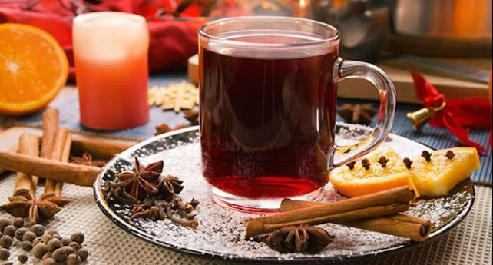

3/4

**National Grammar Day**

National Grammar Day, which is celebrated on March 4, was established in 2008 by Martha Brockenbrough, the author of Things That Make Us and founder of the Society for the Promotion of Good Grammar (SPOGG). Former President George W. Bush sent a letter commemorating the day in its inaugural year. In an interview with Grammarly last year, Martha explained that she founded the day because she wanted to help her students with their grammar in a lively and positive way. As the National Grammar Day website states, “Language is something to be celebrated, and March 4 is the perfect day to do it. It’s not only a date, it’s an imperative: March forth on March 4 to speak well, write well, and help others do the same!”

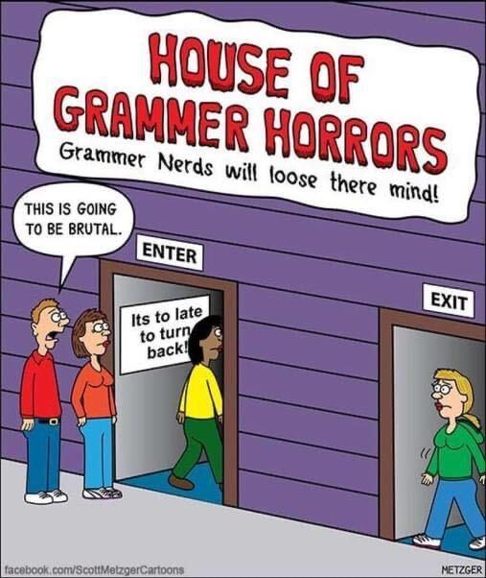

3/5

**National Absinthe Day**

Absinthe traditionally has a natural green color and is commonly referred to in historical literature as *la fée verte* ("the green fairy"). The spirit originated in Switzerland in the late 18th century. It rose to great popularity as an alcoholic drink in late 19th- and early 20th-century France, particularly among Parisian artists and writers. The consumption of absinthe was opposed by social conservatives and prohibitionists, leading to its ban in 1914. Notable absinthe drinkers included Ernest Hemingway, James Joyce, Charles Baudelaire, Pablo Picasso, Vincent van Gogh, Oscar Wilde and Edgar Allan Poe. Since its revival in the 1990s, absinthe has become widely available across the world.

If you're interested in reading more about the history of absinthe (I found it fascinating) check out:<https://www.sciencehistory.org/distillations/the-devil-in-a-little-green-bottle-a-history-of-absinthe> and<https://en.wikipedia.org/wiki/Absinthe>

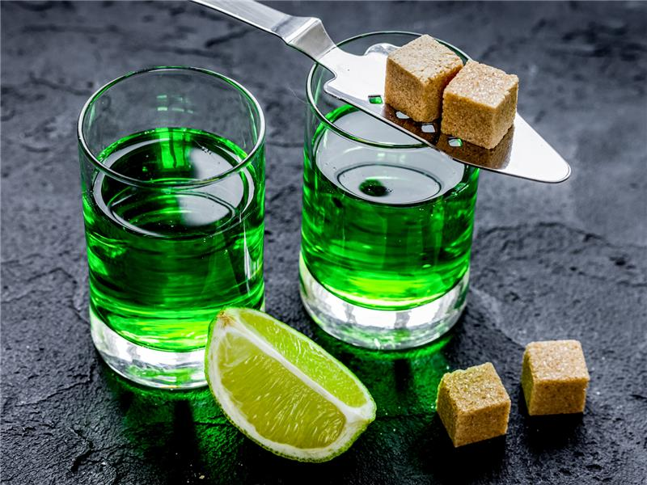

3/8

**International Women's Day**

In 1911, International Women's Day was honored the first time in Austria, Denmark, Germany and Switzerland following a decision in Denmark 1910 where a woman named Clara Zetkin tabled the idea of an International Women's Day. She proposed that every year in every country there should be a celebration on the same day - a Women's Day - to press for their demands. The following year more than one million women and men attended IWD rallies campaigning for women's rights to work, vote, be trained, to hold public office and end discrimination. Similar movements began in other parts of the world and eventually March 8th became the designated day for International Women's Day. The day was recognized by the United Nations in 1975 and by 1996 they began to have a "theme" every year, with 2021's theme being "Women in leadership: Achieving an equal future in a COVID-19 world". If you're interested in previous years' themes you can find a list here:<https://en.wikipedia.org/wiki/International_Women%27s_Day#Official_UN_themes>

If you're interested in finding out more about this year's theme, check out:

<https://www.unwomen.org/en/news/in-focus/international-womens-day>

3/9

**National Barbie Day**

In 1959, Ruth Handler created the Barbie doll and launched an American icon. Barbie’s full name is Barbara Millicent Roberts, and she came with a full array of accessories. While toymakers mass-produced toys for years, before Barbie, none of them had adult features. Barbie’s adult features made the toy a first of its kind. Interestingly, Barbie’s marketing strategy relied on television advertising. For example, Barbie was the sole sponsor of the Mickey Mouse Club, marketing directly to children. At the time, the approach was unique. Estimates place over a billion Barbie dolls have been sold worldwide in over 150 countries. For more interesting facts about Barbie, check out:<https://www.mentalfloss.com/article/21036/facts-about-barbie-doll>

3/10

**National Mario Day**

National Mario Day is celebrated on on **MAR-10** (get it?) and recognizes the iconic character from many popular video games. The character, known today as Mario, first appeared in 1981 in a game called *Donkey Kong* made by Nintendo. In the game he was a carpenter known as Jumpman.

Then in 1983, Nintendo launched a new game in which bad guy Jumpman reinvents himself into an Italian plumber who rescues princesses. Since then Mario (and his brother Luigi) have appeared in numerous games produced by Nintendo. With over 210 million copies of the Mario game series sold, Mario ranks as one of the most popular video games of all time.

To read more interesting facts about Mario, check out:<https://medium.com/super-jump/10-mario-facts-you-did-not-know-aa3d62d45a79>

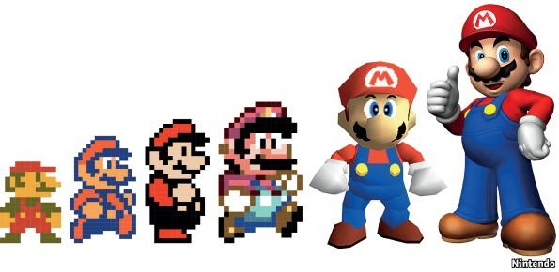

3/11

**National Johnny Appleseed Day**

One of America’s fondest legends is that of Johnny Appleseed, a folk hero and pioneer apple farmer in the 1800’s. There really was a Johnny Appleseed and his real name was John Chapman. He was born in Leominster, Massachusetts in 1774. His dream was to produce so many apples that no one would ever go hungry. Although legend paints a picture of Johnny as a dreamy wanderer, planting apple seeds throughout the countryside, research reveal him to be a careful, organized businessman, who over a period of nearly fifty years, bought and sold tracts of land and developed thousands of productive apple trees.

He always carried a leather bag filled with apple seeds he collected for free from cider mills. Legend says he was constantly planting them in open places in the forests, along the roadways and by the streams. However, research suggests he created numerous nurseries by carefully selecting the perfect planting spot, fencing it in with fallen trees and logs, bushes and vines, sowing the seeds and returning at regular intervals to repair the fence, tend the ground and sell the trees. He soon was known as the “apple seed man” and later he became known only as “Johnny Appleseed.”

for more info, check out<https://bestapples.com/resources-teachers-corner/johnny-appleseed/>

3/12

**National Girl Scouts Day**

Founded by Juliette Gordon Low in 1912, the Girl Scouts was organized after Low met Robert Baden-Powell, the founder of Scouting, in 1911. Upon returning to Savannah, Georgia, she telephoned a distant cousin, saying, "I've got something for the girls of Savannah, and all of America, and all the world, and we're going to start it tonight!"

Girl Scouts prepares girls to empower themselves and promotes compassion, courage, confidence, character, leadership, entrepreneurship, and active citizenship through activities involving camping, community service, learning first aid, and earning badges by acquiring practical skills. Many famous women were Girl Scouts, including 69% of female senators, as well as celebrities like Taylor Swift, Mariah Carey, Katie Couric, Robin Roberts, Dakota Fanning, Gwyneth Paltrow, and Venus and Serena Williams.

Fun Fact: More money is generated from Girl Scout cookie sales each year than Oreos! Which Girl Scout cookie is your favorite?

3/15

**National Napping Day**

Every year, daylight savings time comes and takes an hour of sleep away from us. Well National Napping Day is the response to that! In 1999, William Anthony, Ph.D., a Boston University Professor, and his wife, Camille Anthony, created National Napping Day as an effort to spotlight the health benefits to catching up on quality sleep. “We chose this particular Monday because Americans are more ‘nap-ready’ than usual after losing an hour of sleep to daylight saving time,” Anthony said in B.U.’s press release.

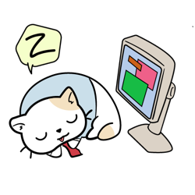

3/16

**National Panda Day**

Pandas have been around for an estimated 1-2 million years and are native to China. Baby pandas grow from tiny to massive in just a few short years. Pink, blind, and hairless, panda infants are about the size of a stick of butter, but within a year, pandas tip the scales at around 100 pounds. Fully mature pandas can be up to six feet long and reach 350 pounds. Pandas are technically carnivores due to their sharp teeth and digestive tracts, but their diets consist nearly exclusively of bamboo. (This is largely because they don’t have the energy to chase anything. Their prey would virtually have to land in their lap, be injured, or too slow to escape.) Pandas eat up to 85 pounds of bamboo a day and can scarf down a shoot in about 40 seconds. But all that fiber has side effects: An adult panda can produce more than 60 pounds of droppings in 24 hours! Eating and sleeping make up most of the panda's day, in fact one reason for pandas being rare is that breeding is not high on their list of priorities. And with only a one-day window a year for a female to conceive naturally, it is hardly surprising that pandas are an endangered species. Of course they are also endangered due to habitat destruction, and thankfully organizations like the WWF are working to keep them around for years to come!

For more panda facts, check out:<https://www.factretriever.com/giant-panda-facts>



3/17

**St. Patrick's Day**

Much of what is known about St. Patrick's life has been interwoven with folklore and legend. Historians generally believe that St. Patrick, the patron saint of Ireland, was born in Britain (not Ireland) near the end of the 4th century. At age 16 he was kidnapped by Irish raiders and sold as a slave to a Celtic priest in Northern Ireland. After toiling for six years as a shepherd, he escaped back to Britain. He eventually returned to Ireland as a Christian missionary. Among the legends associated with St. Patrick is that he stood atop an Irish hillside and banished snakes from Ireland—prompting all serpents to slither away into the sea. In fact, research suggests snakes never occupied the Emerald Isle in the first place. There are no signs of snakes in the country’s fossil record. And water has surrounded Ireland since the last glacial period. Before that, the region was covered in ice and would have been too cold for the reptiles.

Today St. Patrick's day is a popular holiday that has been celebrated in the United States since before we were even officially the United States! New York City's parade, dating back to 1762, is now one of the largest St. Patrick's Day parades in the world (though unfortunately has been cancelled in 2020 and 2021 due to COVID-19). NYC isn't the only place you can find fun St. Paddy's day traditions - since 1962, Chicago has dyed the river green each year to celebrate! See picture below (smile)

For more interesting facts about St. Patrick's day, check out:<https://www.mentalfloss.com/article/93246/13-lucky-facts-about-st-patricks-day>

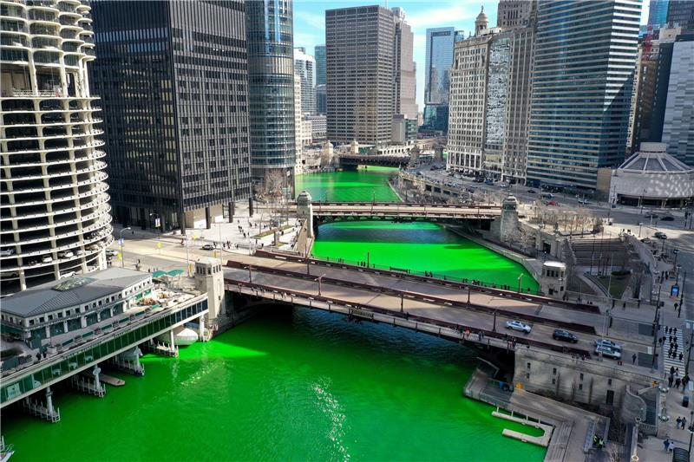

3/18

**National Sloppy Joe Day**

There are different claims to the origin of the Sloppy Joe. In Havana, Cuba, in the 1930s, there was a genuine bartender who gained popularity with vacationers who went by the name of Sloppy Joe. He earned his name for his less than enthusiastic way of cleaning the bar. He was, however, an attentive bartender, and the bar was a hot spot for the jet set. However, no mention is found in papers from the era of a hot sandwich on the menu matching the description of a Sloppy Joe, and the man of the same name retired to Spain in 1933. Town Hall Deli in Maplewood, NJ claims to have a direct connection to Sloppy Joe of Havana fame. It opened in 1927, and during the 1930s, Maplewood’s Mayor Sweeney traveled to Havana, where he met the bartender named Sloppy Joe and was served a delicious sandwich. The mayor came back to New Jersey and with a well-developed taste for Joe’s sandwich. The mayor enjoyed it so much he asked one of Town Hall Deli’s proprietors, Fred Heinz, to replicate it. According to the website, “It was made with coleslaw, ham, cow tongue, swiss cheese, with lots of dressing and was served on thin rye bread. Hence, the origin of the Sloppy Joe sandwich and how Town Hall Deli of South Orange became The Birthplace of the Sloppy Joe!” Then in 1934 at the Ye Olde Tavern Inn, in Sioux City, Iowa, Abraham and Bertha laid claim to the Sloppy Joe when they added a loose meat sandwich on their menu in 1934. Whoever brought the Sloppy Joe to the world, Hunt’s made it more convenient in 1969. They put it in a can and called it Manwich.

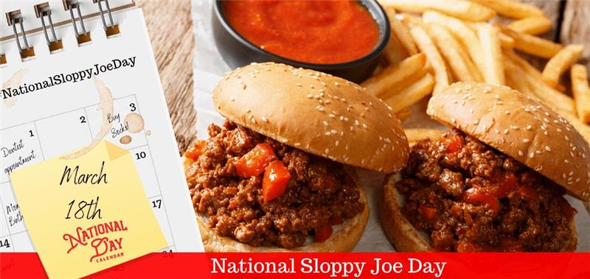

3/19

**National Chocolate Caramel Day**

Recipes for chocolate caramels existed as early as the 1880s. At about the same time, the first mass-produced chocolate bar became available. In 1893, the World’s Colombian Exposition came to Chicago. Milton S. Hershey, a successful caramel maker at the time, was fascinated with an exhibit featuring machinery for the production of German chocolate. So fascinated, in fact, he purchased the equipment. Soon he was producing chocolate bars, many of which included his company’s bedrock ingredient: caramel. Though he eventually sold his caramel business to focus on chocolate, Hershey receives a lot of credit for making chocolate caramel popular.

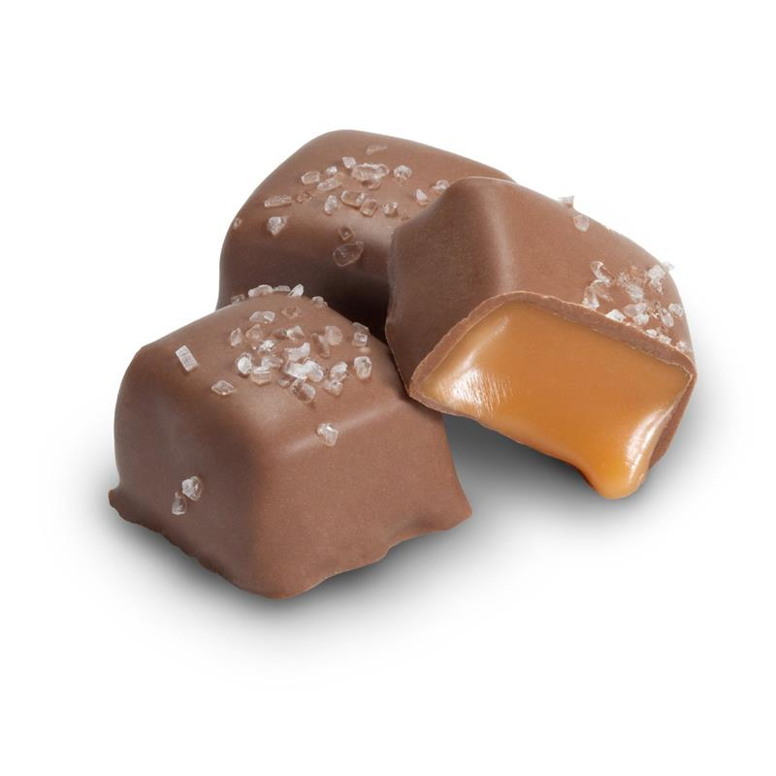

3/22

**National Goof Off Day**

The term *goof off* originated in 1941 with the World War II armed forces, meaning "to make a mistake at drill" and by 1945 it meant "to loaf, waste time." Not much history is known about the origins of this wacky holiday. According to the Detroit Free Press, Monica (Moeller) Dufour of Davidson, MI founded National Goof Off Day some time in the late 1970s.

Here's an interesting article about the value of goofing off a little at work. Turns out, studies show that taking small breaks can make employees overall more productive because they are less likely to get burned out.

<https://red.msudenver.edu/2018/why-you-should-occasionally-goof-off-at-work.html>

3/23

**National Tamale Day**

The word "tamale" is an anglicized version of the Spanish word *tamal*, which is derived from the word *tamalii* from the Nahuatl language spoken by the Aztecs. The word means “wrapped food”. Tamales have been written about since pre-Columbian days and are thought to have originated with the Olmec and Toltec civilizations and Central America. In the 1550's, the Aztecs served the Spaniards tamales during their visits to Mexico. Tamales were also eaten by soldiers on their lengthly sojourns since tamales are easily portable and heatable. The tamales of old came in all shapes and sizes. There were meat, seafood, vegetable, nut and fruit tamales. Some were filled with the corn dough masa we use today and some were not. Crushed rice or beans could be used instead of the masa or the tamale could contain no masa at all. Tamales could be wrapped in corn husks, banana leaves, avocado leaves, other non-toxic leaves, or even paper or bark. Tamales were steamed, grilled, roasted, boiled or even fried. There was quite a variety. Tamales of today are more homogeneous. The most common tamales are made with beef, chicken or pork in a red or green chile sauce or sweet tamales made with raisins and cinnamon. Most are wrapped with corn masa in a corn husk and steamed.

National Tamale Day was founded by a Mexican food lover named Richard Lambert in 2014. Check out this interview on how he started the holiday:<https://elrestaurante.com/interview-mexican-food-lover-founded-national-tamale-day/>

3/24

**National Cheesesteak Day**

Philadelphians Pat and Harry Olivieri are often credited with inventing the sandwich by serving chopped steak on an Italian roll in the early 1930s. The exact story behind its creation is debated, but in some accounts, Pat and Harry Olivieri originally owned a hot dog stand, and on one occasion, decided to make a new sandwich using chopped beef and grilled onions. While Pat was eating the sandwich, a cab driver stopped by and was interested in it, so he requested one for himself. After eating it, the cab driver suggested that Olivieri quit making hot dogs and instead focus on the new sandwich. They began selling this variation of steak sandwiches at their hot dog stand near South Philadelphia's Italian Market. They became so popular that Pat opened up his own restaurant which still operates today as Pat's King of Steaks. The sandwich was originally prepared without cheese; Olivieri said provolone cheese was first added by Joe "Cocky Joe" Lorenza, a manager at the Ridge Avenue location.

3/24

**National Chocolate Covered Raisin Day**

Another food that was popularized in Philadelphia was Raisinets (chocolate covered raisins), made by the Blumenthal Brothers Chocolate Company of Philadelphia in 1927. Over the years they were eventually bought by Nestle 1984 and later by Ferrero in 2018. Raisinets are made with a special type of grape only grown in the USA, Thompson Seedless grapes. All are grown and harvested in California’s Central Valley. Fun fact: According to the Nestle website, if you lined-up the amount of Raisinets produced in one year end-to-end, the length would go around the earth 2.5 times!

3/25

**International Waffle Day**

Waffle Day (Swedish: *Våffeldagen*) is a tradition that is celebrated in Sweden, Norway, and Denmark, on March 25, which is also the Feast of the Annunciation, upon which waffles are typically eaten. The shift from the religious celebration to Waffle Day occurred because the Swedish *Vårfrudagen*, meaning "Our Lady's Day" (the Feast of the Annunciation), sounds similar to *Våffeldagen* ("waffle day") in faster speech, and so over time Swedes began calling it Waffle Day and celebrating by eating waffles.

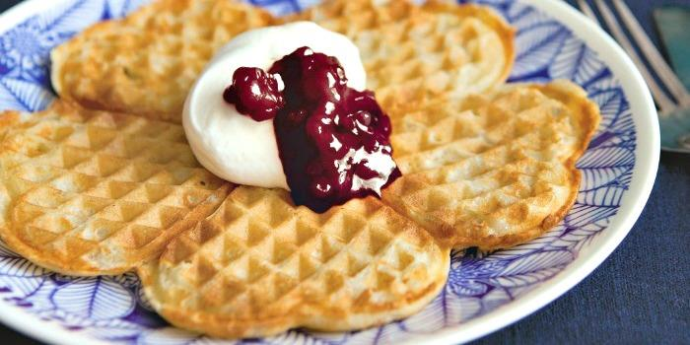

3/26

**National Spinach Day**

* Spinach is a native plant of Persia (modern day Iran). It was introduced to China in the 7th century. It was most probably brought to Europe in about the 12th century and to the US in 1806.
* Medieval artists extracted green pigment from spinach to use as an ink or paint.
* During her reign as queen of France, Catherine de Medici enjoyed spinach so much, it was served at every meal. To this day, dishes made with spinach are known as “Florentine” reflecting Catherine’s birth in Florence.
* In the 1930’s U.S. spinach growers credited Popeye with a 33% increase in domestic spinach consumption – a welcome boost to an industry during the depression era. In fact, the spinach growing town of Crystal City, Texas, erected a statue of Popeye in 1937.
* During World War I, wine was reinforced with spinach juice and given to hemorrhaging French soldiers. The idea was to utilize the high volume of vitamin K in spinach to thicken their blood and improve their situation.
* California is the US’s #1 grower/supplier of spinach, accounting for almost three quarters (3/4) of national production. However, the U.S. is only the world’s second largest producer of spinach, producing a mere 3% of global production. China is the world’s largest spinach producer with 90% of global production.
* In March 2005, Bon Appetit magazine’s annual survey showed that 56% of respondents said that spinach was their favorite vegetable.
* Unlike most veggies, cooking spinach intensifies the health benefits. Half a cup of cooked spinach will grant you with threefold the nutrition as one cup of raw spinach. For more info on the nutritional benefits of spinach, check out:<https://spreademkitchen.com/blog/is-spinach-more-nutritious-cooked-or-raw>

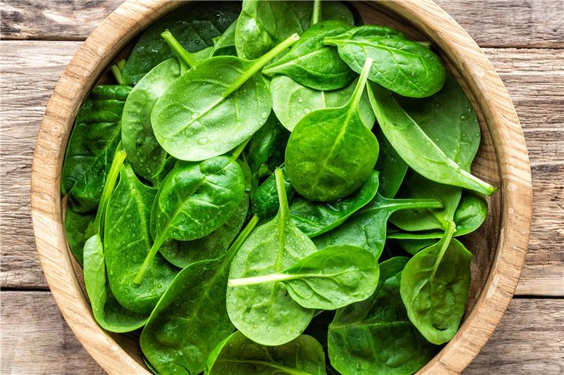

3/29

**National Mom and Pop Business Owners Day**

The holiday was established by Rick and Margie Segel in honor of their parents, who first opened a hat shop called Ruth’s in Everett, Massachusetts on March 29, 1939. The store became successful and later evolved into specialty clothing store for women. The store’s location moved to Medford, Massachusetts, and grew in size, totaling 10,000 square feet. As with the store’s size, the revenue grew too, bringing in over $2 million in revenue. Though the store eventually closed in 1997, it’s pretty amazing when a small shop can grow in size and profitability, and stick around for nearly six decades. National Mom and Pop Business Owners Day is meant to recognize all the hard work of small business owners everywhere.

3/30

**National Doctor's Day**

National Doctor's Day is held every year on March 30th in the United States. It is a day to celebrate the contribution of physicians who serve our country by caring for its citizens. The first Doctor's Day observance was March 30, 1933 in Winder, Georgia. Eudora Brown Almond, wife of Dr. Charles B. Almond, decided to set aside a day to honor physicians. This first observance included the mailing greeting cards and placing flowers on graves of deceased doctors. On March 30, 1958, a Resolution Commemorating Doctors' Day was adopted by the United States House of Representatives. In 1990, legislation was introduced in the House and Senate to establish a national Doctor's Day. Following overwhelming approval by the United States Senate and the House of Representatives, on October 30, 1990, President George Bush signed S.J. RES. #366 (which became Public Law 101-473) designating March 30th as "National Doctor's Day."

3/31

**National Manatee Appreciation Day**

Manatees are mammals, like walruses and seals, which they most closely resemble in shape, but they are not related. In fact, the manatees closest living relative is the elephant! They have very thick skin, sometimes over an inch thick, and even have three to four toenails, like the elephant. The manatee snout is also like a shrunken version of the elephant’s trunk. The use their prehensile lips to grasp and pull food into their mouths similar to the way elephants use their trunks.

Despite their blubbery size and shape, Manatees don’t have much blubber to keep warm. They may look fat, but their body mass is made up of mostly their stomach and intestines. Without insulation, they can get cold stress in water below 68 degrees.

Centuries ago, manatee sightings by sailors at sea gave rise to the myth of mermaids. But the vision was a mirage-like hallucination brought on by sleep deprivation, dehydration, malnutrition, and maybe a little wishful thinking on the sailor’s part! According to Smithsonian magazine, Christopher Columbus is said to have made the first written account of manatees in North America. But it wasn’t flattering. Thinking he was seeing a mermaid, Columbus wrote: “they are not so beautiful as they are said to be, for their faces had some masculine traits."

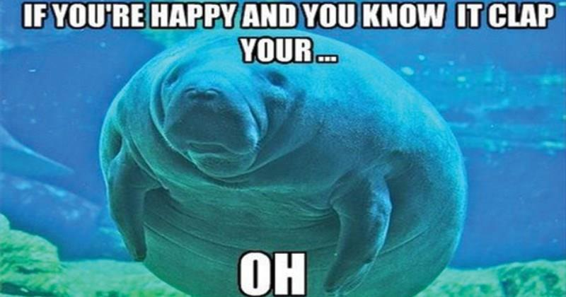

4/1

**National Burrito Day**

We don't know exactly who first invented the burrito, or why. But we do know the name is a diminutive of *burro*, or "donkey" in Spanish. There are a couple of theories for how that name came about, courtesy of *The Encyclopedia of Latino Culture*:

* One theory holds that people from Sonora (a northwestern Mexican state) invented the burrito because it was easy to travel with. The name "burrito" may have come about from its role as a sidekick to the donkey.
* Another theory holds that the burrito came from Chihuahua, during the Mexican revolution in the 1910s. As one story has it, a vendor named Juan Méndez wrapped his food in a flour tortilla, transporting his new creation on a small donkey.
* Alternatively, the name may have originated in Ciudad Juárez in the 1940s, when a street vendor portioned food to serve schoolchildren. He derogatorily called the kids "burritos," meaning they were dimwitted.

Burritos first showed up on American menus in the 1930's when a Los Angeles restaurant called El Cholo Spanish Cafe added them to their menu. In 1956, Duane R. Roberts invented the frozen burrito after success selling frozen burger patties to McDonald's, and brought the burrito nationwide. In the 1960s, a restaurant in San Francisco called El Faro started making the overstuffed burritos that are more like what we see today. That idea was eventually picked up by none other than Steve Ells, the founder of Chipotle. The first Chipotle opened in Colorado in 1993.

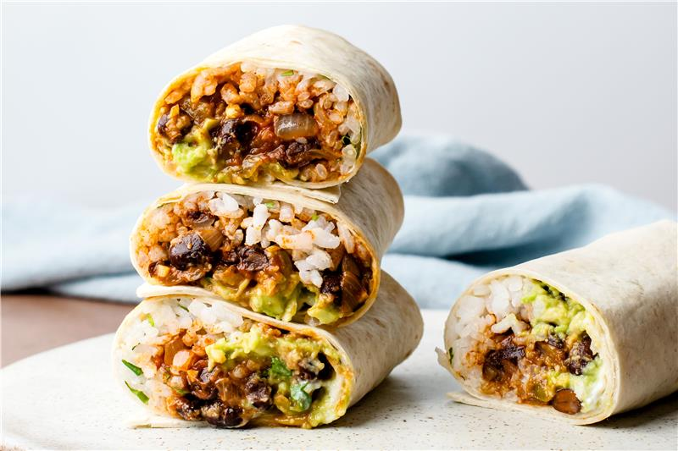

4/6

**National Carbonara Day**

The Italian Association of Confectionery and Pasta Industries and (AIDEPI) and the International Pasta Organization (IPO) created National Carbonara Day in 2017 to celebrate the dish that millions of pasta lovers identify as the taste of Italy. The origins of *pasta alla carbonara* are widely debated and there's no clear answer as to where it came from. Some theories state it is an Italian invention while others claim it is an American invention. An interesting theory is that it was invented in WWII when American GIs were stationed in Rome and their rations consisted of eggs and bacon, which was combined with regional pasta to create the dish. This is somewhat unlikely as many chefs will tell you carbonara cannot be made with powdered eggs, which is how the rations were given. Regardless of how it came to be, the general recipe we know today was first published in American and Italian cookbooks around the 1950s. The recipe usually consists of the same 4 ingredients but the proportions are widely debated. First is the pasta, usually spaghetti but it can be anything as long as it has a lot of surface area for sauce to cling to, so you generally want the long noodles. Second is the eggs, often with more yolks than whites to give it that extra rich texture (again, proportions vary widely from recipe to recipe). Next is the cheese, usually pecorino, parmesan, or some combination of these cheeses. Finally is the pancetta (pork belly) or guanciale (pork jowl), which is often substituted with bacon but many will tell you it's not really the same. Purists will also refute the use of cream in the recipe, reasoning that the egg, when prepared properly, should give all the creaminess necessary. No matter how you prepare it, this rich dish is sure to please - even The New York Times ranks it top of its list of the 20 most popular pasta recipes!

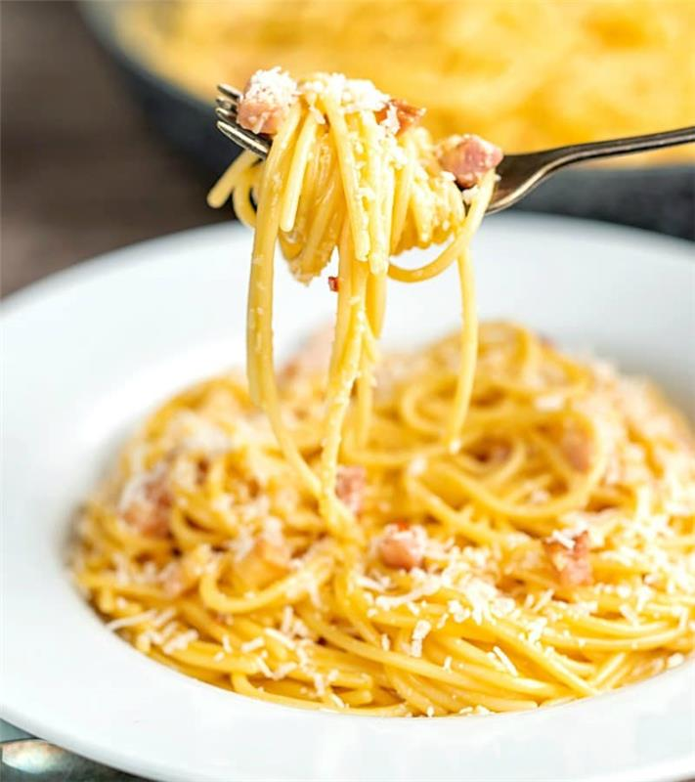

4/5

**National Deep-Dish Pizza Day**

Chicago deep-dish pizza was the happy consequence of unhappy economic and cultural shifts during World War II. The ingredients necessary for pizza dough — wheat flour, corn oil, salt, and yeast — were not among the rationed foods, and the filling could be made from leftover meats and vegetables. The deep-dish pie was also the perfect meal for manual laborers. Two entrepreneurs were quick to spot the appetite of the boys marching home. Ike Sewell, an ex-University of Texas lineman, and Ric Riccardo, a food business operator of Italian-American heritage, teamed up to open Pizzeria Uno. They sold the first deep-dish pie in 1943. It had a thicker crust than a super-skinny Napoli pie, but not the super-thick crust of a Sicilian one, called Sfincione or Sfinciuni. Rather than being baked on the bottom of the oven, deep-dish was baked in a circular pan, two to three inches deep. The pizza was also upside-down. A thick layer of mozzarella cheese was topped with meat or vegetables, covered with tomato sauce, and topped with crust. The concoction required a knife, a fork, and a napkin — and it was cooked to order. This pizza spawned many other deep-dish pizza places in Chicago over the years, and has ignited much debate over its allure. From Anthony Bourdain to Graham Eliot to Mario Batali, chefs deride the Chicago invention, calling it at worst an abomination and at best unworthy of being called pizza. Foodie comedians have joined in on the oh-so-superior complaint festival. But in the Second City, deep-dish pies are beloved. Native Chicago-ans, like Ike Barinholtz and Shonda Rhimes, have come out swinging. And when the forelorn Chicago Cubs were finally a serious contender in baseball, Giordano’s marked the occasion with a pie with the insignia emblazoned in Parmesan cheese.

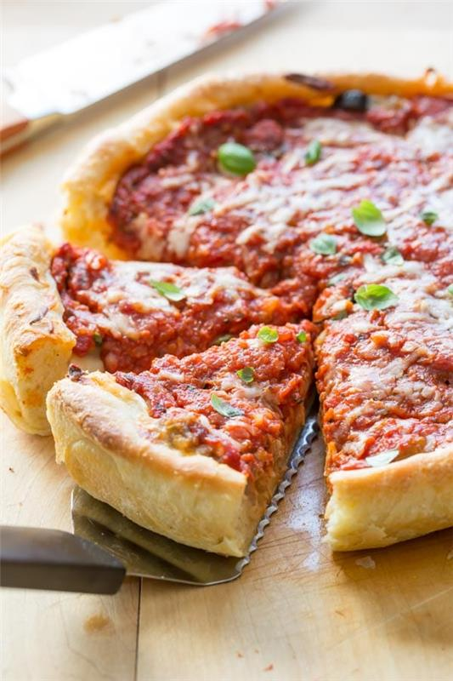

4/7

**National Beer Day**

On April 7, 1933, President Franklin Roosevelt took the first step toward ending Prohibition and signed the Cullen-Harrison Act, which allowed people to brew and sell beer in the United States as long as it remained below 4.0% alcohol by volume (ABV). Upon signing the legislation, Roosevelt made his famous remark, "I think this would be a good time for a beer." Beer drinkers celebrated and were happy to be able to purchase beer again for the first time in thirteen years. (beer)

National Beer Day was created by Justin Smith, a Richmond, Virginia Craft Beer Examiner, and his friend Mike Connolly from Liverpool, England. In 2009, Smith and Connolly created a National Beer Day Facebook page. From this page, they invited friends to join, and word spread to many sources.

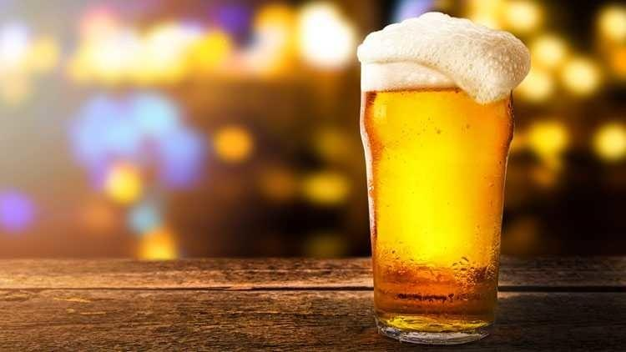

4/8

**National Empanada Day**

The first reference to empanada-like food was found in Persia and dates back to 100 BC. The second empanada milestone was the landing of the Moors in Gibralta where they shared this folded pastry with both Spain and Portugal. The Spanish loved it, created a the term *empanada* (which means "bread-wrapped"), and then went to work spreading their recipe worldwide as they conquered the West. A Catalan chef named Roberto De Nola added the empanada recipe to the very first published cook book in Spain in 1520, *Llibre del Coch* ("cook book" in Catalan).

When the Spanish hit the New World in the 16th century they shared their empanada recipe with the Aztecs and Maya. The Spanish recipe was made with bread dough, the Mexican recipe with corn masa dough. Each region in Mexico has their own version of the empanada. Some regions use wheat flour, some use corn masa dough, some are deep fried some are baked. There is a wide variety of different fillings that can go in these empanadas, including meats, cheeses, and vegetables. For some tasty empanada recipes, check out:<https://www.allrecipes.com/gallery/our-best-empanada-recipes/>

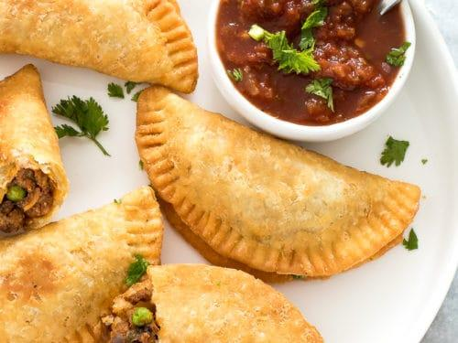

4/9

**National Unicorn Day**

Greek physician and historian Ctesias was the first person to write about the one-horned animal in his book *Indica*, written around 400 BCE. This early description gave the world the image of the horse-like body, the white color, and the single horn, an image that would later be transformed into the medieval unicorn. He actually had the Indian rhinoceros in mind (or perhaps someone's description of it—Ctesias himself never visited India). The Indian rhinoceros and one other Far-Eastern species are the only land mammals with one horn. But the Indian rhinoceros has a massive, ungainly body, stumpy legs, and a thick, folded hide that looks like plates of armor. With the exception of its single horn, it is profoundly unlike the lithe unicorn of medieval art, and one can understand why Marco Polo wasn't exactly dazzled when he first encountered one. The 13th century Italian explorer had finally gotten a glimpse of a "unicorn" and he was sorely disappointed. He wrote:

"Their hair is like that of a buffalo, and their feet like those of an elephant. In the middle of the forehead they have a very large black horn…. Their head is like that of a wild boar, and is always carried bent to the ground. They delight in living in mire and in mud. It is a hideous beast to look at, and in no way like what we think and say in our countries... Indeed, I assure you that it is quite the opposite of what we say it is."

Belief in unicorns was pervasive in medieval times, and its horn was said to have medicinal properties when ground up. It wasn't until the 1700s when the idea became more of a legend than actual living creature. Still, the legend lives on today as unicorns are still seen in popular culture and are usually depicted with having magical powers. For more on the fascinating history behind unicorns, check out:<https://www.livescience.com/59674-unicorn-facts.html>

(Here's picture I drew of a unicorn when I was 15)

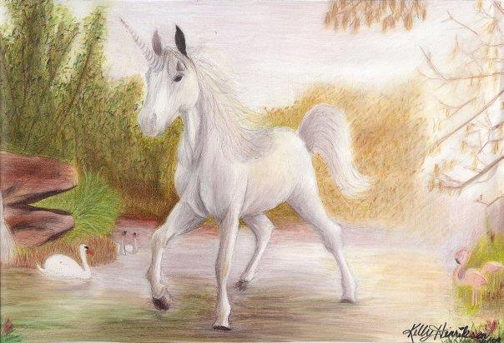

4/12/21

**National Grilled Cheese Day**

Today's notion of the grilled cheese is commonly traced back to the 1920s, when Otto Frederick Rohwedder, considered "the father of sliced bread," invented a bread slicer that made distributing white bread easy and affordable. Shortly before that, processed cheese had been patented by James L. Kraft, an entrepreneur whose revolutionary pasteurizing process ensured that cheese wouldn't spoil, even when transported long distances. By 1914, J.L. Kraft & Bros. Company (the precursor to Kraft Foods) opened its first plant in Illinois; five years later, the company had already expanded into Canada. Of course, this "factory cheese" — disparagingly termed "rattrap cheese" or "rat cheese" by the English who were fiercely proud of their cheddars — was not considered a delicacy. It was, simply, a cheap and scalable product. During World War II, Navy cooks prepared countless "American cheese filling sandwiches" — as instructed by government-issued cookbooks — in ships' kitchens. In the 1940s and '50s, these were usually served open-faced and consisted of one slice of bread topped with grated cheese. In 1949, Kraft Foods introduced Kraft Singles — individually wrapped slices of processed cheese — and supermarkets began stocking them in 1965. Also around that time, the second, perhaps most important, piece of bread was added on top, likely as a way to make the sandwich more filling, and the modern notion of a grilled cheese sandwich was born. It's also worth noting that the actual term "grilled cheese" doesn’t make an appearance in print until the 1960s; before that it was always "toasted cheese” or "melted cheese" sandwiches.

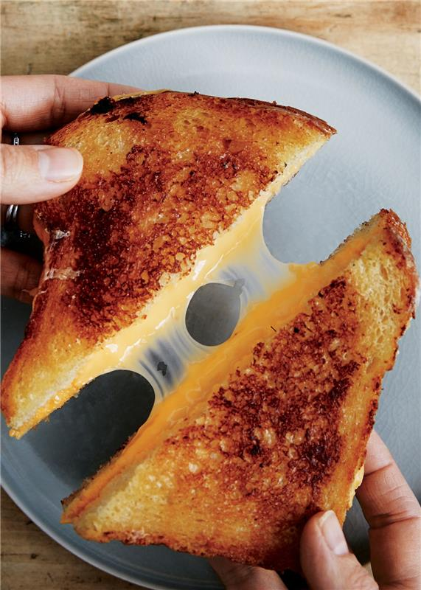

4/13

**National Scrabble Day**

April 13th is the birthday of Alfred Butts, known as the inventor of *Scrabble*. In 1931, Butts wrote a paper entitled "Study of Games." In his paper, he described three categories of games: board games, number games using playing cards or dice, and letter games (or games that fell into more than one). He noted that, although the most popular games were of the first two (e.g., chess and backgammon), the best letter game readily available was a game called *Anagrams*. Around that time, he was reading *The Gold-Bug* by Edgar Allan Poe and noticed a line containing the English letter distribution. This gave him an epiphany: *Anagrams* would be more fun if the most common letters in English were more common in the game. He carefully analyzed letter frequencies in newspapers such as *The New York Times* and other printed works to determine the ideal letter distribution for the game. With a few other changes, he named his project *Lexiko*. The name comes from the Greek *lexicos*, meaning "of or for words". The game design was rejected by game manufacturers such as Parker Brothers and Milton Bradley, but Butts was able to sell copies on his own, though not enough to recoup his development expenses. In 1938, he began work on a board game based on *Lexiko*, which he called *Criss-Cross Words*. In 1948, James Brunot, one of the few owners of the original *Criss-Cross Words* game, bought the rights to manufacture the game. He renamed the game *Scrabble*, a real word which means "to scratch or grope around with one's fingers to find, collect, or hold on to something." *Scrabble*'s big break came in 1952 when Jack Straus, president of Macy's, played the game on vacation. Upon returning from vacation, he was surprised to find that his store did not carry the game. He placed a large order, and within a year, "everyone had to have one".

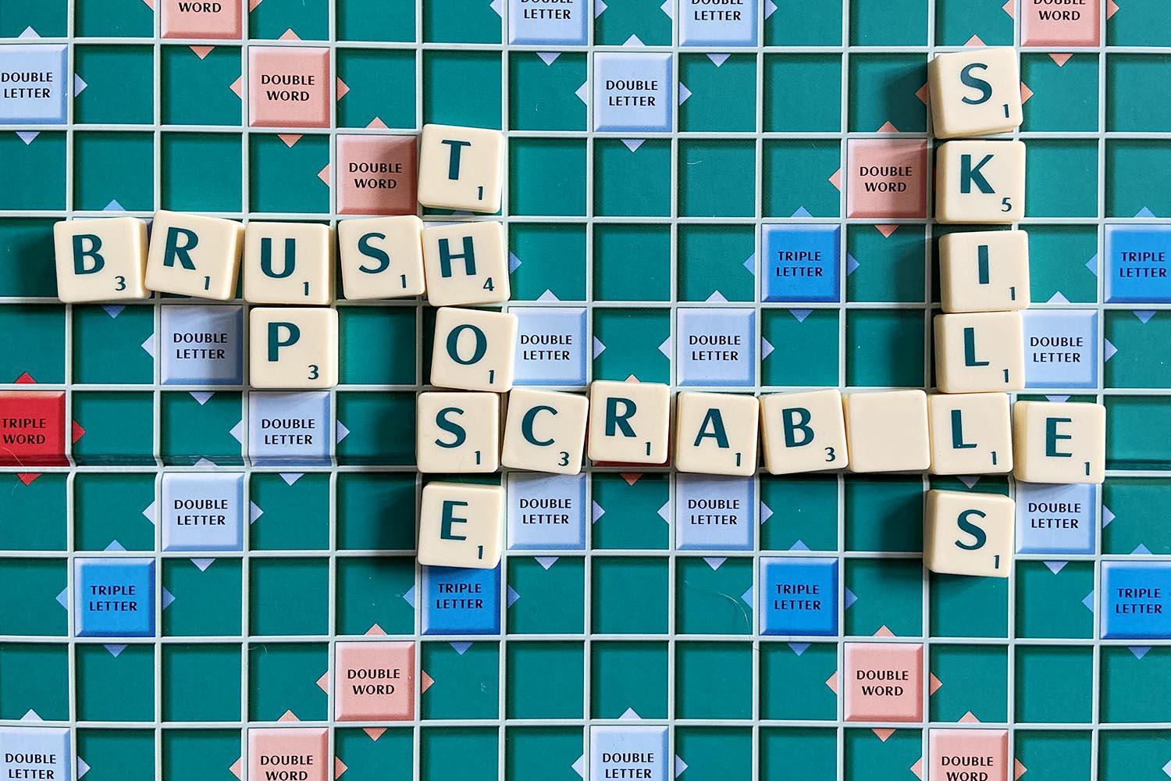

4/14

**National Dolphin Day**

Fun Fact: Since the 1960s, the U.S. Navy has utilized dolphins to detect underwater mines. Much like bomb detection dogs work by smell, dolphins work by echolocation. Their superior ability to scan an area for particular objects allows them to zero in on mines and drop markers at the spots. The Navy can then find and disarm the mines. The echolocation skills of dolphins far outstrip any technology people have come up with to do the same job. However, these Navy programs have been highly controversial, as animal rights advocates have long opposed the use of dolphins for military purposes. Concerns include the stresses dolphins experience with sudden transportation and transplantation to new areas, muzzles that prevent them from foraging while working, and the risk of accidental detonation of a mine. Though the U.S. Navy Marine Mammal Program maintains that it complies with federal laws regarding the care of their dolphins, activists have continued to fight against exploitation.

For more fascinating facts about dolphins, check out:

<https://www.treehugger.com/mind-boggling-dolphin-facts-4863589>

4/14

**International Moment of Laughter Day**

This holiday was created by humorologist Izzy Gesell. “Laughter comes right after breathing as just about the healthiest thing you can do.” says Izzy. “It relieves stress, instills optimism, raises self-confidence, defuses resistance to change, and enhances all your relationships.”

Be sure to have a laugh today

4/15

**National Banana Day**

Banana fun facts:

* Declared the “Banana Republic of Africa,” Uganda consumes more bananas per capita (600 pounds) per year than any other country. (In fact, the Ugandan word *matooke* means both “food” and “banana.”) By comparison, Americans eat 27 pounds of bananas per capita each year.
* We share about 50% of our DNA with bananas.
* In 2012, a man from Illinois, USA, peeled and gobbled down eight bananas in 60 seconds. He broke the world record for peeling and eating the most number of bananas in one minute.
* The type of banana you see in the supermarket is called a Cavendish banana. The preferred variety was originally the Gros Michel, which essentially became extinct by 1960, thanks to a fungus called Panama disease.
* Bananas are naturally slightly radioactive (thanks to their potassium content)—but the level of radiation is not high enough to cause harm.

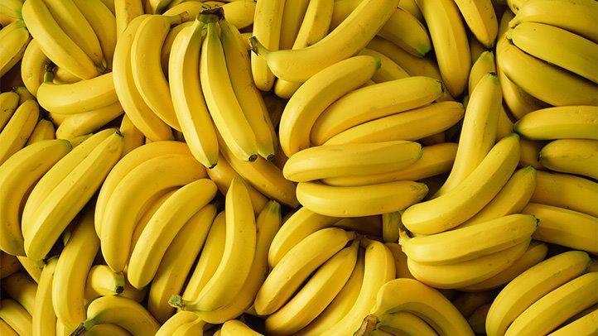

4/16

**National Wear Your Pajamas to Work Day**

Fun Fact: The word “pajama” comes from the Indian word *piejamah*, which described loose pants that were tied at the waist. The comfy trousers were admired by British colonials as the perfect thing to wear when napping in the afternoon, and it wasn’t long before the outfit was deemed perfect for any time spent asleep. When the colonials returned to Britain, the trend caught on.

National Wear Your Pajamas to Work Day was started by Pajamagram in 2004 and takes place on April 16th. It was created as a way to reward people for a late night finishing their taxes the night before, since tax day is (usually) April 15th. 2021 is a different kind of year though; the tax deadline was moved to May 17th. Also, many people wear their pajamas to work all the time now due to working from home. So this year it is likely that more people than ever are celebrating! (Whether they know it or not (laugh))

Since yesterday was National Banana Day, here is picture of the stars of the popular 90's children's television show, "Bananas in Pajamas":

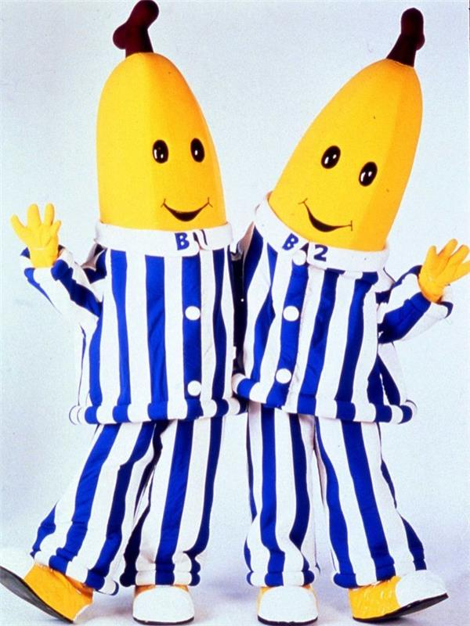

4/21

**National Kindergarten Day**

Each year on April 21st, National Kindergarten Day honors the birthday of the man who started the first Kindergarten. Friedrich Wilhelm August Frobel (April 21, 1782 – June 21, 1852) is credited with starting the very first Kindergarten in Germany in 1837. Frobel was a German teacher and a student of educational reformer Johann Pestalozzi. Frobel laid a foundation for modern education, recognizing that children learn through play and experience.

The first kindergarten (which means garden for the children) was developed in Blankenburg, Germany, in 1837. The kindergarten fostered Frobel’s social experience for children. It allowed them to smoothly transition from home to school.

Eventually, the Prussian government banned Frobel’s unorthodox methods. However, the rest of the world was eager to accept Frobel’s idea of kindergarten, including the United States.

In 1856, Watertown, Wisconsin, opened the first kindergarten in the United States. Founded by Margarethe Schurz, this kindergarten was a German-language class, as were many in this region. Kindergarten eventually found its way into private English-speaking institutions across the country. The first publicly financed kindergarten in the US was established in St. Louis in 1873 by Susan Blow.

4/22

**National Jelly Bean Day**

* While candies made in a similar manner existed before the jelly bean, Boston confectioner William Schrafft made them popular during the Civil War. In 1861, Schrafft encouraged his customers to send jelly beans to Union soldiers.
* Jelly beans were the first candies sold by weight. A 1905 newspaper advertised them for $0.09/lb.
* Very Cherry remained the most popular flavor of Jelly Belly beans for two decades until 1998, when Buttered Popcorn moved into first place. In 2003 Very Cherry moved back into top position by a mere 8 million beans.
* The 40th President of the United States, Ronald Reagan, enjoyed jelly beans so much that they were present at his inauguration. He started eating them when he quit smoking years before. The Herman Goelitz Candy Company (who eventually became the Jelly Belly Candy Company) supplied 7,000 pounds of red, white and blue jelly beans for the 1980 event. At the time, the company didn’t produce blue jelly beans. They created a blueberry jelly bean for the first time, especially for the inauguration.

Here's a portrait for Ronald Reagan made out of approximately 10,000 jelly beans, by artist Peter Rocha:

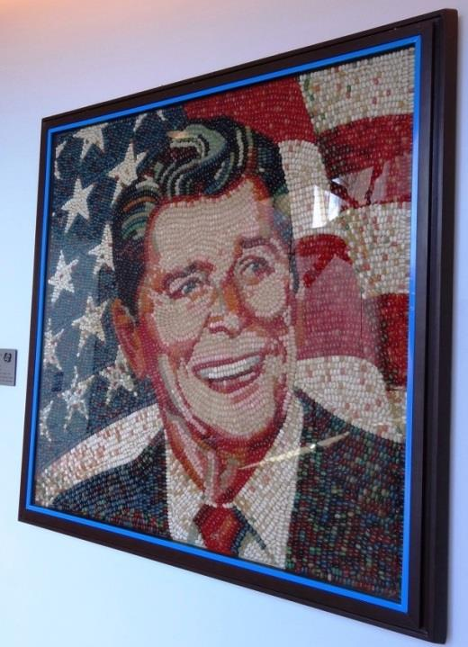

Here it is close up:

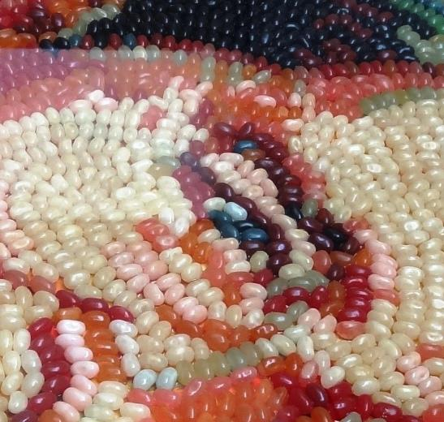

For more on Reagan's love of jelly beans, check out:<https://www.atlasobscura.com/articles/jelly-belly-ronald-reagan>

4/23

**National Talk Like Shakespeare Day**

William Shakespeare is believed to have influenced the English language more than any other writer in history, coining—or, at the very least, popularizing—terms and phrases that still regularly crop up in everyday conversation. Examples include the words “fashionable” (“Troilus and Cressida”), “sanctimonious” (“Measure for Measure”), “eyeball” (“A Midsummer Night’s Dream”) and “lackluster” (“As You Like It”); and the expressions “foregone conclusion” (“Othello”), “in a pickle” (“The Tempest”), “wild goose chase” (“Romeo and Juliet”) and “one fell swoop” (“Macbeth”). He is also credited with inventing the given names Olivia, Miranda, Jessica and Cordelia, which have become common over the years (as well as others, such as Nerissa and Titania, which have not).

National Talk Like Shakespeare Day was first launched in 2009 by the Chicago Shakespeare Theater, which was inspired by another day devoted to talking in character – International Talk Like a Pirate Day (September 19). In 2011, Illinois Governor Pat Quinn proclaimed April 23rd as Talk Like Shakespeare Day giving the theater’s efforts official recognition.

4/26

**National Pretzel Day**

* In terms of history, the soft pretzel came first. And it is largely believed that they originated by Christian monks in Italy around 610 A.D. They were shaped to resemble arms crossed in prayer and given as a reward to children who learned their prayers.
* Pretzels were a part of wedding ceremonies in the 16th century. Similar to a wishbone, the bride and groom would make a wish, break the pretzel and eat it as a symbol of their union.
* Pretzels have been a part of Easter traditions and were even hidden in the same way as Easter eggs.
* Hard pretzels originated in the United States in 1850.
* Pennsylvania is home to 80% of United States pretzel production. The average Philadelphian consumes about twelve times as many pretzels as the national average.
* In 2003, Pennsylvania Governor Ed Rendell declared April 26th "National Pretzel Day" to acknowledge the importance of the pretzel to the state's history and economy.

4/27

**National Babe Ruth Day**

Fun facts about baseball legend Babe Ruth:

* George Herman Ruth, Jr. was brought up in St. Mary’s Industrial School for Orphans, Delinquent, Incorrigible and Wayward Boys. Interestingly though, Ruth was not really an orphan but simply wayward, delinquent, and incorrigible. At just 7 years old, Ruth was such a bad boy that his parents had to send the troubled young man to the Catholic School for guidance. The school was completely responsible for Ruth, and it is here that he developed his interest for baseball.
* Ruth joined minor league Baltimore Orioles when he was only 19 and fresh out of school back in 1914. In order to validate his $250 contract, Jack Dunn, who owned and managed the team, had to take him under his legal guardianship because the age of majority was 25 at that time. When he first encountered the Orioles players, he was referred to as “Jack’s newest babe.”This nickname was shortened to “Babe” in public.
* Ruth had always believed that he was born on February 7, 1984 for several years. It was only after he checked his birth certificate when applying for a passport to sail to Japan in 1934 that he realized his real date of birth was February 6, 1895.
* To keep his head cool in the playing field, the Babe used to wear a piece of cabbage below his hat.
* Babe had a series of automobile accidents, traffic violations, and speeding tickets that subsequently led to his arrest on June 8 1921, when he was caught speeding in Manhattan. Ruth had to spend the rest of the day in jail, and was only released forty five minutes after his game had started. When they let him go, he wore his Yankee uniform beneath his suit and hailed a ride from a motorcycle escort in time to catch the game.
* On April 27th, 1947 at Baseball Commissioner Happy Chandler’s request, the New York Yankees hosted “Babe Ruth Day”, a national event to honor the baseball legend.

4/28

**National Blueberry Pie Day**

* Blueberries are a nutritious fruit native to North America and have been around for more than 13,000 years.
* Native Americans understood the value of wild blueberries, and managed the fields by burning them periodically to get rid of weeds and bugs. They boiled blueberry roots for tea. They dried the berries and made them into a pudding called *Sautauthig* (pronounced sawí-taw-teeg). Historians believe the Pilgrims served Sautathig at the first Thanksgiving meal.
* Wild blueberries are unique to eastern Maine, with its rocky acidic soil and cold climate. New Englanders ate wild blueberries and sold them commercially, but few knew them outside the region. Then came the Civil War. Sardine canneries lost their Southern markets, so they switched to selling canned blueberries to Union troops. The soldiers developed a taste for the sweet wild berry and took it home with them after the war.
* This once wild berry became domesticated during the early 1900s thanks to the observations of Elizabeth Coleman White and the research of Dr. Frederick V. Coville. Before their efforts, wild blueberries were never successfully transplanted and raised in any farming operation for personal or commercial production. The only way to enjoy fresh blueberries was to seek them out where they grew naturally.
* Blueberry pie shows up late in the history of cooking. The earliest reference was the *Appledore Cook Book* from 1872 with a recipe for Berry Pie.

4/29

**National Zipper Day**

* Elias Howe, Jr. (1819–1867), inventor of the sewing machine, received a patent in 1851 for an "Automatic, Continuous Clothing Closure." Perhaps it was the success of the sewing machine, that caused Elias not to pursue marketing his clothing closure system. Howe's device was more like an elaborate drawstring than a true slide fastener.
* Forty-four years later, inventor Whitcomb Judson (1846–1909) marketed a "Clasp Locker" device similar to system described in the 1851 Howe patent. The clasp locker debuted at the 1893 Chicago World's Fair and was met with little commercial success.
* In December of 1913, a Swedish-born electrical engineer named Gideon Sundback (1880–1954) came up with what would become the modern zipper. Gideon Sundback's new-and-improved system increased the number of fastening elements from four per inch to 10 or 11, had two facing-rows of teeth that pulled into a single piece by the slider and increased the opening for the teeth guided by the slider. His patent for the "Separable Fastener" was issued in 1917.
* The popular "zipper" name came from the B. F. Goodrich Company, which decided to use Sundback's fastener on a new type of rubber boots or galoshes. Boots and tobacco pouches with a zippered closure were the two chief uses of the zipper during its early years.
* It took 20 more years to convince the fashion industry to seriously promote the novel closure on garments. A landmark moment happened in 1937 when the zipper beat the button in the "Battle of the Fly." French fashion designers raved over the use of zippers in men's trousers and *Esquire* magazine declared the zipper the "Newest Tailoring Idea for Men." Among the zippered fly's many virtues was that it would exclude "The possibility of unintentional and embarrassing disarray."

4/29

**National Raisin Day**

For this history of raisins, check out:<https://calraisins.org/about/the-raisin-industry/history/>

For raisin fun facts, check out:<https://mobile-cuisine.com/did-you-know/raisin-fun-facts/>

5/3

**National Two Different Colored Shoes Day**

Dr. Arlene Kaiser created National Two Different Colored Shoes Day in 2009 to recognize and celebrate human diversity. According to Dr. Kaiser, the simple act of wearing two different colored shoes proclaims your individuality. By taking this “positive risk,” you can demonstrate your willingness to be different, and show your appreciation for the unique people in your life.

5/4

**National Star Wars Day**

*Star Wars* Day is an informal commemorative day observed annually on May 4 to celebrate George Lucas' *Star Wars* media franchise. The date originated from the pun "May the Fourth be with you", a variant of the popular *Star Wars* catchphrase "May the Force be with you".

In 2011, the first organized celebration of *Star Wars* Day took place in Toronto, Ontario, Canada at the Toronto Underground Cinema. Produced by Sean Ward and Alice Quinn, festivities included an Original Trilogy Trivia Game Show; a costume contest with celebrity judges; and the web's best tribute films, mash-ups, parodies, and remixes on the big screen.

Disney purchased Lucasfilm, including the rights to *Star Wars*, in late 2012. Since then, Disney has officially observed the holiday with several *Star Wars* events and festivities at Disneyland and Walt Disney World.

Happy *Star Wars* Day! May the Fourth be with you!

**Bonus holiday fact:** Some recognize the following day, May 5, as "Revenge of the Fifth", a play on *Star Wars: Episode III – Revenge of the Sith* and celebrate the Sith Lords and other villainous characters from the *Star Wars* series rather than the Jedi. Others celebrate this one day later, on May 6, citing "Revenge of the Sixth" as a better play on "Sith". Those who say the second day should be celebrated on the 6th do so as to not compete with Cinco de Mayo on the 5th. But then those who say it should be "Revenge of the Fifth", say that "Revenge of the Sixth" sounds weird with the x sound. Which do YOU think it should be?

5/5

**Cinco de Mayo**

Cinco de Mayo is not Mexican Independence Day, a popular misconception. Instead, it commemorates a single battle. In 1861, Benito Juárez—a lawyer and member of the Indigenous Zapotec tribe—was elected president of Mexico. At the time, the country was in financial ruin after years of internal strife, and the new president was forced to default on debt payments to European governments. In response, France, Britain and Spain sent naval forces to Veracruz, Mexico, demanding repayment. Britain and Spain negotiated with Mexico and withdrew their forces. France, however, ruled by Napoleon III, decided to use the opportunity to carve an empire out of Mexican territory. Late in 1861, a well-armed French fleet stormed Veracruz, landing a large force of troops and driving President Juárez and his government into retreat. Certain that success would come swiftly, 6,000 French troops under General Charles Latrille de Lorencez set out to attack Puebla de Los Angeles, a small town in east-central Mexico. From his new headquarters in the north, Juárez rounded up a ragtag force of 2,000 loyal men—many of them either Indigenous Mexicans or of mixed ancestry—and sent them to Puebla. The vastly outnumbered and poorly supplied Mexicans, led by Texas-born General Ignacio Zaragoza, fortified the town and prepared for the French assault. On May 5, 1862, Lorencez gathered his army—supported by heavy artillery—before the city of Puebla and led an assault. The battle lasted from daybreak to early evening, and when the French finally retreated they had lost nearly 500 soldiers. Fewer than 100 Mexicans had been killed in the clash. Although not a major strategic win in the overall war against the French, Zaragoza’s success at the Battle of Puebla on May 5 represented a great symbolic victory for the Mexican government and bolstered the resistance movement. In 1867—thanks in part to military support and political pressure from the United States, which was finally in a position to aid its besieged neighbor after the end of the Civil War—France finally withdrew.

The contemporary iteration of the Cinco de Mayo celebrations date only to the Chicano Movement era of the 1960s and 1970s. The growing activism and renewed interest in Mexican cultural traditions sparked a revival of the dormant holiday. Now it is celebrated throughout the United States as a day to recognize Mexican heritage.

5/5

**National Astronaut Day**

May 5th is the anniversary of when NASA launched the first American-manned space flight (1961).

5/6

**National Crepes Suzette Day**

While there are slightly different versions of crepes Suzette, the dish is quite distinct from most other crepe dishes. The recipe first appeared in the 19th century in Paris courtesy of Chef Henri Charpentier. According to the chef’s memoir, he accidentally ruined a sauce for the crepes he was serving Prince Edward of Wales (the would-be King Edward VII) and his guests. With no time to recover, he tasted the burned sauce and discovered the flavors blended deliciously. When he served the dish, Charpentier named it Crepes Princesse. However, when the prince gently protested, Charpentier changed the name to Suzette in honor of the one female guest at the table. Charpentier would later come to the United States and serve as John D. Rockefeller’s chef. However, before that, Charpentier was world renown and learned under Auguste Escoffier (a chef known for other celebrated dishes).

The French dessert consists of a crepe with a beurre Suzette sauce. To make the sauce, caramelized sugar and butter, orange juice and zest, and orange liqueur. Once set afire, the alcohol evaporates quickly, resulting in a thick caramelized sauce. Restaurants often prepare Crepes Suzettes at the table of the guests.

Also it's **National Beverage Day** so if you didn't get your margarita/cerveza for Cinco de Mayo there's still time!

5/7

**National Space Day**

In 1997, Lockheed Martin Corporation created National Space Day as a one-day event. In 2001, due to its extreme popularity, former astronaut and senator John Glenn expanded Space Day to International Space Day. Now it falls on the first Friday in May every year.

I happened to run across an interesting article about space this morning...

<https://www.space.com/red-wine-in-space-aged-faster>

5/11

**National Eat What You Want Day**

National Eat What You Want Day was created by Thomas and Ruth Roy to help people break away from the frustrating health and diet trends of our times, if for only one day, and just let go and enjoy life a little.

Most nutritionists seem to agree that giving yourself a break every now and again can actually be good for us, and that forcing ourselves to eat only low-calorie, tasteless foods for prolonged periods of time is likely to cause us to suddenly gorge on everything in sight when our determination wears off.

5/12

**National Limerick Day**

A limerick is a kind of 5-line poem with a particular rhyming pattern. They are often quite silly. Here are some fun limericks to brighten your day:<https://pun.me/funny/limericks/>

"Limericks I cannot compose, With noxious smells in my nose. But this one was easy, I only felt queasy, Because I was sniffing my toes." (laugh)

5/13

**National Apple Pie Day**

Arguably the country’s most iconic dish, apple pie has been showing up at Fourth of July barbecues and Thanksgiving feasts for generations. But don’t let that fool you. Apple pie isn’t nearly as American as most people believe. In fact, apples aren’t even native to North America, and didn’t grow here until the arrival of European settlers. And cinnamon and nutmeg? Those came from as far away as Sri Lanka and Indonesia.

Apple pie first originated in England, where it arose out of culinary influences from France, the Netherlands, and the Ottoman Empire, centuries before the Pilgrims set foot on Plymouth Rock. The first recorded recipe for apple pie was written in 1381 in England, and called for figs, raisins, pears, and saffron in addition to apples. Early apple pie recipes also generally didn’t include sugar, and their pastry crust was “coffin” pastry, which was intended as an inedible container, not a part of the pie.

The early colonists of Jamestown brought European apple tree cuttings and seeds with them. The only native apple in North America was the crab apple, and the colonists found its tiny fruit to be a poor substitute for *Malus domestica*. Early settlers primarily used apples to make cider, which was preferred to water as a drink and easier to produce than beer, which required labor-intensive land clearing.

Eventually apples were used to make pie, and the dish quickly caught on as it was easy and affordable. America’s first cookbook, *American Cookery* by Amelia Simmons, published in 1796, included two recipes for the fruit-based dessert. However, it didn’t become associated with our cultural identity until the 20th century, when advertising, news, and two world wars transformed the dish into a nationalist symbol.

Though the exact origin of the phrase “as American as apple pie” is unclear, a 1928 New York Times article used it to describe the homemaking abilities of First Lady Lou Henry Hoover. By WWII it was a symbol of feminine love associated with the warmth of home, and soldiers were proudly proclaiming that they were fighting for “mom and apple pie.”

5/17

**National Walnut Day**

Walnuts have a rich history dating back to 7000 B.C. and are the oldest tree food known to man. Early history indicates that English walnuts came from ancient Persia then stretching across Central Asia from the Balkans eastward to the Himalaya and Southwest China where the trees grew in a wild and semi-cultivated environment. It wasn’t until ancient Roman and Greek times, that walnuts were widely cultivated in the Mediterranean where the Romans called walnuts *Juglans regia*, “Jupiter’s royal acorn.” Caravans carried walnuts along the Silk Road route between Asia and the Middle East and eventually through sea trade making their way to Europe. English merchant marines transported the product for trade to ports around the world, and they became known as “English Walnuts.” England, however, never grew walnuts commercially. The outer shell provided a natural protective layer helping to maintain the quality of the nut. Today cultivation of the walnut takes place in many countries worldwide. The annual harvest is around 1.5 million tonnes. China is the world's leading producer followed by the USA, Iran and Turkey.

In June of 1949, the Walnut Marketing Board created the first National Walnut Day to promote the consumption of walnuts. Then on March 3, 1958, a Senate Resolution introduced by William F. Knowland brought an official declaration from President D. Eisenhower making National Walnut Day on May 17, 1958.

5/19

**National Cheese Soufflé Day**

* A soufflé is a baked egg-based dish originating in France in the early eighteenth century. The word *soufflé* is the past participle of the French verb *souffler* which means "to blow", "to breathe", "to inflate" or "to puff".
* It was perfected in the mid-1800s by Marie-Antoine Carême who, in cooking for the newly rich in Paris, was aided by updated ovens that were heated by air drafts rather than coal. This change was key to the rise of the soufflé.
* Gruyère cheese, parmesan, cheddar, provolone, and fontina are just a few of the cheeses of the more common cheeses used to make cheese soufflé.

5/19

**National Devil's Food Cake Day**

How did Devil's Food cake get its name? No one really knows. Most speculate it was because Angel Food cake had already been around for quite some time. Angel Food cake is made with egg whites to make it rise in the oven and is very light (flavor and color) and fluffy. Devil's Food is quite the opposite. It is very dense and rich, as well as full of sinful chocolate (it is actually just a chocolate layer cake). They really couldn't call it a chocolate cake because at the time, a traditional chocolate cake was a yellow cake with chocolate frosting.

As cooks began using chocolate in the actual cake batter, they had a problem, especially if they wanted to print the recipe in a cookbook. If a chocolate cake was a yellow cake with chocolate frosting, cooks would be confused by this newfangled chocolate batter cake, and Chocolate Batter Cake is surely not a good name. A new name was needed. Although we don't know who first used the name, and although it may have been a play off the already existing Angel's food cake, the name Devil's Food was probably born out of practical need. And, since 'chocolate cake' before this had been not so chocolaty, well, this new cake was devilishly rich and chocolaty in comparison.

Devil's Food Cake most likely originated in the Southern United States. It seems to have first appeared in print in 1902, in Sarah Tyson Rorer's book, "Mrs. Rorer's New Cook Book", though it was actually known somewhat before that.

5/20

**National Rescue Dog Day**

<https://www.nationalrescuedogday.com/>

5/21

**National Pizza Party Day**

* In ancient Greece, the Greeks covered their bread with oils, herbs, and cheese, which some attribute to the beginning of the pizza.
* In Byzantine Greek, the word was spelled “*πίτα*,” *pita*, meaning pie.
* The Romans developed a pastry with a sheet of dough topped with cheese and honey, then flavored with bay leaves.
* Our modern pizza had its beginning in Italy as the Neapolitan flatbread.
* The original pizza used only mozzarella cheese, mainly the highest quality buffalo mozzarella variant. It was produced in the surroundings of Naples.
* The first United States pizza establishment opened in New York’s Little Italy in 1905.
* Americans eat approximately 100 acres of pizza each day, or 350 slices per second.
* The largest pizza ever made, according to Guinness World Records, weighed 26,883 pounds. It was made in Norwood, South Africa, on December 8, 1990.
* As far as pizza eating contests go, the winner goes to Kelvin Medina, who ate a 12-inch pizza in 23.62 seconds on April 12, 2015.

5/24

**National Scavenger Hunt Day**

Some history behind scavenger hunts:<https://www.smithsonianmag.com/smart-news/pokemon-go-these-scavenger-hunts-were-all-rage-180959788/>

5/25

**National Wine Day**

* Wine is fat-free and cholesterol-free.
* In Japan there is a spa where you can swim in tea, coffee, and wine.
* The wreck of the Titanic holds the oldest wine cellar in the world and despite the wreckage and the depth, the bottles are still intact.
* Studies have shown that polyphenols in wine (and chocolate!) increase blood flow and oxygen to the brain, boosting cognitive ability. The effect gets even more beneficial as you age, since there is a natural reduction in blood supply around the brain later in life.
* The world’s oldest bottle of wine was found near the town of Speyer, Germany. It dates before to A.D. 325 and is on display at the town’s historical museum.
* The custom of bumping glasses with a “cheers” greeting came from old Rome where they used this method to make sure no one is trying to poison the other (bumping glasses makes the drink spill from one cup to the other). This tradition started even earlier in ancient Greece – where the host was to drink the first cup of wine to show his guests he does not intend to poison them.
* White wine can be made from red & white grapes.
* The smell of young wine is called an “aroma” while a more mature wine offers a more subtle “bouquet”
* One 750ml bottle of wine contains about 2.8 pounds of grapes or 600-800 individual grapes.

5/26

**National Paper Airplane Day**

* Paper as we know it was invented around 2,000 years ago in China.
* The earliest known date of the creation of modern paper planes was said to have been 1909.
* The largest paper aircraft had a wingspan of 59.74 ft. Students and employees from Germany created it on September 28th, 2013.
* Joe Ayoob recorded the longest distance flown by a paper airplane in February 2012. His plane flew 226 feet, 10 inches.
* The longest-lasting paper airplane flight flew 29.2 seconds.

5/27

**National Cellophane Tape Day**

Cellophane tape, known today as invisible tape or Scotch tape was invented in 1930 by Richard Drew, who started out as a banjo-playing, engineering school drop-out. Two-toned cars were popular in the 1920s but painting them was a nightmare, so Drew set out to find a better solution and eventually invented masking tape to be used for the painting since the adhesive did not damage the car. He later invented cellulose tape to solve a different problem with cellophane packaging, but by the time he invented it the initial problem was no longer an issue. However, when the tape was introduced to the public at the beginning of the Great Depression, it became wildly popular because people could fix household items easily in a time where saving money wasn't just smart, it was a necessity.

To read more about this amazing yet under-appreciated invention, check out:<https://www.acs.org/content/acs/en/education/whatischemistry/landmarks/scotchtape.html>

5/28

**National Road Trip Day**

In 2019, Pilot Flying J, the largest travel center operator in North America, founded National Road Trip Day, the Friday before Memorial Day weekend, to officially kick off the unofficial first day of the summer travel season.

Wishing everyone a happy and healthy Memorial Day weekend!

<https://www.thesavvyglobetrotter.com/best-american-road-trips-usa/>

6/1

**National Nail Polish Day**

* Nail polish originated in China as early as 3000 BC. The ingredients included beeswax, egg whites, gelatin, and vegetable dyes. In Ancient Egypt, nail polish was even used to signify class rankings: The lower class often wore nude and light colors, while high society painted their nails red.
* The invention of the car spurred the creation of the first modern-day nail polish. Inspired by automobile paint, a completely colorless version was introduced in 1916. Revlon became the first established nail polish brand in 1932 when they released a cream color.
* In 1934, a bottle of Cutex nail polish cost 35 cents. It was only available in three shades of red.
* The most expensive nail polish costs $250,000. Nope, that's not a typo. The color, Black Diamond King, is made with 267 carats worth of black diamonds.

6/2

**National Rocky Road Day**

Although Rocky Road comes in many variations, traditionally, the ice cream includes chocolate ice cream, nuts, and marshmallows. There are varying accounts of the origin of this ice cream, as there often is with the creation of something new. Sometime during the late 1920s, William Dreyer used inspiration from his partner Joseph Edy’s chocolate candy to make rocky road ice cream. Dreyer did something he was probably told a hundred times not to do: he used his wife’s sewing scissors to chop up marshmallows and walnuts and added them to chocolate ice cream. Of course, it tasted good, so he was (hopefully) forgiven for using her good sewing shears for anything but fabric! Soon after, the stock market crashed, and the ice cream was given the name Rocky Road to bring smiles to faces during the Great Depression.

6/3

**National Egg Day**

* Chef hats traditionally have pleats equal to the number of ways that you can cook an egg.
* Harriet, a hen from the United Kingdom, laid the world’s largest egg in 2010. Her astonishing egg measured 9.1 inches in diameter.
* It takes a hen between 24 and 26 hours to develop an egg. Once she lays an egg, the development of a new egg normally starts within 30 minutes.
* Eggshell colors have nothing to do with the flavor or nutritional value of the egg. Brown, white, and even blue and green eggshells are simply indicative of the breed of hen.
* The hen’s diet determines the color of the yolk. Some producers feed natural supplements like marigold petals so that their hens lay eggs with brighter yolks.
* There are several reasons why commonly we eat chicken eggs instead of duck or turkey eggs. Chickens lay more eggs, they need less nesting space, and they don’t have the strong mothering instincts of turkeys and ducks, which makes egg collection easier.
* White eggs are more popular among commercial producers because chickens that lay white eggs tend to be smaller than their brown egg-laying cousins, therefore needing less food to produce the same number of eggs. Most of today’s egg-laying hens are White Leghorns (white eggs) or Rhode Island Reds and Barred Plymouth Rocks (brown eggs).
* When it comes to the number of eggs laid each year, Iowa leads the nation with more than 14.8 billion eggs produced annually.
* Eating raw eggs won’t help you build muscle. Only 51% of the proteins in raw eggs are digestible, while 91% of the proteins in cooked eggs are digestible.
* Can’t tell if that egg in the refrigerator is raw or hardboiled? Try spinning it! Raw eggs wobble as the liquid inside shifts, but hardboiled eggs spin smoothly.
* Because older eggs have larger air cells, they’re much easier to peel than fresh eggs.
* Cloudy egg whites mean that the eggs are extremely fresh, while clear egg whites are an indicator of older eggs. Cloudiness of raw white is due to the natural presence of carbon dioxide that has not had time to escape through the shell and is an indication of a very fresh egg. As eggs age, carbon dioxide escapes and the white becomes more transparent. Other colors in the egg white may be a sign of spoilage, so if it’s not cloudy-white or clear, don’t eat it!

6/4

**National Doughnut (Donut) Day**

Each year on the first Friday in June, people participate in National Doughnut or Donut Day, celebrating the doughnut and honoring the Salvation Army Lassies. The Salvation Army Lassies are the women who served doughnuts to soldiers during WWI.

In 1917, the original “Salvation Army Doughnut” was first served by the ladies of the Salvation Army. It was during WWI that the Salvation Army Lassies went to the front lines of Europe. Home-cooked foods, provided by these brave volunteers, were a morale boost to the troops.

The doughnuts were often cooked in oil inside the metal helmets of American soldiers. American infantrymen were then commonly called “doughboys.” A more standard spelling of the word is “donut.”

On this day, many bakeries and coffee shops in the United States offer doughnut deals to their customers.

6/7

**National VCR Day**

<https://www.mentalfloss.com/article/642374/vcr-history>

6/8

**National Best Friends Day**

Don't forget to wish your best friend a happy National Best Friends Day!

<https://bucketlistjourney.net/best-friend-bucket-list/>

6/9

**National Donald Duck Day**

* There aren’t many Disney characters with middle names, but Donald has one. His full name is Donald Fauntleroy Duck.
* Usually a character’s birthday is the day they debuted on the big screen, but that’s not the case for Donald Duck. Donald debuted on film on June 9th, 1934 in Disney's *The Wise Little Hen*. However, in one of his cartoons we learn that his birthday is actually on March 13th.
* Donald got his first starring role three years after his debut. The role was in a short titled *Don Donald*. It was eight minutes long and followed Donald’s adventures in Mexico as he tried to win over his love, Donna Duck… (that’s right Daisy wasn’t his first love!).
* In 1947 Walt made an agreement with Oregon’s athletic director, Leo Harris, that resulted in Donald Duck becoming the mascot for University of Oregon’s Fighting Ducks.
* Donald was awarded his own star on the Hollywood Walk of Fame on August 9th, 2004. There are only 17 animated characters that have received this honor. Other Disney characters who share this claim to fame are Mickey Mouse (he was actually the first animated character to receive a star), Snow White, Winnie the Pooh, Tinker Bell, and Minnie Mouse.
* In a history of more than 80 years, Donald has been voiced by only two people. Clarence Nash was the first person who did it from 1934 to 1983 with a great deal of dedication. After 1983, he did a few more commercials until his death. Then Tony Anselmo was handed the baton, having learnt the tricks of the trade from his predecessor.

6/10

**National Egg Roll Day**

The origins of the dish are unclear and remain disputed. Egg rolls are closely related to, but distinct from, the spring rolls served in mainland China, and were first seen in the early 20th century in the United States. An early reference to egg rolls appeared in a 1917 Chinese recipe pamphlet published in the United States, but the dish does not resemble the modern egg roll. The 1917 recipe described a meat and vegetable filling wrapped in an egg omelette, pan fried, and served in slices, similar to Gyeran-mari. The modern American egg roll was probably invented at a Chinese restaurant in New York City in the early 1930s, by one of two chefs who both later claimed credit for the creation: Lung Fong of Lung Fong's, or Henry Low of Port Arthur. Low's recipe, printed in a 1938 cookbook, *Cook at Home in Chinese*, included "bamboo shoots, roast pork, shrimp, scallions, water chestnuts, salt, MSG, sugar, palm oil, and pepper," but notably did not include cabbage, which is the main filling ingredient in modern egg rolls.

Egg rolls do not typically contain egg in the filling, and the wheat flour wrapper may or may not contain egg. In addition to the disputed origin of the dish, it is unclear how the word "egg" appeared in the name, since the predominant flavor in American egg rolls is cabbage, not eggs. A 1979 Washington Post article speculated that the Chinese word for "egg" sounds very similar to the Chinese word for "spring", but this theory has not been widely adopted and is not accurate.

Van’s Kitchen founded National Egg Roll Day in 2019 to honor the company’s founding in June of 1986.

6/11

**National German Chocolate Cake Day**

German chocolate cake is a layered chocolate cake filled and topped with a coconut-pecan frosting. Although the name may sound like the cake originated in Germany, it did not. The cake’s roots can be traced back to 1852 when an American named Sam German made a type of dark baking chocolate for the American Baker’s Chocolate Company. *Baker’s German's Sweet Chocolate* brand was named in honor of Sam German. Over 100 years later in 1957, a recipe for “German’s Chocolate Cake” appeared as the Recipe of the Day in the *Dallas Morning Star*. This recipe, created by Mrs. George Clay, used Baker’s German’s Sweet Chocolate, and it became quite popular. During this time, General Foods owned Baker’s brand and distributed Mrs. Clay’s recipe to other newspapers around the country. The current name of German Chocolate Cake, as we know it today, came to be as publications started dropping the ‘s.

6/14

**National Bourbon Day**

* There isn't a definite answer to where bourbon got its name. It's likely that the House of Bourbon, a powerful dynasty within Europe with many French ties (think Bourbon Street in New Orleans), had some kind of influence.
* All bourbon is whiskey but not all whiskey is bourbon. By definition, whiskey is a spirit distilled from fermented grain mash — grain varieties include wheat, rye, barley, and corn — and then aged in wooden barrels. To be bourbon it needs to be produced in America and made from 51 percent corn.
* Bourbon, by law, must be aged in a brand-new, charred white oak barrel to be called straight bourbon whiskey. After the barrels have been used once, they can no longer be used for bourbon again and many times the barrels then used for aging Scotch.
* There may be a minimum age to drink it, but there’s no set number of years to age bourbon. Technically speaking, as long as it sits in a new oak, charred barrel for even a millisecond, it’s legal to call it bourbon. That said, anything aged for less than four years requires an age statement on the label.
* 95% of the world’s bourbon is made in Kentucky. In fact, there are more barrels of bourbon than people in Kentucky! The state has more than 7.5 million barrels of bourbon that are currently in storage aging – a number that exceeds the state’s population of 4.454 million.

6/15

**National Megalodon Day**

* Reaching lengths of up to 60-70 feet and an estimated maximum weight of over 60 tons, the Megalodon is the largest known predator in Earth’s history. To compare this size, the largest modern Great White sharks max out around 23 feet and 3 ½ tons. This makes the Megalodon nearly 3 times as long, and 20 times and heavy as the Great White Shark.
* Because shark skeletons are made of cartilage that doesn’t fossilize easily, scientists just have the teeth to go on when estimating maximum size. This has caused a wide range of maximum sizes to be proposed over the years, depending on the methodology used, but most scientifically accepted maximum sizes fall in the 50-60 foot range.
* While most adult Megalodon teeth fall into the 4-5” size range, a few massive fossil teeth have been found in excess of 7”. The largest verifiable Megalodon tooth is a 7.48” tooth found near Ocucaje, Peru.
* The Megalodon ate whales for breakfast! Many fossil whale bones have been found with clear signs of large, bite marks made by teeth matching the Megalodon’s. Other excavations have found Megalodon teeth lying next to the chewed remains of whales.
* The Megalodon is believed to have had the most powerful bite of any animal, and it’s not even close. Computer models estimate the Megalodon’s bite force between 24,000 to 40,000 pounds. This is 6-10 times that of the Great White shark and modern crocodiles. This is also 2-3 times that of the estimated bite force of a T-Rex.
* The 15th of June is designated as National Megalodon Day to honor the day that the Aurora Fossil Museum (AFM) first opened to the public, the 15th of June, 1978. AFM is a nonprofit science museum and education resource center in Aurora, North Carolina.

6/16

**National Fudge Day**

The word “fudge” existed before the candy that would be so named, and since at least the early 1800s, has been used to mean nonsense or to express annoyance (its technical definition was “to fit together in a clumsy or underhand manner”).

Chocolate caramels have been around since the 1860s; they were quite similar to fudge, though not identical. Speculation says the soft, rich confection we know today may have been the result of a bungled batch of caramel, with the candy being creamy and crumbly instead of slick and chewy thanks to the unintended formation of tiny sugar crystals, perhaps from stirring one too many times.

In any case, creamy chocolate fudge really took off thanks to Poughkeepsie, New York’s Vassar College, where making it was a certifiable fad. It started with student Emelyn Battersby Hartridge, who made 30 pounds of the stuff for Vassar’s senior auction of 1888. She reported getting her recipe from a classmate’s cousin who had been selling fudge in Baltimore since 1886, and this is the commonly accepted first proof of fudge. Vassar students eagerly took up the tradition of making fudge, cooking it right over the gas lamps in their dorm rooms.

The rise in popularity of fudge also happened to coincide with the emergence of American tourism. Fudge showed up everywhere there were likely to be crowds—with people on vacation apt to be feeling extra indulgent, hence more likely to buy sweets. (At the time, candy in general was considered more of a special occasion treat anyway, not something to mindlessly grab at the grocer’s, and what could be more special than a holiday?) Fudge travels remarkably well compared to more delicate chocolates, which probably also accounts for its strong showing in vacation spots and status as a classic souvenir item.

6/17

**National Eat Your Vegetables Day**

* The word “vegetable” was first recorded in English in the early 15th century. It comes from Old French, and was originally applied to all plants; the word is still used in this sense in biological contexts. It derives from Medieval Latin *vegetabilis* “growing, flourishing” (i.e. of a plant).
* The meaning of “vegetable” as a “plant grown for food” was not established until the 18th century. In 1767, the word was specifically used to mean a “plant cultivated for food, an edible herb or root.” The year 1955 saw the first use of the shortened, slang term “veggie”.
* The United States Supreme Court ruled unanimously in Nix v. Hedden, 1883, that a tomato is a vegetable for the purposes of 1883 Tariff Act even though botanically, a tomato is a fruit.
* In Egypt, onions were considered to be an object of worship. The onion symbolized eternity to the Egyptians who buried onions along with their Pharaohs. The Egyptians saw eternal life in the anatomy of the onion because of its circle-within-a-circle structure.
* Carrots were originally white or purple. The modern day orange carrot wasn’t cultivated until Dutch growers in the late 16th century took mutant strains of the purple carrot and gradually developed them into the sweet, plump, orange variety we have today.
* In Rome, cabbage was considered a luxury and many regarded it as better than all other vegetables. They also used it for medicinal purpose as relief from gout, headaches and the symptoms of poisonous mushroom ingestion.

6/18

**National Flip Flop Day**

Thong sandals have been worn for thousands of years, dating back to pictures of them in ancient Egyptian murals from 4,000 BC. A pair found in Europe was made of papyrus leaves and dated to be approximately 1,500 years old. These early versions of flip-flops were made from a wide variety of materials. Ancient Egyptian sandals were made from papyrus and palm leaves. The Maasai people of Africa made them out of rawhide. In India, they were made from wood. In China and Japan, rice straw was used. The leaves of the sisal plant were used to make twine for sandals in South America, while the natives of Mexico used the yucca plant.

The Ancient Greeks and Romans wore versions of flip-flops as well. In Greek sandals, the toe strap was worn between the first and second toes, while Roman sandals had the strap between the second and third toes. These differ from the sandals worn by the Mesopotamians, with the strap between the third and fourth toes.

The modern flip-flop became popular in the United States as soldiers returning from World War II brought Japanese zōri with them. It caught on in the 1950s during the postwar boom and after the end of hostilities of the Korean War. As they became adopted into American popular culture, the sandals were redesigned and changed into the bright colors that dominated 1950s design. They quickly became popular due to their convenience and comfort, and were popular in beach-themed stores and as summer shoes. During the 1960s, flip-flops became firmly associated with the beach lifestyle of California. As such, they were promoted as primarily a casual accessory, typically worn with shorts, bathing suits, or summer dresses. As they became more popular, some people started wearing them for dressier or more formal occasions.

6/21

**National Selfie Day**

The rise of social media and the front-facing phone camera have made the "selfie" a big part of our culture. National Selfie Day was started in 2014 by a radio DJ in Arlington, TX. This year the same people are trying to break the record for most selfies taken in one hour. Good luck to them! Here's the best selfie I could muster on a Monday morning.

6/22

**National Onion Ring Day**

The first known recipe for onion rings appeared in a recipe book by chef John Mollard called *The Art of Cookery, Made Easy and Refined*, which was published in 1802. The recipe is called "Fried Onions with Parmesan Cheese" and suggests cutting onions into half-inch rings, dipping them into a batter made of flour, cream, salt and pepper, and Parmesan cheese, and then deep frying them in "boiling" lard. It further suggests serving them with a sauce made of melted butter and mustard.

The exact origin of onion rings as we know them today is debated, however. For example, there’s the Pig Stand restaurant chain, founded in Oak Cliff, TX, in the early 1920s, which is among those who claim to have invented onion rings. The reality is that onion rings were probably invented by multiple people independently of each other and now the debate of who actually invented them first is lost to history.

Regardless of who invented them, A&W restaurants gets credit for popularizing onion rings in fast food when they started selling them at drive-ins in the 1960s.

6/23

**National Pink Day**

* The color pink is named after the flowers, pinks, flowering plants in the genus *Dianthus*, and derives from the frilled edge of the flowers. The verb "to pink" dates from the 14th century and means "to decorate with a perforated or punched pattern".
* The zenith of the color pink was the 18th century, when pastel colors became very fashionable in all the courts of Europe. Pink was particularly championed by Madame de Pompadour (1721–1764), the mistress of King Louis XV of France.
* In 19th century England, pink ribbons or decorations were often worn by young boys; boys were simply considered small men, and while men in England wore red uniforms, boys wore pink.
* In the 20th century, pinks became bolder, brighter, and more assertive, in part because of the invention of chemical dyes which did not fade. The pioneer in the creation of the new wave of pinks was the Italian designer Elsa Schiaparelli, (1890-1973). In 1931 she created a new variety of the color, called shocking pink, made by mixing magenta with a small amount of white.
* The transition to pink as a sexually differentiating color for girls occurred gradually, through the selective process of the marketplace, in the 1930s and 40s. In the 1920s, some groups had been describing pink as a masculine color, an equivalent of the red that was considered to be for men, but lighter for boys. But stores nonetheless found that people were increasingly choosing to buy pink for girls, and blue for boys, until this became an accepted norm in the 1940s.

6/24

**National Handshake Day**

The origin of the handshake is hard to pinpoint. As it is a non-verbal mode of communication, it may have existed before written records. Theories suggest it was a way for medieval knights, Roman soldiers, and other weapon carrying men to check for hidden daggers by grasping each other’s forearms in greeting.

Archaeological ruins in ancient Greece support this theory. The funerary stele depicts two soldiers shaking hands and dates back to 5th century BC.

An even older record in Egypt suggests the handshake held a different sort of power – the power of giving. According to Babylonian custom, kings would grasp the hand of the statue of the god Marduk before taking the throne. This act was repeated annually during the festival of Zagmuk to carry his power over into the next year. Even conquering Assyria continued the tradition.

As during ancient times, modern-day handshakes have different customs around the world. Women didn’t usually carry weapons, and therefore didn’t shake hands as a form of greeting. In the United States, Russia, Australia, Brazil, and the United Kingdom handshakes tend to be firm, but even those with firm greetings have lingering differences. However, in most Asian countries such as China, Japan, and South Korea, the grip is light, and there should be no direct eye contact. However, in the Philippines, they make eye contact while keeping the hold light.

Miryam Roddy, on behalf of BRODY Professional Development, founded National Handshake Day. “This gesture is key to 1st impressions & relationships,” says Roddy regarding handshakes. The day has been observed since at least 2005.

​​6/25

**National Catfish Day**

* The smallest species of catfish (banjo catfish) is only 0.39 inches long. The largest species (Mekong catfish) can reach nearly 9 feet in length and 646 pounds of weight.
* A catfish has about 100,000 taste buds, and their bodies are covered with them to help detect chemicals present in the water and also to respond to touch. The greatest concentration of sensory organs is located on the whiskers, also known as barbels. Catfish can develop up to 4 pairs of barbels.
* Some species of catfish are able to breathe through their skin, which is why most species of catfish do not have scales and instead have smooth, mucus covered skin.
* The Asian walking catfish can actually pick itself up and “walk” across the ground with its front fins and tail. It will walk short distances when it needs to relocate to a different pool or body of water.
* Some ancient cultures used to keep catfish in their latrine ponds as a natural way of getting rid of waste.
* Catfish are one of a few fish that have an organ called the Weberian apparatus that they use to communicate with each other underwater. The Weberian apparatus also helps improve its hearing ability. Catfish make additional sounds by rubbing parts of their bodies together underwater.
* In 1987, President Ronald Reagan designated June 25th as National Catfish Day by Presidential Proclamation after Congress called for the day to be established by Joint Resolution 178.

​

6/28

**National Insurance Day**

* The Padres have signed the same player for 23 years so he doesn’t lose his health insurance. Matt LaChappa The San Diego Padres have signed former left-handed pitcher Matt LaChappa to a minor league deal each year since 1996 when LaChappa, only 20 years old at the time, suffered a heart attack while warming up for a game. LaChappa, now 42, still uses a wheelchair and his contract with the Padres gives him access to health insurance.
* No insurance company will underwrite Jackie Chan’s productions. Hong Kong actor Jackie Chan, famous for his daredevil stunts, personally trains his own stuntmen and pays their medical bills out of his own pocket.
* Actress America Ferrera had her smile, including her teeth and gums, insured by her sponsor, Aquafresh, for $10,000,000. The policy covers “any reasonable and necessary dental treatment costs or expenses that result from accidental injury” during the term of her policy.
* An insurance policy exists for death by excessive laughter at a movie theater. During the early 19th century, movie-goers were so scared of dying due to excessive laughter that they bought insurance through Lloyd’s of London.
* An insurance company offered a cash reward to anyone who could capture the Loch Ness monster. In 1971, whiskey manufacturer Cutty Sark offered an award of one million pounds ($2.4 million) to anyone who could capture the Loch Ness Monster. The company also asked Lloyd’s of London to underwrite the contest. Lloyd’s agreed, under one condition: that it would get to keep Nessie.
* Gene Simmons, the bassist for the iconic 70s rock band KISS, once insured his tongue for $1,000,000.
* Silent movie star Ben Turpin began the trend of insuring body parts in 1920 when he bought a $25,000 policy through Lloyd’s of London in case his signature crossed eyes ever uncrossed.
* Alien abduction insurance has been available in the U.S. since 1987. Alien Abduction Insurance Alien abduction insurance, also known as UFO insurance, is supposed to cover you in the event that you can prove that you have been abducted by non-human life forms, provided the terms and conditions of the policy are met along with conditions that would substantiate the proof. UFO Abduction Insurance Company in Altamont Springs, Florida, sells a $10,000,000 alien abduction policy. Interestingly, the company has actually paid claims and has sold more than 100,000 policies.
* Taco Bell once purchased taco insurance. When the Mir space station was intended to crash somewhere in the South Pacific Ocean in 2001, fast-food chain Taco Bell promised to provide everyone in America a free taco if the space station crashed within a tiny designated perimeter in the Pacific Ocean. Ultimately, Mir did not hit the target. If it had, Taco Bell would have been down almost $280 million dollars. Just in case Mir did hit the target, the restaurant chain purchased a taco insurance policy to cover the risks.

6/29

**National Camera Day**

<https://historythings.com/the-history-of-the-camera/>

6/30

**National Meteor Watch Day**

Earth is bombarded with millions of tons of space material each day. Most of the objects vaporize in our atmosphere, but some of the larger pieces (from pebbles to boulder-sized rocks) actually fall to the ground. Most of the objects come from asteroids, which are objects made of various types of rock and have existed since the origin of the solar system. A small rocky or metallic chunk of material that travels through space is called a meteoroid. Very small meteoroids (the size of dust) are often referred to as micrometeoroids or space dust. These fragments may also be leftover comet debris, or were ejected in collisions between other solar system bodies such as the Moon or Mars.

As a meteoroid travels through our atmosphere, it is heated by friction. That causes it to glow, and if this happens at night, we see a long streak of light known as a meteor. If the object survives the trip and falls to Earth’s surface, it is known as a meteorite. Many of these fall into the ocean (since about 71% of Earth’s surface is covered by water). The rest fall on land, where they await discovery by meteorite hunters.

* Millions of meteoroids travel through Earth’s atmosphere each day.
* When a meteor encounters our atmosphere and is vaporized, it leaves behind a trail. That “burning” meteoroid is called a meteor. The appearance of a number of meteors occurring in the same part of the sky over a period of time is called “meteor shower”.
* Many meteor showers are associated with comets, which leave behind debris as they orbit through the solar system. Showers occur when Earth’s orbit crosses the path of a comet’s orbit.
* Most meteorites are one of three types: stony, stony-iron, or iron. These compositions tell us where the meteoroid existed in its parent body. An iron or stony iron was close to the core of an asteroid, while a stony object was closer to the surface.

​

7/2

**National "I Forgot" Day**

Birthdays go unacknowledged, anniversaries pass us by, and some holidays seem to sneak up, catching us without so much as a box of chocolates. Today, ironically, is another one of those holidays that you'll probably forget: July 2 is "I Forgot Day." Creator Gaye Anderson would like to tell you when it all started, but, well … she forgot.

"It probably had to be 10 years ago … it's been well over five," Anderson said in a 2009 interview. "I just went through a particularly forgetful period -- I had a heavy workload doing student service work, as well as teaching, and things were slipping by -- my daughter's anniversary, my daughter's birthday … my anniversary. Our anniversary was April 26th and I always think 4-24 instead of 4-26."

Soon thereafter, "I Forgot Day" was born. Anderson says it's not just a day for occasions you have *already* forgotten, it's also helpful for those events you think you *might* forget in the future.

Here's some tips to help when you forget something:

<https://www.wikihow.com/Remember-Something-That-You-Forgot>

​

7/6

**National Fried Chicken Day**

Who invented fried chicken? Americans weren't the first people to stick a chicken in a frying pan, of course. Europeans have a documented history of frying chickens as far back as the Middle Ages. But it was the Scots, specifically, who preferred to deep-fry their chickens in fat. Of course, they also typically ate their fried chicken without any sort of seasoning, so it's safe to assume Americans would find little similarity between the Scottish fried chicken of the medieval age and the salty, sometimes spicy, golden-brown magnificence they hold so dear.

Waves of Scottish immigrants arrived in America at the end of the 18th century, many of whom settled in Virginia, the Carolinas, and other areas throughout the American South and with them came their cooking traditions. But while Scots provided the ideal cooking method for fried chicken, it was African slaves who invented fried chicken the way we know and love it today. Many became cooks in their owners' households, but brought their own seasoning methods into the mix, reinventing the formerly bland dish and making it a famous staple throughout the South.

So, fried chicken came from Europe and Africa, and was perfected in America, but its evolution didn't end there. Mass chicken production and modern cooking technology made the dish easier (and cheaper) to produce, making it a staple of the American fast-food industry, and eventually popularizing it overseas.

​

7/7

**National Macaroni Day**

* Macaroni is a corruption of the Italian *maccheroni*, which comes from the Latin *macerare*. The word means to bruise or crush; crushing wheat is how pasta is made.
* In the United States and England, they call it macaroni and cheese. In Canada it’s Kraft Dinner.
* Kraft sells about a million boxes of macaroni and cheese per day. All-time bestselling non-elbow shape: SpongeBob SquarePants.
* Why did Yankee Doodle stick a feather in his cap and call it macaroni? In the 1700s, fashionable men who wore expensive Italian clothes were called *macaroni*, another word for “dandies.” The patriotic song is a jab at Americans who were so boorish that they thought a feather would make them fashionable.
* The macaroni penguin, with black and yellow plumes on its head, is named after those very same dandies from “Yankee Doodle.”
* The average American eats 19.8 pounds of pasta each year. The average Italian eats 62 pounds.
* In Hong Kong, macaroni is traditionally a breakfast food, cooked with mushrooms, peas, ham, eggs, and chicken stock.
* Thomas Jefferson introduced macaroni to the United States in 1789. He brought back a macaroni shaping machine after eating the dish in Naples, Italy.

7/8

**National Freezer Pop Day**

The Jel Sert Co. founded National Freezer Pop Day in 2020 to celebrate the summer and being a kid with freezer pops. The Jel Sert Co. is the maker of Fla-Vor-Ice, Otter Pops, Pop Ice, Kool Pops, All Sport, and Wyler’s Authentic Italian Ice.

I will be celebrating this afternoon with some of these alcoholic freezer pops I got at Target the other day

7/9

**National Sugar Cookie Day**

Sugar cookies have a plain, classic flavor and have been made for centuries. The popularity and availability of sugar cookies rose when sugar became widely available. The sugar cookie is believed to have originated in the mid-1700s in Nazareth, Pennsylvania. German Protestant settlers created a round, crumbly and buttery cookie that came to be known as the Nazareth Cookie.

In the late 1950s, Pillsbury began selling pre-mixed refrigerated sugar cookie dough in US grocery stores, as a type of icebox cookie.

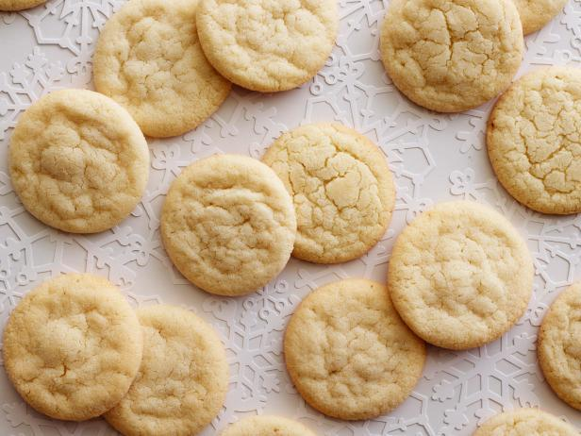

7/12

**National Pecan Pie Day**

Pecan pie is an American creation. Pecans are native to North America; the nuts were propagated by Native Americans as far north as Illinois and the southern part of Iowa. Pecans grew along areas watered by the Mississippi River, spreading a bit to the east into Alabama. Following the Civil War, commercial developers brought in a few varieties of pecans to grow in Georgia (the state is now the main commercial grower of pecans in the U.S.). Grafted pecan trees also became prevalent in Louisiana in the mid to late 1800s.

The name of the nut itself is derived from the French word *pacane*, which is taken from the Algonquian word for “nut.” That may help explain why some believe the French invented the pecan pie after settling in New Orleans, though there’s seemingly little evidence to support that.

Once people had pecans, they started using them for baking. The earliest printed pecan recipes began popping up in Texas cookbooks in 1870s and 1880s; the first recipe that most closely resembles what we know today as pecan pie was published in 1898 in a church charity cookbook in St. Louis, but it was sent in by a Texas woman. By the beginning of the 20th century, recipes for pecan pie had started appearing outside of Texas, but the pie wouldn’t surge in popularity until the mid-1920s. That’s when the manufacturer of Karo syrup began printing a recipe for pecan pie on cans of the product. Wide distribution of Karo syrup introduced many people to pecan pie, who found it was quite simple to make.

Technically classified as a “sugar pie,” the classic pecan pie recipe promulgated by the makers of Karo syrup uses a cup of the product in the mixture, along with eggs, sugar, butter, vanilla extract, and of course, pecans. Alternatives for Karo syrup include brown sugar and molasses, and some recipes add bourbon, rum, or whiskey into the mix. Pecan pie is nearly always baked in a traditional pie crust verses a crumble crust or a cookie crust.

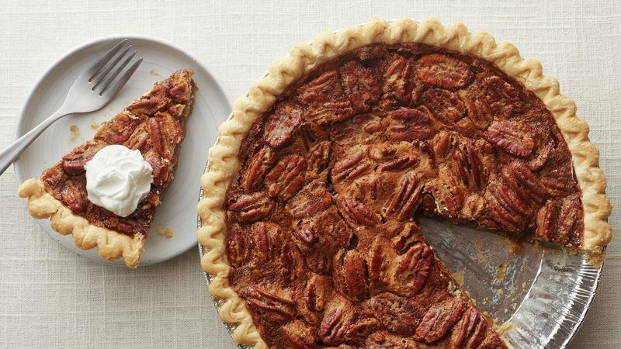

7/13

**National French Fry Day**

In the United States and most of Canada, the term *french fries*, sometimes capitalized as *French fries*, or shortened to *fries*, refers to all dishes of fried elongated pieces of potatoes. Variations in shape and size may have names such as *curly fries*, *shoestring fries*, etc. In the United Kingdom, Australia, South Africa, Ireland and New Zealand, the term *chips* is generally used instead, though thinly cut fried potatoes are sometimes called *french fries* or *skinny fries*, to distinguish them from *chips*, which are cut thicker. In the US or Canada these more thickly-cut *chips* might be called *steak fries*, depending on the shape. The word *chips* is more often used in North America to refer to *potato chips*, known in the UK and Ireland as *crisps*.

Thomas Jefferson had "potatoes served in the French manner" at a White House dinner in 1802. The expression "french fried potatoes" first occurred in print in English in the 1856 work *Cookery for Maids of All Work* by E. Warren, where the recipe was written as follows: "French Fried Potatoes. – Cut new potatoes in thin slices, put them in boiling fat, and a little salt; fry both sides of a light golden brown colour; drain." This account referred to thin, shallow-fried slices of potato (French cut) – it is not clear where or when the now familiar deep-fried batons or fingers of potato were first prepared. In the early 20th century, the term "french fried" was being used in the sense of "deep-fried" for foods like onion rings or chicken.

Who do YOU think has the best fries? McDonalds? Chick-fil-a? Five Guys? Let me know in the comments 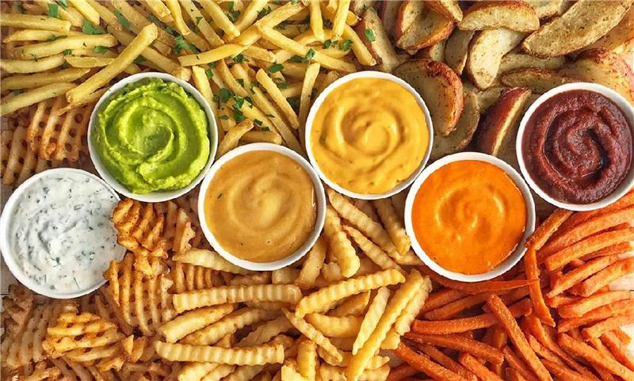

7/14

**National Mac and Cheese Day**

* Medieval chefs were hip to the mac and cheese trend before it was a trend. In the 1420s, King Richard II's master chefs compiled a manuscript called the *Forme of Cury* ("Method of Cookery"). The text featured a recipe for a dish called *makerouns*, which is incredibly similar to the mac and cheese we know today — it might just be the earliest recipe for the dish ever published.
* According to Thomas Jefferson's Monticello estate, the principal author of the Declaration of Independence and America's third president loved mac and cheese — though Jefferson referred to all pasta as "macaroni." He had a pasta machine brought to his estate and ordered pasta from Europe. Jefferson apparently loved pasta of all kinds, but mac and cheese was a favorite.
* Smithsonian Magazine goes a step further in saying that Jefferson is widely credited for popularizing macaroni and cheese in the United States, but that's a somewhat whitewashed version of history. His enslaved chef, James Hemmings, learned to make the dish and is, of course, the one who labored to prepare it and cook it. In fact, mac and cheese was a celebration food for blacks in the South before Jefferson ever caught wind of it, and it remains a weekend party staple in many African-American communities to this day.
* In 1903, a guy named James L. Kraft made money selling cheese out of a wagon on the streets of Chicago. He did so well that he was able to form a company called Kraft Foods. In 1937, America was still clawing its way out of the Great Depression — food insecurity and frugality were the themes of the day. That year, Kraft Foods introduced its now-famous boxed Macaroni & Cheese with the promise that buyers could feed a family of four for 19 cents. Quick, easy, and affordable, Americans bought 8 million boxes that first year alone.
* On Sept. 23, 2010, American chef John Folse, along with the Cabot Creamery Co-operative, set a Guinness World Record for the world's largest macaroni and cheese dish. It weighed roughly 2,469 pounds and was made from 575 pounds of pasta, 286 pounds of mixed cheese, 56 pounds of butter, 26 pounds of flour, 1,100 pounds of milk, and 61 pounds of dried seasoning. The cast-iron kettle it was cooked in weighed 1,902 pounds.

7/15

**National Gummy Worm Day**

In 1920, Hans Riegel of Bonn, Germany, became frustrated with his dead-end job as a confectionary worker and started his own sweets company, making hard, colorless candies using a copper kettle and marble slab in his kitchen. His bicycle-riding wife was the sole delivery person. The name of his new business was a combination of the first two letters of his own first and last names and hometown: Hans Riegel of Bonn=Haribo.

The hard candies sold fairly well at local street fairs, but not as well as Riegel had hoped. Then, after a couple of years, Riegel hit upon what would prove to be a genius idea: He produced a line of soft, gelatin-based, fruit-flavored treats in the shape of dancing bears (then a popular diversion at festivals in Europe). But while Riegel is often credited as the inventor of gummy candy, he actually just improved upon an already successful, centuries-old, formula. Gummy candies descend from Turkish delight and even Japanese rice candy, but both of those are typically made with rice or corn starch versus gelatin.

One of the more popular pre-gummy-bear gummies at the time was wine gums. Gelatin-based chews originating in Great Britain in 1909, wine gums (which contain no alcohol, despite their name), like generic gumdrops, Jujubes (1920) and Chuckles (1921), predate Riegel’s dancing bears. However, starch-based Jujubes and pectin-based Chuckles lacked the precisely satisfying chewy texture of Riegel’s sweet creatures, and none of these candies offered the same brand of zoo-animal whimsy. As one might expect, the *Tanzbären* ("dancing bears") were an instant hit with local tots; by the start of World War II, the future candy superpower had over 400 employees producing ten tons of candy each day. After the war, his two sons took over and expanded the company even further. Hans Riegel Jr. ran the company until his death in 2013, when two nephews took over, ensuring that Haribo would remain a family-run business (Hans Riegel Jr. famously turned down a huge buyout offer from Warren Buffett in 2008, claiming, “Money was never my motivation. I don’t even know when I made my first million.”)

Thanks to German-language teachers in U.S. high schools dispensing gummy bears in classrooms so their students could sample foreign cuisines, and American servicemen bringing gummy souvenirs from overseas for their families, the demand for gummy bears in this country was growing. Naturally, professional sugar pushers were looking to create a similar cash cow (or bear, as it were), and had starting making their own versions of Haribo’s best-selling item.

In 1981, gummy candy manufacturer Trolli was the first to develop the gummy worm. Trolli's idea was built on traditional American marketing values: making something gross enough looking to shock parents and simultaneously attract children.

7/16

**National Corn Fritter Day**

* The corn fritter was invented in the South of the United States, a cuisine that is known for having a lot of deep fried foods. Traditional corn fritters will use melted butter, milk, flour, egg, and corn kernels. They can be baked, shallow fried, and deep fried. They can also be served with cream, honey, fruit, or jam.
* Although corn fritters originated in the South, many other cultures have come up with similar dishes. For example, in Asia *pakoras* are a popular snack. This dish is made with vegetables dipped in batter that are then deep-fried.
* Corn is America’s largest crop and accounts for more than 90 percent of the total value and production of feed grains. Family farmers grow 90 percent of America’s corn. The United States produces 40 percent of the world’s corn, more than any other country.
* It takes about 1,300 kernels to make a pound of corn.
* The word ‘fritter’ comes from the Latin word *frigere* which means "to fry". A fritter applies to almost anything that is either prepared in batter, fried or baked. Enjoyed for centuries, the Romans were the first to relish the delicious taste of chickpea fritters at their lavish dinners.
* The largest corn fritter ever recorded was 4 feet in diameter, 0.5 inches thick, and was made from 30 cobs of corn.

7/18 (Third Sunday in July)

**National Ice Cream Day**

Check out the history of ice cream here:<https://www.idfa.org/the-history-of-ice-cream>

7/19

**National Daiquiri Day**

The drink was supposedly invented by an American mining engineer named Jennings Cox, who was in Cuba at the time of the Spanish–American War. It is also possible that William A. Chanler, a US congressman who purchased the Santiago iron mines in 1902, introduced the daiquiri to clubs in New York in that year.

Originally the drink was served in a tall glass packed with cracked ice. A teaspoon of sugar was poured over the ice and the juice of one or two limes was squeezed over the sugar. Two or three ounces of white rum completed the mixture. The glass was then frosted by stirring with a long-handled spoon. Later the daiquiri evolved to be mixed in a shaker with the same ingredients but with shaved ice. After a thorough shaking, it was poured into a chilled coupe glass.

Consumption of the drink remained localized until 1909, when Rear Admiral Lucius W. Johnson, a U.S. Navy medical officer, tried Cox's drink. Johnson subsequently introduced it to the Army and Navy Club in Washington, D.C., and drinkers of the daiquiri increased over the space of a few decades. It was one of the favorite drinks of writer Ernest Hemingway and U.S. President John F. Kennedy.

The drink became popular in the 1940s. World War II rationing made whiskey and vodka hard to come by, yet rum was easily obtainable due to U.S. President Franklin D. Roosevelt's Good Neighbor policy, which opened up trade and travel relations with Latin America, Cuba and the Caribbean. The Good Neighbor policy, also known as the Pan-American program, helped make Latin America fashionable. Consequently, rum-based drinks (once frowned upon as being the choice of sailors and down-and-outs), also became fashionable, and the daiquiri saw a tremendous rise in popularity in the US.

7/20

**National Fortune Cookie Day**

<https://www.history.com/news/fortune-cookies-invented-chinese-japanese>

7/21

**National Junk Food Day**

* The term *junk food* dates back at least to the early 1950s, although its coinage has been credited to Michael F. Jacobson of the Center for Science in the Public Interest, in 1972.
* In 1952, the phrase appeared in a headline in the Lima, Ohio, News, "'Junk Foods' Cause Serious Malnutrition", over a reprint of a 1948 article from the Ogden, Utah, *Standard-Examiner*, originally titled, "Dr. Brady’s Health Column: More Junk Than Food". In the article, Dr. Brady writes, "What Mrs. H calls 'junk' I call cheat food. That is anything made principally of (1) white flour and or (2) refined white sugar or syrup. For example, white bread, crackers, cake, candy, ice cream soda, chocolate malted, sundaes, sweetened carbonated beverages." The term *cheat food* can be traced back in newspaper mentions to at least 1916.
* Cracker Jack, the candy-coated popcorn-and-peanuts confection, is credited as the first popular name-brand junk food; it was created in Chicago, registered in 1896, and became the best-selling candy in the world 20 years later.
* According to an article in the *New York Times*, "Let Us Now Praise the Great Men of Junk Food": "The history of junk food is a largely American tale: It has been around for hundreds of years, in many parts of the world, but no one has done a better job inventing so many varieties of it, branding it, mass-producing it, making people rich off it and, of course, eating it."

7/22

**National Mango Day**

* Mangoes were first grown in India over 5000 years ago.
* Mango seeds traveled with humans from Asia to the Middle East, East Africa and South America beginning around 300 or 400 A.D.
* The paisley pattern, developed in India, is based on the shape of a mango.
* The mango is a national fruit of not just one country but 3. These countries include India, the Philippines and Pakistan.
* Located in East Khandesh, the oldest known mango tree is 300 years old and still produces viable fruit.
* Mangoes are related to pistachios and cashews.
* Burning mango leaves, woods, or debris is not advisable as they are toxic in nature and can infect eyes and lungs severely.
* Although India is the largest Mango producer country, in terms of international trade, it accounts less than 1%; India consumes most of its own Mango production.
* In the US, the mango arrived in 19th century. The first place was Florida where the cultivators of mango introduced the fruit in 1830s. The next place was California where mango entered in 1880s.
* A particular shade of yellow dye was made in India by feeding cattle a small amount of mango leaves. The cattle’s yellow urine was then harvested and used for making dye. This practice of dye making has been outlawed in India because of two reasons. First, mango leaves can be toxic to cattle. Second, cows are considered to sacred in India.

7/23

**National Vanilla Ice Cream Day**

Many may be familiar with Thomas Jefferson’s vanilla ice cream recipe. The third president of the United States may have discovered vanilla flavor while visiting France. While he wouldn’t have been the first to savor the delicious taste of vanilla ice cream, Jefferson enjoyed jotting down recipes. The same applied to ice cream. He also produced a handwritten copy of a vanilla ice cream recipe in the 1780s. Only ten copies remain. In fact, the Library of Congress houses one copy that has a cookie recipe on the flip side. Today, the ice cream parlor at Mt. Rushmore in South Dakota serves the same recipe so that anyone can have a taste.

Check out the handwritten recipe here:

<https://www.reddit.com/r/Old_Recipes/comments/h7q24h/thomas_jeffersons_vanilla_ice_cream_recipe/>

7/26

**National Bagelfest Day**

Polish-Jewish immigrants introduced the bagel to the United States. Throughout New York City and the surrounding boroughs, they grew thriving businesses. Of course, it didn’t take long for the bakers to organize. In 1907, they created the International Beigel Bakers’ Union. For decades, Bagel Bakers Local 338 held contracts with nearly all bagel bakeries in and around the city for its workers.

Until the 1960s, bakeries made bagels by hand. Then Daniel Thompson invented the bagel maker and along came a heated debate of man versus the machine. Thereafter, the question of the better bagel dangled before customers. Was it the handcrafted bagel or the manufactured bagel?

The bagel became more common throughout North America during the last quarter of the 20th century. Credit for the bagels’ spread across the country goes in part to the efforts of bagel baker Harry Lender, his son, Murray Lender, and Florence Lender. Their pioneering efforts led to the automated production and distribution of frozen bagels in the 1960s. Murray also invented pre-slicing the bagel.

Murray Lender, the owner of Lenders Bagels, founded National Bagelfest Day. In 1986, Murray started the festival in Mattoon, Illinois, home of the world’s largest bagel factory.

7/27

**National Scotch Day**

The earliest record of distillation in Scotland is in the Exchequer Rolls for 1494. The Exchequer Rolls were records of royal income and expenditure and it shows eight bolls of malt given to Friar John Cor to make *aqua vitae* over the previous year (*aqua vitae* is Latin for "water of life" and was the general term for distilled spirits.) This much malt would be enough for 1,500 bottles, which suggests that distillation was well-established by the late 15th century. However, it's probable that whisky was introduced to Scotland from Ireland as evidence of Irish whiskey dating back to 1405, which is nearly 100 years before it shows up in any Scottish context. Considering the abundance of Scottish records during the 15th century and the lack of mention of whisky, it therefore stands to reason that it was recently introduced sometime in the mid to late 15th century from Ireland.

Since Scotch is protected by law, specific guidelines must be followed when making it to be labeled as Scotch. Otherwise, it may be an ordinary whisky (or whiskey if it’s made in the United States). First and foremost, Scotch must be made in Scotland. Another requirement includes the grain used in the fermentation process. For Scotch, only malted barley may be used. The Scotch must also be aged in oak barrels for at least three years and have an ABV of less than 94.8%. While most Scotch is made with barley, water, and yeast, other grains can be included, but no fermentation additives, per law.

Fun fact: A lot of whisky is lost during maturation. Whisky stored in barrels gradually evaporates at an approximate rate of 2% a year. This is referred to as the famous "angels’ share".

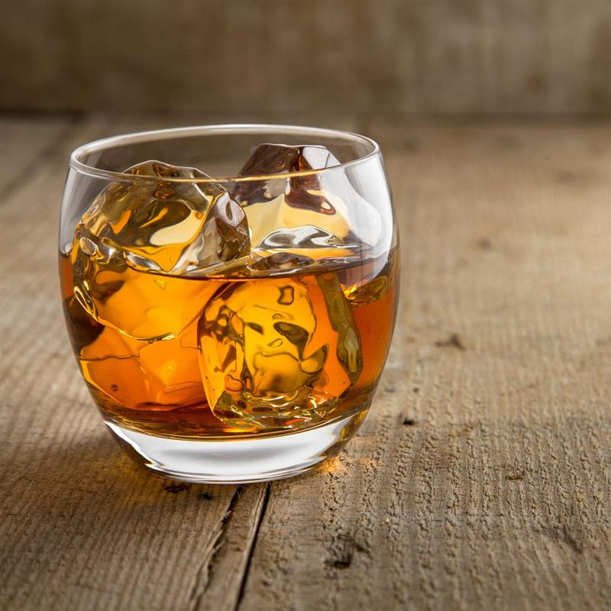

7/28

**National Milk Chocolate Day**

http://justfunfacts.com/interesting-facts-about-milk-chocolate/

7/29

**National Lasagna Day**

* Lasagne originated in Italy, in the region of Emilia-Romagna.
* Originally, in Italy, the word “lasagna” did not refer to a food. The word “lasagna” referred to the pot in which the food was cooked. It is thought that the word “lasagna” for the pot is derived from the Greek word for "chamber pot."
* The earliest lasagna recipes known are dated from the thirteenth century. At that time, tomatoes were not known to Europeans. This means that they couldn’t have used them in the recipes. However, depending on the recipe, different cheeses are used.
* Boiling noodles used to be a requirement for making lasagna. No-boil noodles now exist. These are great as they soften in the oven, but it is absolutely necessary to make sure that there is a great quantity of sauce so the noodles get wet and cook while they are in the oven.
* You can make lasagna in the dishwasher. All you have to do is put the ingredients together in a dish (either boil noodles or use the no boil noodles), cover the dish tightly with aluminum foil, then use the heated dry and sanitize cycle on your dishwasher to cook the lasagna.
* The most well-known bit of lasagna lore is probably that the cat, Garfield, from the comic strip, has lasagna as his favorite food.
* Weird Al Yankovic recorded a song called “Lasagna” that is a parody of “La Bamba”.

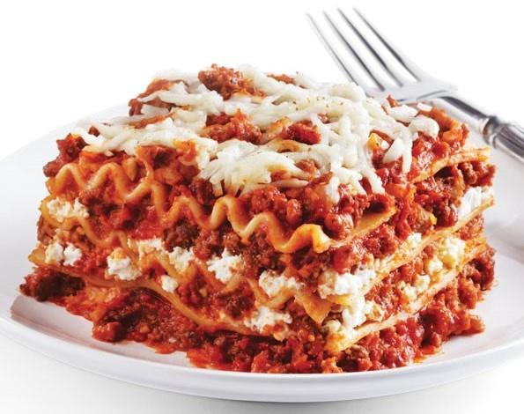

7/30

**National Cheesecake Day**

<https://www.foodbeast.com/news/11-mildly-interesting-cheesecake-facts-for-national-cheesecake-day/>

8/2

**National Coloring Book Day**

Some of the earliest coloring books in the United States were produced in Germany and published in Philadelphia by John Weik & Co." around 1858. But the real ancestor of the modern coloring book is generally agreed to be British illustrator Kate Greenaway. Born in 1846, Greenaway became internationally recognized as a children’s book illustrator. Sometime in the late 1870s, she teamed up with publisher Cassell Petter & Galpin for *The ‘Little Folks’ Painting Book*, a reference to a children’s magazine that Cassell Petter & Galpin published. In some cross-promotion, any child who sent in their colored books to a competition the *Little Folks* magazine was holding could win money and medals, and the books themselves would go to the Children’s Hospitals to "[provide] for the amusement of little ones during their weary hours in the hospital." Several more of these books were published over the following years, some with similar contests.

So why were these books so influential? Thank lax copyright laws. American publisher the McLoughlin Brothers took Greenaway’s illustrations and published them in books for the American audience, almost certainly without her permission. These were the books that became massive hits and helped create a new genre.

In the late 19th and early 20th centuries, reform movements in children’s education helped to shift popular attitudes about the role of education in achieving social progress. Coloring books became an interactive tool that parents gave to their kids to educate and entertain them, in hopes of giving them an advantage in life. During this time, the cost of books (and paper) also decreased, which made coloring books accessible to more children and families than ever before. Some companies that sold consumer goods, such as shoes and paint, even gave free, promotional coloring books to parents with every purchase.

The first adult coloring book mocked corporate culture. Published in 1961 by three advertising executives, *The Executive Coloring Book* was the first coloring book aimed at adults. Featuring drawings and captions depicting a businessman getting ready for work ("This is me. I am an executive. Executives are important. They go to important offices and do important things. Color my underwear important."), the book satirizes and mocks the monotony, conformity, and austerity inherent in corporate workplaces. After *The Executive Coloring Book*’s publication, adult coloring books became trendy. Many of these books satirized societal expectations, political extremism, social movements, the Soviet Union, communism, President John F. Kennedy, and mental illness.

The 1960s weren't the only time period that cartoonists used adult coloring books to lampoon political figures and promote counterculture or fringe views. More recently, creators of coloring books have used the books to comment on events and figures in contemporary politics. You can find coloring books about the death of Osama bin Laden and the Tea Party (complete with drawings of Sarah Palin and text about the evils of political correctness), as well as coloring books devoted to former President Barack Obama, Hillary Clinton, Bernie Sanders, and former President Donald Trump.

According to researchers and art therapists, adults who color in coloring books may experience a variety of therapeutic benefits. Studies in 2005 and 2012 concluded that people who colored in mandalas (complex geometric figures frequently seen in Hinduism and Buddhism) experienced lower levels of anxiety than people who simply colored on a blank piece of paper. By focusing on different shapes and patterns in a structured way, people who color can shut off negative thoughts, becoming calmer. The study concluded that like meditation, the act of coloring patterns can let the brain rest, decrease anxiety, and encourage mindfulness.

8/3

**National Watermelon Day**

* Thanks to their sweet taste, watermelons are most commonly considered a fruit. And they do grow like fruit, originating from flowers that have been pollinated by bees, and, from a botanical perspective, they're fruits because they contain seeds. But many gardeners think of them as vegetables, since they grow them in their gardens alongside other summer veggies like peas and corn. Not to mention, watermelon is classified as part of a botanical family of gourds that includes other culinary vegetables like cucumber, squash, and pumpkin.
* While we tend to focus on the melon’s succulent flesh, watermelon rinds are also edible—as well as full of nutrients with surprising health benefits. In China, the rinds are often stir-fried or stewed, while in the South, cooks like to pickle them. And, across the Middle East and China, the seeds are dried and roasted (similar to pumpkin seeds) to make for a light, easy snack.
* Contrary to what you might have heard, seedless watermelons are not genetically engineered and are the result of hybridization, a perfectly natural phenomenon that farmers can nevertheless capitalize on. A couple of decades ago, seedless watermelons were hard to find, but today they make up around 85 percent of those sold in the U.S. And those white “seeds” that you still find in your seedless slices? They’re actually empty seed coats and are perfectly safe to eat.
* The heaviest watermelon to date was grown by Guinness World Record holder Chris Kent, of Sevierville, Tennessee, in 2013. A Carolina Cross, it weighed in at 350.5 pounds. To give you some perspective, that’s the equivalent of an NFL lineman.

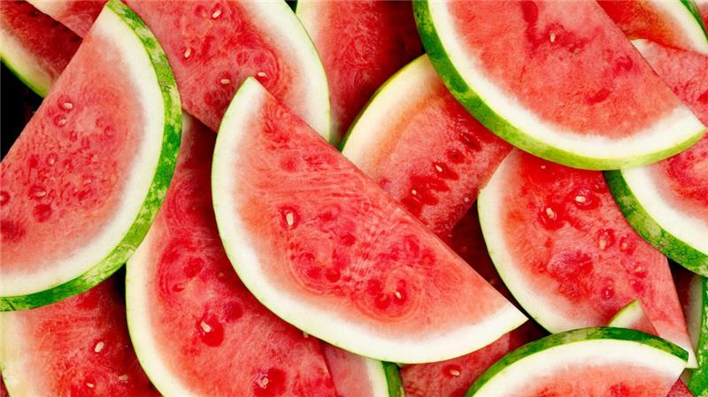

8/4

**National Chocolate Chip Cookie Day**

* Like many great recipes, chocolate chip cookies were invented by accident. Back in 1938, a 33-year-old woman named Ruth Wakefield was baking a batch of her famous butter drop dough cookies when she broke up a bar of Nestlé semi-sweet chocolate and added the pieces to the batter, intending to create a chocolate cookie. Instead of melting into the dough, the chocolate bits held their shape, and the chocolate chip cookie was born.
* They were originally called Toll House Crunch Cookies, named after the Toll House Inn restaurant that Ruth Wakefield owned with her husband in Whitman, Massachusetts.
* Nestlé paid Ruth Wakefield for her recipe with a lifetime supply of chocolate.
* One Nestlé chocolate bar = 160 chocolate chips. In 1939, the company made Ruth's cookie recipe easier to recreate by scoring their chocolate bars into little pieces especially for baking. These eventually evolved to become the teardrop-shaped morsels we find on shelves today, and her classic recipe is always printed on the back of the package.
* Chocolate chip cookies are the official state cookie of Massachusetts. In 1997, a third grade class from Somerset proposed a bill that would honor chocolate chip cookies with the designation of official cookie of the Commonwealth. The cookies have not, however, dethroned Boston Cream Pie as the state dessert.
* Those cookies the Cookie Monster eats on *Sesame Street* are actually rice cakes with brown dots painted on.
* The world's biggest chocolate chip cookie weighed 40,000 pounds and had a diameter of 101 feet. It was created in 2003 by The Immaculate Baking Company in Flat Rock, North Carolina.

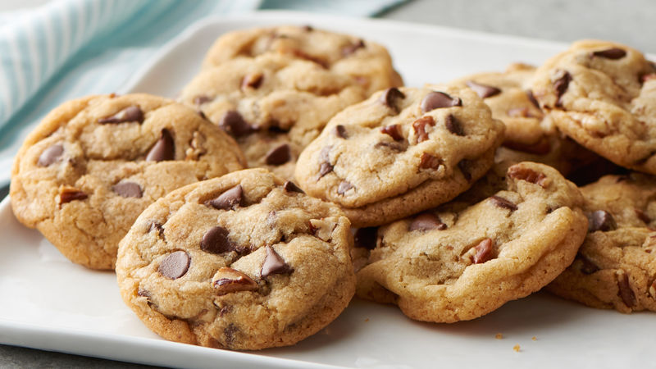

8/5

**National Underwear Day**

* The very first men’s brief was invented in 1935. Reviews mentioned their “scientific suspension” and “restful buoyancy” as key features.
* A 10-year-old by the name of Jack Singer wore 215 pairs of underwear all at once in 2010, breaking the previous record of 200.
* King Tut is short for Tutankhamen, the Egyptian leader who ruled from ages 9-18—and was buried with 145 pairs of underwear.
* Once upon a time (before the 1800’s), it was believed that pairing dirty underwear with wheat grains in a bucket would “generate” mice. This supported the idea of “spontaneous generation”—that life could be created from nonliving objects.
* Italian women like to ring in the New Year wearing red underwear—it’s considered lucky.
* A pair of Queen Victoria’s underwear, featuring white cream fabric and her embroidered initials (VR), recently sold at auction for $14,500.
* Women didn’t wear underwear until much later than men—it was long considered inappropriate for them to wear anything in between their legs. Instead, 19th-century women wore heavy petticoats to prevent cold breezes from blowing up their skirts (and were stuck riding sidesaddle).
* The British Army issues antimicrobial underwear that can be worn for three months at a time.
* Carrie Fisher never wore underwear while filming Star Wars because George Lucas convinced her there is no underwear in outer space.
* Major League Baseball umpires are required to wear black underwear—just in case they split their pants.
* It is illegal in Thailand to leave your house without underwear.
* The Wright Brothers used muslin on the wings of their very first plane—a fabric previously used primarily for women’s underwear.

8/5

**Root Beer Float Day**

The root beer float got its start in Colorado in a mining camp. Frank J. Wisner of Cripple Creek, Colorado, gets the credit for inventing the root beer float way back in August of 1893. One night Wisner, owner of the Cripple Creek Cow Mountain Gold Mining Company, was staring out the window and thinking about the line of soda waters he was producing for the citizens of Cripple Creek when he came upon an idea. The full moon that night shined on the snow-capped Cow Mountain and reminded him of a scoop of vanilla ice cream. He hurried back to his bar and scooped a spoonful of ice cream into the children’s favorite flavor of soda, Myers Avenue Red Root Beer. After trying, he liked it and served it the very next day. It was an immediate hit. Wisner named the new creation, “Black Cow Mountain” but the local children shortened the name to “Black Cow”, which of course now is widely known as the root beer float.

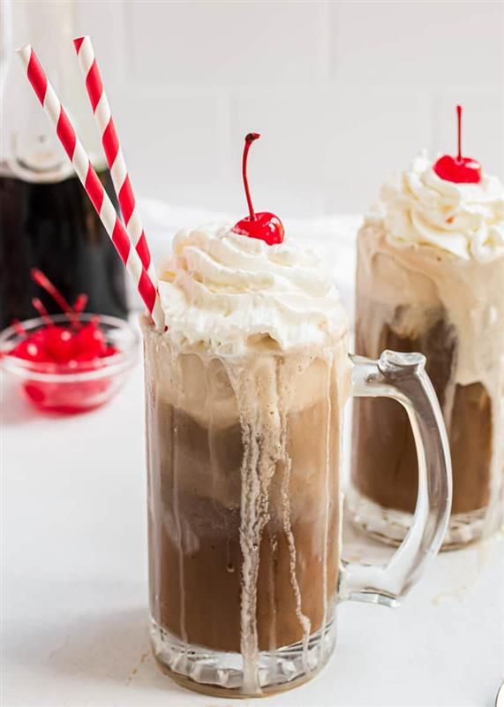

8/9

**National Rice Pudding Day**

Rice pudding has been around for centuries, and was thought to have originated in China, which has an ancient rice culture. This has been disputed by some food historians; they argue that rice pudding likely originated in India, which has an ancient rice culture as well as an ancient sugar culture. In Asia rice pudding was never referred to as rice pudding; instead, it was called a sweet rice porridge. Rice is mixed with water, milk, or cream, and then sweetened to taste before boiling or baking. Sometimes dried fruits are added to the mixture, such as raisins or apricots.

*The Forme of Cury* (1390) – the earliest surviving collection of recipes in England – gives a recipe for a rice pottage, and one for Ryse of Flesh. The Rice of Flesh is savory and made with broth, almond milk and saffron, while the rice pottage is what would become the modern-day rice pudding and the recipe just omits the salt and broth, using water instead to cook the rice the first time. Sugar isn’t added in *The Forme of Cury*; for a sweetened rice pudding we have to wait until the 15th-century Austin manuscripts, which include a pudding sweetened with honey and sugar. John Murell (*A Newe Booke of Cookery*) in 1615 adds eggs, suet, currants, cinnamon, sugar and barberries and stuffs the rice pudding into sausage skins, like a white pudding. In 1660, Robert May (*The Accomplisht Cook*) adds eggs, beef suet, salt, nutmeg, cloves, mace, currants, dates and powdered coriander seeds.

It wasn't until the beginning of the 18th century when the import of rice became more common, that rice pudding became something which is more every day rather than reserved for the elite. By the 20th century it was so cheap and easy it became a staple in hospitals and schools.

Today rice pudding is sometimes considered to be a bit boring, but there are many different types! Check out some of these rice pudding recipes from other countries around the world:<https://www.allrecipes.com/gallery/worlds-best-rice-puddings/>

8/10

**National S'mores Day**

The first official recipe for a s'more came out in the 1927 Girl Scout guidebook "Tramping and Trailing with the Girl Scouts." While the book was meant to give advice on how to be a good Girl Scout (always getting a parent's permission before hiking!) it's lasting legacy was the "Some More." Originally intending to feed 16 hungry scouts, the recipe, which was later credited to a troop leader named Loretta Scott Crew, calls for 16 graham crackers, eight bars of plain chocolate and 16 marshmallows. Next, it says to toast the marshmallows to a "crispy, gooey state." Then, put the marshmallow on top of a chocolate bar and in between two graham crackers and, viola, you got a "Some More." It's unclear when the name was shortened to simply "s'more," but various Girl Scout publications kept referring to the treat as "Some More" until at least 1971.

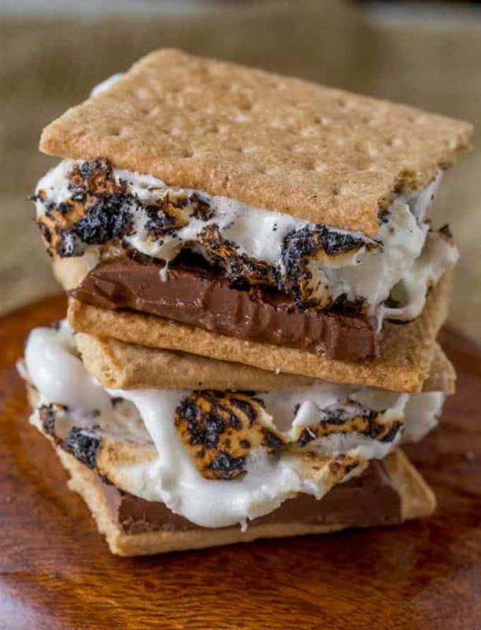

8/11

**National Son's and Daughter's Day**

According to an article in the August 20, 1944, St. Joseph News-Press/Gazette, in 1936, J Henry Dusenberry first pursued the idea of a Son's and Daughter's Day. The thought occurred to him after hearing a child ask why there was no such occasion. Through his efforts, the day started in Missouri and spread. Parents placed a flower representing each of their children in a vase and put the vase in a prominent room in the house. Throughout the day, parents thought about their children as they gazed at the flowers, especially those who no longer lived in the house. By 1945, the celebration reached its peak at 22 states with organizations participating in the event.

8/12

**National Vinyl Record Day**

<https://justfunfacts.com/interesting-facts-about-vinyl-records/>

8/13

**International Left Handers Day**

Where are all my lefties at??? I'm also left handed. Here's some fun facts about left handedness:

* On average, 12% of the world is left handed, 87% right handed, and 1% ambidextrous. However, the percentage of lefties worldwide is slowly creeping up as being left handed becomes more socially accepted. Believe it or not, to this day some countries still try and force children to learn to write with their right hand! For example, in 1860 when a left handed person was essentially seen as being in league with the devil, it is estimated that as little as 2% of the population was left handed. The current 12% figure also varies by country and gender.
* There have been eight U.S. presidents who were left-handed including: James Garfield, Herbert Hoover, Harry Truman, Gerald Ford, Ronald Reagan, George H.W. Bush, Bill Clinton and Barack Obama.
* Sinister (Latin for left), Mollydooker (Australian slang term), Southpaw (name for a left-handed pitcher), Goofy footed and Cuddy wifter are a few terms for left-handed people.
* Left-handers have typing advantages. On a QWERTY keyboard, they can type over 3,000 English words by solely using the left hand. But only around 300 words can be typed with the right hand alone.
* A study found that right-handers, on average, live to be nine years older than left-handers. This left handed statistic was later disproved – although it is still widespread on the internet! A flawed 1980s study which looked at 1000 deceased people from California showed that the average age that right-handed subjects died was 75, whereas for lefties it was just 66. The problem here is that the study assumes that the number of left handed people remained static over time. Many people born in the early 1900s were forced to write right-handed, and so would not have identified as being left handed at death. As a result, the findings from this study have been largely discredited. However, there has been some evidence to suggest that left handers are more likely to have minor accidents than their right handed counterparts, so we’re not quite out of the woods!

8/16

**National Roller Coaster Day**

Roller Coaster Fun Facts:<https://www.smithsonianmag.com/innovation/14-fun-facts-about-roller-coasters-180972920/>

8/16

**National Rum Day**

Rum Fun Facts:<https://mobile-cuisine.com/did-you-know/rum-fun-facts/>

8/17

**National Thrift Store Day**

* Thrift stores began to grow in popularity in the late 19th century. Back in the day, there was a stigma buying and selling used clothing. This stigma began to be tossed out when Christian ministries started to use thrift stores as a way to fund their programs. However, it was not until the 1920s that thrift stores started to look like the ones we have today. The demand for secondhand increased during the Great Depression. During this time, many people could not afford to buy new items. These hard times caused them to seek more secondhand items.
* Generation Z and Millennials do the most thrifting. Both of these generations are driving the growth of secondhand clothing. ThredUp reports that Millenials and Gen Z are adopting shopping for secondhand clothing 2.5 times faster than other generations. The demand for secondhand clothing has only increased throughout the years. From 2017 to 2019, secondhand sales increased by 37 percent in Millennials and 46 percent in Gen Z. These two generations are more likely to buy secondhand because they want to shop more sustainably and ethically.
* Thrift stores help reduce textile waste. Textile waste is a growing problem around the world. Environmental Protection Agency (EPA) reports found that 17 million tons of textile waste end up in landfills. This is a problem because textile takes up to 200 or more years to decompose in landfills. One way that textile waste is being reduced is through the help of thrift stores. These kinds of stores collect clothing and resell it. Items that cannot be sold get recycled. This process helps reduce the amount of textile waste that ends up in landfills.
* Thrifting helps save water and reduce carbon emissions. Water is important for all living things, but it is limited. The fashion industry is the second industry that consumes the most water. Reports state that it consumes an average of 79 billion cubic meters of water per year. Not to mention, the fashion industry produces about 10 percent of carbon emissions.

8/18

**National Fajita Day**

* The first evidence of the fajita comes from Mexican ranch workers living in West Texas along the Rio Grande in the late 1930s and early 1940s. Back then, the workers were sometimes paid with meat as partial payment for their services. They were given the least desirable parts, though – the head, entrails and skirt steak, which can be found underneath the cow’s heart and lungs.
* The word "fajita" comes from the Spanish word “faja,” meaning “belt” or “girdle” in English, so the literal translation of fajita is “little strap.”
* The workers learned to use the tough cuts of meat and make it into an edible meal. They marinated and grilled the meat and served it on tortillas. For decades, the dish was a common backyard and campfire meal, passed down from generation to generation without any real intent to bring it mainstream.
* That all changed with fajitas started to become popular in the late 1960s. A man named Sonny Falcon, a meat market manager for Guajardo’s Cash Grocery, began experimenting with the meat. He set up a fajita concession stand in September 1969 during a festival and sold fajitas to crowds. He also attended other rodeos, fairs and outdoor festivals.
* At about the same time, the fajita appeared for the first time at a restaurant at Otilia Garza’s Round-Up Restaurant in the Rio Grande Valley. Garza claimed she learned the dish from her grandmother.
* Fajitas took off in 1982 when German-born chef George Weidmann started cooking “sizzling fajitas” at the Hyatt Regency’s restaurant La Vista. Weidmann changed the dish up a little by cooking with the tender sirloin section instead of the original skirt steak.
* In 2016, On the Border Mexican Grill & Cantina founded National Fajita Day.

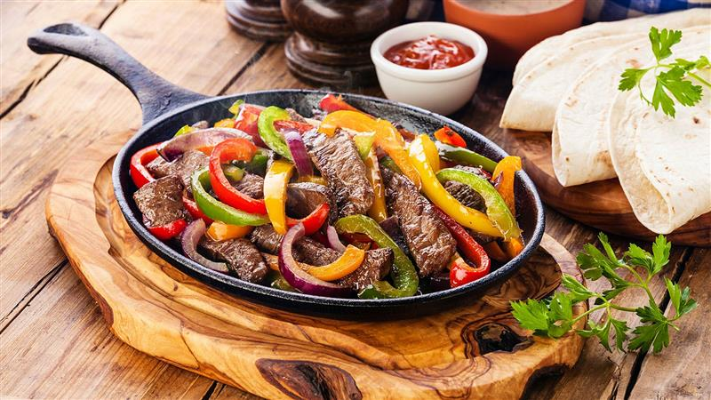

8/19

**National Potato Day**

* In the US, potato products are the second most consumed food overall, trailing only dairy products.
* Potatoes are 80% water.
* The potato originated in the region of southern Peru where it was first domesticated between 3000 BC and 2000 BC.
* Potato was first introduced in Europe by Spain in 1536, and the Spanish claim that that Gonzalo Jimenez de Quesada was the first to introduce the potato to Europe.
* Potatoes were not accepted at once in Europe because clerics said they were not mentioned in the bible, while others believed potatoes can cause some diseases.
* The world’s largest potato producing country is China.
* In 1995, potato plants were taken into space with the space shuttle Columbia. This marked the first time any food was ever grown in space.
* Potatoes are among most environmentally friendly vegetables. They’re easy to grow, and don’t require massive amounts of fertilizer and chemical additives to thrive like many other vegetables do.
* The world’s largest potato weighed in at 18 pounds, 4 ounces. This is enough for more than 70 portions of medium fries at McDonalds. This gigantic potato was found in England in 1795.
* The average American eats 140 pounds of potatoes per year. Germans are among biggest potato lovers as they eat more than 200 pounds of potato per year.

8/20

**National Radio Day**

* The most powerful commercial radio station ever was WLW (700KHz AM), which during certain times in the 1930s broadcasted 500kW radiated power. At night, it covered half the globe. Neighbors within the vicinity of the transmitter heard the audio in their pots, pans, and mattresses.
* 13-year-old called out the Eastern State Penitentiary for having the wrong radio on display in a recreation of Al Capone’s cell. The radio wasn’t available until 1942 and Capone was imprisoned from 1929-1930, resulting in the museum replacing it and giving the teen the inaccurate radio.
* In WWII, weather reports were censored to prevent enemy submarines from learning about conditions. A football game in Chicago was so covered in fog that the radio announcer couldn’t see the field, but afterward he was officially thanked for never using the word “fog” or mentioning the weather.
* On the 28th of September 2006, The City Council of Reykjavik and neighboring municipalities agreed to turn off all the city lights in the capital area for half an hour, while a renowned astronomer talked about the stars and the constellations on national radio.
* The number one most played song on U.S. radio of the 2000s decade was “How You Remind Me” by Nickelback. It was played on the radio over 1.2 million times.
* The 1946 “Adventures of Superman” radio show revealed the “secret” codes and rituals of the KKK, making it a laughing stock and drying up Klan recruitment almost overnight.
* The Eiffel Tower was supposed to be scrapped after 20 years. It only survived because the military started using it as a radio tower, intercepting crucial military transmissions during WWI.
* UVB-76 is a mysterious Russian radio signal that has been transmitting continuously since 1982. Nobody knows who makes the signal, only that it is located near Moscow, makes a buzzing sound 25 times a minute, and every few years will broadcast a string of random names and numbers.
* When cowboy/actor Slim Pickens (Blazing Saddles/Dr. Strangelove) joined the military during WWII he stated his profession was “rodeo”, the recruiter heard “radio” and Slim spent the entire war as a radio operator.
* The first instance of Telephone hold music was a mistake that was caused by a loose piece of wire touching a metal girder at a factory. It turned the building into a giant radio antenna that would play music from a next-door radio station when people were put on hold.
* Robert Plant once donated $10,000 to KBOO, a non-profit community radio station in Portland Oregon, to never play “Stairway to Heaven” ever again.
* The Armed Forces of Colombia commissioned a pop song that included a Morse code message to kidnapped military personnel, “19 people rescued, you’re next. Don’t lose hope”, because the kidnappers would let their captives listen to the radio.
* In order to transmit radio signals to submerged submarines, one technique is to place electrodes in the ground many miles apart, using the earth’s core as a giant antenna.

8/23

**National Sponge Cake Day**

Sponge cake is one of the oldest known sweet goods. Along with angel food cake, it belongs to the category of “foam cakes.” It’s very popular around the world, probably because of their short list of ingredients. This type of cake is often used as the base of other desserts such as snack cakes, jelly rolls, Swiss rolls and Tres Leches. A basic sponge cake is composed of only four essential ingredients: cake flour, eggs (whole or yolks), granulated sugar, and salt.

The earliest recorded mention of sponge cakes was from a Renaissance age Italian baked product. Italian cooks baked “biscuits,” which spread through Italy, England and France. However, it was not until 1615 when the first sponge cake recipe was recorded by the English poet and author Gervase Markham. Still, the cake was much more like a cookie—thin and crispy.

Sponge cakes became well-recognized when bakers started using beaten eggs as a leavening agent in the mid 18th century. Often the batter was poured into elaborate molds, but also into two tin hoops—the precursor to modern cake pans.

To achieve its characteristic light texture, sponge cake uses whipped eggs. Similar to angel food cake, it relies on the leavening action of air whipped into and trapped by egg protein. The increase in volume is achieved by trapped air and water vapor that expand during baking. Baking powder and/or baking soda are sometimes added to sponge cake formulations to provide additional rise through the production of CO2. Such cakes typically have a high volume and feature a light, fluffy texture.

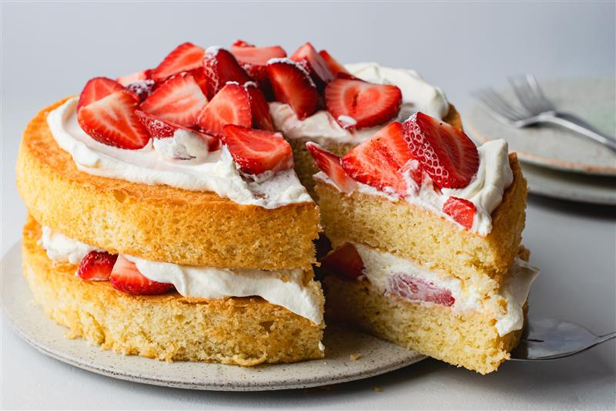

8/24

**National Waffle Day**

* The earliest known recording of a waffle recipe is in an anonymous manuscript called *Le Ménagier de Paris* from the 14th century, which was a set of instructions written by a Frenchman for his young wife. In it, the waffle-loving writer describes his own waffle recipe and even mentions an “iron”, leading historians to believe waffle irons were invented in the 13th-14th century.
* Waffles inspired Nike's first pair of sneakers. Appropriately enough, they were called the Waffle Trainer. Bill Bowerman was watching his wife use their waffle iron one morning in 1971 when he was suddenly struck by the honeycomb shape of the waffle. He realized it would be the perfect shape for the sole of an athletic sneaker. Then, Bowerman actually used a waffle iron to create the first Nike sneaker sole.
* The Waffle House sells 145 waffles a minute.
* There are two waffle holidays. International Waffle Day, as you may remember, falls on March 25th and was started in Sweden. August 24th marks National Waffle Day in the US because on this day in 1869, Cornelius Swarthout received the first U.S. patent for the waffle iron.
* The founders of Eggo waffles originally sold mayonnaise. Their empire, which thrived even during the Great Depression, was called Eggo Mayonnaise. In 1932, brothers Frank, Anthony and Sam Dorsa created their mayo brand, which became an international hit. The brothers became so successful, they then moved on to waffles. (Why that was the next logical place to go is beyond me.) Before being named simply after the company in 1955, Eggo called their waffles "Froffles" - a combination of “frozen” and “waffles”.
* The Belgium waffle was introduced in America at the 1962 Seattle World Fair. Maurice Vermersch, a Brussels native, was using his wife’s famous recipe to sell waffles as a fair vendor. Nervous that Americans wouldn’t know where Brussels was located, he changed the name to Belgium waffles, which stuck with US crowds.

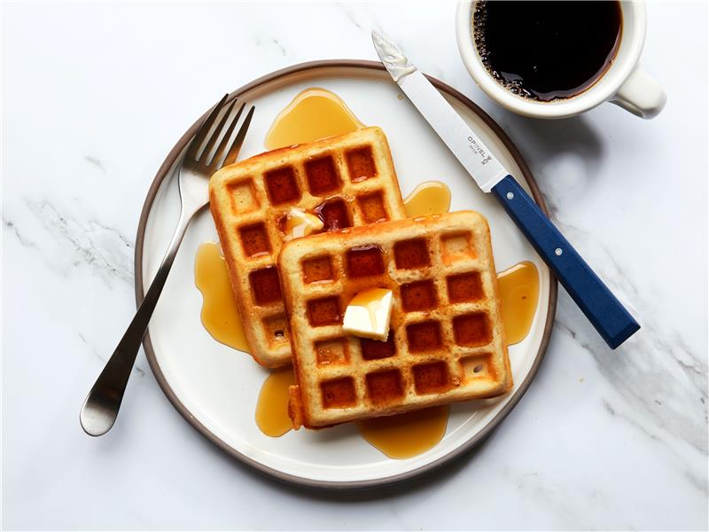

8/25

**National Banana Split Day**

* A 23-year-old apprentice pharmacist at Tassel’s Pharmacy in Latrobe, Pennsylvania, created the first banana split in 1904. David Evans Strickler enjoyed inventing sundaes at the store’s soda fountain. For only 10 cents, Strickler sold his first “banana-based triple ice cream sundae,” double the cost of all the other sundaes.
* Strickler’s hometown of Latrobe, Pennsylvania, proudly celebrates his creation with a festival every August. In 2013, they placed an official marker at the site of the pharmacy where Strickler first made his famous banana split. Then, the United States Post Office honored the banana split and the town of Latrobe in 2016 with a 47-cent “forever stamp” depicting the banana split. It was one of five stamps in the “Soda Fountain Favorites” series. For a time, Latrobe residents could receive a cancellation mark memorializing their claim to fame.
* Walgreen’s drug stores, operated by Charles Rudolph Walgreens is often credited with spreading the banana split’s popularity to a national level. The store had promoted the banana split as their signature dessert.
* On March 25th, 2017, the town of Innisfail, Australia built an 8000 meter (4.97 mile) long banana split with 40,000 bananas, setting a new world record.

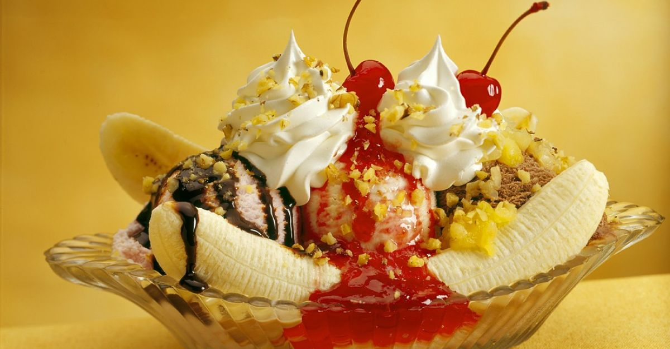

8/26

**National Dog Day**

* The Labrador Retriever has been on the American Kennel Club’s top 10 most popular breeds list for 30 consecutive years—longer than any other breed.
* A dog’s nose print is unique, much like a person’s fingerprint.
* Forty-five percent of U.S. dogs sleep in their owner’s bed.
* Speaking of sleeping … all dogs dream, but puppies and senior dogs dream more frequently than adult dogs.
* Seventy percent of people sign their dog’s name on their holiday cards.
* A dog’s sense of smell is legendary, but did you know that his nose has as many as 300 million receptors? In comparison, a human nose has about 5 million.
* In fact, the Bloodhound’s sense of smell is so accurate that the results of its tracking can be used as evidence in a court of law.
* The Australian Shepherd is not actually from Australia—they are an American breed.
* Dogs are not colorblind. They can see blue and yellow.
* Some dogs are taller or heavier, but according to the Guinness World Records, a Mastiff named Zorba is the world’s overall largest dog ever. Zorba weighed 343 pounds and measured over eight feet from his nose to his tail. He’s been described as being about the size of a small donkey.
* According to the Guinness World Records, the smallest dog ever recorded was Miracle Milly, the Chihuahua. Born in 2011, Milly was a miniscule 3.8 inches tall and weighed in at one pound.

8/27

**National Just Because Day**

Finally, you have a chance to do something without a rhyme or reason!

Most often in life, we do things because we have to, or we want to, or it's expected of us. None of those reasons apply today. Is there something you'd like to do, but there isn't a reason or logic for doing it? Well, today is the day to go out and do something "just because"!

Just Because Day was started in the late 1950s by Joseph J. Goodwin of Los Gatos, California.

8/30

**National Beach Day**

* Beaches became popular as tourist attractions during the 18th century.
* The world's tallest sandcastle was made in July of 2021 in Denmark. It measured 69 feet tall.
* Sandy beaches are mostly made of silica (SiO2) in the form of the mineral quartz.
* The longest beach in the world is arguably Casino Beach in Rio Grande, Brazil. It’s approximately 132 miles long.
* The beach became a popular destination during Britain’s Industrial Revolution, mostly because doctors were prescribing it. From the late 18th century to the early 19th century, doctors believed beach waves could help treat black bile build up in people’s spleens — which they later found out isn’t a thing.
* Technically there aren’t actually any birds called “seagulls”. It is just a casual way of referencing any birds in the gull family.
* The proportion of people that go to the beach that can’t swim is roughly one out of three.
* White sand beaches come from parrotfish poop.

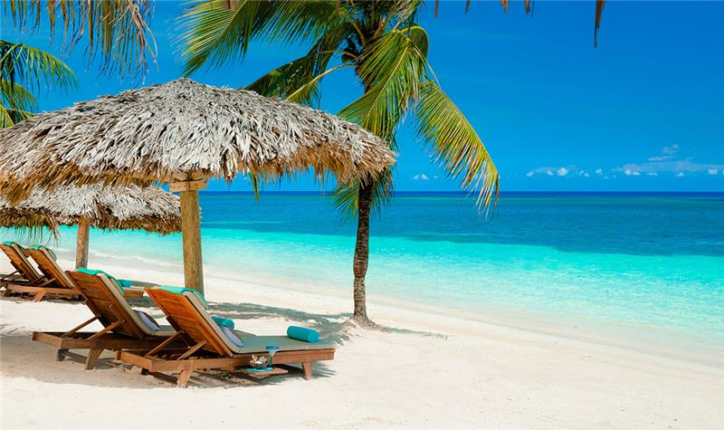

8/31

**National Trail Mix Day**

* Native Americans ate a version of trail mix that included buffalo meat.
* The combination of nuts, raisins and chocolate as a trail snack dates at least to the 1910s, when outdoorsman Horace Kephart recommended it in his popular camping guide.
* Two California surfers claim the creation of trail mix. In 1968, they blended peanuts and raisins for an energy snack. However, in the 1958 novel The Dharma Bums written by Jack Kerouac, the two main characters mention trail mix when planning meals for their hiking trip.
* Trail mix is sometimes referred to as "gorp". According to the Oxford English Dictionary, gorp means to eat greedily. However, a backronym (an acronym developed after a word is coined) suggests that gorp stands for Good Ol’ Raisins and Peanuts.
* Australians and New Zealanders call trail mix “scroggin.”

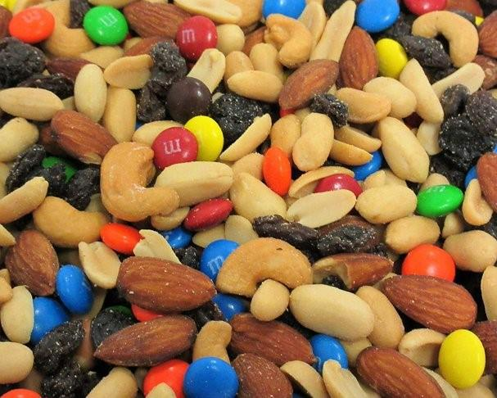

9/1

**National Chicken Boy Day**

On September 1st, National Chicken Boy Day honors the birthday of an interesting statue in California. Chicken Boy stands 22 feet tall and holds a bucket of chicken. The fiberglass statue of a boy with a chicken head can be seen along Route 66. He is named after the former 1960s Chicken Boy Restaurant. Also known as the “Statue of Liberty of Los Angeles,” he joins other notable food characters, such as Big Boy and Ronald McDonald.

The iconic statue remained in place at the restaurant until the owner died in 1984. At that time, Chicken Boy was given to Los Angeles art director, Amy Inouye. For a time, the statue remained cooped up in storage. However, over 20 years later Chicken Boy flew the coop. He now graces the property of Inouye’s design firm. The entire community came together to make the restoration of Chicken Boy possible, too. His restoration and display are partly due to the catalog of Chicken Boy-themed items Inouye offered for purchase for fans to enjoy.

In 2010, California Governor Arnold Schwarzenegger recognized the famous Chicken Boy statue along historic U.S. Route 66 with the Governor’s Historic Preservation Award. The feathered boy not only attracts visitors, but he also has a documentary and a polka song named after him. In addition, he and Inouye have also received several awards.

