Customer Requirements

1. The web app must provide a way for customers to log in
2. The web app must provide a way for customers to log out
3. The web app must provide a way for customers to view account details
4. The web app must provide a way for customers to view transaction history
5. The web app must provide a way for customers to view receivables
6. The web app must provide a way for customers to view statements
7. The web app must provide a way for customers to make a request to update the telephone/fax information
8. The web app must provide a way for customers to make a request to update their address information
9. The web app must provide a way for customers to make a request to update their customer name
10. The web app must provide a way for customers to search through their standing orders
11. The web app must provide a way for customers to make a request to modify standing order days
12. The web app must provide a way for customers to make a request to modify standing order items
13. The web app must provide a way for customers to make a request to modify standing order item quantities
14. The web app must provide a way for customers to make a request to modify standing order frequencies
15. The web app must provide a way for customers to make a request to delete standing orders
16. The web app must provide a way for customers to make a request to create standing order

System Requirements

1. User requirement 1
   1. The web application must be able to accept username and password keyboard input
   2. The web application must be able to validate keyboard inputs against saved database entries
   3. The web application must be able to establish a connection with validated users
2. User requirement 2
   1. The web application must be able to terminate connections with logged in user
3. User requirement 3, 4, 5, 6
   1. The web application must be able to access user account database entries
   2. The web application must be able to display user account information
4. User requirement 7, 8, 9
   1. The web application must be able to provide users with the facilities to edit already populated fields
   2. The web application must be able to save requested changes in temporary storage
   3. The web application must be able to allow authorized employees to access the requested changes
   4. The web application must be able to allow authorized employees to approve and deny requested changes
5. User requirement 10
   1. The web application must be able to allow users to accept keyboard input in the search field
   2. The web application must be able to search through the standing order database based on keyboard input criteria
6. User requirement 11
   1. The web application must be able to allow the user to select the “Day” field for a standing order
   2. The web application must be able to allow the user to choose one of 7 days
7. User requirement 12
   1. The web application must be able to allow the user to select the “Items” field
   2. The web application must be able to allow the user to remove an item and accept keyboard input
   3. The web application must be able to search the item database based on the keyboard input criteria
   4. The web application must be able to save requested changes in temporary storage
   5. The web application must be able to allow authorized employees to access the requested changes
   6. The web application must be able to allow authorized employees to approve and deny requested changes
8. User requirements 13
   1. The web application must be able to allow the user to select the “Quantity” field
   2. The web application must be able to allow the user to accept keyboard input of numerical value
   3. The web application must be able to save requested changes in temporary storage
   4. The web application must be able to allow authorized employees to access the requested changes
   5. The web application must be able to allow authorized employees to approve and deny requested changes
9. User requirement 14
   1. The web application must be able to allow the user to select the “Frequency” field
   2. The web application must be able to allow the user to accept keyboard input of numerical value
   3. The web application must be able to save requested changes in temporary storage
   4. The web application must be able to allow authorized employees to access the requested changes
   5. The web application must be able to allow authorized employees to approve and deny requested changes
10. User requirement 15
    1. The web application must be able to allow the user to search for a standing order and delete
    2. The web application must be able to save requested changes in temporary storage
    3. The web application must be able to allow authorized employees to access the requested changes
    4. The web application must be able to allow authorized employees to approve and deny requested changes
11. User requirement 16
    1. The web application must be able to allow users to click the item field for a new order and accept keyboard input
    2. The web application must be able to search though database for items based on keyboard input
    3. The web application must be able to allow users to accept numerical values for quantity
    4. The web application must be able to allows users to select one of 7 days for “Day”
    5. The web application must be able to save requested changes in temporary storage
    6. The web application must be able to allow authorized employees to access the requested changes
    7. The web application must be able to allow authorized employees to approve and deny requested changes

Customer Web App DFD



Flow of Data:

* Customer is already logged in to the app.
* The customer can make requests to view account details
* The customer can send requests to change account details
* The customer can send requests to modify standing orders
* Requests access the respective databases
* The relevant information is sent back to the customer
* The customer can make modifications and send them for approval
* Approved modifications are sent back to the database

Use Cases

|  |  |  |
| --- | --- | --- |
| **Use Case Number** | 1 | |
| **Use Case Name** | Log in using predetermined credentials | |
| **Related Requirements** | The customer must have and online account for which they can use to interface with the Aki Pro system | |
| **Goal In Context** | Successfully log in with the correct credentials | |
| **Pre-Condition** | The user must have a predetermined account | |
| **Successful End Condition** | The user logs in and is redirected to the account home page | |
| **Fail End Condition** | The user cannot log in and remains at the log in screen | |
| **Primary Actors** | Registered customers | |
| **Secondary Actors** | None | |
| **Trigger** | None | |
| **Main Flow** | **Step** | **Action** |
|  | 1 | User opens the Aki Pro web app |
|  | 2 | User clicks within the “Username” field and types their username |
|  | 3 | User clicks within the “Password” field and types their password |
|  | 4 | User presses enter or clicks log in button |
|  | 5 | User is redirected to homepage |

|  |  |  |
| --- | --- | --- |
| **Use Case Number** | 2 | |
| **Use Case Name** | Log Out | |
| **Related Requirements** | The customer must have and online account for which they can use to interface with the Aki Pro system | |
| **Goal In Context** | Successfully log out of an online session | |
| **Pre-Condition** | The user must be logged in | |
| **Successful End Condition** | The user can log out of a session | |
| **Fail End Condition** | The user cannot log out of a session | |
| **Primary Actors** | Registered customers | |
| **Secondary Actors** | None | |
| **Trigger** | None | |
| **Main Flow** | **Step** | **Action** |
|  | 1 | User goes to the navigation pane on top and selects “Log Out” |
|  | 2 | A confirmation window appears warning that unsaved changes will be lost. User clicks “Ok” |

|  |  |  |
| --- | --- | --- |
| **Use Case Number** | 3 | |
| **Use Case Name** | View Account Details (Refer to figure 1) | |
| **Related Requirements** | The customer must be able to view the details of their account | |
| **Goal In Context** | Successfully check the details of the account | |
| **Pre-Condition** | The user must have a predetermined account and must have done Use case #1 | |
| **Successful End Condition** | The user easily navigates to the account details page | |
| **Fail End Condition** | The user cannot view their account details | |
| **Primary Actors** | Registered customers | |
| **Secondary Actors** | None | |
| **Trigger** | None | |
| **Main Flow** | **Step** | **Action** |
|  | 1 | User browses through the home page and locates the “Account Details” link |
|  | 2 | User clicks the link and is redirected to the status page |

|  |  |  |
| --- | --- | --- |
| **Use Case Number** | 4 | |
| **Use Case Name** | View transaction History (Refer to figure 2) | |
| **Related Requirements** | The customer must be able to view transaction history | |
| **Goal In Context** | Successfully view transaction history | |
| **Pre-Condition** | The user must be logged in with predetermined account | |
| **Successful End Condition** | The user is able to look at their transaction history | |
| **Fail End Condition** | The user is unable to look at their transaction history | |
| **Primary Actors** | Registered customers | |
| **Secondary Actors** | None | |
| **Trigger** | None | |
| **Main Flow** | **Step** | **Action** |
|  | 1 | User goes to the navigation pane on top and selects “Account Details” |
|  | 2 | User goes to the “Transaction History” button and clicks it |

|  |  |  |
| --- | --- | --- |
| **Use Case Number** | 5 | |
| **Use Case Name** | View Receivables (Refer to figure 2) | |
| **Related Requirements** | The customer must be able to view their receivables | |
| **Goal In Context** | Successfully view transaction receivables | |
| **Pre-Condition** | The user must be logged in with predetermined account | |
| **Successful End Condition** | The user is able to look at their receivables | |
| **Fail End Condition** | The user cannot view their receivables | |
| **Primary Actors** | Registered customers | |
| **Secondary Actors** | None | |
| **Trigger** | None | |
| **Main Flow** | **Step** | **Action** |
|  | 1 | User goes to the navigation pane on top and selects “Account Details” |
|  | 2 | User goes to the “Receivables” button and clicks it |

|  |  |  |
| --- | --- | --- |
| **Use Case Number** | 6 | |
| **Use Case Name** | View Statements (Refer to figure 2) | |
| **Related Requirements** | The customer must be view their statements | |
| **Goal In Context** | Successfully view statements | |
| **Pre-Condition** | The user must be logged in with predetermined account | |
| **Successful End Condition** | The user is able to look at their statements | |
| **Fail End Condition** | The user cannot view their statements | |
| **Primary Actors** | Registered customers | |
| **Secondary Actors** | None | |
| **Trigger** | None | |
| **Main Flow** | **Step** | **Action** |
|  | 1 | User goes to the navigation pane on top and selects “Account Details” |
|  | 2 | User goes to the “Statements” button and clicks it |

|  |  |  |
| --- | --- | --- |
| **Use Case Number** | 7 | |
| **Use Case Name** | Change telephone/fax information (Refer to figure 2) | |
| **Related Requirements** | The web app must provide a way for customers to make a request to update their telephone/fax information | |
| **Goal In Context** | Successfully make a request to change telephone/fax | |
| **Pre-Condition** | The user must be logged in with predetermined account | |
| **Successful End Condition** | The user is able to make a request to change telephone/fax information | |
| **Fail End Condition** | The user cannot change their telephone/fax information | |
| **Primary Actors** | Registered customers | |
| **Secondary Actors** | Account Manager | |
| **Trigger** | Telephone/fax information is incorrect | |
| **Main Flow** | **Step** | **Action** |
|  | 1 | User goes to the navigation pane on top and selects “Account Details” |
|  | 2 | User clicks within the telephone/fax field and changes what is there |
|  | 3 | User saves changes |

|  |  |  |
| --- | --- | --- |
| **Use Case Number** | 8 | |
| **Use Case Name** | Change address information (Refer to figure 2) | |
| **Related Requirements** | The web app must provide a way for customers to make a request to update their address information | |
| **Goal In Context** | Successfully make a request to change address | |
| **Pre-Condition** | The user must be logged in with predetermined account | |
| **Successful End Condition** | The user is able to make a request to change address information | |
| **Fail End Condition** | The user cannot change their address information | |
| **Primary Actors** | Registered customers | |
| **Secondary Actors** | Account Manager | |
| **Trigger** | Address information is incorrect | |
| **Main Flow** | **Step** | **Action** |
|  | 1 | User goes to the navigation pane on top and selects “Account Details” |
|  | 2 | User clicks within the address field and changes what is there |
|  | 3 | User saves changes |

|  |  |  |
| --- | --- | --- |
| **Use Case Number** | 9 | |
| **Use Case Name** | Change customer name (Refer to figure 2) | |
| **Related Requirements** | The web app must provide a way for customers to make a request to update their name | |
| **Goal In Context** | Successfully make a request to change their name | |
| **Pre-Condition** | The user must be logged in with predetermined account | |
| **Successful End Condition** | The user is able to make a request to change customer name | |
| **Fail End Condition** | The user cannot change their name | |
| **Primary Actors** | Registered customers | |
| **Secondary Actors** | Account Manager | |
| **Trigger** | Customer Name is incorrect | |
| **Main Flow** | **Step** | **Action** |
|  | 1 | User goes to the navigation pane on top and selects “Account Details” |
|  | 2 | User clicks within the name field and changes what is there |
|  | 3 | User saves changes |

|  |  |  |
| --- | --- | --- |
| **Use Case Number** | 10 | |
| **Use Case Name** | Search for a standing order (Refer to figure 3) | |
| **Related Requirements** | The customer must be able to search for a standing order | |
| **Goal In Context** | Successfully find desired standing order | |
| **Pre-Condition** | The user must have a predetermined account and must have done Use case #1 and must have standing orders | |
| **Successful End Condition** | The user is able to find a standing order | |
| **Fail End Condition** | The user cannot find standing order | |
| **Primary Actors** | Registered customers | |
| **Secondary Actors** | None | |
| **Trigger** | None | |
| **Main Flow** | **Step** | **Action** |
|  | 1 | User goes to the navigation pane on top and selects “Standing Orders” |
|  | 2 | User goes to the right pane and selects “Search for Standing Order” |
|  | 3 | User types the necessary criteria |
|  | 4 | User clicks search |
|  | 5 | User selects one |

|  |  |  |
| --- | --- | --- |
| **Use Case Number** | 11 | |
| **Use Case Name** | Modify Standing Order Day (Refer to figure 4) | |
| **Related Requirements** | The customer must be able make requests to modify standing order days | |
| **Goal In Context** | Successfully make a standing order day modification request | |
| **Pre-Condition** | The user must have standing orders | |
| **Successful End Condition** | The user is able to make the necessary changes and send the request for approval | |
| **Fail End Condition** | The user cannot make changes to a standing order day | |
| **Primary Actors** | Registered customers | |
| **Secondary Actors** | Order Processing Employee | |
| **Trigger** | None | |
| **Main Flow** | **Step** | **Action** |
|  | 1 | User goes to the navigation pane on top and selects “Standing Orders” |
|  | 2 | User does Use case #3 |
|  | 3 | User goes to the right pane and selects “Modify Standing Order” |
|  | 4 | User clicks on the day field and changes the current day of the standing order |
|  | 5 | User clicks the “Save changes” button to the bottom |

|  |  |  |
| --- | --- | --- |
| **Use Case Number** | 12 | |
| **Use Case Name** | Modify Standing Order Item (Refer to figure 4) | |
| **Related Requirements** | The customer must be able make requests to modify standing order items | |
| **Goal In Context** | Successfully make a standing order item modification request | |
| **Pre-Condition** | The user must have standing orders | |
| **Successful End Condition** | The user is able to make the necessary changes and send the request for approval | |
| **Fail End Condition** | The user cannot make changes to a standing order’s items | |
| **Primary Actors** | Registered customers | |
| **Secondary Actors** | Order Processing Employee | |
| **Trigger** | None | |
| **Main Flow** | **Step** | **Action** |
|  | 1 | User goes to the navigation pane on top and selects “Standing Orders” |
|  | 2 | User does Use case #3 |
|  | 3 | User goes to the right pane and selects “Modify Standing Order” |
|  | 4 | User clicks on the “Search Item” field and types desired item name |
|  | 5 | User clicks Add Time |
|  | 6 | User clicks the “Save changes” button to the bottom |

|  |  |  |
| --- | --- | --- |
| **Use Case Number** | 13 | |
| **Use Case Name** | Modify Standing Order Item Quantity (Refer to figure 4) | |
| **Related Requirements** | The customer must be able make requests to modify standing order item quantities | |
| **Goal In Context** | Successfully make a standing order item quantity modification request | |
| **Pre-Condition** | The user must have standing orders | |
| **Successful End Condition** | The user is able to make the necessary changes and send the request for approval | |
| **Fail End Condition** | The user cannot make changes to a standing order item quantity | |
| **Primary Actors** | Registered customers | |
| **Secondary Actors** | Order Processing Employee | |
| **Trigger** | None | |
| **Main Flow** | **Step** | **Action** |
|  | 1 | User goes to the navigation pane on top and selects “Standing Orders” |
|  | 2 | User does use case #3 |
|  | 3 | User goes to the right pane and selects “Modify Standing Order” |
|  | 4 | User clicks on the quantity column for an item and changes the quantity |
|  | 5 | User clicks the “Save changes” button to the bottom |

|  |  |  |
| --- | --- | --- |
| **Use Case Number** | 14 | |
| **Use Case Name** | Modify Standing Order Frequency (Refer to figure 4) | |
| **Related Requirements** | The customer must be able make requests to modify standing order frequency | |
| **Goal In Context** | Successfully make a standing order item frequency modification request | |
| **Pre-Condition** | The user must have standing orders | |
| **Successful End Condition** | The user is able to make the necessary changes and send the request for approval | |
| **Fail End Condition** | The user cannot make changes to a standing order frequency | |
| **Primary Actors** | Registered customers | |
| **Secondary Actors** | Order Processing Employee | |
| **Trigger** | None | |
| **Main Flow** | **Step** | **Action** |
|  | 1 | User goes to the navigation pane on top and selects “Standing Orders” |
|  | 2 | User does use case #3 |
|  | 3 | User goes to the right pane and selects “Modify Standing Order” |
|  | 4 | User clicks on frequency and chooses a desired frequency |
|  | 5 | User clicks the “Save changes” button |

|  |  |  |
| --- | --- | --- |
| **Use Case Number** | 15 | |
| **Use Case Name** | Delete standing order (Refer to figure 3) | |
| **Related Requirements** | The web app must provide a way for customers to make a request to delete standing orders | |
| **Goal In Context** | Successfully make a request to delete a standing order | |
| **Pre-Condition** | The user must be logged in with predetermined account | |
| **Successful End Condition** | The user is able to make a request to delete a standing order | |
| **Fail End Condition** | The user cannot create make a request to delete a standing order | |
| **Primary Actors** | Registered customers | |
| **Secondary Actors** | Order Processing Employee | |
| **Trigger** | None | |
| **Main Flow** | **Step** | **Action** |
|  | 1 | User goes to the navigation pane on top and selects “Standing Orders” |
|  | 2 | User goes to right pane and selects “Delete Standing Order” |
|  | 3 | User does use case #3 |
|  | 4 | User goes to right pane and selects delete |
|  | 5 | Confirmation window comes up and user selects yes |
|  | 6 | User saves changes |

|  |  |  |
| --- | --- | --- |
| **Use Case Number** | 16 | |
| **Use Case Name** | Create standing order (Refer to figure 5) | |
| **Related Requirements** | The web app must provide a way for customers to make a request to create standing orders | |
| **Goal In Context** | Successfully make a request to add a new standing order | |
| **Pre-Condition** | The user must be logged in with a predetermined account | |
| **Successful End Condition** | The user is able to make a request to create and add a new standing order | |
| **Fail End Condition** | The user cannot create and add a new standing order | |
| **Primary Actors** | Registered customers | |
| **Secondary Actors** | Order Processing Employee | |
| **Trigger** | None | |
| **Main Flow** | **Step** | **Action** |
|  | 1 | User goes to the navigation pane on top and selects “Standing Orders” |
|  | 2 | User goes to right pane and selects “Create New Standing order” |
|  | 3 | User chooses a day |
|  | 4 | User chooses and item |
|  | 5 | User chooses a quantity |
|  | 6 | User chooses frequency |
|  | 7 | User saves changes |

User Interfaces

Home Page Fig 1

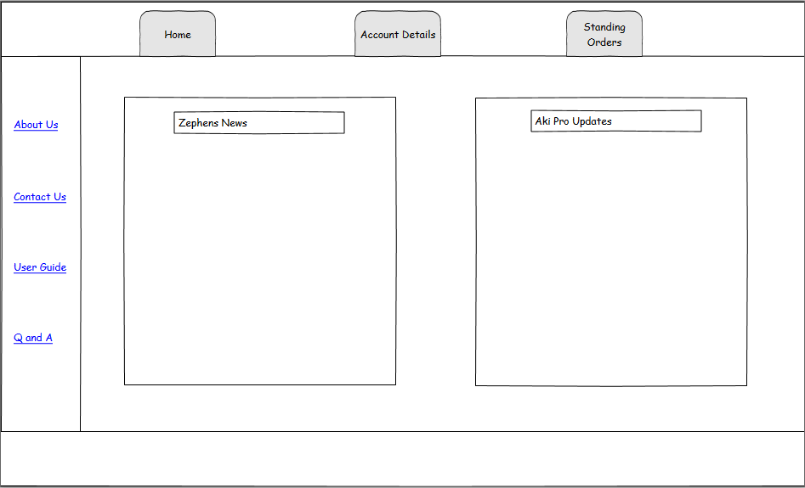

Account Details Page Fig 2

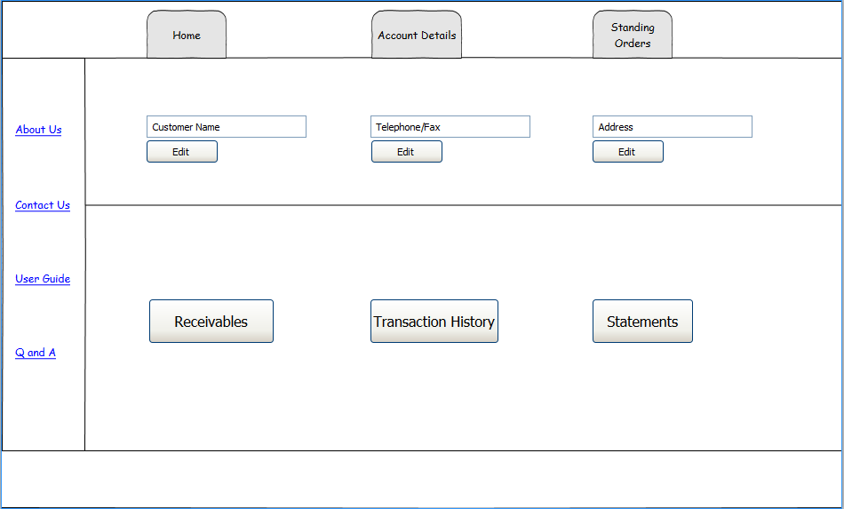

Standing Orders Page Fig 3

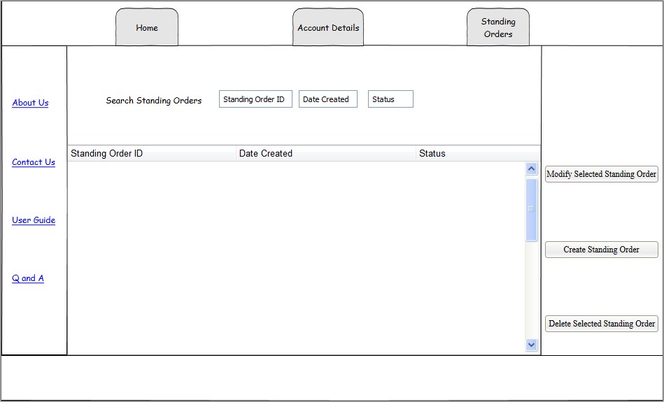

Modify Standing Order Page Fig 4

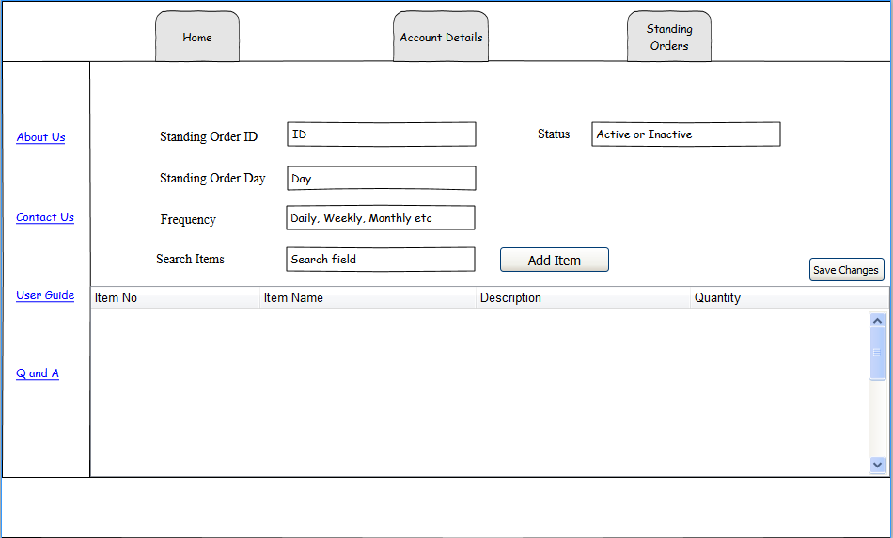

Create Standing Order Page Fig 5

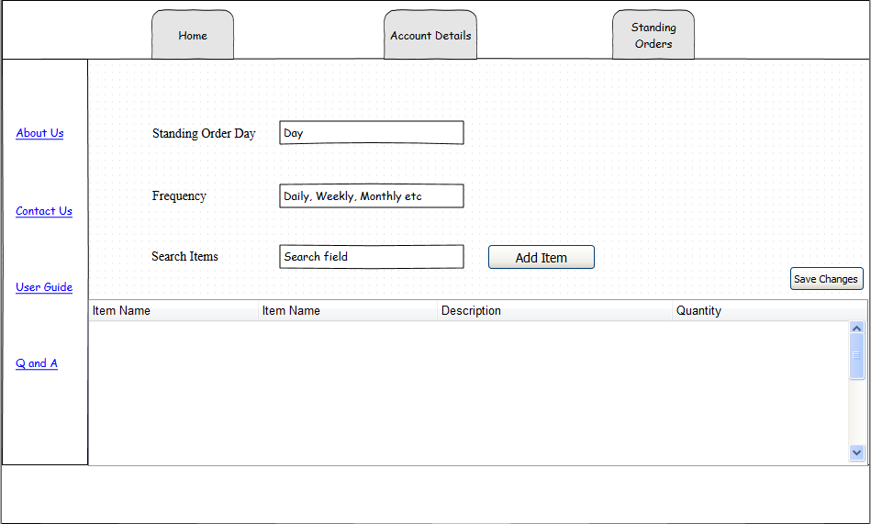

Resource Table for Customer Web App

|  |  |  |  |
| --- | --- | --- | --- |
| Action | Input Parameters | Output | Description |
| GET | CustNo/Token | StdOrder#, ItemNo, Description, Sell Price, Quantity, Ext Price | Bring up list of all of a customer’s standing orders |
| PUT | CustNo/Data (Day/Frequency/Items/Quantity)/Token |  | Creates a standing order for a customer |
| POST | StdOrderID/Data (Day/Frequency/Items/Quantity)/Token | Updated Standing Order Information (New Day/New Frequency/New Items/New Quantity) | Modifies a standing order based on customer input |
| DELETE | StdOrderID/Token |  | Deletes a standing order |

Activity Diagram for Standing Order Modification

