Kelly, Jeff, Seth

Screenshots of DB Schema

* Appointment table

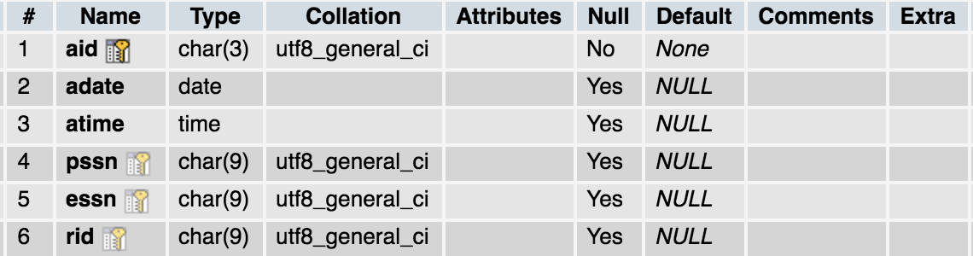

* Employee table

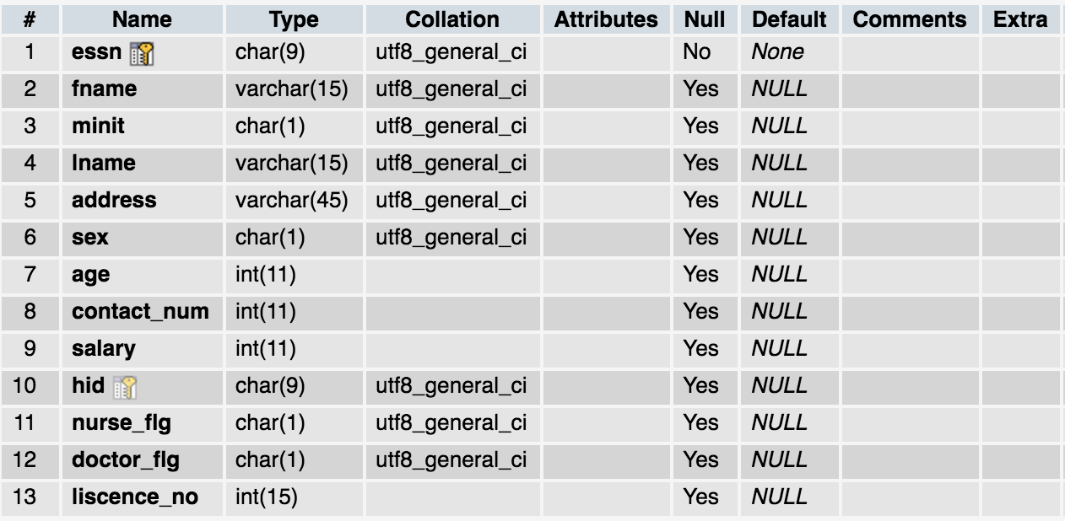

* Hospital table

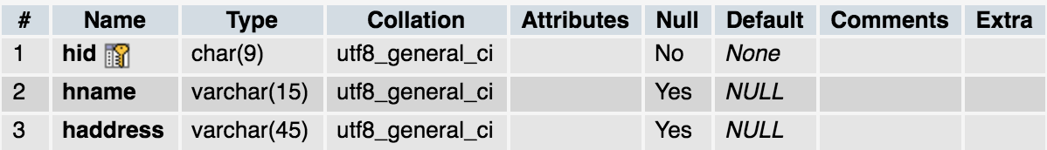

* Medicine table

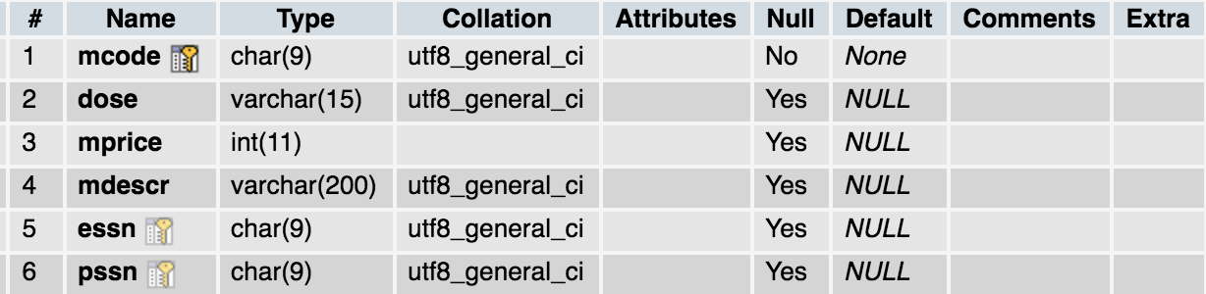

* Patient table

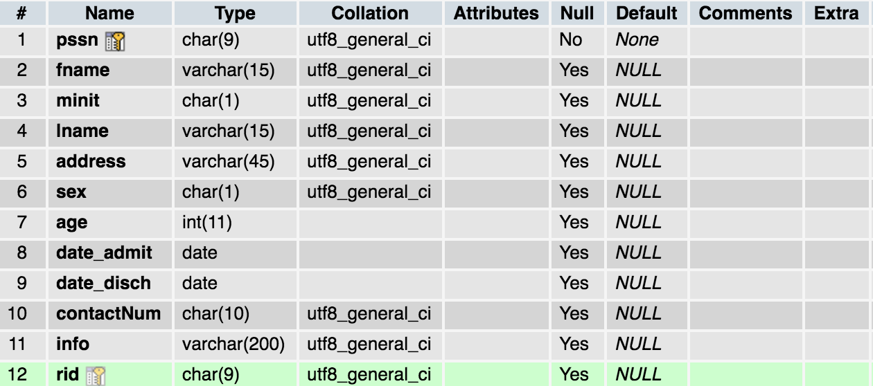

* Procedures table

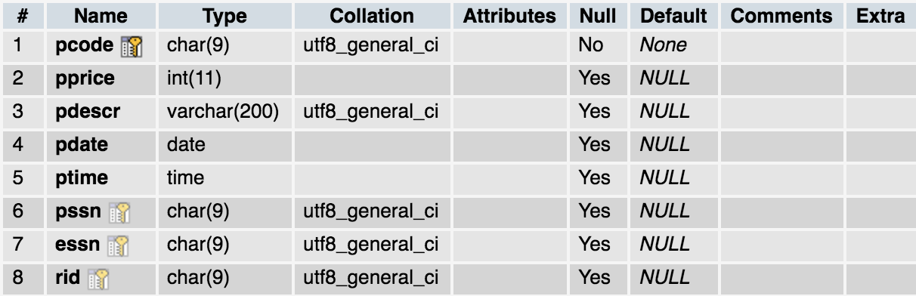

* Porcedure_nurse table

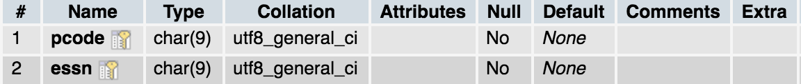

* Room table

