Kelly, Jeff, Seth

Screenshots

* addPatient.html

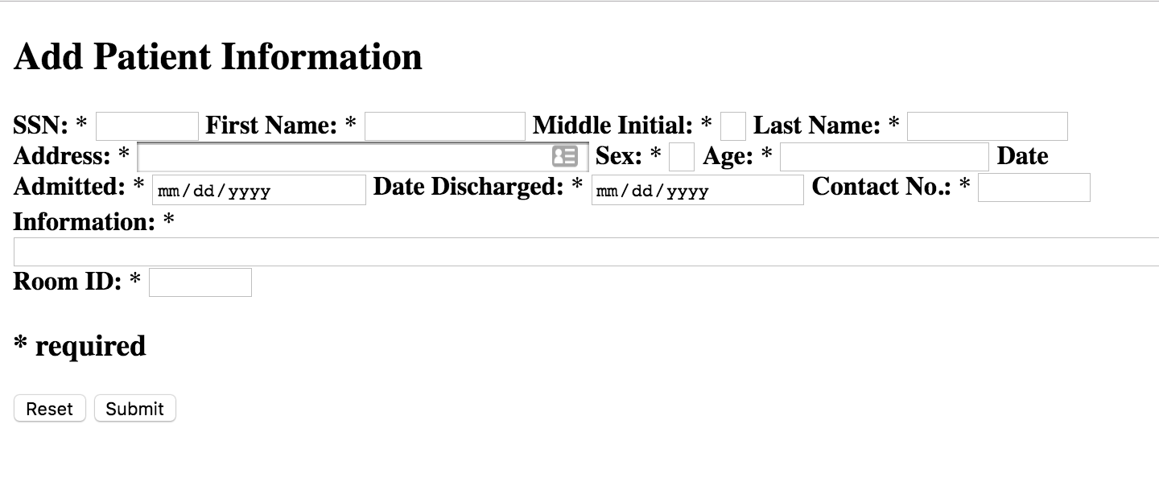

* addPatient.php



* patient.php

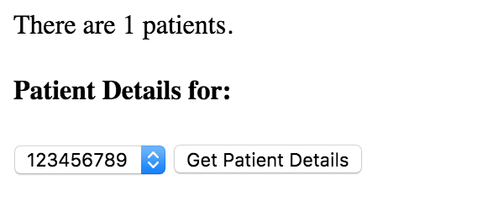

* patientView.php

