How to Use NeuroTri2-VISDOT
NeuroTri2-VISDOT is an interactive online tool to visualize data from the second trimester human brain development dataset published by Bhaduri et al.
Table of Contents
Access 2
About 3
Plot a Gene of Interest 4
Download Plots 7
Download Data 10
Scaling 12
Cell Type Selection 14
Plotting Multiple Genes 15
Troubleshooting 17

Access
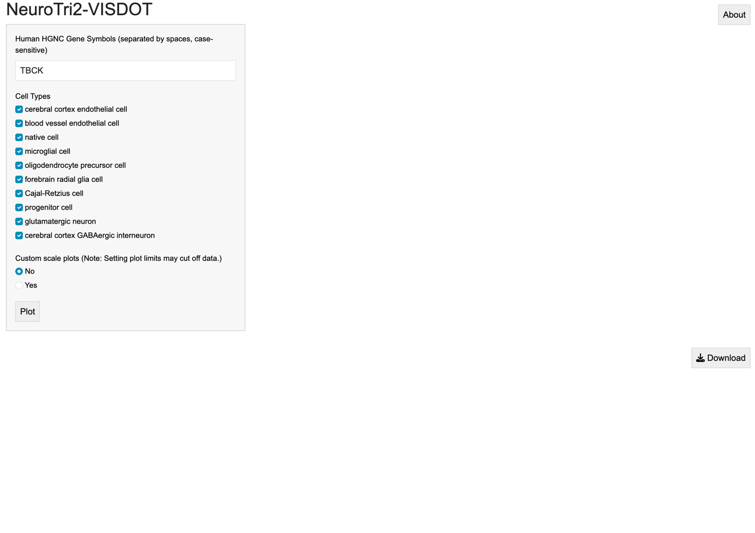
NeuroTri2-VISDOT can be openly accessed at bhojlab.shinyapps.io/NeuroTri2-VISDOT. Code and associated documentation can be found at github.com/kellyclark1/VISDOT. When you visit the web page for NeuroTri2-VISDOT, this will be the first screen you see:

About
When you click the “About” button in the upper right, you will see a pop-up box that contains gene name instructions and current citation information. Please check this tab for information about how to cite the tool and the dataset.
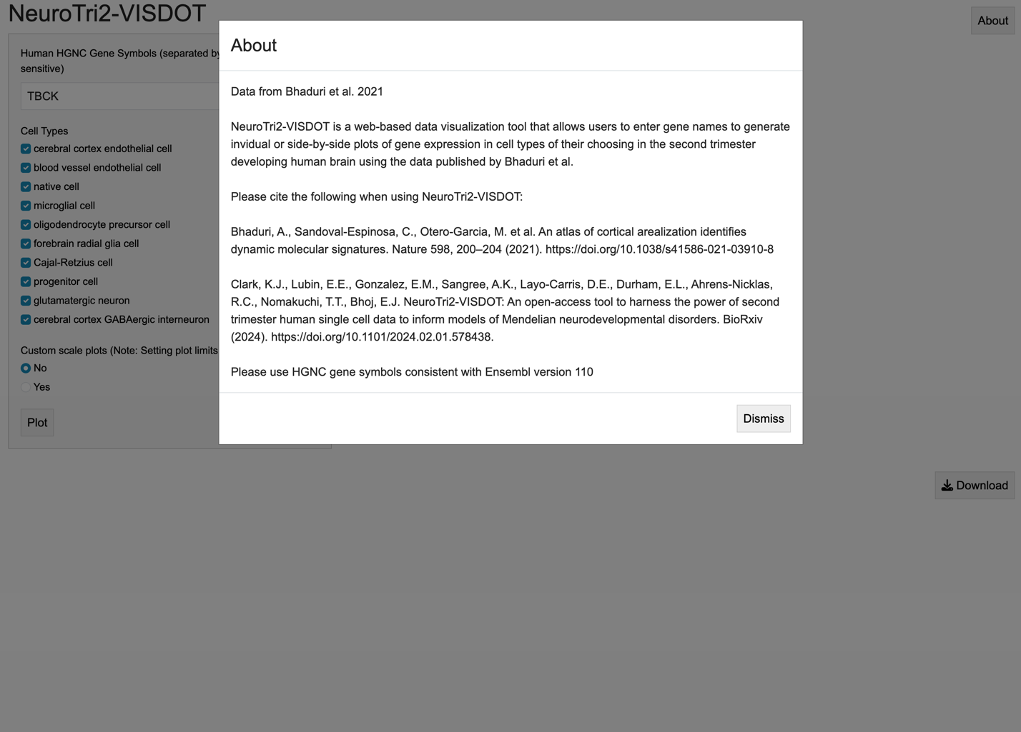

Plot a Gene of Interest
To plot a gene of interest, type in the gene name as the HGNC symbol according to Ensembl version 110. Here, we will use the histone H3.3 gene H3-3A as an example (formerly H3F3A).
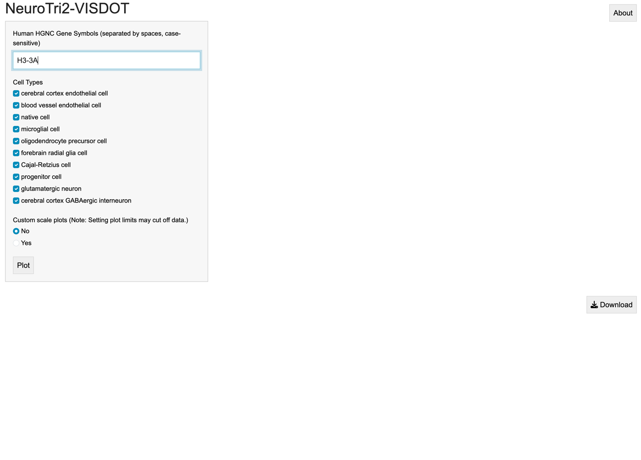

When we click plot (you must click- the enter key will not generate plots, we see each of the three plots like this:

Download Plots
We can download each plot by clicking the download button under that plot:
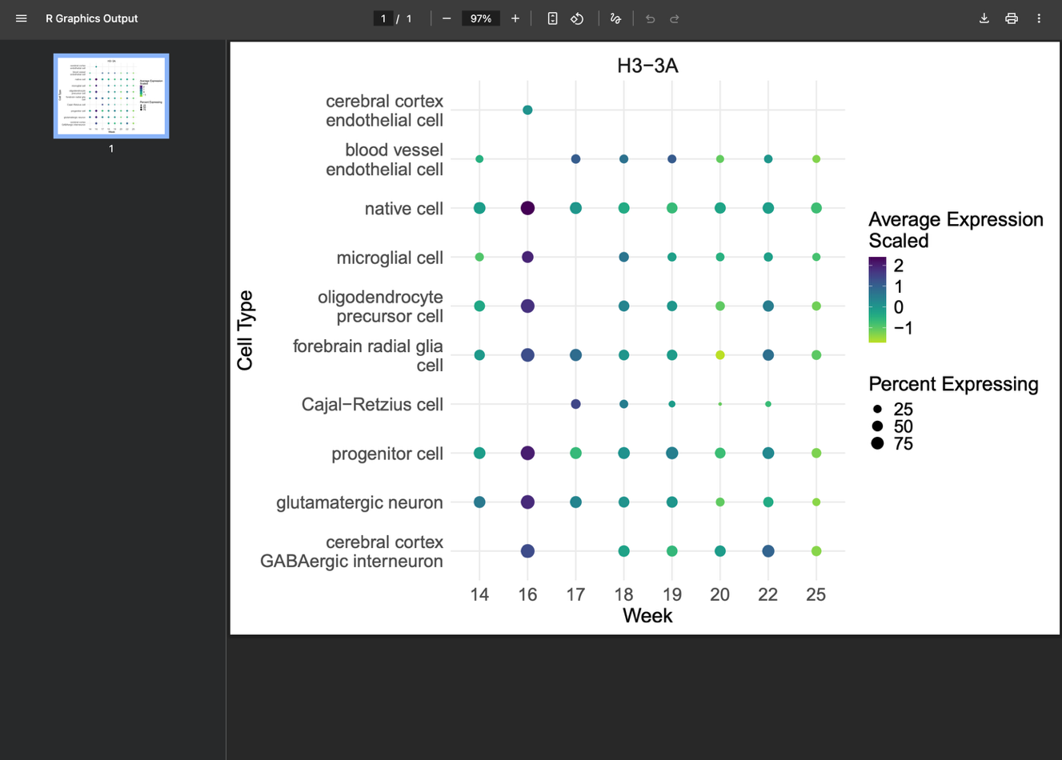
For example, we get this PDF if we download the dot plot:

Plots will be automatically scaled according to the number of genes included.

Download Data
If we want to download the data for our gene of interest, we can use the “Data” button at the bottom of the page to download a comma-separated, spreadsheet-compatible CSV file:

We get a CSV that looks like this, with the gene, cell type, week of prenatal development, percent of that cell type expressing the gene, and the scaled average expression:
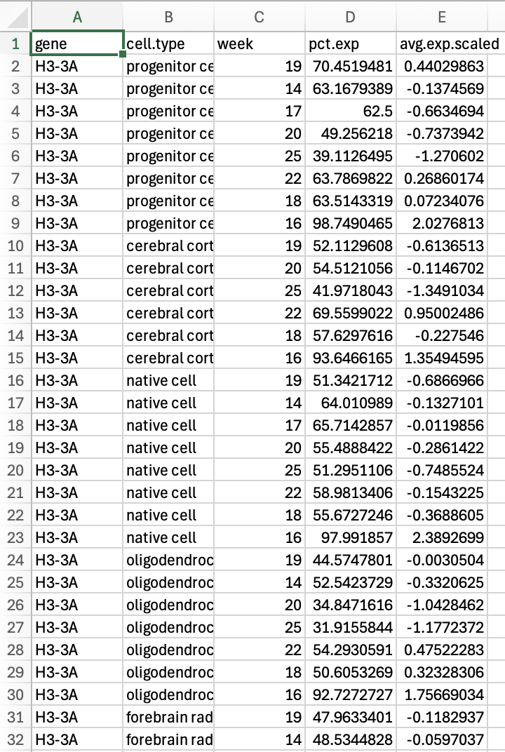

Scaling
We can also custom scale the plots by selecting “Yes” for “Custom scale plots.” We see this when we select “Yes”:
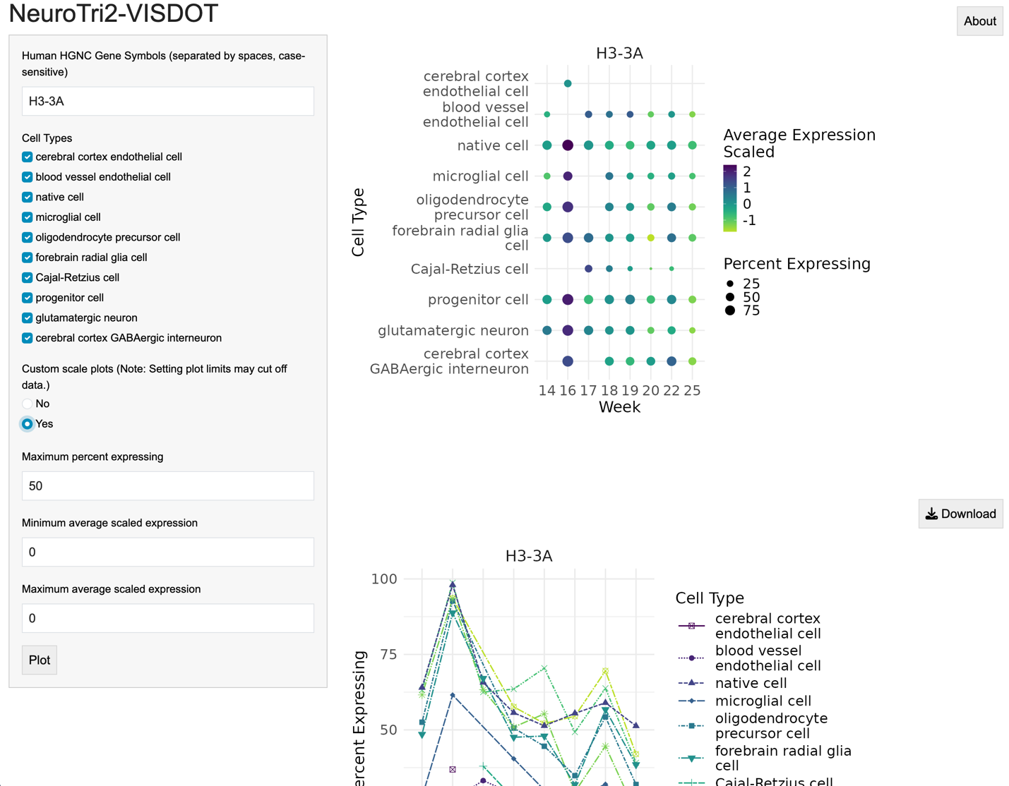

Let’s say we want to center 0 on the average expression line plot. We can assign 100 to “Maximum percent expressing,” -2.5 to “Minimum average scaled expression,” and 2.5 to “Maximum average scaled expression,” and click “Plot” again. Now we can see that the limits on the plots have changed:

Cell Type Selection
We can also choose which cell types to include on the plots. Maybe we are not interested in looking at endothelial or immune cells. We can uncheck these in the “Cell Types” list, and plot again, this time without those cell types:
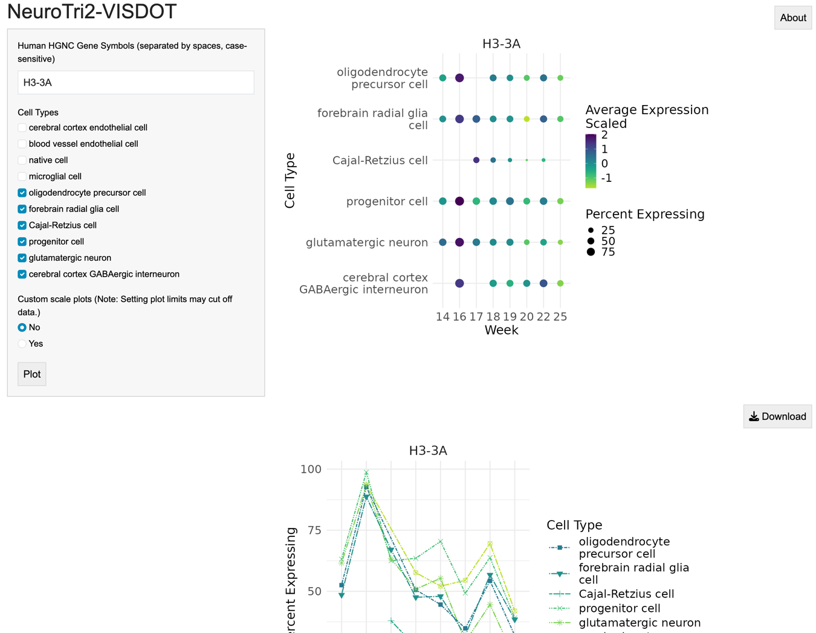

Plotting Multiple Genes
We can plot multiple genes on the same scale by typing in gene names separated by spaces. With two genes, you will get side-by-side plots:
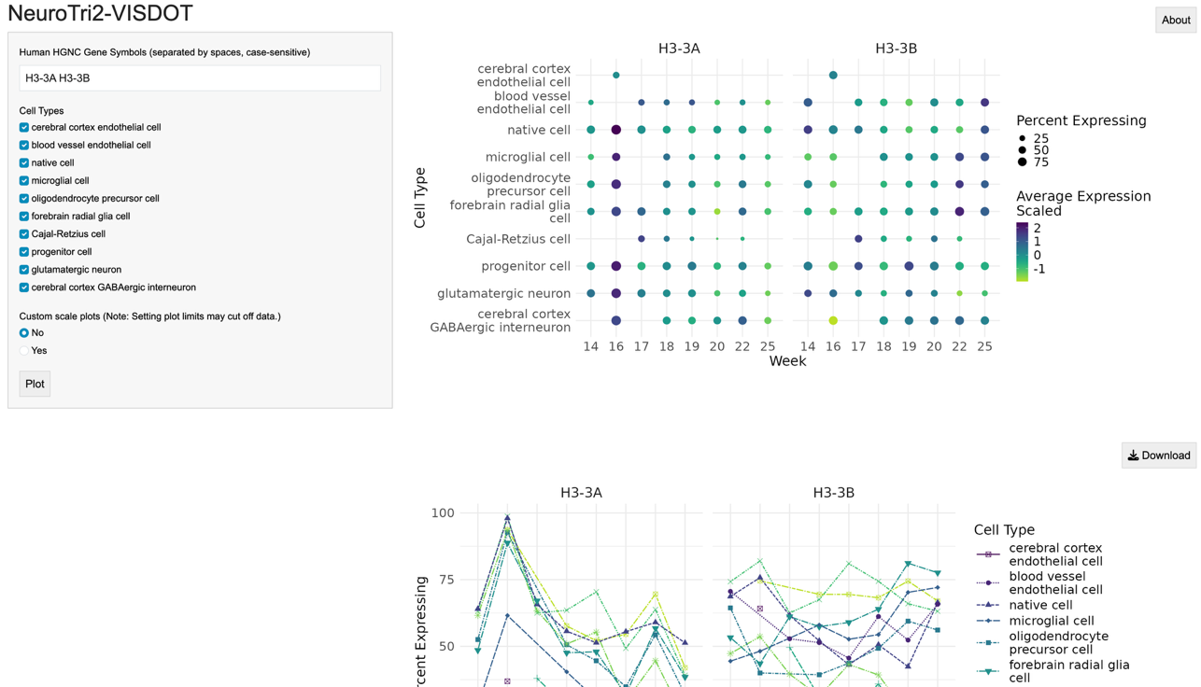

With three or more, the plots will be automatically arranged into equal (or near-equal) numbers of rows and columns. For example, if we plot H3-3A, H3-3A, MACROH2A1, and MACROH2A2, we get two plots by two plots:
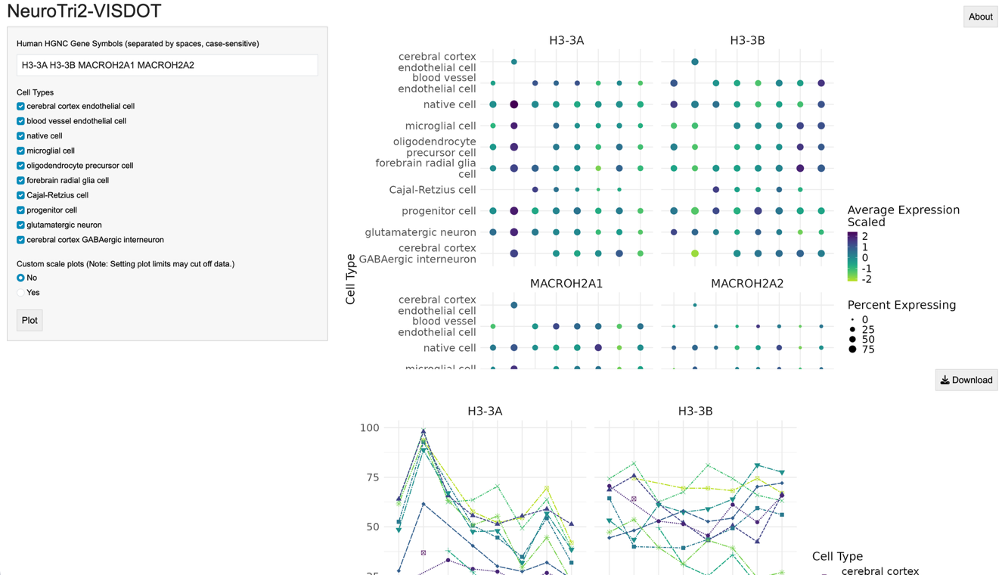
You may need to scroll within plotting spaces on the web page, but the plots can also be downloaded and will automatically resize:

The data can be downloaded the same as single-gene plot data. Multiple-gene plots can also be produced with cell type and scaling options in the same way as single-gene plots.

Troubleshooting
Gene X not found.
If you get an error “Gene [gene name] not found,” this means that gene name is not present in the data. This may mean that it is not an HGNC gene symbol included in Ensembl version 110, or it may not be present in the dataset. Try checking Ensembl to make sure you have the correct version, and make sure the gene name is in the proper case (input is case-sensitive).

Please enter at least one gene.
If you get this error, there is nothing in the input text box.

Please select at least one cell type.
If you get this error, there are no cell types checked.

Missing data on plots
If you have “floating points” not connected to lines on the line plots and have custom scaled, or you are missing points on the dot plot compared to auto scaled plots, your plot limits are likely narrower than the data range. You can check this by selected “No” for custom scaling, or by downloading the data.

