business intelligence data warehousing
an open source approach
by
shalaka borker
B.E., Goa University, India, 2002

A REPORT

submitted in partial fulfillment of the
requirements for the degree

MASTER OF SCIENCE

Department of Computing and Information Sciences
College of Engineering

Kansas State University
Manhattan, Kansas
2006

Approved by:

Major Professor
Dr. William Hankley
Department of Computing and Information Sciences
ABSTRACT

This report describes the construction of a functional data warehouse application and investigates the use of open source tools for the same. The study reported here is based on a data warehouse implemented using a commercial database server for data storage but using open source tools for analysis and reporting. The model developed for the study is therefore only partly open source.
In this work, SQL Server 2005 has been used as the database server. The source database used is the sample Northwind relational database that ships with SQL Server. The data warehouse has also been designed in SQL Server 2005. The analysis and reporting has been performed using an open source OLAP server called Mondrian and an open source OLAP client called JPivot. Using Mondrian one can interactively analyze large quantities of data in real time. JPivot allows one to navigate and build OLAP reports in a web browser.
ACKNOWLEDGEMENTS

First and foremost, I would like to extend my special thanks an acknowledgement to Dr. William Hankley. He has been a wonderful advisor and his support and encouragement has led me to the successful completion of my project and report. Thank you Dr. Hankley for being there whenever I needed help and guidance. Your open and honest sharing of ideas helped me achieve the objectives of this work.
I would also like to thank Dr. Torben Amtoft and Dr. Gurdip Singh for serving on my graduate committee. They have been very kind and understanding. Their insightful suggestions have proven valuable to this work.
I wish to thank my cousins Prathit Bondre and Siddhit Desai for their continued guidance on this project. Without their assistance, the idea for this project would have remained just that, an idea.
I extend my warm thanks to my friends Pranshu Gupta, Shambhavi Prabhu and Chirag Gosalia for their kindness, concern and support during the process of this work.
My sincere thanks to Ms. Delores Winfough for all her help and for carefully and patiently guiding me through the graduate school procedures.
I particularly wish to thank my family; my parents, my brother Ojas and my husband Sumit Patankar, for their perpetual belief in me and for their unrelenting, patient and embracing love that surrounds and supports me in everything I do.

TABLE OF CONTENTS

LIST OF FIGURES v
LIST OF TABLES viii
Chapter 1 Introduction 9
1.1 Objective 9
1.2 Motivation 9
1.3 Target Audience 10
Chapter 2 Literature Review 11
Chapter 3 Theory 13
3.1 Fundamental Data Warehousing Concepts 13
3.1.1 Definition and Theoretical Background 13
3.1.2 Advantages 14
3.2 Data Warehousing Framework 15
3.2.1 Component Structure 15
3.3 Business Analysis Process 18
3.3.1 Identifying Business Drivers and Objectives 19
3.3.2 Identifying High Level Information Analysis Needs 20
3.3.3 Identifying Roles and Processes 20
3.3.4 Identifying Key Performance Indicators 20
3.3.5 Establishing Dimensions, Events and Facts 20
3.3.6 Identifying Data Sources and Modeling Transformations 21
3.4 System Architecture 21
3.5 Technologies Used 22
3.5.1 Microsoft SQL Server 2005 23
3.5.2 SQL Server Integration Services 23
3.5.3 Mondrian 24
3.5.4 JPivot 24
3.5.5 Apache Tomcat 24
Chapter 4 Implementation 25
4.1 Review of the Source System Design 25
4.2 Logical Design of the Northwind Data Warehouse 28
4.2.1 Requirements 28
4.2.2 Dimensional Schema Design 29
4.2.3 Data Warehouse Size Estimation 32
4.3 Data Transformation and Load 33
4.3.1 SSIS Transformation Package 33
4.3.2 Assumptions 39
4.4 Mondrian Schema Design 41
4.5 Query and Reporting 44
4.5.1 Multi-Dimensional Expressions (MDX) Language 44
4.5.2 JPivot Reports 44
4.6 Processing 58
Chapter 5 Reflections 60
5.1.1 Experiences during Development 60
5.1.2 Knowledge Gained 61
Chapter 6 Future Work 63
Chapter 7 Conclusion 64
References 65
APPENDIX A Database Structure 66
A.1 Table Properties - Northwind Database 66
A.2 Table Properties - Northwind Data Warehouse 70
APPENDIX B JPivot 74
B.1 JPivot Queries 74
APPENDIX C Screenshots 76
C.1 Application and Report Screenshots 76

LIST OF FIGURES

Figure 3.1: Components of a Data Warehouse 15
Figure 3.2: Data Warehousing Analysis Process 18
Figure 3.3: The System Architecture 22
Figure 4.1: Database Table Model for the Northwind Database 26
Figure 4.2: Database Table Model for the Northwind Data Warehouse 31
Figure 4.3: Size Estimation of the Sales_Fact Table 33
Figure 4.4: Control Flow of the SSIS package – Load Northwind Data Warehouse 35
Figure 4.5: Data Flow of the Load Geography_Dim Control Task 35
Figure 4.6: Data Flow of the Load Customer_Dim Control Task 36
Figure 4.7: Data Flow of the Load Employee_Dim Control Task 36
Figure 4.8: Data Flow of the Load Supplier_Dim Control Task 37
Figure 4.9: Data Flow of the Load Product_Dim Control Task 38
Figure 4.10: Data Flow of the Load Shipper_Dim Control Task 38
Figure 4.11: Data Flow of the Load Sales_Fact Control Task 39
Figure 4.12: Mondrian Schema for the Northwind Data Warehouse 43
Figure 4.13: An Example MDX Query 44
Figure 4.14: The JPivot Toolbar 45
Figure 4.15: Sample report giving the Dollar Sales 46
Figure 4.16: OLAP Cube Navigator Tool – Options 47
Figure 4.17: OLAP Cube Navigator Tool – Result 48
Figure 4.18: MDX Query Tool 49
Figure 4.19: Sort Tool – Options 50
Figure 4.20: Sort Tool – Results 50
Figure 4.21: Show Parent Members Button – Result 52
Figure 4.22: Hide Spans Button – Result 53
Figure 4.23: Show Properties Button – Result 53
Figure 4.24: Suppress Empty Rows/Columns Button – Result 54
Figure 4.25: Swap Axes Button – Result 54
Figure 4.26: The Report being Drilled Through 55
Figure 4.27: Chart Options and Selection 56
Figure 4.28: Pie Chart giving the Dollar Sales for Employee 57
Figure 4.29: Print Option Settings 58
Figure A.1.1: Categories Table 66
Figure A.1.2: Customer-Customer Demographics Table 66
Figure A.1.3: Customer Demographics Table 66
Figure A.1.4: Customers Table 67
Figure A.1.5: Employees Table 67
Figure A.1.6: Employee Territories Table 68
Figure A.1.7: Order Details Table 68
Figure A.1.8: Orders Table 68
Figure A.1.9: Products Table 69
Figure A.1.10: Region Table 69
Figure A.1.11: Shippers Table 69
Figure A.1.12: Suppliers Table 70
Figure A.1.13: Territories Table 70
Figure A.2.14: Calendar Dimension Table 71
Figure A.2.15: Customer Dimension Table 72
Figure A.2.16: Employee Dimension Table 72
Figure A.2.17: Geography Dimension Table 72
Figure A.2.18: Product Dimension Table 73
Figure A.2.19: Shipper Dimension Table 73
Figure A.2.20: Supplier Dimension Table 73
Figure A.2.21: Sales Fact Table 74
Figure B.1.22: Query 1 – Generates Unit and Dollar Sales by Year 74
Figure B.1.23: Query 2 – Generates Unit and Dollar Sales in 1997 by Product 75
Figure B.1.24: Query 3 – Generates Unit and Dollar Sales by Year and Product 75
Figure B.1.25: Query 4 – Generates Dollar Sales by Year and Customer Region 75
Figure B.1.26: Query 5 – Generates Dollar Sales by Year and Employee 76
Figure C.1.27: Index Page showing the Report Options 76
Figure C.1.28: Unit and Dollar Sales for all Products by Year 77
Figure C.1.29: Unit and Dollar Sales for a particular year by Product 77
Figure C.1.30: Unit and Dollar Sales by Year and Product 78
Figure C.1.31: Dollar Sales by Year and Customer Region 78
Figure C.1.32: Dollar Sales by Year and Employee 79

LIST OF TABLES

Table 4.1: Northwind Database – Table Sizes 27
Table 4.2: Business Drivers and Business Objectives for Northwind Traders. 28
Table 4.3: Northwind Data Warehouse – Table Sizes 33

Introduction

Objective
This report has two main objectives. The first is to study the technique of developing a functional data warehouse. A data warehouse serves as a consistent source of data for the decision makers in a company and is a reliable and fast method for retrieving answers to analytical questions. During the construction of a data warehouse, the analysis process involves understanding the business objectives, identifying factors that drive the business, and then understanding how one could design the warehouse such that all the information needed by decision makers is available to them in the fastest possible way. This may uncover new business intelligence that aids in better business decisions. The aim is thus to gain experience in building a data warehouse and achieve a detailed understanding of the thought process involved in the design.
The second objective is to investigate the use of open source software in the implementation of a data warehouse. This approach shows promise because most commercial software available for data warehousing exceeds the budget of an average sized company. The aim is thus to understand the advantages and tradeoffs of using open source tools in the design and implementation of a business-intelligence data warehouse.

Motivation
The motivation for this report stems from the increasing demand for data warehousing in today’s businesses. Almost all businesses today, big or small, rely on some form of analysis and reporting on which to base their business decisions. Businesses need to access historical data for spotting business trends, customer buying patterns, data relationships and other time and demography based studies. A data warehouse provides a business with all such data in an easy and quick manner.
Today, different proprietary tools are available for data analysis and warehousing but they are expensive and accessible only to large companies with higher budgets. However, using open source software, as opposed to commercial products for data warehousing provides a huge financial gain. Open source gives smaller and medium-sized companies, which are tight on budgets, an opportunity to use data warehouses and reap benefits that they could never have imagined. With major companies moving towards open source as a shelter to cut down costs in all of their different applications, an open source approach to data warehousing seems like a promising technique to study.

Target Audience
This report serves are a guide to anyone who wishes to design a data warehouse. Specifically, small and mid-sized companies that have been unable to use data warehousing due to the high costs involved can now tap this resource. Since the report stresses on the open source tools Mondrian [10] and JPivot [11], the user will gain insight into the use of these tools. However, the target audience could also include someone who is a beginner to data warehousing and wants to simply build a data warehouse, irrespective of the database software and tools used. This is so because the study encompasses all the groundwork necessary to build a data warehouse and lays out the basic procedure to follow.

Literature Review

The Mondrian OLAP Server is part of the Pentaho Open Source Business Intelligence Platform [12]. Pentaho BI is an initiative by the Open Source community and is centrally managed by the Pentaho Corporation. Pentaho owns and sponsors many other open source projects in application areas including Reporting, Analysis and Data Mining. They leverage costs of open source technologies and build new, innovative products faster than other commercial vendors. The Pentaho Technical White Paper [12] describes this BI platform, how it integrates open source components and standards with a process-driven engine to solves BI problems and describes its advantages.
Another company leading the way in the open source technology concerning data warehouses and BI is Greenplum [13]. It has a line to database products called Bizgres which caters to the enterprises. The latest of its open source databases is the DeepGreen database for data warehousing. DeepGreen is based off the PostgreSQL database which is also open source. With a range of products for all sizes of data, open source data warehousing is sure to reach new heights in the market.
Yet another work in this field is that of Dr. John Bernardino [14] in which he proposes the construction of affordable data warehouses based on his Data Warehouse Stripping (DWS) approach. The main goal of his work is to allow small and medium sized enterprises to acquire and use data warehousing and OLAP technology by providing very low cost platforms based on open source technology; open source operating system, open source databases and open source reporting and analysis tools.
There are several other works by individuals who want to try a hand at open source data warehousing. With a myriad of open source applications tools and software to choose from, the choice is left solely to the developer. There is definitely an option available for all kinds of customers. One needs to contemplate the advantages and disadvantages of using a particular tool in the context of their business and requirements. Keeping in mind the objectives of this work I chose to experiment with the Mondrian OLAP server and the JPivot reporting tool for this study.

Theory

Fundamental Data Warehousing Concepts

Definition and Theoretical Background
“A data warehouse is a database specifically structured for query and analysis. A data warehouse typically contains data representing the business history of an organization. Data is usually less detailed and longer-lived than data from an online transaction processing (OLTP) system." [1]
A data warehouse may be defined in several different ways. These definitions are often based upon the company using the data warehouse and the way the data warehouse is structured. However, the high-level definition of a data warehouse, as stated above suffices as a basic functional definition.
A data warehouse is thus a repository for long-term data, often in a summarized form. The data is collected from multiple heterogeneous sources but is made consistent prior to storage in the warehouse. It seldom changes and is generally considered read-only. The structure of the data warehouse and the format of the data is such that it facilitates querying and analysis.
In earlier days, most companies would accumulate data about its business transactions and details about its customer. More often, this would be data stored either as paper reports or as spreadsheets. This data would sometimes include knowledge that was held by a long time employee of the company. For making any business decisions this data would need to be accessed and retrieved manually. With the advent of data warehousing this changed and data was more readily made available for analysis.

Advantages
Use of a data warehouse may yield advantages that are not foreseen during the design phase of the warehouse. Sometimes the advantages may not be describable in a generic manner. However, some of the common advantages of data warehousing are listed below.
- A data warehouse may uncover new business intelligence and thus provide a strategic advantage to the company.
- Since data from all over the company is brought together in the warehouse, one can have access to all the relevant data from various departments at one place.
- The heterogeneous data is now in a homogeneous form and can thus be compared and used efficiently.
- The consistency of data facilitates querying and quickens analysis thus providing larger horizons for data mining.
- The data warehouse construction phase may help identify duplicate effort within the company to maintain the same data. This can be eliminated leading to increased profitability.
- Data warehouse construction helps discover if any important data collection is being overlooked by any of the business processes. Care can then be taken to ensure that this data is indeed being correctly collected thus improving effectiveness.
- Building an independent data warehouse reduces the administrative costs. Administering a single system that takes care of transactional and analytical processing would have resulted in an increased overhead; the overhead due to the efforts required for the maintenance and surveillance of the system that actually has contradicting requirements for the different types of processing.

Data Warehousing Framework

Component Structure
Data in a data warehouse needs to be structured and stored in a manner that facilitates the quick retrieval of information for even the most complex queries, queries which are for analytical purposes and not transactional. Thus, the data from the source system is restructured and loaded into the data warehouse. This data is used by the reporting tools for reporting and for analysis by the end user.
Figure 3.1 shows the basic components of a common data warehouse, each of which is described in detail here. The figure also shows the technologies that form each of these components in this study. These technologies are later described in Section 3.5.
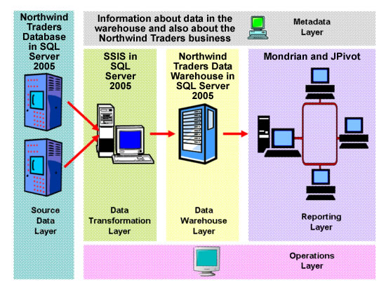
Figure 3.1: Components of a Data Warehouse

Source Data Layer
The source layer of the framework is the layer where the source data resides. In most cases, it is a relational database. However, it could be any electronic repository that stores information that is of importance to business management and which aids in decision- making and analysis. In this study the source layer consists of the relational database for Northwind Traders [9] which is a client-server SQL Server database.

Data Transformation Layer
Data from the source systems needs to be transferred to its destination in the data warehouse, but before loading the data, it needs to be transformed into a standard style and format. The information needs to undergo several types of transformations typically involving 1) Format change – ex. A column in the source database may be representing whether a product is discontinued or not in the form of numeric values ‘1’ or ‘0’ whereas your data warehouse stores it as text values ‘true’ or ‘false’. Thus, the data format needs to be changed. 2) Restructuring and mapping of data – ex. The data in the order details table and in the products table is taken and combined for storing it in the sales fact table. 3) Checking and enforcing data consistency (data scrubbing) – ex. A country name may be stored by different spellings in the different sources but we need to have a consistent spelling for it in the data warehouse and 4) Data validation- ex. Making sure that a customer already exists in the data warehouse and has a valid CustomerID before we add additional data for him. Data transformation can therefore be performed either by manually created code or by a specific type of software called an ETL (Extract-Tansform-Load) tool.
This study uses SSIS, SQL Server 2005 Integration Services [8] to develop packages for data extraction, transformation and loading within the SQL Server Business Intelligence Development Studio.

Data Warehouse Layer
The data warehouse is where all the information from the multiple resources is stored in a structure, a relational database, for easier querying and faster reporting and analysis. This study uses SQL Server 2005 for design and implementation of the Northwind Traders data warehouse. Design of the data warehouse is covered in the later sections.

Reporting Layer
The data contained in the data warehouse is not useful if it is not accessible to the employees and others in management. For this purpose several tools and applications are available that can be custom-developed to suit the business needs. The most common are OLAP tools, Business Intelligence Tools, Data Mining tools and Executive Information Systems. This study uses the Mondrian OLAP Server and JPivot OLAP tool for the reporting and analysis.

Metadata Layer
This layer contains all the information about the data contained in the data warehouse and the state of the warehouse. Metadata serves as a resource for the users, a source from where they can get information like when data was last loaded into the warehouse and number of users using the warehouse at a current time.

Operations Layer
This layer involves the incremental loading, manipulating and extracting of data from the data warehouse. This also comprises of issues relating to the management of data warehouse capacity, its security and other related issues.

Business Analysis Process
The implementation of the data warehouse is preceded with a thorough analytical process that involves understanding the business, identifying the requirements and determining which reports would be needed and would help in making intelligent business decisions. The idea is to understand how the construction and use of the data warehouse will prove beneficial to the organization. This analysis results in the identification of the dimension tables and fact tables, which drive the actual design of the data warehouse.
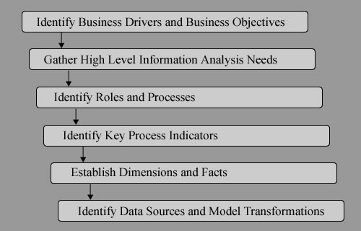
Figure 3.2: Data Warehousing Analysis Process
Figure 3.2 illustrates the steps involved in the analysis process. We shall discuss each of the steps in the following subsections.

Identifying Business Drivers and Objectives
In order to understand how business decisions are made one first needs to identify factors that drive the business. These factors, generally external factors that change, affect the company in some manner. Thus they play a vital role in business decisions, which may in turn give rise to more business requirements, and are thus called business drivers. A common example of such a factor is the entrance of new competitors, which would affect the prices of products/services and the market share. New strategies and reporting criteria would have to be developed to understand how to deal with this change and to make beneficial decisions.
Business objectives comprise of a set of clearly defined statements about what the company aims to achieve. They also help in identifying what needs to be done in order to achieve the desired results. Stating the business objectives is easier once the business drivers have been identified. An example of an objective derived due to the above mentioned business driver (entrance of new competitors), could be ‘increase customer satisfaction and retention’. This in-turn leads to a series of ideas and thoughts as to how one could possibly do that. Understanding the business drivers and defining the business objectives plays a vital role in identifying the scope of the data warehouse and aids in the design.

Identifying High Level Information Analysis Needs
Information about the business processes are needed before one can design a structure that can be used to gather and hold data that is the basis of all analysis and decisions. To gather this information one needs to understand processes in different business units. Hence, meetings with senior managers in the different business units need to be conducted. The information collected helps in establishing the analytical needs and what the initial iteration aims to achieve.

Identifying Roles and Processes
To understand how data flows within the business one needs to identify the various processes involved in the business. It is also important to know the roles of people so that one can identify the needs of that particular role which in turns helps in the prioritization of business objectives and in establishing the project scope.

Identifying Key Performance Indicators
Key Performance Indicators, KPIs, are quantifiable measurements that reflect the critical success factors of an organization and help an organization define and measure progress toward organizational goals. The KPIs are pre-defined by an organization according to its structure and therefore they vary from organization to organization. Once the analysis process is complete, it yields a set of KPIs and these help in establishing the events, dimensions and facts for the data warehouse.

Establishing Dimensions, Events and Facts
An event is an activity within the business or related to the business that changes the attributes of certain information objects. These objects are persistent entities, like products, in which case an event would be the sale of the product. A fact is a measure that is recorded during each occurrence of an event. Ex. units sold per order. A dimension is an entity with which events interact. It is a structural attribute of a cube which may be an organized hierarchy of categories that describe data in the fact table. The categories are typically members upon which the analysis is based. Ex. Time, with a hierarchy of Year, Quarter, Month. Establishing these events, dimensions and facts to suit the requirements is critical to the data warehouse design.

Identifying Data Sources and Modeling Transformations
After the dimensions and facts are well established, a base model of the data warehouse is ready. One now knows what data the warehouse must contain and how it should be stored. The next step is to identify from where and how this data can be brought into the warehouse that involves identifying the data sources and then transforming that data for storage into the data warehouse. This is one of the most important steps in the design and construction of a data warehouse. It is at this stage that the data consistency, integrity and validity are checked and asserted.

System Architecture
The system has three-tier architecture as shown in Figure 3.3. The user interface constitutes the top-most layer of the system which is the presentation later. The application logic data and results are converted by the presentation layer into a format that users can understand. The application logic layer is where all the logic lies. This is where the logical statements and queries are processed. All the calculations take place in this tier. As it is the middle-tier the data is transported between the two surrounding layers by the logic tier. The data tier is where the database server resides. The data is stored here and retrieved from here for processing by the logic tier.
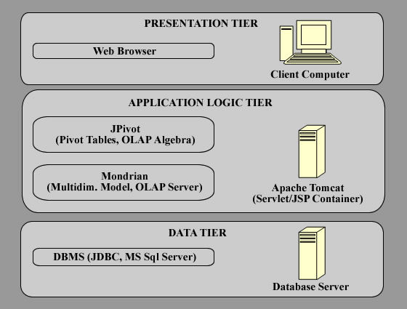
Figure 3.3: The System Architecture

Technologies Used
This study is based on the 3-tier system architecture given in Figure 3.3. The technologies that comprise of these layers fit into the component structure of a data warehouse as shown earlier in Figure 3.1. The rest of the section describes these technologies.

Microsoft SQL Server 2005
The SQL Server 2005 database platform provides with a high quality of data management. It comprises of the SQL Server Management Studio and the SQL Server Business Intelligence Development Studio, which together provide business intelligent tools and a variety of services. These services include Analysis Services (SSAS), Integration Services (SSIS), Replication Services, Reporting Services (SSRS) and Notification Services [8]. The database engine forms the core of the enterprise data management solution and provides a secure and reliable structure for the storage of relational and well-structured data. SQL Server 2005 is also integrated with Microsoft Visual Studio and the Microsoft Office System. SQL Server 2005 thus serves as an excellent platform for OLTP, data warehousing and e-commerce, enabling one to build innovative solutions.

SQL Server Integration Services
SSIS is an application that provides the platform for building data integration and workflow solutions. It is the next generation DTS in SQL Server 2005 and serves as a data ETL tool for data warehousing, providing enterprise-wide data integration. It contains a rich set of tools for building and managing data integration solutions, including built in tasks, containers, transformations and data adapters. Therefore, by using the graphical interface and without writing any code, one can create custom SSIS solutions, solutions that use ETL and business intelligence to solve complex business problems and manage SQL Server databases.

Mondrian
The Mondrian OLAP server is written in the Java programming language and as mentioned earlier it is part of the Pentaho BI Platform. Using Mondrian one can interactively analyze large quantities of data in real time. It implements queries written in the MDX language and one need not write SQL. It also supports XMLA (XML for Analysis) and JOLAP (Java OLAP) specifications. Data from various any JDBC data sources can be read and aggregated in cache memory. The data is analyzed and processed and the results are presented in a multidimensional format using a Java API.

JPivot
JPivot is a JSP based OLAP client. It is an application that allows one to navigate and build OLAP reports in a web browser. It is a custom tag library that renders OLAP tables and aids users in performing the slice-and-dice and drill down operations that constitute the primary OLAP navigations. It also has support for visualizing the data by creating charts. It is designed to work with several OLAP Servers including Mondrian.

Apache Tomcat
Mondrian and JPivot have been hosted by the Apache Tomcat Server which is a Servlet/JSP container. Tomcat has an internal HTTP server of its own and has thus been used here as a standalone web server. Since it is written in Java it runs on any operating system that has JVM.

Implementation

Review of the Source System Design
The source system in this study is an Online Transaction Processing (OLTP) system, a relational database for Northwind Traders. This database is a sample database that is installed as a sample database with MS SQL Server 2000. It had to be installed here to work with SQL Server 2005. Northwind Traders is primarily a wholesale food supplier. It sells a variety of products, bought from various suppliers, to its customers located worldwide. The database schema for the Northwind database is given in Figure 4.4. The data types and details of attributes of each table can be found in Appendix A.1.
The tables and their contents are intuitive. The Customers table contains the details of the customers. The CustomerDemographics table stores the CustomerTypeID and their description. The CustomerCustomerDemo table stores the mapping between the Customers and CustomerDemographics table. However, in this study we are not working with the CustomerDemographics and CustomerCustomerDemo table.
A customer places an order for products and the high-level order-related data is stored in the Orders table. The OrderDetails table stores the details of the products contained in a particular order, their quantity, price and discount offered for that particular product order. The two tables are linked by the OrderID. Since the Northwind database is an OLTP system it is normalized and hence the two tables to store order information. Each order is shipped to the customer by a specific Shipper whose details are stored in the Shippers table.

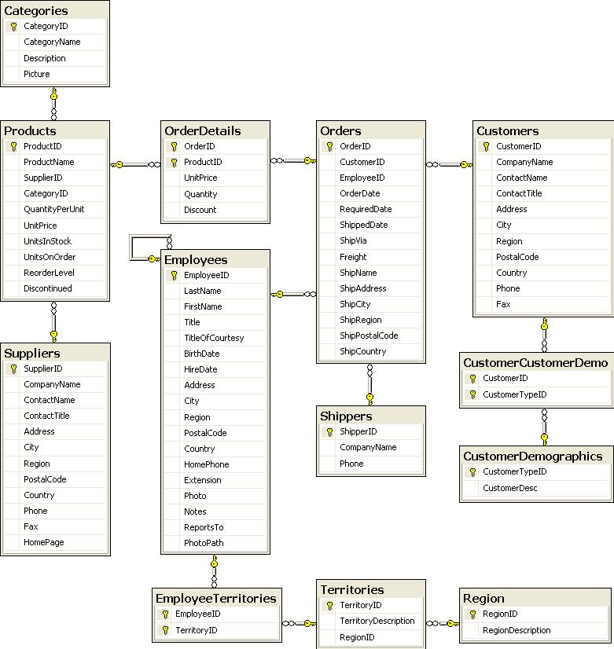
Figure 4.4: Database Table Model for the Northwind Database
As the name suggests, the Products table stores the details of each product. The Categories table stores the product category and description for each product and is linked to the Products table by the CategoryID. Each product is supplied by the supplier whose details are stored in the Suppliers table. The Products and Suppliers tables are linked by the SupplierID. Each order is taken by an employee and the employee details are stored in the Employees table. The different territories that the employees come from are stored in the Territories table, linked to the Employees table via the EmployeeTerritories table. The Territories are further divided into regions and these region details are stored in the Regions table.
Table | Rows | Data Size(MB) | Index Size(MB) | Total Size(MB)
Categories | 8 | 0.109 | 0.023 | 0.132
CustomerCustomerDemo | 0 | 0.000 | 0.000 | 0.000
CustomerDemographics | 0 | 0.000 | 0.000 | 0.000
Customers | 91 | 0.023 | 0.078 | 0.101
Employees | 9 | 0.227 | 0.039 | 0.266
EmployeeTerritories | 49 | 0.008 | 0.023 | 0.031
OrderDetails | 2155 | 0.070 | 0.188 | 0.258
Orders | 830 | 0.156 | 0.313 | 0.469
Products | 77 | 0.008 | 0.086 | 0.094
Region | 4 | 0.008 | 0.023 | 0.031
Shippers | 3 | 0.008 | 0.008 | 0.016
Suppliers | 29 | 0.023 | 0.039 | 0.062
Territories | 53 | 0.008 | 0.023 | 0.031
Table 4.1: Northwind Database – Table Sizes

Table 4.1 gives the number or rows and the sizes of the tables in the Northwind database. The largest of the tables is the OrderDetails table with 2155 records. The entire database along with the data diagram in SQL Server 2005 takes about 4.19 MB.

Logical Design of the Northwind Data Warehouse

Requirements
The business drivers and corresponding business objective considered in this implementation are stated below in Table 4.2.
Business Drivers | Business Objectives
Addition of new customers | Manage the increase in volume
Addition/Removal of products | Manage change within the budget
Entry of new competitors | Customer Retention

Table 4.2: Business Drivers and Business Objectives for Northwind Traders.

The main goal behind the construction of this data warehouse is to provide the users of this warehouse access to information that will provide answers to all their business queries. Majority of the queries would be based on the sales of the company in different geographic regions, by different customers, by different employees and at different times and within specific time periods. Some possible requirements are stated below in the form of queries.
- What were the total sales in dollars and by unit quantity for all the years and in a particular year, quarter or month?
- What were the total sales in dollars and by unit quantity for all the categories of product, each category of product and every particular product in the given year?
- What were the total sales in dollars and by unit quantity for all the categories of product, each category of product and every particular product for all the years, quarters and months?
- What were the total sales in dollars for all the years, quarters and months by customer region?
- What were the total sales in dollars made by a particular employee in all the years, in a particular year, quarter or month?
- What was a particular suppliers share in the total sales in dollars in all the years, in a particular year, quarter or month?
- What was a particular shippers share in the total sales in dollars in all the years, in a particular year, quarter or month?

This study only addresses requirements 1 through 5 due to the need for limiting the scope.

Dimensional Schema Design
Majority of the business decisions are based off the fact attributes and thus they need to be chosen carefully. The granularity of the fact table is of utmost importance here as it determines the configuration of the fact attributes, which in turn reflects on the data accessible. Given the above requirements and the desired reports, a total of seven dimension tables and one fact table were designed for the Northwind data warehouse. The appropriate level of summarization has been selected for the fact table in order to be able to access the data at the desired level of detail and to suit the data warehouse needs. The database schema for the Northwind Data Warehouse is given in Figure 4.5. The data types and details of attributes of each table can be found in Appendix A.2. The data types have been assigned to match the data types of the corresponding attributes in the Northwind source database.
A new surrogate key, also known as a candidate key, has been created for each of the dimension tables. It is a simple numeric value that is set to auto-increment. The surrogate key is necessary to uniquely identify each row in a dimension table and it avoids any confusion with the source system keys. This way, if the key structure in the source system changes or if the source application reuses keys, the data in the warehouse is still valid and the data warehouse application continues to be valid.
The table schema structure used for the data warehouse is a Star Schema. This schema resolves issues resulting from the use of normalized databases. As seen in Figure 4.5 the center of the star is the Sales fact table whose attributes are the KPIs. The points of the star are the seven dimension tables and they are related to the fact table by the surrogate key. Relational database technology is used to implement this star schema.
The data from the OrderDetails table forms the basis for the Sales_Fact table. The details of each order, the customer who ordered it, the employee who fetched the order, the shipper, the supplier, the customer location and the order date details are all stored in the respective tables. These details in the tables are linked to the Sales_Fact table by means of the surrogate keys of each table. The idea in a data warehouse is to minimize the number of joins needed to fetch data in order to improve the response time of queries. Hence the data from the Orders and OrderDetails tables in the source database are combined into the Sales_Fact table. The details about how the dimension tables are loaded are explained in Section 4.3.
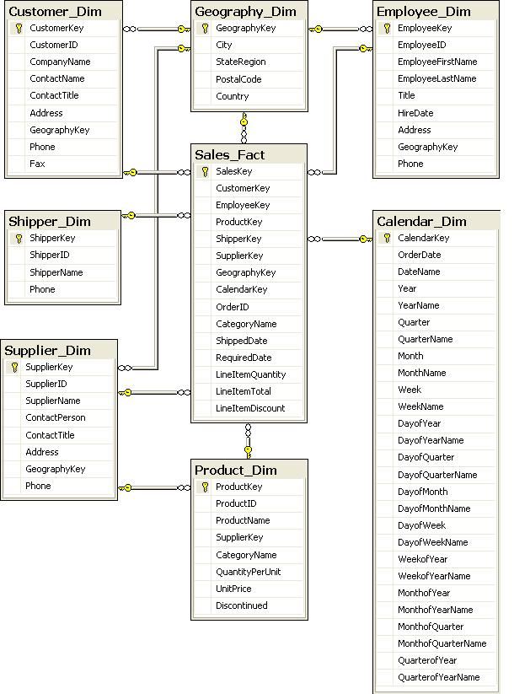
Figure 4.5: Database Table Model for the Northwind Data Warehouse

Data Warehouse Size Estimation
The size of the data warehouse was estimated by calculating the storage requirements of the designed table schema and the number of rows the database would contain. The most important table to consider is the fact table as it requires the maximum amount of storage. The space requirements of the dimension tables could be neglected in the estimation. However, the dimension table will need to be considered in case they are expected to change frequently. Especially if one is using the Type 2 approach for managing changing dimension records (discussed later in Section 4.3.2). This study considers the size of the dimension tables as the database is not too large and any amount of space is significant. The granularity of the fact table is another factor that affects the database size. One needs to know the frequency of the event (transaction in our case) whose measure is captured in the fact table, for example, the average number of transactions per customer.
Let us now estimate the size of the Sales_Fact table. The Sales_Fact table stores details of transactions by customers over a period of 2.5 years. Let us assume that a customer has an average of 8 transactions per year. The calculation is as seen in Figure 4.6. The sizes of the dimension tables can be estimated in a similar fashion. The actual size of the final data warehouse is 9.25 MB. The actual sizes of the different tables in the Northwind Data Warehouse are given in Table 4.3. We can see that the actual size of the Sales_Fact table is 0.211 MB which is approximately equal to the estimated size of the table, which was 0.227 MB.

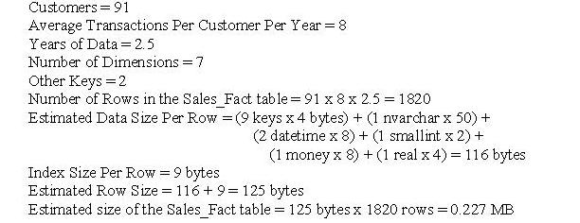
Figure 4.6: Size Estimation of the Sales_Fact Table
Table | Rows | Data Size (MB) | Index Size (MB) | Total Size (MB)
Geography_Dim | 124 | 0.008 | 0.008 | 0.016
Customer_Dim | 91 | 0.023 | 0.016 | 0.039
Employee_Dim | 9 | 0.008 | 0.008 | 0.016
Calendar_Dim | 708 | 0.266 | 0.016 | 0.282
Product_Dim | 77 | 0.016 | 0.016 | 0.032
Shipper_Dim | 3 | 0.008 | 0.008 | 0.016
Supplier_Dim | 29 | 0.008 | 0.023 | 0.031
Sales_Fact | 1963 | 0.195 | 0.016 | 0.211
Table 4.3: Northwind Data Warehouse – Table Sizes

Data Transformation and Load

SSIS Transformation Package
An SSIS package was created and executed for loading the Northwind data warehouse. This package is comprised of a control flow consisting of several control flows tasks, which, as the name suggests, controls the flow of execution of the package. Each of these control flow tasks has a data flow associated with it which takes data from the specified source connection, may or may not transform it, and then loads it into the specified destination. The control flow for the SSIS package that loads the Northwind Data Warehouse is given in Figure 4.7. The data flow associated with each control flow task is given in Figure 4.8 through Figure 4.14. The package has to be designed so that the data warehouse is loaded in an orderly fashion. The tables that depend on other dimensions and keys need to be loaded after the dimensions that they depend on are loaded. The customer, employee and supplier dimensions and the sales fact table are thus loaded only after the geography dimension is loaded.

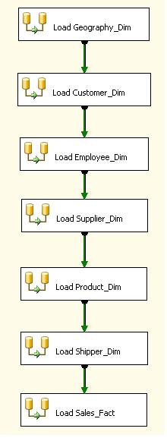
Figure 4.7: Control Flow of the SSIS package – Load Northwind Data Warehouse
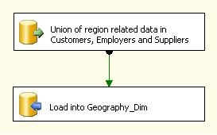
Figure 4.8: Data Flow of the Load Geography_Dim Control Task
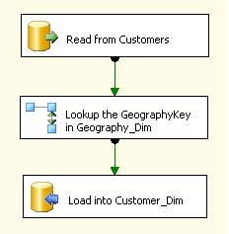
Figure 4.9: Data Flow of the Load Customer_Dim Control Task
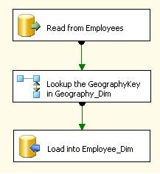
Figure 4.10: Data Flow of the Load Employee_Dim Control Task
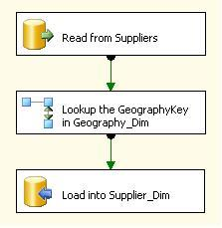
Figure 4.11: Data Flow of the Load Supplier_Dim Control Task
In order to load the Geography dimension for the first time, a union of the tuples containing the city, state, postal code and country is taken from the Customers, Employers and Suppliers tables in the Northwind database. This set of tuples is then loaded into the Geography dimension by appending the auto-incrementing Geography Key. For each of the Customer, Employee and Supplier dimensions the Geography Key is first looked up by matching the tuples in the Geography dimension with the city, state, postal code and country in the concerned table. Other relevant columns are picked from the source tables, possibly transformed, and then loaded into the destination dimension tables. The Product dimension is loaded in a similar fashion by first looking up the Supplier Key in the Supplier Dimension and the Category Name in the Categories table. The Shipper Dimension did not require any look-ups or transformations. The Calendar dimension was created in SQL Server Analysis Services by simply specifying a start and end date for the data, specifying the columns and by designing the table structure. The Sales Fact table is the last to be populated. Several looks-ups were needed as it contains all the keys from the various dimension tables including one from the Orders table in the source database in order to fetch the OrderID, Shipped Date and Required Date for the Orders. The Calendar Key is populated after a look-up into the Calendar dimension to match the Order Date. The measures were also loaded after some transformations. The time taken to run the entire package and load the data warehouse was approximately 12 minutes. Successful execution of the package thus resulted in the entire data warehouse being populated in the order specified by the package control flow.
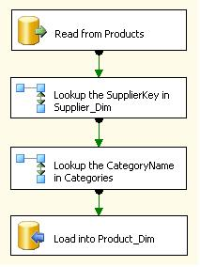
Figure 4.12: Data Flow of the Load Product_Dim Control Task
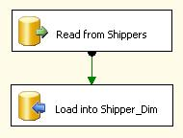
Figure 4.13: Data Flow of the Load Shipper_Dim Control Task

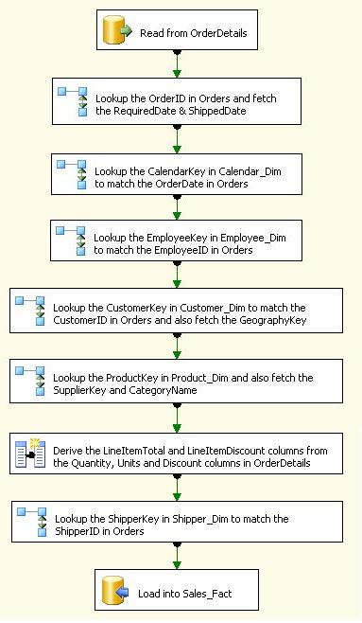
Figure 4.14: Data Flow of the Load Sales_Fact Control Task

Assumptions
The data warehouse has been designed and populated under a few assumptions. The first one is that there is only one-time load; there is no incremental load. The data warehouse has been designed so that data is loaded into the tables only once and no updates are allowed. For incremental load the source tables would need to have a “DateModified” column that would store the last modified date. In that case, if the process that feeds the data to the data warehouse runs daily at 2:00 a.m. then only those records that have been modified the previous day will be copied into the data warehouse tables, thus preventing any overheads. Due to this missing data in the source tables the data warehouse has been structured for only one-time load.
The second assumption is related to the first one and deals with overwriting of data in the data warehouse. In the event of a change to the attributes of the dimensions in the warehouse the data integrity is at risk. It is therefore important to manage these changes to ensure data consistency. There are three solution options that address this issue namely Type 1, Type 2 and Type 3. A Type 1 data warehouse is one in which the old records in the dimension are overwritten by the updated records. A Type 2 warehouse is one in which there is no overwriting of data. Instead a new instance is created in the dimension table whenever a specific attributes changes. In a Type 3 warehouse the changed attribute is updated in the same instance and the old value is moved to a separate attribute in the instance. Now, keeping this in mind, if the data warehouse is designed to be of Type 2 then there would need to be an additional “Active” column in all the tables indicating whether the record was valid or invalid. Thus on every load, the old records which have been modified and are being re-loaded would have to be inactivated by setting the “Active” column to “No” or “Inactive” and then setting the newly loaded record to be “Active”. This would significantly expand the size of the table. Instead, incase of Type 1 no additional columns would be needed as the new updated record simply overwrites the existing record. In our case, since the data warehouse is not designed for incremental load the Type is not significant. However, formally the data warehouse would be of Type 1 as we do not provide for active or inactive records and would simply overwrite a changed dimension attribute.
In this study the importance of the solution approach taken to managing the changing dimensional attributes may seem minimal. However, when the data in the source system is prone to change frequently it is of importance. With respect to the source system in this study we may cite a relevant example. A customer could move from one location to another. Assume that the data warehouse is of Type 1. Now, if we were viewing the sales by customer region then, although majority of the sales had taken place at the old location, the report will count those sales in the new region and that will reduce the significance of the report. Instead, if the data warehouse is of Type 2 or Type 3 we can view the sales for the same customer by the two different regions and obtain a more accurate report.

Mondrian Schema Design
In order to use Mondrian one needs to design a schema defining a multidimensional database. A schema consists of a logical model which is made of constructs like cubes, hierarchies, levels and members, and a mapping of this model to the physical model, which is a set of tables the relational database. Mondrian schemas are defined in XML and stored as XML files. Mondrian thus enables ad-hoc and interactive data exploration with the ability to slice-and-dice, drill-down and pivot.
In order to design the XML schema for the Northwind data warehouse the cubes and dimensions were designed to suit the desired reporting requirements. The hierarchies were set for each of the relevant dimensions and all the measures were also set up in the schema. Since the main objective of this work is to grasp an understanding of how the Mondrian server and JPivot can be used for data warehousing, and not to explore the tools in detail, only the basic schema design constructs were explored. The Mondrian schema designed for use in this study has been designed by keeping in mind the reports listed earlier and has been given in Figure 4.15 for your reference.
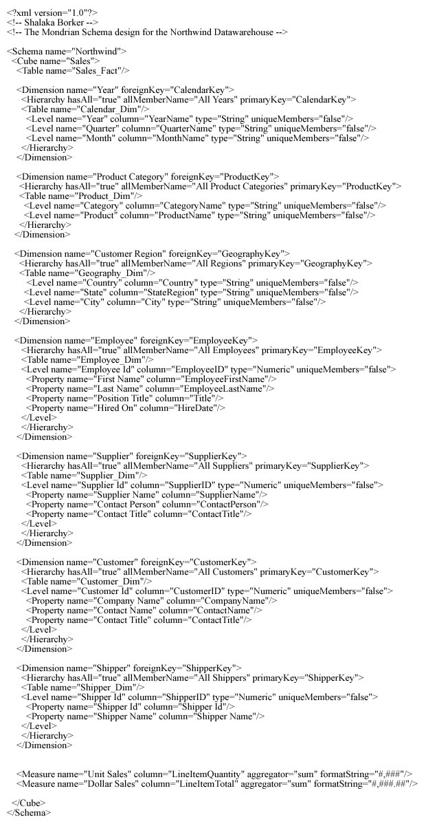
Figure 4.15: Mondrian Schema for the Northwind Data Warehouse

Query and Reporting

Multi-Dimensional Expressions (MDX) Language
Designing queries based on the Mondrian schema does not require one to know SQL. The query language used by Mondrian and JPivot is called the Multi-Dimensional Expressions Language (MDX). MDX syntax is similar to SQL syntax but the two differ in the semantics. MDX also provides a large set of built-in functions and the ability to set parameters, localize format strings and to define calculated members and sets. An MDX query consists basically of two axes; the rows and the columns, the Measures and the Members on the axes and the ‘WHERE’ clause; which is known as the Slicer Expression. A cube forms the basis of a query and the name of the cube is specified by the ‘FROM’ clause. An example of an MDX query is given in Figure 4.16.
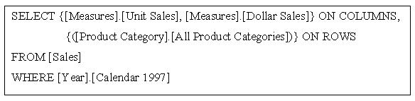
Figure 4.16: An Example MDX Query

JPivot Reports
A JPivot report page has a very user-friendly interface. It has a toolbar which provides various buttons for slice-and-dice and charting purposes. Figure 4.17 shows a snapshot of the toolbar.
Figure 4.17: The JPivot Toolbar
The buttons are very intuitive and will allow one to view the report at different levels of details and to ones liking. Let us first see a sample report and then we will see how the different buttons can be used and the effect they will have on the report. A sample report is given in Figure 4.18. The report takes about 5 seconds to load. The report that shows up originally is rolled-up and shown at the highest level of hierarchy but by drilling down one may view the report at various levels of detail. In Figure 4.18 the first row shows the Dollar Sales made by all the employees together over all the years. The years have been drilled down to show the quarters and the quarters to show the months. Even the employees have been drilled down in the calendar year 1996.
As mentioned earlier Mondrian is an OLAP engine and the OLAP uses the Multidimensional Analysis technique. A multidimensional dataset consists of axes and cells as opposed to rows and columns of a relational database. The rows axis in Figure 4.18 consists of the members ‘All Years’, ‘Calendar 1996’, ‘Quarter 3’, and so forth and the column axis consists of the measure ‘Dollar Sales’. Each cell represents the sales made by a particular employee in a particular Month, Quarter or Year, thus presenting a richer view of the data than that presented by a relational database. The members of the multidimensional dataset, in this case Calendar Year, Quarter, Month, are not always values from a relational column but are members at successive levels in a hierarchy, each of which is rolled up to the next. The dimensions used here, employee, time, and measures, are just three of the many dimensions by which the dataset can be categorized and filtered.
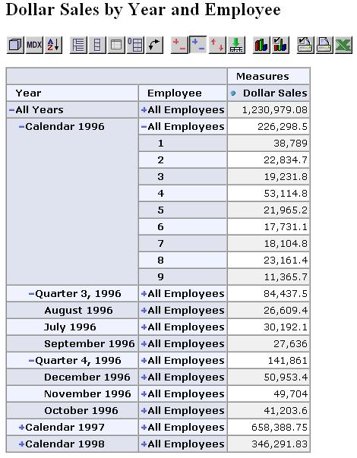
Figure 4.18: Sample report giving the Dollar Sales

OLAP Cube Navigator
Clicking the OLAP navigator button opens the cube navigator tool. It gives a very graphical view of the cube, showing the rows and columns being used, the filters that can be applied and the measures that are being calculated and being displayed. One can make changes to them and then click “OK” to generate a new/modified report. In this case the Product Category was selected and the sales filtered for to view only the Daily Products as seen in Figure 4.19. The result of the modified query is seen in Figure 4.20. The report now also shows the slicer, Dairy Products, which is the factor over which the report has been filtered.
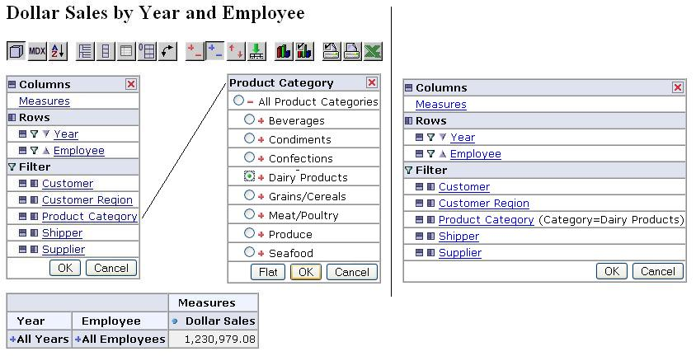
Figure 4.19: OLAP Cube Navigator Tool – Options
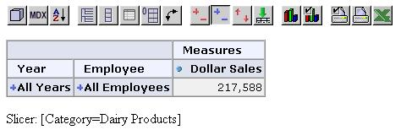
Figure 4.20: OLAP Cube Navigator Tool – Result

MDX Query Tool
The MDX button opens the MDX editor, as seen in Figure 4.21. The current query shows the result for all the years and for all employees. One can make changes to the MDX query and click on apply to see a new report. For example, the query could be updated to show results only for the Calendar Year 1996.
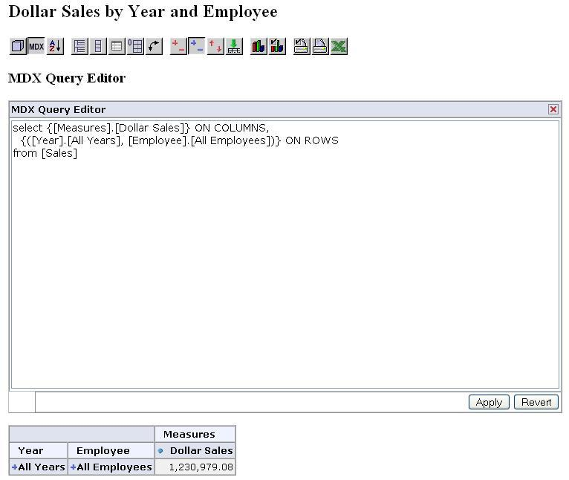
Figure 4.21: MDX Query Tool

Sort Options
The third button in Figure 4.17 is for sorting. It opens the Sort Options box which allows one to select an ascending or descending sort order by either maintaining or breaking up the hierarchies. This is seen in Figure 4.22. But before clicking on the sort button one needs to select atleast one measure which needs to be sorted and to see the sorting result view the sales for individual employees by clicking on the ‘+’ sign against the ‘All Years’. The result of selecting ‘Keep Hierarchy Ascending’ and clicking ‘OK’ is seen in Figure 4.23.
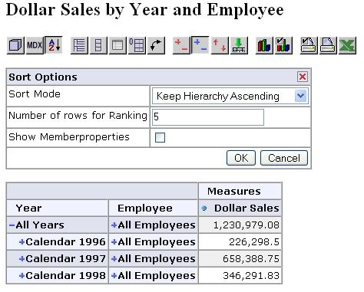
Figure 4.22: Sort Tool – Options
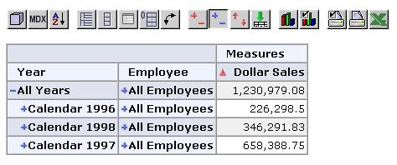
Figure 4.23: Sort Tool – Results

View Options
The next five buttons in Figure 4.17 alter the way the data is presented allowing one to view parent members, hide spans, show member properties, suppress empty rows or columns and also to swap the axes. The explanation of each of these buttons with respect to the sample report in Figure 4.18 follows.
As seen in Figure 4.24, the Show Parent Members button displays the parents of members in a tree like structure, showing the hierarchy in columns. On the other hand, the Hide Spans button hides the hierarchical spans and shows them in each and every row of the report, as seen in Figure 4.25. The Show Properties Button shows the properties of those members whose properties have been defined in the Mondrian schema. The properties of employees are seen in Figure 4.26 as the schema for Employees contains these properties listed under the Level tag in the Hierarchy. The Suppress Empty Rows/Columns Button does just that, it omits the empty rows/columns. In Figure 4.27 the rows for Employees 5 and 9 in August 1996 have been omitted from the report as they were empty. Employees 5 and 9 had made no sales in the August 1996. Figure 4.28 is self-explanatory. The X and Y axes have been swapped to present a different view.
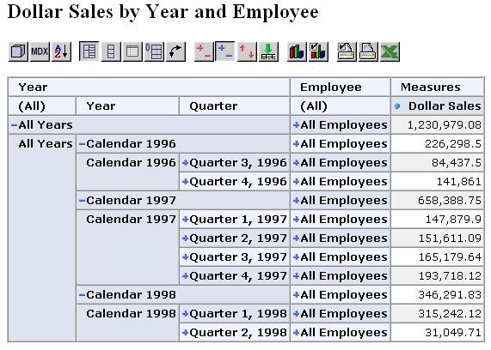
Figure 4.24: Show Parent Members Button – Result
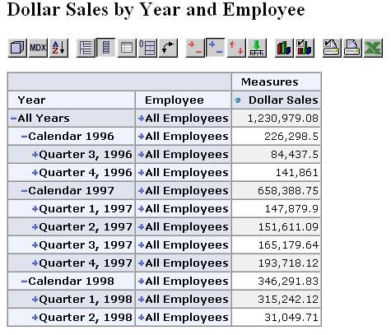
Figure 4.25: Hide Spans Button – Result
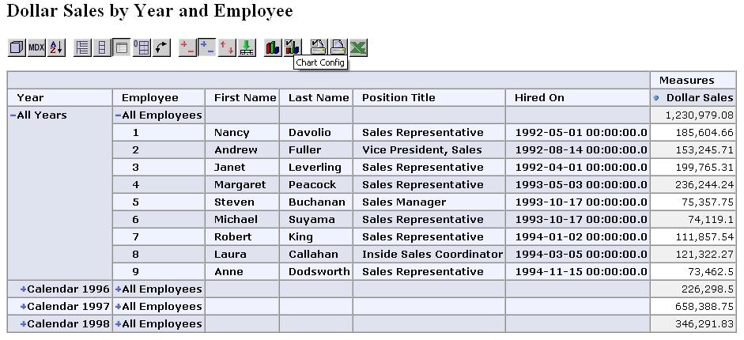
Figure 4.26: Show Properties Button – Result
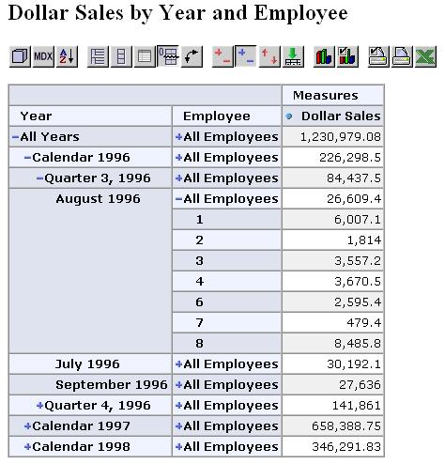
Figure 4.27: Suppress Empty Rows/Columns Button – Result
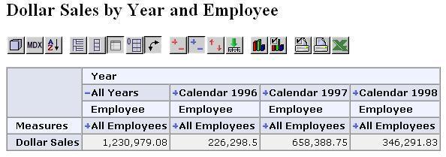
Figure 4.28: Swap Axes Button – Result

Drill Tools
The next four buttons in Figure 4.17 are the ones that control the drill-down of data allowing one to view the report at the desired level of detail and in a form that is comprehendible. The four buttons together provide flexibility to the report. One can mark the drill position and then click on the drill through button. This gives a view of the entire table and one can view the entire the data in the table and sort it at any level, as seen in Figure 4.29.
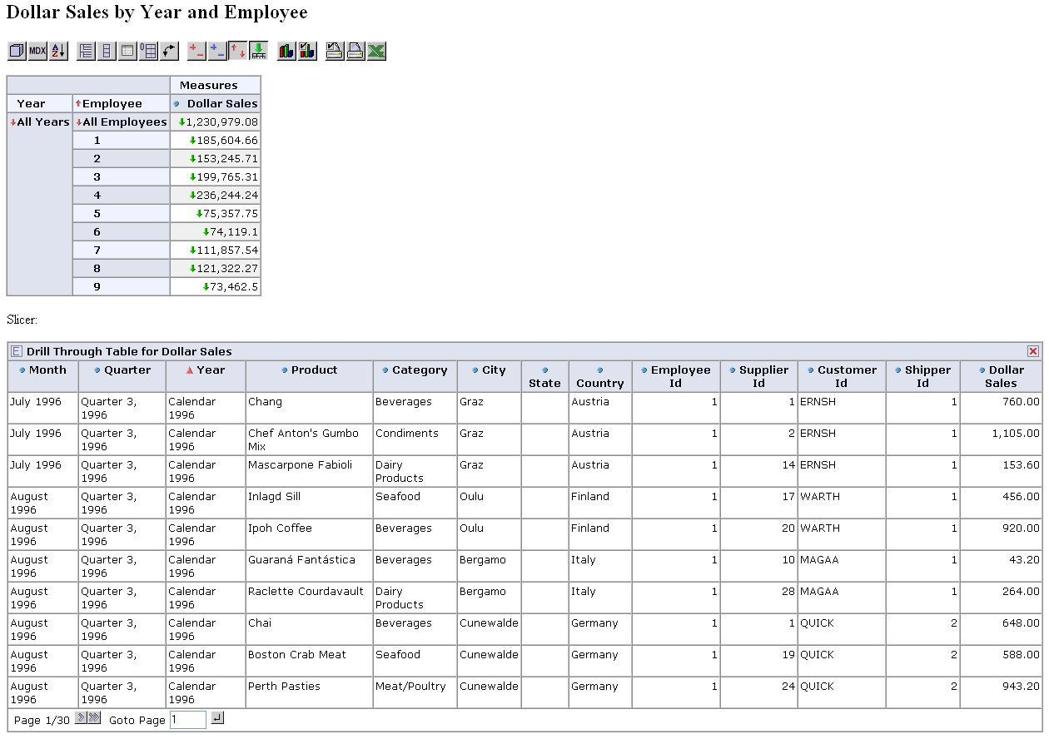
Figure 4.29: The Report being Drilled Through

Charting Options
The first chart button displays the report in a chart form. The button following that one allows one to set the chart options and properties. The options box and the types of charts that can be created are seen in Figure 4.30. A pie chart of the sample report shown earlier is given in Figure 4.31.
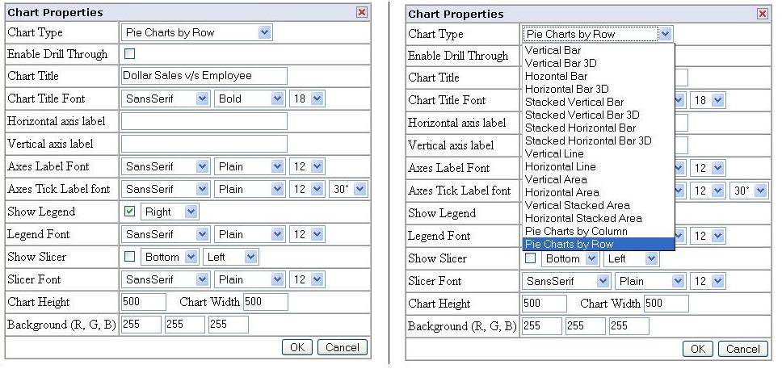
Figure 4.30: Chart Options and Selection
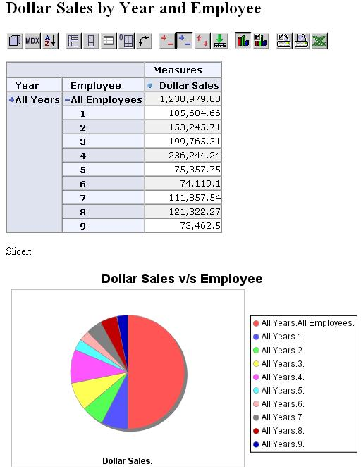
Figure 4.31: Pie Chart giving the Dollar Sales for Employee

Print Options
The last three buttons in the JPivot Toolbar are the print buttons. The first button lets one configure the print settings, the next one converts the report into a PDF and the last button exports the report into an Excel file. The print settings available can be seen in Figure 4.32.
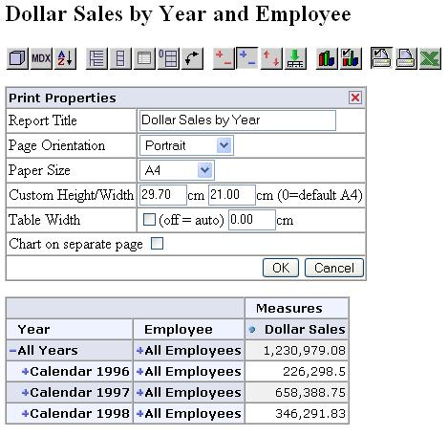
Figure 4.32: Print Option Settings

Processing
OLAP Servers are classified as MOLAP (multidimensional OLAP) or ROLAP (relational OLAP) based on how they store data. A MOLAP server stores all of its data on disk in structures optimized for multidimensional access. A ROLAP server stores its data in a relational database. Each row in a fact table has a column for each dimension and measure. One needs to store fact table data, aggregates, and dimensions. Pre-computed aggregates are important when dealing with large data sets otherwise one would need to read the entire fact table to answer certain queries. The cache holds pre-computed aggregations in memory so that subsequent queries can access cell values without going to the disk and hence forms an important component of the aggregation strategy. If the cache holds the required data set at a lower level of aggregation, it can compute the required data set by rolling up. Also, the cache is adaptive. In a system where data is changing in real-time, it is impractical to maintain pre-computed aggregates as one would not know which aggregates to pre-compute without taking up large amounts of space. In such a system a reasonably sized cache can allow it to perform adequately in the face of unpredictable queries, with few or no pre-computed aggregates.
In Mondrian, fact data is stored in the relational database system and aggregate data is stored into the cache by submitting ‘Group by” queries. If materialized views are used by the administrator for particular aggregations, and if they are supported by the database system, then Mondrian will use them implicitly. The general idea is to use the database utilities that are present. This may place additional burden on the database, but once those features are added to the database, all clients of the database will benefit from them. Mondrian therefore uses no storage of its own and thus there are no redundant data sets to manage, due to which, the data-loading process is easier. The reports generated in this study taken an average of 5 seconds to load. This is the time taken by Mondrian to refresh the data in the cubes.

Reflections

Experiences during Development
Early in the development of this project I had a difficult time trying to satisfy the system requirements for the project. I first started out with SQL Server 2000 and although I had access to the SQL Server 2000 software finding a system where I could get it installed was difficult as it required a Windows NT Server. I spent quite a few days trying to find a system for the same and then switched over to SQL Server 2005 as I could have it installed on a Windows XP Professional machine. Now, with SQL Server 2005 the Northwind sample database that I had planned to work with was no longer available. Getting the source database loaded into SQL Server 2005 took a while but it was finally done. SQL Server 2000 was my first choice as I already had a fair understanding of the SQL Server 2000 DTS that is used to build packages for ETL. Now that I had to switch to SQL Server 2005 I had to start right from scratch and learn about SQL Server Integration Services (SSIS) that makes up for DTS in SQL Server 2005.
The next step involving the installation of the Apache Tomcat Server was pretty smooth. However, installing Mondrian and JPivot and setting them up for interaction with the SQL Server database was a major hurdle. Right from finding the correct JDBC Driver to opening the relevant data ports and setting the connection strings it was an interesting experience and finally I managed to make a successful connection to the database. The rest of the project was all about learning Mondrian, JPivot and MDX, designing the schemas and writing the queries. The project was thus successfully implemented.

Knowledge Gained
My desire to step outside the circle and get acquainted with new application tools is what drove me to choose this project. I knew exactly what I was getting myself into and that it was not going to be an easy task. But now, after it is all done, I am glad I made the choice. All through the process I learnt new things and gained a lot of experience.
SQL Server is an extensively large server technology and having to work in it in great depth helped me hone my fundamental SQL skills. I gained expertise in SQL Server, learning to work in both the Management Studio and the Business Intelligence Development Studio. With databases now omnipresent in all businesses, experience in one of the key database server technologies is certainly a bonus point.
I explored the Mondrian and JPivot applications tools and learnt about these new technologies. Although learning new tools was not an easy job it taught me the virtue of endurance and certitude. Being open source tools both Mondrian and JPivot did not have extensive documentation. The only documentation that I had access to was that available on the project homepage. Sometimes I had to write to online forums in order to discuss an issue and sort it out. This helped me improve my communication skills.
On a larger perspective I understood the thought process that goes behind the design of a data warehouse and gained experience in modeling and implementing one. Experimenting with an open source approach to data warehouse design was a great experience. I am now convinced that there are always alternative solutions to problems that are equally, and sometimes even more, productive. The only hurdle is ones hesitation in taking that alternative because it has not been explored. One only needs to access the problem thoroughly and find the most profitable solution that fits ones needs. This project has definitely imbibed confidence in me. I know that I can now engage in a project on my own and take it through to completion, handling the entire process from installation of the software to error handling and deployment.

Future Work

This work creates a data warehouse for the sample Northwind database using the open source software Mondrian and JPivot. However, only limited Mondrian constructs have been demonstrated here. One possible extension could be modifying the schema so that all the possible constructs and features of Mondrian and JPivot are explored. Being open source, both tools have a vast number of features which often keep changing and it was difficult to implement all of them in this work due the need of limiting the scope. Secondly the main objective of this work was to explore the possibility of using open source tools for data warehouse design and not to study a sole tool.
Another possible extension could involve developing a completely open source data warehouse where the database is also open source, example MySql. This study takes an open source approach to data warehousing but as seen it is only party open source as the underlying databases use SQL Server 2005 which is a commercial technology. SQL Server was used in this work because the Northwind source database is available only with SQL Server. It was a better option to use a database containing real data rather than creating one and populating it with random data. By extending the work to be completely open source one can take the application to a completely new level.

Conclusion

Open source tools like Mondrian and JPivot can be successfully used in data warehouse applications. With Mondrian and JPivot, BI is embedded into the application. They prove to be extremely fruitful for small and mid-sized organizations that want to move to a cost-productive data warehouse solution. As the software is open source there are hundreds and thousands of developers and end-user testers who work on the source code of the software simultaneously, thus reducing costs. One can fix bugs themselves too and the open aspect of the software gives one the power to control an application and model it to suit ones needs. Using open source tools allows one to upgrade patches of software when it is most suitable, without having to go through the formal process and placing an order for the new software.
The advantages of using open source for BI are similar to those of other open source applications; the initial investments costs are lower, they total cost of ownership is lower, they provide greater control and they can be easily customized. However there are a few limitations of open source that cannot be neglected. The open source reporting tools currently in market today are in the early stages of their development. They focus more on Java developers and do not offer the flexibility and extensibility that end-users actually desire. The open source tools have limited features and are thus not comparable to their feature-rich commercial counterparts. However open source tools are a suitable alternative for developers who can be creative and extend, modify and customize their application code.
References
- Microsoft, SQL Server 7.0 Data Warehousing Training, Microsoft Press, 2000.
- Data Warehousing with Microsoft SQL Server 7.0: Technical Reference, Microsoft Press, 2000.
- The Data Warehouse Toolkit, 2nd Edition, Wiley.
- The Complete Guide to Dimensional Modeling, Ralph Kimball and Mary Ross.
- Database System Concepts, Abraham Silberschatz, Henry F. Korth and S. Sudarshan, Mc Graw Hill.
- Microsoft SQL Server 2005 Books Online
http://msdn2.microsoft.com/en-us/library/ms130214.aspx
- Microsoft E-learning for SQL Server 2005
https://www.microsoftelearning.com/sqlserver2005/
- MSDN Help Microsoft SQL Server 2005
http://msdn.microsoft.com/sql/
- http://www.microsoft.com/downloads/
- http://mondrian.sourceforge.net/
- http://jpivot.sourceforge.net/
- http://www.pentaho.com
- http://www.greenplum.com
- http://cisuc.dei.uc.pt/view_project.php?id_p=50

Database Structure
This section contains figures that show the data types and details pertaining to the table structures in the source Northwind database and the destination Northwind data warehouse.

Table Properties - Northwind Database
Figure A.1.33 through Figure A.1.45 show the properties of the thirteen different tables in the Northwind Database.
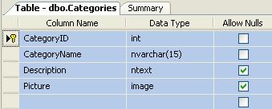
Figure A.1.33: Categories Table
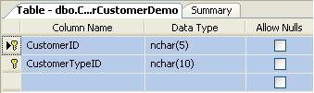
Figure A.1.34: Customer-Customer Demographics Table
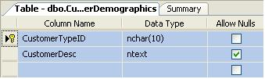
Figure A.1.35: Customer Demographics Table
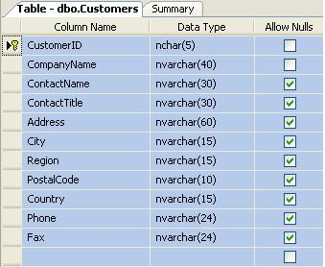
Figure A.1.36: Customers Table
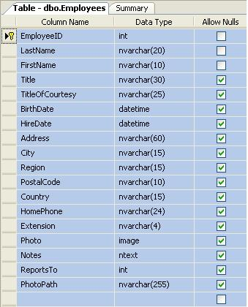
Figure A.1.37: Employees Table
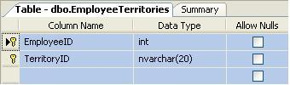
Figure A.1.38: Employee Territories Table
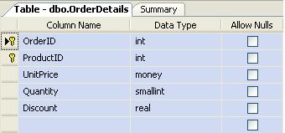
Figure A.1.39: Order Details Table
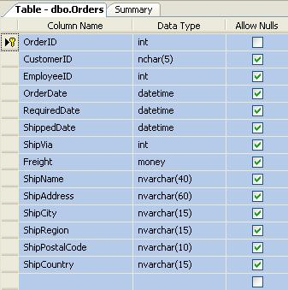
Figure A.1.40: Orders Table
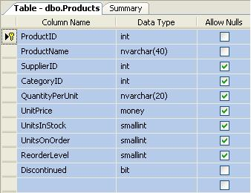
Figure A.1.41: Products Table
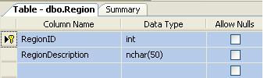
Figure A.1.42: Region Table
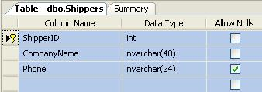
Figure A.1.43: Shippers Table

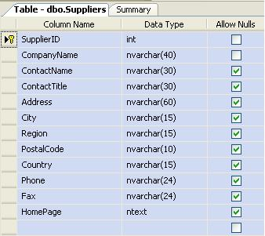
Figure A.1.44: Suppliers Table
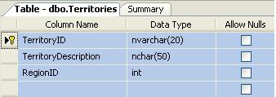
Figure A.1.45: Territories Table

Table Properties - Northwind Data Warehouse
Figure A.2.46 through Figure A.2.53 show the properties of the eight tables in the Northwind Data Warehouse.
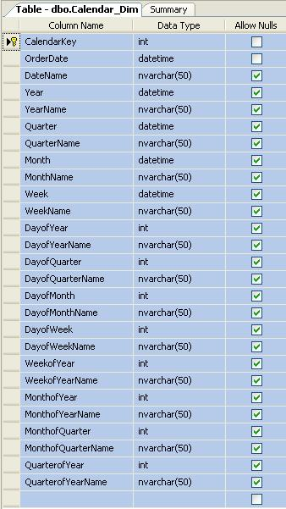
Figure A.2.46: Calendar Dimension Table

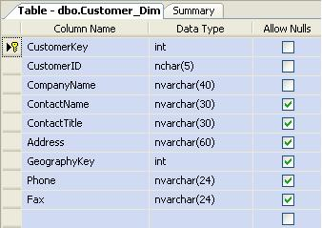
Figure A.2.47: Customer Dimension Table
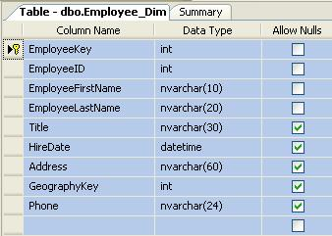
Figure A.2.48: Employee Dimension Table
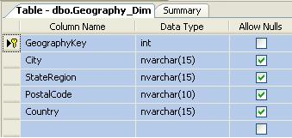
Figure A.2.49: Geography Dimension Table
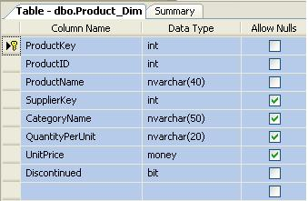
Figure A.2.50: Product Dimension Table
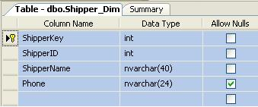
Figure A.2.51: Shipper Dimension Table
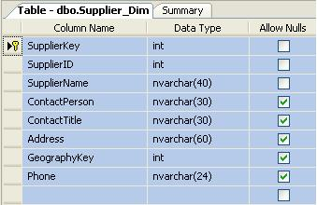
Figure A.2.52: Supplier Dimension Table

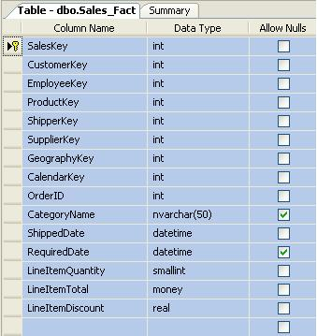
Figure A.2.53: Sales Fact Table

JPivot

JPivot Queries
The JPivot sample queries that have been used in this study are given below from Figure B.1.54 through Figure B.1.58.
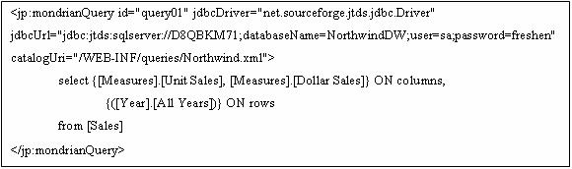
Figure B.1.54: Query 1 – Generates Unit and Dollar Sales by Year
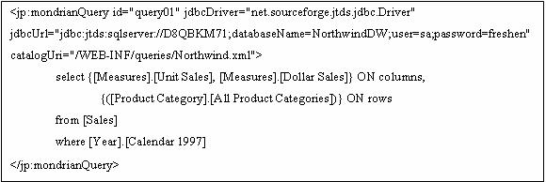
Figure B.1.55: Query 2 – Generates Unit and Dollar Sales in 1997 by Product
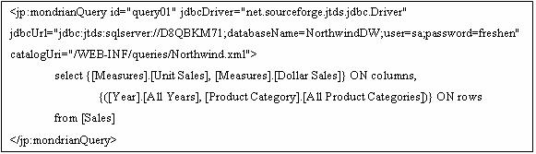
Figure B.1.56: Query 3 – Generates Unit and Dollar Sales by Year and Product
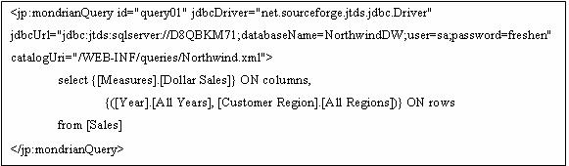
Figure B.1.57: Query 4 – Generates Dollar Sales by Year and Customer Region
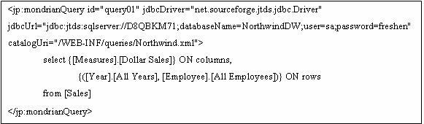
Figure B.1.58: Query 5 – Generates Dollar Sales by Year and Employee

Screenshots

Application and Report Screenshots
The following figures from Figure C.1.59 through Figure C.1.64 show the screenshots of the application and the different reports generated.
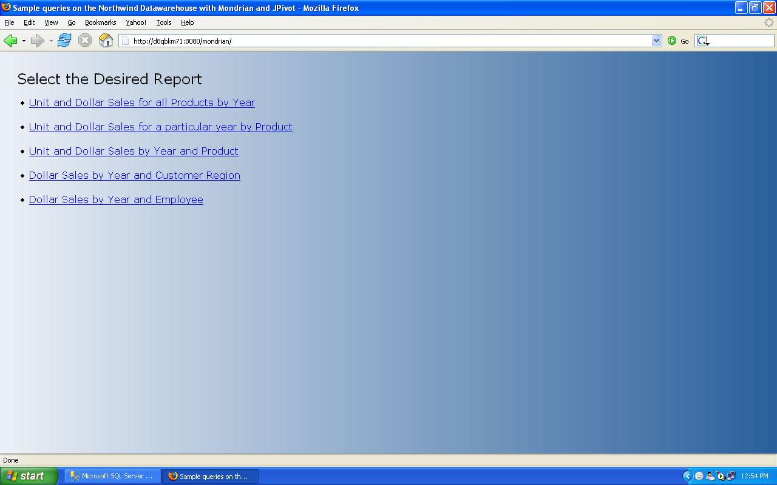
Figure C.1.59: Index Page showing the Report Options
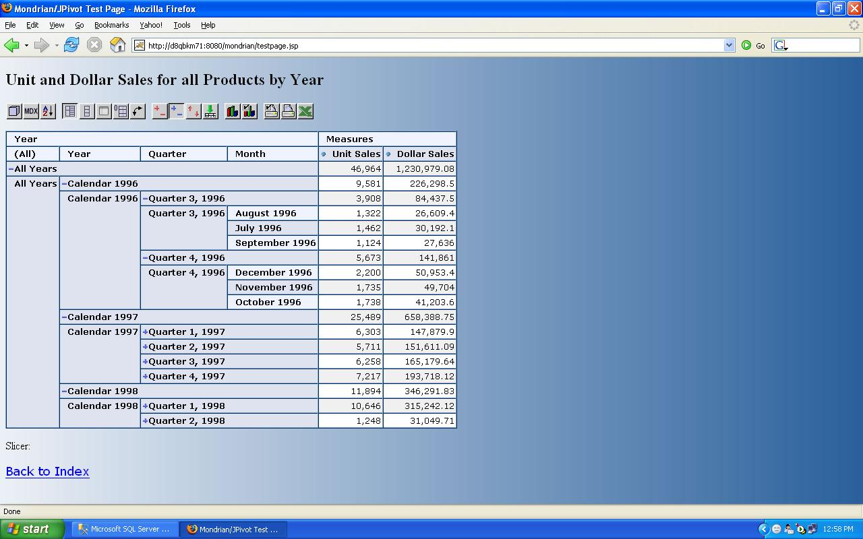
Figure C.1.60: Unit and Dollar Sales for all Products by Year
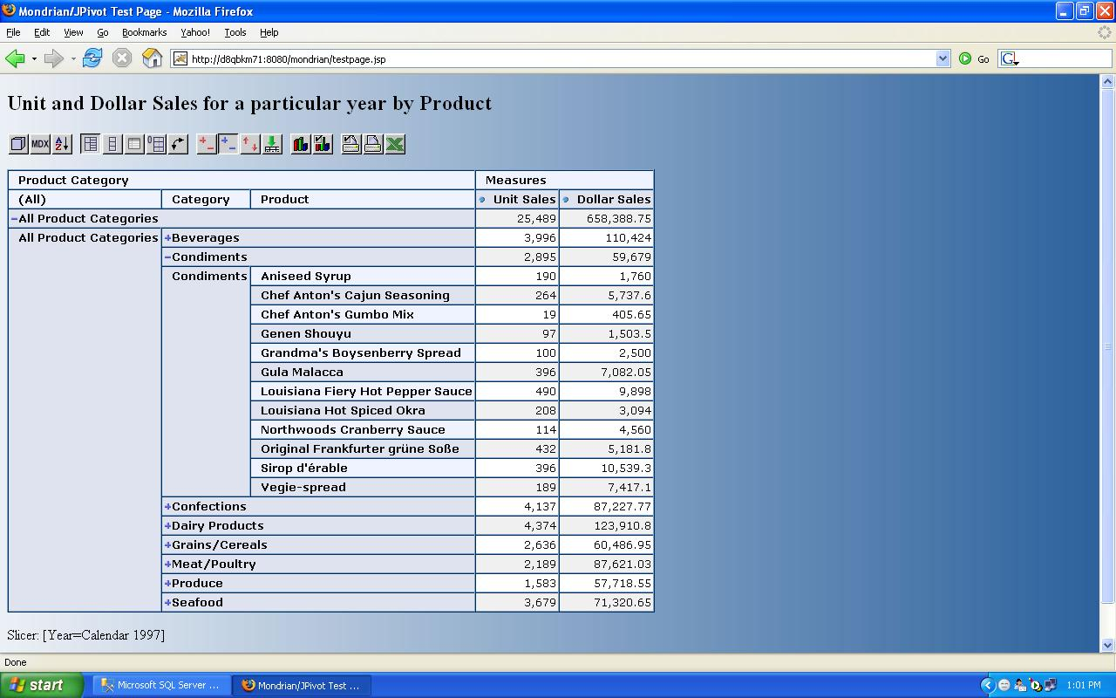
Figure C.1.61: Unit and Dollar Sales for a particular year by Product
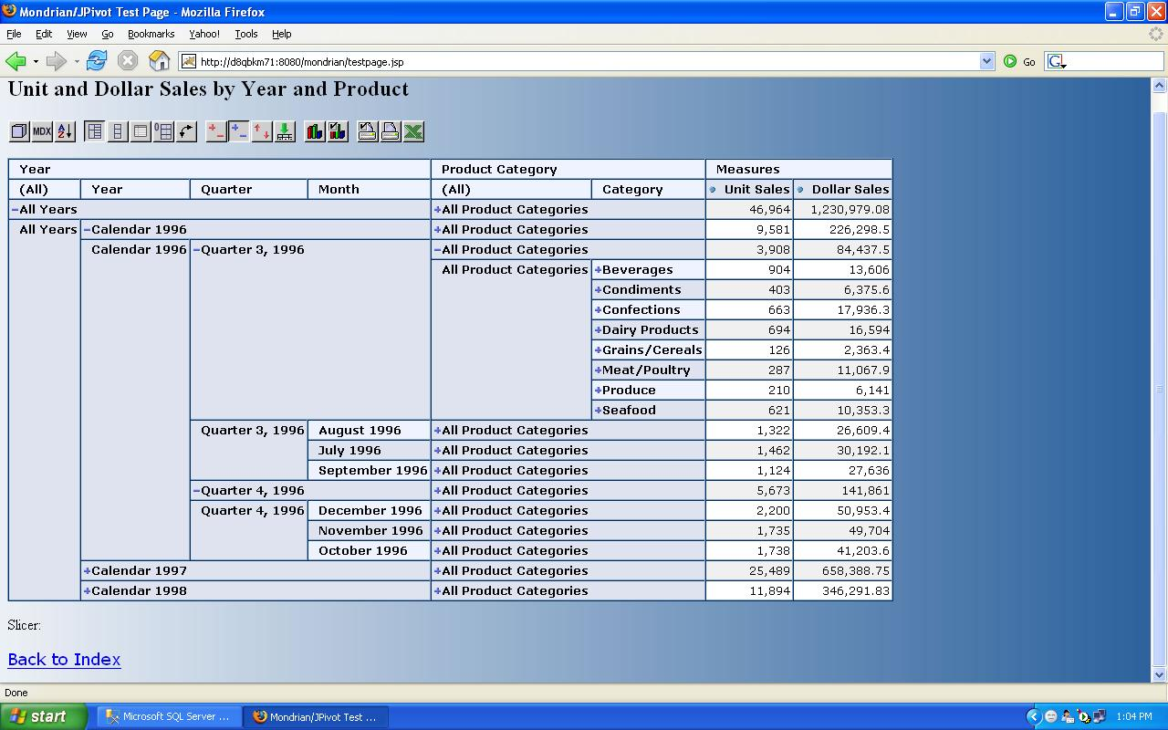
Figure C.1.62: Unit and Dollar Sales by Year and Product
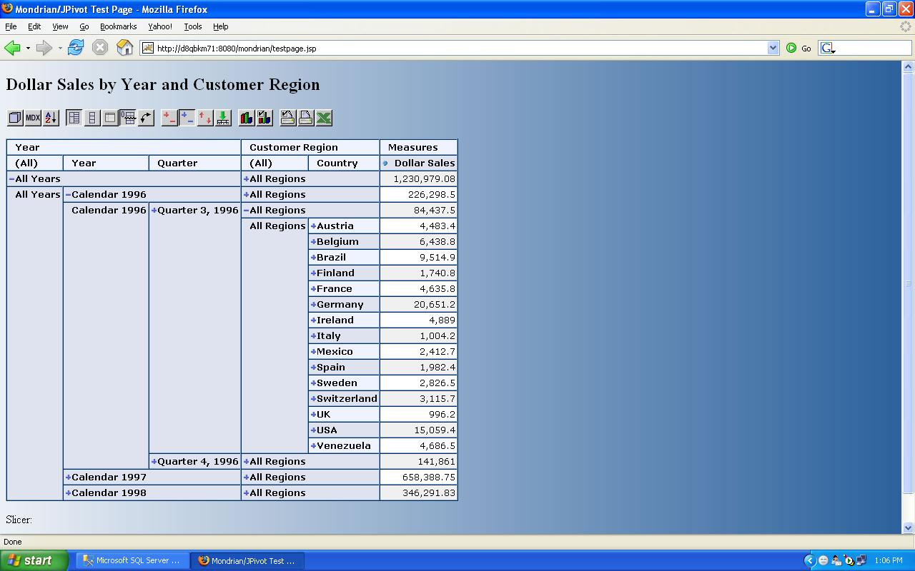
Figure C.1.63: Dollar Sales by Year and Customer Region
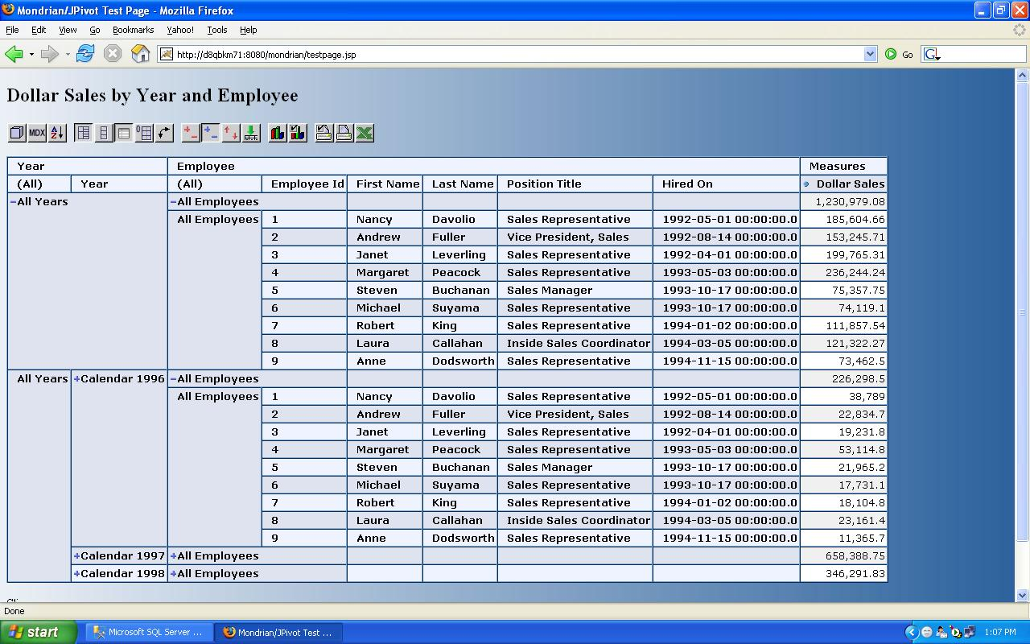
Figure C.1.64: Dollar Sales by Year and Employee

