29/09/25

NAME: TCHACHOU KEMDOUNG KELLY-HANS

ID: 27265

COURSE: Database Development with PL/SQL

INSTRUCTOR: ERIC MANIRAGUHA

GROUP: B

**Individual Assignment I: PL/SQL Window Functions Mastery Project**

**STEP 1: Problem Definition**

**Business Context**

Joie du Peuple, a company in the beverage distribution industry, specializes in selling drinks such as beer and juice. The sales and marketing department aims to gain a deeper understanding of product performance across various regions and time periods.

**Data Challenge**

Although the company collects transaction data regularly (including customer information, products, sales dates, and amounts), it is challenging to identify the best-selling drinks by region and track monthly sales growth. In addition, the company struggles to segment customers effectively for targeted marketing campaigns

**Expected Outcome**

By applying PL/SQL window functions, the company expects to identify top-performing drinks, monitor sales growth trends, calculate running totals, and segment customers into categories that will support smarter marketing and sales strategies.

**STEP 2: Success criteria**

Define exactly 5 measurable goals:

1-Top 5 products per region/quarter: RANK ()

-Rank the sales of beer and juice across regions and quarters to identify the most popular products

2-Running monthly sales totals: SUM () OVER ()

-Calculate cumulative monthly sales to track how revenue grows over time

3-Month-over-month growth: LAG () / LEAD ()

-Compare sales between consecutive months to measure growth or decline in drink sales

4-Customer quartiles: NTLE (4)

-Divide customers into four groups based on their total spending

5-3-month moving averages: AVG () OVER ()

-Calculate rolling averages of sales over 3 months to smooth out short-term fluctuations and reveal long-term trends

**STEP 3: Database Schema**

**Create a user:**

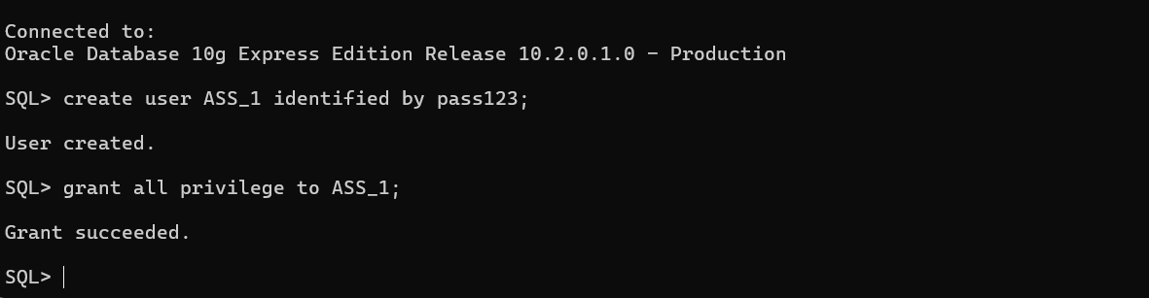

Create tables:

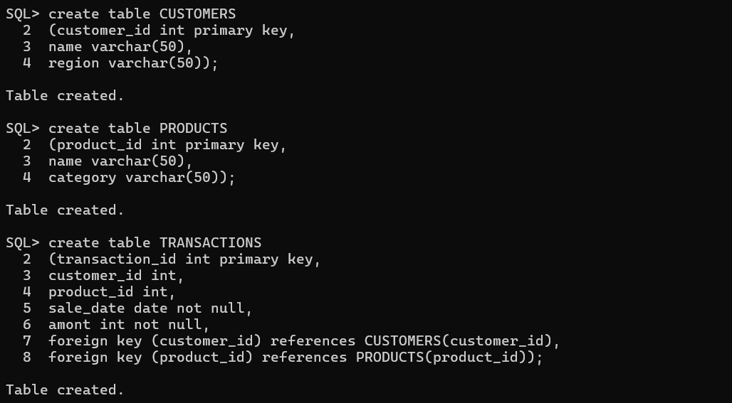

Insert into tables:

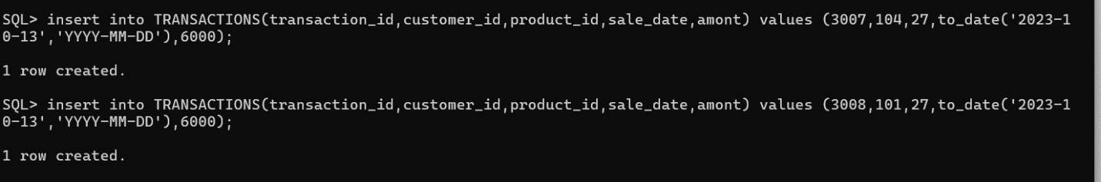

ER diagram:

Products

do

Transactions

do

CUSTOMERS

Table Customers:

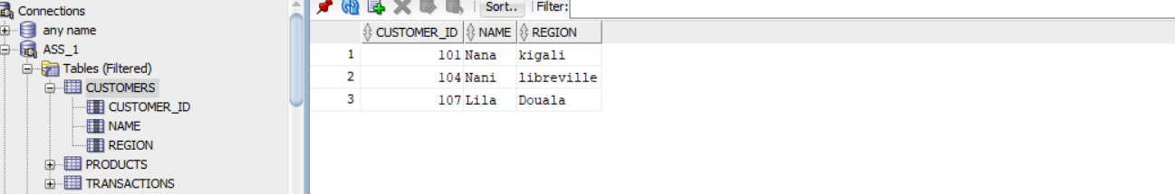

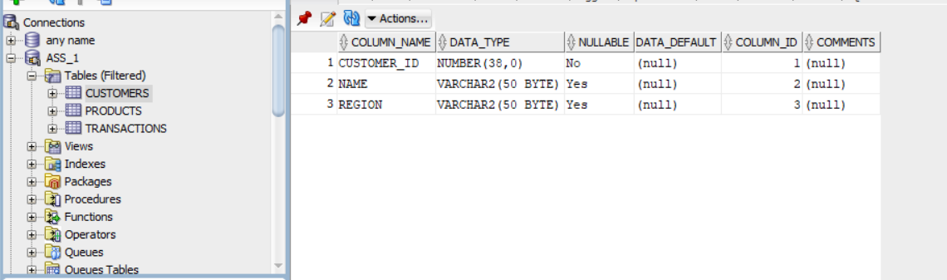

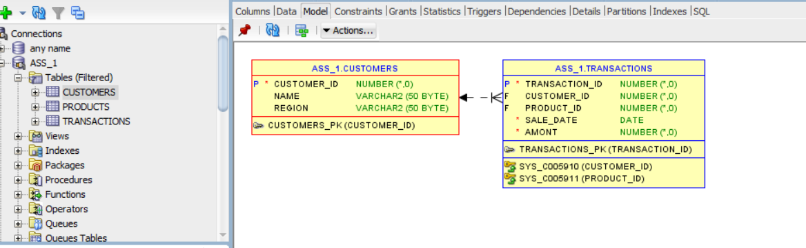

Table Products:

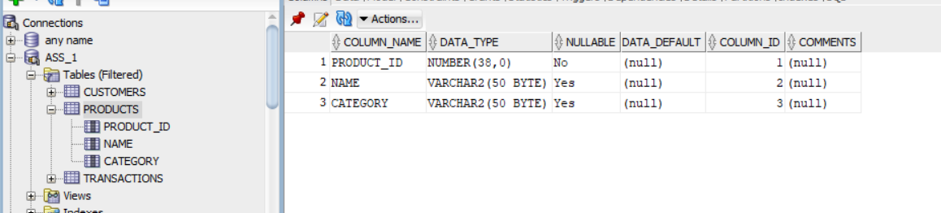

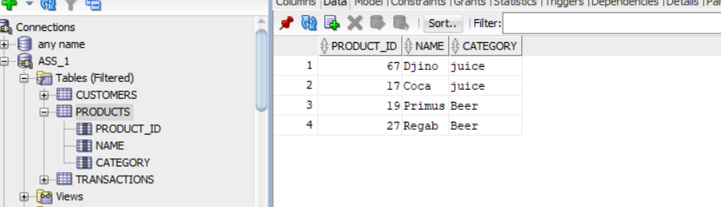

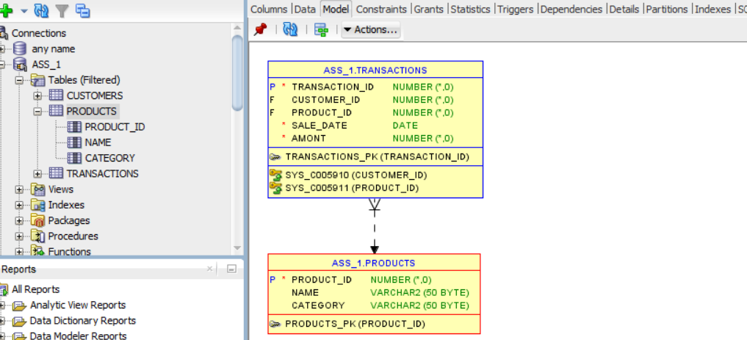

Table Transactions:

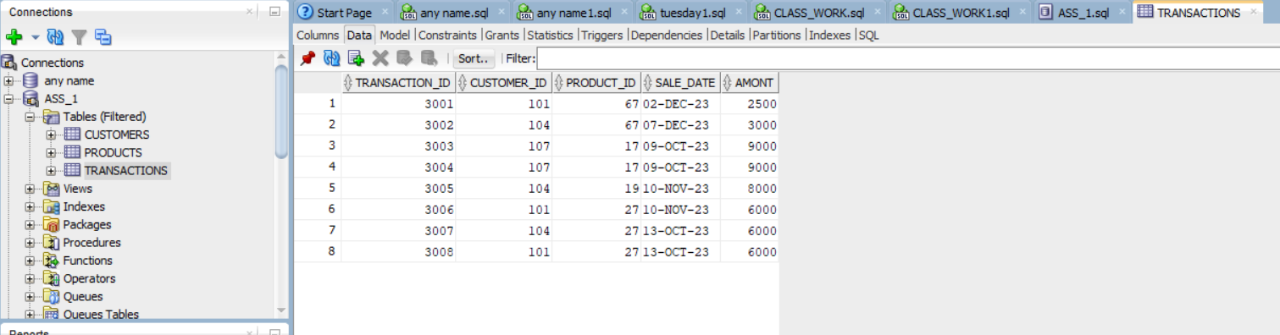

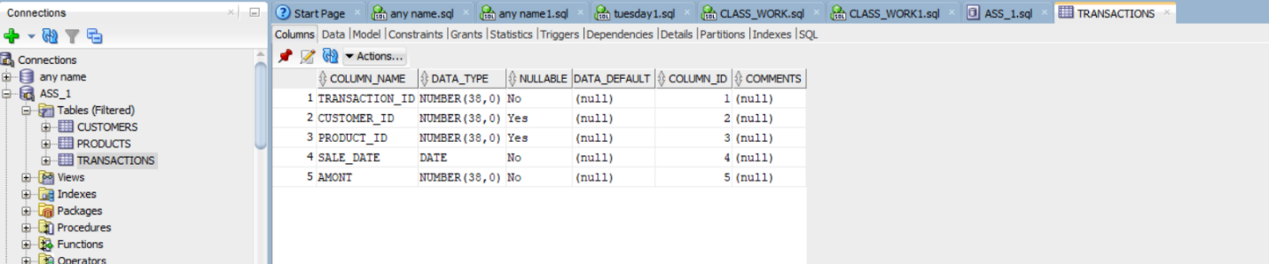

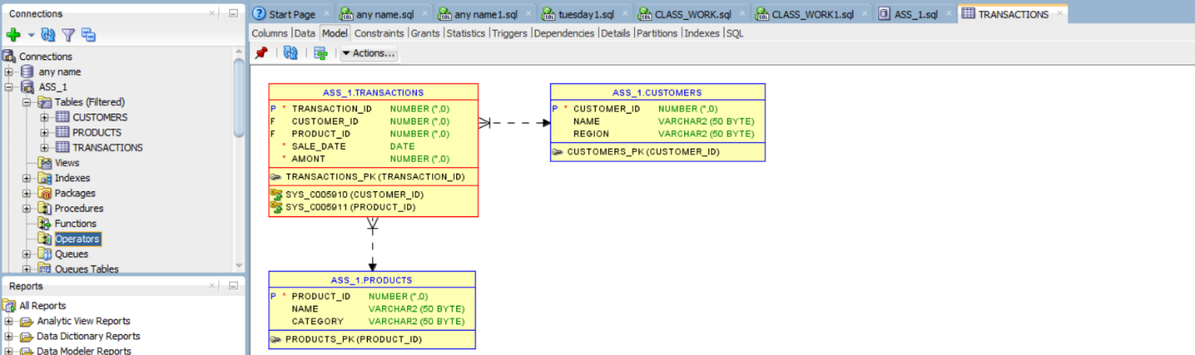

**STEP 4: Window Functions Implementation**

1-Ranking: ROW_NUMBER(), RANK(), DENSE_RANK(), PERCENT_RANK()

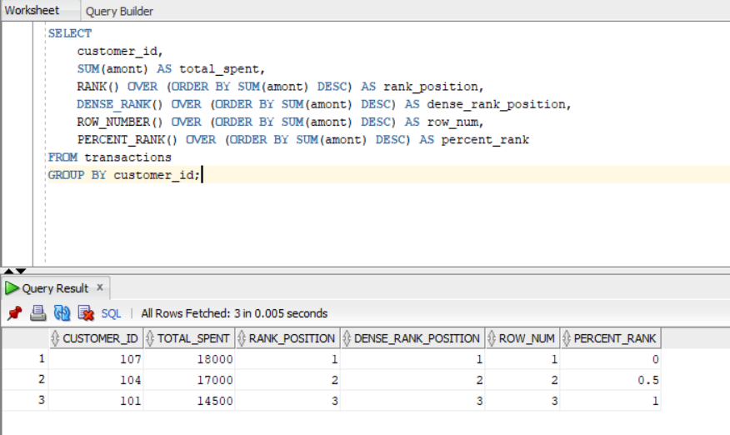

2-Aggregate: SUM(), AVG, MIN(), MAX(), with frame comparisons (ROWS vs RANGE) use case: Running totals & trends

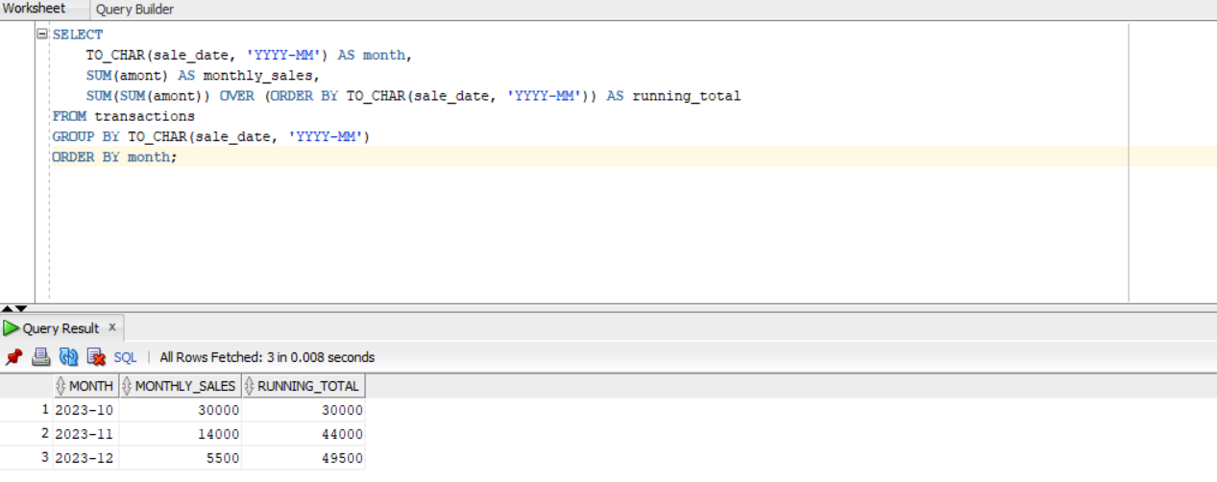

3-Navigation: LAG(), LEAD(), growth % calculation use case: Period-to-period analysis

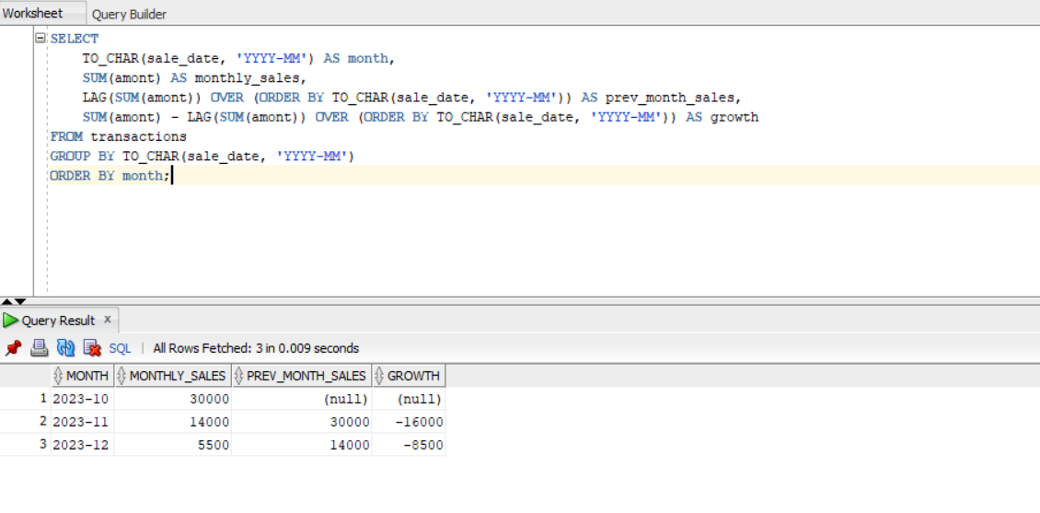

4-Distribution: NTILE(4), CUME_DIST() Use case: Customer segmentation

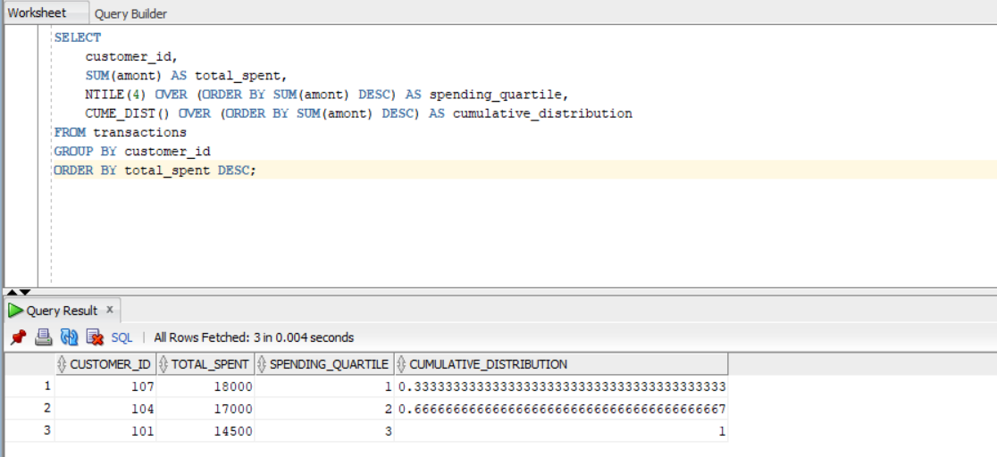

**STEP 5: GitHub Repository**

**Repo name:** plsql-window-functions-TVHACHOUKEMDOUNG-Kelly-Hans

**STEP 6: Results Analysis**

**1-Descriptive:**

Customer 107 is the top spender with 18000, followed by 104 with 17000 and 101 with 14500. Total sales reached 49500 between October and December 2023. Sales started high in October with 30000 but dropped in November with 14000 and further in December with 5500. Month-over-month growth was -16000 in November and -8500 in December, showing two consecutive declines.

**2-Diagnostic:**

Sales performance was heavily dependent on a few high-spending customers, with 107 and 104 together representing 67% of total spending. The decline in sales after October suggests that seasonal factors or a lack of promotion in November and December may be at play. The quartile distribution reveals a narrow customer base, with most revenue generated from three clients, making the company vulnerable if even one of them reduces their purchases.

**3-Presciptive**

Joie du Peuple should create loyalty programs for top-spending customers to maintain their commitment. Targeted promotions for medium-spending customers can encourage them to buy more frequently. Seasonal campaigns during low-performing months like November and December will help stabilize sales. Expanding the customer base is necessary to reduce reliance on only a few heavy spenders. Finally, diversifying the product line, especially with new juice flavors, will attract more customers and balance seasonal fluctuations.

**STEP 7: References**

-Class notes, particularly Database Management Systems (DBMS), AUCA (2024-2025).

-YouTube, programming with SQL and PL/SQL tutorials.

-YouTube, Oracle Window Function Explained.

-Personal Experience, Depot Management(Family Business)