Comparative Cognition Numerosity Analysis of Cowlog data Part II

Kelly Wallace

March 16, 2018

This document takes the output from "Comparative Cognition Numerosity Cowlog Analysis.Rmd" and graphs relevant data. Comparative Cognition Numerosity Cowlog Analysis.Rmd takes all the individual cowlog score sheets for numerosity and summarized them into one datasheet, df.sum

Individuals in the data output from the first rmd: wahida, wheatley,winnifred, wisteria,wayne, gabi,wile, wyatt,wedelia, gavin,gretchen, wade,willis, gloria,waldhurga, garrison,george, waverly,wilbur, wildflower,gemma, gertrude,grayson, watson,gary, winter,georgiafixed, wendy,gladys, gibson,gina, griffin,gabriel, winona,gideon,gordon,

ORDER OF ANALYSIS: 1. Pairwise comparisons of the following (one value per individual) performance metrics: Average performance over full 4 minutes Average performance over T30 to T50 Proportion of correct first choices Average latency to approach correct side Mean of median perofomance on each ratio number of medians above 0.60 using full 4 minutes data number of medians above 0.60 using full 4 minutes data

1. Pairwise comparison of the performance metrics (one value per individual) to the following behavior metrics: Average number of entries Average reaction time
2. Investigating other factors (compare performance to): sex, size, order,
3. See how consistent individuals are across trials within the same individuals (so will have an average repeatibility score?) Performance over the full 4 minutes Performance over T30 to T50 Which side was chosen first

STATS: To determine if one slope is significantly different from zero: mod<- lm(y ~ x) summary(mod)

T-test to determine if two groups (boxplot with 2 groups) have significantly different distributions: t.test(y~x) # where y is numeric and x is a binary factor

Nonparametric version of a t test wilcox.test(y,x) (Note from previous script: you can use a shapiro test to test for normality)

one-way ANOVA to determine if any one group (boxplot with > 2 groups)has a significantly different distribution fit <- aov(y ~ A, data=mydataframe) summary(fit)

Nonparametric version of a one-way ANOVA kruskal.test(y ~ x, data = mydata)

Linerar model finding the interaction term: mod<-lm(y~a+b) e.g number of entries x performance (latency to enter correct) - does this relationship vary by sex? mod<-lm(performance~entries+sex) summary(mod)

Template:

mod<- lm(df $XXX df$ XXX, na.rm = TRUE) summary(mod)

number <- df %>% filter(!is.na(XXX)) %>% filter(!is.na(XXX)) %>% nrow p_value <- mod %>% broom::tidy() %>% filter(term != "(Intercept)") %>% select(p.value) %>% unlist r_squared <- mod %>% broom::glance() %>% select(r.squared) %>% unlist

p <- ggplot(df, aes(XXX, XXX)) p + geom_point(size = 3) + theme(text = element_text(size=10)) + annotate("text", x=50, y=0.5, label= glue::glue("p = {round(p_value,4)}, R-squared: {round(r_squared,3)} n = {number}"), size = 6, color = "black") + labs(x= "XXX",y="XXX") + ggtitle ("XXX") + geom_smooth(method = "lm")

##   
## Call:  
## lm(formula = df$average_performance_across_all_9_testing_trials_using_full_4_minutes_data ~   
## df$average_performance_across_all_9_testing_trials_using_T30_to_T50_data,   
## na.rm = TRUE)  
##   
## Residuals:  
## Min 1Q Median 3Q Max   
## -0.24700 -0.02389 0.01115 0.03964 0.11937   
##   
## Coefficients:  
## Estimate  
## (Intercept) 0.34048  
## df$average_performance_across_all_9_testing_trials_using_T30_to_T50_data 0.26166  
## Std. Error  
## (Intercept) 0.04401  
## df$average_performance_across_all_9_testing_trials_using_T30_to_T50_data 0.09146  
## t value  
## (Intercept) 7.736  
## df$average_performance_across_all_9_testing_trials_using_T30_to_T50_data 2.861  
## Pr(>|t|)  
## (Intercept) 6.54e-09  
## df$average_performance_across_all_9_testing_trials_using_T30_to_T50_data 0.00728  
##   
## (Intercept) ***  
## df$average_performance_across_all_9_testing_trials_using_T30_to_T50_data **   
## ---  
## Signif. codes: 0 '***' 0.001 '**' 0.01 '*' 0.05 '.' 0.1 ' ' 1  
##   
## Residual standard error: 0.0763 on 33 degrees of freedom  
## (1 observation deleted due to missingness)  
## Multiple R-squared: 0.1987, Adjusted R-squared: 0.1744   
## F-statistic: 8.184 on 1 and 33 DF, p-value: 0.007277

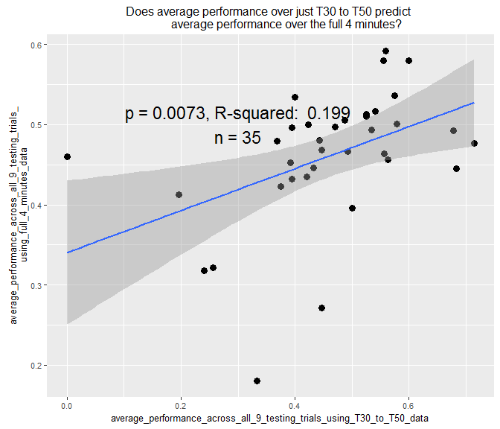

##   
## Call:  
## lm(formula = df$average_performance_across_all_9_testing_trials_using_T30_to_T50_data ~   
## df$proportion_of_correct_first_choices, na.rm = TRUE)  
##   
## Residuals:  
## Min 1Q Median 3Q Max   
## -0.34399 -0.06966 0.02644 0.09640 0.21707   
##   
## Coefficients:  
## Estimate Std. Error t value  
## (Intercept) 0.3440 0.0522 6.590  
## df$proportion_of_correct_first_choices 0.2340 0.0949 2.466  
## Pr(>|t|)   
## (Intercept) 1.72e-07 ***  
## df$proportion_of_correct_first_choices 0.019 *   
## ---  
## Signif. codes: 0 '***' 0.001 '**' 0.01 '*' 0.05 '.' 0.1 ' ' 1  
##   
## Residual standard error: 0.1334 on 33 degrees of freedom  
## (1 observation deleted due to missingness)  
## Multiple R-squared: 0.1556, Adjusted R-squared: 0.13   
## F-statistic: 6.08 on 1 and 33 DF, p-value: 0.01904

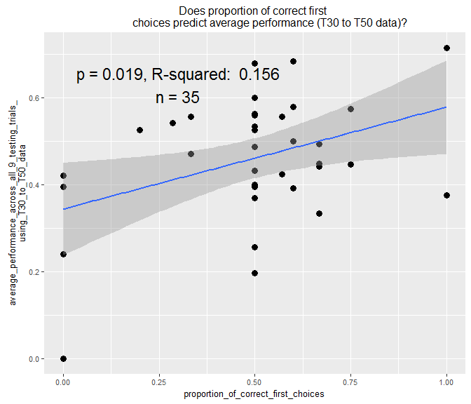

##   
## Call:  
## lm(formula = df$average_performance_across_all_9_testing_trials_using_full_4_minutes_data ~   
## df$proportion_of_correct_first_choices, na.rm = TRUE)  
##   
## Residuals:  
## Min 1Q Median 3Q Max   
## -0.27846 -0.02322 0.01844 0.04238 0.13096   
##   
## Coefficients:  
## Estimate Std. Error t value  
## (Intercept) 0.46582 0.03333 13.976  
## df$proportion_of_correct_first_choices -0.01002 0.06059 -0.165  
## Pr(>|t|)   
## (Intercept) 2.04e-15 ***  
## df$proportion_of_correct_first_choices 0.87   
## ---  
## Signif. codes: 0 '***' 0.001 '**' 0.01 '*' 0.05 '.' 0.1 ' ' 1  
##   
## Residual standard error: 0.0852 on 33 degrees of freedom  
## (1 observation deleted due to missingness)  
## Multiple R-squared: 0.0008276, Adjusted R-squared: -0.02945   
## F-statistic: 0.02733 on 1 and 33 DF, p-value: 0.8697

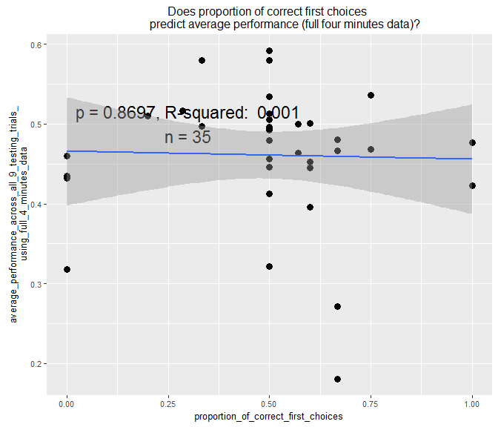

##   
## Call:  
## lm(formula = df$proportion_of_correct_first_choices ~ df$average_latency_to_enter_correct_side,   
## na.rm = TRUE)  
##   
## Residuals:  
## Min 1Q Median 3Q Max   
## -0.46801 -0.06161 0.00611 0.12209 0.63571   
##   
## Coefficients:  
## Estimate Std. Error t value  
## (Intercept) 0.577670 0.070866 8.152  
## df$average_latency_to_enter_correct_side -0.002117 0.001513 -1.398  
## Pr(>|t|)   
## (Intercept) 2.07e-09 ***  
## df$average_latency_to_enter_correct_side 0.171   
## ---  
## Signif. codes: 0 '***' 0.001 '**' 0.01 '*' 0.05 '.' 0.1 ' ' 1  
##   
## Residual standard error: 0.2378 on 33 degrees of freedom  
## (1 observation deleted due to missingness)  
## Multiple R-squared: 0.05595, Adjusted R-squared: 0.02734   
## F-statistic: 1.956 on 1 and 33 DF, p-value: 0.1713

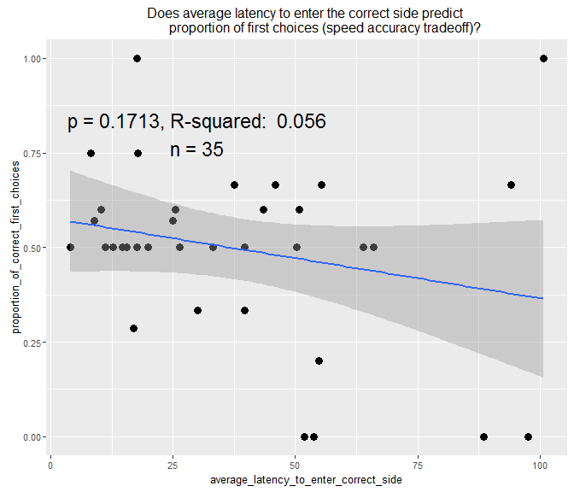

## Warning in lm.fit(x, y, offset = offset, singular.ok = singular.ok, ...):  
## extra argument 'na.rm' is disregarded.

##   
## Call:  
## lm(formula = df$average_performance_across_all_9_testing_trials_using_full_4_minutes_data ~   
## df$average_latency_to_enter_correct_side, na.rm = TRUE)  
##   
## Residuals:  
## Min 1Q Median 3Q Max   
## -0.200319 -0.021913 -0.001059 0.038753 0.158174   
##   
## Coefficients:  
## Estimate Std. Error t value  
## (Intercept) 0.5162678 0.0225355 22.909  
## df$average_latency_to_enter_correct_side -0.0014370 0.0004813 -2.986  
## Pr(>|t|)   
## (Intercept) <2e-16 ***  
## df$average_latency_to_enter_correct_side 0.0053 **   
## ---  
## Signif. codes: 0 '***' 0.001 '**' 0.01 '*' 0.05 '.' 0.1 ' ' 1  
##   
## Residual standard error: 0.07563 on 33 degrees of freedom  
## (1 observation deleted due to missingness)  
## Multiple R-squared: 0.2127, Adjusted R-squared: 0.1888   
## F-statistic: 8.915 on 1 and 33 DF, p-value: 0.005296

## Warning: Removed 1 rows containing non-finite values (stat_smooth).

## Warning: Removed 1 rows containing missing values (geom_point).

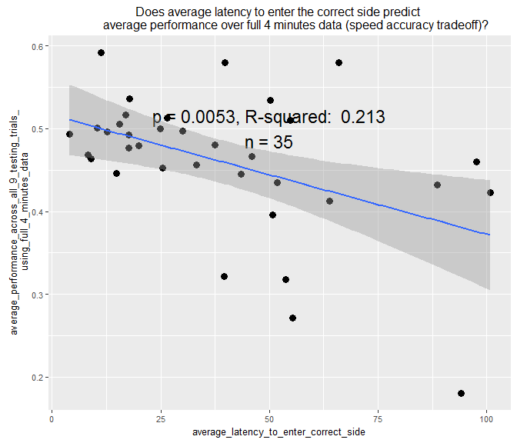

##   
## Call:  
## lm(formula = df$average_performance_across_all_9_testing_trials_using_T30_to_T50_data ~   
## df$average_latency_to_enter_correct_side, na.rm = TRUE)  
##   
## Residuals:  
## Min 1Q Median 3Q Max   
## -0.29452 -0.08507 0.02047 0.07474 0.23734   
##   
## Coefficients:  
## Estimate Std. Error t value  
## (Intercept) 0.5682184 0.0367380 15.467  
## df$average_latency_to_enter_correct_side -0.0028047 0.0007846 -3.575  
## Pr(>|t|)   
## (Intercept) <2e-16 ***  
## df$average_latency_to_enter_correct_side 0.0011 **   
## ---  
## Signif. codes: 0 '***' 0.001 '**' 0.01 '*' 0.05 '.' 0.1 ' ' 1  
##   
## Residual standard error: 0.1233 on 33 degrees of freedom  
## (1 observation deleted due to missingness)  
## Multiple R-squared: 0.2791, Adjusted R-squared: 0.2573   
## F-statistic: 12.78 on 1 and 33 DF, p-value: 0.001105

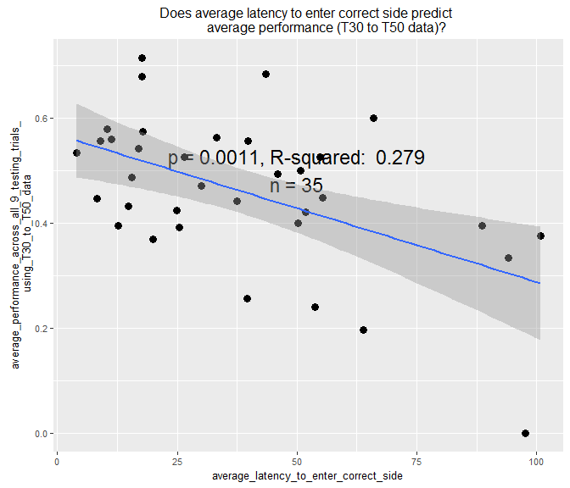

##   
## Call:  
## lm(formula = df$proportion_of_correct_first_choices ~ df$mean_of_median_performance_on_each_ratio_T30_to_T50_data,   
## na.rm = TRUE)  
##   
## Residuals:  
## Min 1Q Median 3Q Max   
## -0.42386 -0.11245 0.03507 0.13433 0.62858   
##   
## Coefficients:  
## Estimate  
## (Intercept) 0.30055  
## df$mean_of_median_performance_on_each_ratio_T30_to_T50_data 0.42524  
## Std. Error  
## (Intercept) 0.08936  
## df$mean_of_median_performance_on_each_ratio_T30_to_T50_data 0.17579  
## t value  
## (Intercept) 3.363  
## df$mean_of_median_performance_on_each_ratio_T30_to_T50_data 2.419  
## Pr(>|t|)   
## (Intercept) 0.00196 **  
## df$mean_of_median_performance_on_each_ratio_T30_to_T50_data 0.02124 *   
## ---  
## Signif. codes: 0 '***' 0.001 '**' 0.01 '*' 0.05 '.' 0.1 ' ' 1  
##   
## Residual standard error: 0.2256 on 33 degrees of freedom  
## (1 observation deleted due to missingness)  
## Multiple R-squared: 0.1506, Adjusted R-squared: 0.1249   
## F-statistic: 5.852 on 1 and 33 DF, p-value: 0.02124

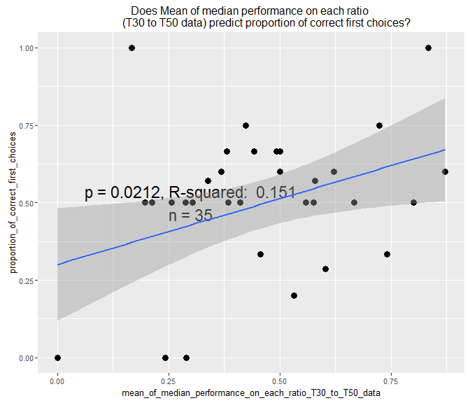

##   
## Call:  
## lm(formula = df$proportion_of_correct_first_choices ~ df$mean_of_median_performance_on_each_ratio_full_four_minutes_data,   
## na.rm = TRUE)  
##   
## Residuals:  
## Min 1Q Median 3Q Max   
## -0.53935 -0.01906 0.01813 0.10150 0.51219   
##   
## Coefficients:  
## Estimate  
## (Intercept) 0.5771  
## df$mean_of_median_performance_on_each_ratio_full_four_minutes_data -0.1828  
## Std. Error  
## (Intercept) 0.1523  
## df$mean_of_median_performance_on_each_ratio_full_four_minutes_data 0.3307  
## t value  
## (Intercept) 3.789  
## df$mean_of_median_performance_on_each_ratio_full_four_minutes_data -0.553  
## Pr(>|t|)  
## (Intercept) 0.000611  
## df$mean_of_median_performance_on_each_ratio_full_four_minutes_data 0.584144  
##   
## (Intercept) ***  
## df$mean_of_median_performance_on_each_ratio_full_four_minutes_data   
## ---  
## Signif. codes: 0 '***' 0.001 '**' 0.01 '*' 0.05 '.' 0.1 ' ' 1  
##   
## Residual standard error: 0.2437 on 33 degrees of freedom  
## (1 observation deleted due to missingness)  
## Multiple R-squared: 0.009174, Adjusted R-squared: -0.02085   
## F-statistic: 0.3056 on 1 and 33 DF, p-value: 0.5841

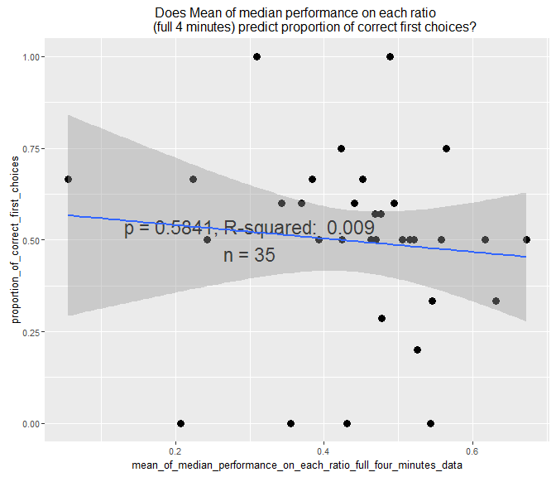

##   
## Call:  
## lm(formula = df$mean_of_median_performance_on_each_ratio_full_four_minutes_data ~   
## df$average_latency_to_enter_correct_side, na.rm = TRUE)  
##   
## Residuals:  
## Min 1Q Median 3Q Max   
## -0.284548 -0.062978 -0.003009 0.067706 0.251652   
##   
## Coefficients:  
## Estimate Std. Error t value  
## (Intercept) 0.5156183 0.0350437 14.714  
## df$average_latency_to_enter_correct_side -0.0018705 0.0007484 -2.499  
## Pr(>|t|)   
## (Intercept) 4.7e-16 ***  
## df$average_latency_to_enter_correct_side 0.0176 *   
## ---  
## Signif. codes: 0 '***' 0.001 '**' 0.01 '*' 0.05 '.' 0.1 ' ' 1  
##   
## Residual standard error: 0.1176 on 33 degrees of freedom  
## (1 observation deleted due to missingness)  
## Multiple R-squared: 0.1592, Adjusted R-squared: 0.1337   
## F-statistic: 6.247 on 1 and 33 DF, p-value: 0.01759

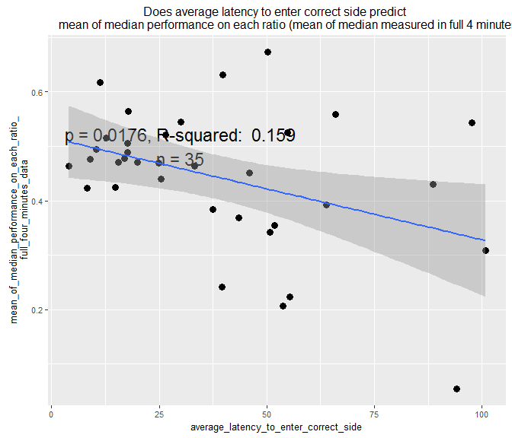

##   
## Call:  
## lm(formula = df$mean_of_median_performance_on_each_ratio_T30_to_T50_data ~   
## df$average_latency_to_enter_correct_side, na.rm = TRUE)  
##   
## Residuals:  
## Min 1Q Median 3Q Max   
## -0.40401 -0.16600 -0.01747 0.14737 0.43031   
##   
## Coefficients:  
## Estimate Std. Error t value  
## (Intercept) 0.600609 0.059533 10.089  
## df$average_latency_to_enter_correct_side -0.003653 0.001271 -2.873  
## Pr(>|t|)   
## (Intercept) 1.3e-11 ***  
## df$average_latency_to_enter_correct_side 0.00705 **   
## ---  
## Signif. codes: 0 '***' 0.001 '**' 0.01 '*' 0.05 '.' 0.1 ' ' 1  
##   
## Residual standard error: 0.1998 on 33 degrees of freedom  
## (1 observation deleted due to missingness)  
## Multiple R-squared: 0.2001, Adjusted R-squared: 0.1759   
## F-statistic: 8.255 on 1 and 33 DF, p-value: 0.007055

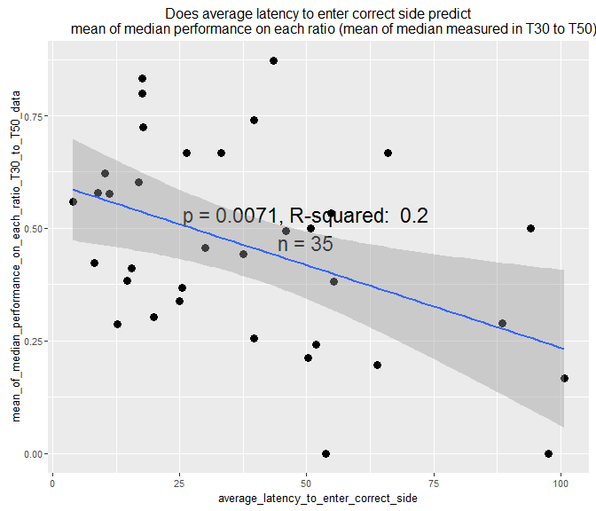

##   
## Call:  
## lm(formula = df$average_performance_across_all_9_testing_trials_using_full_4_minutes_data ~   
## df$mean_of_median_performance_on_each_ratio_full_four_minutes_data,   
## na.rm = TRUE)  
##   
## Residuals:  
## Min 1Q Median 3Q Max   
## -0.069567 -0.015362 -0.000565 0.021596 0.056295   
##   
## Coefficients:  
## Estimate  
## (Intercept) 0.18435  
## df$mean_of_median_performance_on_each_ratio_full_four_minutes_data 0.62348  
## Std. Error  
## (Intercept) 0.01845  
## df$mean_of_median_performance_on_each_ratio_full_four_minutes_data 0.04005  
## t value  
## (Intercept) 9.993  
## df$mean_of_median_performance_on_each_ratio_full_four_minutes_data 15.568  
## Pr(>|t|)  
## (Intercept) 1.65e-11  
## df$mean_of_median_performance_on_each_ratio_full_four_minutes_data < 2e-16  
##   
## (Intercept) ***  
## df$mean_of_median_performance_on_each_ratio_full_four_minutes_data ***  
## ---  
## Signif. codes: 0 '***' 0.001 '**' 0.01 '*' 0.05 '.' 0.1 ' ' 1  
##   
## Residual standard error: 0.02951 on 33 degrees of freedom  
## (1 observation deleted due to missingness)  
## Multiple R-squared: 0.8802, Adjusted R-squared: 0.8765   
## F-statistic: 242.4 on 1 and 33 DF, p-value: < 2.2e-16

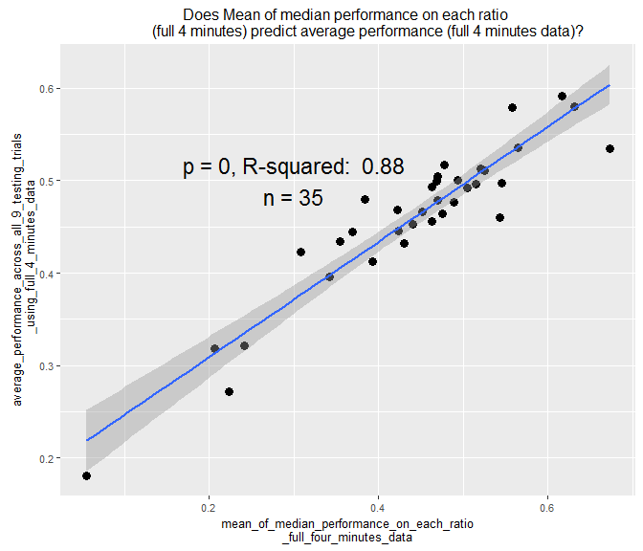

##   
## Call:  
## lm(formula = df$average_performance_across_all_9_testing_trials_using_T30_to_T50_data ~   
## df$mean_of_median_performance_on_each_ratio_T30_to_T50_data,   
## na.rm = TRUE)  
##   
## Residuals:  
## Min 1Q Median 3Q Max   
## -0.18988 -0.01659 0.01628 0.03402 0.08876   
##   
## Coefficients:  
## Estimate  
## (Intercept) 0.18988  
## df$mean_of_median_performance_on_each_ratio_T30_to_T50_data 0.58769  
## Std. Error  
## (Intercept) 0.02459  
## df$mean_of_median_performance_on_each_ratio_T30_to_T50_data 0.04837  
## t value  
## (Intercept) 7.723  
## df$mean_of_median_performance_on_each_ratio_T30_to_T50_data 12.151  
## Pr(>|t|)   
## (Intercept) 6.79e-09 ***  
## df$mean_of_median_performance_on_each_ratio_T30_to_T50_data 9.97e-14 ***  
## ---  
## Signif. codes: 0 '***' 0.001 '**' 0.01 '*' 0.05 '.' 0.1 ' ' 1  
##   
## Residual standard error: 0.06207 on 33 degrees of freedom  
## (1 observation deleted due to missingness)  
## Multiple R-squared: 0.8173, Adjusted R-squared: 0.8118   
## F-statistic: 147.6 on 1 and 33 DF, p-value: 9.965e-14

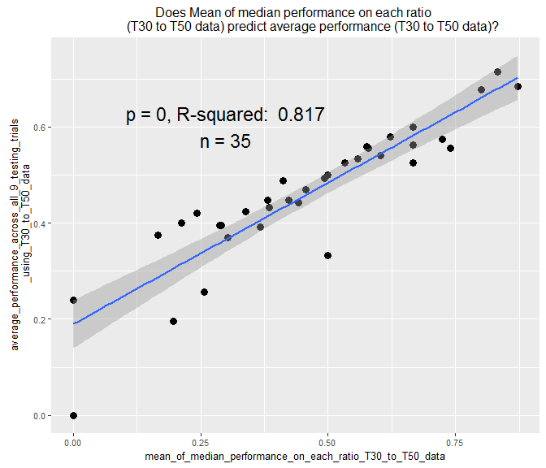

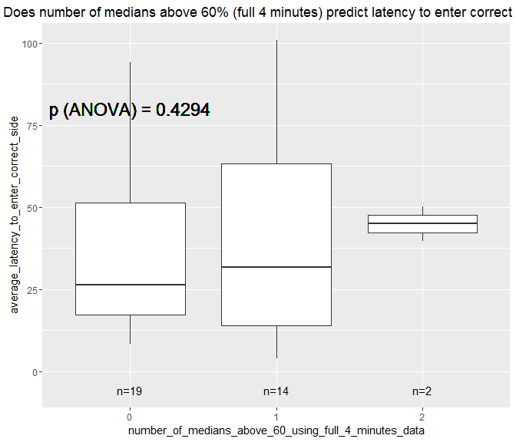

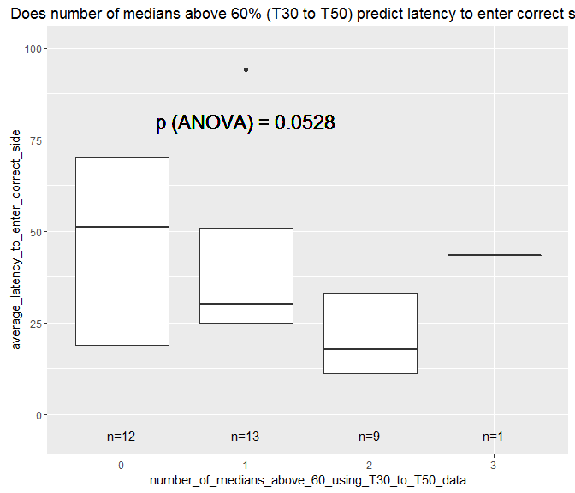

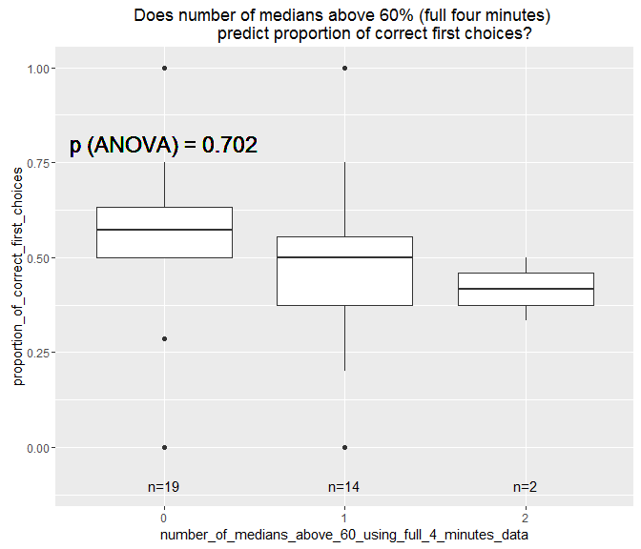

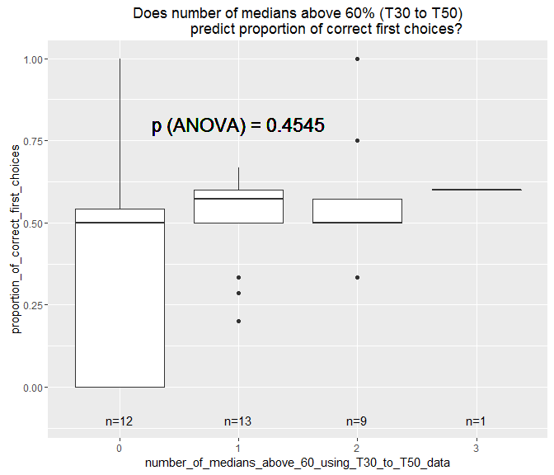

## Warning in lm.fit(x, y, offset = offset, singular.ok = singular.ok, ...):  
## extra argument 'na.rm' is disregarded.

##   
## Call:  
## lm(formula = df$average_performance_across_all_9_testing_trials_using_full_4_minutes_data ~   
## df$average_number_of_entries, na.rm = TRUE)  
##   
## Residuals:  
## Min 1Q Median 3Q Max   
## -0.25527 -0.02100 0.01714 0.04316 0.15489   
##   
## Coefficients:  
## Estimate Std. Error t value Pr(>|t|)   
## (Intercept) 0.4124579 0.0300237 13.738 3.32e-15 ***  
## df$average_number_of_entries 0.0008852 0.0004883 1.813 0.0789 .   
## ---  
## Signif. codes: 0 '***' 0.001 '**' 0.01 '*' 0.05 '.' 0.1 ' ' 1  
##   
## Residual standard error: 0.08129 on 33 degrees of freedom  
## (1 observation deleted due to missingness)  
## Multiple R-squared: 0.09058, Adjusted R-squared: 0.06302   
## F-statistic: 3.287 on 1 and 33 DF, p-value: 0.07894

## Warning: Removed 1 rows containing non-finite values (stat_smooth).

## Warning: Removed 1 rows containing missing values (geom_point).

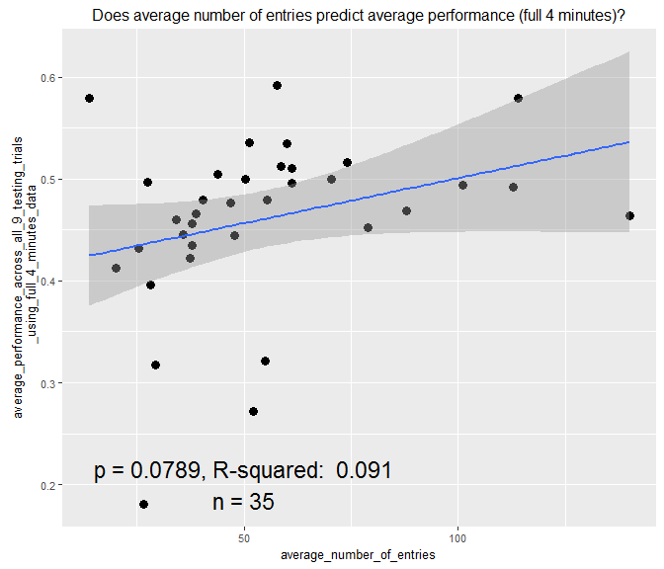

##   
## Call:  
## lm(formula = df$average_performance_across_all_9_testing_trials_using_T30_to_T50_data ~   
## df$average_number_of_entries, na.rm = TRUE)  
##   
## Residuals:  
## Min 1Q Median 3Q Max   
## -0.42181 -0.06719 -0.00792 0.07603 0.26880   
##   
## Coefficients:  
## Estimate Std. Error t value Pr(>|t|)   
## (Intercept) 0.3580616 0.0497819 7.193 3.03e-08 ***  
## df$average_number_of_entries 0.0018657 0.0008096 2.305 0.0276 *   
## ---  
## Signif. codes: 0 '***' 0.001 '**' 0.01 '*' 0.05 '.' 0.1 ' ' 1  
##   
## Residual standard error: 0.1348 on 33 degrees of freedom  
## (1 observation deleted due to missingness)  
## Multiple R-squared: 0.1386, Adjusted R-squared: 0.1125   
## F-statistic: 5.311 on 1 and 33 DF, p-value: 0.02763

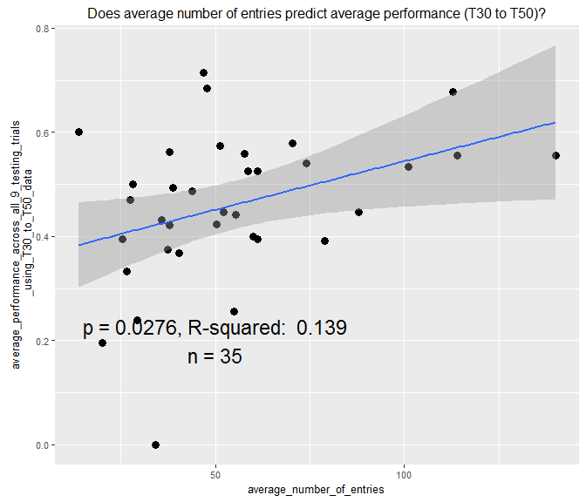

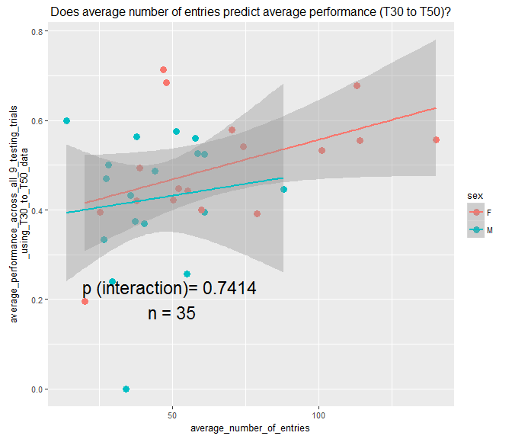

##   
## Call:  
## lm(formula = df$proportion_of_correct_first_choices ~ df$average_number_of_entries,   
## na.rm = TRUE)  
##   
## Residuals:  
## Min 1Q Median 3Q Max   
## -0.47881 -0.04941 0.01858 0.12097 0.52153   
##   
## Coefficients:  
## Estimate Std. Error t value Pr(>|t|)   
## (Intercept) 0.440248 0.089749 4.905 2.44e-05 ***  
## df$average_number_of_entries 0.001021 0.001460 0.699 0.489   
## ---  
## Signif. codes: 0 '***' 0.001 '**' 0.01 '*' 0.05 '.' 0.1 ' ' 1  
##   
## Residual standard error: 0.243 on 33 degrees of freedom  
## (1 observation deleted due to missingness)  
## Multiple R-squared: 0.0146, Adjusted R-squared: -0.01526   
## F-statistic: 0.4891 on 1 and 33 DF, p-value: 0.4892

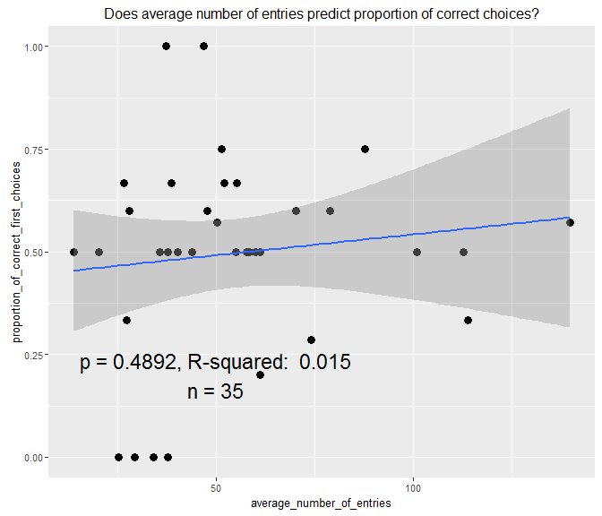

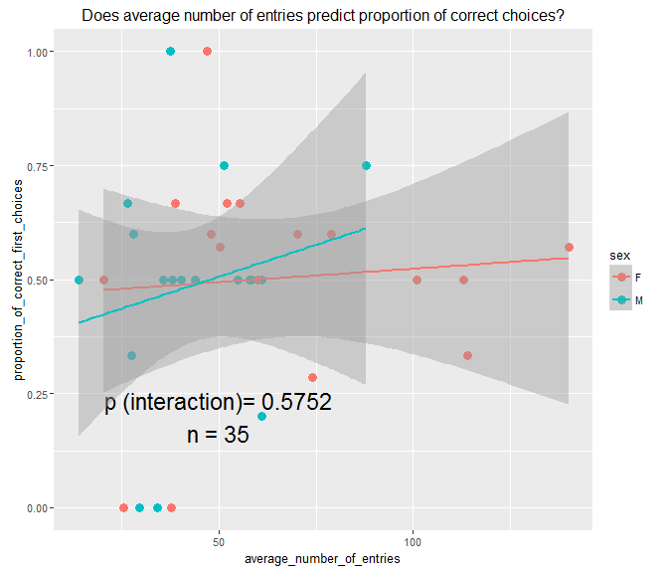

##   
## Call:  
## lm(formula = df$average_latency_to_enter_correct_side ~ df$average_number_of_entries,   
## na.rm = TRUE)  
##   
## Residuals:  
## Min 1Q Median 3Q Max   
## -33.700 -17.981 -0.757 11.947 53.270   
##   
## Coefficients:  
## Estimate Std. Error t value Pr(>|t|)   
## (Intercept) 67.0812 8.4214 7.966 3.46e-09 ***  
## df$average_number_of_entries -0.5216 0.1370 -3.809 0.000577 ***  
## ---  
## Signif. codes: 0 '***' 0.001 '**' 0.01 '*' 0.05 '.' 0.1 ' ' 1  
##   
## Residual standard error: 22.8 on 33 degrees of freedom  
## (1 observation deleted due to missingness)  
## Multiple R-squared: 0.3054, Adjusted R-squared: 0.2843   
## F-statistic: 14.51 on 1 and 33 DF, p-value: 0.0005769

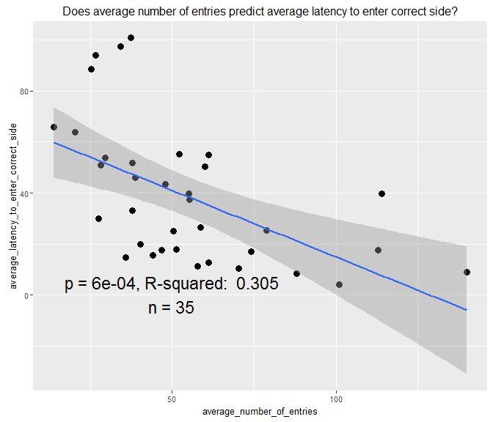

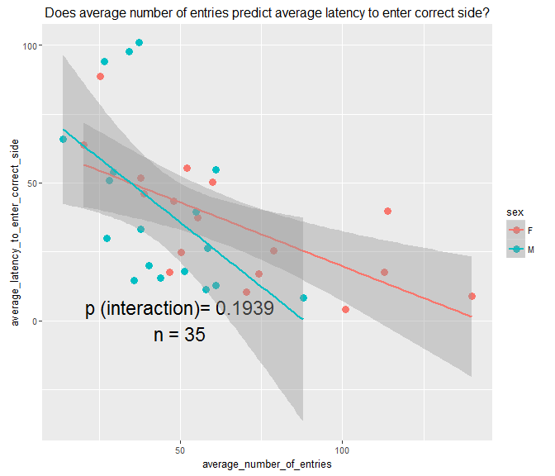

##   
## Call:  
## lm(formula = df$average_performance_across_all_9_testing_trials_using_full_4_minutes_data ~   
## df$average_reaction_time, na.rm = TRUE)  
##   
## Residuals:  
## Min 1Q Median 3Q Max   
## -0.268765 -0.015633 0.009745 0.032312 0.175595   
##   
## Coefficients:  
## Estimate Std. Error t value Pr(>|t|)   
## (Intercept) 0.487087 0.020984 23.212 <2e-16 ***  
## df$average_reaction_time -0.003063 0.001842 -1.663 0.106   
## ---  
## Signif. codes: 0 '***' 0.001 '**' 0.01 '*' 0.05 '.' 0.1 ' ' 1  
##   
## Residual standard error: 0.08188 on 33 degrees of freedom  
## (1 observation deleted due to missingness)  
## Multiple R-squared: 0.07733, Adjusted R-squared: 0.04937   
## F-statistic: 2.766 on 1 and 33 DF, p-value: 0.1058

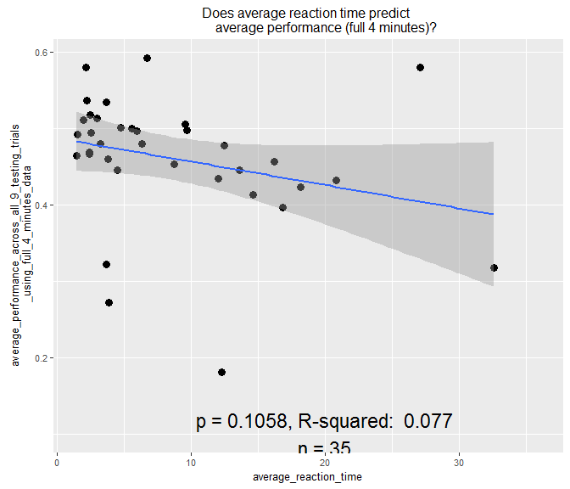

##   
## Call:  
## lm(formula = df$average_performance_across_all_9_testing_trials_using_T30_to_T50_data ~   
## df$average_reaction_time, na.rm = TRUE)  
##   
## Residuals:  
## Min 1Q Median 3Q Max   
## -0.4778 -0.0586 0.0101 0.0714 0.2687   
##   
## Coefficients:  
## Estimate Std. Error t value Pr(>|t|)   
## (Intercept) 0.491917 0.036480 13.484 5.61e-15 ***  
## df$average_reaction_time -0.003720 0.003202 -1.162 0.254   
## ---  
## Signif. codes: 0 '***' 0.001 '**' 0.01 '*' 0.05 '.' 0.1 ' ' 1  
##   
## Residual standard error: 0.1423 on 33 degrees of freedom  
## (1 observation deleted due to missingness)  
## Multiple R-squared: 0.03928, Adjusted R-squared: 0.01016   
## F-statistic: 1.349 on 1 and 33 DF, p-value: 0.2538

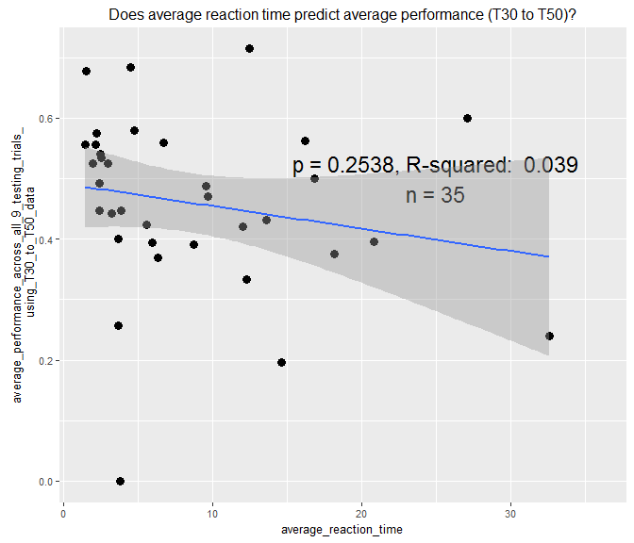

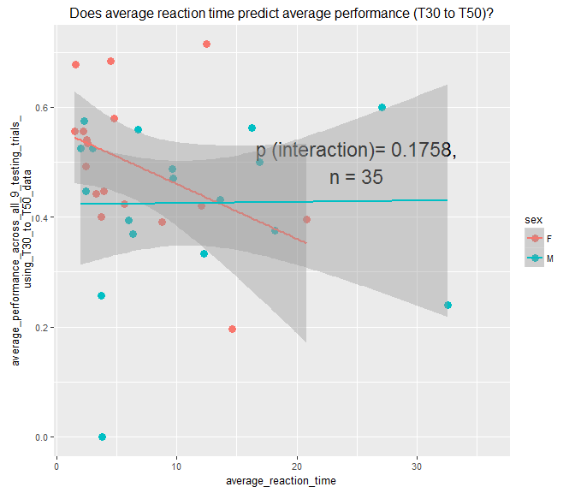

##   
## Call:  
## lm(formula = df$proportion_of_correct_first_choices ~ df$average_reaction_time,   
## na.rm = TRUE)  
##   
## Residuals:  
## Min 1Q Median 3Q Max   
## -0.52601 -0.03706 0.03076 0.12634 0.56462   
##   
## Coefficients:  
## Estimate Std. Error t value Pr(>|t|)   
## (Intercept) 0.549947 0.061481 8.945 2.44e-10 ***  
## df$average_reaction_time -0.006294 0.005397 -1.166 0.252   
## ---  
## Signif. codes: 0 '***' 0.001 '**' 0.01 '*' 0.05 '.' 0.1 ' ' 1  
##   
## Residual standard error: 0.2399 on 33 degrees of freedom  
## (1 observation deleted due to missingness)  
## Multiple R-squared: 0.03958, Adjusted R-squared: 0.01047   
## F-statistic: 1.36 on 1 and 33 DF, p-value: 0.2519

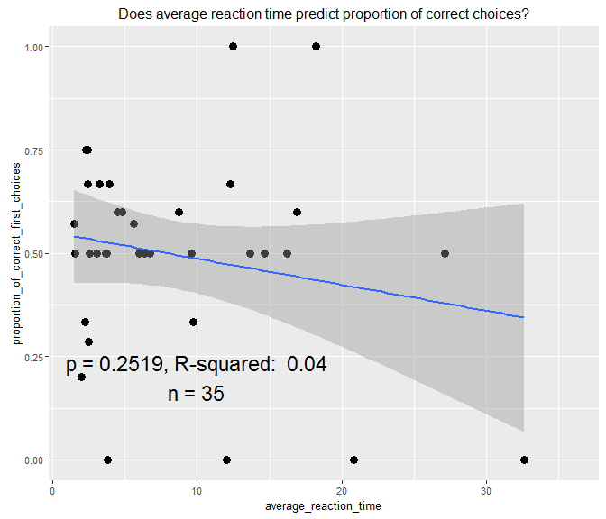

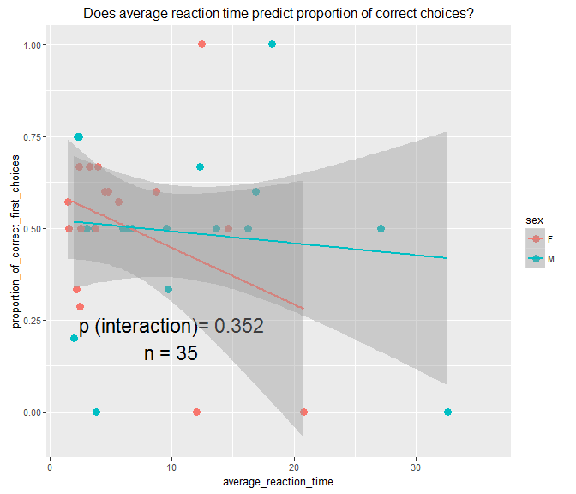

##   
## Call:  
## lm(formula = df$average_latency_to_enter_correct_side ~ df$average_reaction_time,   
## na.rm = TRUE)  
##   
## Residuals:  
## Min 1Q Median 3Q Max   
## -31.821 -19.567 -8.989 13.529 66.513   
##   
## Coefficients:  
## Estimate Std. Error t value Pr(>|t|)   
## (Intercept) 25.0894 6.2787 3.996 0.00034 ***  
## df$average_reaction_time 1.5733 0.5512 2.854 0.00739 **   
## ---  
## Signif. codes: 0 '***' 0.001 '**' 0.01 '*' 0.05 '.' 0.1 ' ' 1  
##   
## Residual standard error: 24.5 on 33 degrees of freedom  
## (1 observation deleted due to missingness)  
## Multiple R-squared: 0.198, Adjusted R-squared: 0.1737   
## F-statistic: 8.148 on 1 and 33 DF, p-value: 0.007395

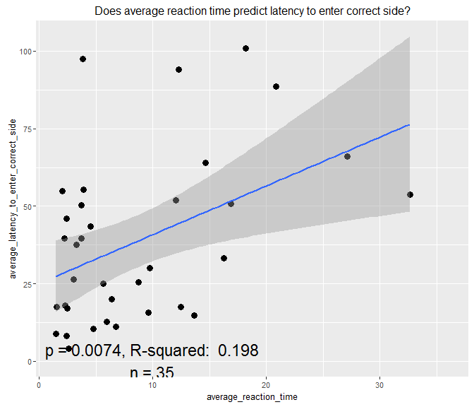

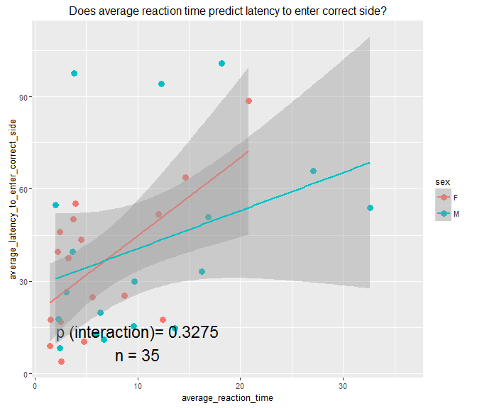

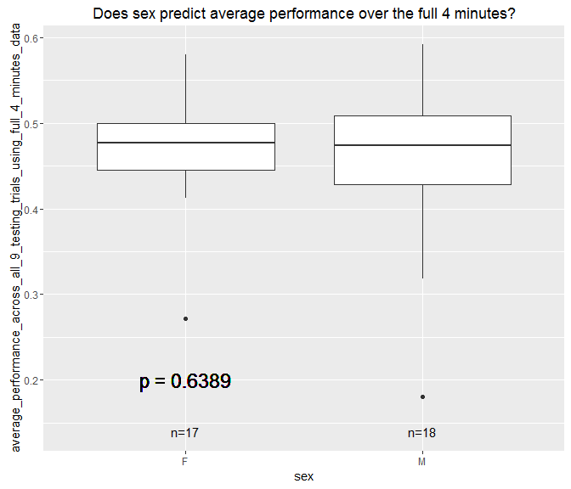

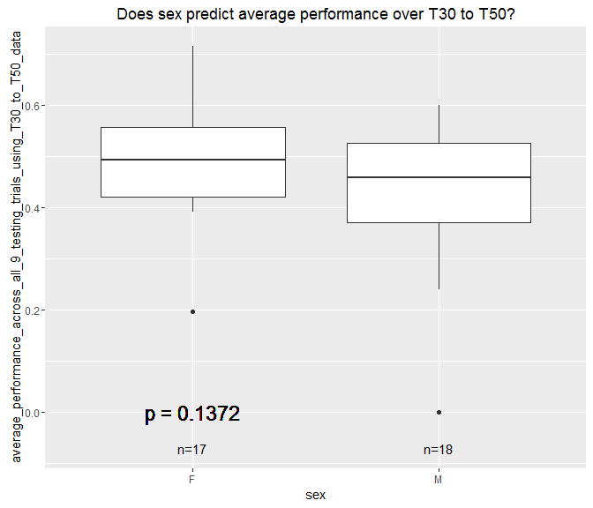

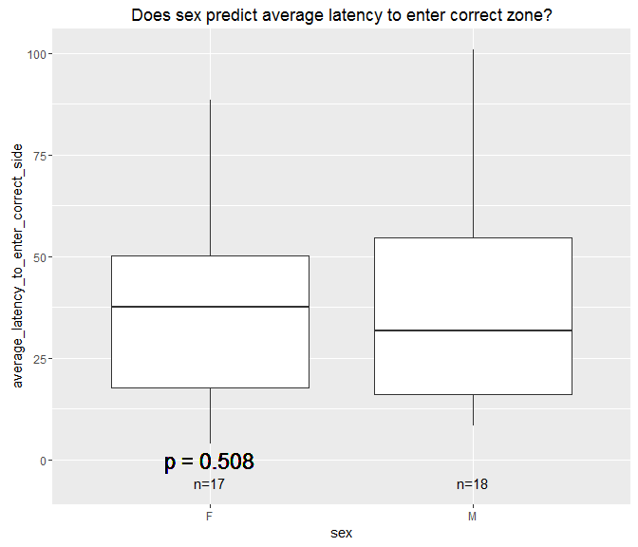

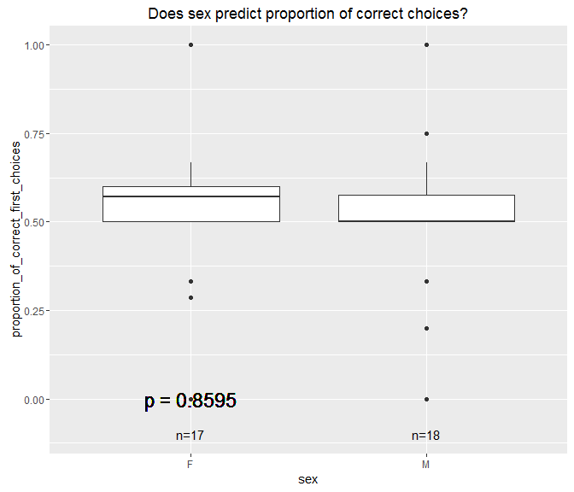

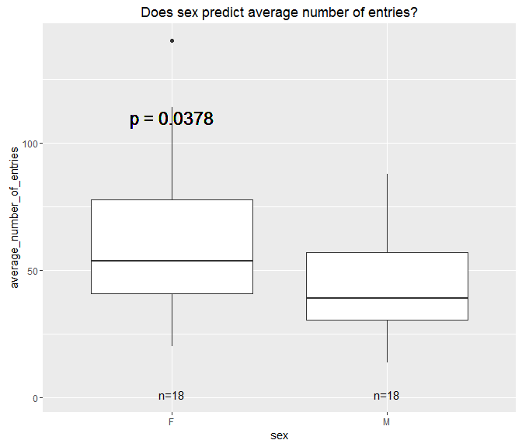

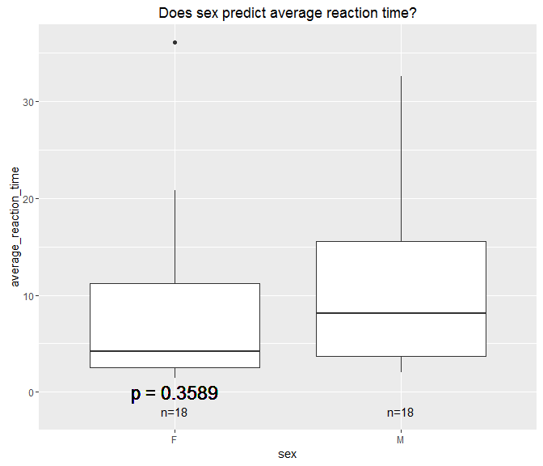

##   
## Call:  
## lm(formula = df$average_performance_across_all_9_testing_trials_using_full_4_minutes_data ~   
## df$standard_length, na.rm = TRUE)  
##   
## Residuals:  
## Min 1Q Median 3Q Max   
## -0.274027 -0.023507 0.007894 0.045255 0.140520   
##   
## Coefficients:  
## Estimate Std. Error t value Pr(>|t|)   
## (Intercept) 3.843e-01 5.421e-02 7.089 4.08e-08 ***  
## df$standard_length 3.268e-05 2.235e-05 1.462 0.153   
## ---  
## Signif. codes: 0 '***' 0.001 '**' 0.01 '*' 0.05 '.' 0.1 ' ' 1  
##   
## Residual standard error: 0.0826 on 33 degrees of freedom  
## (1 observation deleted due to missingness)  
## Multiple R-squared: 0.06086, Adjusted R-squared: 0.0324   
## F-statistic: 2.139 on 1 and 33 DF, p-value: 0.1531

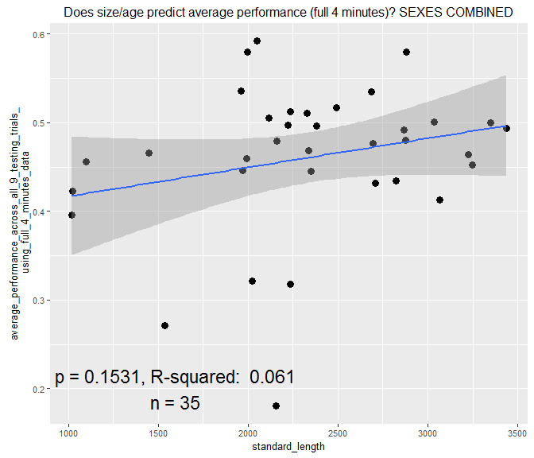

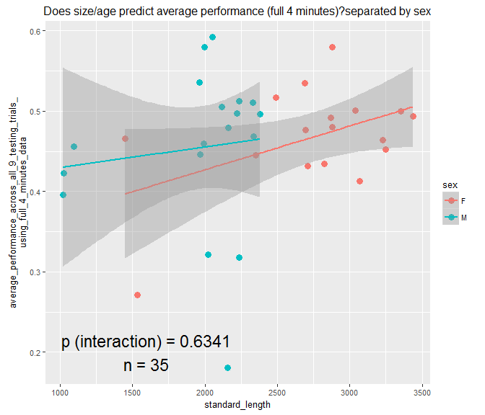

##   
## Call:  
## lm(formula = df$average_performance_across_all_9_testing_trials_using_T30_to_T50_data ~   
## df$standard_length, na.rm = TRUE)  
##   
## Residuals:  
## Min 1Q Median 3Q Max   
## -0.45419 -0.06597 0.01194 0.08404 0.24835   
##   
## Coefficients:  
## Estimate Std. Error t value Pr(>|t|)   
## (Intercept) 4.209e-01 9.503e-02 4.429 9.82e-05 ***  
## df$standard_length 1.671e-05 3.918e-05 0.427 0.672   
## ---  
## Signif. codes: 0 '***' 0.001 '**' 0.01 '*' 0.05 '.' 0.1 ' ' 1  
##   
## Residual standard error: 0.1448 on 33 degrees of freedom  
## (1 observation deleted due to missingness)  
## Multiple R-squared: 0.005484, Adjusted R-squared: -0.02465   
## F-statistic: 0.182 on 1 and 33 DF, p-value: 0.6725

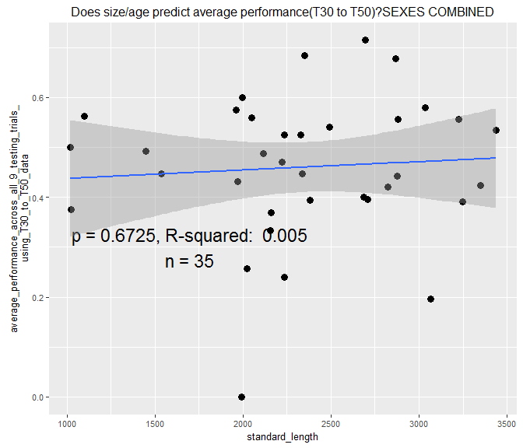

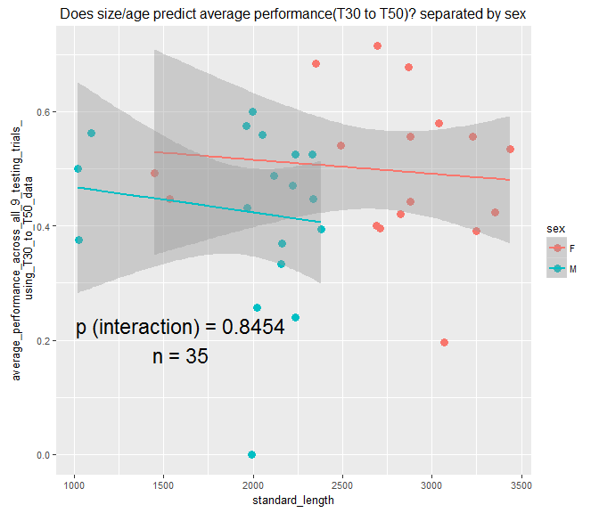

##   
## Call:  
## lm(formula = df$proportion_of_correct_first_choices ~ df$standard_length,   
## na.rm = TRUE)  
##   
## Residuals:  
## Min 1Q Median 3Q Max   
## -0.52008 -0.05146 0.01347 0.13990 0.52793   
##   
## Coefficients:  
## Estimate Std. Error t value Pr(>|t|)   
## (Intercept) 6.561e-01 1.580e-01 4.152 0.000218 ***  
## df$standard_length -6.830e-05 6.515e-05 -1.048 0.302084   
## ---  
## Signif. codes: 0 '***' 0.001 '**' 0.01 '*' 0.05 '.' 0.1 ' ' 1  
##   
## Residual standard error: 0.2408 on 33 degrees of freedom  
## (1 observation deleted due to missingness)  
## Multiple R-squared: 0.03223, Adjusted R-squared: 0.002906   
## F-statistic: 1.099 on 1 and 33 DF, p-value: 0.3021

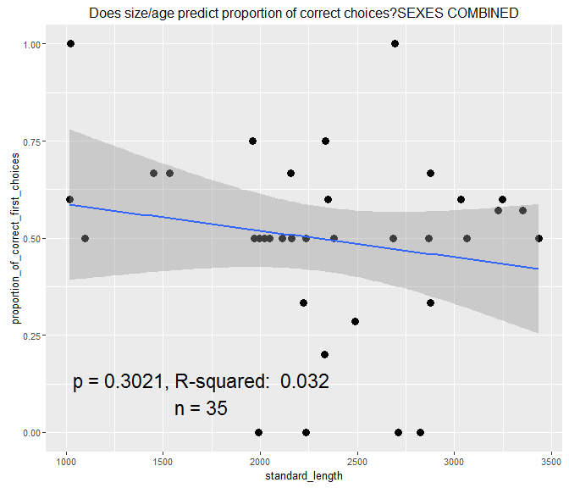

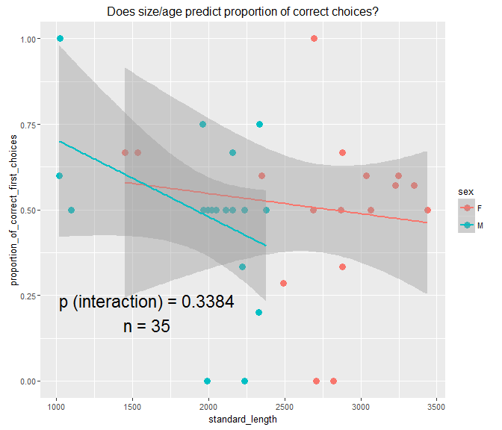

##   
## Call:  
## lm(formula = df$average_latency_to_enter_correct_side ~ df$standard_length,   
## na.rm = TRUE)  
##   
## Residuals:  
## Min 1Q Median 3Q Max   
## -31.736 -18.883 -5.849 14.847 55.440   
##   
## Coefficients:  
## Estimate Std. Error t value Pr(>|t|)   
## (Intercept) 73.406226 16.818310 4.365 0.000118 ***  
## df$standard_length -0.014867 0.006934 -2.144 0.039477 *   
## ---  
## Signif. codes: 0 '***' 0.001 '**' 0.01 '*' 0.05 '.' 0.1 ' ' 1  
##   
## Residual standard error: 25.63 on 33 degrees of freedom  
## (1 observation deleted due to missingness)  
## Multiple R-squared: 0.1223, Adjusted R-squared: 0.09569   
## F-statistic: 4.598 on 1 and 33 DF, p-value: 0.03948

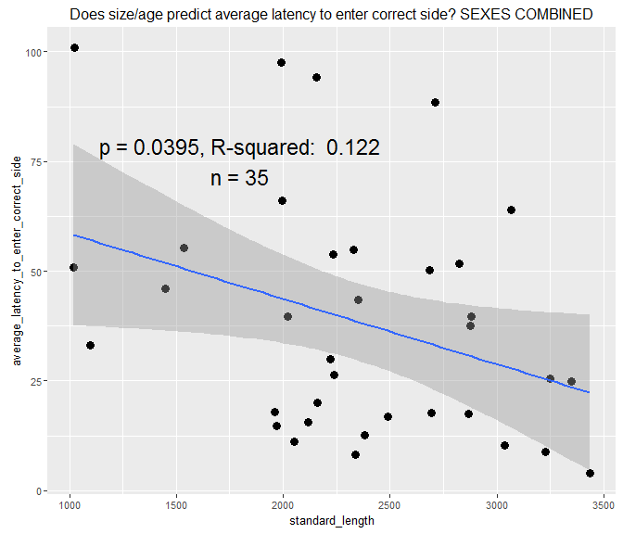

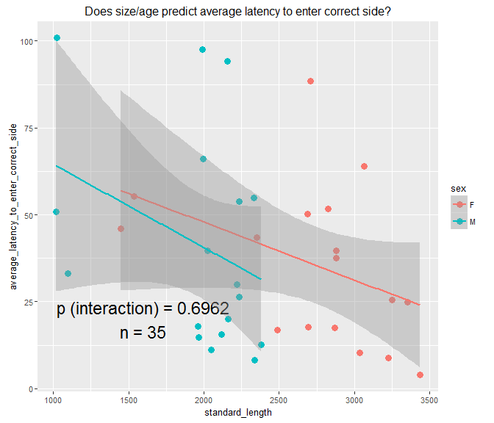

##   
## Call:  
## lm(formula = df$average_number_of_entries ~ df$standard_length,   
## na.rm = TRUE)  
##   
## Residuals:  
## Min 1Q Median 3Q Max   
## -51.337 -12.882 1.247 11.082 64.617   
##   
## Coefficients:  
## Estimate Std. Error t value Pr(>|t|)   
## (Intercept) -1.271105 15.413614 -0.082 0.934759   
## df$standard_length 0.023754 0.006418 3.701 0.000755 ***  
## ---  
## Signif. codes: 0 '***' 0.001 '**' 0.01 '*' 0.05 '.' 0.1 ' ' 1  
##   
## Residual standard error: 24.59 on 34 degrees of freedom  
## Multiple R-squared: 0.2872, Adjusted R-squared: 0.2663   
## F-statistic: 13.7 on 1 and 34 DF, p-value: 0.0007551

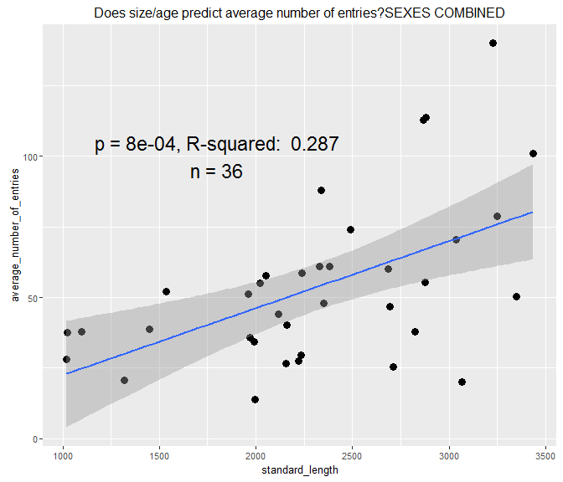

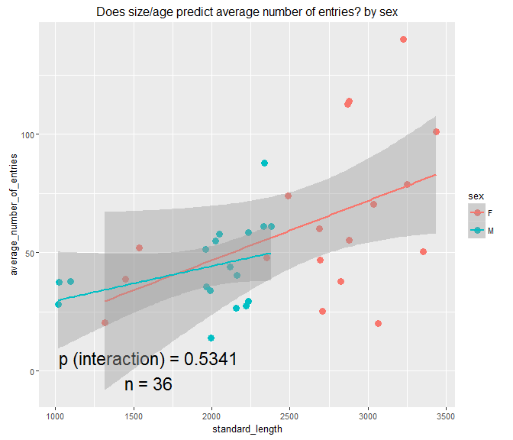

##   
## Call:  
## lm(formula = df$average_reaction_time ~ df$standard_length, na.rm = TRUE)  
##   
## Residuals:  
## Min 1Q Median 3Q Max   
## -11.320 -5.215 -2.035 2.344 22.879   
##   
## Coefficients:  
## Estimate Std. Error t value Pr(>|t|)   
## (Intercept) 21.163842 5.186484 4.081 0.000257 ***  
## df$standard_length -0.005112 0.002159 -2.367 0.023743 *   
## ---  
## Signif. codes: 0 '***' 0.001 '**' 0.01 '*' 0.05 '.' 0.1 ' ' 1  
##   
## Residual standard error: 8.275 on 34 degrees of freedom  
## Multiple R-squared: 0.1415, Adjusted R-squared: 0.1163   
## F-statistic: 5.605 on 1 and 34 DF, p-value: 0.02374

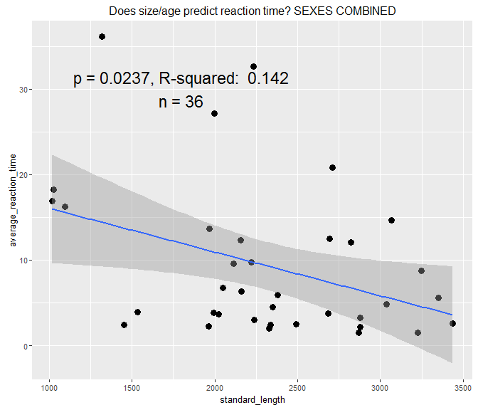

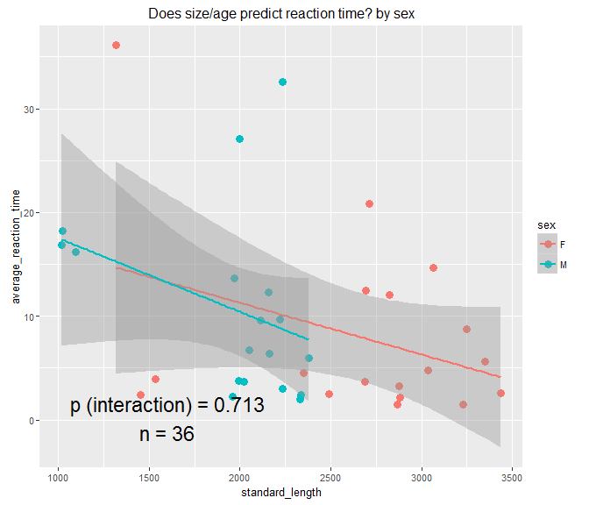

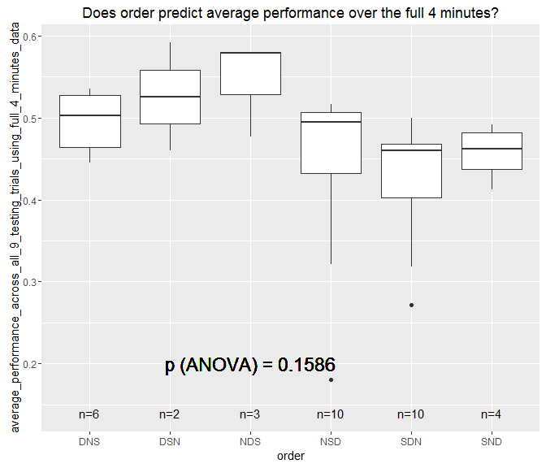

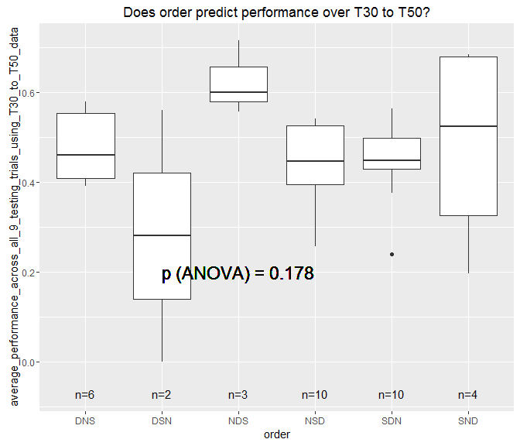

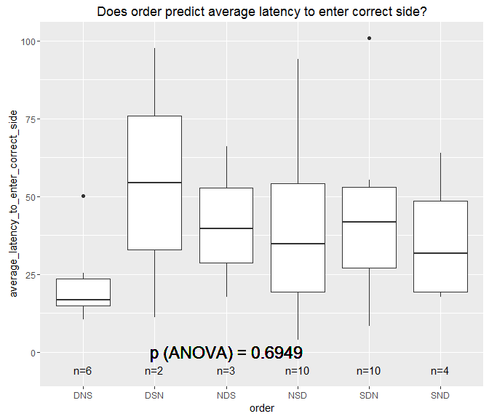

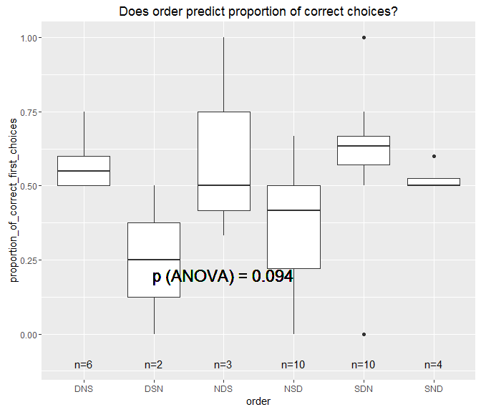

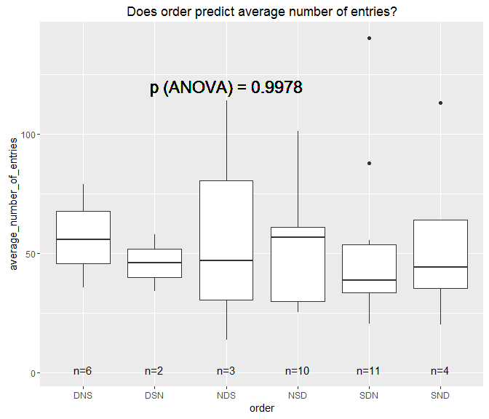

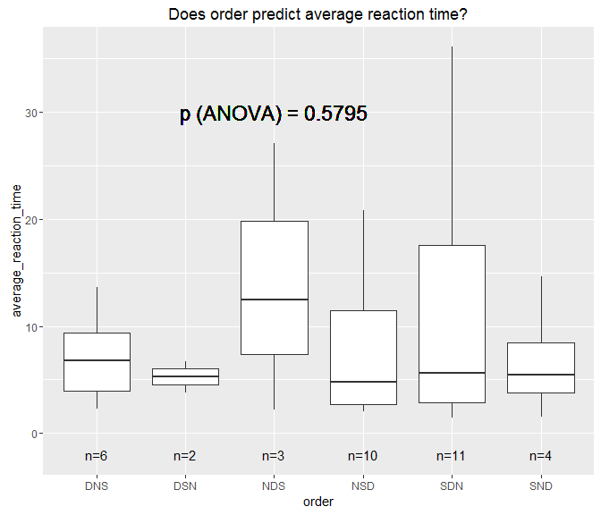

TEMPLATE AGAIN

mod<- lm(df $XXX df$ XXX, na.rm = TRUE) summary(mod)

number <- df %>% filter(!is.na(XXX)) %>% filter(!is.na(XXX)) %>% nrow p_value <- mod %>% broom::tidy() %>% filter(term != "(Intercept)") %>% select(p.value) %>% unlist r_squared <- mod %>% broom::glance() %>% select(r.squared) %>% unlist

p <- ggplot(df, aes(XXX, XXX)) p + geom_point(size = 3) + theme(text = element_text(size=10)) + annotate("text", x=50, y=0.5, label= glue::glue("p = {round(p_value,4)}, R-squared: {round(r_squared,3)} n = {number}"), size = 6, color = "black") + labs(x= "XXX",y="XXX") + ggtitle ("XXX") + geom_smooth(method = "lm")

1. See how consistent individuals are across trials within the same individuals (so will have an average repeatibility score?) Performance over the full 4 minutes Performance over T30 to T50 Which side was chosen first

Here's the column names coming from df.sum:

"fish_name"  
[2] "sex"  
[3] "standard_length"  
[4] "order"

[149] "average_number_of_entries"  
[150] "average_reaction_time"  
[151] "average_performance_across_all_9_testing_trials_using_full_4_minutes_data"  
[152] "average_performance_across_all_9_testing_trials_using_T30_to_T50_data"  
[153] "total_number_of_testing_trials_using_full_4_minutes_data"  
[154] "total_number_of_testing_trials_using_T30_to_T50_data"  
[155] "number_of_trials_on_0.50_ratio_using_full_4_minutes_data"  
[156] "number_of_trials_on_0.67_ratio_using_full_4_minutes_data"  
[157] "number_of_trials_on_0.75_ratio_using_full_4_minutes_data"  
[158] "number_of_trials_on_0.50_ratio_using_T30_to_T50_data"  
[159] "number_of_trials_on_0.67_ratio_using_T30_to_T50_data"  
[160] "number_of_trials_on_0.75_ratio_using_T30_to_T50_data"  
[161] "median_performance_on_0.50_ratio_using_full_4_minutes_data"  
[162] "median_performance_on_0.67_ratio_using_full_4_minutes_data"  
[163] "median_performance_on_0.75_ratio_using_full_4_minutes_data"  
[164] "median_performance_on_0.50_ratio_using_T30_to_T50_data"  
[165] "median_performance_on_0.67_ratio_using_T30_to_T50_data"  
[166] "median_performance_on_0.75_ratio_using_T30_to_T50_data"  
[167] "number_of_medians_above_60_using_full_4_minutes_data"  
[168] "number_of_medians_above_60_using_T30_to_T50_data"  
[169] "shapiro_wilk_test_p_value_using_full_4_minutes_data"  
[170] "was_average_performance_significantly_different_from_0.5_full_4_minutes_p_value_of_either_t_test_or_wilcox"  
[171] "shapiro_wilk_test_p_value_using_T30_to_T50_data"  
[172] "was_average_performance_significantly_different_from_0.5_T30_to_T50_p_value_of_either_t_test_or_wilcox"  
[173] "learning_category_according_to_etheredge_T30_to_T50"  
[174] "learning_category_according_to_etheredge_full_4_minutes"  
[175] "average_latency_to_enter_correct_side"  
[176] "average_latency_to_enter_incorrect_side"  
[177] "proportion_of_correct_first_choices"  
[178] "number_of_trials_in_a_row_greater_than_60_percent_full_4_minutes"  
[179] "number_of_trials_in_a_row_greater_than_60_percent_T30_to_T50"  
[180] "number_of_trials_in_a_row_correct_choice_first"  
[181] "mean_of_median_performance_on_each_ratio_full_four_minutes_data"  
[182] "mean_of_median_performance_on_each_ratio_T30_to_T50_data"

[5] "Trial_9_1_correctside"  
[6] "Trial_9_1_ratio"  
[7] "Trial_9_1_total_entries"  
[8] "Trial_9_1_performance_over_full_4_minutes_ie_correct_screen_proportion_divided_by_sum_proportion_at_both_screens" [9] "Trial_9_1_performance_over_T30_to_T50_ie_correct_screen_proportion_divided_by_sum_proportion_at_both_screens"  
[10] "Trial_9_1_was_performance_over_full_4_minutes_greater_than_60_percent"  
[11] "Trial_9_1_was_performance_T30_to_T50_greater_than_60_percent"  
[12] "Trial_9_1_reaction_time"  
[13] "Trial_9_1_latency_to_enter_correct_side"  
[14] "Trial_9_1_latency_to_enter_incorrect_side"  
[15] "Trial_9_1_screen_entered_first"  
[16] "Trial_9_1_time_spent_in_correct_screen_full_4_minutes_absolute_seconds"  
[17] "Trial_9_1_time_spent_in_incorrect_screen_full_4_minutes_absolute_seconds"  
[18] "Trial_9_1_time_spent_in_correct_screen_T30_to_T50_absolute_seconds"  
[19] "Trial_9_1_time_spent_in_incorrect_screen_T30_to_T50_absolute_seconds"  
[20] "Trial_9_3_correctside"  
[21] "Trial_9_3_ratio"  
[22] "Trial_9_3_total_entries"  
[23] "Trial_9_3_performance_over_full_4_minutes_ie_correct_screen_proportion_divided_by_sum_proportion_at_both_screens" [24] "Trial_9_3_performance_over_T30_to_T50_ie_correct_screen_proportion_divided_by_sum_proportion_at_both_screens"  
[25] "Trial_9_3_was_performance_over_full_4_minutes_greater_than_60_percent"  
[26] "Trial_9_3_was_performance_T30_to_T50_greater_than_60_percent"  
[27] "Trial_9_3_reaction_time"  
[28] "Trial_9_3_latency_to_enter_correct_side"  
[29] "Trial_9_3_latency_to_enter_incorrect_side"  
[30] "Trial_9_3_screen_entered_first"  
[31] "Trial_9_3_time_spent_in_correct_screen_full_4_minutes_absolute_seconds"  
[32] "Trial_9_3_time_spent_in_incorrect_screen_full_4_minutes_absolute_seconds"  
[33] "Trial_9_3_time_spent_in_correct_screen_T30_to_T50_absolute_seconds"  
[34] "Trial_9_3_time_spent_in_incorrect_screen_T30_to_T50_absolute_seconds"  
[35] "Trial_9_5_correctside"  
[36] "Trial_9_5_ratio"  
[37] "Trial_9_5_total_entries"  
[38] "Trial_9_5_performance_over_full_4_minutes_ie_correct_screen_proportion_divided_by_sum_proportion_at_both_screens" [39] "Trial_9_5_performance_over_T30_to_T50_ie_correct_screen_proportion_divided_by_sum_proportion_at_both_screens"  
[40] "Trial_9_5_was_performance_over_full_4_minutes_greater_than_60_percent"  
[41] "Trial_9_5_was_performance_T30_to_T50_greater_than_60_percent"  
[42] "Trial_9_5_reaction_time"  
[43] "Trial_9_5_latency_to_enter_correct_side"  
[44] "Trial_9_5_latency_to_enter_incorrect_side"  
[45] "Trial_9_5_screen_entered_first"  
[46] "Trial_9_5_time_spent_in_correct_screen_full_4_minutes_absolute_seconds"  
[47] "Trial_9_5_time_spent_in_incorrect_screen_full_4_minutes_absolute_seconds"  
[48] "Trial_9_5_time_spent_in_correct_screen_T30_to_T50_absolute_seconds"  
[49] "Trial_9_5_time_spent_in_incorrect_screen_T30_to_T50_absolute_seconds"  
[50] "Trial_10_1_correctside"  
[51] "Trial_10_1_ratio"  
[52] "Trial_10_1_total_entries"  
[53] "Trial_10_1_performance_over_full_4_minutes_ie_correct_screen_proportion_divided_by_sum_proportion_at_both_screens" [54] "Trial_10_1_performance_over_T30_to_T50_ie_correct_screen_proportion_divided_by_sum_proportion_at_both_screens"  
[55] "Trial_10_1_was_performance_over_full_4_minutes_greater_than_60_percent"  
[56] "Trial_10_1_was_performance_T30_to_T50_greater_than_60_percent"  
[57] "Trial_10_1_reaction_time"  
[58] "Trial_10_1_latency_to_enter_correct_side"  
[59] "Trial_10_1_latency_to_enter_incorrect_side"  
[60] "Trial_10_1_screen_entered_first"  
[61] "Trial_10_1_time_spent_in_correct_screen_full_4_minutes_absolute_seconds"  
[62] "Trial_10_1_time_spent_in_incorrect_screen_full_4_minutes_absolute_seconds"  
[63] "Trial_10_1_time_spent_in_correct_screen_T30_to_T50_absolute_seconds"  
[64] "Trial_10_1_time_spent_in_incorrect_screen_T30_to_T50_absolute_seconds"  
[65] "Trial_10_3_correctside"  
[66] "Trial_10_3_ratio"  
[67] "Trial_10_3_total_entries"  
[68] "Trial_10_3_performance_over_full_4_minutes_ie_correct_screen_proportion_divided_by_sum_proportion_at_both_screens" [69] "Trial_10_3_performance_over_T30_to_T50_ie_correct_screen_proportion_divided_by_sum_proportion_at_both_screens"  
[70] "Trial_10_3_was_performance_over_full_4_minutes_greater_than_60_percent"  
[71] "Trial_10_3_was_performance_T30_to_T50_greater_than_60_percent"  
[72] "Trial_10_3_reaction_time"  
[73] "Trial_10_3_latency_to_enter_correct_side"  
[74] "Trial_10_3_latency_to_enter_incorrect_side"  
[75] "Trial_10_3_screen_entered_first"  
[76] "Trial_10_3_time_spent_in_correct_screen_full_4_minutes_absolute_seconds"  
[77] "Trial_10_3_time_spent_in_incorrect_screen_full_4_minutes_absolute_seconds"  
[78] "Trial_10_3_time_spent_in_correct_screen_T30_to_T50_absolute_seconds"  
[79] "Trial_10_3_time_spent_in_incorrect_screen_T30_to_T50_absolute_seconds"  
[80] "Trial_10_5_correctside"  
[81] "Trial_10_5_ratio"  
[82] "Trial_10_5_total_entries"  
[83] "Trial_10_5_performance_over_full_4_minutes_ie_correct_screen_proportion_divided_by_sum_proportion_at_both_screens" [84] "Trial_10_5_performance_over_T30_to_T50_ie_correct_screen_proportion_divided_by_sum_proportion_at_both_screens"  
[85] "Trial_10_5_was_performance_over_full_4_minutes_greater_than_60_percent"  
[86] "Trial_10_5_was_performance_T30_to_T50_greater_than_60_percent"  
[87] "Trial_10_5_reaction_time"  
[88] "Trial_10_5_latency_to_enter_correct_side"  
[89] "Trial_10_5_latency_to_enter_incorrect_side"  
[90] "Trial_10_5_screen_entered_first"  
[91] "Trial_10_5_time_spent_in_correct_screen_full_4_minutes_absolute_seconds"  
[92] "Trial_10_5_time_spent_in_incorrect_screen_full_4_minutes_absolute_seconds"  
[93] "Trial_10_5_time_spent_in_correct_screen_T30_to_T50_absolute_seconds"  
[94] "Trial_10_5_time_spent_in_incorrect_screen_T30_to_T50_absolute_seconds"  
[95] "Trial_11_1_correctside"  
[96] "Trial_11_1_ratio"  
[97] "Trial_11_1_total_entries"  
[98] "Trial_11_1_performance_over_full_4_minutes_ie_correct_screen_proportion_divided_by_sum_proportion_at_both_screens" [99] "Trial_11_1_performance_over_T30_to_T50_ie_correct_screen_proportion_divided_by_sum_proportion_at_both_screens"  
[100] "Trial_11_1_was_performance_over_full_4_minutes_greater_than_60_percent"  
[101] "Trial_11_1_was_performance_T30_to_T50_greater_than_60_percent"  
[102] "Trial_11_1_reaction_time"  
[103] "Trial_11_1_latency_to_enter_correct_side"  
[104] "Trial_11_1_latency_to_enter_incorrect_side"  
[105] "Trial_11_1_screen_entered_first"  
[106] "Trial_11_1_time_spent_in_correct_screen_full_4_minutes_absolute_seconds"  
[107] "Trial_11_1_time_spent_in_incorrect_screen_full_4_minutes_absolute_seconds"  
[108] "Trial_11_1_time_spent_in_correct_screen_T30_to_T50_absolute_seconds"  
[109] "Trial_11_1_time_spent_in_incorrect_screen_T30_to_T50_absolute_seconds"  
[110] "Trial_11_3_correctside"  
[111] "Trial_11_3_ratio"  
[112] "Trial_11_3_total_entries"  
[113] "Trial_11_3_performance_over_full_4_minutes_ie_correct_screen_proportion_divided_by_sum_proportion_at_both_screens" [114] "Trial_11_3_performance_over_T30_to_T50_ie_correct_screen_proportion_divided_by_sum_proportion_at_both_screens"  
[115] "Trial_11_3_was_performance_over_full_4_minutes_greater_than_60_percent"  
[116] "Trial_11_3_was_performance_T30_to_T50_greater_than_60_percent"  
[117] "Trial_11_3_reaction_time"  
[118] "Trial_11_3_latency_to_enter_correct_side"  
[119] "Trial_11_3_latency_to_enter_incorrect_side"  
[120] "Trial_11_3_screen_entered_first"  
[121] "Trial_11_3_time_spent_in_correct_screen_full_4_minutes_absolute_seconds"  
[122] "Trial_11_3_time_spent_in_incorrect_screen_full_4_minutes_absolute_seconds"  
[123] "Trial_11_3_time_spent_in_correct_screen_T30_to_T50_absolute_seconds"  
[124] "Trial_11_3_time_spent_in_incorrect_screen_T30_to_T50_absolute_seconds"  
[125] "Trial_11_5_correctside"  
[126] "Trial_11_5_ratio"  
[127] "Trial_11_5_total_entries"  
[128] "Trial_11_5_performance_over_full_4_minutes_ie_correct_screen_proportion_divided_by_sum_proportion_at_both_screens" [129] "Trial_11_5_performance_over_T30_to_T50_ie_correct_screen_proportion_divided_by_sum_proportion_at_both_screens"  
[130] "Trial_11_5_was_performance_over_full_4_minutes_greater_than_60_percent"  
[131] "Trial_11_5_was_performance_T30_to_T50_greater_than_60_percent"  
[132] "Trial_11_5_reaction_time"  
[133] "Trial_11_5_latency_to_enter_correct_side"  
[134] "Trial_11_5_latency_to_enter_incorrect_side"  
[135] "Trial_11_5_screen_entered_first"  
[136] "Trial_11_5_time_spent_in_correct_screen_full_4_minutes_absolute_seconds"  
[137] "Trial_11_5_time_spent_in_incorrect_screen_full_4_minutes_absolute_seconds"  
[138] "Trial_11_5_time_spent_in_correct_screen_T30_to_T50_absolute_seconds"  
[139] "Trial_11_5_time_spent_in_incorrect_screen_T30_to_T50_absolute_seconds"  
[140] "Trial_9_1_was_fish_in_correct_screen_at_start"  
[141] "Trial_9_3_was_fish_in_correct_screen_at_start"  
[142] "Trial_9_5_was_fish_in_correct_screen_at_start"  
[143] "Trial_10_1_was_fish_in_correct_screen_at_start"  
[144] "Trial_10_3_was_fish_in_correct_screen_at_start"  
[145] "Trial_10_5_was_fish_in_correct_screen_at_start"  
[146] "Trial_11_1_was_fish_in_correct_screen_at_start"  
[147] "Trial_11_3_was_fish_in_correct_screen_at_start"  
[148] "Trial_11_5_was_fish_in_correct_screen_at_start"