Comparative Cognition Numerosity Analysis of Cowlog data Part III

Kelly Wallace

March 21, 2018

This script is going to incorportate the outpus from part II and add in a spreadsheet that has the detour data for the fish. Note- there are two ways to assess detour performance: barrier problem- get around the barrier (minus time it took to get to barrier) full social problem- enter the social reward zone (minus time it took to get to barrier)

Analaysis:

COMPARE NUMEROSITY AND DETOUR Does latency to solve barrier problem predict average performance (full 4 minutes)? Does latency to solve full solution problem predict average performance (full 4 minutes)?

Does latency to solve barrier problem predict average performance (T30 to T50)? Does latency to solve full solution problem predict average performance (T30 to T50)?

Does latency to solve barrier problem predict latency to enter correct side? Does latency to solve full solution problem predict latency to enter correct side?

WITHIN DETOUR (PERFORMANCE) Does latency to solve barrier problem predict latency to solve full social problem? How frequently do individuals only solve barrier problem but not full social problem(histogram)? Do individuals who solve the full social problem have shorter latencies to solving the barrier problem (boxplot)

WITHIN DETOUR (OTHER BEHAVIORS) Does proportion time in social reward predict latency to solve detour problem? Does proportion time in social reward predict latency to solve full social problem?

Does latency to approach barrier predict latency to solve detour problem? Does latency to approach barrier predict latency to solve full social problem?

Does latency to approach barrier predict time in social reward? Do individuals who solve the barrier problem approach the barrier more quickly? (boxplot) Do individual who solvev the full social problem approach the barrier more quickly? (boxplot)

OTHER FACTORS: Does sex predict time to solve barrier problem? Does sex predict time to solve full social problem? Does sex predict if you solve barrier problem? Does sex predict if you solve foll social problem? Does sex predict latency to approach barrier? Does sex predict proportion time in social reward?

Does size predict time to solve barrier problem? Does size predict time to solve full social problem? Does size predict if you solve barrier problem? Does size predict if you solve foll social problem? Does size predict latency to approach barrier? Does size predict proportion time in social reward?

Does order predict time to solve barrier problem? Does order predict time to solve full social problem? Does order predict if you solve barrier problem? Does order predict if you solve foll social problem? Does order predict latency to approach barrier? Does order predict proportion time in social reward?

## # A tibble: 52 × 193  
## fish_name sex.x standard_length order Trial_9_1_correctside  
## <chr> <chr> <int> <chr> <chr>  
## 1 wahida F 1535 SDN R  
## 2 wheatley M 2380 NSD R  
## 3 winnifred F 2351 SND R  
## 4 wisteria F 2490 NSD R  
## 5 wayne M 2115 DNS R  
## 6 gabi F 3248 DNS L  
## 7 wile M 2236 NSD R  
## 8 wyatt M 2336 SDN R  
## 9 wedelia F 1450 SDN R  
## 10 gavin M 1992 DSN L  
## # ... with 42 more rows, and 188 more variables: Trial_9_1_ratio <int>,  
## # Trial_9_1_total_entries <dbl>,  
## # Trial_9_1_performance_over_full_4_minutes_ie_correct_screen_proportion_divided_by_sum_proportion_at_both_screens <dbl>,  
## # Trial_9_1_performance_over_T30_to_T50_ie_correct_screen_proportion_divided_by_sum_proportion_at_both_screens <dbl>,  
## # Trial_9_1_was_performance_over_full_4_minutes_greater_than_60_percent <dbl>,  
## # Trial_9_1_was_performance_T30_to_T50_greater_than_60_percent <dbl>,  
## # Trial_9_1_reaction_time <dbl>,  
## # Trial_9_1_latency_to_enter_correct_side <dbl>,  
## # Trial_9_1_latency_to_enter_incorrect_side <dbl>,  
## # Trial_9_1_screen_entered_first <chr>,  
## # Trial_9_1_time_spent_in_correct_screen_full_4_minutes_absolute_seconds <dbl>,  
## # Trial_9_1_time_spent_in_incorrect_screen_full_4_minutes_absolute_seconds <dbl>,  
## # Trial_9_1_time_spent_in_correct_screen_T30_to_T50_absolute_seconds <dbl>,  
## # Trial_9_1_time_spent_in_incorrect_screen_T30_to_T50_absolute_seconds <dbl>,  
## # Trial_9_3_correctside <chr>, Trial_9_3_ratio <int>,  
## # Trial_9_3_total_entries <dbl>,  
## # Trial_9_3_performance_over_full_4_minutes_ie_correct_screen_proportion_divided_by_sum_proportion_at_both_screens <dbl>,  
## # Trial_9_3_performance_over_T30_to_T50_ie_correct_screen_proportion_divided_by_sum_proportion_at_both_screens <dbl>,  
## # Trial_9_3_was_performance_over_full_4_minutes_greater_than_60_percent <dbl>,  
## # Trial_9_3_was_performance_T30_to_T50_greater_than_60_percent <dbl>,  
## # Trial_9_3_reaction_time <dbl>,  
## # Trial_9_3_latency_to_enter_correct_side <dbl>,  
## # Trial_9_3_latency_to_enter_incorrect_side <dbl>,  
## # Trial_9_3_screen_entered_first <chr>,  
## # Trial_9_3_time_spent_in_correct_screen_full_4_minutes_absolute_seconds <dbl>,  
## # Trial_9_3_time_spent_in_incorrect_screen_full_4_minutes_absolute_seconds <dbl>,  
## # Trial_9_3_time_spent_in_correct_screen_T30_to_T50_absolute_seconds <dbl>,  
## # Trial_9_3_time_spent_in_incorrect_screen_T30_to_T50_absolute_seconds <dbl>,  
## # Trial_9_5_correctside <chr>, Trial_9_5_ratio <int>,  
## # Trial_9_5_total_entries <dbl>,  
## # Trial_9_5_performance_over_full_4_minutes_ie_correct_screen_proportion_divided_by_sum_proportion_at_both_screens <dbl>,  
## # Trial_9_5_performance_over_T30_to_T50_ie_correct_screen_proportion_divided_by_sum_proportion_at_both_screens <dbl>,  
## # Trial_9_5_was_performance_over_full_4_minutes_greater_than_60_percent <dbl>,  
## # Trial_9_5_was_performance_T30_to_T50_greater_than_60_percent <dbl>,  
## # Trial_9_5_reaction_time <dbl>,  
## # Trial_9_5_latency_to_enter_correct_side <dbl>,  
## # Trial_9_5_latency_to_enter_incorrect_side <dbl>,  
## # Trial_9_5_screen_entered_first <chr>,  
## # Trial_9_5_time_spent_in_correct_screen_full_4_minutes_absolute_seconds <dbl>,  
## # Trial_9_5_time_spent_in_incorrect_screen_full_4_minutes_absolute_seconds <dbl>,  
## # Trial_9_5_time_spent_in_correct_screen_T30_to_T50_absolute_seconds <dbl>,  
## # Trial_9_5_time_spent_in_incorrect_screen_T30_to_T50_absolute_seconds <dbl>,  
## # Trial_10_1_correctside <chr>, Trial_10_1_ratio <int>,  
## # Trial_10_1_total_entries <dbl>,  
## # Trial_10_1_performance_over_full_4_minutes_ie_correct_screen_proportion_divided_by_sum_proportion_at_both_screens <dbl>,  
## # Trial_10_1_performance_over_T30_to_T50_ie_correct_screen_proportion_divided_by_sum_proportion_at_both_screens <dbl>,  
## # Trial_10_1_was_performance_over_full_4_minutes_greater_than_60_percent <dbl>,  
## # Trial_10_1_was_performance_T30_to_T50_greater_than_60_percent <dbl>,  
## # Trial_10_1_reaction_time <dbl>,  
## # Trial_10_1_latency_to_enter_correct_side <dbl>,  
## # Trial_10_1_latency_to_enter_incorrect_side <dbl>,  
## # Trial_10_1_screen_entered_first <chr>,  
## # Trial_10_1_time_spent_in_correct_screen_full_4_minutes_absolute_seconds <dbl>,  
## # Trial_10_1_time_spent_in_incorrect_screen_full_4_minutes_absolute_seconds <dbl>,  
## # Trial_10_1_time_spent_in_correct_screen_T30_to_T50_absolute_seconds <dbl>,  
## # Trial_10_1_time_spent_in_incorrect_screen_T30_to_T50_absolute_seconds <dbl>,  
## # Trial_10_3_correctside <chr>, Trial_10_3_ratio <int>,  
## # Trial_10_3_total_entries <dbl>,  
## # Trial_10_3_performance_over_full_4_minutes_ie_correct_screen_proportion_divided_by_sum_proportion_at_both_screens <dbl>,  
## # Trial_10_3_performance_over_T30_to_T50_ie_correct_screen_proportion_divided_by_sum_proportion_at_both_screens <dbl>,  
## # Trial_10_3_was_performance_over_full_4_minutes_greater_than_60_percent <dbl>,  
## # Trial_10_3_was_performance_T30_to_T50_greater_than_60_percent <dbl>,  
## # Trial_10_3_reaction_time <dbl>,  
## # Trial_10_3_latency_to_enter_correct_side <dbl>,  
## # Trial_10_3_latency_to_enter_incorrect_side <dbl>,  
## # Trial_10_3_screen_entered_first <chr>,  
## # Trial_10_3_time_spent_in_correct_screen_full_4_minutes_absolute_seconds <dbl>,  
## # Trial_10_3_time_spent_in_incorrect_screen_full_4_minutes_absolute_seconds <dbl>,  
## # Trial_10_3_time_spent_in_correct_screen_T30_to_T50_absolute_seconds <dbl>,  
## # Trial_10_3_time_spent_in_incorrect_screen_T30_to_T50_absolute_seconds <dbl>,  
## # Trial_10_5_correctside <chr>, Trial_10_5_ratio <int>,  
## # Trial_10_5_total_entries <dbl>,  
## # Trial_10_5_performance_over_full_4_minutes_ie_correct_screen_proportion_divided_by_sum_proportion_at_both_screens <dbl>,  
## # Trial_10_5_performance_over_T30_to_T50_ie_correct_screen_proportion_divided_by_sum_proportion_at_both_screens <dbl>,  
## # Trial_10_5_was_performance_over_full_4_minutes_greater_than_60_percent <dbl>,  
## # Trial_10_5_was_performance_T30_to_T50_greater_than_60_percent <dbl>,  
## # Trial_10_5_reaction_time <dbl>,  
## # Trial_10_5_latency_to_enter_correct_side <dbl>,  
## # Trial_10_5_latency_to_enter_incorrect_side <dbl>,  
## # Trial_10_5_screen_entered_first <chr>,  
## # Trial_10_5_time_spent_in_correct_screen_full_4_minutes_absolute_seconds <dbl>,  
## # Trial_10_5_time_spent_in_incorrect_screen_full_4_minutes_absolute_seconds <dbl>,  
## # Trial_10_5_time_spent_in_correct_screen_T30_to_T50_absolute_seconds <dbl>,  
## # Trial_10_5_time_spent_in_incorrect_screen_T30_to_T50_absolute_seconds <dbl>,  
## # Trial_11_1_correctside <chr>, Trial_11_1_ratio <int>,  
## # Trial_11_1_total_entries <dbl>,  
## # Trial_11_1_performance_over_full_4_minutes_ie_correct_screen_proportion_divided_by_sum_proportion_at_both_screens <dbl>,  
## # Trial_11_1_performance_over_T30_to_T50_ie_correct_screen_proportion_divided_by_sum_proportion_at_both_screens <dbl>,  
## # Trial_11_1_was_performance_over_full_4_minutes_greater_than_60_percent <dbl>,  
## # Trial_11_1_was_performance_T30_to_T50_greater_than_60_percent <dbl>,  
## # Trial_11_1_reaction_time <dbl>,  
## # Trial_11_1_latency_to_enter_correct_side <dbl>,  
## # Trial_11_1_latency_to_enter_incorrect_side <dbl>,  
## # Trial_11_1_screen_entered_first <chr>, ...

# TEMPLATE---------

Template:

mod<- lm(df $XXX df$ XXX, na.rm = TRUE) summary(mod)

number <- df %>% filter(!is.na(XXX)) %>% filter(!is.na(XXX)) %>% nrow p_value <- mod %>% broom::tidy() %>% filter(term != "(Intercept)") %>% select(p.value) %>% unlist r_squared <- mod %>% broom::glance() %>% select(r.squared) %>% unlist

p <- ggplot(df, aes(XXX, XXX)) p + geom_point(size = 3) + theme(text = element_text(size=10)) + annotate("text", x=50, y=0.5, label= glue::glue("p = {round(p_value,4)}, R-squared: {round(r_squared,3)} n = {number}"), size = 6, color = "black") + labs(x= "XXX",y="XXX") + ggtitle ("XXX") + geom_smooth(method = "lm")

##   
## Call:  
## lm(formula = df.full$average_performance_across_all_9_testing_trials_using_full_4_minutes_data ~   
## df.full$detour_trial_1_barrier_problem_time_around_barrier_minus_time_to_contact_barrier)  
##   
## Residuals:  
## Min 1Q Median 3Q Max   
## -0.105914 -0.016848 -0.003229 0.013797 0.086319   
##   
## Coefficients:  
## Estimate  
## (Intercept) 5.070e-01  
## df.full$detour_trial_1_barrier_problem_time_around_barrier_minus_time_to_contact_barrier -1.556e-04  
## Std. Error  
## (Intercept) 1.439e-02  
## df.full$detour_trial_1_barrier_problem_time_around_barrier_minus_time_to_contact_barrier 9.238e-05  
## t value  
## (Intercept) 35.236  
## df.full$detour_trial_1_barrier_problem_time_around_barrier_minus_time_to_contact_barrier -1.684  
## Pr(>|t|)  
## (Intercept) 7.69e-16  
## df.full$detour_trial_1_barrier_problem_time_around_barrier_minus_time_to_contact_barrier 0.113  
##   
## (Intercept) ***  
## df.full$detour_trial_1_barrier_problem_time_around_barrier_minus_time_to_contact_barrier   
## ---  
## Signif. codes: 0 '***' 0.001 '**' 0.01 '*' 0.05 '.' 0.1 ' ' 1  
##   
## Residual standard error: 0.05216 on 15 degrees of freedom  
## (35 observations deleted due to missingness)  
## Multiple R-squared: 0.159, Adjusted R-squared: 0.103   
## F-statistic: 2.836 on 1 and 15 DF, p-value: 0.1128

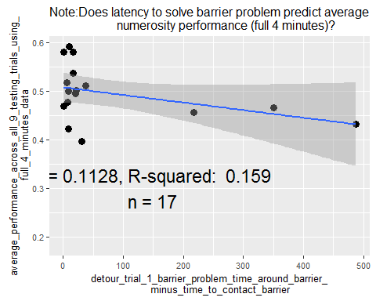

##   
## Call:  
## lm(formula = df.full$average_performance_across_all_9_testing_trials_using_T30_to_T50_data ~   
## df.full$detour_trial_1_barrier_problem_time_around_barrier_minus_time_to_contact_barrier,   
## na.rm = TRUE)  
##   
## Residuals:  
## Min 1Q Median 3Q Max   
## -0.15269 -0.04849 0.01314 0.04857 0.18642   
##   
## Coefficients:  
## Estimate  
## (Intercept) 0.5290918  
## df.full$detour_trial_1_barrier_problem_time_around_barrier_minus_time_to_contact_barrier -0.0001758  
## Std. Error  
## (Intercept) 0.0240632  
## df.full$detour_trial_1_barrier_problem_time_around_barrier_minus_time_to_contact_barrier 0.0001545  
## t value  
## (Intercept) 21.988  
## df.full$detour_trial_1_barrier_problem_time_around_barrier_minus_time_to_contact_barrier -1.138  
## Pr(>|t|)  
## (Intercept) 7.96e-13  
## df.full$detour_trial_1_barrier_problem_time_around_barrier_minus_time_to_contact_barrier 0.273  
##   
## (Intercept) ***  
## df.full$detour_trial_1_barrier_problem_time_around_barrier_minus_time_to_contact_barrier   
## ---  
## Signif. codes: 0 '***' 0.001 '**' 0.01 '*' 0.05 '.' 0.1 ' ' 1  
##   
## Residual standard error: 0.08722 on 15 degrees of freedom  
## (35 observations deleted due to missingness)  
## Multiple R-squared: 0.07946, Adjusted R-squared: 0.01809   
## F-statistic: 1.295 on 1 and 15 DF, p-value: 0.273

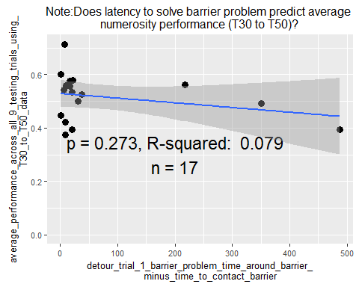

##   
## Call:  
## lm(formula = df.full$average_performance_across_all_9_testing_trials_using_full_4_minutes_data ~   
## df.full$detour_trial_1_full_problem_time_to_social_reward_minus_time_to_contact_barrier,   
## na.rm = TRUE)  
##   
## Residuals:  
## Min 1Q Median 3Q Max   
## -0.096162 -0.013580 0.005072 0.021000 0.084080   
##   
## Coefficients:  
## Estimate  
## (Intercept) 4.959e-01  
## df.full$detour_trial_1_full_problem_time_to_social_reward_minus_time_to_contact_barrier -9.766e-05  
## Std. Error  
## (Intercept) 1.648e-02  
## df.full$detour_trial_1_full_problem_time_to_social_reward_minus_time_to_contact_barrier 7.919e-05  
## t value  
## (Intercept) 30.080  
## df.full$detour_trial_1_full_problem_time_to_social_reward_minus_time_to_contact_barrier -1.233  
## Pr(>|t|)  
## (Intercept) 1.14e-12  
## df.full$detour_trial_1_full_problem_time_to_social_reward_minus_time_to_contact_barrier 0.241  
##   
## (Intercept) ***  
## df.full$detour_trial_1_full_problem_time_to_social_reward_minus_time_to_contact_barrier   
## ---  
## Signif. codes: 0 '***' 0.001 '**' 0.01 '*' 0.05 '.' 0.1 ' ' 1  
##   
## Residual standard error: 0.04697 on 12 degrees of freedom  
## (38 observations deleted due to missingness)  
## Multiple R-squared: 0.1125, Adjusted R-squared: 0.03851   
## F-statistic: 1.521 on 1 and 12 DF, p-value: 0.2411

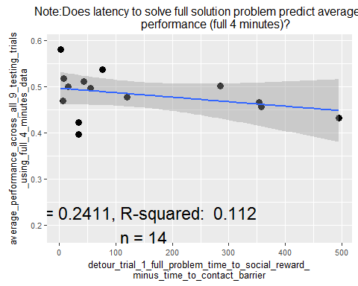

##   
## Call:  
## lm(formula = df.full$average_performance_across_all_9_testing_trials_using_T30_to_T50_data ~   
## df.full$detour_trial_1_full_problem_time_to_social_reward_minus_time_to_contact_barrier,   
## na.rm = TRUE)  
##   
## Residuals:  
## Min 1Q Median 3Q Max   
## -0.135225 -0.081540 0.002295 0.063037 0.205227   
##   
## Coefficients:  
## Estimate  
## (Intercept) 5.107e-01  
## df.full$detour_trial_1_full_problem_time_to_social_reward_minus_time_to_contact_barrier -1.355e-05  
## Std. Error  
## (Intercept) 3.501e-02  
## df.full$detour_trial_1_full_problem_time_to_social_reward_minus_time_to_contact_barrier 1.682e-04  
## t value  
## (Intercept) 14.586  
## df.full$detour_trial_1_full_problem_time_to_social_reward_minus_time_to_contact_barrier -0.081  
## Pr(>|t|)  
## (Intercept) 5.35e-09  
## df.full$detour_trial_1_full_problem_time_to_social_reward_minus_time_to_contact_barrier 0.937  
##   
## (Intercept) ***  
## df.full$detour_trial_1_full_problem_time_to_social_reward_minus_time_to_contact_barrier   
## ---  
## Signif. codes: 0 '***' 0.001 '**' 0.01 '*' 0.05 '.' 0.1 ' ' 1  
##   
## Residual standard error: 0.09976 on 12 degrees of freedom  
## (38 observations deleted due to missingness)  
## Multiple R-squared: 0.0005409, Adjusted R-squared: -0.08275   
## F-statistic: 0.006494 on 1 and 12 DF, p-value: 0.9371

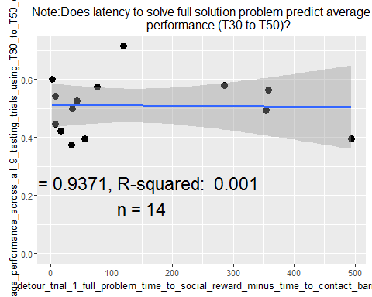

##   
## Call:  
## lm(formula = df.full$detour_trial_1_full_problem_time_to_social_reward_minus_time_to_contact_barrier ~   
## df.full$detour_trial_1_barrier_problem_time_around_barrier_minus_time_to_contact_barrier,   
## na.rm = TRUE)  
##   
## Residuals:  
## Min 1Q Median 3Q Max   
## -35.32 -32.00 -24.58 -11.06 226.47   
##   
## Coefficients:  
## Estimate  
## (Intercept) 37.3594  
## df.full$detour_trial_1_barrier_problem_time_around_barrier_minus_time_to_contact_barrier 0.9622  
## Std. Error  
## (Intercept) 17.1706  
## df.full$detour_trial_1_barrier_problem_time_around_barrier_minus_time_to_contact_barrier 0.1102  
## t value  
## (Intercept) 2.176  
## df.full$detour_trial_1_barrier_problem_time_around_barrier_minus_time_to_contact_barrier 8.735  
## Pr(>|t|)  
## (Intercept) 0.0424  
## df.full$detour_trial_1_barrier_problem_time_around_barrier_minus_time_to_contact_barrier 4.43e-08  
##   
## (Intercept) *   
## df.full$detour_trial_1_barrier_problem_time_around_barrier_minus_time_to_contact_barrier ***  
## ---  
## Signif. codes: 0 '***' 0.001 '**' 0.01 '*' 0.05 '.' 0.1 ' ' 1  
##   
## Residual standard error: 65.91 on 19 degrees of freedom  
## (31 observations deleted due to missingness)  
## Multiple R-squared: 0.8006, Adjusted R-squared: 0.7901   
## F-statistic: 76.3 on 1 and 19 DF, p-value: 4.435e-08

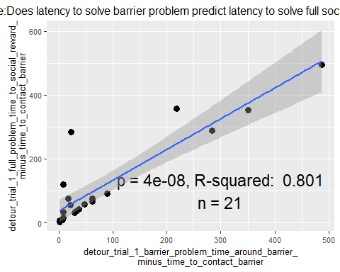

##   
## Call:  
## lm(formula = df.full$detour_trial_1_latency_to_enter_reward_following_barrier_solution ~   
## df.full$detour_trial_1_barrier_problem_time_around_barrier_minus_time_to_contact_barrier,   
## na.rm = TRUE)  
##   
## Residuals:  
## Min 1Q Median 3Q Max   
## -35.32 -32.00 -24.58 -11.06 226.47   
##   
## Coefficients:  
## Estimate  
## (Intercept) 37.35941  
## df.full$detour_trial_1_barrier_problem_time_around_barrier_minus_time_to_contact_barrier -0.03778  
## Std. Error  
## (Intercept) 17.17056  
## df.full$detour_trial_1_barrier_problem_time_around_barrier_minus_time_to_contact_barrier 0.11016  
## t value  
## (Intercept) 2.176  
## df.full$detour_trial_1_barrier_problem_time_around_barrier_minus_time_to_contact_barrier -0.343  
## Pr(>|t|)  
## (Intercept) 0.0424  
## df.full$detour_trial_1_barrier_problem_time_around_barrier_minus_time_to_contact_barrier 0.7354  
##   
## (Intercept) *  
## df.full$detour_trial_1_barrier_problem_time_around_barrier_minus_time_to_contact_barrier   
## ---  
## Signif. codes: 0 '***' 0.001 '**' 0.01 '*' 0.05 '.' 0.1 ' ' 1  
##   
## Residual standard error: 65.91 on 19 degrees of freedom  
## (31 observations deleted due to missingness)  
## Multiple R-squared: 0.006152, Adjusted R-squared: -0.04616   
## F-statistic: 0.1176 on 1 and 19 DF, p-value: 0.7354

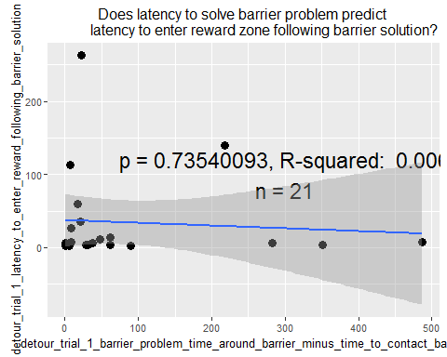

##   
## Call:  
## lm(formula = df.full$detour_trial_1_full_problem_time_to_social_reward_minus_time_to_contact_barrier ~   
## df.full$detour_trial_1_prop_time_in_social_reward_following_solution,   
## na.rm = TRUE)  
##   
## Residuals:  
## Min 1Q Median 3Q Max   
## -152.19 -87.83 -61.36 47.27 265.89   
##   
## Coefficients:  
## Estimate  
## (Intercept) 65.06  
## df.full$detour_trial_1_prop_time_in_social_reward_following_solution 187.96  
## Std. Error  
## (Intercept) 42.13  
## df.full$detour_trial_1_prop_time_in_social_reward_following_solution 103.48  
## t value  
## (Intercept) 1.544  
## df.full$detour_trial_1_prop_time_in_social_reward_following_solution 1.816  
## Pr(>|t|)  
## (Intercept) 0.1390  
## df.full$detour_trial_1_prop_time_in_social_reward_following_solution 0.0851  
##   
## (Intercept)   
## df.full$detour_trial_1_prop_time_in_social_reward_following_solution .  
## ---  
## Signif. codes: 0 '***' 0.001 '**' 0.01 '*' 0.05 '.' 0.1 ' ' 1  
##   
## Residual standard error: 136.3 on 19 degrees of freedom  
## (31 observations deleted due to missingness)  
## Multiple R-squared: 0.1479, Adjusted R-squared: 0.1031   
## F-statistic: 3.299 on 1 and 19 DF, p-value: 0.08513

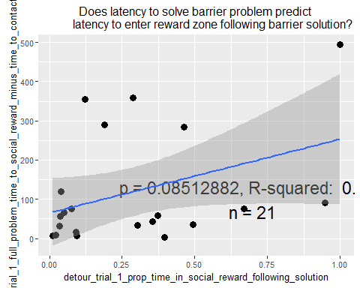

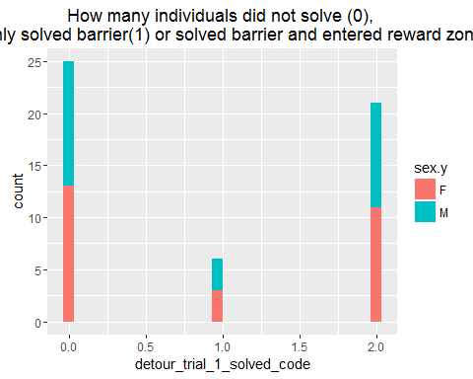

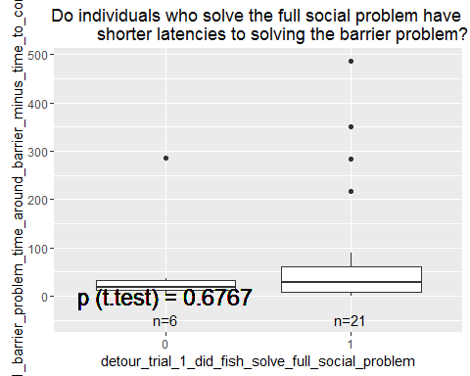

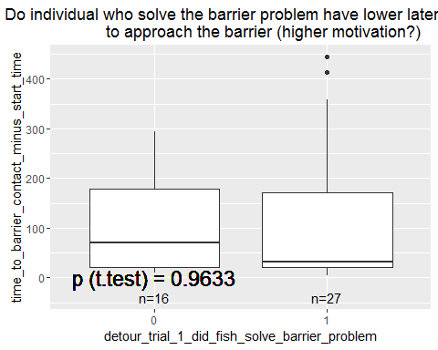

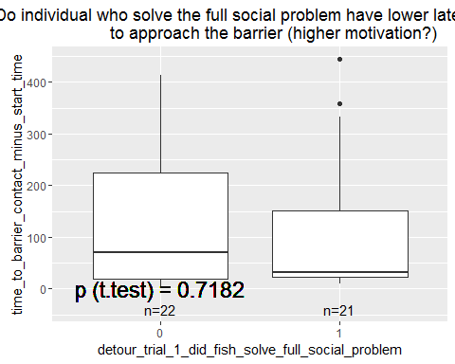

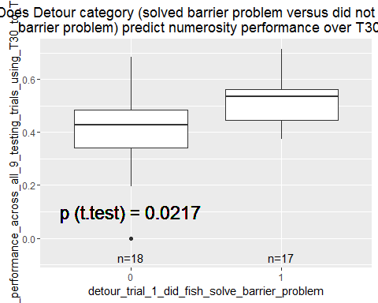

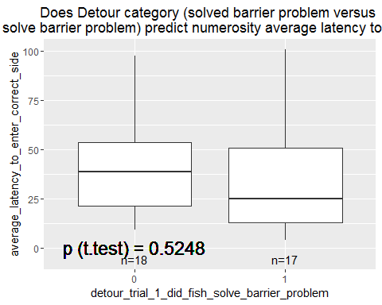

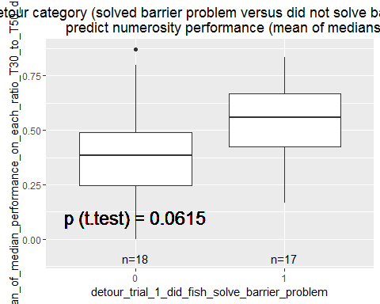

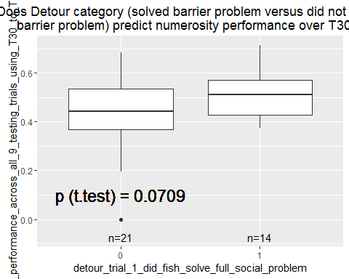

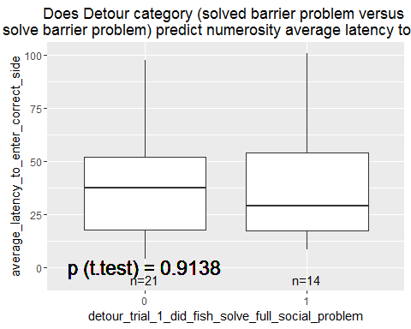

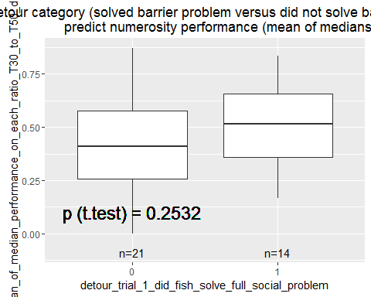

COMPARE NUMEROSITY AND DETOUR Does latency to solve barrier problem predict average performance (full 4 minutes)? Does latency to solve full solution problem predict average performance (full 4 minutes)?

Does latency to solve barrier problem predict average performance (T30 to T50)? Does latency to solve full solution problem predict average performance (T30 to T50)?

Does latency to solve barrier problem predict latency to enter correct side? Does latency to solve full solution problem predict latency to enter correct side?

WITHIN DETOUR (PERFORMANCE) Does latency to solve barrier problem predict latency to solve full social problem? How frequently do individuals only solve barrier problem but not full social problem(histogram)? Do individuals who solve the full social problem have shorter latencies to solving the barrier problem (boxplot)

WITHIN DETOUR (OTHER BEHAVIORS) Does proportion time in social reward predict latency to solve detour problem? Does proportion time in social reward predict latency to solve full social problem?

Does latency to approach barrier predict latency to solve detour problem? Does latency to approach barrier predict latency to solve full social problem?

Does latency to approach barrier predict time in social reward? Do individuals who solve the barrier problem approach the barrier more quickly? (boxplot) Do individual who solvev the full social problem approach the barrier more quickly? (boxplot)

OTHER FACTORS: Does sex predict time to solve barrier problem? Does sex predict time to solve full social problem? Does sex predict if you solve barrier problem? Does sex predict if you solve foll social problem? Does sex predict latency to approach barrier? Does sex predict proportion time in social reward?

Does size predict time to solve barrier problem? Does size predict time to solve full social problem? Does size predict if you solve barrier problem? Does size predict if you solve foll social problem? Does size predict latency to approach barrier? Does size predict proportion time in social reward?

Does order predict time to solve barrier problem? Does order predict time to solve full social problem? Does order predict if you solve barrier problem? Does order predict if you solve foll social problem? Does order predict latency to approach barrier? Does order predict proportion time in social reward?